EXPERIMENT NO.1

**AIM:**

**THEORY:**

**HTML**

* HTML stands for Hyper Text Mark-up Language
* HTML describes the structure of a Web page
* HTML consists of a series of elements
* HTML elements tell the browser how to display the content
* HTML elements are represented by tags
* HTML tags label pieces of content such as "heading", "paragraph", "table", and so on
* Browsers do not display the HTML tags, but use them to render the content of the page

**BASIC HTML PAGE STRUCTURE**

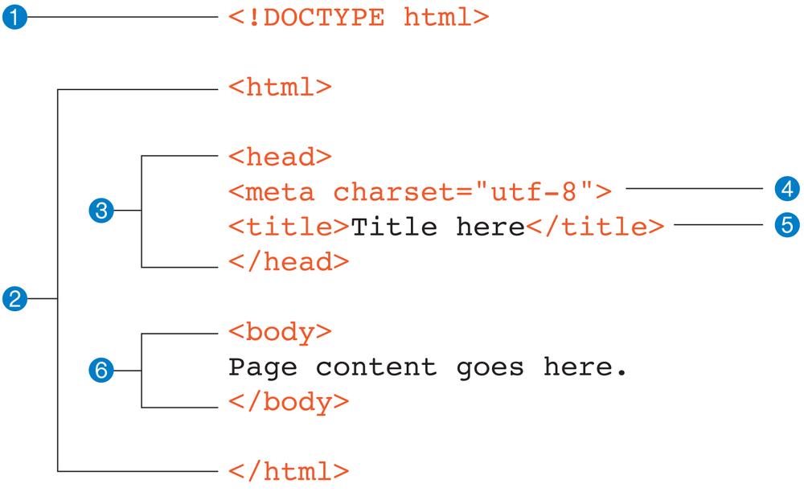

**HTML TAGS USED**

**HTML Tag :**

The HTML document itself begins with <html> and ends with </html>.It indicates start amd end o f the document.

**The <!DOCTYPE> Declaration**

The <!DOCTYPE> declaration represents the document type, and helps browsers to display web pages correctly.

It must only appear once, at the top of the page (before any HTML tags).

The <!DOCTYPE> declaration is not case sensitive.

**HEAD Tag:**

HTML paragraphs are defined with the <p> tag.

**Title Tag:**

The <title> tag is required in all HTML documents and it defines the title of the document.

**Body Tag:**

The HTML <body> tag defines the main content of the HTML document or the section of the HTML document that will be directly visible on your web page. This tag is also commonly referred to as the <body> element.

**Paragraph Tag :**

HTML paragraphs are defined with the <p> tag.

**HTML Headings :**

HTML headings are defined with the <h1> to <h6> tags.

**Line Break Tag :**

It is used to add a new line in document.

**Image Tag:**

You can insert any image in your web page by using <img> tag. Following is the simple syntax to use this tag.

<img src = "Image URL" ... attributes-list/>

**Anchor Tag:**

The <a> tag defines a hyperlink, which is used to link from one page to another.

**Center Tag:**

The <center> tag is used to center-align text.

**HTML PAGE LAYOUT**

<!DOCTYPE html>

<html>

<head>

<title>Quote's Website</title>

</head>

<body bgcolor="#99ccff">

<center>

<img src="logo_img.png" alt="Logo image" width="50" height="50">

<h1>Quote's Website </h1>

</center>

<nav>

<a href="#">HOME</a> |

<a href="#">MY PROFILE</a>|

<a href="#">AUTHORS</a>|

<a href="#">TRENDING PAGE</a>|

<a href="#">ABOUT</a>

</nav>

<center><h3><i>A place to enrich your mind and get inspired!</i></h3></center>

<center><button>Share your thoughts</button></center> <br> <br>

<center><img src="aspire.png" width="250" height="250"></center>

<br><br>

<p>

A website to surf for life-changing and impactful quotes by great authors of the past and present.Create your own user-account and build your own profile. You can post your own quotes as well and get appreciated by the people all around the globe.

</p>

</body>

</html>