In20-S5-EN3160 – Assignment 1

Index Number – 200709K Wickramanayake R.S.D

Github Repository :- [RuchchaSD/EN3160 (github.com)](https://github.com/RuchchaSD/EN3160)

**Question 1**

**Question 2 (Only Image transformation code snippet)**

**Question 3 (Only Image transformation code snippet)**



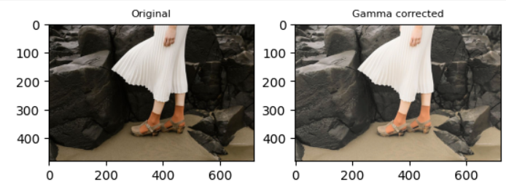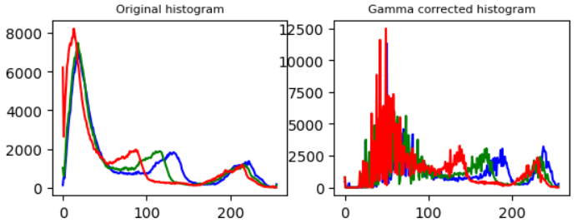

**Question 4 (Only Image transformation code snippet)**

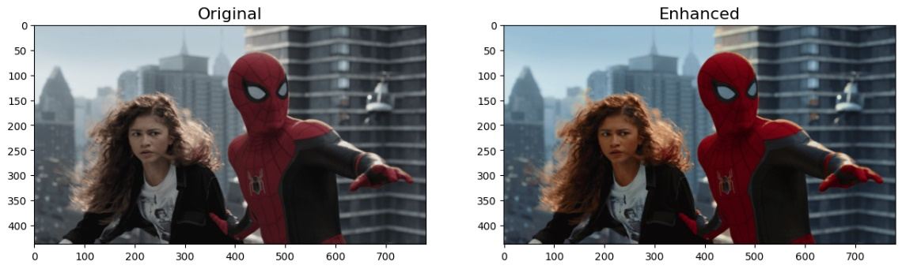

**Question 5 (Only Image transformation code snippet)**

**Question 6 (Only Image transformation code snippet)******

**Question 7**



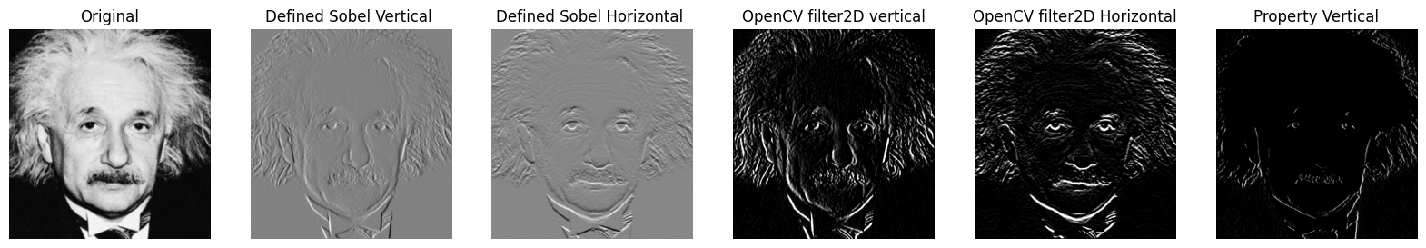

**Question 8**

**Question 9**

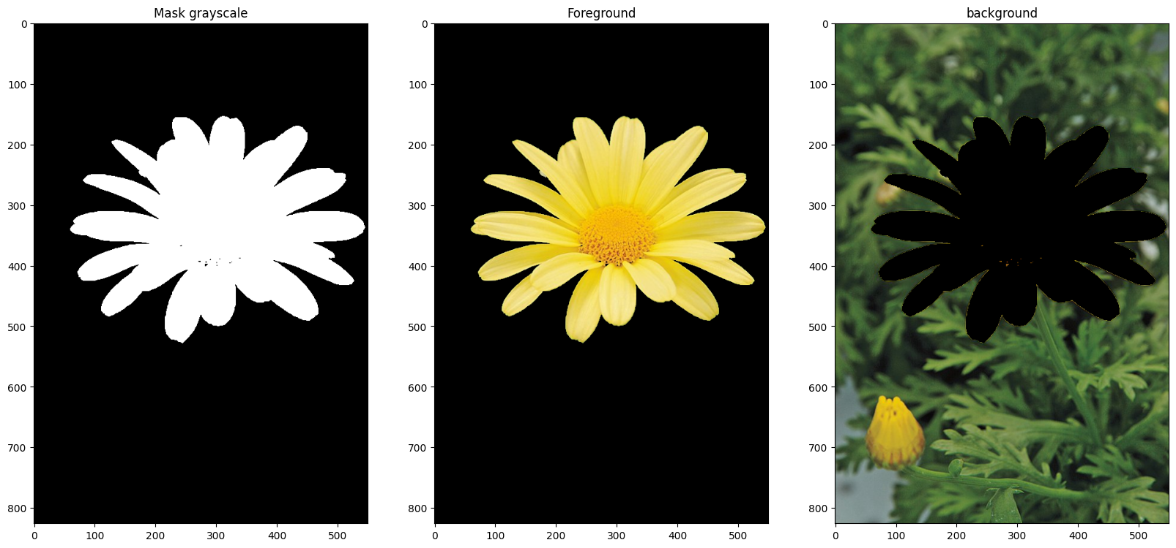****

Q9.(c) The dark edges were introduced due to gaussian blur applied to the background image. The part were the foreground flower was present was black when gaussian blur was applied. So the kernel for gaussian blur would have taken the black pixels in the cut part for calculating values for the edges in the final image.