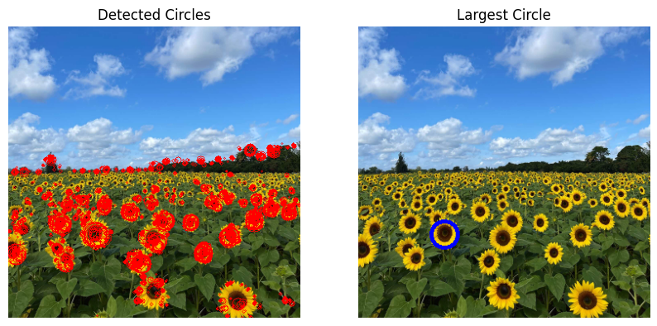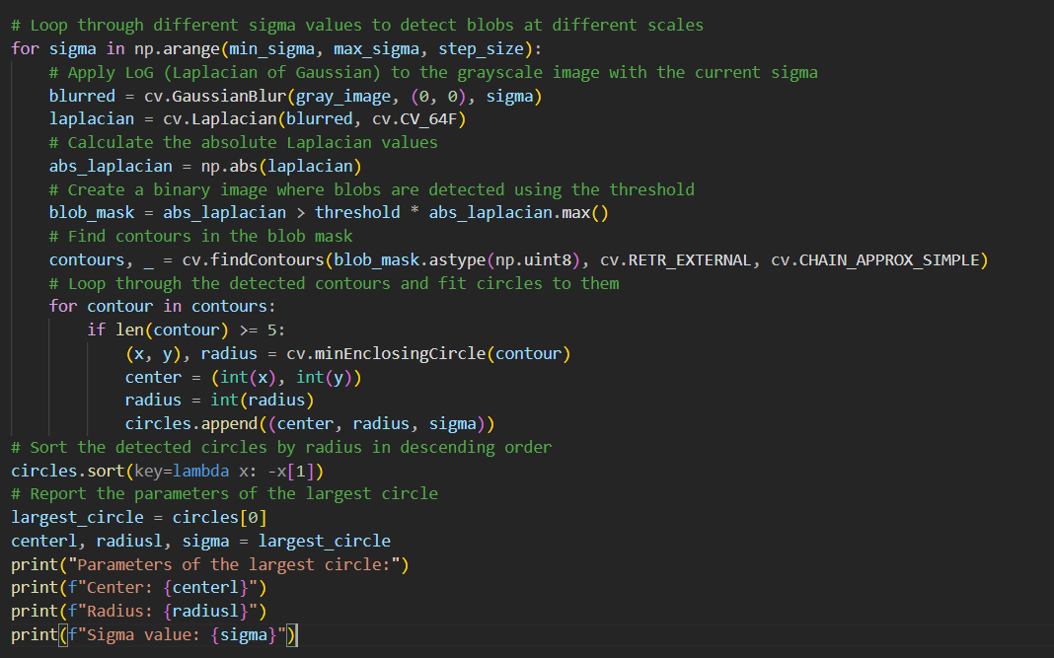1.

2.

First one is also an image from the given image set, second one

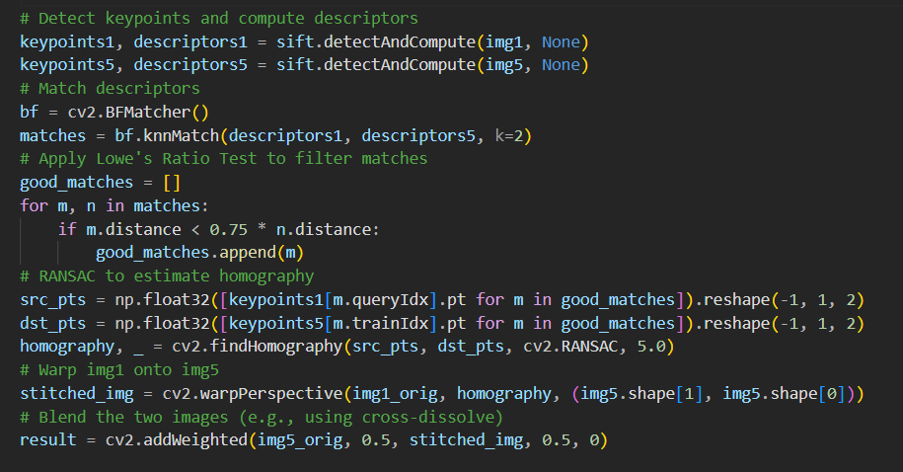4.

is Lasith Malinga on Galle clock tower.