E-COMMERCE CUSTOMER ANALYTICS
Customer Segmentation
Business Insights Report
Prepared using K-Means clustering on demographic and behavioral data from a 2,500-customer e-commerce dataset. This report translates the clustering output into five actionable customer personas, revenue-concentration findings, and segment-specific strategy recommendations.
2,500  Customers Analyzed | 5  Segments Identified | 0.236  Silhouette Score | 61.3%  Top Segment Revenue Share

1. Executive Summary
Clustering the customer base on purchase frequency, spend, recency, engagement, and discount behavior surfaces five distinct segments with very different economics. The headline finding: revenue is highly concentrated. Premium Loyalists make up just 17% of customers but generate 61.3% of total revenue — a 3.6x value index — while the largest segment by headcount, New & Occasional Shoppers (23% of customers), contributes only 3.8% of revenue.
This has direct implications for where retention, personalization, and CRM budget should be spent first. It also identifies a meaningful At-Risk segment (19.3% of customers, avg. 96.5 days since last purchase) that represents a concrete win-back opportunity rather than a lost cause.

2. Methodology

2.1 Data
A synthetic dataset of 2,500 customers was constructed with realistic demographic attributes (age, gender, income, city tier) and behavioral metrics (purchase frequency, average order value, recency, app engagement, discount usage, cart abandonment, return rate, satisfaction score).

2.2 Feature Engineering
Behavioral features were framed using the RFM (Recency, Frequency, Monetary) marketing framework, extended with engagement and risk signals. All numeric features were standardized (zero mean, unit variance); categorical features (city tier, primary channel) were one-hot encoded.

2.3 Clustering
K-Means was run for k = 2 through 10, evaluated via the elbow method (inertia) and silhouette score. k = 5 was selected as the point where the elbow flattens while keeping segments operationally interpretable for a marketing team. The final model achieved a silhouette score of 0.236 and a Davies-Bouldin index of 1.649.
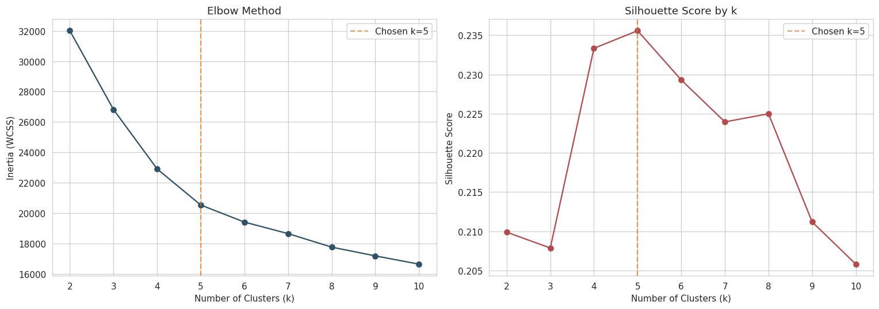

3. Segment Overview
Segment | % Customers | % Revenue | Avg. Spend (₹) | Value Index
Premium Loyalists | 17.0% | 61.3% | 1,04,661 | 3.60x
Premium Browsers | 17.8% | 16.0% | 26,029 | 0.90x
Frequent Bargain Hunters | 22.8% | 12.9% | 16,417 | 0.56x
At-Risk / Churn-Prone | 19.3% | 6.1% | 9,162 | 0.32x
New & Occasional Shoppers | 23.0% | 3.8% | 4,753 | 0.16x

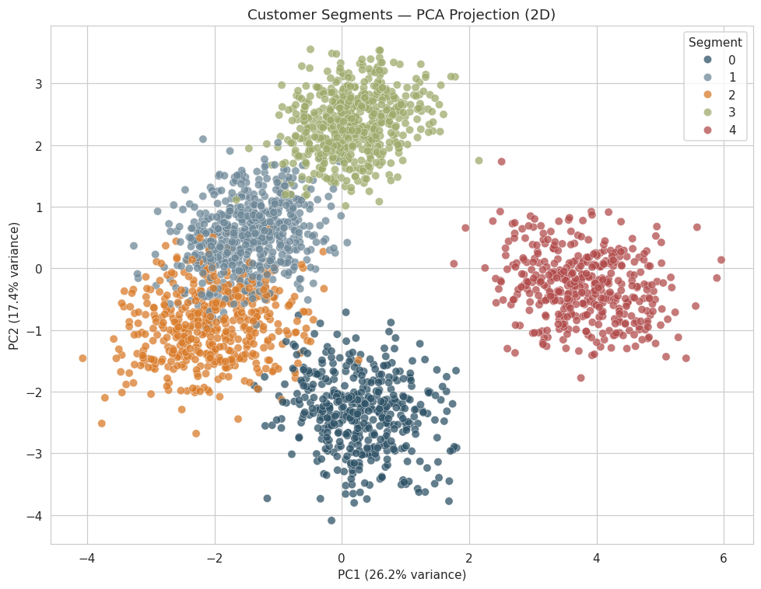
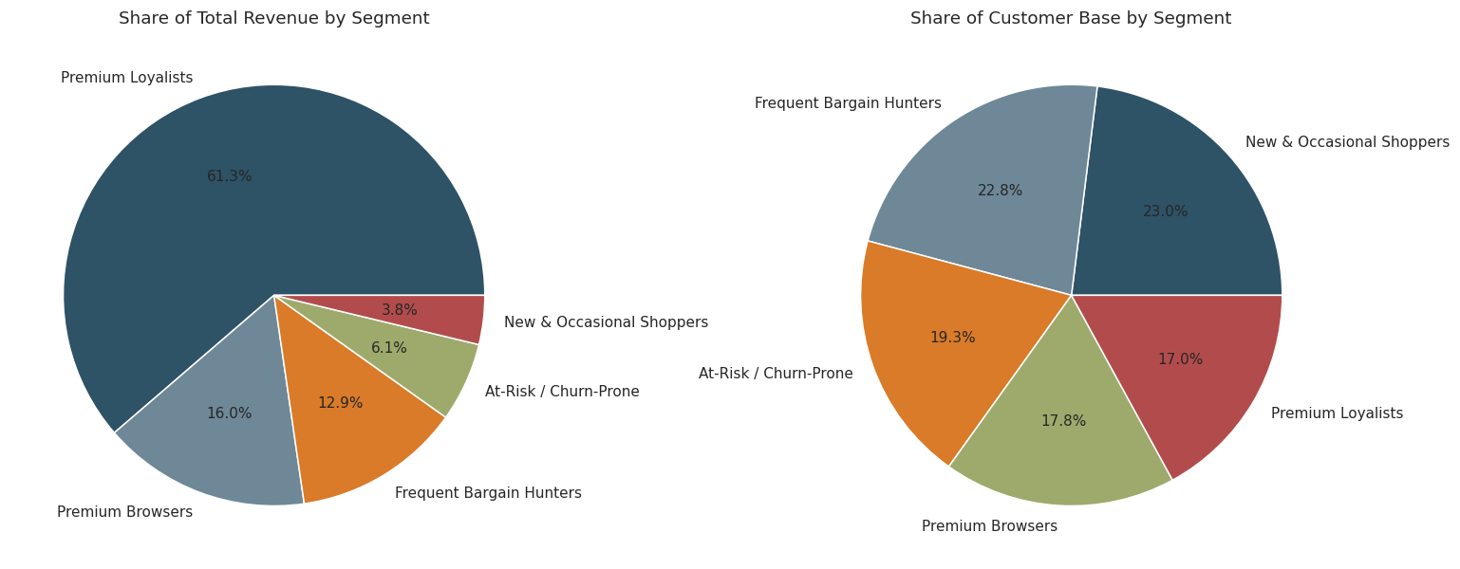

4. Segment Profiles & Recommendations

4.1 Premium Loyalists — 17.0% of customers, 61.3% of revenue
High spend, high frequency (27.7 purchases/yr), very recent activity (avg. 6 days), low discount reliance (12%), highest satisfaction (3.83/5).
- Protect this segment aggressively — it is the single most valuable group by a wide margin.
- Offer VIP tiering, early access to new arrivals, and referral incentives rather than blanket discounts, which would erode margin unnecessarily.
- Monitor for early churn signals (rising recency, falling sessions) since losing even a few of these customers has outsized revenue impact.

4.2 Premium Browsers — 17.8% of customers, 16.0% of revenue
Highest income and average order value (₹5,222) but low purchase frequency (5.0/yr); older average age (40.7); lowest discount usage.
- Use curated, editorial-style content and high-touch personalization rather than volume discounting.
- Retarget with premium new arrivals and limited releases to convert browsing into purchase.
- Investigate the moderate satisfaction score (3.17) — likely tied to purchase friction rather than price sensitivity.

4.3 Frequent Bargain Hunters — 22.8% of customers, 12.9% of revenue
Very high frequency (18.9/yr) and app engagement, but low average order value (₹865) and heavy discount reliance (69%).
- Introduce bundle offers and loyalty points that reward full-price purchases to gradually lift basket size.
- Cross-sell complementary categories to increase order value without relying solely on markdowns.
- Treat as a volume-and-engagement asset, not a margin driver — optimize for lifetime value, not per-order profit.

4.4 At-Risk / Churn-Prone — 19.3% of customers, 6.1% of revenue
Longest recency (avg. 96.5 days since last purchase), lowest app engagement (3.0 sessions/month), below-average satisfaction (3.01).
- Launch a win-back campaign with personalized reactivation offers, prioritizing customers with previously high lifetime value.
- Deploy a short feedback survey to diagnose the specific reason for disengagement (price, assortment, service, competitor switch).
- Set a reactivation-rate KPI and track it as a leading indicator, since this segment overlaps with previously higher-value customers who are drifting away.

4.5 New & Occasional Shoppers — 23.0% of customers, 3.8% of revenue
Lowest tenure (0.56 yrs), lowest frequency (3.4/yr) and spend, youngest average age (26.2) — still in an exploratory phase with the brand.
- Build a structured onboarding journey with category-discovery nudges in the first 30–60 days.
- Offer a second-purchase incentive to move customers past the highest-risk early drop-off window.
- Track segment migration over time — the goal is graduation into Bargain Hunter or Loyalist, not permanent residency here.

5. Key Takeaways
- Revenue is concentrated, not evenly distributed — a 3.6x value index for the top segment means retention spend should be prioritized there first.
- The At-Risk segment is a reactivation opportunity, not a lost cause: these were previously active, higher-frequency customers.
- Discount-driven volume (Bargain Hunters) and low-frequency premium spend (Premium Browsers) require opposite playbooks — one needs margin protection, the other needs frequency-building.
- Segments should be refreshed quarterly, since behavior drifts and a customer's segment membership is not permanent.

6. Next Steps
- Feed the cluster/persona label into the CRM and ad platforms as a custom audience field.
- A/B test segment-specific campaigns against a control group and measure incremental lift, not just response rate.
- Track segment migration (e.g., Bargain Hunter → Premium Loyalist) as a formal loyalty-program KPI.
- Extend the feature set with product-level affinity data if/when available, to support segment-specific merchandising.

