**PACKAGE**

**A package is the collection of related classes and interfaces as a single unit.**

**A package is a folder that contains .class files representing related classes and interfaces**

**In Java applications, packages are able to provide the following advantages.**

**• Modularity**

**• Abstraction**

**• Security**

**• Shareability**

**• Reusability**

**There are 2 types of packages in Java.**

**• Predefined Packages**

**• User defined Packages**

**Predefined Packages:- These packages are provided by the java language the types of packages are known as predefined packages.**

**Example:-**

**java.lang java.beans java.text java.sql java.io java.net java.nio java.math java.util java.applet java.rmi java.awt java.times java.security**

**Note:- The default package in java is java.lang package this package is implicitly available to all java programs.**

**Note:-When we used any classes and interfaces in our application and that classes and interfaces are not parts of java.lang package then we must import the package in which these classes and interfaces are available by using the import statement.**

**Example:-**

**import java.util.Scanner;**

**class Test1**

**{**

**public static void main(String[] args)**

**{**

**Scanner sc=new Scanner(System.in);**

**}**

**}**

**Note:-In the above application Scanner class is not part of the java.lang package so we have required to import the corresponding package.**

**There are two types of import statements:-**

1. **Implicit import statement.**
2. **Explicit import statement.**

**Implicit import statement:-In this import statement we write import a statement at the package or sub-package level such type of import statement are known as an implicit import statement.**

**Example:-**

**import java.util.*;**

**import java.awt.event.*;**

**Explicit import statement:-In this import statement we write import a statement at the class or interface level such type of import statement are known as an Explicit import statement.**

**Example:-**

**import java.util.Scanner;**

**import java.awt.event.ActionListener;**

**User-defined packages:-**

**The packages are defined by the user, and these packages contain a .class file of user-defined classes and interfaces.**

**Declare the package by using the package keyword. and package statement must be the first statement of the java application.**

**syntax:- package package-name;**

**example:- package com.gla;**

**where:- com package and gla is a sub package of com package.**

**Example:-**

**package com.abc.gla;**

**public class Test1**

**{**

**public void m1()**

**{**

**System.out.println("com.abc.gla.Test1 class m1 method");**

**}**

**}**

**package com.xyz.gla;**

**import com.abc.gla.Test1;**

**public class Test2**

**{**

**public void m2()**

**{**

**System.out.println("com.xyz.gla.Test2 class m2 method");**

**}**

**public static void main(String[]args)**

**{**

**Test1 t1=new Test1();**

**Test2 t2=new Test2();**

**t1.m1();**

**t2.m2();**

**}**

**}**

**Compile and Execute the above application:-**

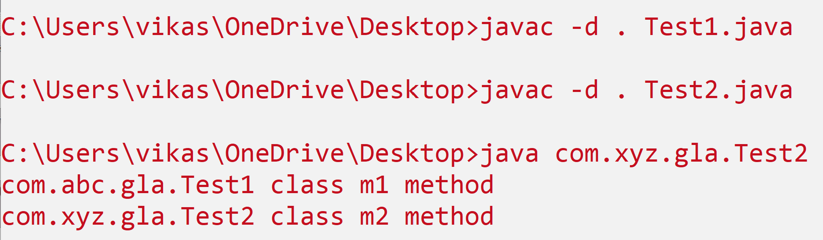

**Where -d represents the directory and .(dot) represents the current working directory, in place of .(dot) we use any valid directory of our system.**