**Aim:** ImplementDecision Tree classifier models to perform supervised classification and evaluate model performance.

**Software Used:** Google Collaborative Python

**Theory:**

**Decision Tree:**

A decision tree is a supervised learning algorithm used for both classification and regression tasks. It has a hierarchical tree structure which consists of a root node, branches, internal nodes and leaf nodes. It It works like a flowchart help to make decisions step by step where:

* Internal nodes represent attribute tests
* Branches represent attribute values
* Leaf nodes represent final decisions or predictions.

Decision trees are widely used due to their interpretability, flexibility and low preprocessing needs.

**How Does a Decision Tree Work?**

A decision tree splits the dataset based on feature values to create pure subsets, ideally all items in a group belong to the same class. Each leaf node of the tree corresponds to a class label and the internal nodes are feature-based decision points. Let’s understand this with an example.

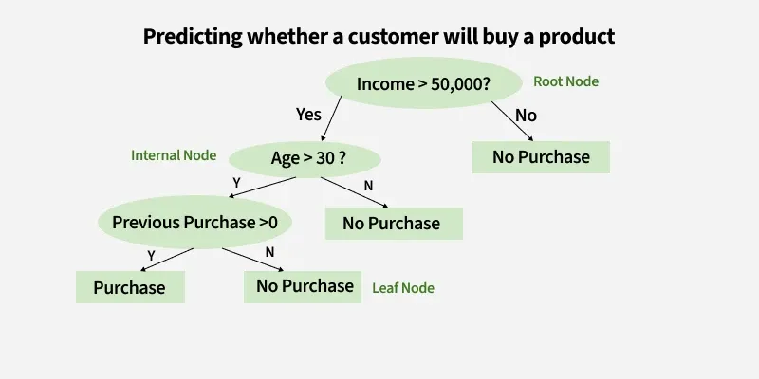

**Information Gain**

Information Gain tells us how useful a question (or feature) is for splitting data into groups. It measures how much the uncertainty decreases after the split. A good question will create clearer groups and the feature with the highest Information Gain is chosen to make the decision.

For example if we split a dataset of people into "Young" and "Old" based on age and all young people bought the product while all old people did not, the Information Gain would be high because the split perfectly separates the two groups with no uncertainty left

Suppose S is a set of instances A is an attribute, Sv is the subset of S v represents an individual value that the attribute A can take and Values (A) is the set of all possible values of Athen



**Entropy**

Entropy is the measure of uncertainty of a random variable; it characterizes the impurity of an arbitrary collection of examples. The higher the entropy the more the information content.

For example if a dataset has an equal number of "Yes" and "No" outcomes (like 3 people who bought a product and 3 who didn’t), the entropy is high because it’s uncertain which outcome to predict. But if all the outcomes are the same (all "Yes" or all "No") the entropy is 0 meaning there is no uncertainty left in predicting the outcome

Suppose S is a set of instances, A is an attribute, Sv is the subset of S with A= v and Values (A) is the set of all possible values of A, then



Decision Trees are easy to **interpret** and **visualize**, making them useful for understanding decision-making processes. They can handle both **categorical** and **numerical** data and do not require feature scaling. However, they are prone to **overfitting**, which can be addressed through techniques like **pruning** or using **ensemble methods** (e.g., Random Forest).

Model performance is evaluated using metrics such as **accuracy**, **precision**, **recall**, **F1-score**, and the **confusion matrix**, depending on the classification problem.

**Output:**

**1)titanic.csv**

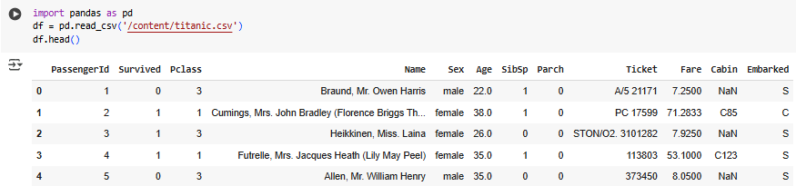

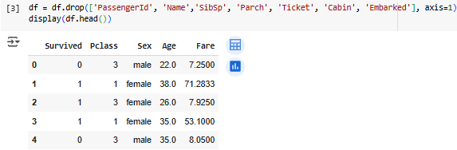

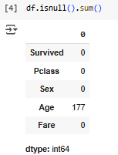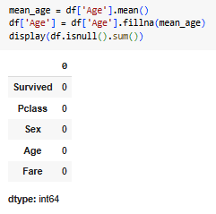

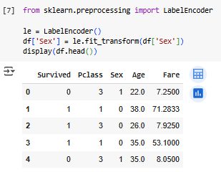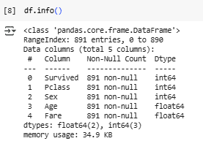

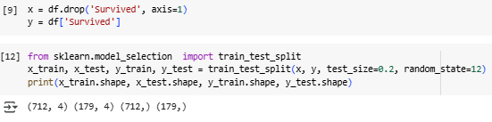

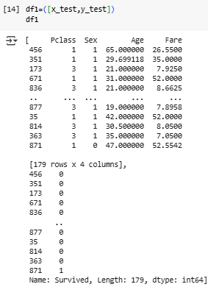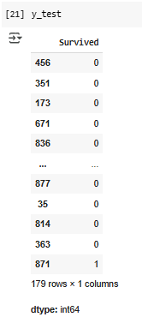

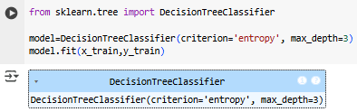

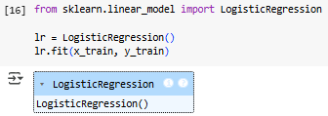

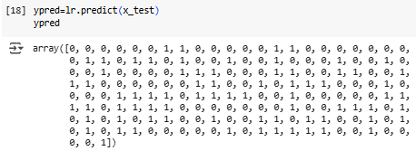



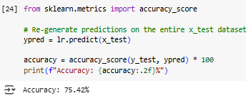

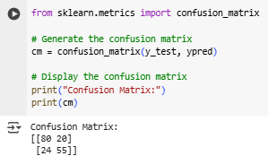

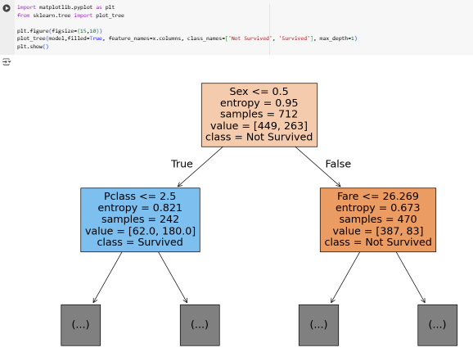

**2)company.csv**

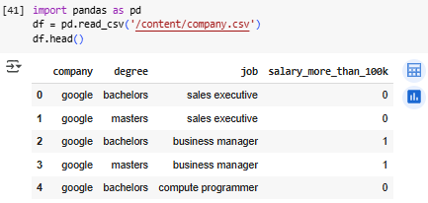

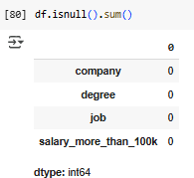

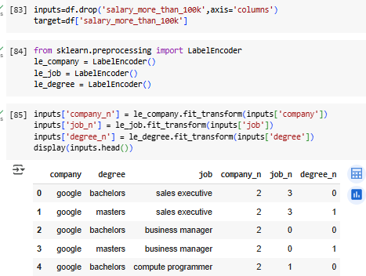

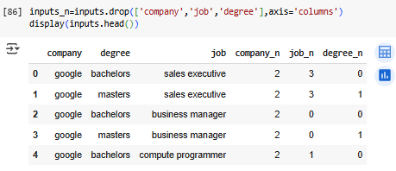

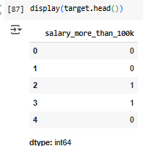

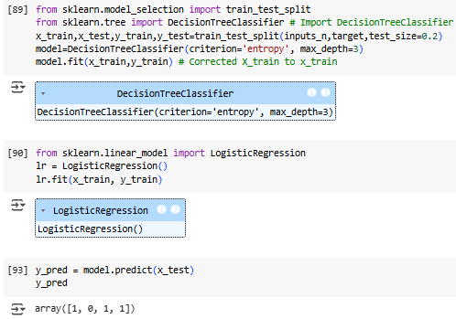

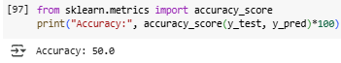

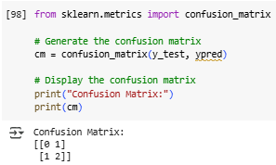

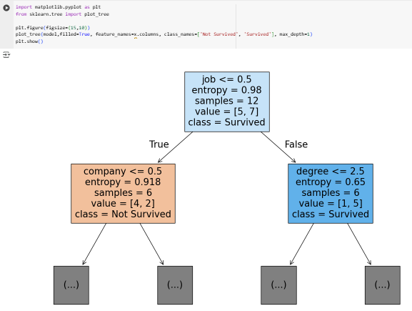

**Conclusion:** Hence, through this experiment, we learned how to implement a Decision Tree Classifier to perform supervised classification, train it on given datasets, and evaluate its performance