**Online Test Application.**

**Screenshot**

# **Header**



# **Welcome**

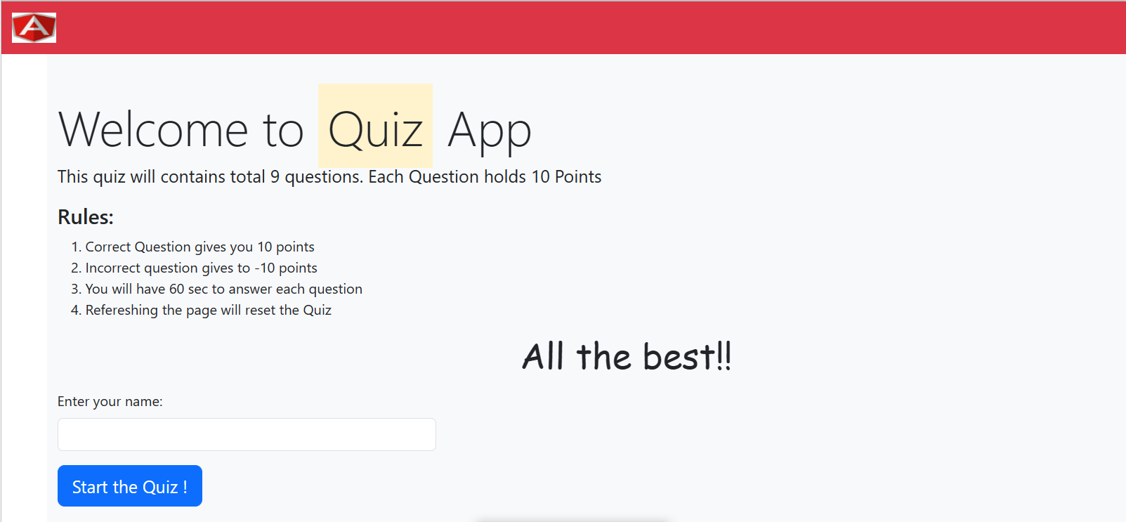

# **Questions**

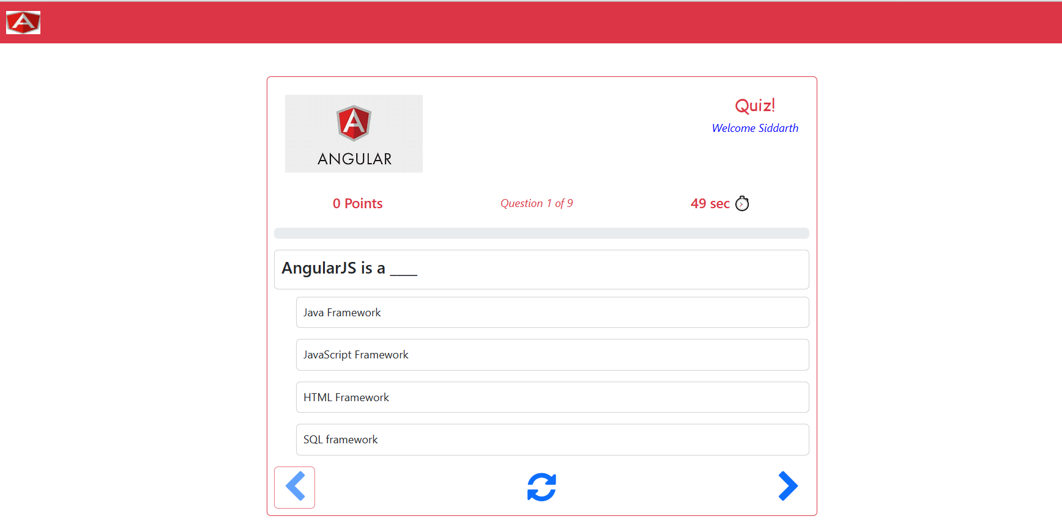

# **Points, Question, Timer**



# **Previous, Refresh, Next Button**

# **Result:**

