**Online Test Application.**

Course-end Project 1

DESCRIPTION

**Project Objective:**

As a Full Stack Developer, you have to develop an online test portal for assessment.

**Background of the problem statement:**

As the project is progressing, the management has asked you to create an online test application in order to help the recruitment team take online tests of the candidates coming for interviews.

**You must use the following:**

* Visual Studio Code
* NodeJS
* Angular
* GitHub

**Following requirements should be met:**

* A few of the source codes should be tracked on GitHub repositories. You need to document the tracked files that are ignored during the final push to the GitHub repository.

# How to start (Steps)

## 1. Create a Project named as

> ng new Online_test_app

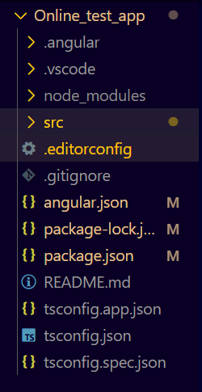

## 2. Configure Bootstrap

## 3.Create Component:

### Header

1. Create a header.html File.
2. Put a nav bar

### Welcome

1. Create a welcome.html file
2. As soon as the button <Start Quiz> is activated,
3. It will store the name of applicant in local storage and
4. display name of applicant throughout out project (from the local storage).
5. Route to next question page

### Questions

Question.component.html

Steps:

1. Put an Image
2. Quiz Header with the name of applicant
3. Mention Points, Question Remain, Timer
4. Progress bar
5. Design a Card – Displaying all questions in a card from question list.
6. Put answer Options for each question on a card.
7. Changing the background option of correct ans:
8. Create and action taken on buttons as : Previous , Refresh , Next
9. If the Quiz is completed Display Result Score Card.

## 4. Quiz Question in JSON file

Create a json file : questions.json in asset folder uses Array of Objects.

Put all questions in JSON Format.

To call this json file , we need a service ,

Inside app foler we created a service folder inside which we create a question service.



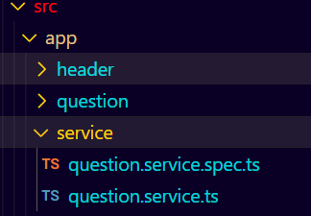

In question.service.ts

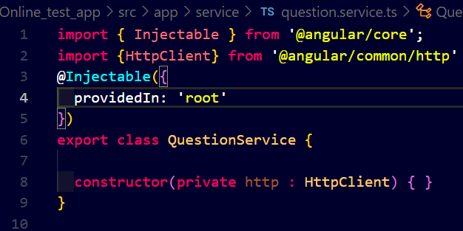

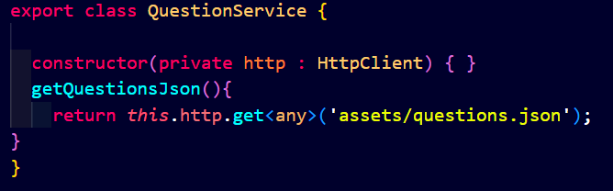

## 5. Routing

Routing.module.ts

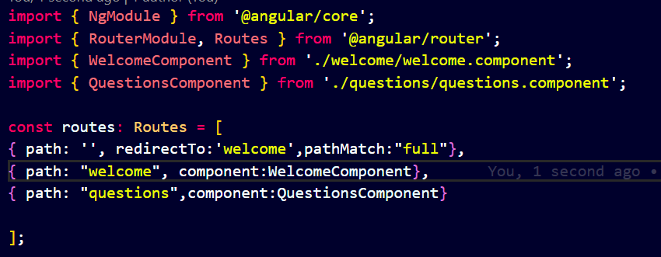

To make this router work, we need to set the router outlet in app.component.html