ACTIVITY 1

Generate the Same Image Using Different Tools:
PROMPT: Create a photorealistic image of a female airline customer-service executive standing at a modern international airport check-in counter. She is wearing a professional navy-blue uniform and looking directly at the camera. Soft natural light is entering from camera-left. The airport background is clean and modern, with passengers visible in soft focus. Use realistic skin texture, natural facial features, professional commercial photography, shallow depth of field and a 16:9 aspect ratio. Do not include any airline logo or readable text.

TOOL 1: CHATGPT


TOOL 2 GEMINI
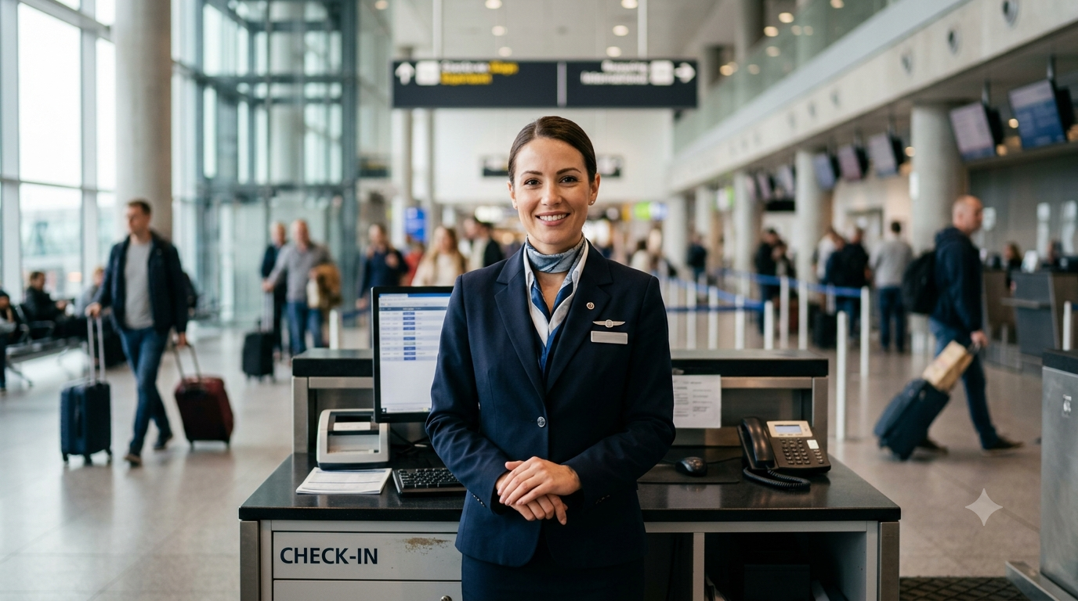

Activity 2

Observe the Model’s Visual Accent

Activity 2: Observe the Model’s Visual Accent

Evaluation Criterion | Tool 1 – Gemini | Tool 2 – ChatGPT
Name of AI tool | Gemini | ChatGPT
Prompt followed correctly? | Mostly | Mostly
Human face appears realistic? | Yes | Yes
Skin texture appears natural? | Mostly natural | Yes, very natural
Eyes and hands are correct? | Eyes are correct; hands are mostly correct | Eyes are correct; hands are mostly correct
Airport environment is realistic? | Yes | Yes
Light comes from camera-left? | Yes | Yes
Uniform is professional? | Yes | Yes
Unwanted text or logos present? | Yes – readable “CHECK-IN” text and background signage | No obvious readable text or airline logo
Image looks AI-generated? Why? | Slightly – smooth face, hands and artificial-looking text | Slightly – very polished facial features and background
Overall score out of 10 | 8/10 | 9/10

Analysis Questions

1. Which tool followed the prompt more accurately?
ChatGPT followed the prompt more accurately. It created a professional female airline executive in a navy-blue uniform with realistic facial features, camera-left lighting, and a modern airport background without obvious readable text or airline logos.
2. Which image appeared more realistic?
ChatGPT’s image appeared slightly more realistic overall. The face, skin texture, lighting, and background depth looked more natural and similar to a professional commercial photograph.
3. What differences did you observe in lighting?
Both images used bright, soft lighting coming mainly from the camera-left side. Gemini’s lighting was slightly more evenly distributed, while ChatGPT’s image had softer and more natural-looking highlights and shadows.
4. Did either image contain distorted eyes, hands or facial features?
Neither image had major distortions in the eyes or facial features. Gemini’s hands appeared slightly less natural, while ChatGPT’s hands were mostly accurate but partly hidden by the counter.
5. Which image would you use on an airline’s website?
I would use the ChatGPT image because it has a clean, professional commercial appearance and better matches the requested visual style. It also avoids obvious readable text and airline logos, making it more suitable for general airline website use.

6. What is the “visual accent” of each model?
Gemini: Its visual accent is a formal, realistic airport-service scene with a clear full-body composition and detailed airport environment.
ChatGPT: Its visual accent is soft, polished commercial realism, with stronger focus on the executive’s face, natural skin texture, and shallow depth of field.

Activity 3: Test Spatial Instructions

Prompt A — Camera-Left
Create a photorealistic image of an airport ground-staff executive standing beside a check-in counter. Soft morning light must enter from camera-left and illuminate the left side of the image. The executive should hold a tablet. Include a modern airport background in soft focus. Professional photography, realistic facial features, 16:9 aspect ratio, no logos and no readable text.

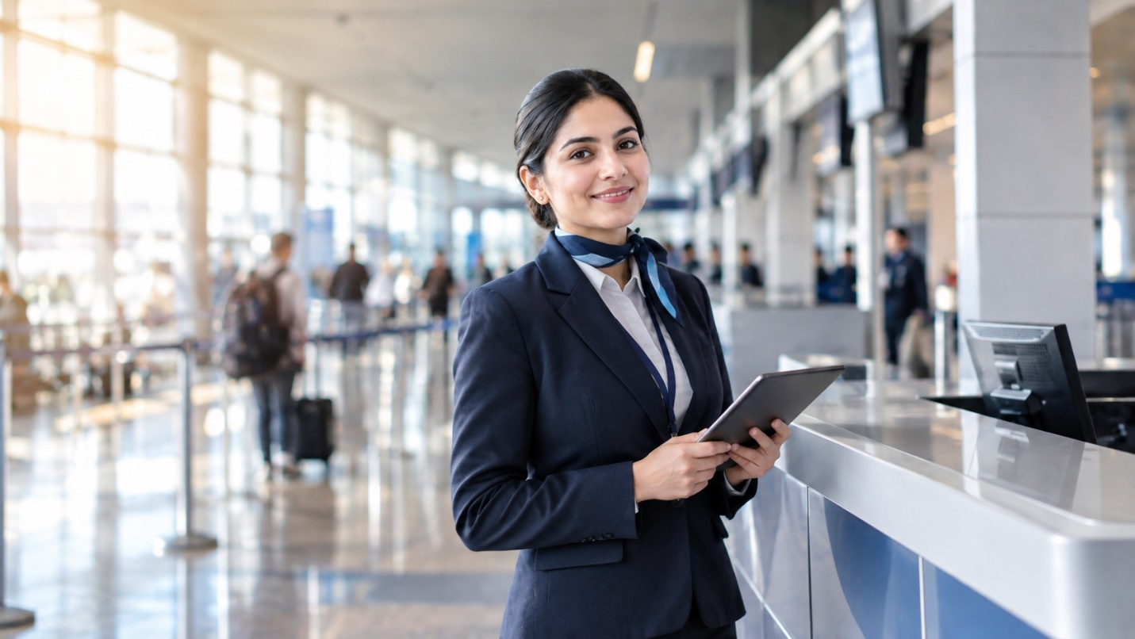

Prompt B — Camera-Right
Create a photorealistic image of an airport ground-staff executive standing beside a check-in counter. Soft morning light must enter from camera-right and illuminate the right side of the image. The executive should hold a tablet. Include a modern airport background in soft focus. Professional photography, realistic facial features, 16:9 aspect ratio, no logos and no readable text.



Question | Observation
Did the lighting direction change? | Yes. The lighting direction changed from camera-left in the first image to camera-right in the second image.
Was camera-left followed correctly? | Yes. In the first image, soft light enters from the camera-left side and illuminates the left side of the scene.
Was camera-right followed correctly? | Yes. In the second image, bright morning light enters from the camera-right side and illuminates the right side of the image.
Did the background remain consistent? | Yes. Both images show a modern airport check-in environment with counters, passengers, glass windows, and a soft-focus background.
Did the person’s appearance change? | The person remained similar in both images, with a professional navy-blue uniform, neat hairstyle, and professional appearance.
Which instruction was ignored, if any? | The main instructions were followed. However, some background screens contain indistinct visual elements, although there is no clearly readable text or visible airline logo.

