CUSTOMER BEHAVIOR DATA ANALYSIS

PROBLEM STATEMENT
A leading retail company wants to better understand its customers’ shopping behavior in order to improve sales, customer satisfaction, and long-term loyalty. The management team has noticed changes in purchasing patterns across demographics, product categories, and sales channels (online vs. offline). They are particularly interested in uncovering which factors, such as discounts, reviews, seasons, or payment preferences, drive consumer decisions and repeat purchases.
You are tasked with analysing the company’s consumer behaviour dataset to answer the following overarching business question:
“How can the company leverage consumer shopping data to identify trends, improve customer engagement, and optimize marketing and product strategies?”

- Why this analysis is needed?
- Customers are shopping both online and offline, and their behaviour is changing.
- Buying decisions are influenced by discounts, reviews, seasons, and payment options.
- The company currently does not clearly know what factors drive purchases and repeat buying.
- Raw data exists, but it is not yet converted into meaningful business insights.
- This analysis helps the company understand customer behaviour, improve engagement, and build long-term loyalty using data instead of assumptions.

- What decision it supports?
  - Identifying which customers to target and how.
  - Deciding which discounts and offers actually work.
  - Choosing the right marketing channels (online vs. offline).
  - Improving product focus and seasonal strategies.
  - Planning better customer retention and engagement strategies.

- Business goal
  - Increase overall sales and revenue.
  - Improve customer satisfaction.
  - Build long-term customer loyalty.
  - Use customer data to make better marketing and product decisions.

- Analytical goal
- Analyze customer shopping behavior across:
- Demographics
- Product categories
- Sales channels
- Seasons and promotions
- Identify key factors that influence purchasing and repeat purchases.
- Segment customers based on their behavior.
- Provide clear, actionable insights to support business and marketing strategies.

Dataset Information
- Dataset source: Kaggle
- Dataset name: Customer Shopping Behavior Dataset
- Number of rows: 3,900
- Number of columns: 18
- Type of data: Transactional + Demographic + Behavioral
Key attributes include:
Age, Gender, Location, Item Purchased, Category, Purchase Amount, Season, Discount Applied, Review Rating, Shipping Type, Subscription Status, Purchase Frequency

Data Quality & Assumptions
Data issues found:
- 37 missing values in the Review Rating column
Actions taken:
- Missing review ratings were replaced using the median rating of the same product category
- Promo code column was removed after redundancy check
Assumptions:
- Review behavior is consistent within product categories
- Customers with higher purchase frequency represent loyalty

Data Cleaning Steps
- Loaded dataset using Python (pandas)
- Checked structure and summary statistics
- Identified missing review ratings
- Imputed missing ratings using category-wise median
- Standardized column names (lowercase, snake_case)
- Removed redundant column (promo_code_used)
- Ensured data consistency before SQL analysis

Exploratory Data Analysis (EDA)
Key observations:
- Male customers generated higher total revenue than females
- Subscribers and non-subscribers had similar average spend, but non-subscribers contributed higher total revenue due to volume
- Express shipping users spent more on average than standard shipping users
- A small group of loyal customers made the majority of purchases
- Strong correlation between frequency and total spend.

Feature Engineering
New features created:
- age_group – Customers grouped into Young Adult, Adult, Middle-aged, Senior
- purchase_frequency_days – Derived from purchase history
- customer_segment – New, Returning, Loyal customers based on purchase count
Reason:
To enable customer segmentation and behavior-based analysis.

Modeling / Analysis Approach
- SQL-based aggregation and filtering in PostgreSQL
- Business-focused queries to analyze revenue, spending, and segmentation
- No predictive modeling; emphasis on descriptive and diagnostic analytics
Customer Segments / Results
- Loyal customers: 3,116
- Returning customers: 701
- New customers: 83
Loyal customers dominate the dataset and are key revenue drivers.
Retention & Business Insights
- Loyal and repeat buyers should be rewarded with exclusive offers
- Discount-heavy products should be monitored for margin control
- Subscription benefits should be promoted more aggressively
- Express shipping customers represent higher spending potential
Visualizations Used
- Bar charts for revenue by gender and age group
- Tables for product rankings and segmentation
- KPI cards and charts in Power BI dashboard
Tools & Technologies
- Python: pandas
- Database: PostgreSQL
- Visualization: Power BI
- IDE: Jupyter Notebook
Limitations & Future Work
Limitations:
- No real-time data
- Limited behavioral attributes (payment method not included)
Future scope:
- Churn prediction modeling
- RFM-based customer segmentation
- Campaign performance analysis

Conclusion & Future Scope
- This analysis successfully transformed raw customer shopping data into meaningful insights. By understanding customer segments, purchasing behavior, and revenue drivers, the company can make smarter marketing and retention decisions. Future enhancements can further strengthen predictive and personalization capabilities.
Python coding for Data Cleaning
File fetch and read
1.
import pandas as pd
df = pd.read_csv('customer_shopping_behavior.csv')
2.
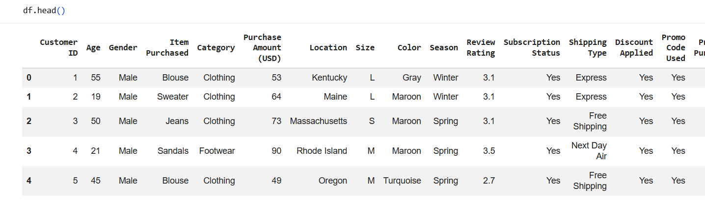,
3.
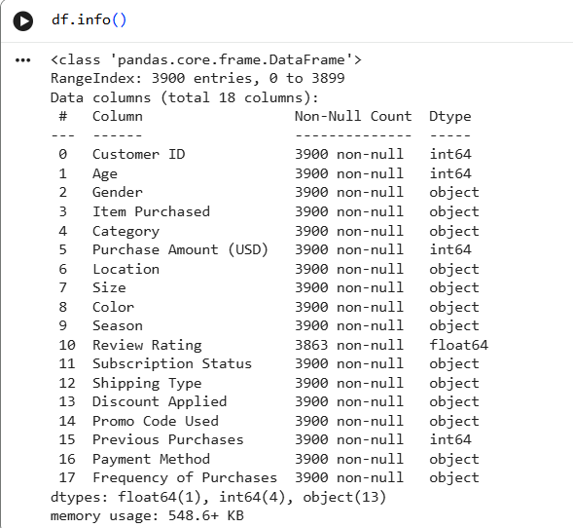

4. to check the summary statistics , by default it only fetches numerical values to get all statistics write include all
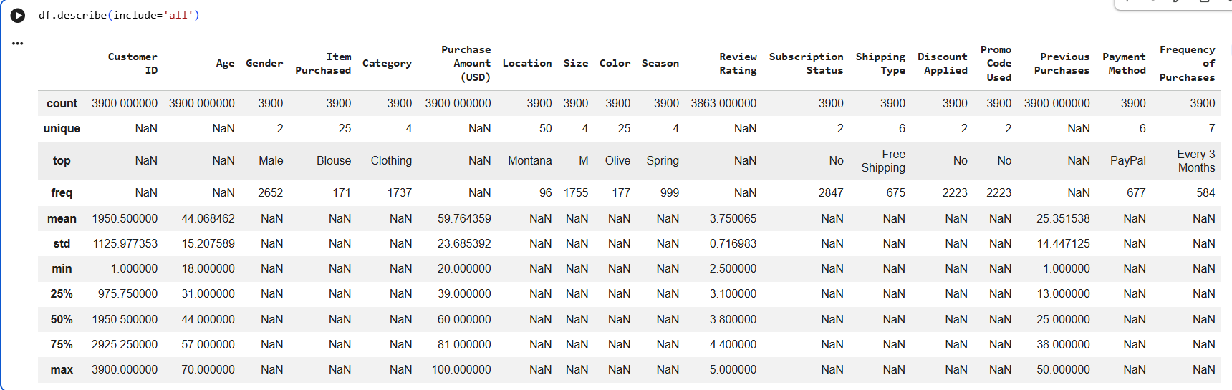

5. checking the missing values
We will replace the missing value of an item with the median of the particular category item
Ex: if a review is missing of a clothing item then its been replaced with the median of clothing item and not with the footwear item.
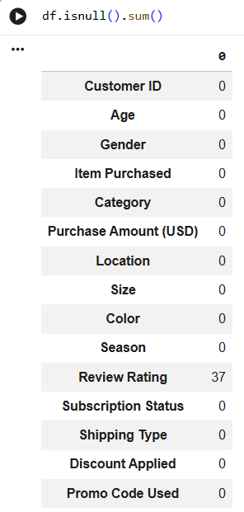

6.Data cleaning : removed all null functions . i.e. All review Rating null values
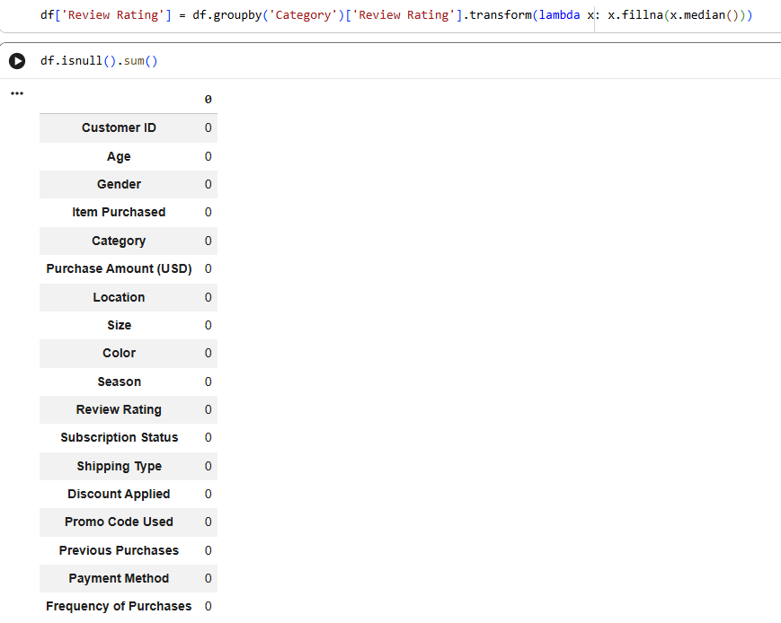

6. Changing to lowercase every word and replacing the space with ‘_’ and renaming
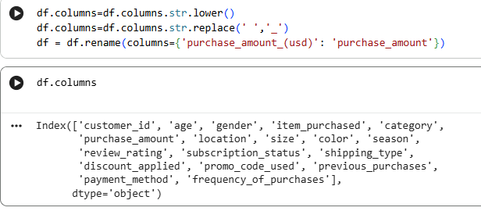

7.creating a column of age group for dividing age of people in 4 groups (FEATURE ENGINEERING)
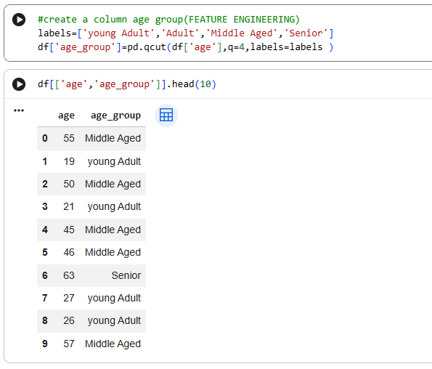
8. Creating a column for counting number of people purchased and categorising them into different weekly, monthly.. etc
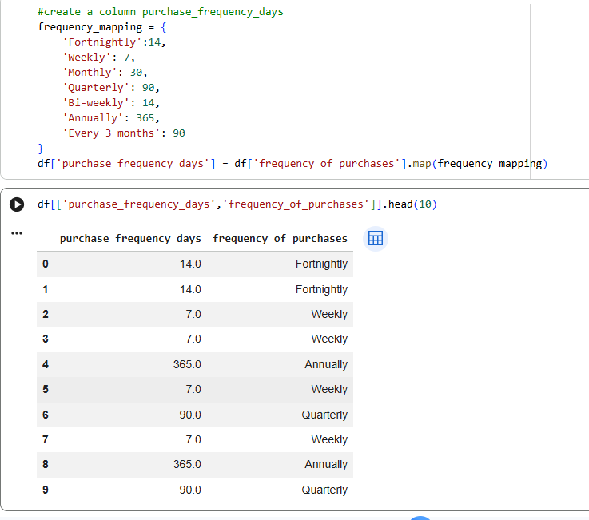

9.removing unnecessary columns from the table , first checking if the column is needed or not if not then the column is dropped
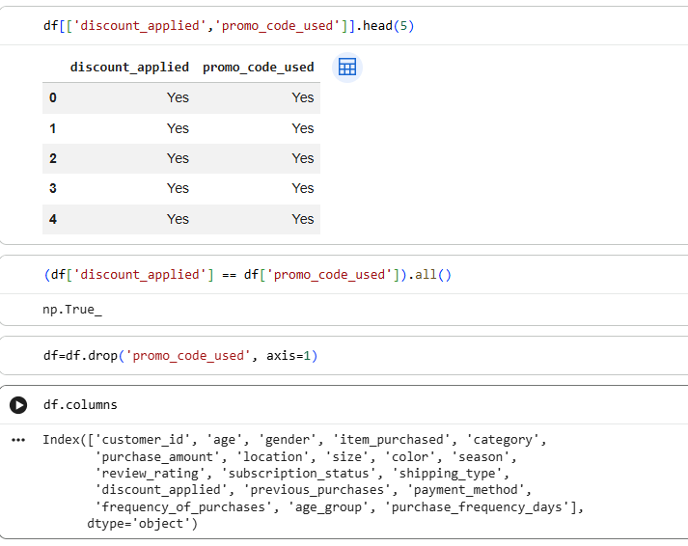

Using AI / chatgpt to fix the errors
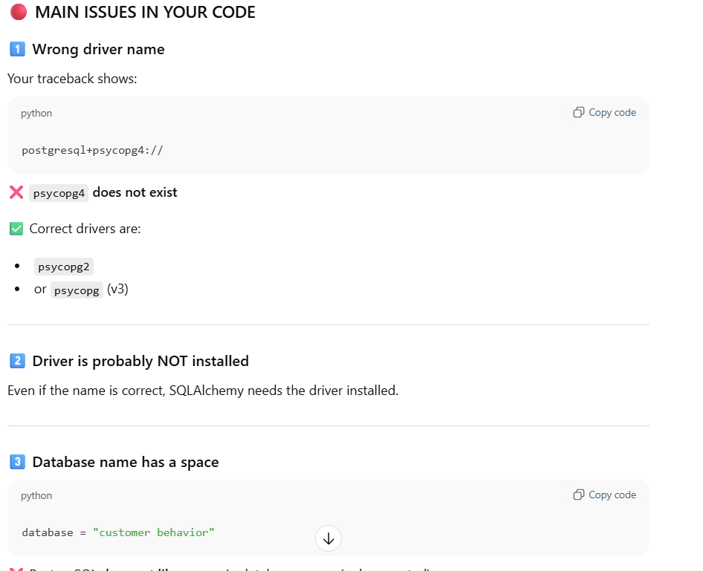

SQL queries
1. What is the total revenue generated by male vs. female customers?
SELECT gender, SUM(purchase_amount) AS total_revenue
FROM customer
GROUP BY gender
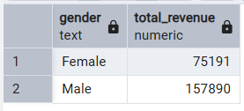

2. Which customers used a discount but still spent more than the average purchase amount?
SELECT customer_id, purchase_amount
FROM customer
WHERE discount_applied = 'Yes' and purchase_amount>=(SELECT AVG(purchase_amount) from customer)
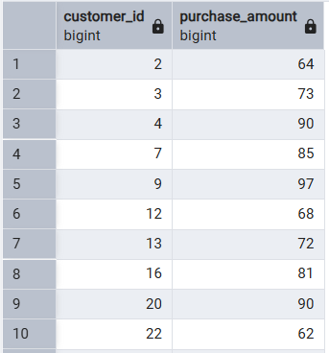

3. Which are the top 5 products with the highest average review rating?
SELECT item_purchased, round(AVG(review_rating::numeric),2) AS "Average product Rating"
FROM customer
GROUP BY item_purchased
ORDER BY AVG(review_rating) DESC
LIMIT 5
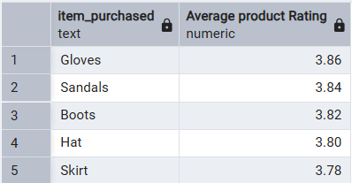

4.Compare the average Purchase Amounts between Standard and Express Shipping.
SELECT shipping_type,
ROUND(AVG(purchase_amount),2)
FROM customer
WHERE shipping_type in ('Express','Standard')
GROUP BY shipping_type
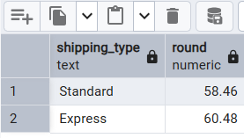

5. Do subscribed customers spend more? Compare average spend and total revenue
--between subscribers and non-subscribers.
SELECT subscription_status,
COUNT(customer_id) AS total_customers,
ROUND(SUM(purchase_amount),2) as total_revenue,
ROUND(AVG(purchase_amount),2) AS avg_spend
FROM customer
GROUP BY subscription_status
ORDER BY total_revenue, avg_spend DESC

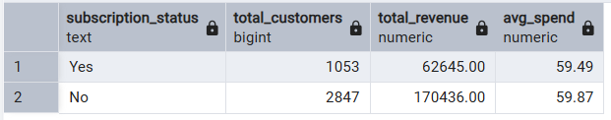
6. Which 5 products have the highest percentage of purchases with discounts applied?
SELECT item_purchased,
ROUND(100* SUM(CASE WHEN discount_applied='Yes' THEN 1 ELSE 0 END)/COUNT(*),2) AS discount_rate
FROM customer
GROUP BY item_purchased
ORDER BY discount_rate DESC
limit 5
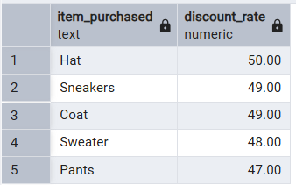

7. Segment customers into New, Returning, and Loyal based on their total number of previous purchases, and show the count of each segment.
with customer_type as(
SELECT customer_id, previous_purchases,
CASE
WHEN previous_purchases = 1 THEN 'new'
WHEN previous_purchases BETWEEN 2 AND 10 THEN 'returning'
ELSE 'loyal'
END AS customer_segment
FROM customer)
SELECT customer_segment, count(*) as "number_of_customer"
from customer_type
GROUP BY customer_segment
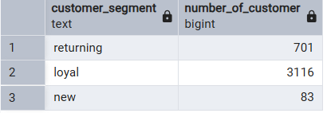

8. What are the top 3 most purchased products within each category?
WITH item_count AS
(SELECT category,
item_purchased,
COUNT (customer_id) AS total_orders,
ROW_NUMBER() OVER (PARTITION BY category ORDER BY COUNT (customer_id ) DESC) as item_rank
FROM customer
GROUP BY category, item_purchased
)
SELECT item_rank,category, item_purchased ,total_orders
FROM item_count
WHERE item_rank <=3
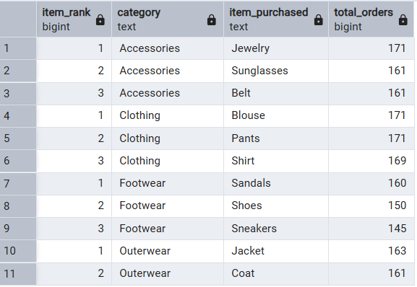
9. Are customers who are repeat buyers (more than 5 previous purchases) also likely to subscribe?
SELECT subscription_status,
COUNT (customer_id)AS repeat_buyers
FROM customer
WHERE previous_purchases>5
GROUP BY subscription_status
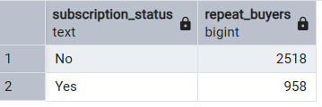

10.What is the revenue contribution of each age group?
SELECT
age_group,
SUM(purchase_amount) AS total_revenue
FROM customer
GROUP BY age_group
ORDER BY total_revenue DESC
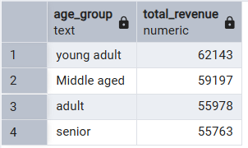

DASHBOARD

