BCSE331L – Exploratory Data Analysis
Course Project Report (Phase I, II and III)
Analysis of Police Shooting Incidents in the USA (2015 – 2020)
GitHub Repository | https://github.com/Ruchika0912/BCSE331L-EDA-Course-Project
Video Demonstration | [Paste your public video link here – Google Drive / YouTube, access set to “Anyone with the link can view”]

Student Name | Ruchika Tuteja
Register Number | 23BDS0050
Course | BCSE331L – Exploratory Data Analysis
Faculty | Prof. Prakash M
Dataset | shootings.csv (4,895 records, 15 columns)
Tools | Python 3, pandas, NumPy, Matplotlib, Seaborn, scikit-learn, SciPy

Table of Contents

(If the page numbers are not shown, right-click the table and choose “Update Field”.)

1. Introduction

1.1 Problem statement
This project performs a systematic exploratory data analysis (EDA) of fatal police shootings in the United States. The aim is to understand who is involved in these incidents, under what circumstances they occur, which variables are related to each other, whether natural groups exist in the data, and whether the recorded circumstances can predict if the person showed signs of mental illness.

1.2 Objectives
- Load, inspect, clean and transform the dataset, including the treatment of missing values (Module 2).
- Describe the data with descriptive statistics and univariate (1D) visualisations (Module 3).
- Study relationships through bivariate (2D), multivariate (3D) and correlation analysis (Module 4).
- Group the incidents using K-Means and hierarchical clustering (Module 5).
- Reduce dimensionality using Principal Component Analysis (Module 6).
- Build and evaluate a classification model using Logistic Regression (Module 7).

1.3 Dataset description
The dataset is the faculty-provided shootings.csv file, loaded directly from the course GitHub repository. Each row is one fatal shooting between 2 January 2015 and mid-2020.
Table 1: Variables in the dataset
Column | Type | Description
id, name | ID / text | Record identifier and name of the person
date | Date (dd/mm/yy) | Date of the incident
manner_of_death | Categorical | shot / shot and Tasered
armed, arms_category | Categorical | Weapon (89 values) and its grouped category (12 groups)
age | Numeric | Age of the person (6 – 91)
gender, race | Categorical | M / F; White, Black, Hispanic, Asian, Native, Other
city, state | Categorical | Location (2,288 cities, 51 states)
signs_of_mental_illness | Boolean | Whether signs of mental illness were reported
threat_level | Categorical | attack / other / undetermined
flee | Categorical | Not fleeing / Car / Foot / Other
body_camera | Boolean | Whether an officer wore a body camera

2. Module 2 – Data Loading, Cleaning and Transformation

2.1 Loading and inspection
DATA_URL = "https://raw.githubusercontent.com/salemprakash/EDA/main/Data/shootings.csv"
df = pd.read_csv(DATA_URL)
print("Dataset shape:", df.shape) # (4895, 15)
df.info()
print("Duplicate rows:", df.duplicated().sum()) # 0
The dataset has 4,895 rows and 15 columns. Two columns are numeric (id, age), signs_of_mental_illness is Boolean, and the rest are text. No exact duplicate rows were found.

2.2 Missing-value analysis
The raw file uses placeholders such as “?” and “Unknown” instead of blanks. These were converted to NaN so that they are counted as missing.
df = df.replace(["?", "NA", "N/A", "Unknown"], np.nan)
missing = df.isna().sum().sort_values(ascending=False)
missing_pct = (missing / len(df) * 100).round(2)
Table 2: Missing values after placeholder conversion
Column | Missing values | Missing %
arms_category | 420 | 8.58
manner_of_death | 3 | 0.06
race | 2 | 0.04
body_camera | 2 | 0.04
gender | 1 | 0.02
All other columns | 0 | 0.00

2.3 Data cleaning
- signs_of_mental_illness and body_camera were converted to nullable Boolean values (TRUE/FALSE text → True/False).
- Exact duplicate rows were removed (none existed, the shape stayed 4,895 × 15).
- Before clustering, PCA and classification, numeric gaps were filled with the median and categorical gaps with the mode. The 420 missing arms_category values were kept as a separate “Unknown” level for the classifier, because the absence of weapon information may itself be informative.

2.4 Data transformation and feature engineering
df["date"] = pd.to_datetime(df["date"], format="%d/%m/%y", errors="coerce")
df["year"], df["month"] = df["date"].dt.year, df["date"].dt.month
df["day"], df["day_of_week"] = df["date"].dt.day, df["date"].dt.day_name()
df["mental_illness_binary"] = bool_to_float(df["signs_of_mental_illness"])
df["body_camera_binary"] = bool_to_float(df["body_camera"])
New time variables (year, month, day, day of week) and numeric 0/1 versions of the Boolean columns were created. These make time-trend analysis, correlation and modelling possible. Categorical variables were one-hot encoded and all model inputs were standardised (mean 0, SD 1) with StandardScaler.

3. Module 3 – Descriptive Statistics and Univariate (1D) Analysis

3.1 Statistical summary
Table 3: Descriptive statistics of age
Statistic | Age
Count | 4,895
Mean | 36.55
Standard deviation | 12.69
Minimum | 6
25th percentile (Q1) | 27
Median | 35
75th percentile (Q3) | 45
Maximum | 91
Skewness | 0.71

Table 4: Most frequent category of each categorical variable
Variable | Most frequent value | Share
manner_of_death | shot | 94.9%
gender | M | 95.4%
race | White | 50.6%
threat_level | attack | 64.6%
flee | Not fleeing | 62.8%
arms_category | Guns | 56.4%
signs_of_mental_illness | False | 77.5%
state | CA | 14.3%

3.2 Univariate visualisations
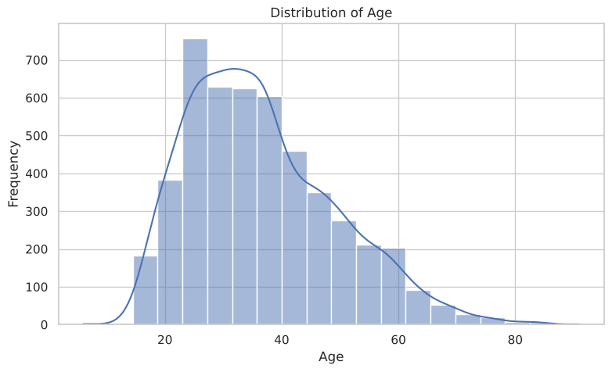
Figure 1: Distribution of age (histogram with KDE)
Age is right-skewed. Most people are between 27 and 45 years old, with a long tail of older individuals up to 91.
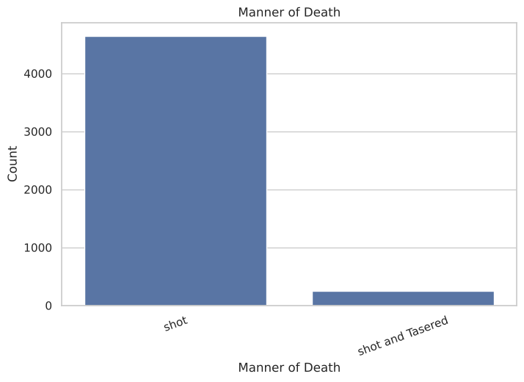
Figure 2: Manner of death
94.9% of incidents are recorded as “shot”, and only 5.1% as “shot and Tasered”. The variable is highly imbalanced.
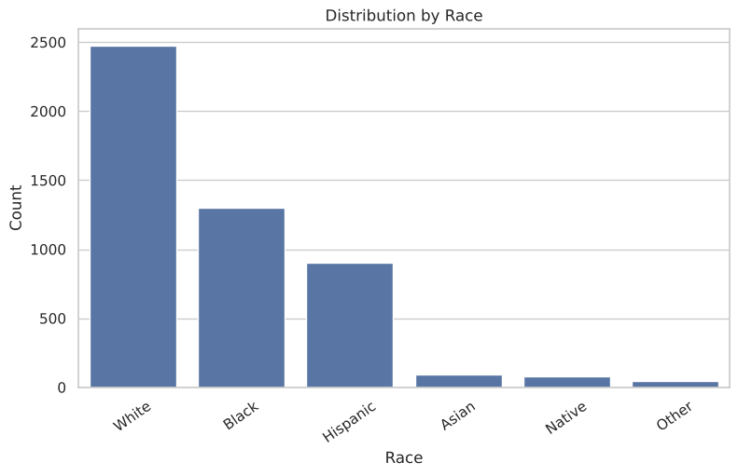
Figure 3: Distribution by race
White individuals account for 50.6% of records, followed by Black (26.5%) and Hispanic (18.4%). Asian, Native and Other together form less than 5%. These are raw counts, not rates per population.

4. Module 4 – Bivariate, Multivariate and Correlation Analysis

4.1 Bivariate (2D) analysis
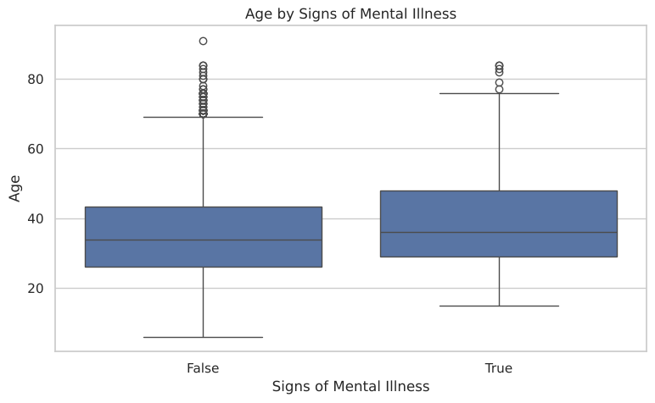
Figure 4: Age by signs of mental illness
People with signs of mental illness are slightly older (median 36 vs 34), and both groups have a similar spread.
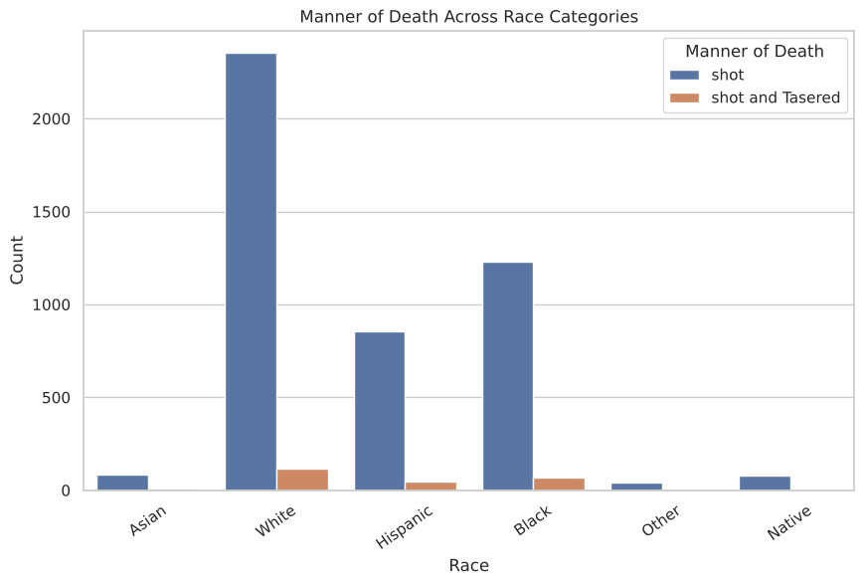
Figure 5: Manner of death across race categories
The share of “shot and Tasered” is similar across the larger race groups (about 4.7–5.4%). It is higher in the small Asian (8.6%) and Other (10.4%) groups, where counts are small and the estimates are less reliable.
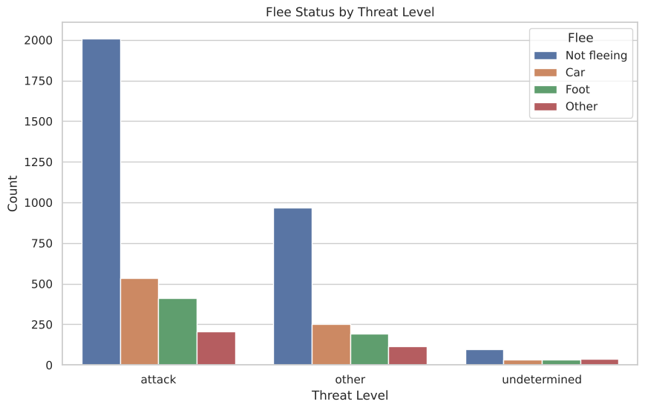
Figure 6: Flee status by threat level
For both “attack” (63.5%) and “other” (63.3%) threat levels, about two-thirds of people were not fleeing. The “undetermined” group has fewer “Not fleeing” cases (47.8%) and more “Other” flee values.

4.2 Multivariate (3D) analysis
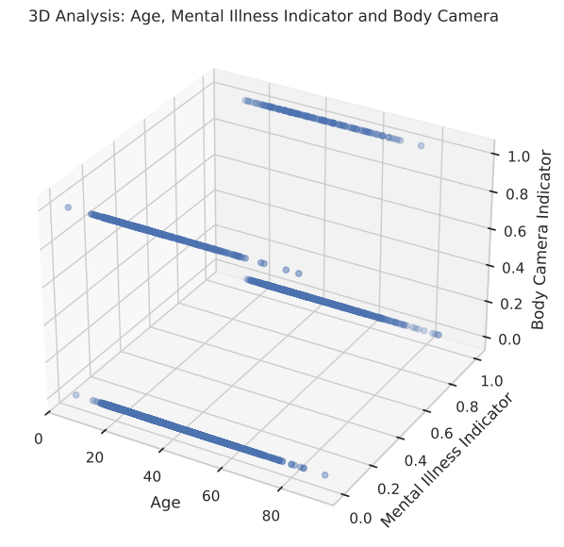
Figure 7: 3D scatter of age, mental-illness indicator and body-camera indicator
Because two of the three axes are binary, the points form four horizontal bands. Every combination appears across the whole age range, so no strong three-way pattern is visible.

4.3 Correlation analysis
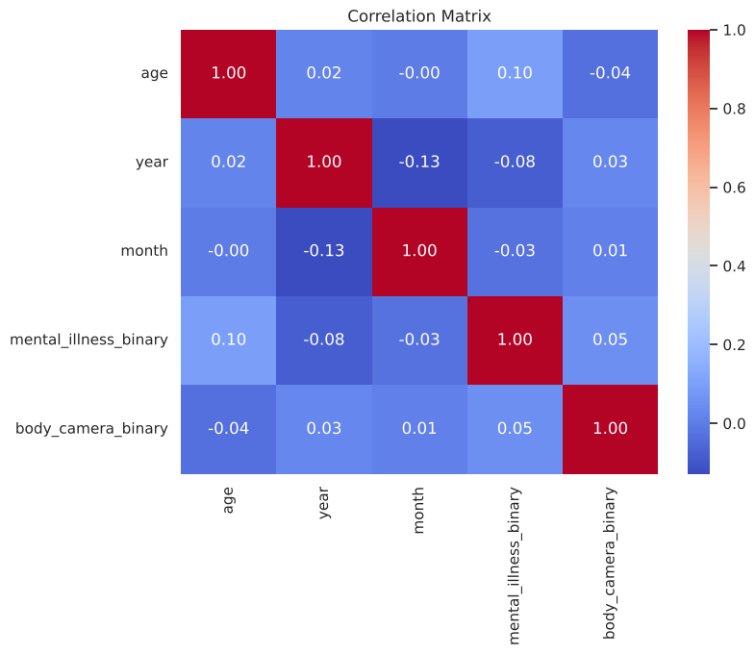
Figure 8: Correlation matrix of numeric variables
All correlations are weak (|r| < 0.13). The largest is year–month (−0.13), because 2020 contains data only up to mid-year. Age–mental illness (+0.10) and year–mental illness (−0.08) are small positive and negative associations. This low redundancy is important later for PCA.
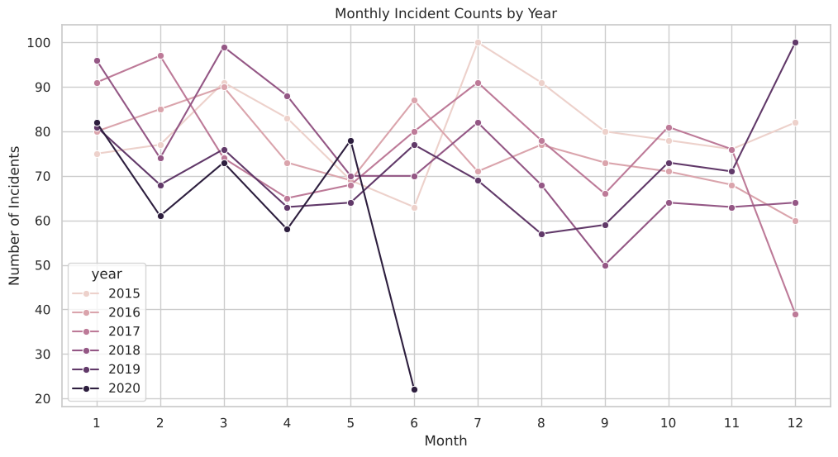
Figure 9: Monthly incident counts by year
Monthly counts for 2015–2019 mostly fall between 68 and 82 incidents (median 74.5, range 39–100). Yearly totals were 965 (2015), 904 (2016), 906 (2017), 888 (2018), 858 (2019) and 374 (2020, partial year).

5. Module 5 – Clustering
Fourteen features (age, the two binary indicators and one-hot encodings of manner of death, threat level, flee and gender) were standardised and clustered.

5.1 K-Means clustering
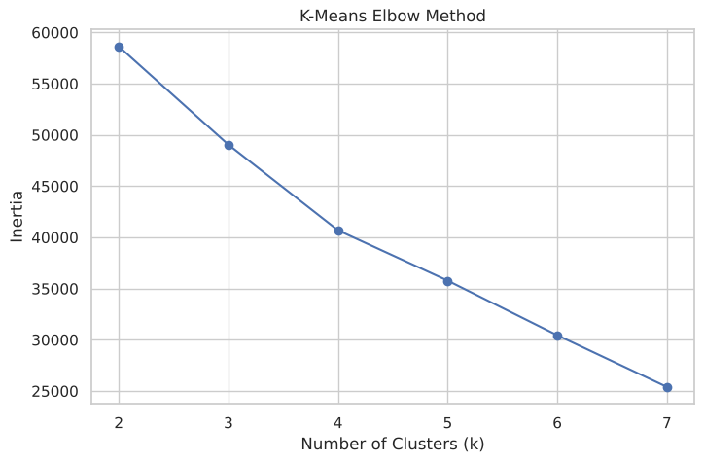
Figure 10: Elbow method for choosing k
The elbow curve does not have a sharp bend, so k = 3 was chosen as a simple, interpretable solution.
Table 5: K-Means cluster summary (k = 3)
Cluster | Size | Mean age | Median age | Profile
0 | 4,431 | 36.5 | 34 | Male, shot
1 | 222 | 37.0 | 35 | All female
2 | 242 | 36.3 | 35 | Male, shot and Tasered

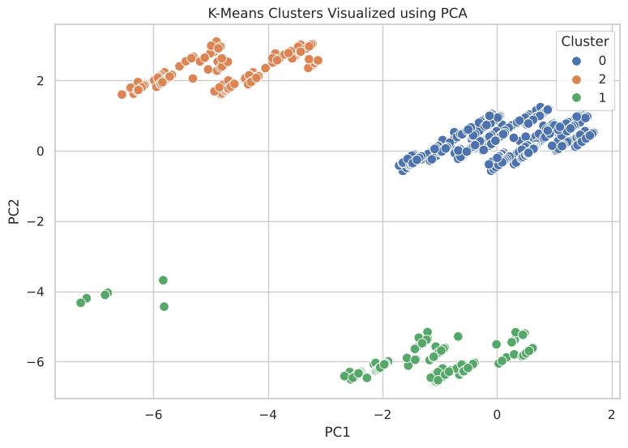
Figure 11: K-Means clusters visualised on the first two principal components

5.2 Hierarchical clustering
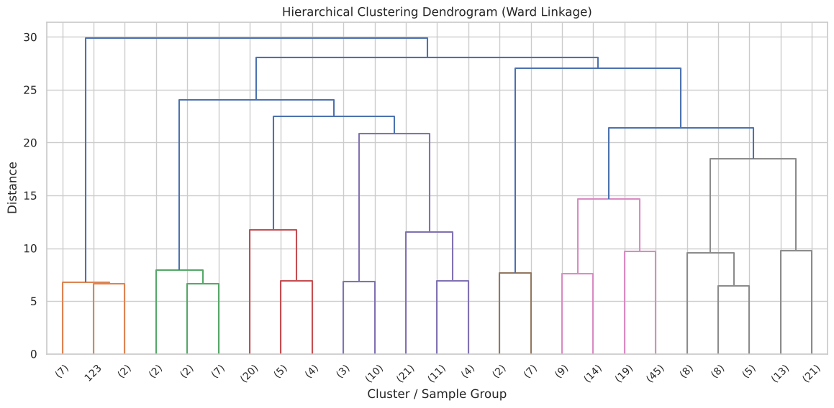
Figure 12: Dendrogram (Ward linkage, sample of 250 records)
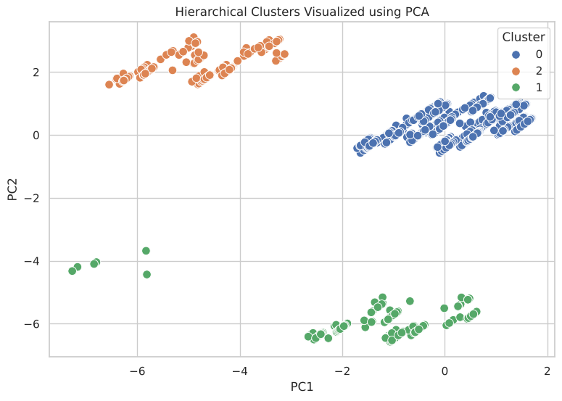
Figure 13: Hierarchical clusters visualised on the first two principal components
Agglomerative clustering with Ward linkage and three clusters produced exactly the same groups as K-Means (4,431 / 222 / 242). Both methods split the data along two rare binary categories, female gender and “shot and Tasered”, and the age profiles of the clusters are almost identical. The clustering therefore separates rare categories rather than revealing hidden behavioural groups. This is a useful finding in itself: the incident attributes do not form natural, well-separated groups.

6. Module 6 – Principal Component Analysis (PCA)

6.1 Method
PCA converts correlated variables into uncorrelated principal components, ordered by the variance they explain. A 16-feature matrix was built: age, year, the mental-illness and body-camera indicators, and one-hot encodings (drop_first = True) of manner of death, threat level, flee, gender and race. All features were standardised, because PCA is sensitive to scale.
pca_num = ["age", "year", "mental_illness_binary", "body_camera_binary"]
pca_cat = ["manner_of_death", "threat_level", "flee", "gender", "race"]
X_pca_features = pd.get_dummies(pca_input, columns=pca_cat, drop_first=True, dtype=float)
X_pca_scaled = StandardScaler().fit_transform(X_pca_features) # shape (4895, 16)

pca_full = PCA(random_state=42).fit(X_pca_scaled)
evr = pca_full.explained_variance_ratio_
cum_evr = np.cumsum(evr)

6.2 Explained variance
Table 6: Eigenvalues and explained variance of all 16 components
Component | Eigenvalue | Variance % | Cumulative %
PC1 | 2.119 | 13.24 | 13.24
PC2 | 1.494 | 9.34 | 22.58
PC3 | 1.315 | 8.22 | 30.80
PC4 | 1.192 | 7.45 | 38.25
PC5 | 1.115 | 6.97 | 45.22
PC6 | 1.067 | 6.67 | 51.89
PC7 | 1.048 | 6.55 | 58.43
PC8 | 1.025 | 6.41 | 64.84
PC9 | 0.982 | 6.14 | 70.98
PC10 | 0.977 | 6.10 | 77.08
PC11 | 0.888 | 5.55 | 82.64
PC12 | 0.839 | 5.24 | 87.88
PC13 | 0.809 | 5.05 | 92.93
PC14 | 0.790 | 4.93 | 97.87
PC15 | 0.311 | 1.95 | 99.81
PC16 | 0.030 | 0.19 | 100.00

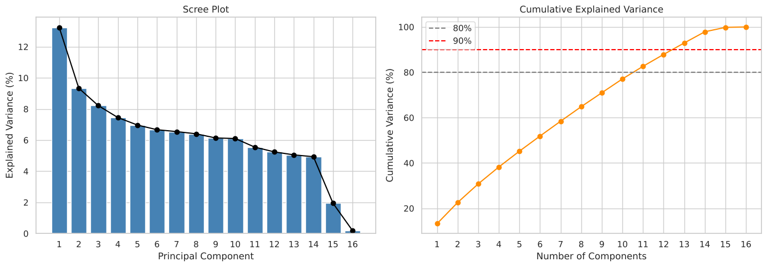
Figure 14: Scree plot and cumulative explained variance
- Kaiser rule: 8 components have eigenvalue > 1.
- 80% variance: 11 components are needed; 90% needs 13.
- First three components: together explain only 30.80% of the variance.

6.3 Loadings
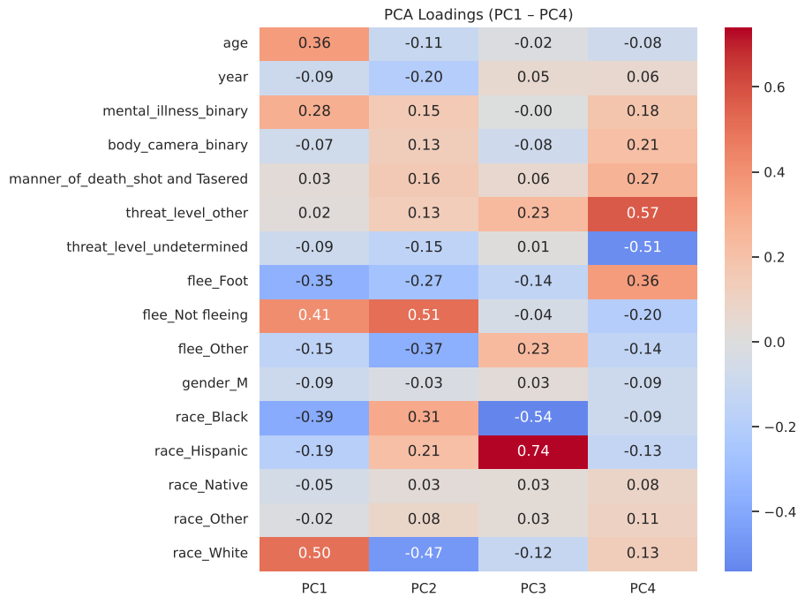
Figure 15: Loadings of PC1 – PC4
Table 7: Interpretation of the leading principal components
Component | Main contributing features (loading) | Interpretation
PC1 | race_White (+0.50), flee_Not fleeing (+0.41), race_Black (−0.39) | White / not-fleeing vs Black records
PC2 | flee_Not fleeing (+0.51), race_White (−0.47), flee_Other (−0.37) | Flee-status axis
PC3 | race_Hispanic (+0.74), race_Black (−0.54) | Hispanic vs Black records
PC4 | threat_level_other (+0.57), threat_level_undetermined (−0.51), flee_Foot (+0.36) | Threat-level axis

6.4 Projection of the data
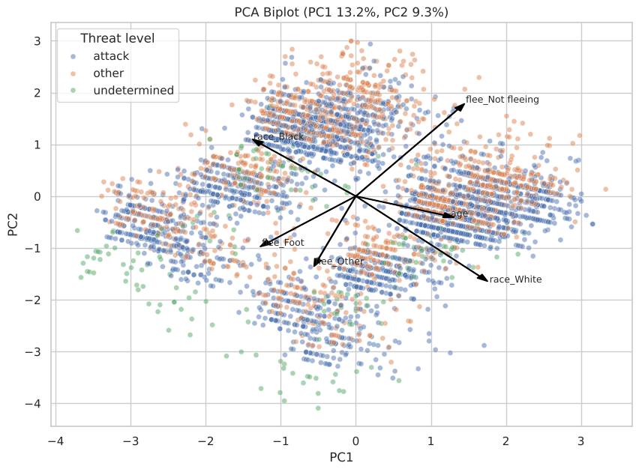
Figure 16: PCA biplot of PC1 vs PC2, coloured by threat level, with the strongest loading vectors
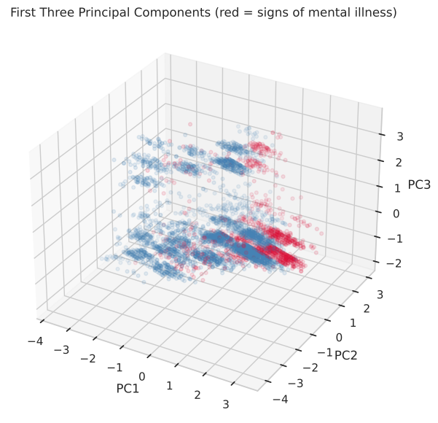
Figure 17: First three principal components (red = signs of mental illness)

6.5 Interpretation
- No single dominant direction exists. PC1 explains only 13.24% of the variance and the scree plot declines slowly instead of showing a sharp elbow.
- The reason is that the features are mostly independent binary indicators with weak pairwise correlations (|r| < 0.13, Section 4.3). PCA can only compress variance that variables share, so here it cannot reduce the data to a few components without losing much information.
- PC15 and PC16 have very small eigenvalues (0.31 and 0.03), which shows near-redundancy among the race dummy variables (they almost sum to a constant).
- In the biplot and 3D plot, the threat-level groups and the mental-illness groups overlap heavily. The leading components do not separate these groups, which agrees with the moderate classifier performance in Module 7.
- Conclusion for this dataset: PCA is valuable as an exploratory check that confirms low redundancy, but keeping only 2–3 components would discard about 70% of the information. The original features are therefore used for classification.

7. Module 7 – Classification using Logistic Regression

7.1 Problem definition
Target: signs_of_mental_illness (1 = True, 0 = False). Predictors: age, year, body camera, manner of death, threat level, flee, gender, race and arms category.
Logistic Regression was chosen because the target is binary, it is the standard baseline classifier, and each coefficient can be converted to an odds ratio, which makes the model easy to interpret.
The classes are imbalanced: 3,792 False (77.47%) and 1,103 True (22.53%). A model that always predicts False would be 77.5% accurate while being useless. Therefore class_weight = "balanced" was used, a majority-class baseline was included for comparison, and precision, recall, F1 and ROC-AUC were reported instead of accuracy alone. Categories with fewer than 30 records (for example “Hand tools”) were grouped into one infrequent level to avoid unstable coefficients.

7.2 Implementation
X_train, X_test, y_train, y_test = train_test_split(
X_clf, y_clf, test_size=0.2, random_state=42, stratify=y_clf) # 3916 / 979 rows

preprocess = ColumnTransformer([
("num", StandardScaler(), ["age", "year", "body_camera_binary"]),
("cat", OneHotEncoder(handle_unknown="infrequent_if_exist", min_frequency=30),
["manner_of_death", "threat_level", "flee", "gender", "race", "arms_category"]),
])
log_reg = Pipeline([("prep", preprocess),
("model", LogisticRegression(class_weight="balanced", max_iter=1000))])
log_reg.fit(X_train, y_train)
baseline = DummyClassifier(strategy="most_frequent").fit(X_train, y_train)

7.3 Results
Table 8: Test-set performance (979 records)
Model | Accuracy | Precision | Recall | F1-score | ROC-AUC
Majority-class baseline | 0.774 | 0.000 | 0.000 | 0.000 | 0.500
Logistic Regression | 0.622 | 0.341 | 0.724 | 0.464 | 0.710

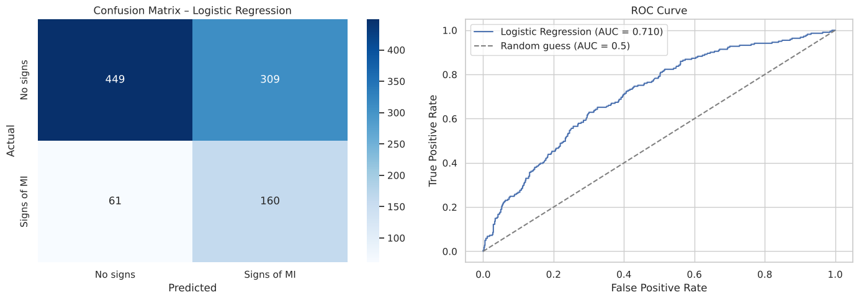
Figure 18: Confusion matrix and ROC curve of the Logistic Regression model
Table 9: Confusion matrix
 | Predicted: No signs | Predicted: Signs of MI
Actual: No signs (758) | 449 (TN) | 309 (FP)
Actual: Signs of MI (221) | 61 (FN) | 160 (TP)

5-fold stratified cross-validation: ROC-AUC = 0.709 ± 0.012 and F1 = 0.465 ± 0.016. The fold-to-fold variation is small, so the test result is stable and not due to a lucky split.

7.4 Model interpretation
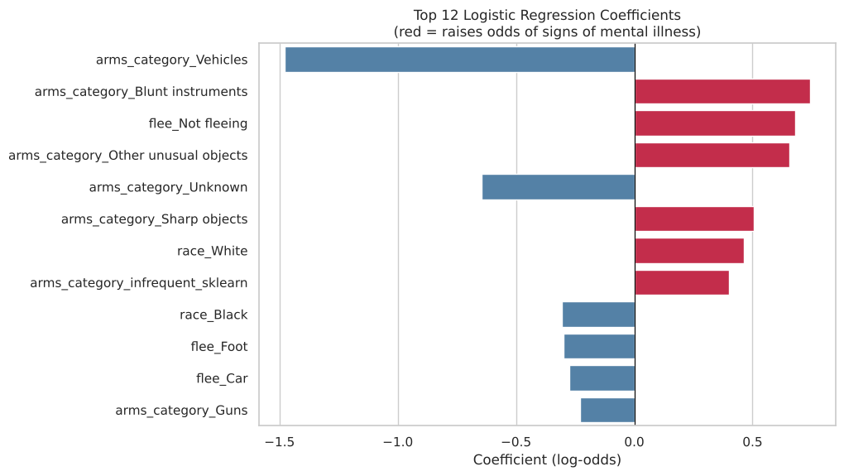
Figure 19: Twelve largest Logistic Regression coefficients (red = raises the odds)
Table 10: Strongest predictors
Feature | Coefficient | Odds ratio | Effect on odds of signs of MI
arms_category = Vehicles | −1.477 | 0.23 | Strongly lower
arms_category = Blunt instruments | +0.742 | 2.10 | Higher
flee = Not fleeing | +0.680 | 1.97 | Higher
arms_category = Other unusual objects | +0.654 | 1.92 | Higher
arms_category = Unknown | −0.645 | 0.53 | Lower
arms_category = Sharp objects | +0.504 | 1.66 | Higher
race = White | +0.464 | 1.59 | Higher
race = Black | −0.308 | 0.74 | Lower
flee = Foot | −0.301 | 0.74 | Lower
flee = Car | −0.275 | 0.76 | Lower

7.5 Discussion
- The baseline reaches 77.4% accuracy but detects none of the 221 positive test cases. Logistic Regression has lower accuracy (62.2%), but correctly identifies 160 of them (recall 72.4%). This shows why accuracy is misleading on imbalanced data.
- The balanced class weights intentionally accept more false positives (309) in exchange for far fewer missed cases (61). If precision mattered more, the decision threshold could be raised above 0.5.
- Weapon category and flee status are the strongest predictors. Incidents involving blunt, sharp or unusual objects and people who were not fleeing are more likely to have signs of mental illness recorded. Vehicle-related incidents and fleeing are less likely.
- An ROC-AUC of 0.71 means the incident attributes carry a moderate signal. The model is suitable for understanding associations, not for real-world decisions. The coefficients describe patterns in recorded data, not causes.

8. Conclusion
This project applied a complete EDA workflow, Modules 2 to 7, to 4,895 records of fatal police shootings.
- Data quality: the data was largely complete. The main gap was arms_category (8.58%). Placeholders were standardised and dates converted to a proper datetime format.
- Description: the typical record is a man in his mid-thirties, shot, armed with a gun, classed as an “attack” threat and not fleeing. Age is right-skewed and 22.5% of people showed signs of mental illness.
- Relationships: numeric correlations are all weak (|r| < 0.13), and the incident count was steady across years.
- Clustering: K-Means and hierarchical clustering agreed exactly, but they only split off rare categories (female, shot and Tasered). No strong natural groups exist.
- PCA: the first three components explain only 30.8% of the variance, and 11 of 16 are needed for 80%, which confirms the low redundancy among the variables.
- Classification: Logistic Regression predicted signs of mental illness with ROC-AUC 0.71 and recall 72%, clearly outperforming the majority-class baseline. Weapon category and flee status were the most informative features.
Limitations and future work: the data covers only fatal incidents and only up to mid-2020, and counts are not adjusted for population. Future work could add census population data to compute rates, use the city and state columns for geographic analysis, and compare Logistic Regression with tree-based classifiers such as Random Forest.

References
- Dataset: shootings.csv, BCSE331L course repository – https://github.com/salemprakash/EDA
- Pedregosa et al., “Scikit-learn: Machine Learning in Python”, JMLR 12, 2011.
- McKinney, W., Python for Data Analysis, O’Reilly Media.
- Mukhiya, S. K. & Ahmed, U., Hands-On Exploratory Data Analysis with Python, Packt Publishing, 2020.

