BCSE331L – Exploratory Data Analysis
Course Project Report (Phase I, II and III)
Analysis of Police Shooting Incidents in the USA (2015 – 2020)
GitHub Repository | https://github.com/Ruchika0912/BCSE331L-EDA-Course-Project
Video Demonstration | [Paste your public video link here – Google Drive / YouTube, access set to “Anyone with the link can view”]

Student Name | Ruchika Tuteja
Register Number | 23BDS0050
Course | BCSE331L – Exploratory Data Analysis
Faculty | Prof. Prakash M
Dataset | shootings.csv (4,895 records, 15 columns)
Tools | Python 3, pandas, NumPy, Matplotlib, Seaborn, scikit-learn, SciPy

Table of Contents

(If the page numbers are not shown, right-click the table and choose “Update Field”.)

1. Introduction

1.1 Problem statement
This project performs a systematic exploratory data analysis (EDA) of fatal police shootings in the United States. The aim is to understand who is involved in these incidents, under what circumstances they occur, which variables are related to each other, whether natural groups exist in the data, and whether the recorded circumstances can predict if the person showed signs of mental illness.

1.2 Objectives
The project follows the BCSE331L syllabus, Modules 2 to 7:
- Module 2 – Data Transformation: deduplication, replacing values, handling missing data, discretization and binning.
- Module 3 – Correlation Analysis and Time Series Analysis: univariate, bivariate and multivariate analysis, correlation, and time series indexing, resampling and grouping.
- Module 4 – Data Summarization and Visualization: summary measures, 1-D / 2-D / n-D statistical analysis, contingency tables, outliers, scatter plots, dot charts and bar plots.
- Module 5 – Clustering Algorithms: K-Means, hierarchical agglomerative clustering and outlier detection using clustering.
- Module 6 – Dimensionality Reduction: Principal Component Analysis and Singular Value Decomposition.
- Module 7 – Model Development and Evaluation: a Logistic Regression classifier, evaluated with accuracy and with metrics suited to imbalanced data.

1.3 Dataset description
The dataset is the faculty-provided shootings.csv file, loaded directly from the course GitHub repository. Each row is one fatal shooting between 2 January 2015 and 15 June 2020.
Table 1: Variables in the dataset
Column | Type | Description
id, name | ID / text | Record identifier and name of the person
date | Date (dd/mm/yy) | Date of the incident
manner_of_death | Categorical | shot / shot and Tasered
armed, arms_category | Categorical | Weapon (89 values) and its grouped category (12 groups)
age | Numeric | Age of the person (6 – 91)
gender, race | Categorical | M / F; White, Black, Hispanic, Asian, Native, Other
city, state | Categorical | Location (2,288 cities, 51 states)
signs_of_mental_illness | Boolean | Whether signs of mental illness were reported
threat_level | Categorical | attack / other / undetermined
flee | Categorical | Not fleeing / Car / Foot / Other
body_camera | Boolean | Whether an officer wore a body camera

2. Module 2 – Data Transformation

2.1 Loading and inspection
DATA_URL = "https://raw.githubusercontent.com/salemprakash/EDA/main/Data/shootings.csv"
df = pd.read_csv(DATA_URL)
print("Dataset shape:", df.shape) # (4895, 15)
df.info()
The dataset has 4,895 rows and 15 columns. Two columns are numeric (id, age), signs_of_mental_illness is Boolean, and the rest are text.

2.2 Replacing values
The raw file uses placeholders such as “?” and “Unknown” instead of blanks. These were replaced with NaN so that they are counted as missing. The text values TRUE/FALSE in signs_of_mental_illness and body_camera were replaced with proper Boolean values.
df = df.replace(["?", "NA", "N/A", "Unknown"], np.nan)
for col in ["signs_of_mental_illness", "body_camera"]:
df[col] = to_nullable_bool(df[col])

2.3 Data deduplication
print("Duplicate rows:", df.duplicated().sum()) # 0
df = df.drop_duplicates().copy() # shape stays (4895, 15)
No exact duplicate rows were found. The name column has 4,851 unique values for 4,895 rows, but repeated names such as the placeholder “TK TK” belong to different incidents (different dates and places), so they are not duplicates.

2.4 Missing data analysis
Table 2: Missing values after replacing placeholders
Column | Missing values | Missing %
arms_category | 420 | 8.58
manner_of_death | 3 | 0.06
race | 2 | 0.04
body_camera | 2 | 0.04
gender | 1 | 0.02
All other columns | 0 | 0.00

2.5 Handling missing data: traditional methods and MLE
# (a) Listwise deletion
listwise = df.dropna(subset=["arms_category", "manner_of_death", "race", "body_camera", "gender"])
# (b) Imputation
df_imputed["arms_category"] = df_imputed["arms_category"].fillna("Unknown")
for col in ["manner_of_death", "race", "gender", "body_camera"]:
df_imputed[col] = df_imputed[col].fillna(df_imputed[col].mode().iloc[0])
# (c) MLE of category probabilities = observed relative frequencies
mle_race = df["race"].value_counts(normalize=True)
- Listwise deletion would keep only 4,468 of 4,895 rows, losing 8.72% of the data, almost all because of arms_category.
- Imputation keeps every row. The mode was used for manner_of_death, race, gender and body_camera, which each have at most 3 missing values. The 420 missing arms_category values became a separate “Unknown” level, because missing weapon information may itself be informative.
- Maximum Likelihood Estimation: for a categorical variable, the MLE of each category's probability is its observed relative frequency (for race: White 0.506, Black 0.265, Hispanic 0.184, Asian 0.019, Native 0.016, Other 0.010). Mode imputation assigns the category with the highest MLE probability.
Imputation was chosen because deletion would discard 427 complete-information rows. Age and the other numeric columns have no missing values, so no numeric imputation was needed.

2.6 Feature engineering
df["date"] = pd.to_datetime(df["date"], format="%d/%m/%y", errors="coerce")
df["year"], df["month"] = df["date"].dt.year, df["date"].dt.month
df["day"], df["day_of_week"] = df["date"].dt.day, df["date"].dt.day_name()
df["mental_illness_binary"] = bool_to_float(df["signs_of_mental_illness"])
df["body_camera_binary"] = bool_to_float(df["body_camera"])
New time variables (year, month, day, day of week) and numeric 0/1 versions of the Boolean columns were created for time series analysis, correlation and modelling.

2.7 Discretization and binning
age_bins = [0, 17, 25, 35, 45, 55, 65, 100]
age_labels = ["<18", "18-25", "26-35", "36-45", "46-55", "56-65", "65+"]
df["age_group"] = pd.cut(df["age"], bins=age_bins, labels=age_labels) # domain-based bins
df["age_quartile"] = pd.qcut(df["age"], q=4, labels=["Q1", "Q2", "Q3", "Q4"]) # equal-frequency bins
Table 3: Age after discretization into groups
Age group | Count | Percent
<18 | 97 | 1.98
18–25 | 930 | 19.00
26–35 | 1,560 | 31.87
36–45 | 1,169 | 23.88
46–55 | 679 | 13.87
56–65 | 346 | 7.07
65+ | 114 | 2.33

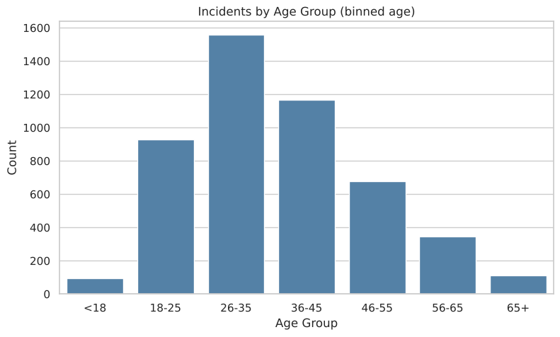
Figure 1: Incidents by age group
The 26–35 group is the largest (31.9%). Equal-frequency binning gave quartiles of 6–27, 28–35, 36–45 and 46–91 years. Binning turns a continuous variable into categories that can be used in contingency tables (Section 4.2).

3. Module 3 – Correlation Analysis and Time Series Analysis

3.1 Univariate analysis
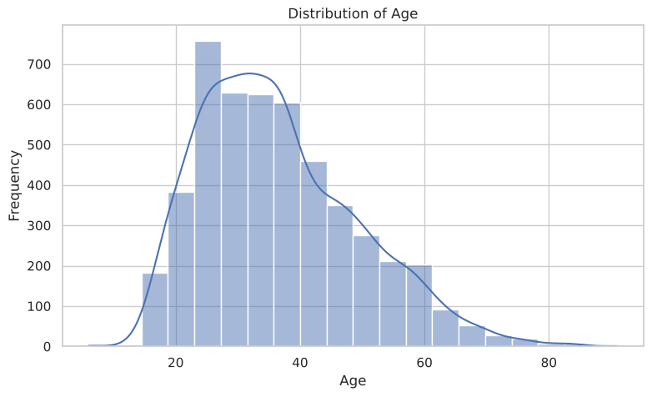
Figure 2: Distribution of age (histogram with KDE)
Age is right-skewed. Most people are between 27 and 45 years old, with a long tail of older individuals up to 91.
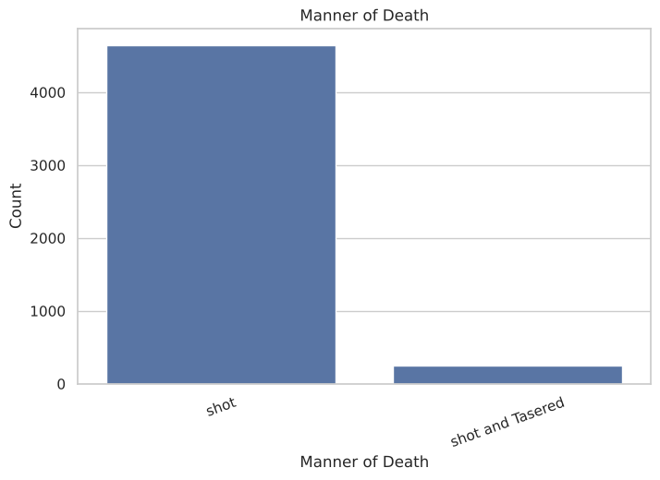
Figure 3: Manner of death
94.9% of incidents are recorded as “shot”, and only 5.1% as “shot and Tasered”. The variable is highly imbalanced.
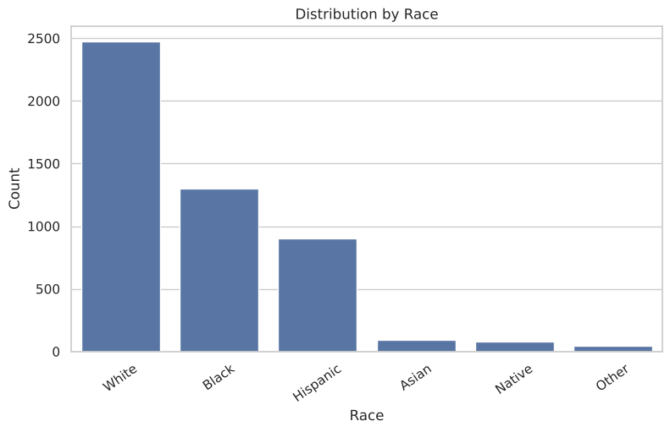
Figure 4: Distribution by race
White individuals account for 50.6% of records, followed by Black (26.5%) and Hispanic (18.4%). Asian, Native and Other together form less than 5%. These are raw counts, not rates per population.

3.2 Bivariate analysis
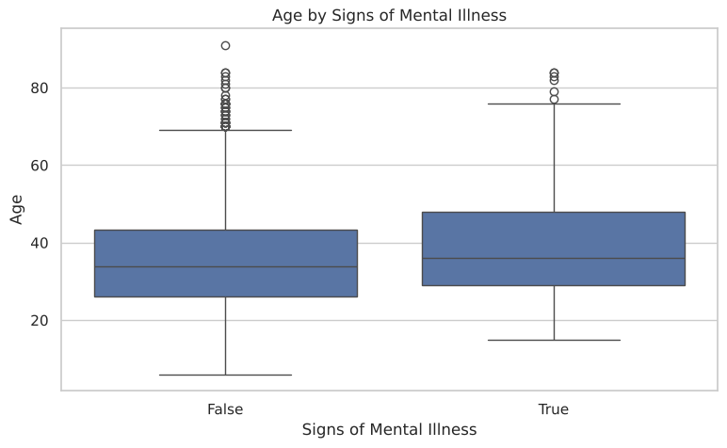
Figure 5: Age by signs of mental illness
People with signs of mental illness are slightly older (median 36 vs 34), and both groups have a similar spread.
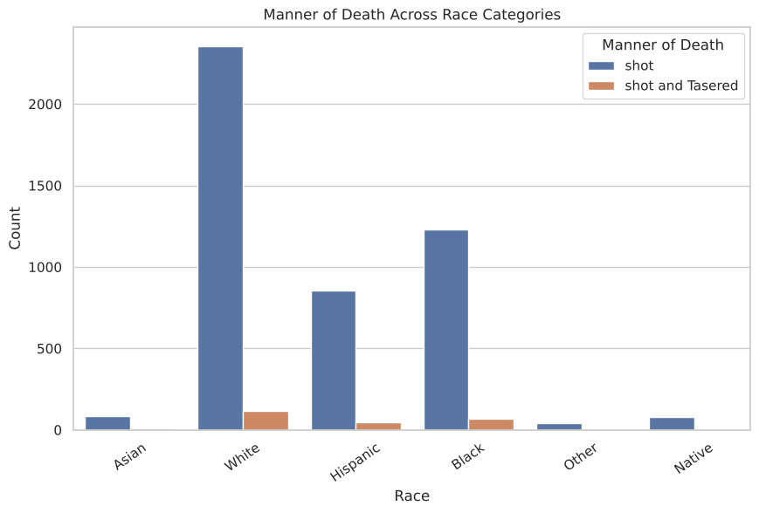
Figure 6: Manner of death across race categories
The share of “shot and Tasered” is similar across the larger race groups (about 4.7–5.4%). It is higher in the small Asian (8.6%) and Other (10.4%) groups, where counts are small and the estimates are less reliable.
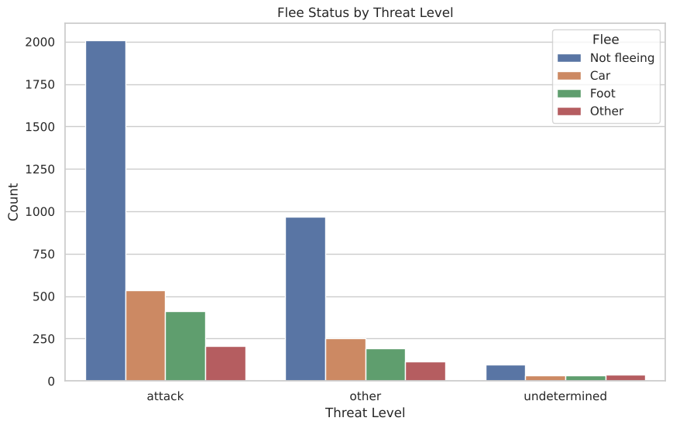
Figure 7: Flee status by threat level
For both “attack” (63.5%) and “other” (63.3%) threat levels, about two-thirds of people were not fleeing. The “undetermined” group has fewer “Not fleeing” cases (47.8%) and more “Other” flee values.

3.3 Multivariate analysis
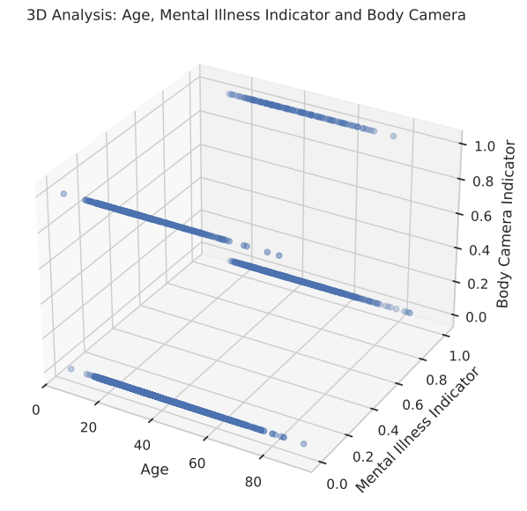
Figure 8: 3D scatter of age, mental-illness indicator and body-camera indicator
Because two of the three axes are binary, the points form four horizontal bands. Every combination appears across the whole age range, so no strong three-way pattern is visible.

3.4 Correlation analysis
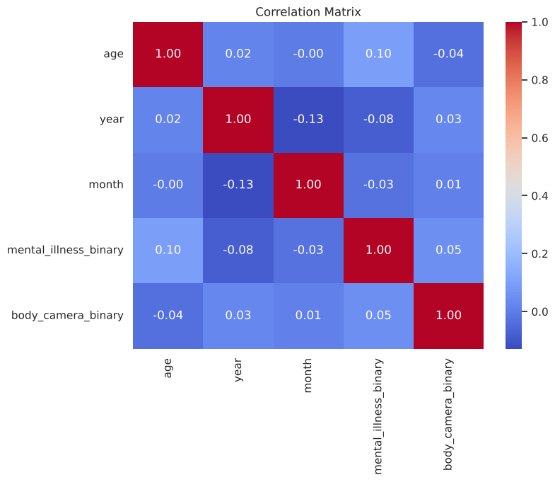
Figure 9: Correlation matrix of numeric variables
All correlations are weak (|r| < 0.13). The largest is year–month (−0.13), because 2020 contains data only up to June. Age–mental illness (+0.10) and year–mental illness (−0.08) are small associations. This low redundancy becomes important for PCA in Module 6.

3.5 Time series analysis
The date column was used as a time-based index, and the series was resampled from daily counts to monthly, quarterly and yearly totals.
ts = df.set_index("date").sort_index() # time-based indexing
daily = ts.resample("D").size()
monthly_ts = ts.resample("MS").size() # resampling
quarterly_ts = ts.resample("QS").size()
trend = monthly_ts.rolling(6, center=True).mean()
by_dow = df["day_of_week"].value_counts() # grouping time series data
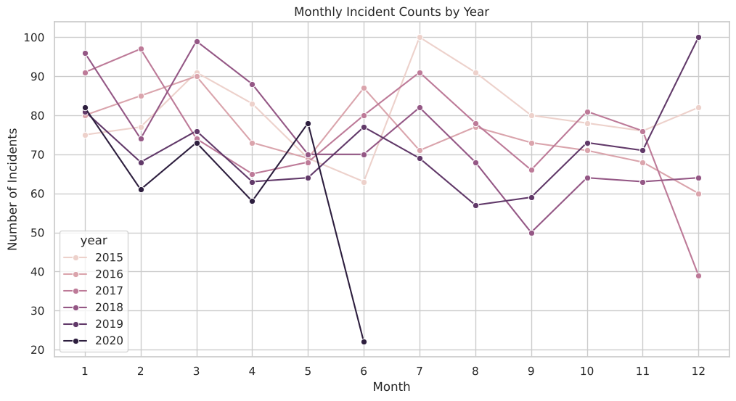
Figure 10: Seasonal view: monthly incident counts for each year
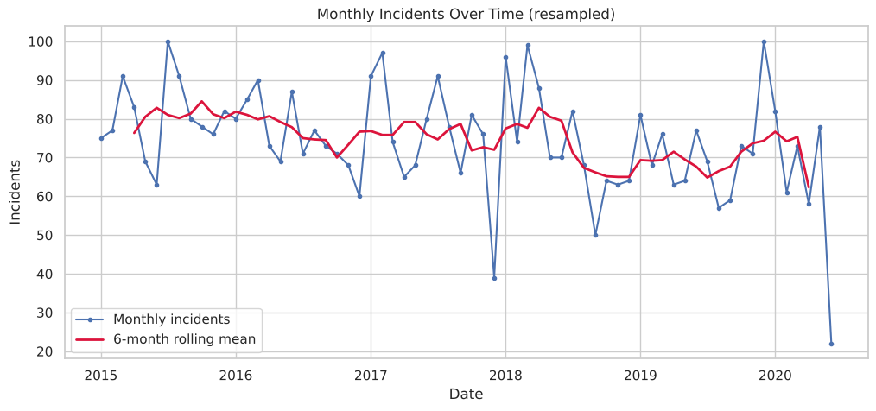
Figure 11: Monthly resampled series with a 6-month rolling mean
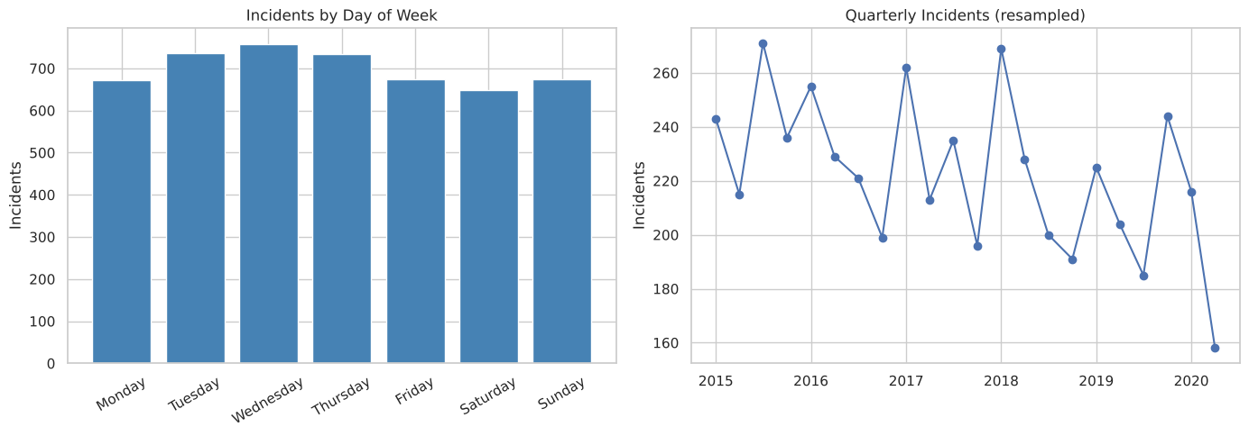
Figure 12: Incidents grouped by day of week, and quarterly resampled series
Table 4: Yearly totals (*2020 data ends on 15 June)
Year | 2015 | 2016 | 2017 | 2018 | 2019 | 2020*
Incidents | 965 | 904 | 906 | 888 | 858 | 374

- Characteristics: the data covers 2 January 2015 to 15 June 2020, with an average of 2.46 incidents per day.
- Trend: the 6-month rolling mean stays almost flat around 75 incidents per month. There is no clear upward or downward trend.
- Fluctuations: individual months vary between 39 (December 2017) and 100 (July 2015 and December 2019). The very low June 2020 value (22) is only because the data stops mid-month.
- Grouping: Wednesday has the most incidents (758) and Saturday the fewest (648), so differences between weekdays are small. Complete quarters range from 185 to 271 incidents.

4. Module 4 – Data Summarization and Visualization

4.1 Statistical summary measures (1-D statistical analysis)
Table 5: Summary measures of age
Measure | Age
Count | 4,895
Mean | 36.55
Median | 35
Mode | 25
Variance | 161.15
Standard deviation | 12.69
Minimum / Maximum | 6 / 91
Range | 85
Q1 / Q3 | 27 / 45
IQR | 18
Coefficient of variation | 34.73%
Skewness | 0.71
Kurtosis | 0.17

Mode (25) < median (35) < mean (36.55) confirms the right skew. A kurtosis close to 0 means the tails are similar to a normal distribution.
Table 6: Most frequent category of each categorical variable
Variable | Most frequent value | Share
manner_of_death | shot | 94.9%
gender | M | 95.4%
race | White | 50.6%
threat_level | attack | 64.6%
flee | Not fleeing | 62.8%
arms_category | Guns | 56.4%
signs_of_mental_illness | False | 77.5%
state | CA | 14.3%

4.2 2-D statistical analysis: contingency tables
Table 7: Contingency table of threat level × flee status
Threat level | Car | Foot | Not fleeing | Other | Total
attack | 533 | 414 | 2,007 | 206 | 3,160
other | 253 | 194 | 967 | 114 | 1,528
undetermined | 34 | 34 | 99 | 40 | 207
Total | 820 | 642 | 3,073 | 360 | 4,895

A chi-square test of independence checks whether two categorical variables are related. Cramér's V measures the strength of the relationship (0 = none, 1 = perfect).
Table 8: Chi-square tests of independence
Variables | Chi-square | df | p-value | Cramér's V
race × signs of mental illness | 123.01 | 5 | 7.2 × 10⁻²⁵ | 0.159
age group × signs of mental illness | 51.62 | 6 | 2.2 × 10⁻⁹ | 0.103
threat level × flee | 53.06 | 6 | 1.1 × 10⁻⁹ | 0.074
gender × manner of death | 2.22 | 1 | 0.136 | 0.021

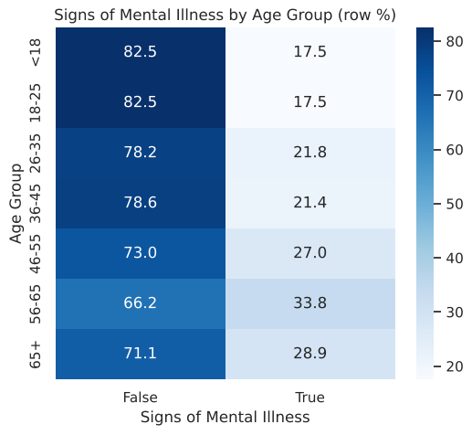
Figure 13: Signs of mental illness by age group (row percentages)
Three of the four pairs are significantly related (p < 0.001), but all associations are weak (V < 0.16). Gender and manner of death are independent (p = 0.136). The share with signs of mental illness rises with age, from 17.5% for people under 26 to 33.8% for ages 56–65.

4.3 n-D statistical analysis and dot chart
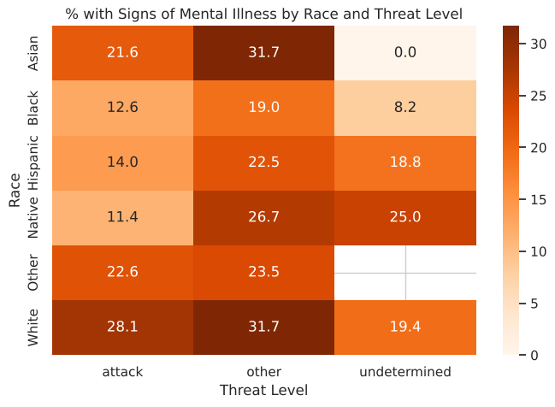
Figure 14: Percentage with signs of mental illness by race and threat level
Combining three variables shows that, within every race group, signs of mental illness are more common when the threat level is “other” rather than “attack” (for example, Black 19.0% vs 12.6%, Hispanic 22.5% vs 14.0%). The blank cell has no records.
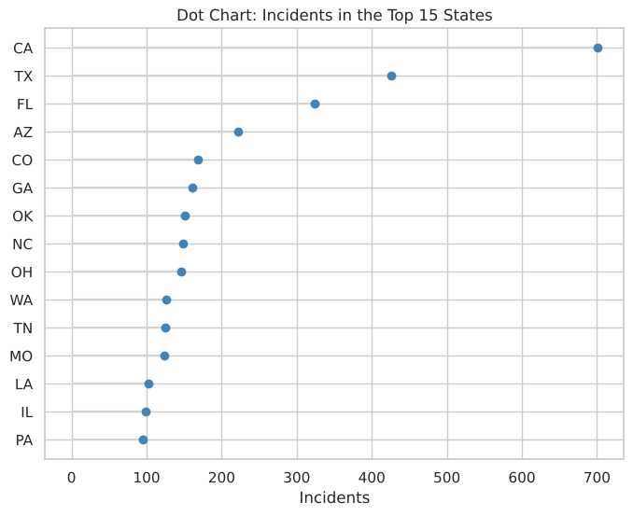
Figure 15: Dot chart of incidents in the 15 states with the most records
California (701), Texas and Florida have the most records. These are counts, not per-capita rates, so they partly reflect population size.

4.4 Outlier detection
q1, q3 = df["age"].quantile([0.25, 0.75]); iqr = q3 - q1
lower, upper = q1 - 1.5 * iqr, q3 + 1.5 * iqr # [0, 72]
z = (df["age"] - df["age"].mean()) / df["age"].std() # z-score rule: |z| > 3
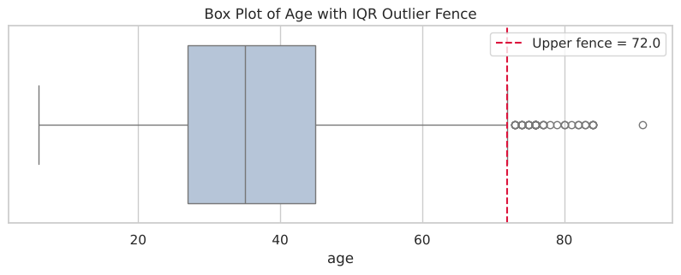
Figure 16: Box plot of age with the IQR upper fence
The IQR rule flags 37 ages from 73 to 91, and the z-score rule flags 29 ages from 75 to 91. No low-age outliers exist (the lower fence is 0). These are genuine older individuals, not recording errors, so they were kept in the analysis.

5. Module 5 – Clustering Algorithms
Fourteen features (age, the two binary indicators and one-hot encodings of manner of death, threat level, flee and gender) were standardised and clustered.

5.1 K-Means clustering
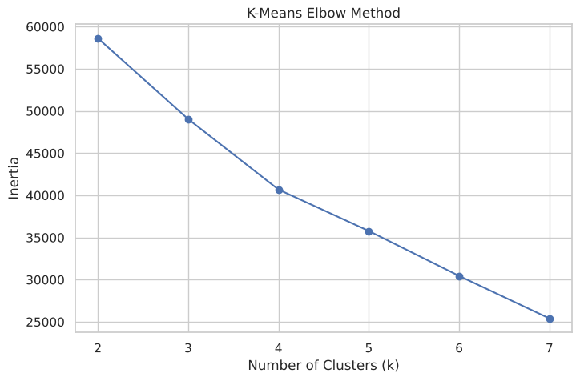
Figure 17: Elbow method for choosing k
The elbow curve does not have a sharp bend, so k = 3 was chosen as a simple, interpretable solution.
Table 9: K-Means cluster summary (k = 3)
Cluster | Size | Mean age | Median age | Profile
0 | 4,431 | 36.5 | 34 | Male, shot
1 | 222 | 37.0 | 35 | All female
2 | 242 | 36.3 | 35 | Male, shot and Tasered

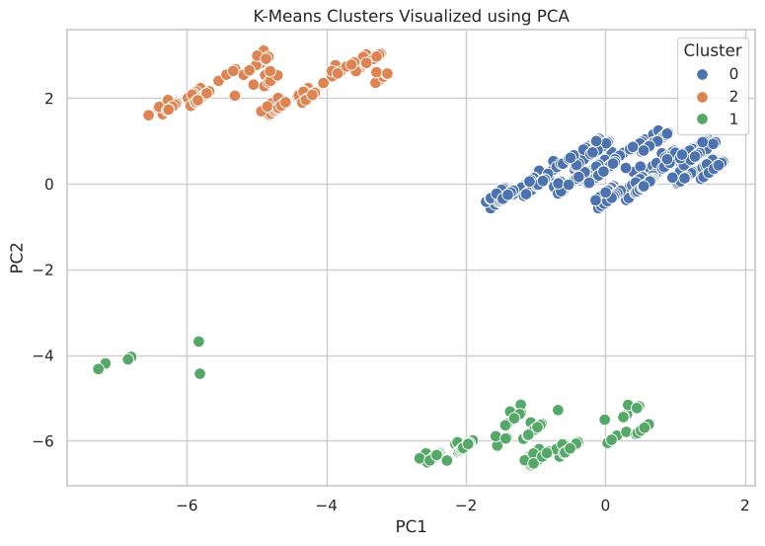
Figure 18: K-Means clusters visualised on the first two principal components

5.2 Hierarchical agglomerative clustering
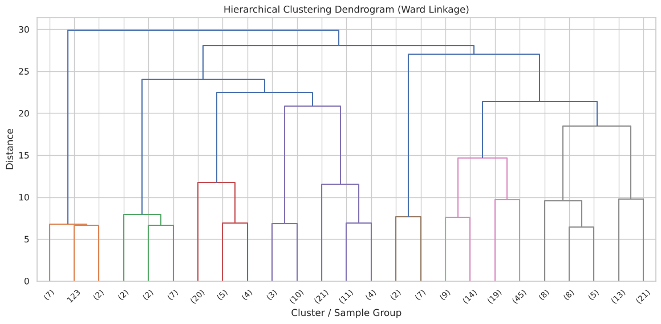
Figure 19: Dendrogram (Ward linkage, sample of 250 records)
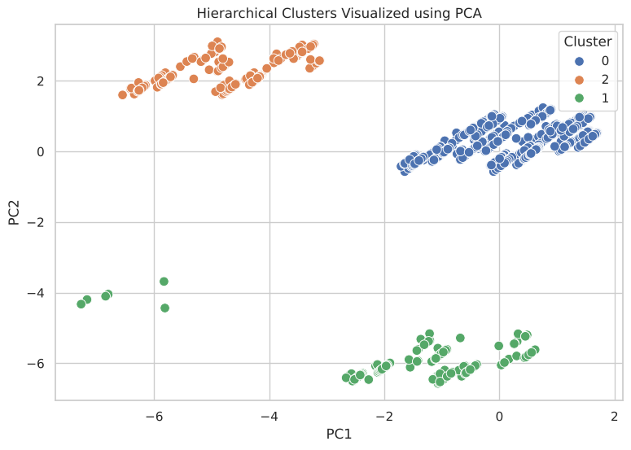
Figure 20: Hierarchical clusters visualised on the first two principal components
Agglomerative clustering with Ward linkage and three clusters produced exactly the same groups as K-Means (4,431 / 222 / 242). Both methods split the data along two rare binary categories, female gender and “shot and Tasered”, and the age profiles of the clusters are almost identical. The clustering therefore separates rare categories rather than revealing hidden behavioural groups.

5.3 Outlier detection using clustering
dist = np.linalg.norm(X_scaled - kmeans.cluster_centers_[df["kmeans_cluster"]], axis=1)
threshold = np.percentile(dist, 99) # 6.31
df["cluster_outlier"] = dist > threshold # 49 records
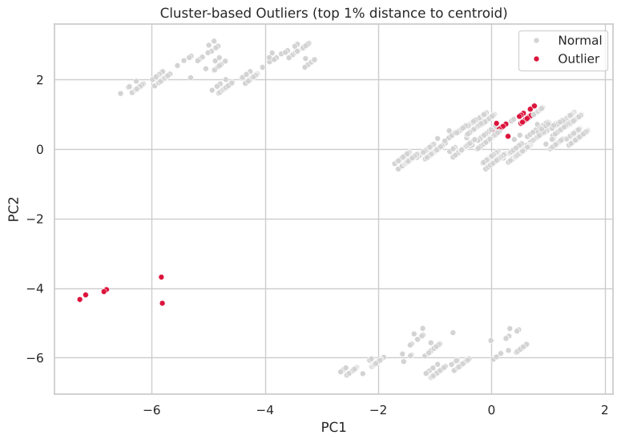
Figure 21: Cluster-based outliers (top 1% distance to their K-Means centroid)
Table 10: Profile of cluster-based outliers
Measure | Outliers (49) | All records
Mean age | 34.94 | 36.55
% signs of mental illness | 22.45 | 22.53
% body camera | 18.37 | 11.81
% threat level undetermined | 87.76 | 4.23

Records that lie unusually far from their cluster centre were treated as outliers. 87.8% of them have the rare “undetermined” threat level (vs 4.2% overall), and they also have more body cameras. Clustering-based outlier detection therefore finds unusual combinations of categories, which the IQR rule on a single variable cannot detect.

6. Module 6 – Dimensionality Reduction

6.1 Principal Component Analysis: method
PCA converts correlated variables into uncorrelated principal components, ordered by the variance they explain. A 16-feature matrix was built: age, year, the mental-illness and body-camera indicators, and one-hot encodings (drop_first = True) of manner of death, threat level, flee, gender and race. All features were standardised, because PCA is sensitive to scale.
pca_num = ["age", "year", "mental_illness_binary", "body_camera_binary"]
pca_cat = ["manner_of_death", "threat_level", "flee", "gender", "race"]
X_pca_features = pd.get_dummies(pca_input, columns=pca_cat, drop_first=True, dtype=float)
X_pca_scaled = StandardScaler().fit_transform(X_pca_features) # shape (4895, 16)

pca_full = PCA(random_state=42).fit(X_pca_scaled)
evr = pca_full.explained_variance_ratio_
cum_evr = np.cumsum(evr)

6.2 Explained variance
Table 11: Eigenvalues and explained variance of all 16 components
Component | Eigenvalue | Variance % | Cumulative %
PC1 | 2.119 | 13.24 | 13.24
PC2 | 1.494 | 9.34 | 22.58
PC3 | 1.315 | 8.22 | 30.80
PC4 | 1.192 | 7.45 | 38.25
PC5 | 1.115 | 6.97 | 45.22
PC6 | 1.067 | 6.67 | 51.89
PC7 | 1.048 | 6.55 | 58.43
PC8 | 1.025 | 6.41 | 64.84
PC9 | 0.982 | 6.14 | 70.98
PC10 | 0.977 | 6.10 | 77.08
PC11 | 0.888 | 5.55 | 82.64
PC12 | 0.839 | 5.24 | 87.88
PC13 | 0.809 | 5.05 | 92.93
PC14 | 0.790 | 4.93 | 97.87
PC15 | 0.311 | 1.95 | 99.81
PC16 | 0.030 | 0.19 | 100.00

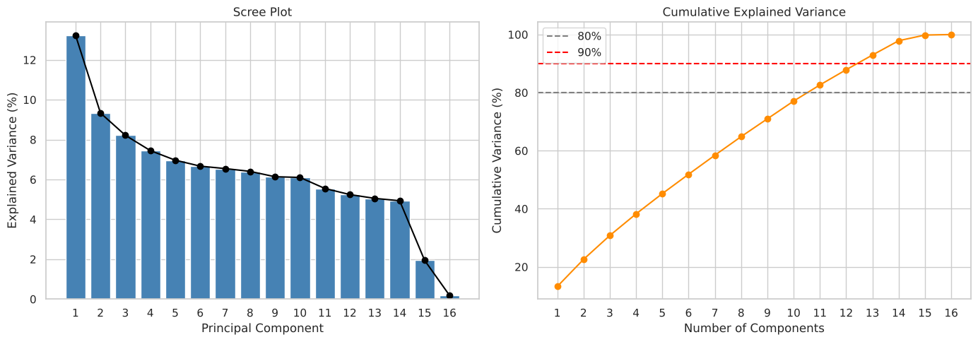
Figure 22: Scree plot and cumulative explained variance
- Kaiser rule: 8 components have eigenvalue > 1.
- 80% variance: 11 components are needed; 90% needs 13.
- First three components: together explain only 30.80% of the variance.

6.3 Loadings
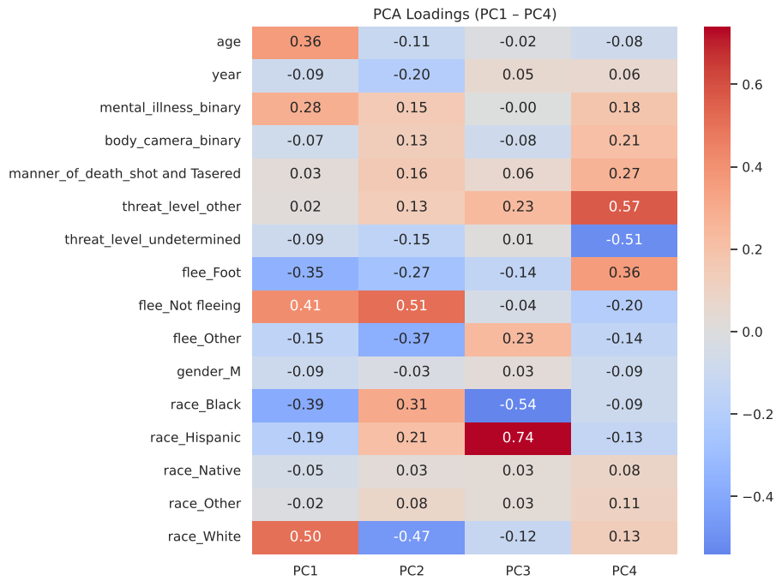
Figure 23: Loadings of PC1 – PC4
Table 12: Interpretation of the leading principal components
Component | Main contributing features (loading) | Interpretation
PC1 | race_White (+0.50), flee_Not fleeing (+0.41), race_Black (−0.39) | White / not-fleeing vs Black records
PC2 | flee_Not fleeing (+0.51), race_White (−0.47), flee_Other (−0.37) | Flee-status axis
PC3 | race_Hispanic (+0.74), race_Black (−0.54) | Hispanic vs Black records
PC4 | threat_level_other (+0.57), threat_level_undetermined (−0.51), flee_Foot (+0.36) | Threat-level axis

6.4 Projection of the data
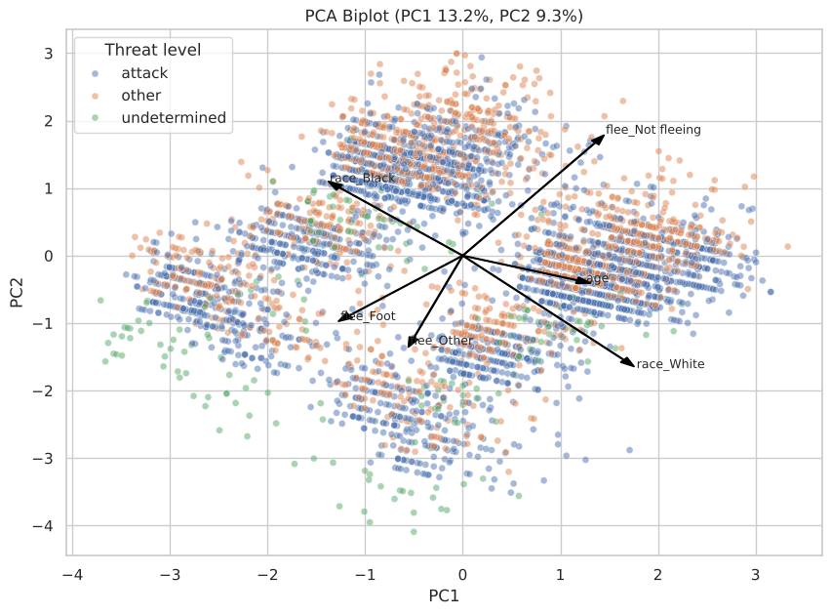
Figure 24: PCA biplot of PC1 vs PC2, coloured by threat level, with the strongest loading vectors
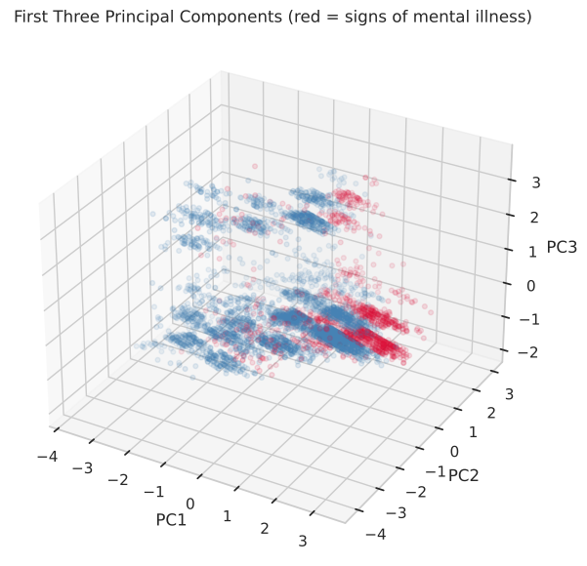
Figure 25: First three principal components (red = signs of mental illness)

6.5 Singular Value Decomposition (SVD)
PCA is computed through SVD. For the centred data matrix X = U S Vᵀ, the rows of Vᵀ are the principal directions, and each eigenvalue equals sᵢ² / (n − 1), where sᵢ is a singular value.
U, s, Vt = np.linalg.svd(X_pca_scaled - X_pca_scaled.mean(axis=0), full_matrices=False)
eig_from_svd = s**2 / (X_pca_scaled.shape[0] - 1)
np.allclose(eig_from_svd, pca_full.explained_variance_) # True
Table 13: SVD reproduces the PCA eigenvalues
Component | Singular value | Eigenvalue from SVD | Eigenvalue from PCA
PC1 | 101.841 | 2.119 | 2.119
PC2 | 85.517 | 1.494 | 1.494
PC3 | 80.221 | 1.315 | 1.315
PC4 | 76.390 | 1.192 | 1.192
PC5 | 73.880 | 1.115 | 1.115

The eigenvalues obtained from SVD match the PCA eigenvalues exactly, which confirms the PCA result.

6.6 Interpretation
- No single dominant direction exists. PC1 explains only 13.24% of the variance and the scree plot declines slowly instead of showing a sharp elbow.
- The reason is that the features are mostly independent binary indicators with weak pairwise correlations (|r| < 0.13, Section 3.4). PCA can only compress variance that variables share, so here it cannot reduce the data to a few components without losing much information.
- PC15 and PC16 have very small eigenvalues (0.31 and 0.03), which shows near-redundancy among the race dummy variables (they almost sum to a constant).
- In the biplot and 3D plot, the threat-level groups and the mental-illness groups overlap heavily. The leading components do not separate these groups, which agrees with the moderate classifier performance in Module 7.
- Conclusion for this dataset: PCA is valuable as an exploratory check that confirms low redundancy, but keeping only 2–3 components would discard about 70% of the information. The original features are therefore used for classification.

7. Module 7 – Model Development and Evaluation

7.1 Model choice and problem definition
The faculty guideline for Module 7 allows Simple Linear Regression or any one classification method. A classification model was chosen because the only continuous variable is age, which has weak correlations with every other variable (|r| < 0.10), so a linear regression would explain almost none of its variance. The evaluation follows the syllabus topics of computing accuracy and understanding what accuracy does and does not show.
Target: signs_of_mental_illness (1 = True, 0 = False). Predictors: age, year, body camera, manner of death, threat level, flee, gender, race and arms category.
Logistic Regression was chosen because the target is binary, it is the standard baseline classifier, and each coefficient can be converted to an odds ratio, which makes the model easy to interpret.
The classes are imbalanced: 3,792 False (77.47%) and 1,103 True (22.53%). A model that always predicts False would be 77.5% accurate while being useless. Therefore class_weight = "balanced" was used, a majority-class baseline was included for comparison, and precision, recall, F1 and ROC-AUC were reported instead of accuracy alone. Categories with fewer than 30 records (for example “Hand tools”) were grouped into one infrequent level to avoid unstable coefficients.

7.2 Implementation
X_train, X_test, y_train, y_test = train_test_split(
X_clf, y_clf, test_size=0.2, random_state=42, stratify=y_clf) # 3916 / 979 rows

preprocess = ColumnTransformer([
("num", StandardScaler(), ["age", "year", "body_camera_binary"]),
("cat", OneHotEncoder(handle_unknown="infrequent_if_exist", min_frequency=30),
["manner_of_death", "threat_level", "flee", "gender", "race", "arms_category"]),
])
log_reg = Pipeline([("prep", preprocess),
("model", LogisticRegression(class_weight="balanced", max_iter=1000))])
log_reg.fit(X_train, y_train)
baseline = DummyClassifier(strategy="most_frequent").fit(X_train, y_train)

7.3 Results
Table 14: Test-set performance (979 records)
Model | Accuracy | Precision | Recall | F1-score | ROC-AUC
Majority-class baseline | 0.774 | 0.000 | 0.000 | 0.000 | 0.500
Logistic Regression | 0.622 | 0.341 | 0.724 | 0.464 | 0.710

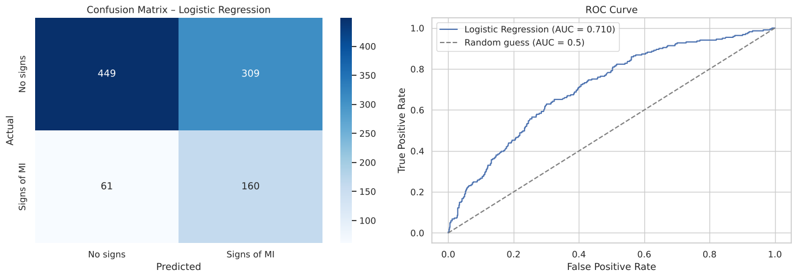
Figure 26: Confusion matrix and ROC curve of the Logistic Regression model
Table 15: Confusion matrix
 | Predicted: No signs | Predicted: Signs of MI
Actual: No signs (758) | 449 (TN) | 309 (FP)
Actual: Signs of MI (221) | 61 (FN) | 160 (TP)

5-fold stratified cross-validation: ROC-AUC = 0.709 ± 0.012 and F1 = 0.465 ± 0.016. The fold-to-fold variation is small, so the test result is stable and not due to a lucky split.

7.4 Model interpretation
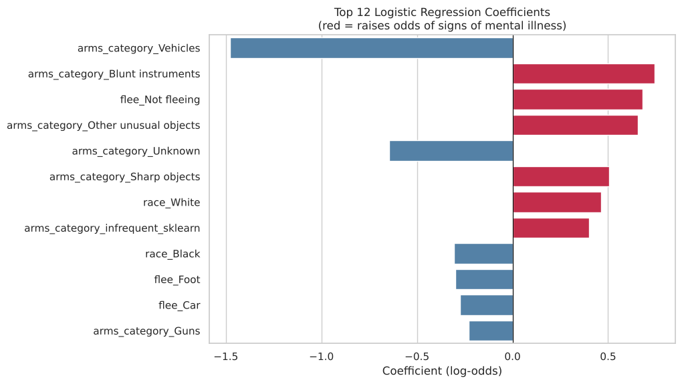
Figure 27: Twelve largest Logistic Regression coefficients (red = raises the odds)
Table 16: Strongest predictors
Feature | Coefficient | Odds ratio | Effect on odds of signs of MI
arms_category = Vehicles | −1.477 | 0.23 | Strongly lower
arms_category = Blunt instruments | +0.742 | 2.10 | Higher
flee = Not fleeing | +0.680 | 1.97 | Higher
arms_category = Other unusual objects | +0.654 | 1.92 | Higher
arms_category = Unknown | −0.645 | 0.53 | Lower
arms_category = Sharp objects | +0.504 | 1.66 | Higher
race = White | +0.464 | 1.59 | Higher
race = Black | −0.308 | 0.74 | Lower
flee = Foot | −0.301 | 0.74 | Lower
flee = Car | −0.275 | 0.76 | Lower

7.5 Understanding accuracy and discussion
- The baseline reaches 77.4% accuracy but detects none of the 221 positive test cases. Logistic Regression has lower accuracy (62.2%), but correctly identifies 160 of them (recall 72.4%). This shows why accuracy is misleading on imbalanced data.
- The balanced class weights intentionally accept more false positives (309) in exchange for far fewer missed cases (61). If precision mattered more, the decision threshold could be raised above 0.5.
- Weapon category and flee status are the strongest predictors. Incidents involving blunt, sharp or unusual objects and people who were not fleeing are more likely to have signs of mental illness recorded. Vehicle-related incidents and fleeing are less likely.
- An ROC-AUC of 0.71 means the incident attributes carry a moderate signal. The model is suitable for understanding associations, not for real-world decisions. The coefficients describe patterns in recorded data, not causes.

8. Conclusion
This project applied the BCSE331L workflow, Modules 2 to 7, to 4,895 records of fatal police shootings.
- Module 2 – Data Transformation: placeholders were replaced, duplicates checked, and missing data handled by imputation instead of listwise deletion (which would lose 8.72% of rows). Age was discretized into groups and quartiles.
- Module 3 – Correlation and Time Series: numeric correlations are all weak (|r| < 0.13). The monthly series is stable around 75 incidents with no clear trend, and weekday differences are small.
- Module 4 – Summarization and Visualization: age is right-skewed (mean 36.5, median 35, mode 25), with 37 high-age outliers by the IQR rule. Contingency tables show weak but significant links between race, age group and signs of mental illness.
- Module 5 – Clustering: K-Means and hierarchical clustering agreed exactly but only isolated rare categories (female, shot and Tasered). Cluster-based outlier detection highlighted “undetermined” threat cases.
- Module 6 – Dimensionality Reduction: PC1–PC3 explain only 30.8% of the variance and 11 of 16 components are needed for 80%. SVD reproduced the same eigenvalues.
- Module 7 – Model Development and Evaluation: Logistic Regression predicted signs of mental illness with ROC-AUC 0.71 and recall 72%. Its accuracy (62%) was lower than the majority baseline (77%), which shows why accuracy alone is misleading on imbalanced data.
Limitations and future work: the data covers only fatal incidents and only up to mid-2020, and counts are not adjusted for population. Future work could add census population data to compute rates, use the city and state columns for geographic analysis, and compare Logistic Regression with tree-based classifiers such as Random Forest.

References
- Dataset: shootings.csv, BCSE331L course repository – https://github.com/salemprakash/EDA
- Pedregosa et al., “Scikit-learn: Machine Learning in Python”, JMLR 12, 2011.
- McKinney, W., Python for Data Analysis, O’Reilly Media.
- Mukhiya, S. K. & Ahmed, U., Hands-On Exploratory Data Analysis with Python, Packt Publishing, 2020.

