**wSteps to do for Order Creation**

1. Create your organization.

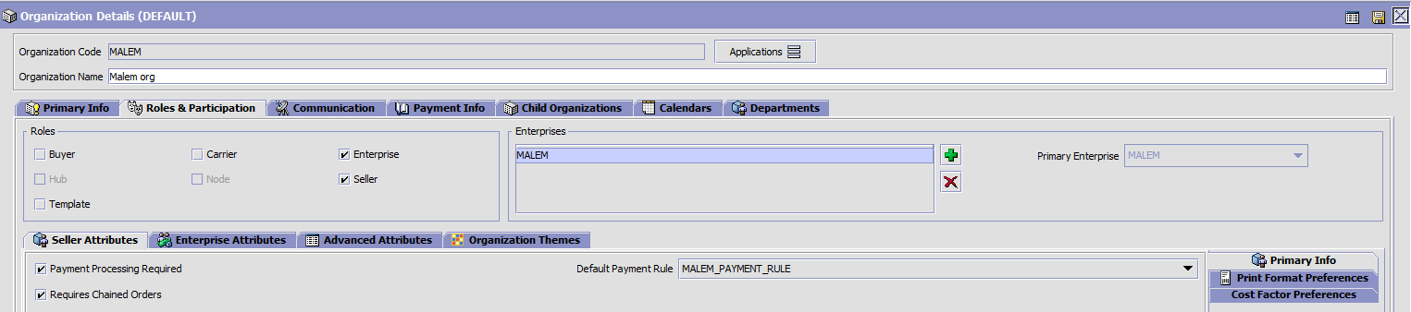

1. Create its child nodes and make sure you give their proper address.



1. Create an item without product class.

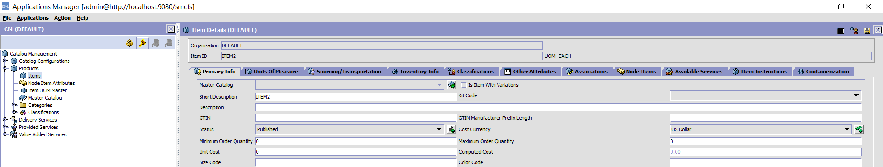

1. Create Fulfillment Types as PRODUCT_SOURCING and YCD_STORE_SEARCH under your Org.

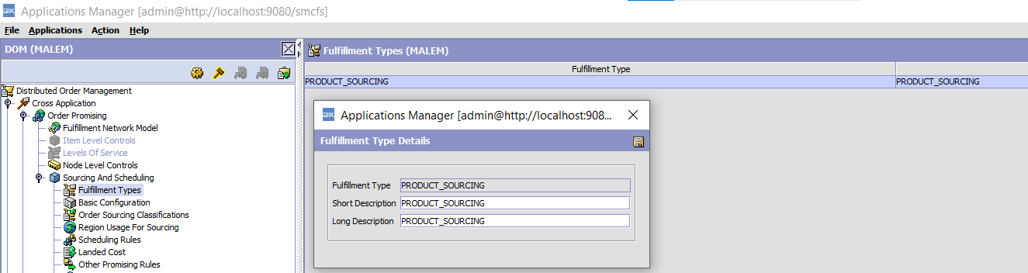



1. Create a new Distribution Groups in both DEFAULT org and your Org. And add the nodes inside the DG.

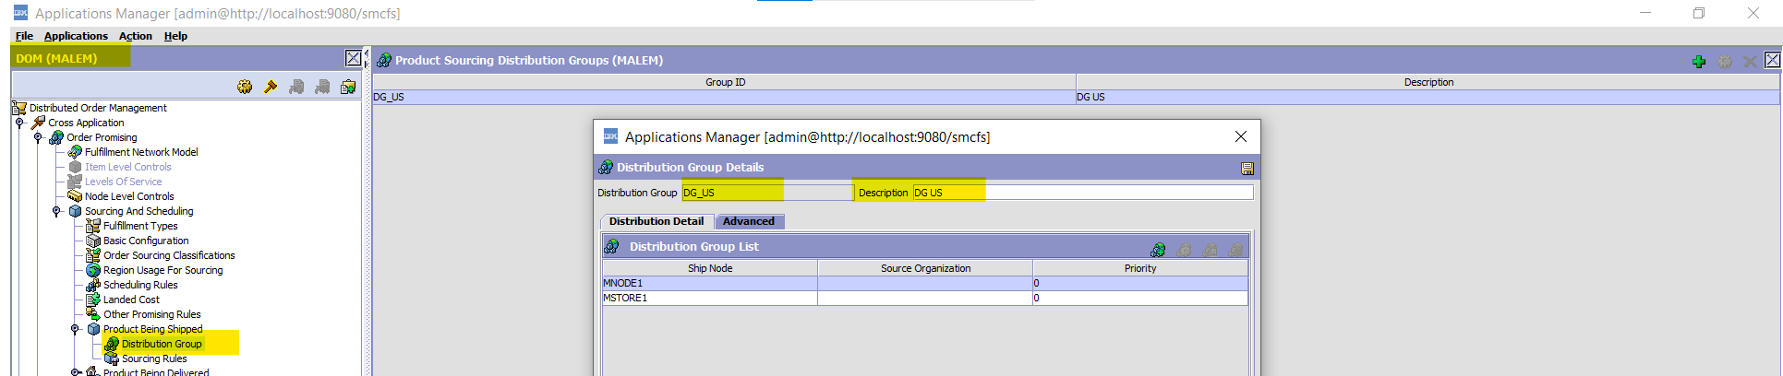

1. Create sourcing rule under your Org for PRODUCT_SOURCING and YCD_STORE_SEARCH.

1. Create a monitoring rule.

1. Create an agent for Monitor Rule 3

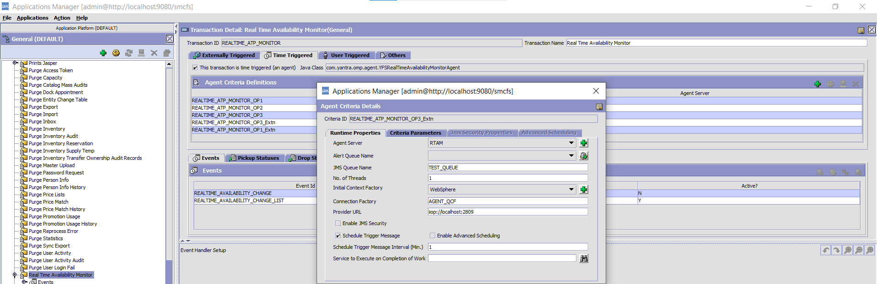

1. Adjust your inventory in API tester.

|  |
| --- |
| <Items>  <Item AdjustmentType="ABSOLUTE" ItemID="ITEM2" OrganizationCode="DEFAULT" ProductClass="" Quantity="15" ShipNode="MNODE1" SupplyType="ONHAND" UnitOfMeasure="EACH" />  <Item AdjustmentType="ABSOLUTE" ItemID="ITEM2" OrganizationCode="DEFAULT" ProductClass="" Quantity="20" ShipNode="MSTORE1" SupplyType="ONHAND" UnitOfMeasure="EACH" />  </Items> |

10. Run the RTAM agent .

~~11. Implement com.yantra.yfs.japi.ue.YFSBeforeChangeOrderUE to adjust/overrider the UnitPrice for Item to show it on UI. In CC, we can’t create a zero dollar order, so implement the UE.~~

|  |
| --- |
|  |

~~12. execute this sql in sql developer~~

|  |
| --- |
| ~~update yfs_base_rules set rule_set_value='N' where rule_name='YCD_USE_CACHE_INVENTORY_CHECK';~~ |

13. Implement the com.yantra.yfs.japi.ue.YFSCollectionOthersUE in your custom code

14. Go to SBC and set up for payment rules and types for your Org.

Create a payment type for Others only.

15. Implement the com.yantra.yfs.japi.ue.YFSGetFundsAvailableUE

Logic: return some value in funds Available

<PaymentMethod FundsAvailable=”1000”/>

Then you can confirm the Order.

MODIFICATION RULE:

