**FirstName, LastName, Email to be case Insensitive**

Go to path **Path: Foundation\extensions\global\entities\Extensions.xml**

**Update the below xml in Extensions.xml**

|  |
| --- |
| <Entity TableName="YFS_CUSTOMER_CONTACT">  <!-- table columns -->  <Attributes>  <Attribute ColumnName="FIRST_NAME" CaseInsensitiveSearch="Y" ShadowColumnName="CC_FIRST_NAME_SC" />  <Attribute ColumnName="LAST_NAME" CaseInsensitiveSearch="Y" ShadowColumnName="CC_LAST_NAME_SC" />  <Attribute ColumnName="EMAILID" CaseInsensitiveSearch="Y" ShadowColumnName="CC_EMAILID_SC" />  </Attributes>  <Indices>                 <Index Name="EXTN_REI_CU_CO_X1" AllowCompressedColumns="false">                      <Column Name="CC_FIRST_NAME_SC"/>                      <Column Name="CC_LAST_NAME_SC"/>                      <Column Name="CC_EMAILID_SC"/>                  </Index>  </Indices>  </Entity> |

Go to Winscp to the following path - /mw/sterling/10/Foundation/extensions/global/entities

Go to putty – and navigate to this path and give permission to Extensions.xml for modifying it

Run the command – chmod -R 777 Extensions.xml

login as sterbld user, by running below commands

**sudo su – sterbld**

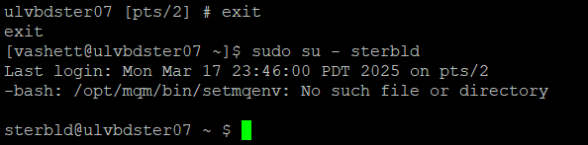

Go inside foundation/bin and run the dbverify.sh

**cd /mw/sterling/10/Foundation/bin**

**./dbverify.sh**

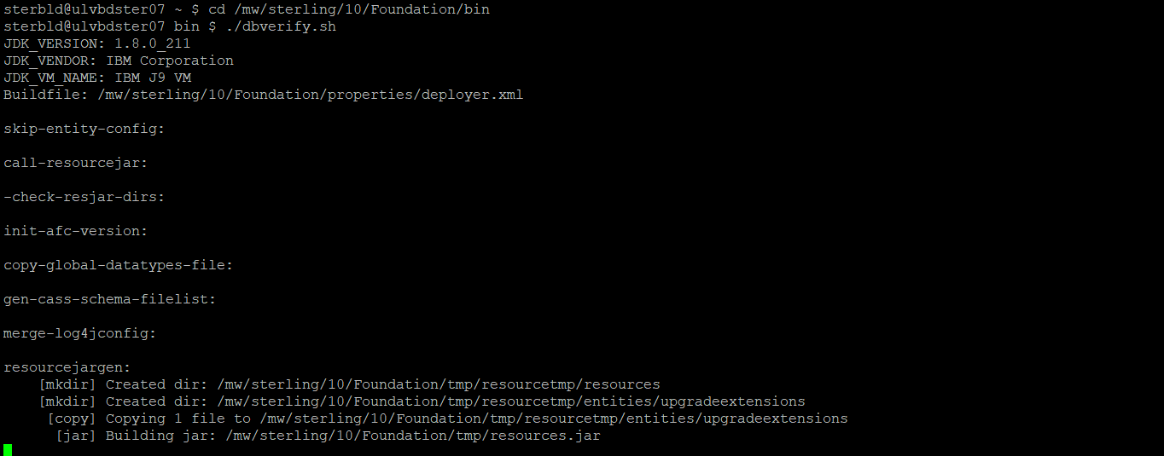

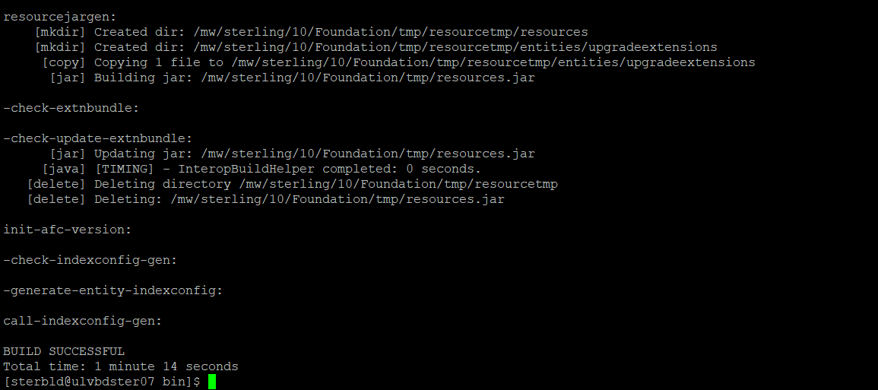

Go to /mw/sterling/10/Foundation/repository/scripts

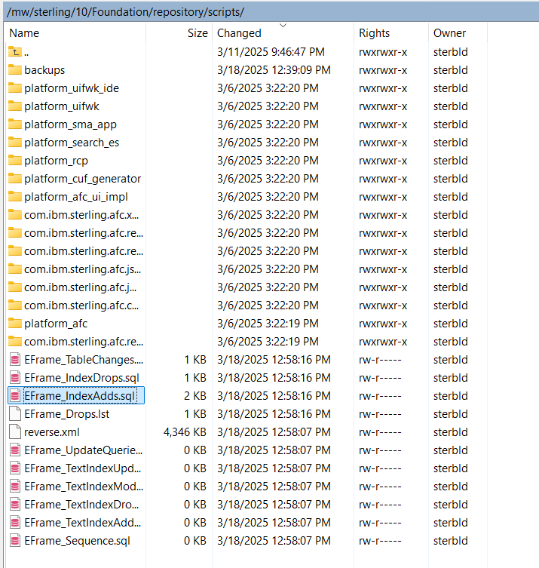

Now run your added table scripts and commit them

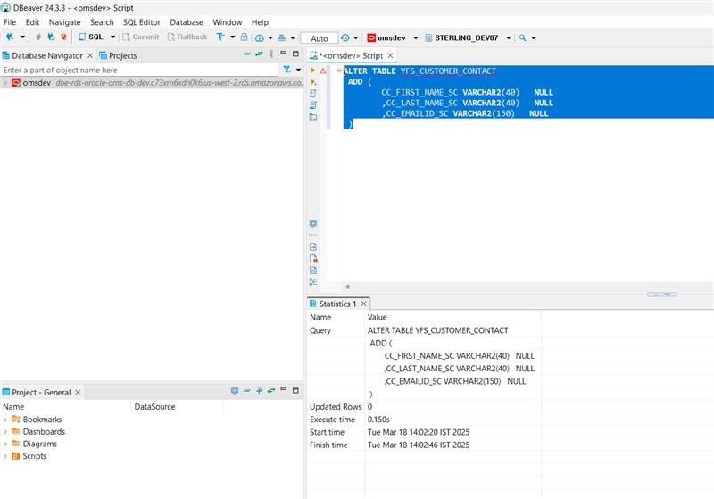

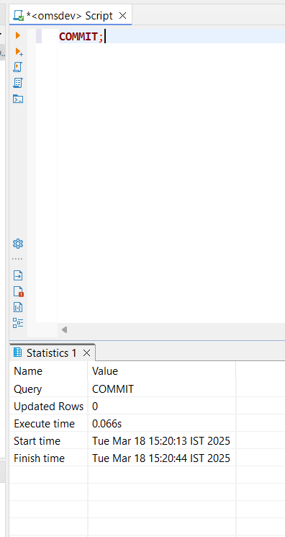

Run below commands

./deployer.sh -t resourcejar

./deployer.sh -t entitydeployer

./buildear.sh -Dearfile=smcfs.ear -Dwarfiles=smcfs,sbc,sma,wscdev,icc -Dappserver=websphere -Dnowebservice=false -Ddevmode=true -Duidevmode=true -Dnodocear=true create-ear

Deploy ear in WAS from below path

/mw/sterling/10/Foundation/external_deployments/smcfs.ear