Go to Winscp to the following path - /mw/sterling/10/Foundation/extensions/global/entities

Go to putty – and navigate to this path and give permission to Extensions.xml for modifying it

Run the command – chmod -R 777 Extensions.xml



Make changes to Extensions.xml and override it with server Extensions.xml

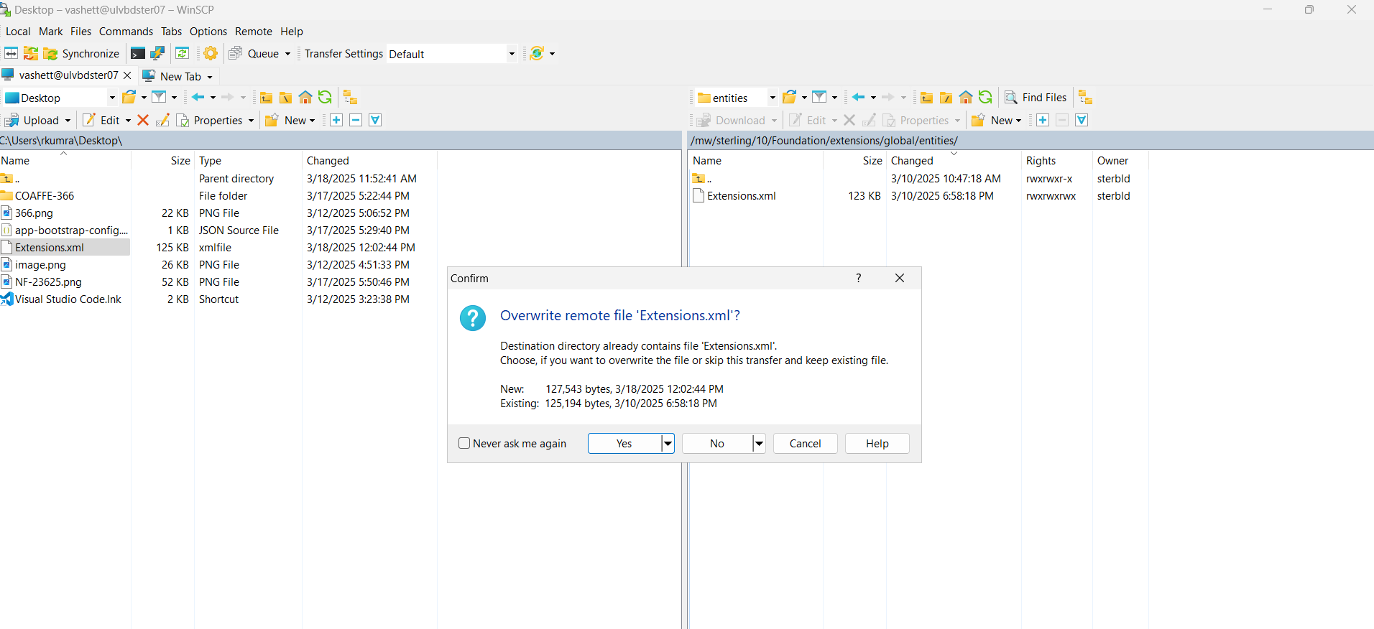

If override is not helping so replace the file in temp and copy it in putty using the below command

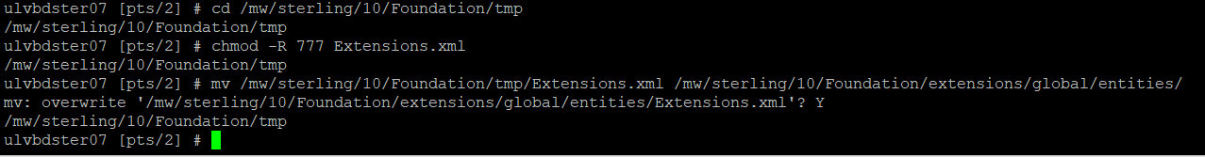

mv /mw/sterling/10/Foundation/tmp/Extensions.xml /mw/sterling/10/Foundation/extensions/global/entities/

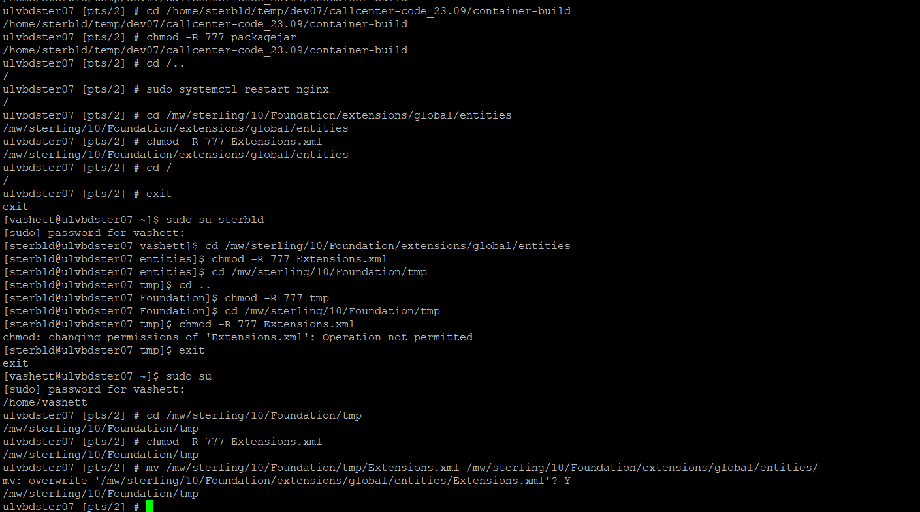

Now exit and login as sterbld user, by running below commands

**sudo su – sterbld**

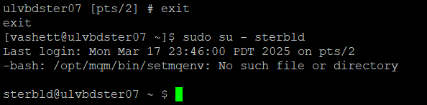

Go inside foundation/bin and run the dbverify.sh

**cd /mw/sterling/10/Foundation/bin**

**./dbverify.sh**

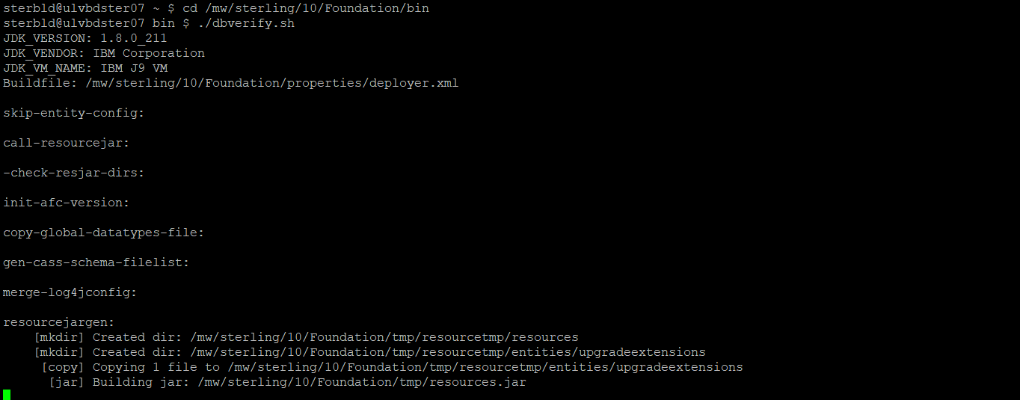

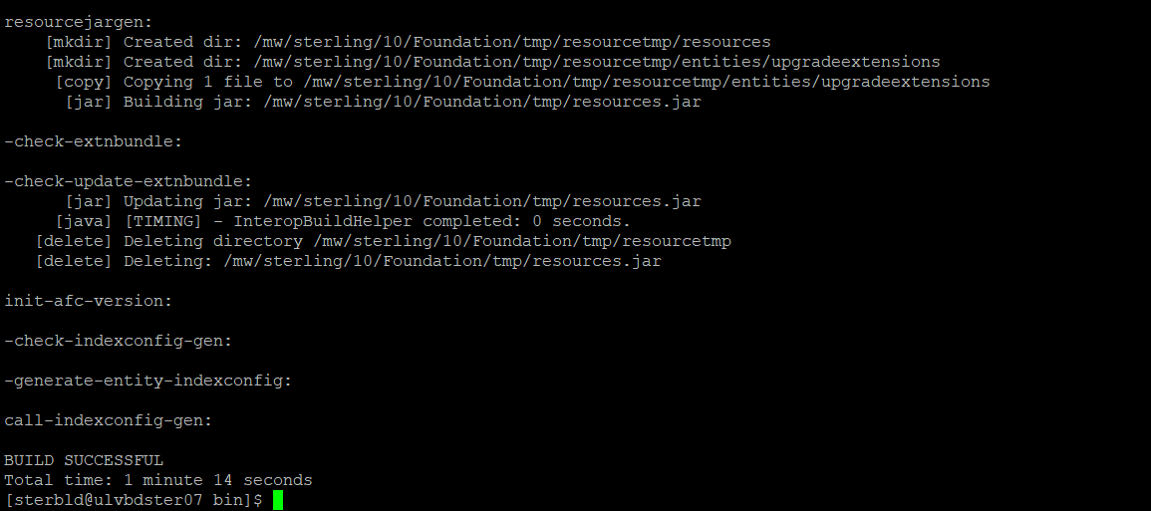

Go to /mw/sterling/10/Foundation/repository/scripts

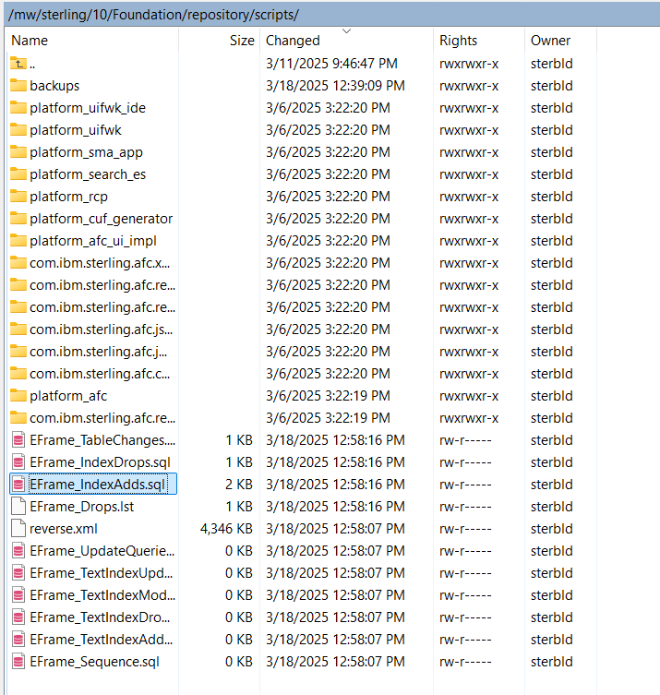

Now run your added table scripts and commit them

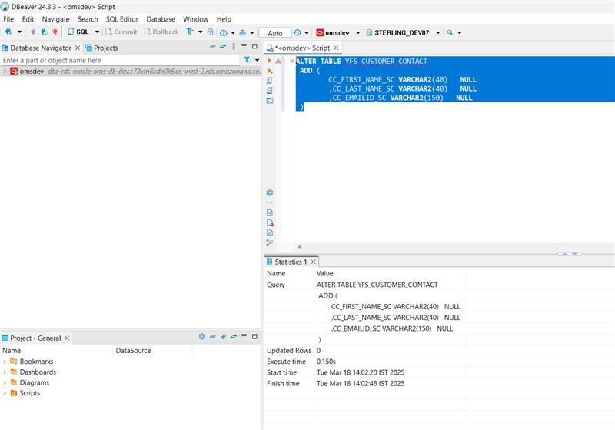

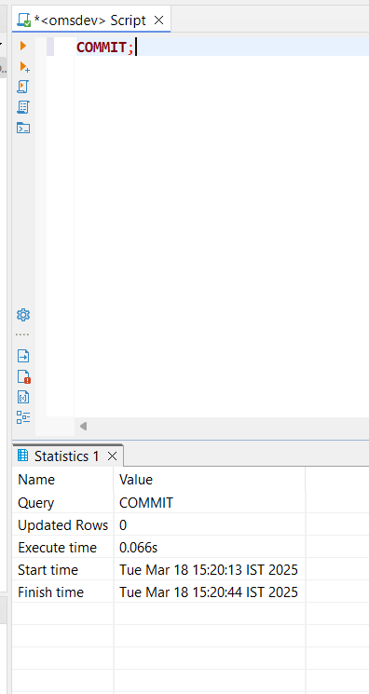

Run below commands

./deployer.sh -t resourcejar

./deployer.sh -t entitydeployer

./buildear.sh -Dearfile=smcfs.ear -Dwarfiles=smcfs,sbc,sma,wscdev,icc -Dappserver=websphere -Dnowebservice=false -Ddevmode=true -Duidevmode=true -Dnodocear=true create-ear

Deploy ear in WAS from below path

/mw/sterling/10/Foundation/external_deployments/smcfs.ear

**To generate SQL files:**

1. As *sterbld*user, log in to any environment server (can even be the build box) and go to Foundation/bin   
   **cd /mw/sterling/10/Foundation/bin/**
2. Execute the dbverify.sh script  
   **./dbverify.sh**
3. The script will compare the database (user, and connection string taken from *Foundation/properties/customer_overrides.properties* and it will generate SQL scripts to apply required changes, the sql scripts can be found under the *Foundation/repository/scripts*folder
4. The correct execution sequence is the following: (saneSqlExec):

**EFrame_TextIndexDrops.sql**  
**EFrame_IndexDrops.sql**  
**EFrame_TableChanges.sql**  
**EFrame_IndexAdds.sql**  
**EFrame_TextIndexAdds.sql**  
**EFrame_Sequence.sql**  
**EFrame_TextIndexModify.sql**  
**EFrame_TextIndexUpdates.sql**  
**EFrame_TextIndexUpgrade.sql**  
**EFrame_Static.sql**

Notes on Entities:

Entities build will package the entities.jar and also generate a set of SQL files after checking the differences between the DB and Extensions.xml file.  
During entities build, changes **will NOT** apply the SQL changes  - **this is the default option on REI for all of our environments (including production).**

in Foundation/properties go to *sandbox.cfg* file and look for the following properties: **NO_DBVERIFY, REINIT_DB**  
If set **NO_DBVERIFY** to **true** it will not run the dbverify.sh during entities build,  
If set **NO_DBVERIFY** to **false** it will apply directly extensions.xml changes to db during entity build, after creating sql scripts in /mw/sterling/9.4/Foundation/repository/scripts dir.

If you want to create the .sql files but NOT RUN them during entities build (This is the default workflow at REI)  
**NO_DBVERIFY=false**  
**REINIT_DB=false**