Call-center-return Module

1. Disabling the View notes button on ToolbarAction

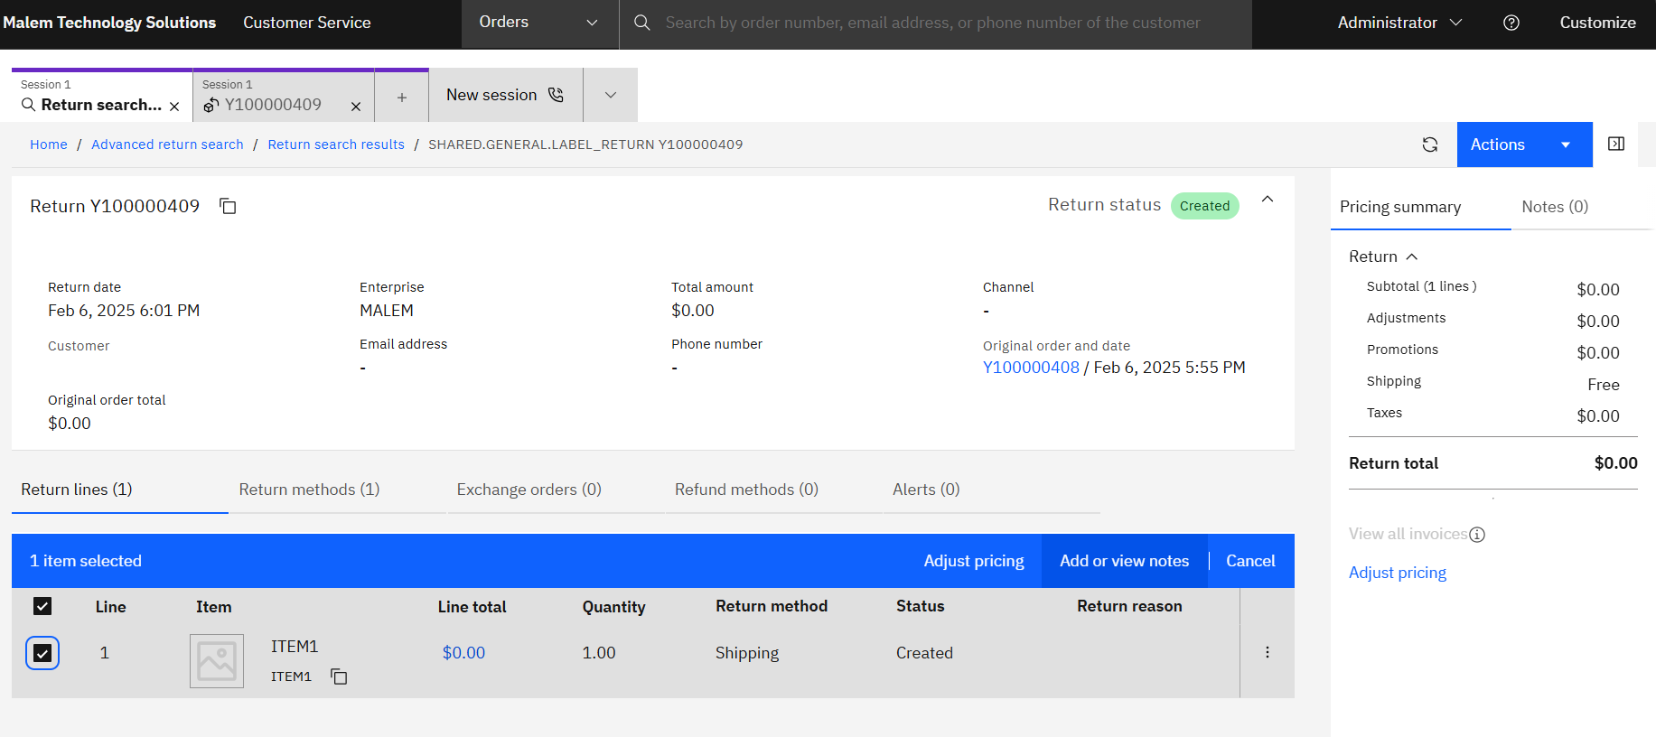

First perform the generalized steps for making customization to call-center-return Module

* In overrides.json file , The port number should match the port number in nginx.conf file and, enable the runAsCustomization true for your route(for eg- return-details route I have modified)

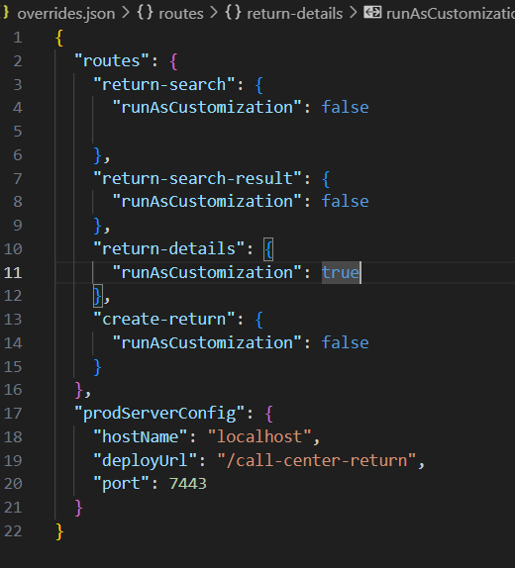

* Cd to call-center-return folder in cmd and perform below steps
  + yarn config set "strict-ssl" false
  + yarn cache clean
  + yarn install --update-checksums
  + yarn start-app
* Now go to C:\cc-customCode\call-center-return\packages\return-details\src and copy and paste the environment folder to C:\cc-customCode\call-center-return\packages\return-details\src-custom , make environment.customization = true;” in both the files inside environment*.ts files.
* Copy return-lines from C:\cc-customCode\call-center-return\packages\return-details\**src**\app\features\return and paste it to C:\cc-customCode\call-center-return\packages\return-details\**src-custom**\app\features\return
* Copy past call-center-return folder from C:\cc-customCode\call-center-return\packages\return-shared\assets and paste it to C:\cc-customCode\call-center-return\packages\return-details\src-custom\assets
* Add component to app-customization-impl.ts

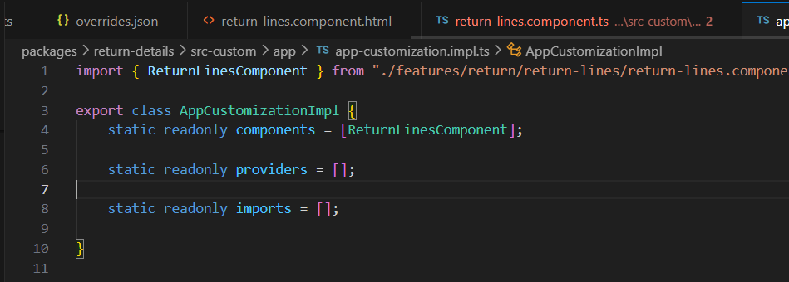

* Now let’s check where button logic is written

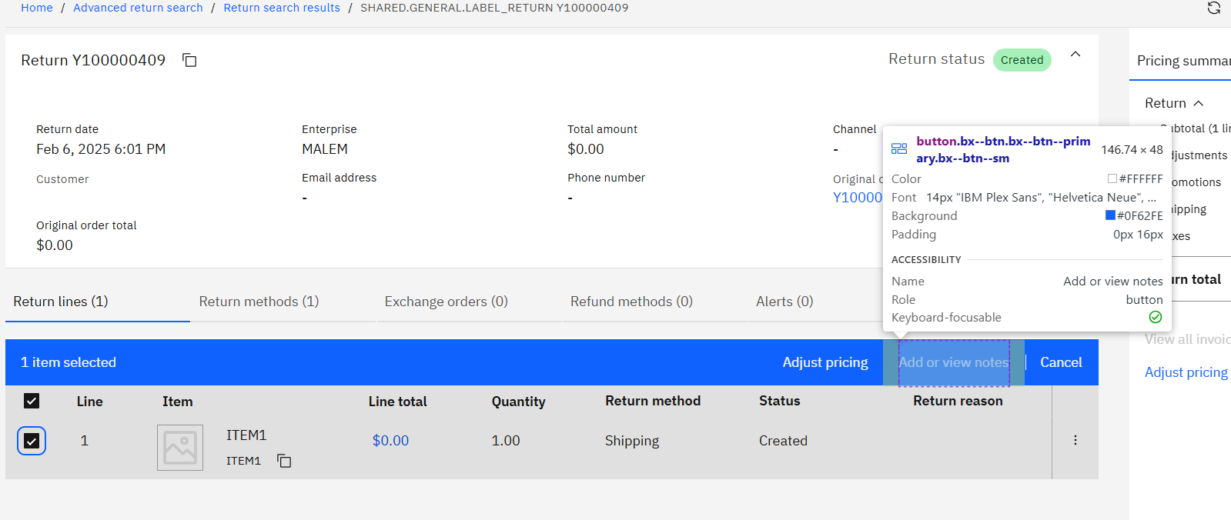

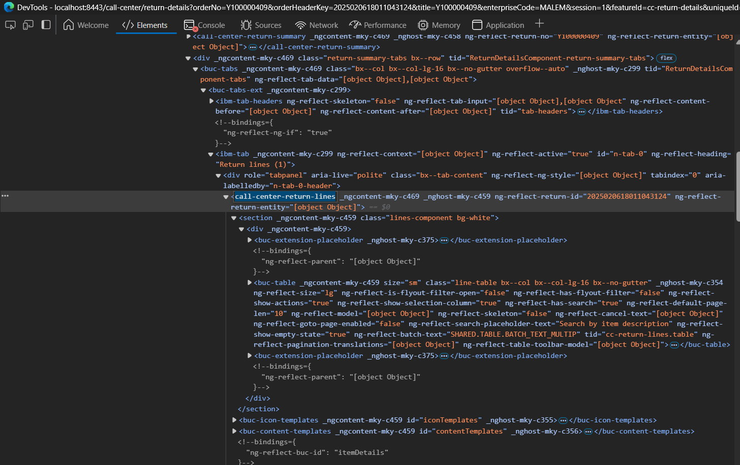

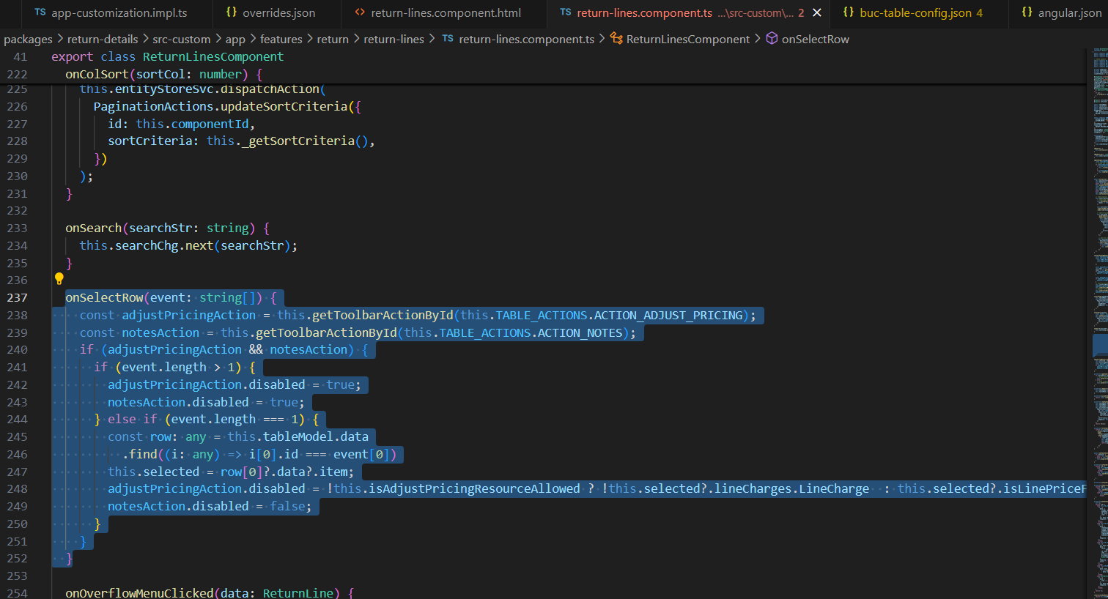

Make notesAction.disabled = true;

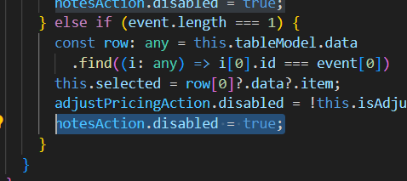

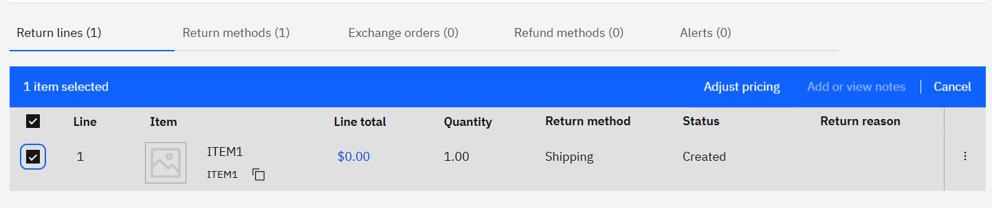

**Customizing Order-shared folder**

**Call-center-order Module**

* Disable the shown Add Note button
* **Disable the shown icon**

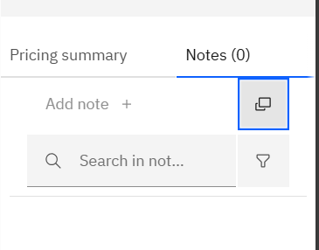

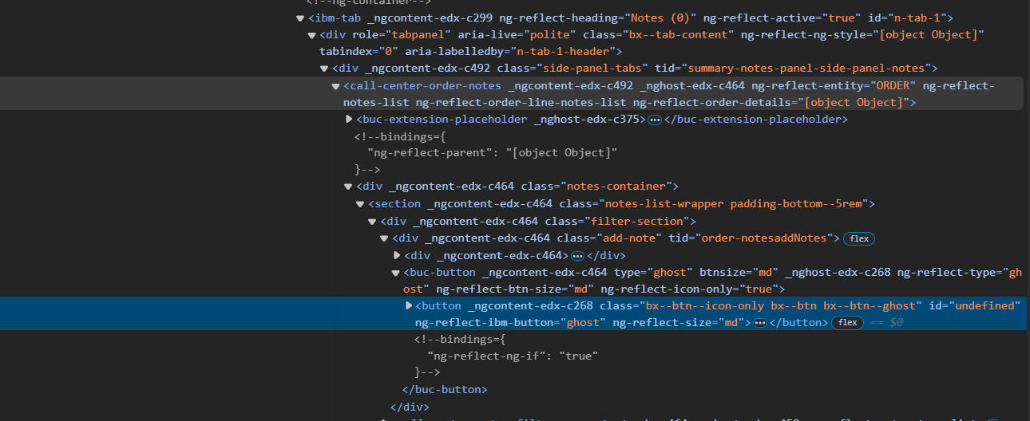

This icon is coming from .html file of Call-center-order notes which is coming from order-shared folder.

Now Call-center-order-notes is coming from call-center-order-summary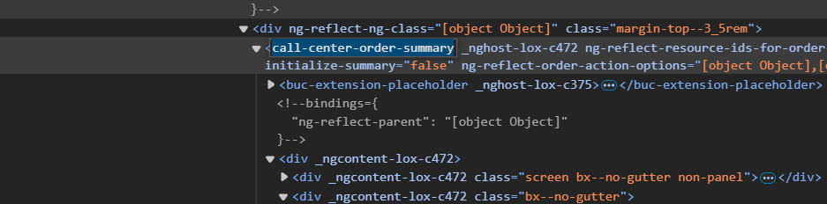

Below steps to be followed to customize it-

Copy and paste Order-summary folder from C:\cc-customCode\call-center-order\packages\order-details\src\app\features\order to C:\cc-customCode\call-center-order\packages\order-details\src-custom\app\features\order

OPEN order-summary.component.html file and change call-center-summary-notes to extn-call-center-summary-notes

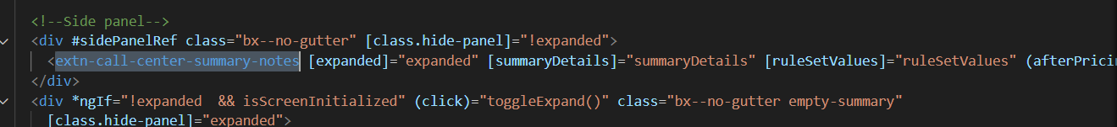

Copy paste the order-summary-notes-panel from C:\cc-customCode\call-center-order\packages\order-shared\src\lib\components and paste to C:\cc-customCode\call-center-order\packages\order-details\**src-custom**\app\custom

Open.ts file

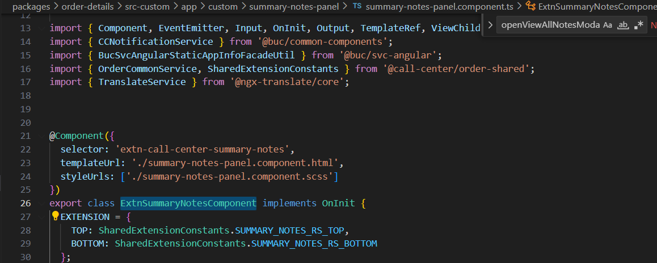

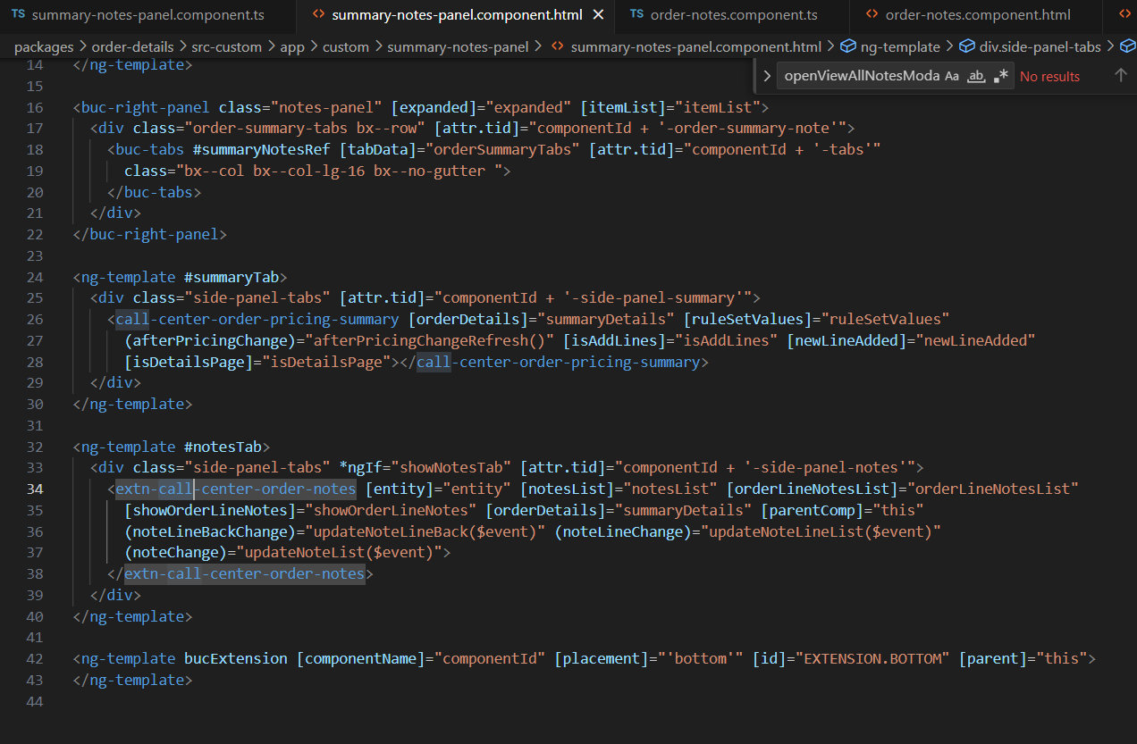

Copy and paste **order-notes** folder from C:\cc-customCode\call-center-order\packages\**order-shared**\src\lib\components\notes to C:\cc-customCode\call-center-order\packages\order-details\**src-custom**\app\custom

Open .ts file

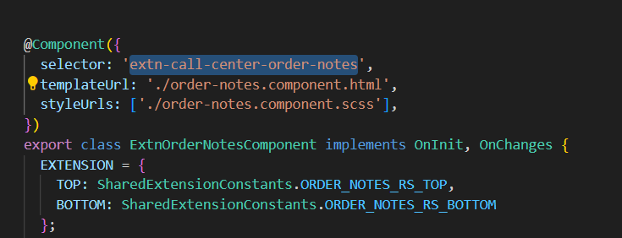

Add Extn to the class name and add extn- to the selector name

Selector: ‘extn-call-center-order-notes’

Open its .html file and disable the button

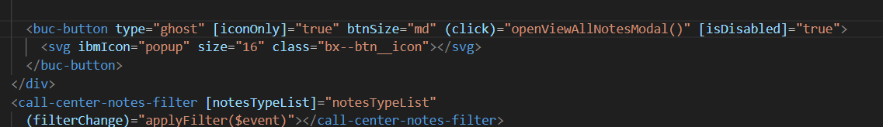

Open app-customization.impl.ts file and add components and providers name

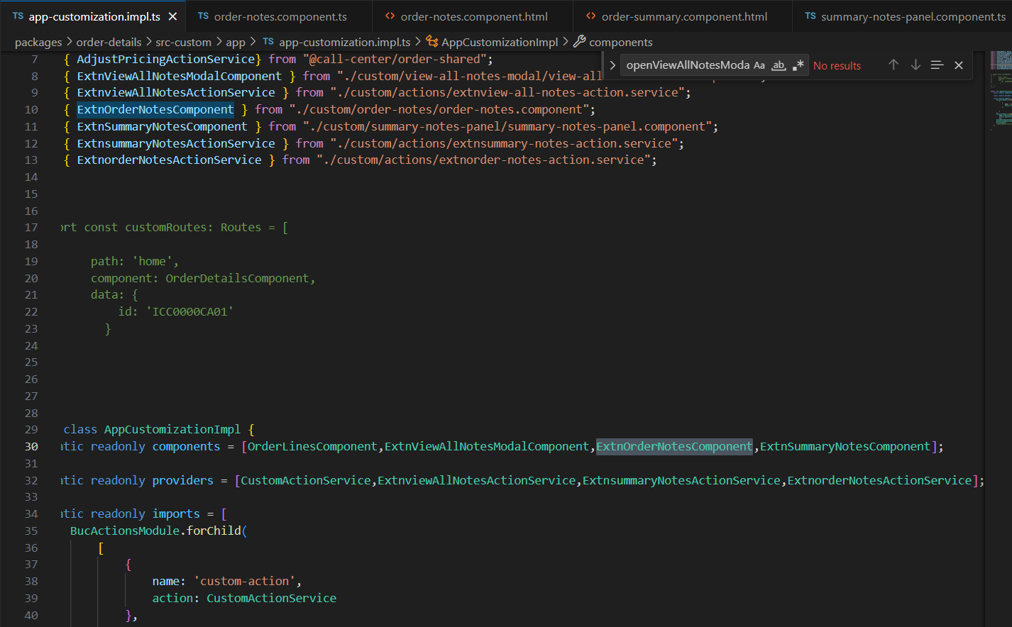

Generate service action files in following path C:\cc-customCode\call-center-order\packages\order-details\src-custom\app\custom\actions

ng g s extnsummary-notes-action and ng g s extnorder-notes-action

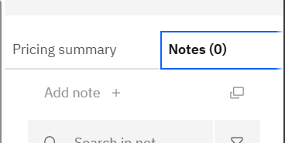

Now for Add note+ in the same file disable this

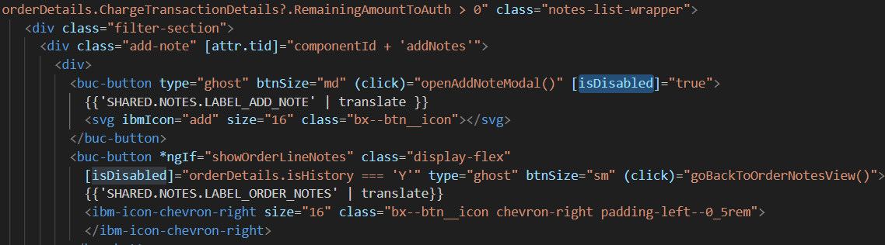

After this change the screen is looking like this

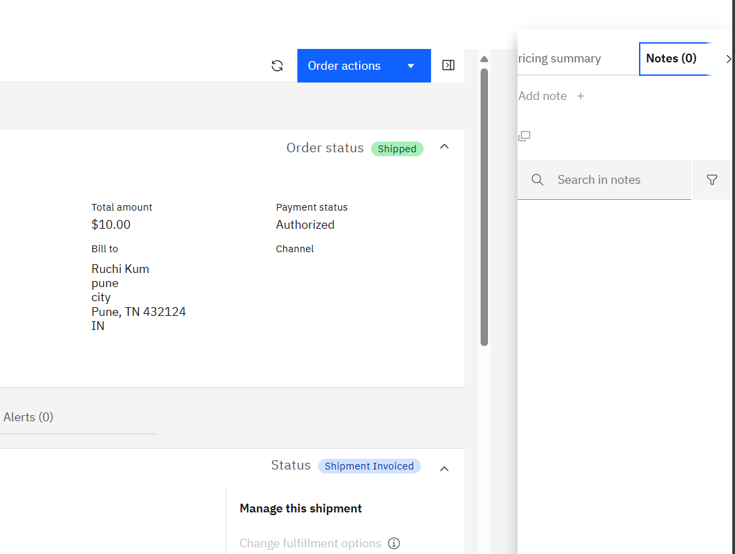

search the selector name in the nodemodules and copy the .scss code in your component scss file

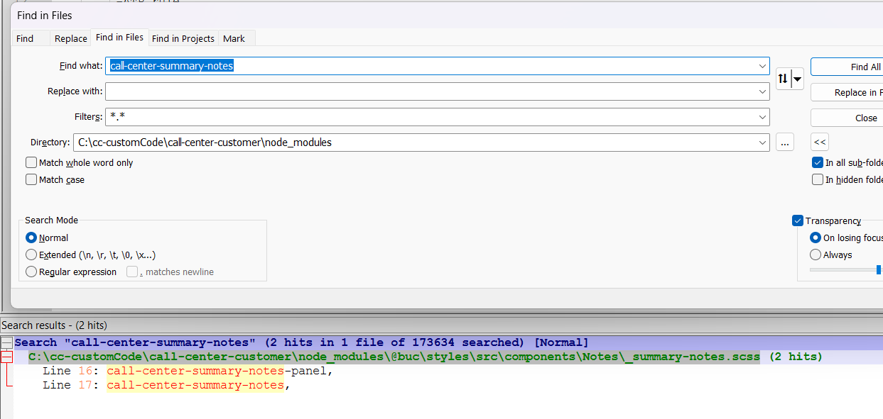

C:\cc-customCode\call-center-customer\node_modules\@buc\styles\src\components\Notes\_summary-notes.scss

Copy and paste the _summary-notes.scss file to summary-notes-panel-component.css file

|  |
| --- |
| /*   * IBM Confidential   * OCO Source Materials   * 5737-D18, 5725-D10   *   * (C) Copyright International Business Machines Corp. 2019, 2023   *   * The source code for this program is not published or otherwise divested   * of its trade secrets, irrespective of what has been deposited with the   * U.S. Copyright Office.   */   @import '@carbon/type/scss/type';   @import '@carbon/themes/scss/index';       extn-call-center-summary-notes {     .notes-title {       font-weight: 600;       padding: 1rem;       font-size: 1rem;       padding-bottom: .5rem;     }       .order-summary-tabs {       margin: 0;         ibm-tabs nav {         margin-left: 1.5%;       }         .bx--tab-content {         padding: 0 0.5rem;       }         .bx--tab--overflow-nav-button {         display: none;       }     }       .bx--panel--overlay {       top: 4rem !important;       position: fixed;       height: 100%;       margin-top: 2.5rem;       width: 18rem;       padding-bottom: 5.5rem;     }       .notes-panel {       .bx--panel--expanded {         box-shadow: none;       }     }     } |

Now is summary-note-panel.component.ts file add this

encapsulation: ViewEncapsulation.None

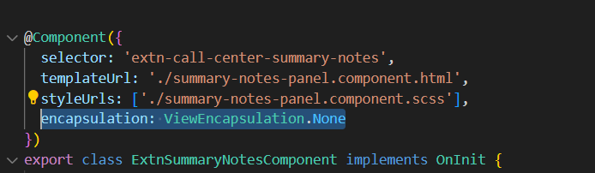

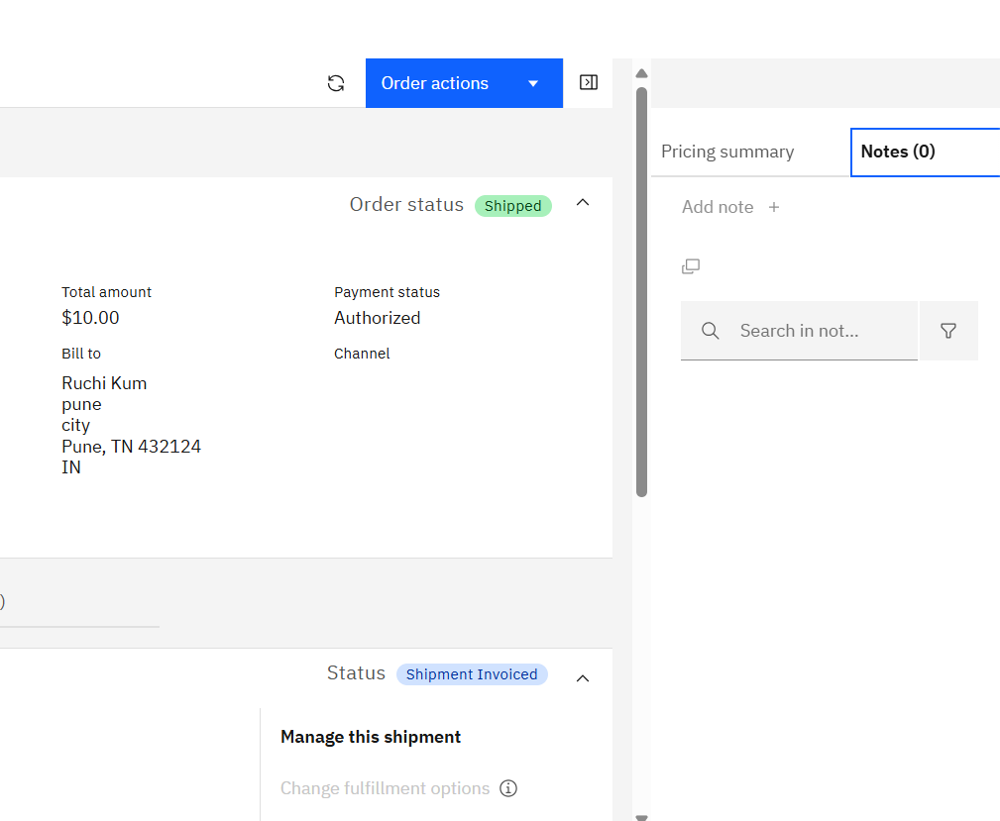

* **Disable the below Add Note Button**

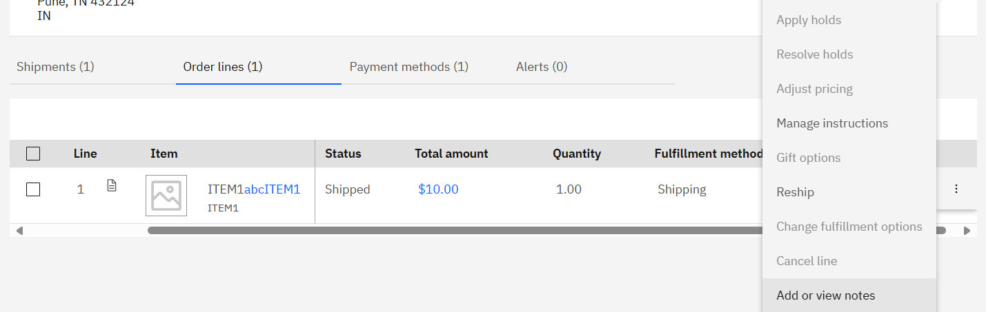

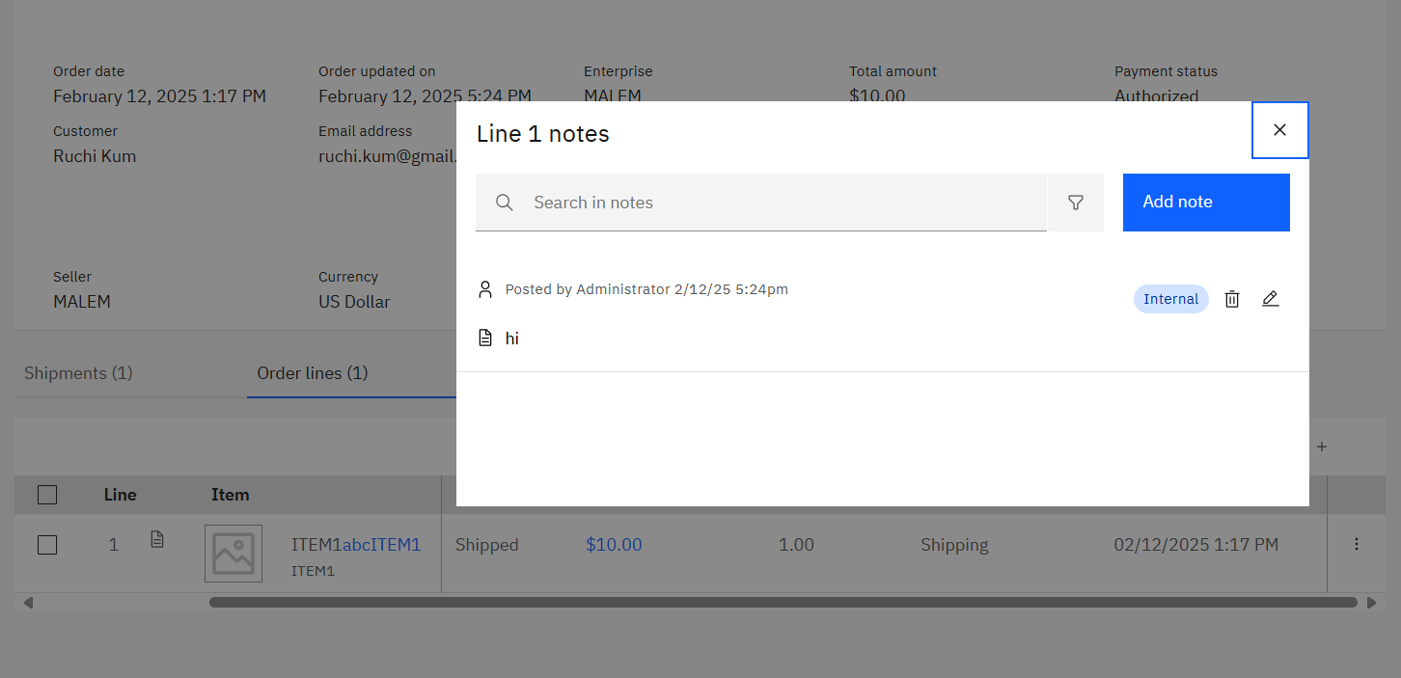

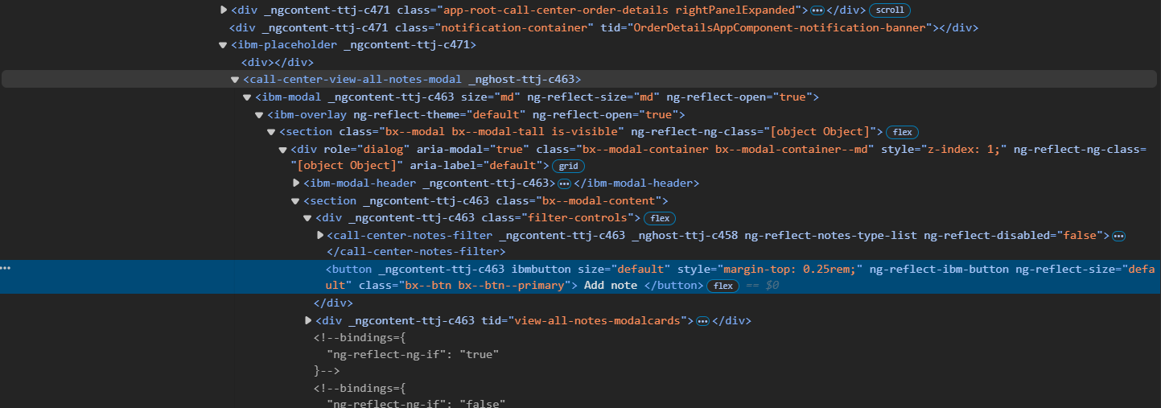

It is coming from call-center-view-all-notes modal which is coming from order shared folder. Since it is coming from order-shared-folder so we have to follow below steps

[ibm](https://www.ibm.com/docs/en/call-center/10.0?topic=code-customizing-existing-actions)

* Copy paste the **view-all-notes-model** folder from C:\cc-customCode\call-center-order\packages\**order-shared**\src\lib\components\notes

And paste it to C:\cc-customCode\call-center-order\packages\order-details\src-custom\app\custom

Open .ts file

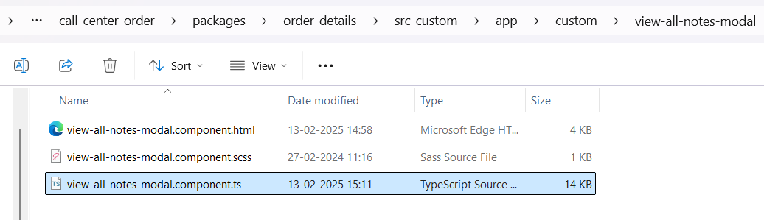

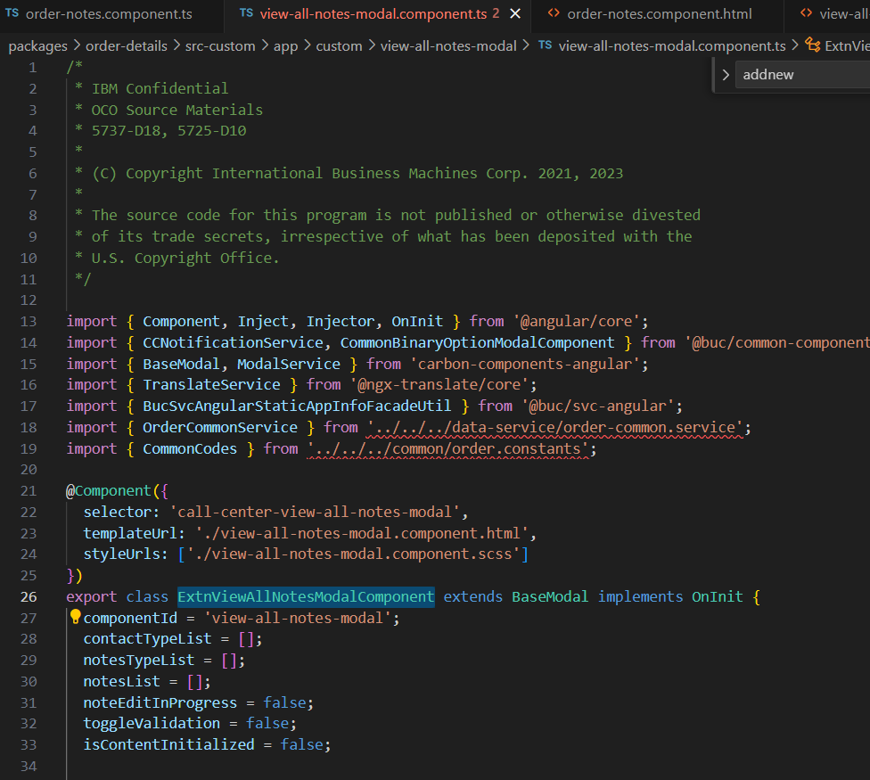

Add Extn to the class name – ExtnViewAllNotesModalComponent

Open.html file and do customization, disable the button

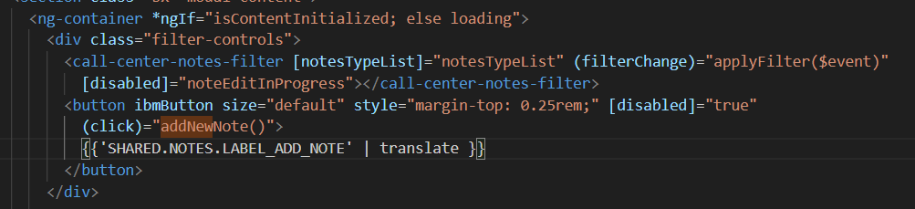

Then Navigate to C:\cc-customCode\call-center-order\packages\order-details\src-custom\app\features\order\order-lines and open its .ts file

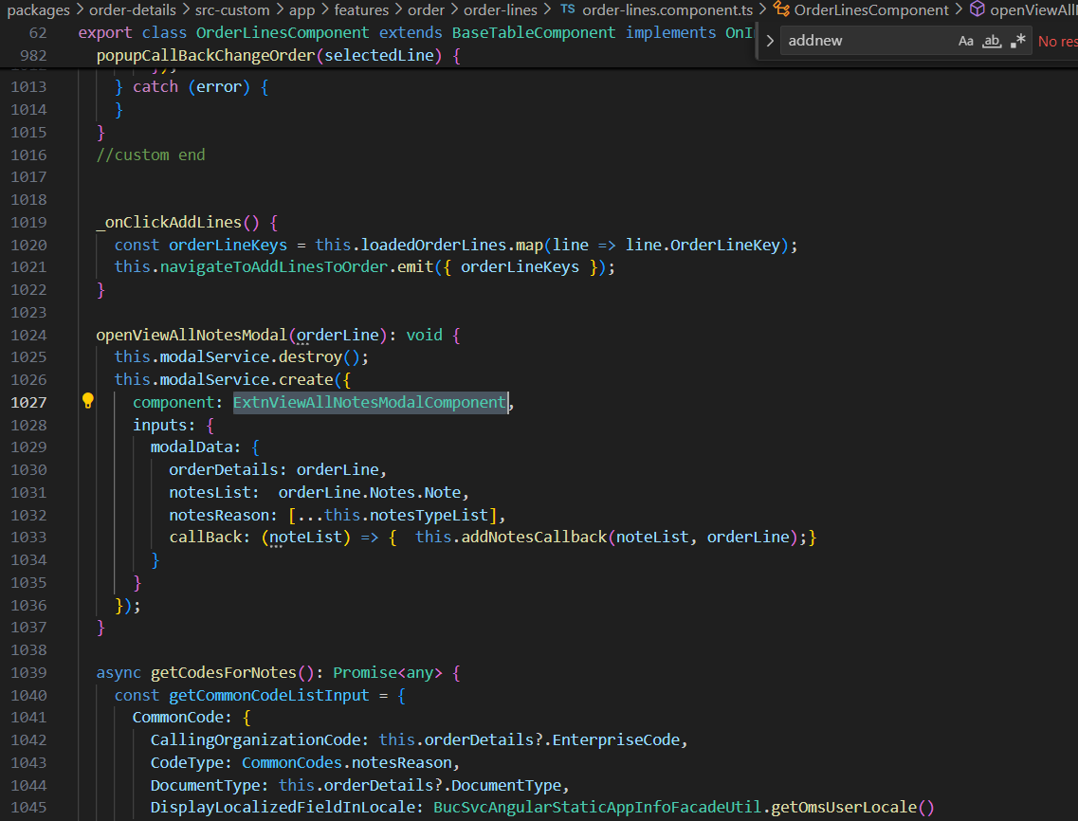

Change component name to ExtnViewAllNotesModalComponent

* Generate service file

Run the command ng g s Extnview-all-notes-action in C:\cc-customCode\call-center-order\packages\order-details\src-custom\app\custom\actions



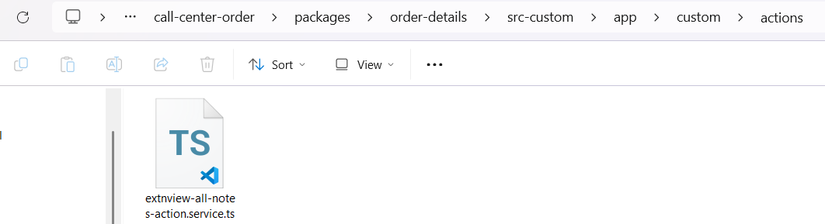

* Open app-customization.impl.ts file from C:\cc-customCode\call-center-order\packages\order-details\src-custom\app and add your component and Service to Component and provider
* 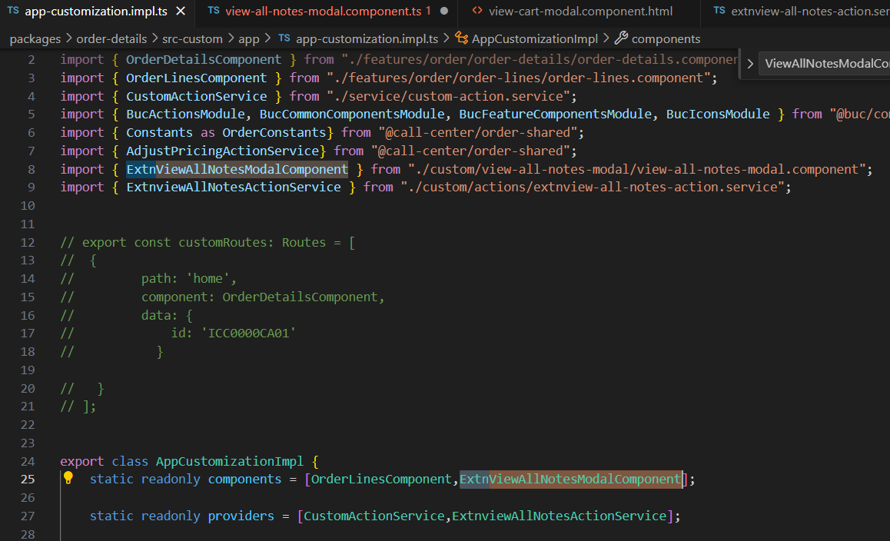

If getting this error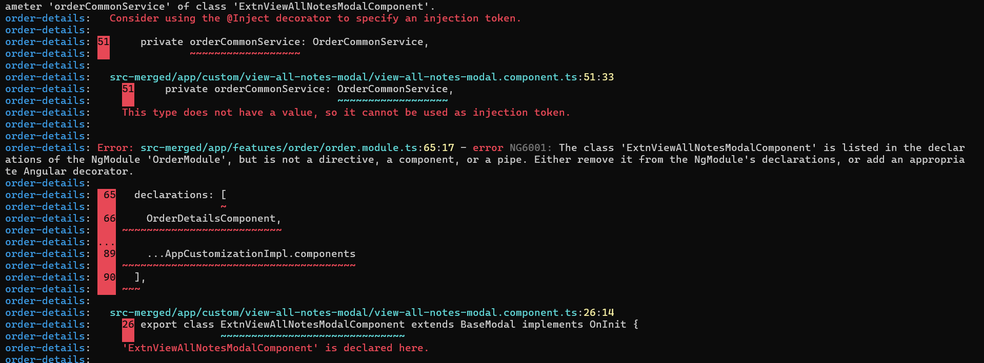

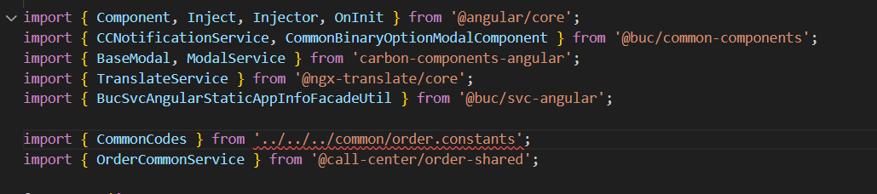

Import CommonCodes from OrderShared folder it will resolve the error

Button is disabled

