**Disabling Add Note button coming from return-lines overflow menu**

**This button logic is using redux pattern/ngrx store which is coming from sidepanel state from return shared route.**

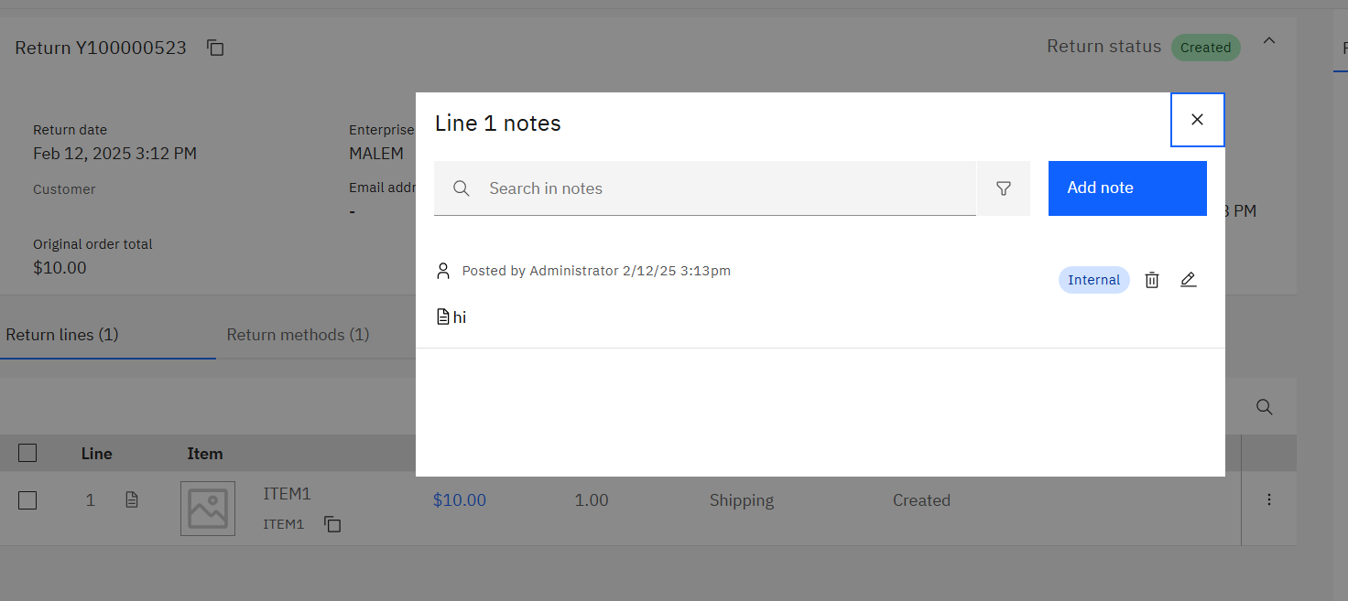

* Copy **view-all-notes-modal** from C:\cc-customCode\call-center-return\packages\**return-shared**\src\lib\components\notes to C:\cc-customCode\call-center-return\packages\**return-details**\src-custom\app\custom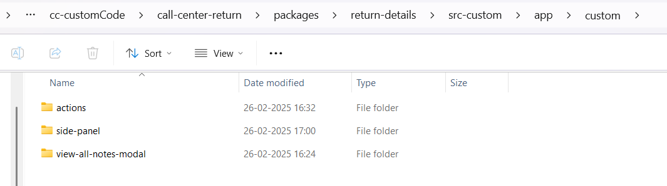
* Open view-all-notes-modal.component.ts file and Rename the class name to **ExtnViewAllNotesModalComponent**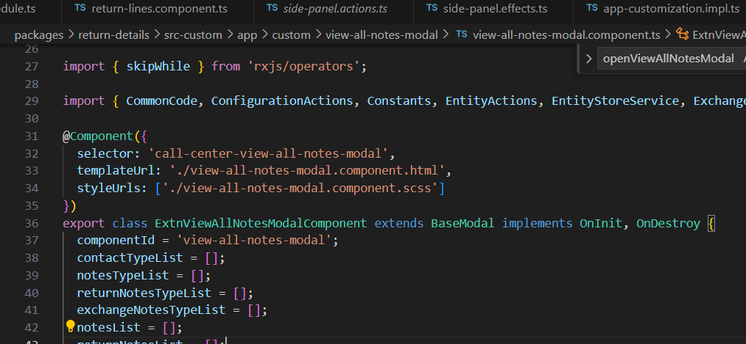
* Create service file for it, go to C:\cc-customCode\call-center-return\packages\return-details\src-custom\app\custom\actions, create custom and actions folder if not present

Open this path in cmd and run

**ng g s Extnview-all-notes-action**



After this command it will create service file.

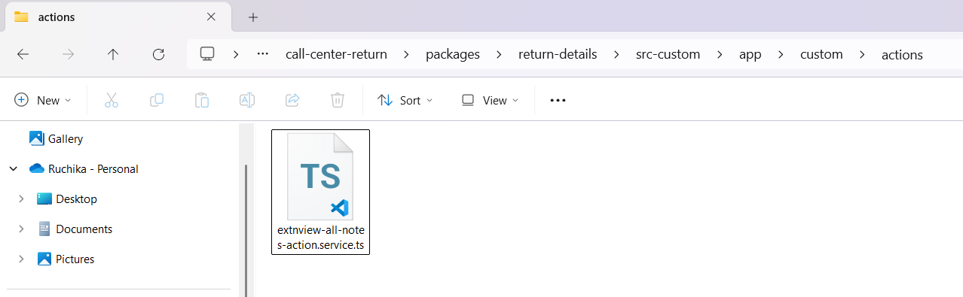

[ibm-orderSharedCustomizing](https://www.ibm.com/docs/en/call-center/10.0?topic=code-customizing-existing-actions)

* Copy Side-panel folder from return-shared route C:\cc-customCode\call-center-return\packages\**return-shared**\src\lib\state to C:\cc-customCode\call-center-return\packages\**return-details**\src-custom\app\custom  
  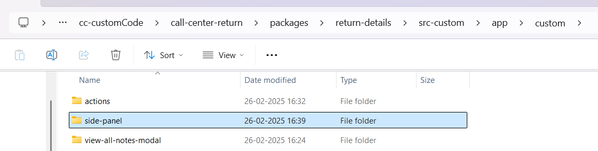
* Go to return-lines.component.ts file C:\cc-customCode\call-center-return\packages\return-details\src-custom\app\features\return\return-lines\return-lines.component.ts

Rename the SidePanelStateActions to ExtnSidePanelStateActions and import it from your custom side panel

import * as ExtnSidePanelStateActions from '../../../custom/side-panel/side-panel.actions';

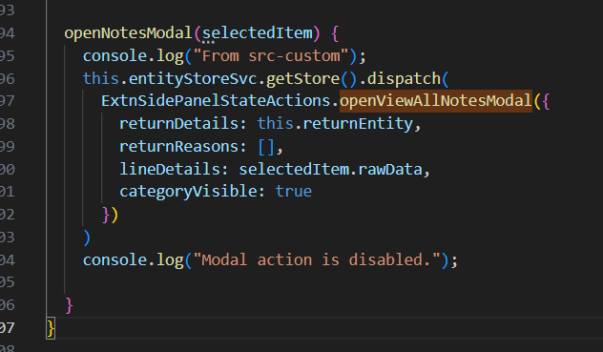

* Open side-panel.actions.ts from your custom side-panel folder and change SidePanelStateActions to ExtnSidePanelStateActions for openViewAllNotesModal

and remove all other actions

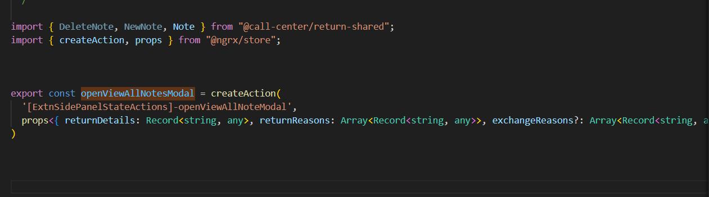

* Open side-panel.effects.ts , remove all other effects apart from openViewAllModalEffect and modify SidePanelStateActions to ExtnSidePanelStateActions and import it from  
   import * as ExtnSidePanelStateActions from './side-panel.actions';
* Also change the component name to ExtnViewAllNotesModalComponent and import it from custom folder  
  import { ExtnViewAllNotesModalComponent } from "../view-all-notes-modal/view-all-notes-modal.component";

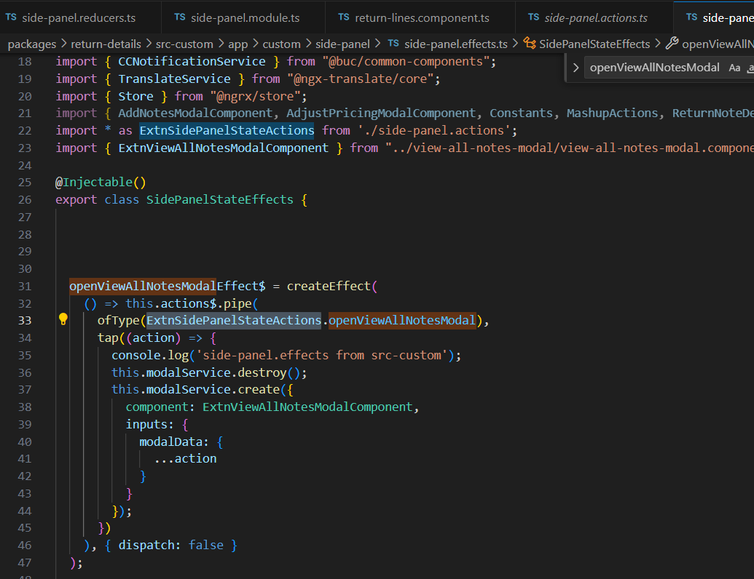

* Open side-panel.reducers.ts and remove all reducer except openViewAllNotesModal

And rename SidePanelStateActions to

ExtnSidePanelStateActions  
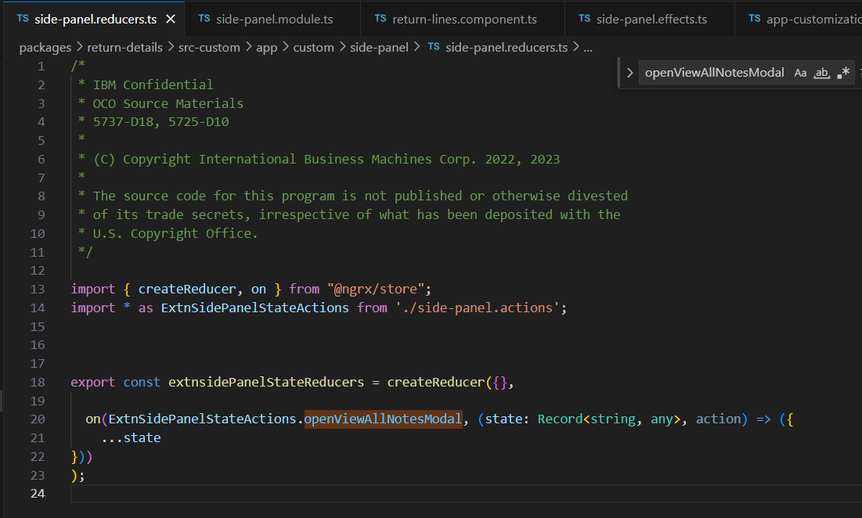

* side-panel.module.ts rename the class to ExtnSidePanelStateModule

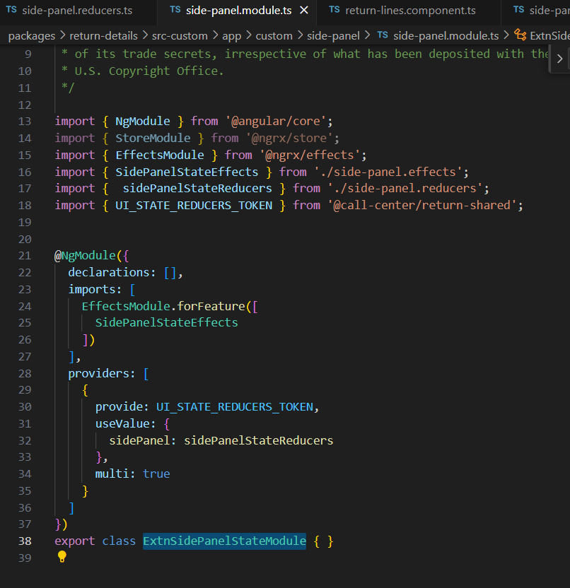

* Open app-customization.impl.ts from C:\cc-customCode\call-center-return\packages\return-details\src-custom\app add the component and imports as shown below

|  |
| --- |
| export class AppCustomizationImpl {      static readonly components = [ReturnLinesComponent,ExtnViewAllNotesModalComponent ];      static readonly providers = [        ];        static readonly imports = [          BucCommonComponentsModule,      BucFeatureComponentsModule,      BucIconsModule,      ExtnSidePanelStateModule      ];  } |

* 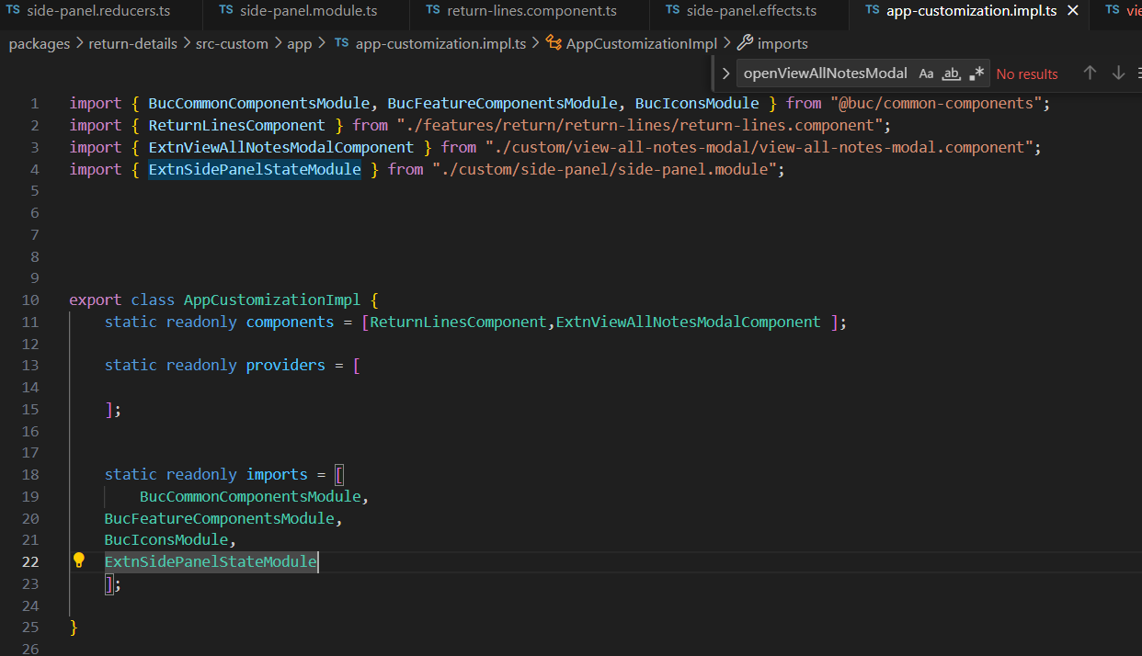

Navigate to C:\cc-customCode\call-center-return\packages\return-details\src-custom\app\custom\view-all-notes-modal and open view-all-notes-modal.component.html file

And disable the Add note button

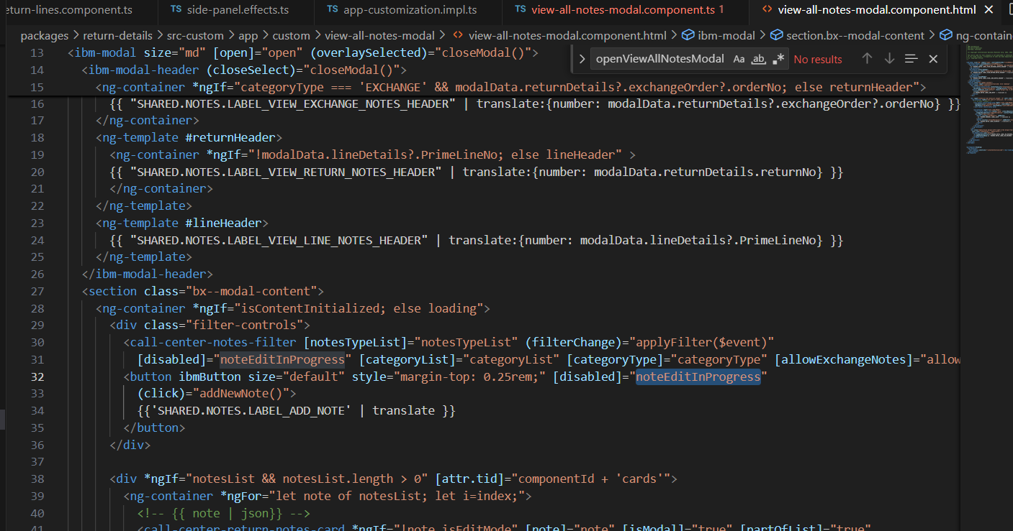

Make [disabled] = “true”

