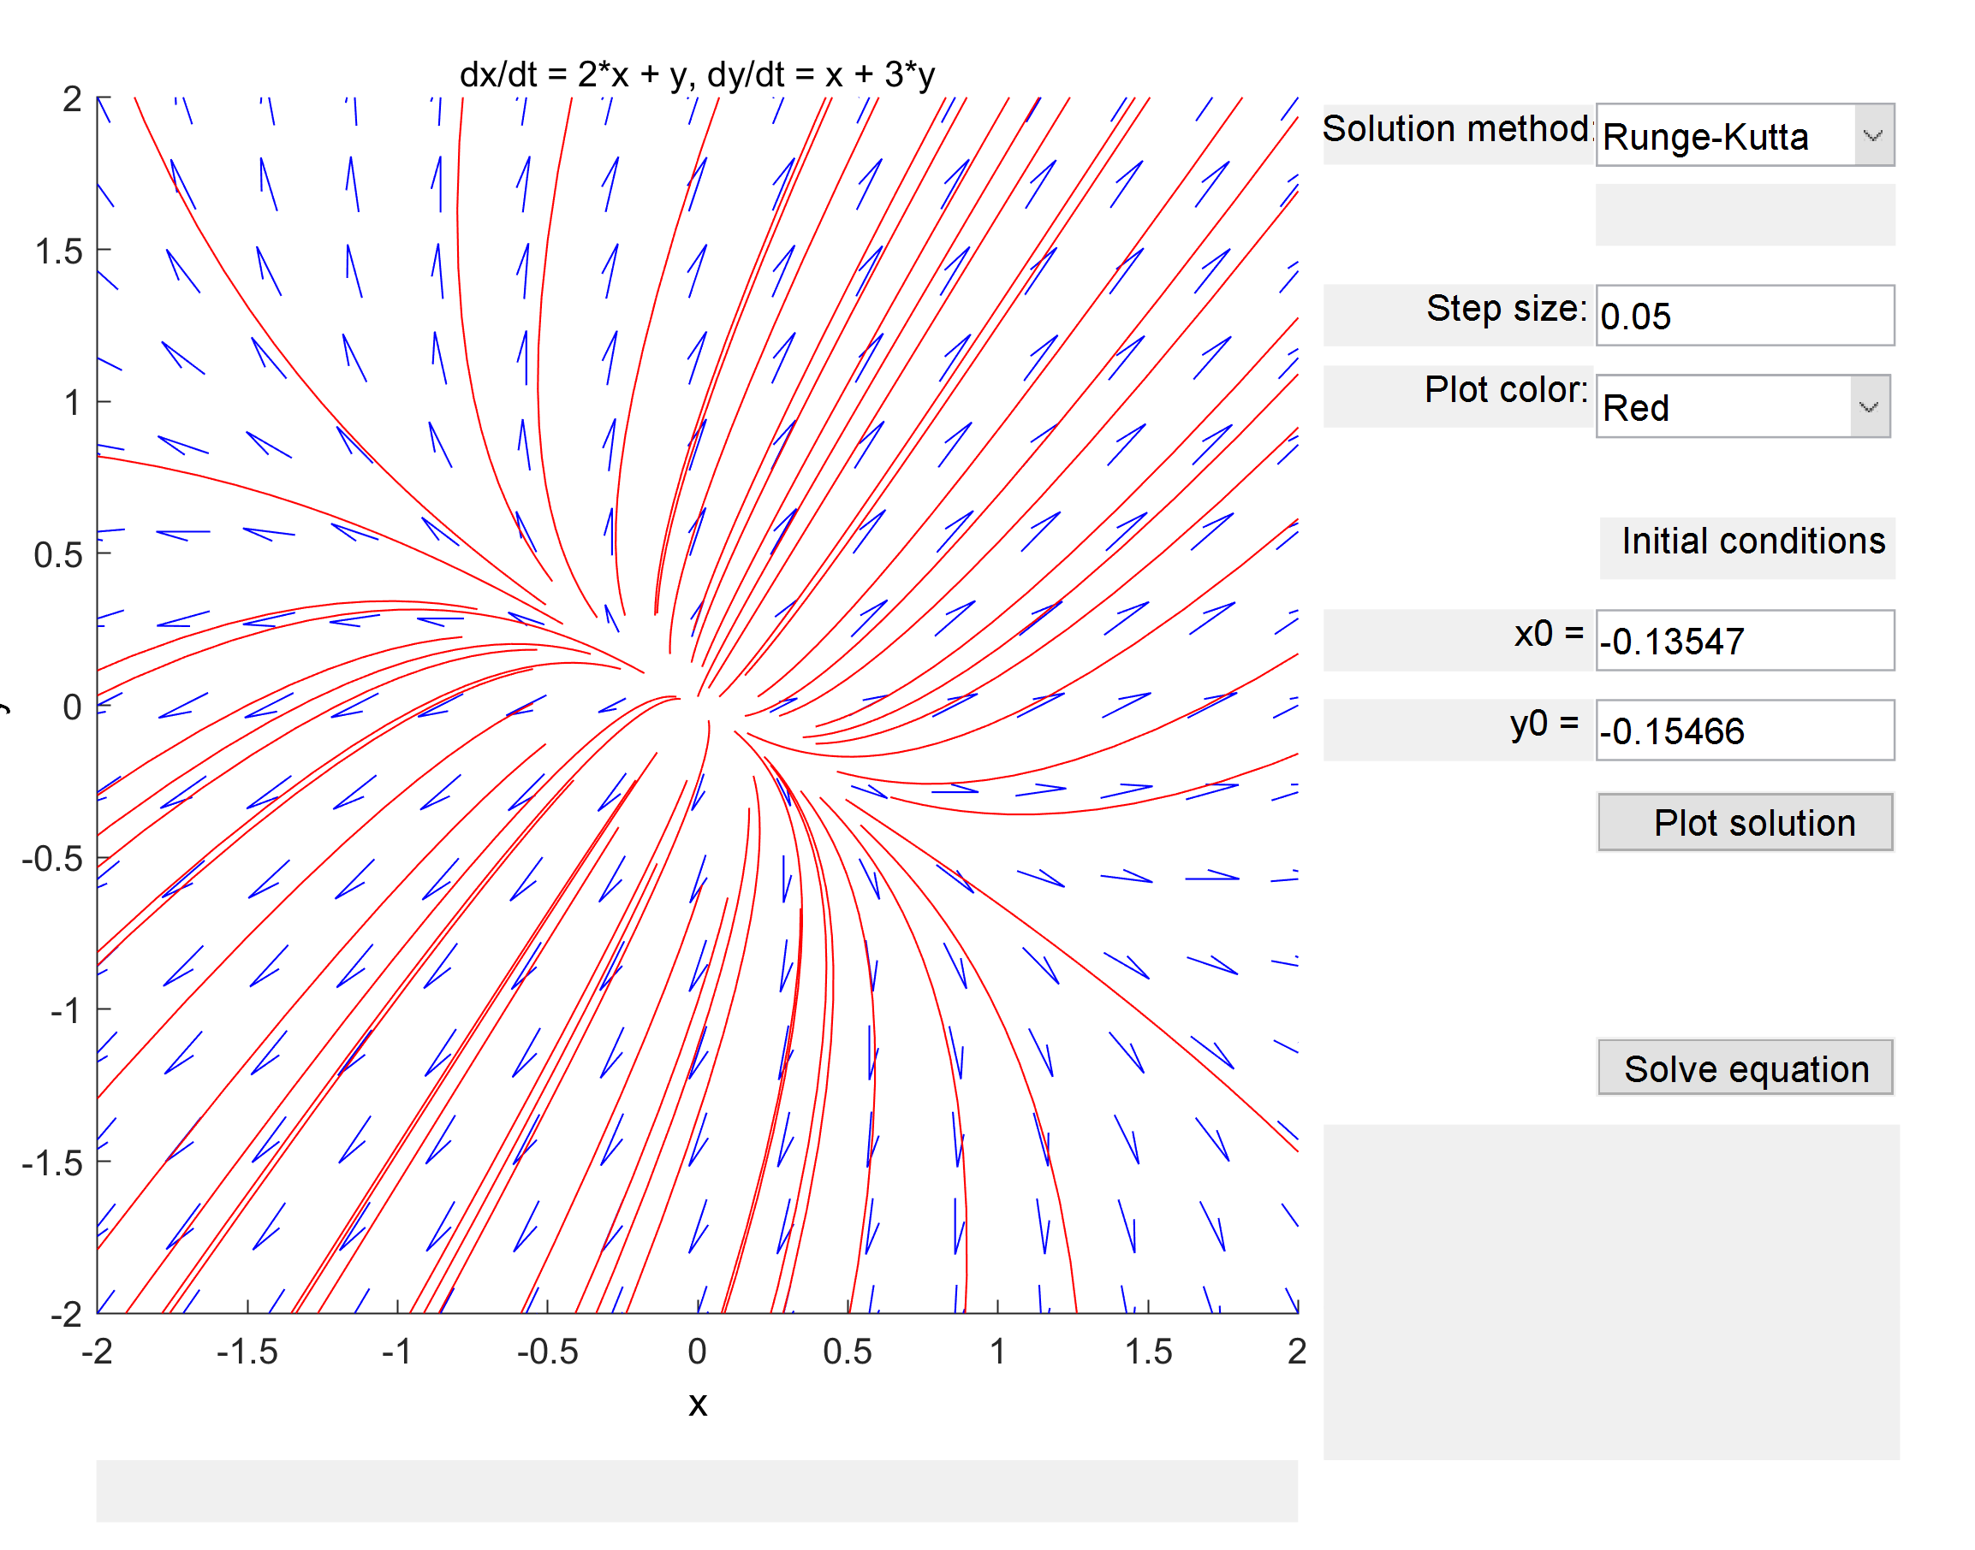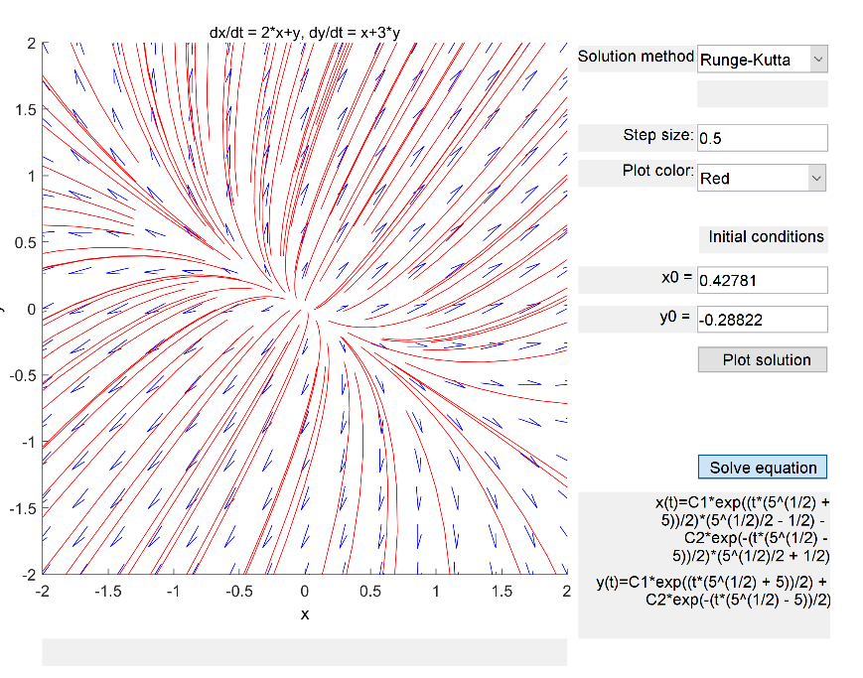4.1)

This is a nodal source with equilibrium solution x = [0;0]. It is asymptotically unstable, because the eigenvalues have the same sign.

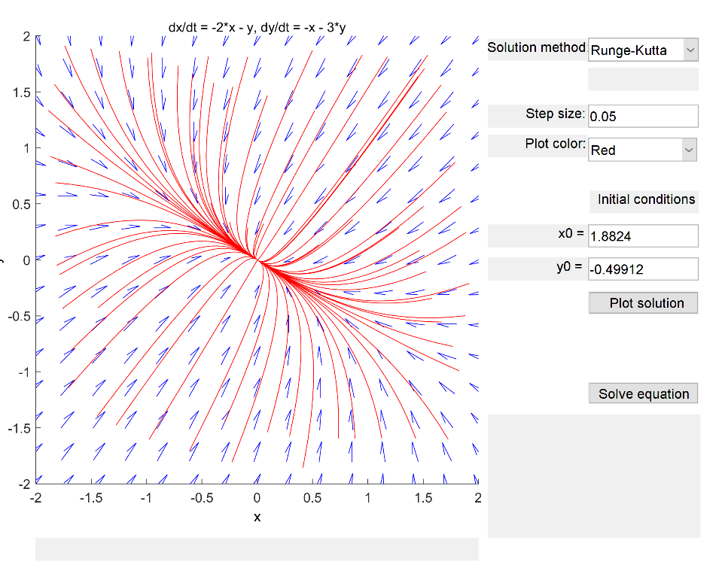4.2)

This is a nodal sink corresponding to equilibrium solution x = [0,0] and eigenvalues .

It is stable since the eigenvalues differ in sign.

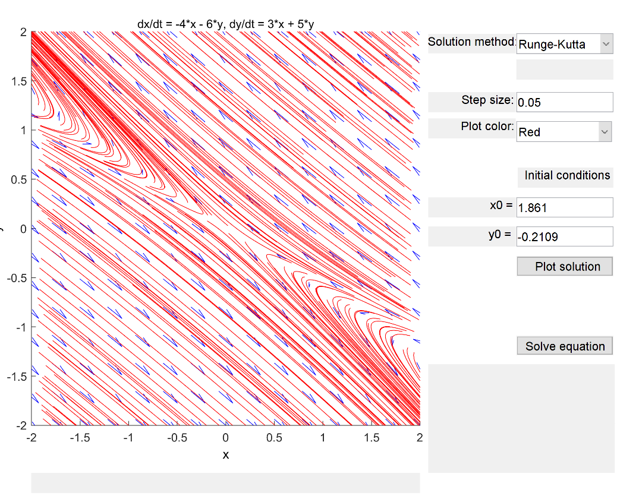4.3)

The eigenvalues are 2, -1. The equilibrium solution is x = [0,0]. This is a stable saddle-point, since the eigenvalues differ in sign.

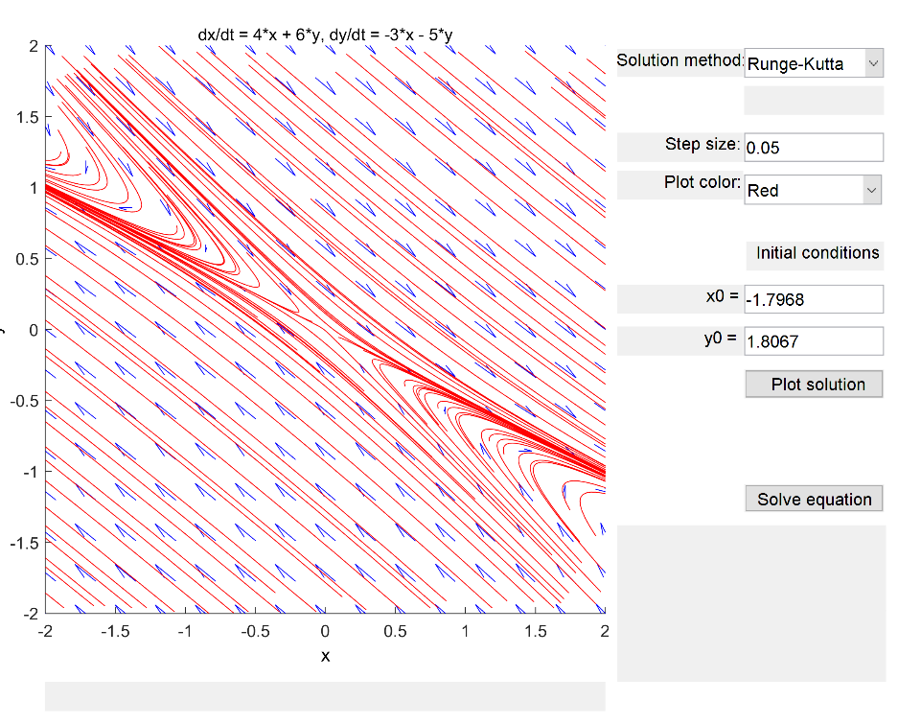4.4)

The eigenvalues are -2, 1. The equilibrium solution is x = [0,0]. This is a stable saddle-point, since the eigenvalues differ in sign.

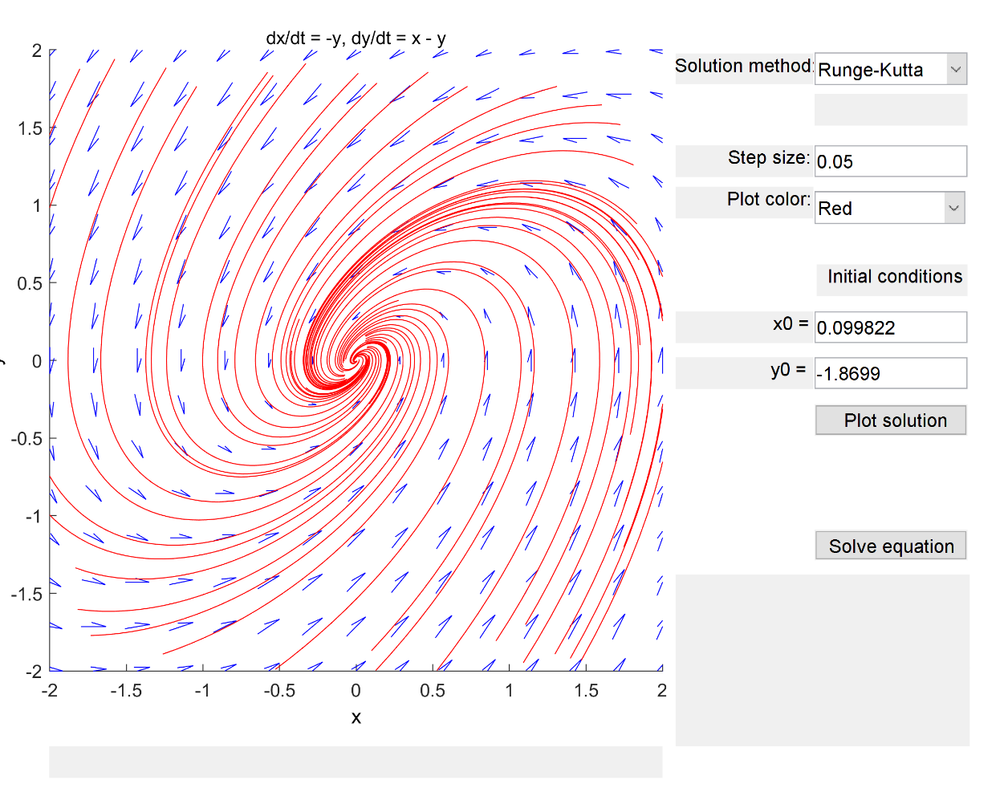4.5)

The eigenvalues are . The equilibrium solution is at x = [0,0]. This is a counter-clockwise spiral which is asymptotically stable, since the real part of the eigenvalues is negative and the eigenvalues themselves are complex.

4.6)

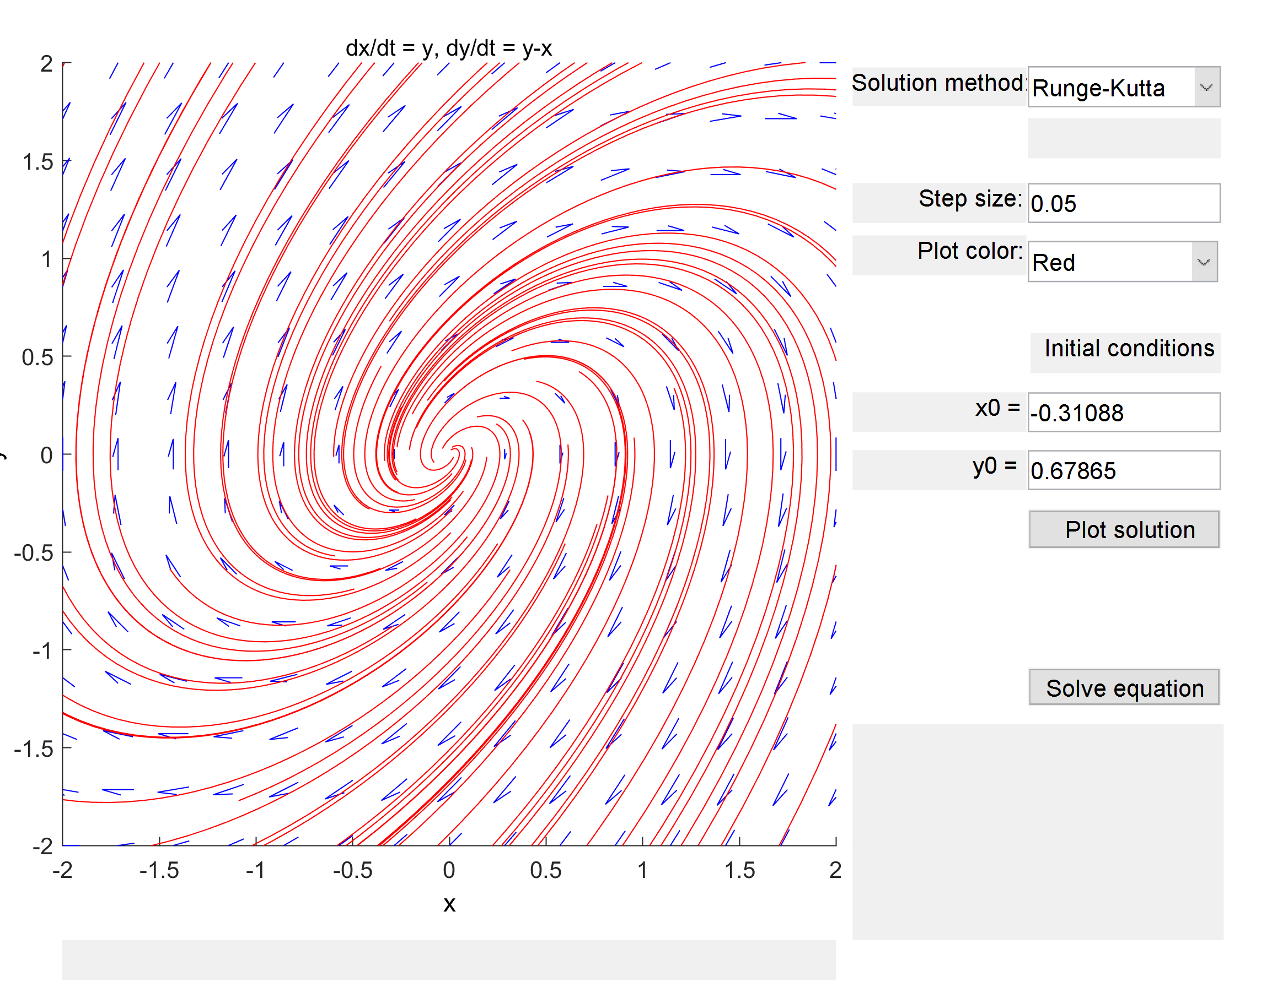

The eigenvalues are . The equilibrium solution is at x = [0,0]. This is a clockwise spiral, which is asymptotically unstable. This is because the real part of the eigenvalues are positive, and the eigenvalues are complex.

4.7)

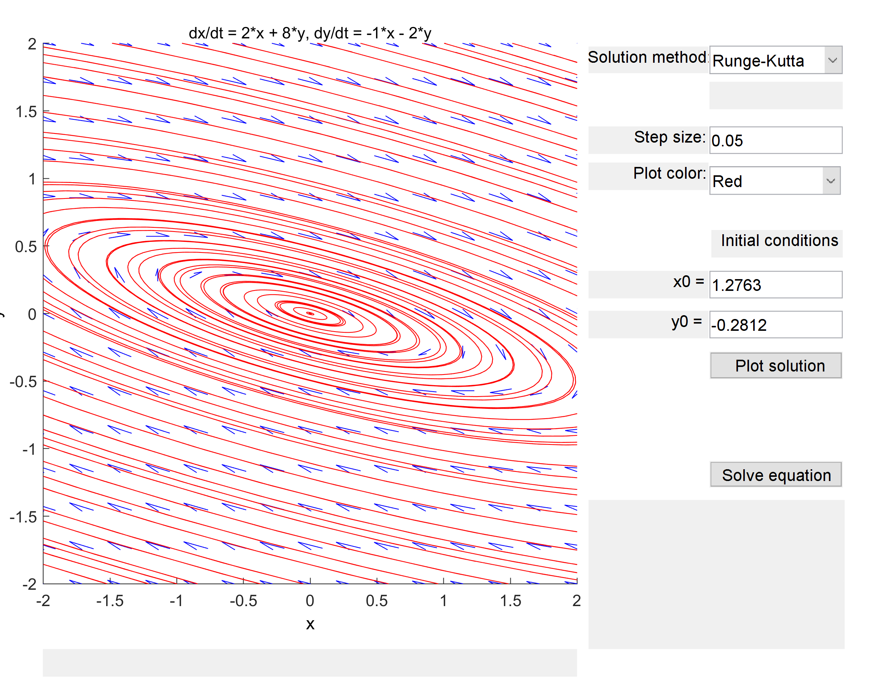

The eigenvalues are . The equilibrium solution corresponds to x = [0,0]. This is a clockwise oriented center, which is stable because the eigenvalues are complex, and both the real parts are equal to 0.

4.8)

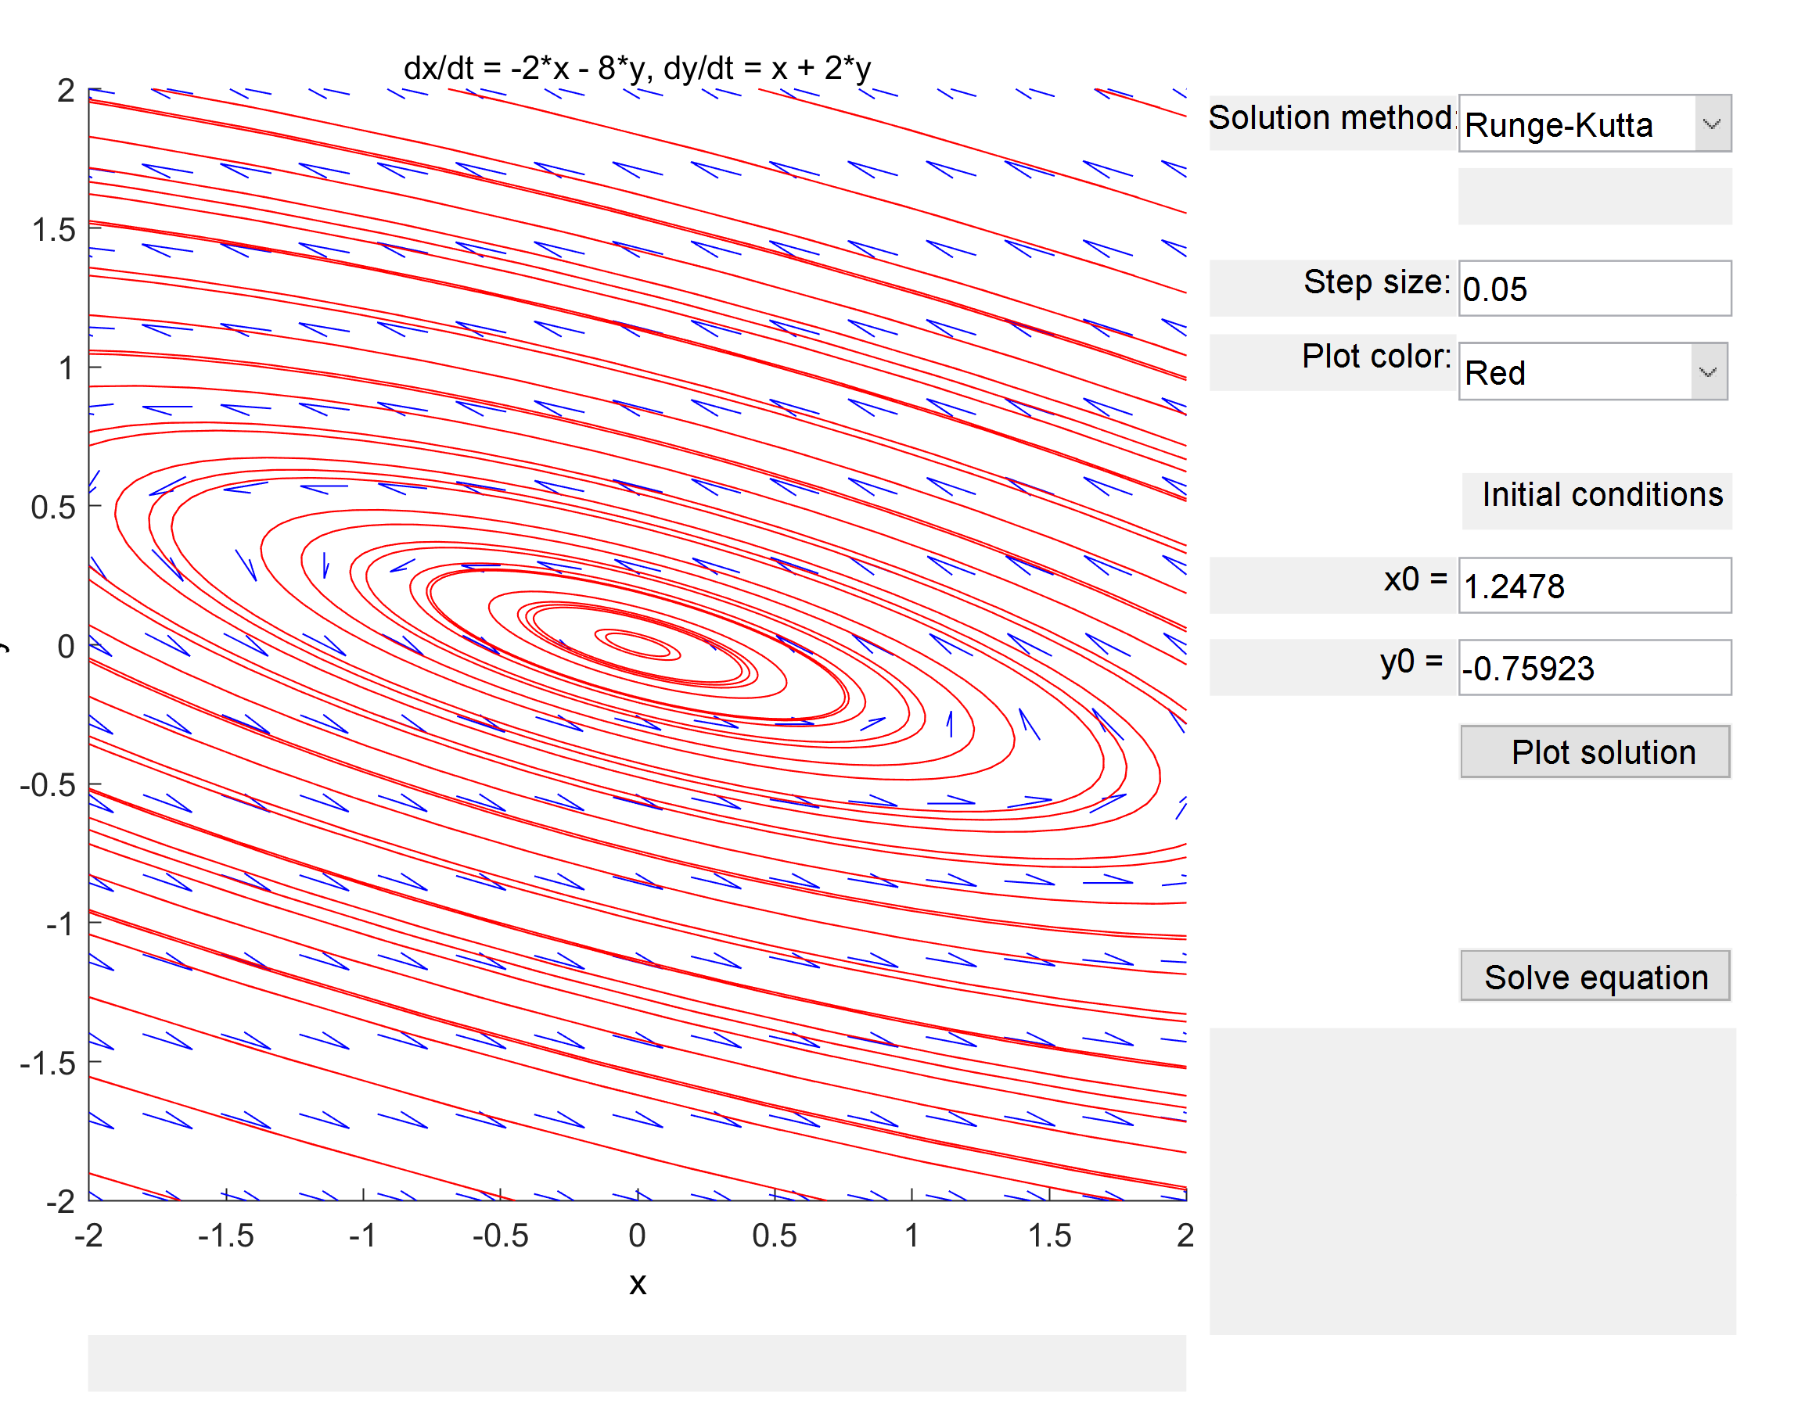

The eigenvalues are . The equilibrium solution corresponds to x = [0,0]. This is a counter-clockwise oriented center, which is stable because the eigenvalues are complex, and both the real parts are equal to 0.

4.9)

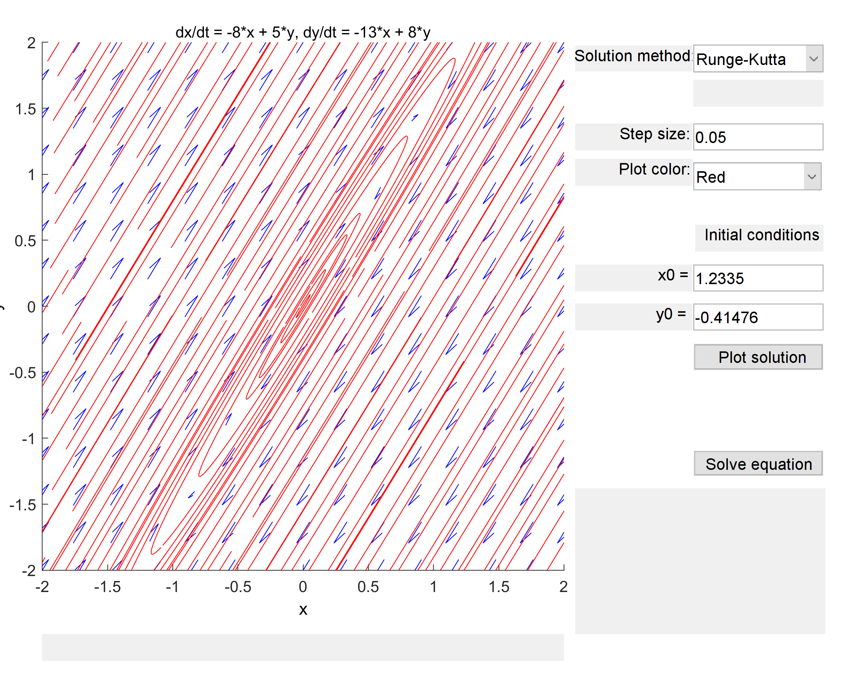

The eigenvalues are . The equilibrium solution is at x = [0,0]. This is a clockwise-oriented center, which is stable because the eigenvalues are complex, and both the real parts are equal to 0.

4.10)

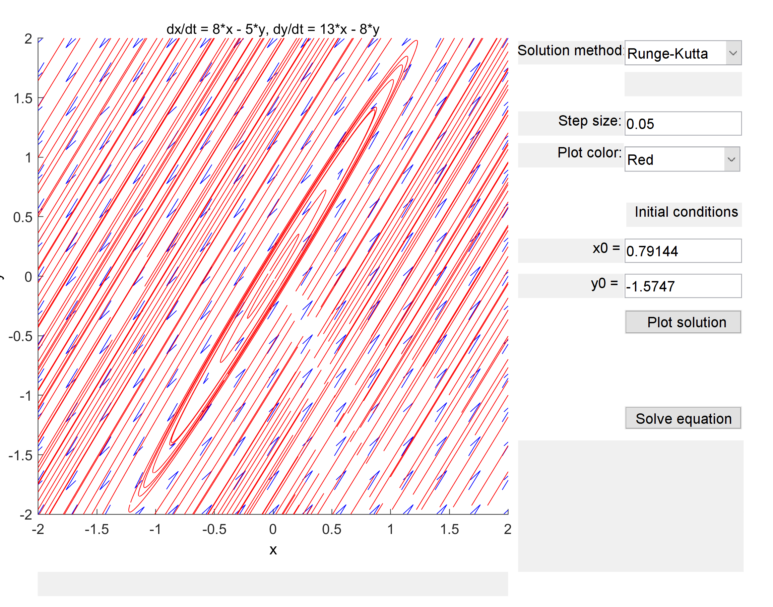

The eigenvalues are . The equilibrium solution is at x = [0,0]. This is a counter-clockwise-oriented center, which is stable because the eigenvalues are complex, and both the real parts are equal to 0.