Sri Lanka Institute of Information Technology

**Data warehousing and Business Intelligence (IT3021)**

**Assignment** **02**

Report

Dasanayake D. R. L

IT22350800

# 

Table of Contents

1. Introduction 3

2. Data source 3

3. SSAS Cube Implementation 4

3.1 Overview 4

3.2 Data Source View 6

3.3 Cube structure 7

3.4 Creating hierarchies for the Dim Date and Dim Customer dimensions. 7

3.5 Cube deployment 8

4. Demonstration of OLAP 9

4.1 Main pivot table in excel 9

4.2 Roll-Up Operation in Excel 9

4.2 Drill-Down Operation in Excel 10

4.3 Slice Operation in Excel 11

4.4 Dice Operation in Excel 13

4.5 Pivot Operation in Excel 13

5. Power BI Reports 14

5.1 Report 1: Matrix Visual 14

5.2 Report 2: Slicer with Graphical Presentations 15

5.3 Report 3: Drill-Down 16

5.4 Report 4: Drill-Through 18

6. Conclusion 19

7. References 19

# 1. Introduction

This report documents the implementation of Assignment 02 for the module IT3021 – Data Warehousing and Business Intelligence, conducted as part of the BSc (Hons) in Information Technology specializing in Data Science. Building upon the data warehouse developed in Assignment 01, this assignment involves the design and implementation of an SSAS cube, performing OLAP operations using Excel, and developing interactive Power BI reports to analyze and visualize business data. The goal is to apply business intelligence techniques to derive meaningful insights and demonstrate proficiency in data modeling, multidimensional analysis, and visualization using industry-standard tools such as SQL Server Analysis Services (SSAS), Microsoft Excel, and Power BI.

# 2. Data source

**Dataset Chosen:** Data Warehouse implemented using the Brazilian E-Commerce Public Dataset by Olist as source dataset.

**Source:** Kaggle (<https://www.kaggle.com/datasets/olistbr/brazilian-ecommerce>)

**Description:** The data used in this assignment was obtained from a structured relational database developed in Assignment 01. It contains information related to sales, customers, products, time, and geography. This data was cleaned, transformed, and loaded into a data warehouse, which serves as the source for building the SSAS cube and generating business intelligence reports.

Entity relationship diagram of the data source is given below:

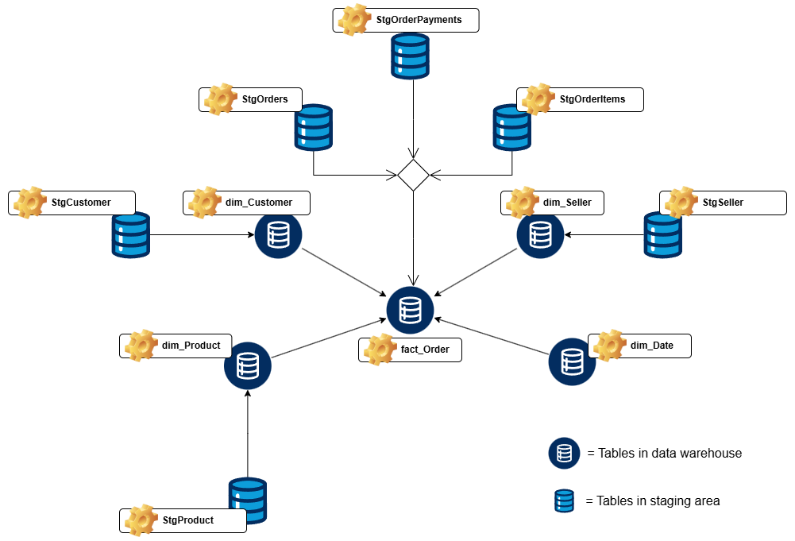

Detailed structure of the tables in data warehouse is presented below.

|  |  |  |
| --- | --- | --- |
| Table Name | Description | Key Columns / Notable Attributes |
| dim_Customer | Customer dimension table with Slowly Changing Dimension (SCD) Type 2 | CustomerKey (PK), CustomerID, CustomerUniqueID, CustomerZipCodePrefix, CustomerCity, CustomerState, EffectiveStartDate, EffectiveEndDate, IsCurrent |
| dim_Product | Product dimension table storing product-specific attributes | ProductKey (PK), ProductID, ProductCategoryName, ProductNameLength, ProductDescriptionLength, ProductWeightGrams, ProductPhotosQty, ProductLengthCM, ProductHeightCM, ProductWidthCM |
| dim_Seller | Seller dimension table storing location and identity info | SellerKey (PK), SellerID, SellerZipCodePrefix, SellerCity, SellerState |
| dim_Date | Date dimension table for time-based analysis | DateKey (PK), FullDate, Day, Month, Year, Quarter, DayName, MonthName, IsWeekend |
| fact_Order | Fact table capturing transaction-level order and payment data | OrderKey (PK), OrderID, CustomerKey (FK), SellerKey (FK), ProductKey (FK), OrderStatus, OrderPurchaseDateKey (FK), OrderApprovedDateKey (FK), OrderDeliveredCustomerDateKey (FK), OrderEstimatedDeliveryDateKey (FK), PaymentType, PaymentInstallments, PaymentValue, FreightValue, ProductPrice, accm_txn_create_time, accm_txn_complete_time, txn_process_time_hours |

# 3. SSAS Cube Implementation

## 3.1 Overview

To enable multidimensional analysis and support Online Analytical Processing (OLAP), a cube was implemented using SQL Server Analysis Services (SSAS). The process was carried out in several structured steps as outlined below:

**Step 1: Create a New SSAS Project**

A new Analysis Services Multidimensional Project named **Brazilian_E_Commerce_DW_Cube** was created using SQL Server Data Tools (SSDT).

**Step 2: Connect to the Data Warehouse**

The data warehouse designed in Assignment 01 (Brazilian_E_Commerce_DW) was used as the data source. A service account was used to establish the connection to the data warehouse.

**Step 3: Create a Data Source View (DSV)**

A Data Source View (DSV) was created to include the necessary fact and dimension tables. Relationships among these tables were defined to reflect the schema structure accurately.

**Step 4: Design the Cube**

The Cube Wizard was used to design the cube.

* Required measures were selected from the fact.
* Dimensions were added based on related tables to meet business analysis requirements.

**Step 5: Add Hierarchies**

To enhance analytical capabilities, hierarchies were added:

* Customer Dimension: State → City
* Date Dimension: Year → Quarter → Month → Day

These hierarchies support drill-down functionality for more detailed analysis.

**Step 6: Configure and Finalize the Cube**

All cube elements were reviewed to ensure proper connections between measures and dimensions. Attribute properties and visibility were adjusted for usability.

**Step 7: Deploy and Process the Cube**

The cube was deployed to the SSAS server. It was then processed to populate it with data from the data warehouse.

**Step 8: Validate the Cube**

Post-deployment, the cube was tested using tools such as Microsoft Excel and SQL Server Management Studio (SSMS) to ensure that it returns accurate results and supports expected analytical operations.

Below are the screenshots demonstrating processes of creating the SSAS cube.

## 3.2 Data Source View

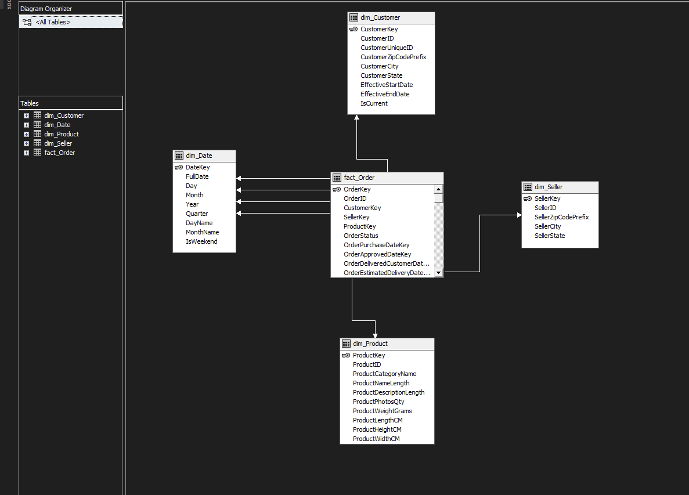

## 3.3 Cube structure

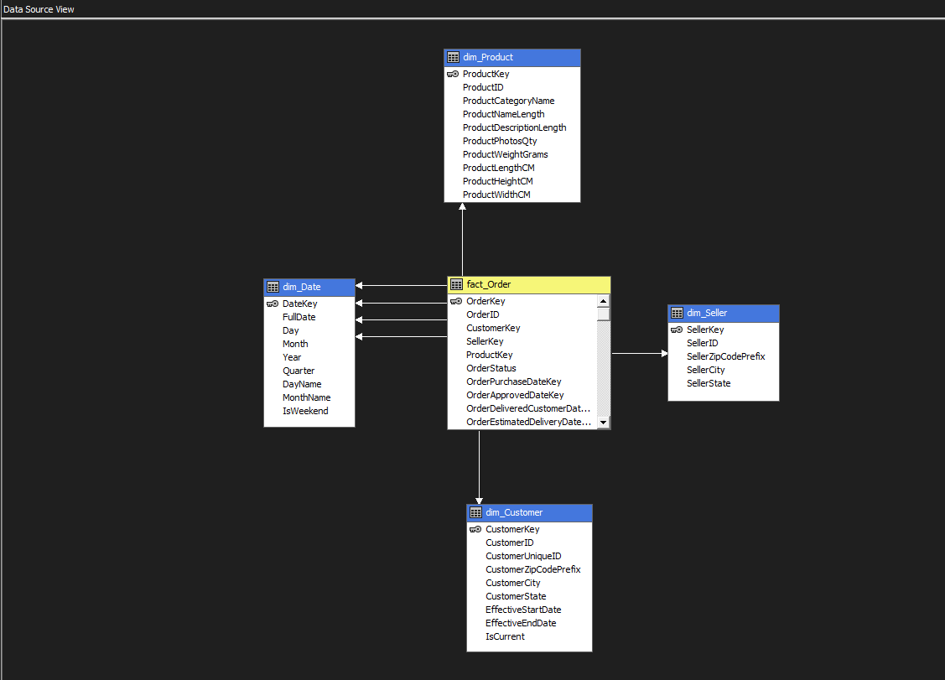

## 3.4 Creating hierarchies for the Dim Date and Dim Customer dimensions.

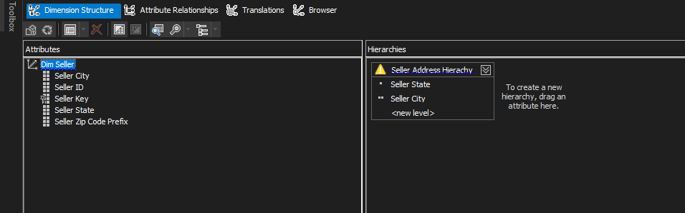

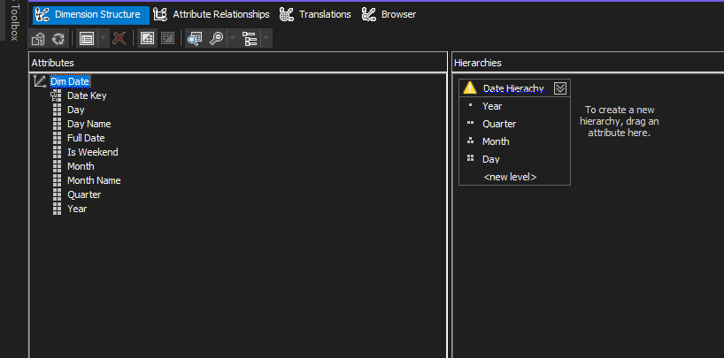

## 3.5 Cube deployment

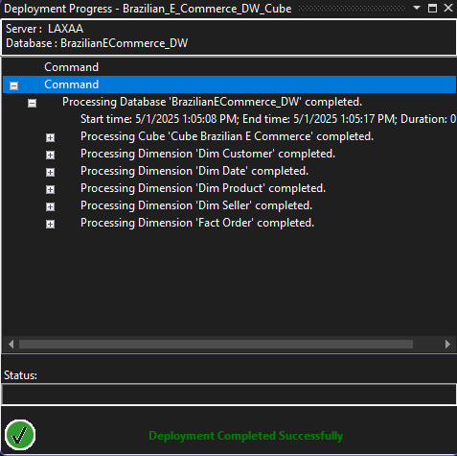

# 4. Demonstration of OLAP

To demonstrate OLAP functionalities, Microsoft Excel was connected to the deployed SSAS cube using the built-in "From Analysis Services" option under the Data tab. A PivotTable was created to explore the cube data interactively. OLAP operations were demonstrated by performing roll-up and drill-down actions using hierarchies, slicing the data with filters, dicing by selecting multiple dimensions simultaneously, and pivoting to rearrange rows and columns for different analytical perspectives. These visualizations showcased how multidimensional analysis can be applied effectively using Excel’s capabilities.

Below are the screenshots demonstrating the OLAP operations performed using Excel.

## 4.1 Main pivot table in excel

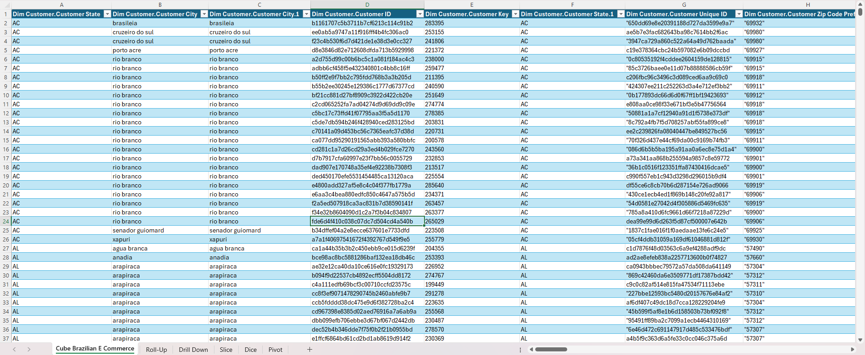

## 4.2 Roll-Up Operation in Excel

**Roll-up**: This operation aggregates data to a higher level in the hierarchy, such as viewing total orders by state instead of by city. Below is the screenshot demonstrating the Roll-up operation.

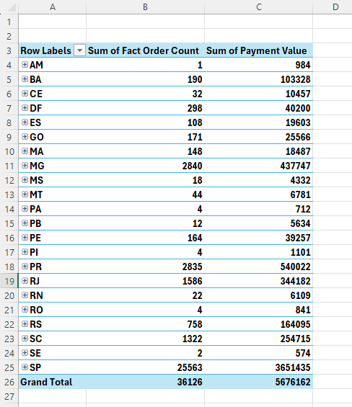

## 4.2 Drill-Down Operation in Excel

**Drill-down**: This allows exploring data at a more detailed level, breaking down yearly sales into quarterly or monthly or daily figures. Below is the screenshot demonstrating the Drill-Down operation.

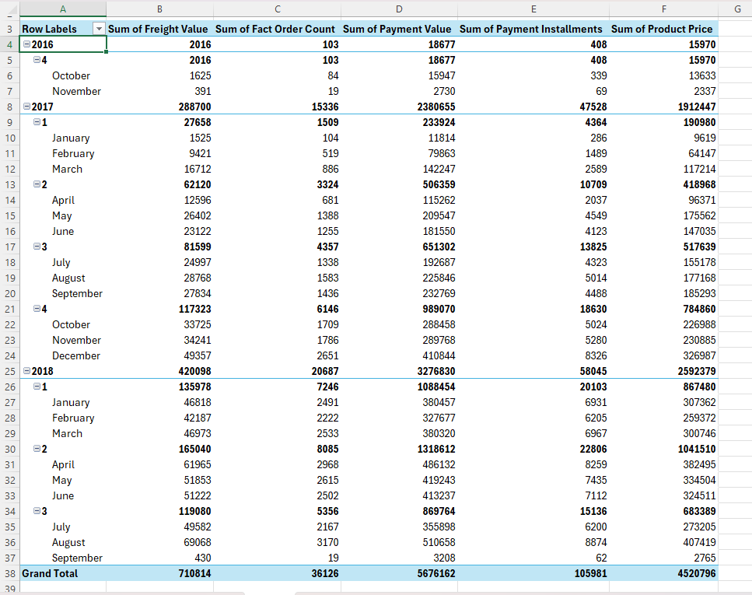

## 4.3 Slice Operation in Excel

**Slice**: Filters data by a single dimension, such as showing orders for a selected product category name. Below is the screenshot demonstrating the Slice operation.

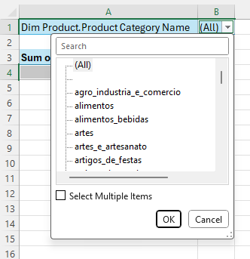

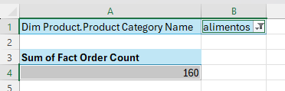

## 4.4 Dice Operation in Excel

Applies filters on multiple dimensions to analyze specific combinations. Specifically using category name and customer state to filter order count in this scenario. Below is the screenshot demonstrating the Dice operation.

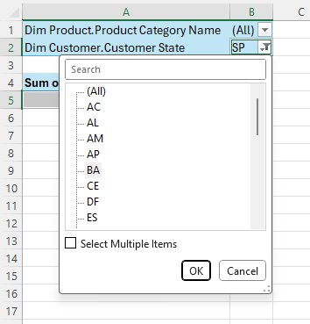

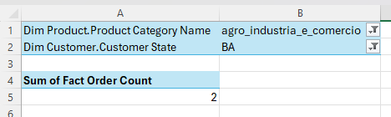

## 4.5 Pivot Operation in Excel

**Pivot**: Rearrange data to view it from different dimensions. Below is the screenshot demonstrating the Pivot operation.

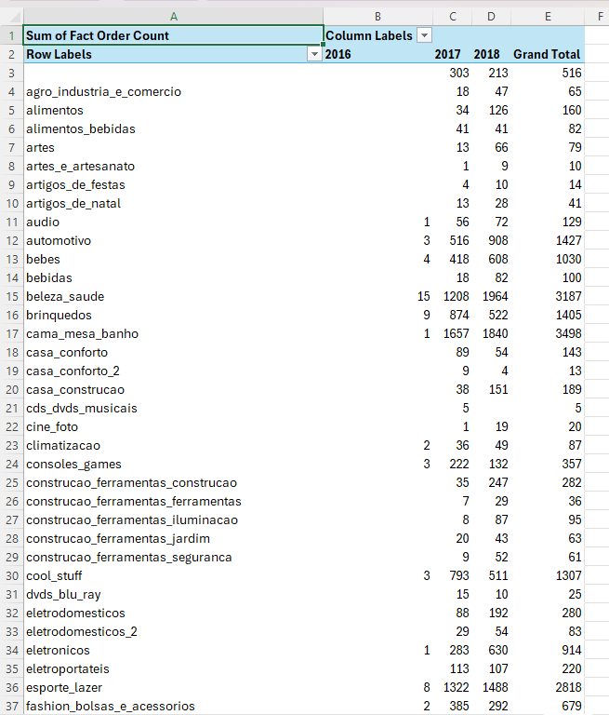



# 5. Power BI Reports

The SSAS cube was connected to Power BI Desktop using the "Analysis Services" connector, allowing live data exploration. For each report, data fields were selected from dimensions and fact tables and added to the report canvas using visuals such as matrix tables, bar charts, line charts, cards, gauges and slicers.

Below are the screenshots demonstrating the reports created using Power BI.

## 5.1 Report 1: Matrix Visual

**Report 1 – Matrix Visual**: Displays detailed tabular data with row and column groupings.  
Below is the screenshot of Report 1 in Power BI.

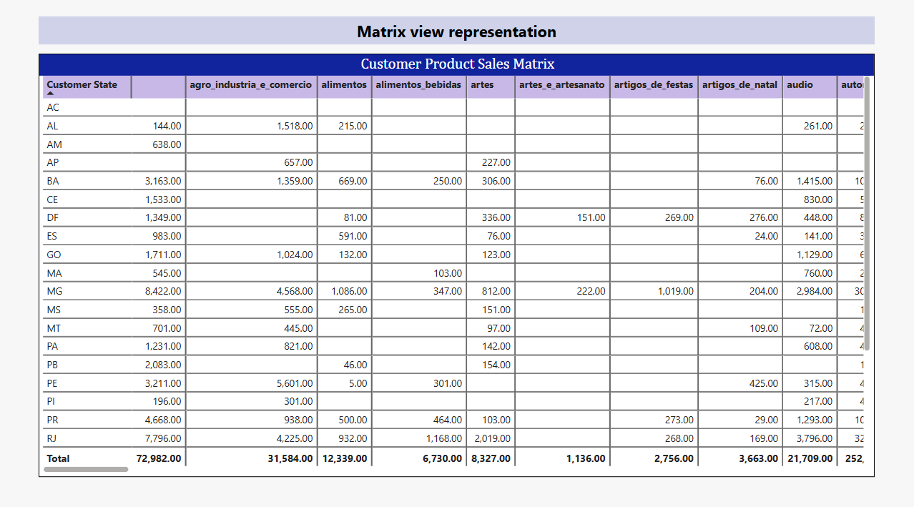

## 5.2 Report 2: Slicer with Graphical Presentations

**Report 2 – Cascading Slicers**: Uses dependent slicers and multiple visuals to show filtered insights. Customer state and customer city are used as filters here. Below is the screenshot of Report 2 in Power BI.

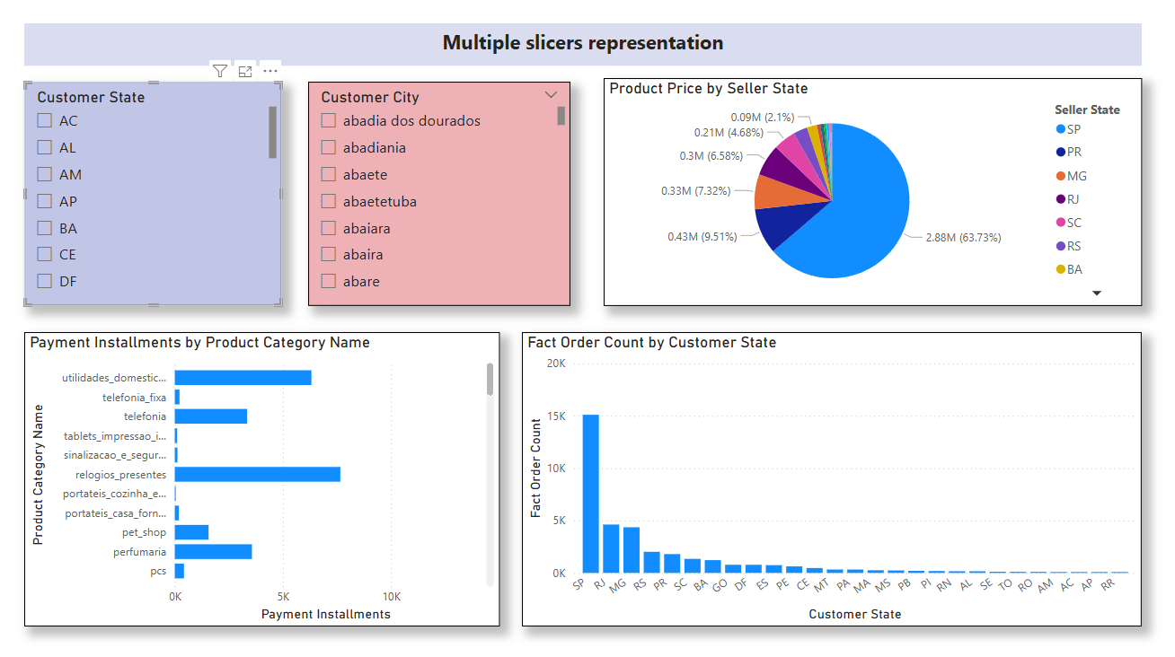

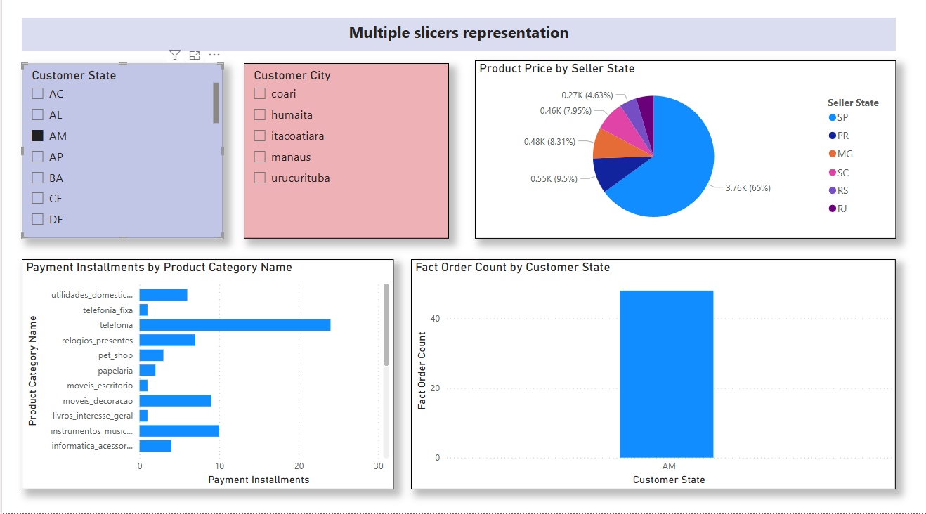

## 5.3 Report 3: Drill-Down

**Report 3 – Drill-down Report**: Allows exploring data hierarchically. Specifically, from year -> quarter -> month -> day in this scenario. Below is the screenshot of Report 3 in Power BI.

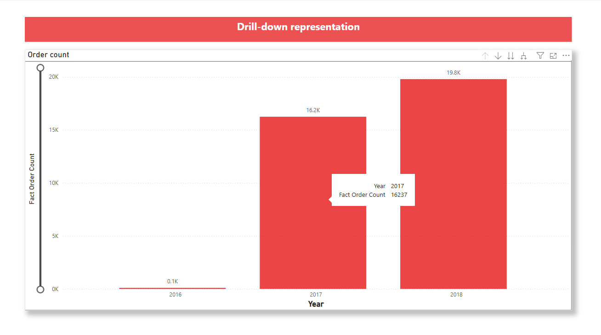

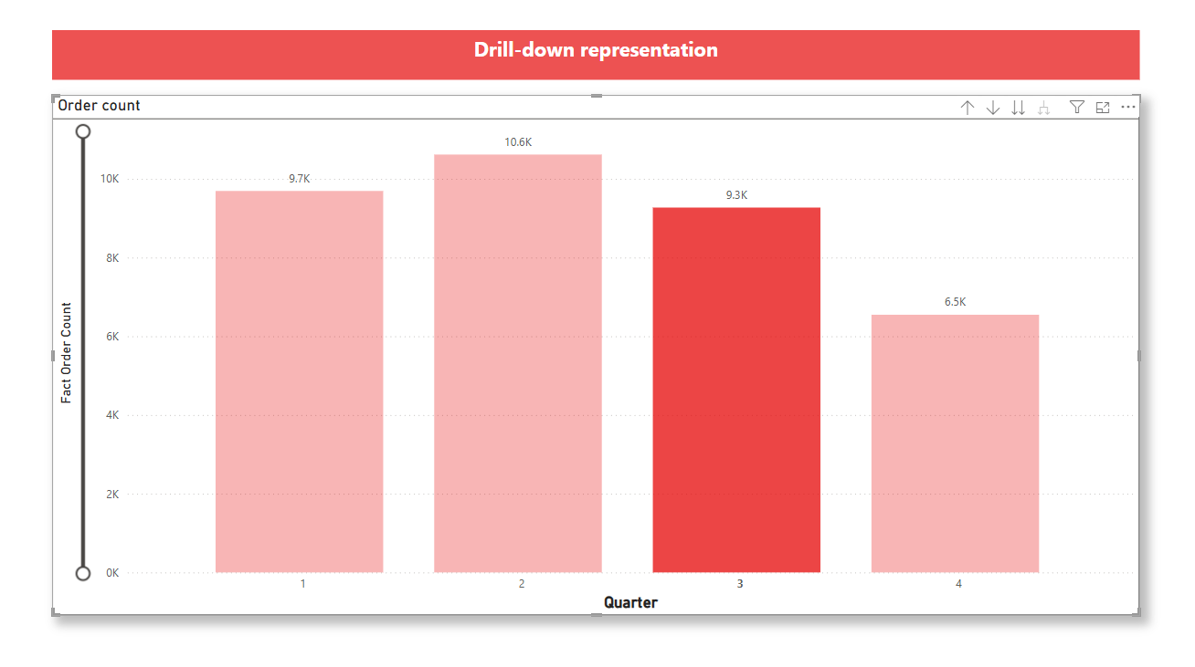

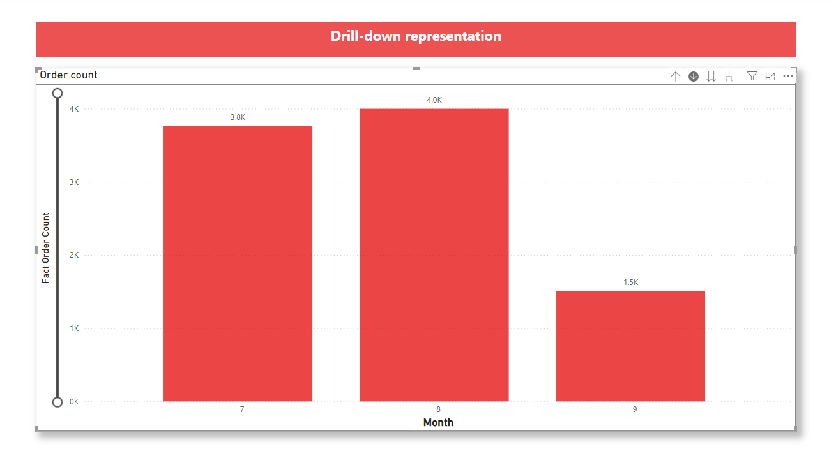

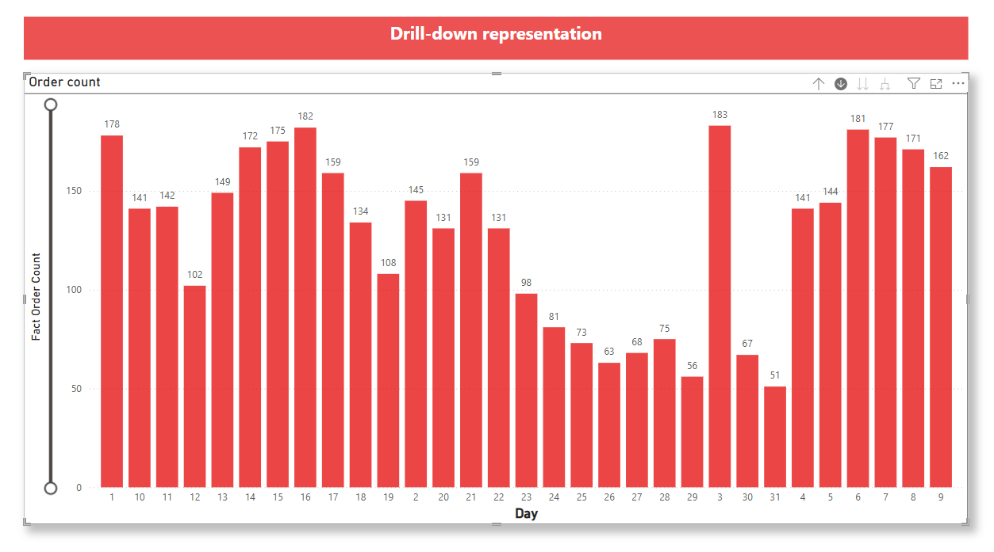

## 5.4 Report 4: Drill-Through

**Report 4 – Drill-through Report:** Lets users navigate to detailed pages from summary visuals.  
Below are the screenshots of Report 4 in Power BI.

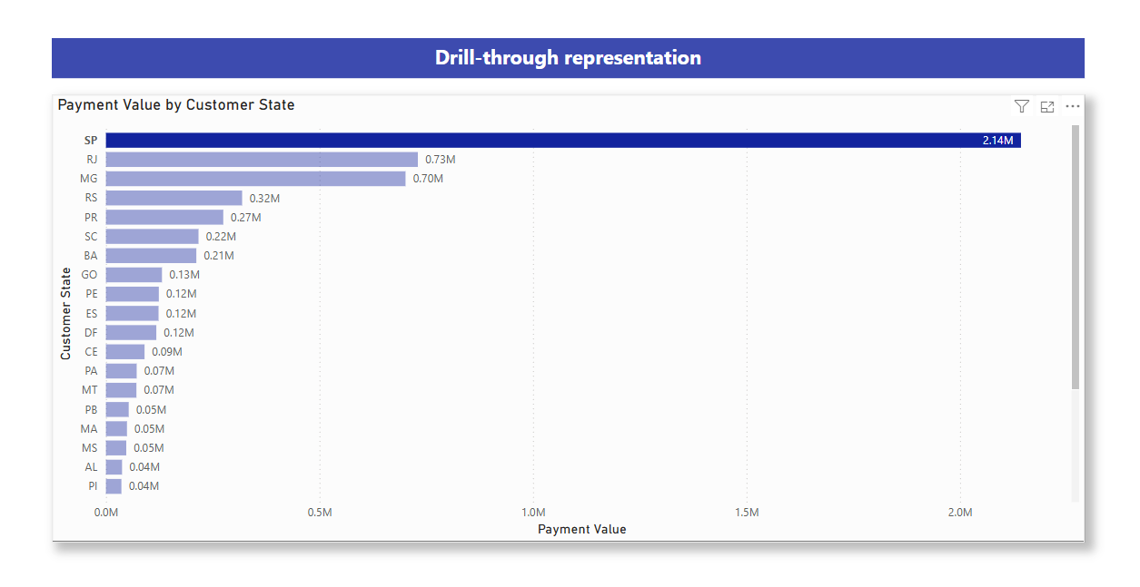

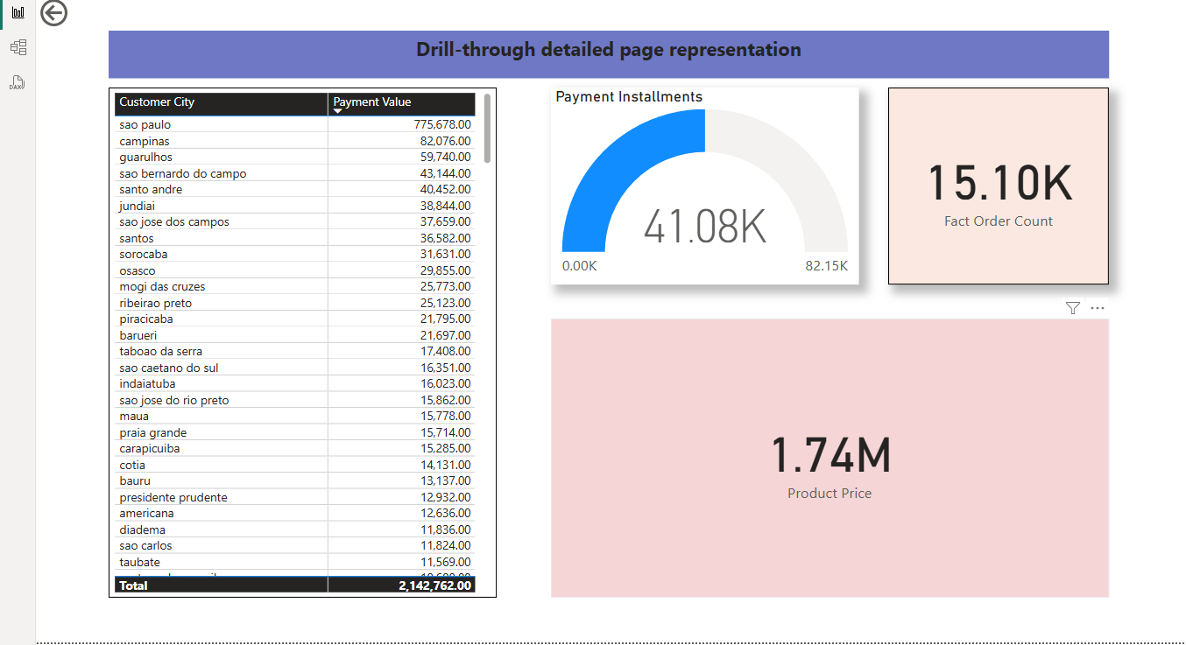

# 6. Conclusion

This assignment demonstrated the practical implementation of a business intelligence solution using a data warehouse, SSAS cube, Excel OLAP operations, and Power BI reports. Each task helped to apply key BI concepts such as multidimensional modeling, interactive data analysis, and visualization. The tools used enabled efficient data exploration and insight generation, supporting informed decision-making.

# 7. References

[1] Microsoft, “Power BI Documentation,” Microsoft Learn, 2024. [Online]. Available: <https://learn.microsoft.com/en-us/power-bi/>

[2] SolarWinds, “SSIS (SQL Server Integration Services),” *SolarWinds IT Glossary*, 2024. [Online]. Available: <https://www.solarwinds.com/resources/it-glossary/ssis-sql-server-integration-services>