**Automated Toll System with recognition of Number Plate**

Rishabh Kumar Roy 21BPS1365

Ruchismita Pal 21BPS1152

Shraddha Pandey 21BAI1673

Charchit Sharma 21BPS143

**ABSTRACT :** Conventional toll tax collection has been difficult nowadays due to increase in number of vehicles which causes huge traffic congestion. So, this research paper addresses the inefficiencies in conventional toll tax methods and our methodology proposes an Automated Toll System with integration of Number Plate.The number plate recognition will be done using a method called Automated Number Plate Recognition(ANPR).The conventional toll collection processes involve time-consuming manual transactions. So, in our system , IR sensors detect the presence of the vehicle and it will activate the IR camera and captures the image.The image will be processed and the alpha numeric characters will be extracted from the image. Once a vehicle is identified, the system will extract the owner details and will check for the balance ,by implementing this approach it can reduce the manual workload and can automate the process giving conveniency to driver wait time. In this way, toll collection will be easier ,more efficient and user-friendly.

**KEYWORDS :** Automated Toll Collection, ANPR, Infrared Cameras, Real-Time Balance, Sensor Synergy, Payment Systems, User Experience, Transportation Infrastructure

1. **INTRODUCTION**

Conventional toll collection systems on our roads often run into issues – causing delays and prolonged travel times due to manual processes. These challenges become even more troublesome in situations with poor visibility. To tackle these issues and increase the process time, we propose the implementation of our Automated Toll System, which integrates advanced technologies such as Automatic Number Plate Recognition (ANPR), Infrared (IR) sensors, and infrared cameras.

The integration of IR sensors and infrared cameras specifically targets the limitations faced by conventional systems in challenging lighting conditions, ensuring optimal performance day and night. This research is dedicated to exploring the design and implementation of our system, with a particular focus on highlighting the crucial role played by infrared cameras in enhancing visibility, IR camera works very well even in dense fog or in rainy weather .

The IR sensor detects the vehicle which will arrive at the toll booth and triggers the IR cameras , IR cameras click the pictures of the vehicle.Then the image is preprocessed and the picture is cropped and the number plate having alpha numeric characters can be extracted. In this way, number plate is recognised and the technology is called ANPR(Automatic Number Plate Recognition) , after this the number plate details will be checked and the user account balance will also be checked, if the user balance is more than the total tax then they will be allowed to enter else a notification will be displayed that insufficient balance cannot proceed further.

By minimizing human involvement and overall improving efficiency, our system addresses the challenges inherent in traditional toll collection methods. This paper delves into technical aspects, explaining the functions of the IR sensor and infrared cameras, detailing image processing techniques, and shedding light on real-time balance verification. The aim of this research is to contribute valuable insights to the development of an automated toll system that is not only efficient but also reliable, thereby paving the way for a seamlessly integrated and enhanced transportation experience.

1. **RELATED WORKS**

Safhira et al [1] suggested ab approach by utilising combination of Single Shot Detector (SSD) for plate localization, Connected Component Labeling (CCL) for character segmentation, and Recurrent Neural Network (RNN) for character recognition. This model takes data from the cctv in all lighting conditions.The afternoon condition demonstrates the best performance, with average accuracies of 94.01% for localization, 84.08% for segmentation, and 93.53% for character recognition. The night condition shows the lowest performance due to blurred or low-contrast images.But this approach doesn’t work efficient under low-light conditions, indicating a need for more robust preprocessing techniques or adaptive algorithms.

Tapas Guha et at[2] used computer vision along with artificial intelligence to detect the number plate.This model used Artificial Intelligence for character recognition using OCR and template matching, Morphological Operators for image enhancement and noise reduction,Histogram Equalization for contrast enhancement,Gaussian Blur for noise reduction and image smoothening.But this approach didn’t worked well in foggy and misty weather conditions and with varying license plate formats and fonts it has to struggle sometimes hence decreasing the overall performance and reliability .

An efficient solution utilizing Automatic Number-Plate Recognition (ANPR) technology for efficient toll collection by A Maanasa et al [3] employs cameras for vehicle image capture, ANPR algorithms for number plate extraction, and database matching for toll deduction. In this paper various image preprocessing techniques like grayscale conversion, noise reduction, and binarization are used. But still the accuracy is at 90% due to vulnerability to changes in lighting/weather conditions.

Sultana Et at [4] proposed a multi way solution , comprising automatic toll as well as lane management system using RFID and image processing to reduce traffic congestion and improve toll collection efficiency on highways .The automatic toll collection system utilizes RFID tags and image processing for rush-free toll plaza operations. The system is automated, reliable, and user-friendly, reducing the probability of error and corruption but RFID tags and image processing equipment require regular maintenance & RFID tags are susceptible to theft or damage, especially in outdoor environments such as toll plazas and highways.

Arokianathan P et al[5] designed a system which proposes automating toll payments using RFID and security algorithms, aiming to reduce journey interruptions , they also added theft detection system in which all the number plate information along with the time and location will be saved in the cloud which can help if any car has been stolen.Drawbacks include potential RFID detection failures, mitigated by high-frequency systems and the cost of using high frequency RFID is also high, Morever live data storage need extra layer of protection.

M. G. Rao et at[6] solved the problem of vehicle number plate detection and recognition and implemented authentication before parking vehicles in a campus. He used a model called Automatic Vehicle Management System(AVMS) that implemented machine learning algorithms to extract and recognise the liscence plate from the picture.This method extracted the characters from the picture and authorises before alloting a parking slot. The research paper used Optical Character Recognition(OCR) for recognition.It also used sensor based detection and video capture for Vehicle Number Plate detection. It used Gaussian Blur for smoothening edges and K-neighbour algorithm for character recognition,bounding box techniques for number plate detection, Convolutional Neural Network(CNN) and other machine learning algorithms for number plate extraction.

P. Patil et at[7] proposed an implementation of an Automatic Number Plate Recognition(ANPR) system.It solved the problem of vehicle identification for security reasons in various areas.The system uses image classification and identification using MATLAB,Zigbee for wireless communication, the ARMLPC2148 processorfor controlling system. The ANPR system uses image processing,character recognition and it also uses embedded systems which is programmed using embedded C.

P. Sai Kiran et at[8] proposed a method which uses Automatic Toll Collection System(ATCS) using Vehicle Number Recognition.It solves the problem of collecting Toll tax manually, making it more efficient by automating it. The system uses image processing techniques such as OpenCV and Tesseract OCR Engine for recognising vehicle Number Plate. It sends the toll amount as an SMS to the car owner for payment of money. It also uses GSM(Global System for Mobile) which is the technology used for sending SMS to the car owner.It uses Python for implementing algorithms and implements use of four deep neural networks including CNN,VGG16,VGG19 and YOLOV3.It also uses Support Vendor Machine(SVM) for character recognition in liscence plate . The microcontroller Atmega328P is used for controlling GSM module and manages communication.

C. T. Jayapriyaa et al[9] proposed a method which aims to improve security by implementation of an ID-based multi-signature scheme which enhances security of toll fee transactions and payment processes.It solves the problem of waiting in long queues and traffic congestion.The system aims to remove the toll plazas where vehicles have to stop and wait in long queues. It uses Wireless Sensor

Network(WSN) for data transmission and automates toll fee collection.It uses Optical Character Recognition(OCR),Radio-Frequency Recognition(RFID) and Global Positioning System(GPS).It also uses Multi-Signature Scheme which is helpful for authentication and securing transaction processing.

B. S. Prabhu et al[10] proposed Automatic Liscence Plate Recognition(ALPR) technology which is used for extracting information from the liscence plates from the image.It uses CCTV cameras for capturing live stream videos and helps in recognition of liscence plates. It also uses k-Nearest Neighbour Algorithm(k-NN) and Convolutional Neural Networks(CNN) for character recognition in the number plate. It uses OpenALPR library for recognising number plates based on patterns and optical character recognition.It also uses Rasberry Pi,MATLAB. It solves the problems of liscence plate recognition , so it uses machine learning algorithm to sove such issues.

An automated toll system is important to implement in India as it helps with reducing congestion, as well as corruption at the toll booth. According to Miral M. Desai,Jignesh J. Patoliya [11], an automated license plate recognition system which is cheaper than the other methods available right now can be developed using an embedded linux environment. The embedded system would contain a Raspberry Pi board as that is most suitable for implementing an image processing algorithm, a webcam which is used to capture the image of vehicles’ license plates and an Optical Character Recognizer (OCR) which will process the captured images. The OCR converts the number into ASCII characters which can further be sent to the RTO server to identify the type and owner of the vehicle. The information retrieved from RTO would go through the GSM module interfaced with Raspberry Pi and according to the type of the vehicle, the appropriate toll amount would be deducted from the driver’s account.

According to Loay Alzubaidi, Ghazanfar Latif, Jaafar Alghazo [ ], Stand along single board computers (SoC) have become so inexpensive yet so powerful that it is now extremely easy to develop fully functional, fully automated systems. SoC are systems that have inbuilts sensors, cameras, and multiple embedded systems which is perfect for automating a manual process such as toll detection. Using SoCs, we can extremely easily, capture images of License plates and use OCR techniques to develop License plate recognition systems. The authors of this paper [12] proposed a Raspberry Pi based LP recognition for numerical numbers and english language characters from license plates. Preprocessing is done to the images captured, which are then undergone segmentation where in characters and numerals are segmented. The segmented images are then used for feature extraction by using pixel distribution and horizontal projection profiles. Finally, knn classifiers are used to classify the number plates and this helps to achieve an accuracy of 90.6% making it an easily to create and deploy system with high accuracy.

An automated toll collection system is not only about identifying the type of vehicle and charging the appropriate amount of toll, but it should also help with violation enforcement. In this paper [13], authors L.R. LIN, G.H. HSU, R.H. JAN, C. CHEN, propose a non-payment vehicle searching method by using a Photograph-to-Transaction matching algorithm (PT algorithm). The performance of this algorithm was evaluated in ns-2 simulator and 3 different traffic scenarios: congested traffic, normal traffic and sparse traffic. Results prove that this method is more feasible and reliable for an electronic toll collection system.

A multi-camera video and position sensors can be used to implement a moving object performance analysis system according to authors Changeun Lee, Gi-Mun Um, Sangjoon Park [14] The video feed from the multiple cameras will use a tracking technique to detect moving objects, which can be done more precisely by using IR-UWB fusion technology. UWB or Ultra-Wide Band are sensors that can measure each vehicles’ position by communicating with the tag attached to each vehicle. The system showed the performance of average tracking with a speed of 16 fps with four cameras, with accuracy ranging to 99.8% with a nominal 0.48 position error.

HVAC, or Heating, Ventilation, and Cooling can be adapted to a dynamic environment rto help save energy without compromising the comfort level of occupants, and the best approach for it has been a wireless camera-based sensing. In this paper [15], authors Ningyuan Cao, Shreyas Sen, and Arijit Raychowdhury, propose a prototype for the same using an IR camera incorporated with an optical camera which helps to provide collaborative intelligence at low power and high accuracy. This prototype demonstrates a 65x improvement in miss rate, 5x reduction in detection of false positive rate, and a 25% lifetime extension for battery usage.

As the global vehicle population surges, Shashirangana et al [16] suggested ALPR systems for diverse tasks, including **law enforcement, surveillance,** and **toll booth operations**. These systems operate across a spectrum of scenarios, from handheld devices to cloud servers, and must function effectively even in **low-light conditions and adverse weather.**The study meticulously examines recent literature, dissecting the **myriad techniques** employed in ALPR. Researchers have made significant strides, yet challenges persist. Many existing approaches are **sensitive to illumination changes** and primarily function during daylight. The need for robust ALPR techniques in complex environments remains unmet.

As modern transportation services demand efficiency and minimal delays, the transition from manual toll collection to automation becomes crucial. In this context D. Jadhav et al [17] suggested, Open Road Tolling (ORT) which leverages video evidence to identify vehicle usage without the need for toll booths or stopping to pay the toll. The proposed NPR techniques involve histogram-based number plate localization and template matching for efficient recognition. While this concept has gained traction abroad, its adoption in India remains at an early stage. The paper, published in the 2015 International Conference on Technologies for Sustainable Development, sheds light on the potential of ORT in enhancing traffic management and convenience.

C. -H. Lin et al [18] suggested **license plate recognition (LPR)** systems that can handle varying angles and complex environments. As modern transportation services demand efficiency and minimal delays, the transition from manual toll collection to automation becomes crucial. This model aims to simplify traditional LPR approaches while maintaining accuracy. collect a diverse dataset of license plate images from different environments, angles, and sizes to train their model effectively. he model achieves a recall rate of **84.5%** for license plates tilted between 0 and 60 degrees.

M. M. Kurdi et al [19] suggested license plate recognition technology, specifically focusing on image preprocessing, segmentation, and recognition of license plates’ numbers. This technology allows efficient recognition of Lebanese license plates from both day and night images. The proposed system utilizes a neural network for optical character recognition (NNOCR) after capturing vehicle license plate images using a digital camera. By applying this system in Lebanon, it aims to enhance parking performance, security, and fee collection without relying on electronic cards1. The study contributes to the advancement of intelligent transport systems and underscores the potential of automated number plate recognition (ANPR) in various applications, including highway electronic toll collection, traffic monitoring, and parking management.

In the realm of modern transportation systems, **automatic toll collection** has become essential for efficient traffic management. S. Ahmed et al [20] suggested One effective approach is **Radio Frequency Identification (RFID)** technology. Radio Frequency Identification (RFID) technology is revolutionizing toll collection systems, offering a seamless and efficient way to charge vehicles for road usage. RFID-based toll collection systems use RFID tags attached to vehicles' windshields or license plates to identify and track vehicles as they pass through toll plazas.

**III. Proposed Automated Toll System with recognition of Number Plate**

This project proposes a comprehensive enhancement of toll collection systems, targeting inefficiencies and prioritising an improved user experience. The primary objective is to streamline toll collection by minimising manual processes and expediting driver wait-times through the integration of advanced technologies.One of the biggest concerns to be faced while trying to implement an automatic toll system is adverse lighting conditions. To combat which, this project incorporates infrared (IR) cameras. This enhances system performance and ensures that the system operates consistently under low-light scenarios or unfavourable weather.

A key component in setting up the system is the implementation of Automatic Number Plate Recognition (ANPR) technology. ANPR automates vehicle identification, facilitating a seamless and expedited toll collection experience. This automation not only expedites individual transactions but also contributes to the overall efficiency of the toll system.To ensure the security and reliability of the toll collection process, real-time balance verification mechanisms will also be needed to be implemented. These mechanisms allow only vehicles with sufficient funds to proceed through the toll booth, mitigating the risk of fraudulent transactions.Another critical aspect involves investigating and optimizing the synergy between IR sensors, IR cameras, and electronic payment systems. The goal is to create a cohesive and efficient automated toll system where these technologies work seamlessly in tandem, enhancing the overall system performance. In conclusion, the project’s overarching aim is to enhance the user experience by making toll collection more seamless and user-friendly. This involves not only addressing technical challenges through advanced technologies but also designing intuitive and user-friendly interfaces for both drivers and administrators, ultimately contributing to a positive and efficient transportation experience.

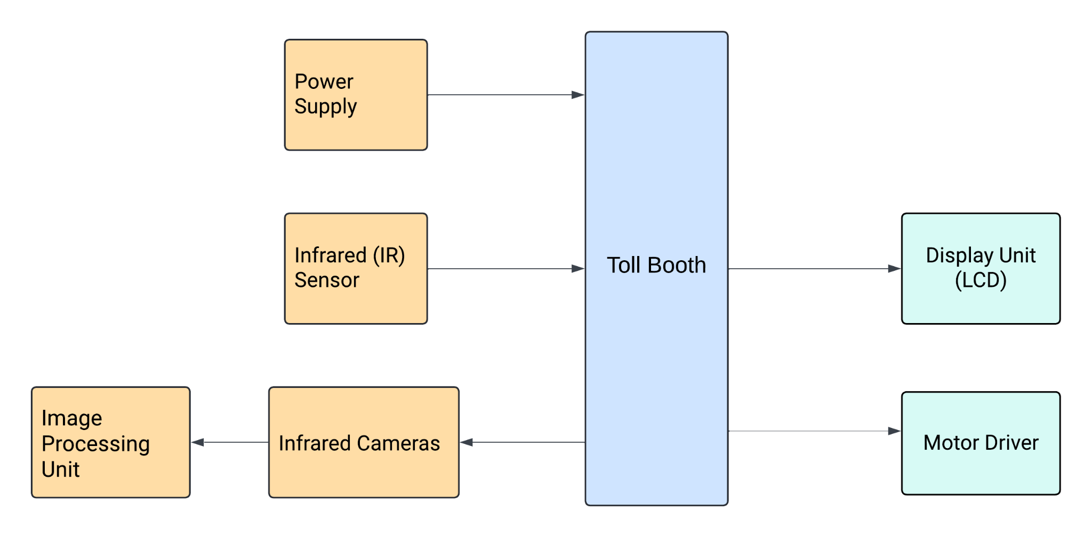

**Figure 1:**

Figure 1 diagram represents an Automatic Toll System with recognition of Number plate that is centered around a Toll Booth . Each block represents a different component or module, and the arrows indicate the flow of information or control signals between components. The arrows show the direction of communication:

* The IR Sensor detects the vehicle and sends the signal to the Toll Booth.
* The IR cameras capture the photos of the vehicle and forward it to the Image Processing Unit.
* The Image Processing Unit processes the captured photo and extracts the alphanumeric characters.
* The Power Supply gives power to the toll booth and its components.
* The Display Unit (LCD) displays the user details and the amount to be paid by the user.
* The Motor Driver enables the user to open/close the gate so that the user can go/stop.

**3.1 IR Sensors**

An IR (infrared) sensor is a device designed to detect infrared radiation in its surroundings, which is electromagnetic radiation with wavelengths longer than visible light but shorter than radio waves as shown as Figure 2. Such a sensor typically comprises an IR emitter and an IR detector. The emitter sends out infrared radiation, while the detector, utilizing technologies such as photodiodes, phototransistors, or thermopiles, captures this radiation to sense the presence of objects or changes in the environment. IR sensor detect the vehicle and sends the signal to the Toll Booth. It detects the presence of a vehicle and triggers activates the IR Cameras.

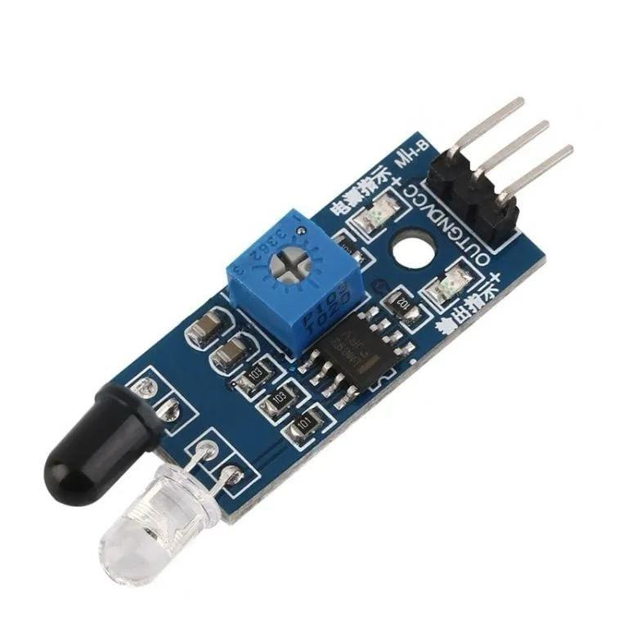Figure 2:**IR Sensor**s

**3.2 IR Camera**

Infrared cameras capture images through infrared radiation, allowing them to operate effectively in low-light conditions, fog, or total darkness as shown in Figure 3, unlike traditional cameras that rely on visible light. This capability enables IR cameras to detect infrared radiation emitted by objects, which can vary based on factors such as temperature, moisture content, or surface texture, helping users navigate challenging environments or detect objects in conditions where traditional cameras would struggle.The IR cameras capture 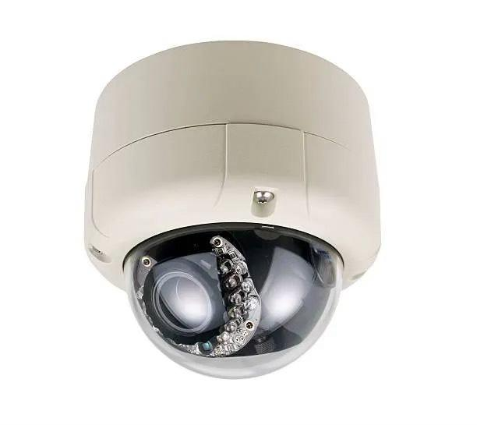the photos of the vehicle and forward it to the Image Processing Unit. After capturing the photo, it crops the photo and sends to the Image Processing Unit.

Figure 3: **IR Camera**

**3.3 Image Processing Unit**

An Image Processing Unit (IPU) is a specialized component or system within a device or computer architecture that is dedicated to processing visual information, such as images or videos as shown in Figure 4. The primary function of an IPU is to perform various operations on visual data to enhance, analyze, or manipulate it using visual data according to specific requirements and applications. IPUs are commonly found in devices such as digital cameras, smartphones, computers, and dedicated image processing systems. IPU functions include : Image Processing Algorithms, Parallel Processing Architecture, Hardware Acceleration, Memory image-processing algorithms, parallel processing architecture, hardware acceleration, memory, and Storage. storage. In our project,the Image Processing Unit processes the captured photo photograph and extracts the alphanumeric characters.

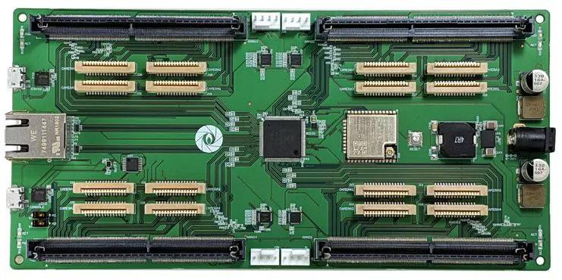

Figure 4: **Image Processing Unit**

**3.4 Power Supply**

A power supply is a hardware component that supplies electrical power to other devices as shown in Figure 5.Power supply plays a crucial role in maintaining the functionality of an automated toll collection system using RFID technology. It ensures that all components operate smoothly, contributing to efficient toll collection and reduced traffic congestion



Figure 5:**Power Supply**

**3.5 Display Unit (LCD)**:

An LCD (Liquid Crystal Display) is a flat-panel display technology commonly used in various devices, including TVs, computer monitors, smartphones, and digital signage as shown in Figure 6.When a vehicle approaches the toll gate, If the user has sufficient balance, the LCD screen displays “successful” else “insufficient balance” message.

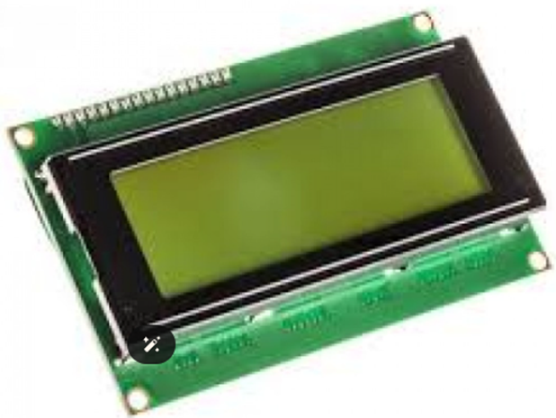

Figure 6:**Display Unit (LCD)**

**3.6** **Motor Driver**:

A motor driver is an electronic circuit or device that controls the speed, direction, and torque of an electric motor as shown in Figure 7. The motor driver acts as an intermediary between the controller and the servo motor. When a payment is successful , the controller sends a signal to the motor driver. The motor driver interprets this signal and provides the necessary voltage and current to the servo motor. It ensures that the motor rotates in the correct direction (anticlockwise) to open the gate. After a delay (to allow the vehicle to pass), the motor driver receives another signal to rotate the motor clockwise, closing the gate.

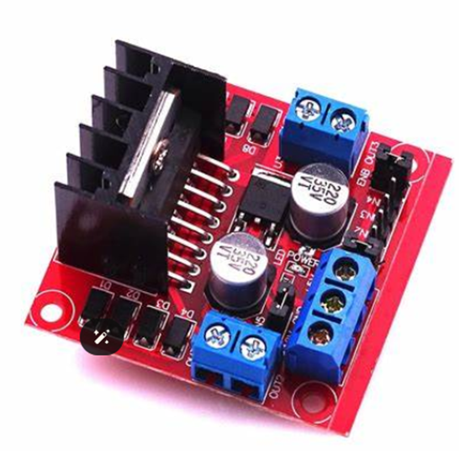

Figure 7:**Motor Driver**

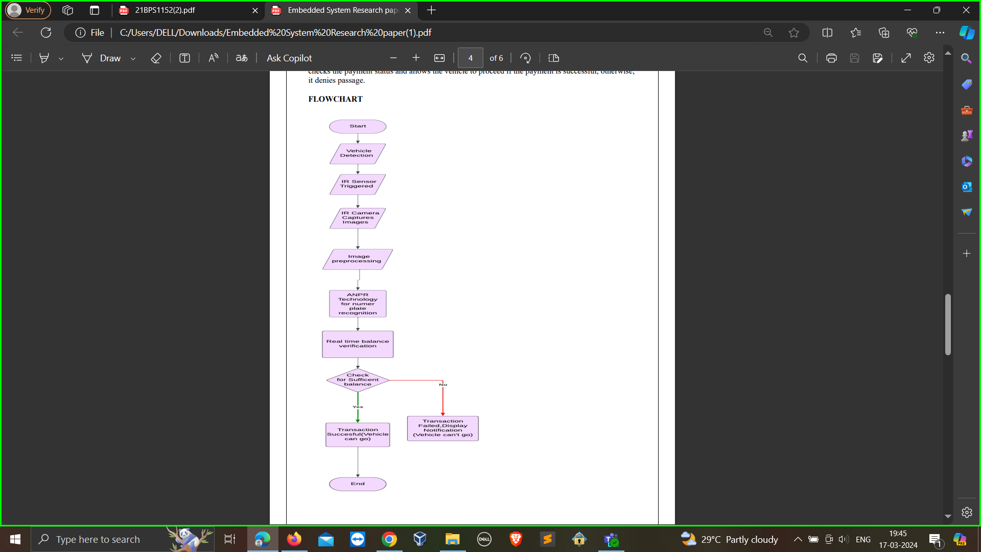

**Figure 8 :**

Figure 8 shows the flow of Automated Toll System with recognition of Number Plate. The Automated Toll System with Number Plate Recognition integrates IR sensors and cameras for vehicle detection and enhanced visibility. ANPR technology enables automatic recognition of alphanumeric characters on license plates, ensuring efficient extraction and storage of number plate information. Real-time balance verification streamlines electronic payment processing, while advanced image processing techniques enhance accuracy. Technical synergy among system components optimizes performance and reduces human intervention, minimizing wait times for drivers. Emphasizing efficiency and scalability, the system accommodates increased traffic and future enhancements. Its robust design promises a streamlined toll collection experience, combining innovation with reliability to meet evolving transportation needs effectively.

**3.8 Automated Toll System with Recognition of Number Plate Algorithm**

**Step 1:** Initialization of the System: Trigger the activation of the Infrared (IR) sensor for detecting vehicles. Enhance visibility by enabling Infrared cameras.

**Step 2:** Vehicle Detection: Upon detection by the IR sensor , capture images for identification using infrared cameras.

**Step 3:** Utilization of Automatic Number Plate Recognition (ANPR) Technology: Employ ANPR technology to identify alphanumeric characters on license plates. Extract and preserve the information stored on the license plate.

**Step 4:** Verification of Real-Time Balance: Retrieve vehicle details, including license plate information. Utilize the electronic payment system to verify the real-time balance. If the balance is sufficient,permit passage through the toll. If the balance is insufficient, notify the driver and restrict access.

**Step 5:** Application of Image Processing Techniques: Utilize advanced image processing methods to refine the accuracy of number plate extraction.

**Step 6:** Synergy of Technical Components: Ensure seamless cooperation among IR sensors, infrared cameras, ANPR technology, and electronic payment systems. Continuously enhance performance through feedback and adjustments.

**Step 7:** Efficiency Enhancement and Reduction of Human Intervention: Automate toll collection procedures to minimize manual interventions. Expedite the identification and verification processes to decrease driver wait times.

**Step 8:** Scalability and Adaptability: Develop the system to accommodate increased traffic and accommodate future enhancements.

**Step 9:** End of Algorithm.

**REFERENCES**

[1] D. A. Navastara, N. Musyafira, C. Fatichah and S. Maharani, "Video-Based License Plate Recognition Using Single Shot Detector and Recurrent Neural Network," *2021 13th International Conference on Information & Communication Technology and System (ICTS)*, Surabaya, Indonesia, 2021, pp. 151-154, doi: 10.1109/ICTS52701.2021.9608790.

[2] S. Rabindranath, P. KV, D. BJ and T. Guha, "License Plate Detection using Computer Vision technique with Artificial Intelligence," *2022 IEEE 2nd Mysore Sub Section International Conference (MysuruCon)*, Mysuru, India, 2022, pp. 1-5, doi: 10.1109/MysuruCon55714.2022.9972497.

[3] B. VeerasekharReddy, V. N. Thatha, A. Maanasa, S. S. Gadupudi, S. K. Japala and L. H. Goud, "An ANPR-Based Automatic Toll Tax Collection System Using Camera," *2023 3rd International Conference on Pervasive Computing and Social Networking (ICPCSN)*, Salem, India, 2023, pp. 133-140, doi: 10.1109/ICPCSN58827.2023.00028.

[4] T. Ahmed, M. M. Hassan, R. Sultana, A. N. Afif and M. S. R. Zishan, "Design and Development of Lane Management and Automatic Toll Collection System," *2021 2nd International Conference on Robotics, Electrical and Signal Processing Techniques (ICREST)*, DHAKA, Bangladesh, 2021, pp. 629-634, doi: 10.1109/ICREST51555.2021.9331186.

[5] P. Arokianathan, V. Dinesh, B. Elamaran, M. Veluchamy and S. Sivakumar, "Automated toll booth and theft detection system," *2017 IEEE Technological Innovations in ICT for Agriculture and Rural Development (TIAR)*, Chennai, India, 2017, pp. 84-88, doi: 10.1109/TIAR.2017.8273691.

[6] M. G. Rao, G. G, N. T. C and A. B. Pradeep, "Authentication and Parking of the Vehicle Using License Plate Detection and Recognition in the Campus," 2022 International Conference on Artificial Intelligence and Data Engineering (AIDE), Karkala, India, 2022, pp. 74-79, doi: 10.1109/AIDE57180.2022.10059957.

[7] P. Patil, C. Kanagasabapathi and S. S. Yellampalli, "Automatic number plate recognition system for vehicle identification," 2017 International Conference on Electrical, Electronics, Communication, Computer, and Optimization Techniques (ICEECCOT), Mysuru, India, 2017, pp. 431-434, doi: 10.1109/ICEECCOT.2017.8284543.

[8] P. Sai Kiran, Y. Ayyappa, M. K. Sree, J. Jampani, M. Raavi and K. Aluru, "Automatic Toll Collection using Vehicle Number Recognition System," 2023 3rd International Conference on Pervasive Computing and Social Networking (ICPCSN), Salem, India, 2023, pp. 5-10, doi: 10.1109/ICPCSN58827.2023.00009.

[9] C. T. Jayapriyaa and Y. B. Jinila, "Secured short time automated toll fee collection for private group transportation," 2015 International Conference on Innovations in Information, Embedded and Communication Systems (ICIIECS), Coimbatore, India, 2015, pp. 1-5, doi: 10.1109/ICIIECS.2015.7193130.

[10] B. S. Prabhu, S. Kalambur and D. Sitaram, "Recognition of Indian license plate number from live stream videos," 2017 International Conference on Advances in Computing, Communications and Informatics (ICACCI), Udupi, India, 2017, pp. 2359-2365, doi: 10.1109/ICACCI.2017.8126199.

[11] M. M. Desai and J. J. Patoliya, "Smart toll collection system using embedded Linux environment," 2017 2nd International Conference for Convergence in Technology (I2CT), Mumbai, India, 2017, pp. 79-83, doi: 10.1109/I2CT.2017.8226098.

[12] L. Alzubaidi, G. Latif and J. Alghazo, "Affordable and Portable Realtime Saudi License Plate Recognition using SoC," 2019 2nd International Conference on new Trends in Computing Sciences (ICTCS), Amman, Jordan, 2019, pp. 1-5, doi: 10.1109/ICTCS.2019.8923061.

[13] L. R. Lin, G. H. Hsu, R. H. Jan and C. Chen, "A novel non-payment vehicle searching method for multilane-free-flow electronic-toll-collection systems," 2012 14th International Conference on Advanced Communication Technology (ICACT), PyeongChang, Korea (South), 2012, pp. 904-909.

[14] C. Lee, G. -M. Um, S. Park and K. -i. Lee, "Moving Object Performance Analysis System Using Multi-camera Video and Position Sensors," 2020 IEEE International Conference on Big Data and Smart Computing (BigComp), Busan, Korea (South), 2020, pp. 441-445, doi: 10.1109/BigComp48618.2020.00-31.

[15] N. Cao, S. Sen and A. Raychowdhury, "Collaborative intelligence in optical/IR camera based wireless sensor nodes for HVAC control," 2017 IEEE SENSORS, Glasgow, UK, 2017, pp. 1-3, doi: 10.1109/ICSENS.2017.8234091.

[16] J. Shashirangana, H. Padmasiri, D. Meedeniya and C. Perera, "Automated License Plate Recognition: A Survey on Methods and Techniques," in *IEEE Access*, vol. 9, pp. 11203-11225, 2021, doi: 10.1109/ACCESS.2020.3047929.

[17] D. Jadhav and M. Sabnis, "Open road tolling in India by pattern recognition," *2015 International Conference on Technologies for Sustainable Development (ICTSD)*, Mumbai, India, 2015, pp. 1-5, doi: 10.1109/ICTSD.2015.7095911.

[18] C. -H. Lin and C. -H. Wu, "A Lightweight, High-Performance Multi-Angle License Plate Recognition Model," *2019 International Conference on Advanced Mechatronic Systems (ICAMechS)*, Kusatsu, Japan, 2019, pp. 235-240, doi: 10.1109/ICAMechS.2019.8861688.

[19] M. M. Kurdi, I. A. Elzein, J. Issa and I. S. Ahmad, "Lebanese automated number plate reading based on neural network recognition," *2017 13th International Computer Engineering Conference (ICENCO)*, Cairo, Egypt, 2017, pp. 79-84, doi: 10.1109/ICENCO.2017.8289767.

[20] S. Ahmed, T. M. Tan, A. M. Mondol, Z. Alam, N. Nawal and J. Uddin, "Automated Toll Collection System Based on RFID Sensor," *2019 International Carnahan Conference on Security Technology (ICCST)*, Chennai, India, 2019, pp. 1-3, doi: 10.1109/CCST.2019.8888429.

**Team Work:**

Paper [1-5] : Rishabh Kumar Roy 21BPS1365

Paper [6-10] : Ruchismita Pal 21BPS1152

Paper [11-15] : Shraddha Pandey 21BAI1673

Paper [16-20] : Charchit Sharma 21BPS1431