NEAR.ME
NearMe Navigator
Project Report and Technical Documentation

Project type | Full Stack Development / Web Application
Benchmark platform | OpenStreetMap
Core purpose | Category-based discovery of nearby facilities
Prepared by | Name: Chovatiya Ruchit Rameshbhai
A focused interface for finding everyday places nearby

1. Project Overview
NearMe Navigator (near.me) is a lightweight web application concept that helps users discover nearby everyday facilities by entering a destination and selecting a category. It uses geographic data from OpenStreetMap services and presents matching places as concise result cards with links to view each location on OpenStreetMap.
The project is designed as a focused companion to a full mapping platform. Rather than recreating all map and navigation functionality, it concentrates on a simple task: finding a particular type of place around a chosen location.

1.1 Problem Statement
Users visiting an unfamiliar area may need to locate a specific facility—such as a café, pharmacy, ATM, or bus stop—without navigating through a broad map interface. NearMe Navigator aims to reduce the steps required for this task by combining destination entry, category selection, and a readable list of nearby results in one interface.

1.2 Objectives
- Provide a simple destination search using a place name or address.
- Allow users to filter nearby results by facility category.
- Display matching places in readable cards with available location details.
- Provide direct links to the corresponding OpenStreetMap location.
- Create a responsive, visually distinct interface for desktop and mobile screens.

2. Benchmark Analysis: OpenStreetMap

2.1 Target Users
Students, tourists, commuters, and people visiting unfamiliar locations who need to discover nearby facilities.

2.2 Existing Features and Workflow
OpenStreetMap provides an interactive geographic map with location search, zooming, panning, alternative map layers, and access to information about mapped features. A user can search for a location, navigate to the relevant area, and inspect geographic information.

2.3 Observations
- The platform provides extensive map information and navigation capabilities, allowing users to explore locations visually.
- A category-specific nearby-facility task should be evaluated separately from general map navigation.
- The interface should be checked at both mobile and desktop widths to identify genuine usability issues.
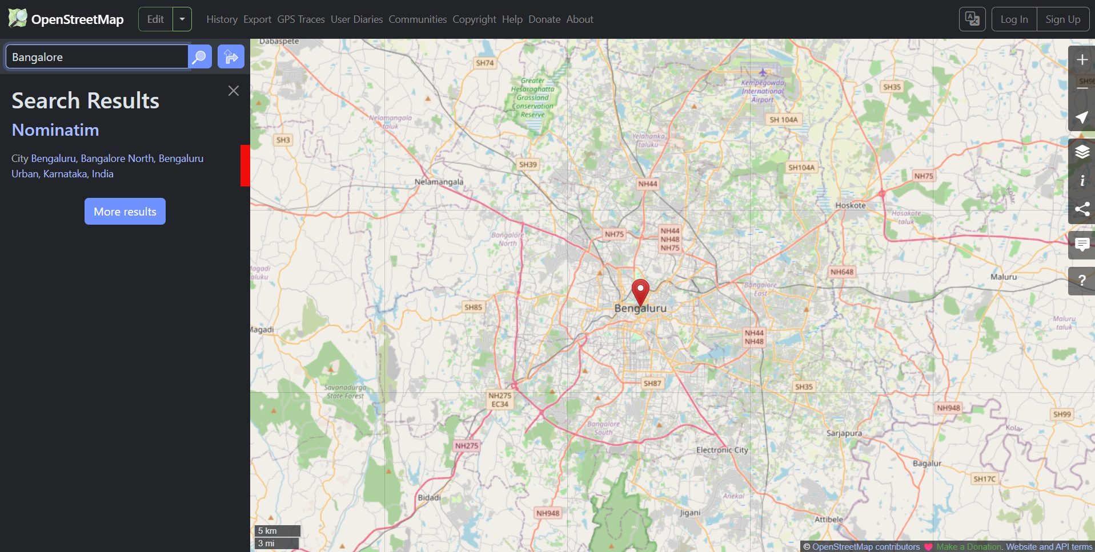
Figure 1. OpenStreetMap benchmark screenshot included in the original report.
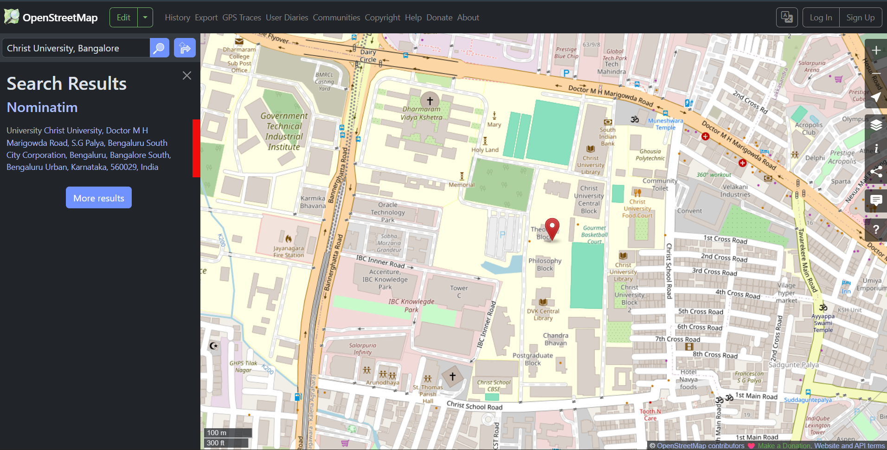
Figure 2. A closer view of the mapped area included in the original report.

2.4 Improvement Opportunity
A focused, category-based nearby-place finder can make essential facilities easier to discover by combining location search, category filters, concise result cards, and direct map links in one interface. The proposed application complements OpenStreetMap rather than attempting to reproduce its complete platform.

3. Proposed Solution and Interface Design
The interface uses the name near.me and an editorial visual style with a warm off-white background, dark green panels, and terracotta accents. The main search panel contains a destination field, a category selector, a search button, and a status message. Four category cards provide a second way to start a search.

3.1 Supported Categories
Category | What it finds | OpenStreetMap tag used
Cafés | Cafés and coffee stops | amenity=cafe
Pharmacies | Nearby pharmacies | amenity=pharmacy
ATMs | Cash access points | amenity=atm
Bus stops | Mapped bus stops | highway=bus_stop

3.2 Main User Workflow
- Enter a destination, for example, “Christ University, Bengaluru”.
- Select a category from the dropdown, or choose a category card.
- The application sends the destination to the geocoding service to obtain coordinates.
- The application requests matching facilities within a 3 km radius from the nearby-place data service.
- Matching results are deduplicated and displayed as cards with available address/tag details.
- Select “Explore this place” to open the location on OpenStreetMap.

4. Technology Stack and Implementation
Implementation update: the current version uses Geoapify for both geocoding and nearby-place search. The app requests up to 75 results within a 3 km radius and retains direct links to each place on OpenStreetMap. A Geoapify API key is required for requests.
Technology / service | Role in the application
HTML5 | Defines the page structure, form, category cards, result section, and footer.
CSS and Tailwind CSS CDN | Provides layout, responsive styling, typography, colors, and interaction states.
JavaScript (Fetch API) | Handles form events, requests, result processing, rendering, and error/status messages.
Geoapify Geocoding API | Converts the entered place name/address into geographic coordinates.
Geoapify Places API | Returns nearby places matching the selected Geoapify category within the configured radius and result limit.
OpenStreetMap | Provides the geographic data and destination links for individual results.

4.1 Data Processing
- The destination text is trimmed and validated before a request is sent.
- The geocoding response is checked; if no matching location is found, the user receives a message.
- Coordinates are used in an Overpass query with the selected category filter and a 3,000-metre radius.
- Returned elements are deduplicated using the place name and coordinates.
- The result cards display a name, available address or tag information, and a map link when coordinates are available.

5. Testing and Validation
Complete the checks below in the browser before submission. The Geoapify API key has been corrected and the key test now works; record the observed result for each full application test after running it in the browser. Do not mark a test as passed until you have observed it.
Test case | Action | Expected outcome | Observed result
Valid destination | Search a known place and select Cafés. | Café results or a clear no-results message appears. | To be tested
Category filter | Repeat with Pharmacy, ATM, and Bus stop. | Results correspond to the selected category. | To be tested
Unknown location | Enter a deliberately invalid place name. | A location-not-found message appears. | To be tested
Empty input | Clear the destination and submit. | The form asks for a destination. | To be tested
Service/network failure | Test with network disconnected or service unavailable. | A readable error appears and the button becomes usable again. | To be tested
Responsive layout | Inspect at desktop and narrow mobile widths. | Fields and cards remain readable without horizontal overflow. | To be tested

6. Limitations and Future Enhancements

6.1 Current Limitations
- Search results depend on the completeness and accuracy of OpenStreetMap contributions in the selected area.
- Geoapify Geocoding API and Overpass are public services; network availability, response times, or usage limits can affect a search.
- The application searches within a fixed 3 km radius and currently supports four categories.
- Result cards show only the address/tag information available in the returned map data; some places may have incomplete details.
- The current implementation provides links to map locations rather than turn-by-turn navigation within the application.

6.2 Possible Future Enhancements
- Add distance sorting and show the approximate distance from the selected destination.
- Add more categories such as restaurants, hospitals, libraries, parks, and public toilets.
- Provide an interactive map view alongside the result cards.
- Allow users to adjust the search radius and sort results by distance or name.
- Improve request handling with service fallback, clearer retry guidance, and loading indicators.
- Add accessibility checks and more extensive mobile-device testing.

7. Conclusion
NearMe Navigator presents a focused approach to nearby-facility discovery using OpenStreetMap data. Its core workflow combines destination geocoding, category-based querying, result cards, and direct map links. The project demonstrates how HTML, CSS, JavaScript, and public geographic services can be combined to build a practical web interface. Final submission should include browser test observations and screenshots of the working application, with any unresolved limitations reported honestly.

8. References
- OpenStreetMap — https://www.openstreetmap.org/
- Geoapify Geocoding API Search API documentation — https://nominatim.org/release-docs/latest/api/Search/
- Geoapify Places API documentation — https://wiki.openstreetmap.org/wiki/Overpass_API
- Tailwind CSS documentation — https://tailwindcss.com/docs
Attribution: Geographic data © OpenStreetMap contributors. Review the relevant service usage policies before deployment or high-volume use.

