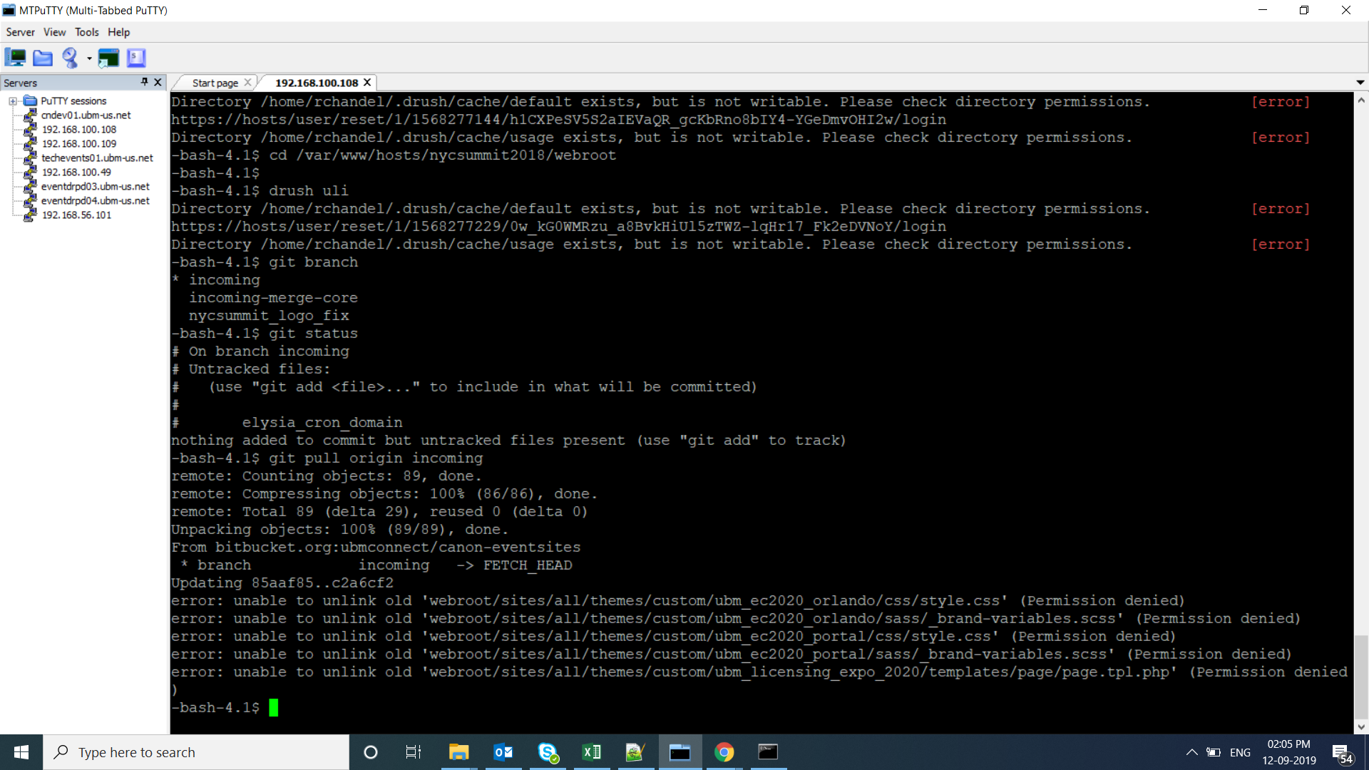

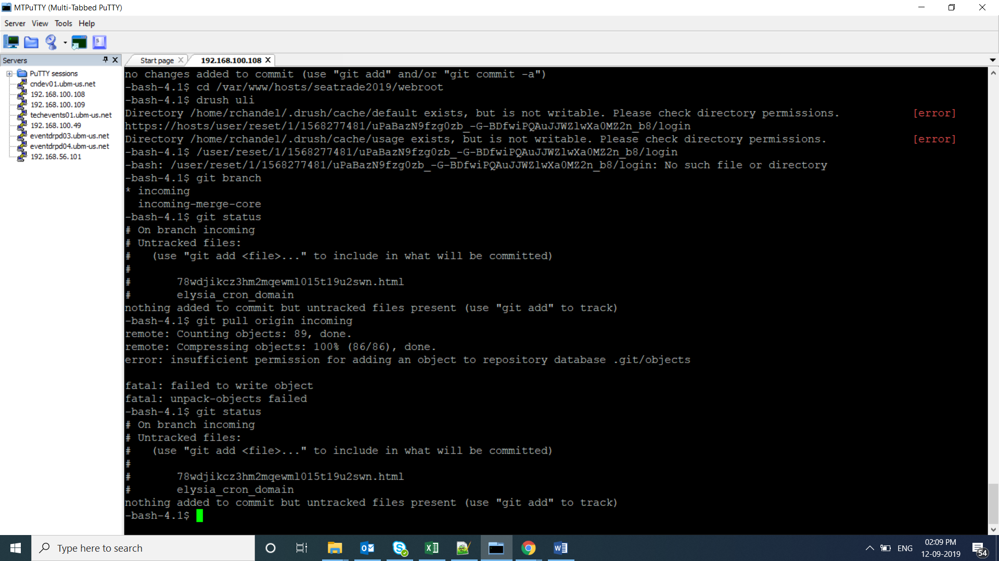

|  |
| --- |
| <https://event.powderbulksolids.com/> |
| <http://amgeventscalendar.com/> |
| [https://admcleveland.com](https://admcleveland.com/) |
| <https://insecurity.com/> |
| <http://www.embeddedconf.com/> |
| <https://admmontreal.com/> |
| <https://mirecweek.com/> |
| [https://biomedevicesj.mddionline.com/](http://biomedevicesj.mddionline.com/) |
| <https://www.theconstructionsummit.com.mx/> |
| |  | | --- | | <https://conference.catersource.com/> | | http://cphinorthamerica.com/ | |  |   <https://www.enterpriseconnect.com/>  <https://newto2.com/>  <https://www.thegloballicensinggroup.com/>  [www.nyclicensingsummit.com](http://www.nyclicensingsummit.com/)   |  | | --- | | <https://seatradecruiseglobal.com/> | | <https://createyournextcustomer.com/> |   www.artofcateringfood.com  <https://am-expo.com/> |

