Project Report
On

Data Driven Residential Property Price Analysis and Modeling


Submitted
In partial fulfilment
For the award of the Degree of

PG-Diploma in Big Data Analytics

(C-DAC, ACTS (Pune))

Guided By: Prakash Sinha Submitted By:
Ruchita Dighe (250840125017)
Aishwarya Mahajan(250840125033) Aditya Patil (250840125039)
Ei Han (250840125061)

Centre for Development of Advanced Computing (C-DAC), ACTS (Pune- 411008)

This project focuses on the development of an end-to-end machine learning pipeline designed to predict residential property prices with high precision. The system addresses the inherent volatility of the real estate market by utilizing a multi-stage workflow, beginning with automated data acquisition via web scraping APIs to ensure the use of real-time market data. This is followed by rigorous exploratory data analysis (EDA) to handle statistical anomalies, identify correlations, and manage null values through mean and mode imputation.

Predictions of house prices are expected to help people who plan to buy a house so they can know the price range, then they can plan their finances well. In addition, house price predictions are also beneficial for property investors to know the trend of housing prices in a certain location.

The goal of this project is to create a regression model that is able to accurately estimate the price of the house on the basis of certain features.

S. No | Title | Page No.
 | Front Page Acknowledgement Abstract  Table of Contents | I.  II.  II.
1  1.1  1.2  1.3 | Introduction Introduction Problem Statement  Objective | 01-02  01  01  02
2 | Literature Review | 03-04
3 | Methodology/ Techniques | 05-14
3.1 | Methodology | 05
3.2 | Model Description | 09
3.3 | Metrics | 12
4 | Implementation | 15-23
4.1 | Implementation | 15
5 | Results | 24-32
5.1 | Results | 24
6 | Conclusion | 33-34
6.1 | Conclusion | 33
7 | References | 35
7.1 | References | 35

Chapter 1 Introduction

Introduction
The valuation of residential real estate is a multifaceted challenge that balances physical property characteristics with geographic variables. For most individuals, purchasing a home is the largest financial commitment of their lives, yet the "fair market price" often feels like a moving target. To provide clarity, this project develops a data-driven approach to estimate property values using the most influential drivers of real estate pricing.

The Complexity of Property Valuation

Predicting a house's price is not merely a matter of calculating square footage; it requires understanding how a property fits into its local context. This project focuses on six primary features that define a home's value:
      - Structural Metrics: The living area (sq ft), number of bedrooms, and number of bathrooms serve as the core indicators of a property's utility and capacity.
      - Geographic Context: Location variables—Zipcode, City, and State—capture market demand that can cause identical houses to have vastly different price tags.

The Problem Statement

While buyers need to understand price ranges for financial planning and investors seek trends to maximize returns, the raw data is often messy and unstructured. Missing values, outliers in square footage, and the high cardinality of geographical data (like having hundreds of different zip codes) make simple estimation difficult. Without a sophisticated model, stakeholders are left with "best guesses" rather than actionable insights.

Objective

The primary objective of this project is to develop a machine learning pipeline that provides accurate residential property valuations to assist homebuyers and investors in financial planning. By utilizing web-scraping APIs, the system gathers real-time data on key features including living area, bedrooms, bathrooms, and geographic locations (Zipcode, City, and State). The project aims to implement rigorous data preprocessing and regression modeling to identify pricing trends and minimize prediction errors. We also used ML FLow to store model and log metrics in it. Furthermore, the goal is to visualize these insights through tools like Tableau and Seaborn to enhance market transparency. Ultimately, the system will be deployed via a Streamlit interface on Amazon EC2, ensuring that high-precision price estimations are easily accessible to users in a scalable, cloud-based environment.

Chapter 2 LITERATURE REVIEW
- "Machine Learning Engine for Real Estate Price Estimation" CEUR-WS.org / AISD (Published: 2024)
- Abstract/Summary:This research explores the development of an automated engine for property price estimation, specifically emphasizing the role of Feature Engineering. The paper highlights how traditional economic variables are now being supplemented by micro-level property data to increase accuracy.
- What was done: Systematically cleaned data by removing duplicate addresses and converting square footage ranges into single numeric values.
  - Introduced a new engineered feature: Price per Square Foot (PPSQFT).
  - Integrated structural features like bedrooms and bathrooms.
  - Achieved R2 values between 0.93 and 0.99 using Random Forest and XGBoost.
- "House Price Prediction Using Machine Learning" Iconic Research and Engineering (IRE) Journals, Vol. 4, Issue 11 (May 2021)
- Abstract/Summary: This paper addresses the inconsistencies and financial losses (estimated at 20-25% error rates) associated with manual property valuation. The authors propose a machine learning-based system to provide accurate, data-driven price estimations to help buyers and investors avoid the need for intermediaries or brokers. The study emphasizes that house prices are not static but fluctuate based on a combination of physical attributes and market demand.
- What was done: Data Acquisition: Utilized historical datasets containing key features such as location, square footage, and the number of

bedrooms/bathrooms.
  - Preprocessing: Implemented a rigorous pipeline involving data cleaning, handling missing values (using mean imputation), and feature engineering to find new correlations between variables.
  - Modeling: Compared four major algorithms: Linear Regression, Decision Tree Regression, K-Means Regression, and Random Forest Regression.
  - Evaluation: Used an 80/20 split for training and testing. The researchers identified Random Forest Regression as the superior model, achieving the highest accuracy and lowest error in predicting house values.

"House Price Prediction Using Regression Techniques: A Comparative Study"

International Conference on Smart Structures and Systems, IEEE Xplore (2019)

- Abstract/Summary: The paper addresses the difficulty non-house holders face when trying to forecast property prices according to their financial aspirations. The objective is to evaluate which regression technique provides the most coherent and accurate forecast by analyzing historical market trends and physical property attributes. The study highlights that because house prices are influenced by complex factors—such as location, physical condition, and square footage—a single linear model is often insufficient.

What was done:
  - Algorithm Comparison: The researchers implemented and compared a wide array of models: Multiple Linear Regression, Ridge Regression, Lasso Regression, Elastic Net, Gradient Boosting, and AdaBoost.
  - Features Used: The study utilized structural features like bedrooms and bathrooms, as well as location-based data.
The paper concluded that while linear models (Lasso/Ridge) are useful for regularizing data and preventing overfitting, Ensemble methods like Gradient Boosting produced the most accurate results with the lowest error rates (RMSE).

Chapter 3 Methodology and Techniques

Methodology:

The project follows a systematic, linear pipeline designed to transform raw data into a deployed predictive application. The methodology is divided into four primary phases: Data Preparation, Model Development, Performance Assessment, and Deployment.

Data Acquisition and Preprocessing

The foundation of the project rests on gathering and refining the dataset to ensure high-quality input for the model.
      - Data Collection: Raw data is programmatically gathered through Scrapping a Zillow website (https://www.zillow.com/) using an API. This ensures the dataset is dynamic and reflects real-world conditions. Relevant housing attributes such as location, lot area, living area, number of bedrooms, bathrooms, and price were extracted.
      - Exploratory Data Analysis (EDA): Statistical summaries are generated to understand the distribution of numeric columns and identify missingness in the data. Exploratory Data Analysis (EDA) was performed to:
        - Identify missing (null) values.
        - Understand statistical properties (mean, median, variance, etc.) of numerical features.
This step helped in understanding data distribution and quality.

      - Data Cleaning: We handle missing values using Imputation (Mean/Mode) and perform data type corrections to ensure the format is consistent across all features. Irrelevant and inconsistent entries were removed to improve data reliability.
      - Feature Engineering: New insights are derived, such as calculating "Living Area" from "Lot Area." Additionally, we address missing price data by labeling based on specific price categories i.e. Missing values in the Price column were filled using the price label logic. Feature engineering helped capture hidden patterns in the data.

Data Transformation and Modeling

Once cleaned, the data is converted into a format suitable for mathematical modeling.

      - Encoding & Scaling: Categorical variables are transformed via One-Hot Encoding, and numerical features are normalized using Standard Scaler to ensure that no single feature dominates the model due to its scale.
      - Data Partitioning: The dataset is split using an 80:20 ratio into Training and Testing sets respectively. This validates the model's ability to generalize to unseen data. This separation ensures unbiased evaluation of model performance.
      - Model Building: Multiple Regression Models (such as Linear Regression, Decision Trees, Random Forests, etc) are trained on the training set to learn the relationship between features and the target variable (price in $).

Evaluation and Tracking

To ensure reliability, the models are rigorously tested and their progress is documented.

      - Model Testing: The trained models are applied to the test set to observe their predictive accuracy. Predicted values were compared with actual prices to evaluate performance.
      - Evaluation Metrics: Performance is measured using standard regression metrics:

        - MAE (Mean Absolute Error)
        - MSE (Mean Squared Error)
        - RMSE (Root Mean Squared Error)
        - R2 Score (Coefficient of Determination)

The best-performing model was selected based on these metrics. The finalized model was prepared for real-time usage through a web-based interface.
      - ML Flow: MLflow is an open-source platform designed to manage the end-to-end machine learning lifecycle, covering experimentation, reproducibility, and deployment. It streamlines MLOps by allowing users to track metrics, package code, and manage models in a central registry. It is widely used to organize, compare, and deploy models, replacing manual tracking methods.
We utilize ML Flow for experiment tracking. This allows for logging versions of models and their respective metrics, ensuring reproducibility and easy comparison. The best model was registered and prepared for deployment.

Visualization and Deployment

The final phase focuses on making the model accessible and the insights interpretable.

      - Data Visualization: Post-prediction analysis is performed using Tableau, Matplotlib, and Seaborn to visualize trends and model errors. Visualizations helped interpret trends, correlations, and prediction results.
      - UI Design: A user-friendly interface is built using Streamlit, allowing users to input data and receive real-time predictions.
      - Cloud Deployment: The entire application, including the trained model and the Streamlit UI, is hosted on Amazon EC2, making it accessible via the web.

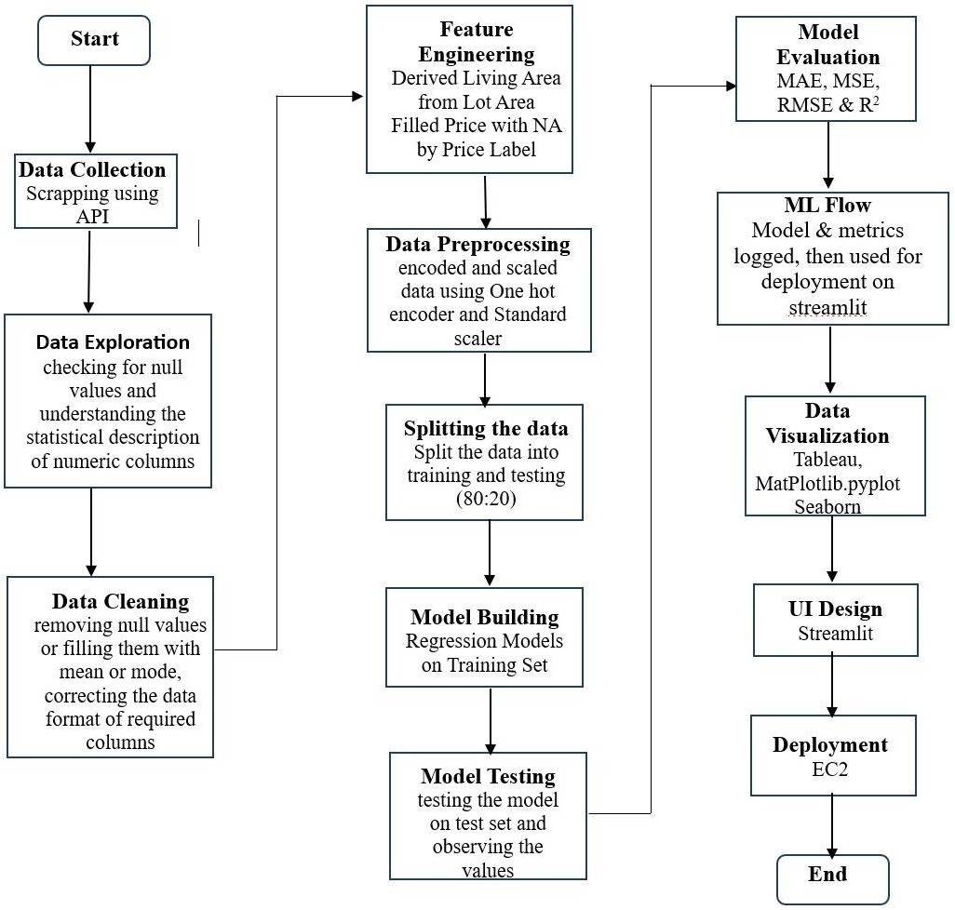

Fig.1 Workflow Diagram

  - Model Description:

    - Linear Regression
The baseline model for your project. Linear Regression establishes a relationship between the independent variables (like Area, Rooms, etc.) and the dependent variable (Price) by fitting a linear equation to the observed data.
      - Use Case: Ideal for identifying general trends and ensuring the model isn't overly
complex.
      - Technique: It minimizes the Sum of Squared Residuals to find the "line of best fit."

3.2.2 Elastic Net (The Balanced Linear Model)

Elastic Net is a regularized linear regression model. It is particularly useful if your real estate data has many features that might be related to each other (multicollinearity).
- How it Works: It combines the penalties of two other models: Lasso (L1) and

Ridge (L2).
- Lasso Penalty: Can shrink some feature coefficients to zero, effectively performing automatic Feature Selection.
- Ridge Penalty: Keeps all features but shrinks their coefficients to prevent any single feature from having too much influence.
- The Blend: Elastic Net uses a mixing parameter (l1_ratio) to decide how much of each penalty to use.
- Strengths: It is more stable than Lasso when features are highly correlated. If you have 5 different features all measuring "Size," Elastic Net will likely include them all with reduced weights, whereas Lasso might arbitrarily pick just one.

3.2.3 Decision Tree
A Decision Tree is a non-parametric supervised learning method used for both classification and regression. In your project, it acts as a "flowchart" of rules to predict house prices.
- How it Works: The model splits the dataset into smaller and smaller subsets (branches) based on feature values that result in the highest Standard Deviation Reduction or lowest Mean Squared Error (MSE).
- Key Concept: It eventually reaches a "leaf node" which contains the final predicted value—usually the average price of all training samples that fell into that specific branch.
- Strengths: Highly interpretable and easy to visualize. It requires very little data preparation (e.g., it doesn’t strictly require feature scaling).
- Weakness: Prone to overfitting; it can become too complex and "memorize" the training data rather than learning general patterns.

3.2.4. Random Forest

An Ensemble Learning technique that builds multiple decision trees and merges their results together to get a more accurate and stable prediction.
- Strength: It is excellent at capturing non-linear relationships between house features (e.g., how the interaction of 'Location' and 'Age' affects price) without requiring extensive data scaling.
- Technique: It uses Bootstrap Aggregating (Bagging) to reduce variance and prevent overfitting, which is common in single decision trees.

Gradient Boosting (The Refiner)

Gradient Boosting is an Ensemble Technique that builds models sequentially. It is often the "heavy hitter" in terms of accuracy in your pipeline.

      - How it Works: It starts with a simple initial prediction (like the average price). It then calculates the "residuals" (the errors or difference between actual and predicted). A new Decision Tree is trained specifically to predict those errors, not the actual price.
      - Key Concept: This process repeats. Each new tree "boosts" the previous ensemble by focusing solely on fixing the mistakes made by the prior trees.
      - Technique: It uses a Learning Rate (shrinkage) to ensure that each tree only contributes a small amount to the final prediction, which helps prevent overfitting and makes the model more robust.
      - Strengths: Often provides state-of-the-art predictive performance for structured tabular data.

XGBoost (Extreme Gradient Boosting)

A more advanced ensemble method often used in high-performance ML projects. Unlike Random Forest, which builds trees in parallel, XGBoost builds them sequentially, where each new tree corrects the errors made by the previous ones.
      - Strength: Highly efficient and often provides the highest accuracy (R2 score) in real estate datasets.
      - Technique: It uses Gradient Descent to minimize loss and includes built-in regularization to prevent the model from becoming too complex.

CatBoost (Categorical Boosting)

Developed by Yandex, CatBoost is specifically engineered to handle categorical variables (like Neighborhood, House Style, or City) better than any other algorithm.
      - Native Categorical Handling: Most models require you to manually use One-Hot Encoding. CatBoost does this internally using Ordered Target Statistics, which converts categories into numbers based on the target value (Price) without

"leaking" information from the future into the past.
      - Symmetric Trees (Oblivious Trees): Unlike traditional trees, CatBoost builds Symmetric Trees. This means that at every level of the tree, the same split condition is used for all nodes.
        - Benefit: This makes the model extremely fast at making predictions (inference) and acts as a strong regularizer to prevent overfitting.
      - Ordered Boosting: It uses a special permutation-based approach to calculate gradients, which helps the model stay robust even on smaller datasets.

LightGBM (Light Gradient Boosting Machine)

Developed by Microsoft, LightGBM is the "speed demon" of the machine learning world. It is designed to be memory-efficient and incredibly fast, especially when your dataset grows very large.
      - Leaf-wise Tree Growth: Traditional models grow trees "level-by-level" (horizontally). LightGBM grows trees "leaf-wise" (vertically). It finds the leaf that will reduce the most loss and splits only that one, regardless of the rest of the level.
        - Benefit: This allows it to achieve much lower error (loss) faster than other models. However, it requires careful tuning of the max_depth to avoid overfitting.

Metrics:

    - Mean Absolute Error (MAE)

MAE is the simplest metric to understand. It is the average of the absolute differences between the actual house prices and the predicted prices.
      - What it tells you: "On average, how many dollars (or units) is my prediction off?"

      - Characteristics: It treats all errors equally. A $50,000 error is exactly twice as bad as a $25,000 error.
        - It is robust to outliers, meaning one extremely "wrong" prediction won't ruin the whole score.
      - Interpretation: If your MAE is 15,000, it means your model’s house price estimates are, on average, $15,000 away from the actual price.

Mean Squared Error (MSE)

MSE is the average of the squared differences between actual and predicted values.

      - What it tells you: It measures the variance of your residuals.
      - Characteristics: Because it squares the errors, large errors are penalized heavily.
        - Example: An error of 10 becomes 100, but an error of 100 becomes 10,000.
      - Interpretation: It is harder to visualize because the unit is "dollars squared," but it is vital for training models because it forces the algorithm to avoid making massive mistakes.

Root Mean Squared Error (RMSE)

RMSE is simply the square root of the MSE. It was likely included in your project to bridge the gap between MSE and MAE.
      - What it tells you: Like MAE, it is in the same units as your target (dollars).
      - Comparison to MAE: If your RMSE is much higher than your MAE, it indicates that your model is making a few very large errors (outliers) that are skewing the results.
      - Interpretation: It acts as a "standard deviation" of your prediction errors.

R2 Score (Coefficient of Determination)

While the previous metrics focus on "error," R2 focuses on "fit." It is usually a value

between 0 and 1 (or 0% to 100%).
      - What it tells you: What percentage of the variance in house prices can be explained by your features (Area, Rooms, etc.)

Interpretation:
        - R2=0.85: Your model explains 85% of the price variations. The remaining 15% is due to factors not in your data (e.g., "vibes" or a very specific buyer's preference).
        - R2=1.0: A perfect model (likely overfitted).

Chapter 4 Implementation
- Use of Python Platform for writing the code with
- Hardware and Software Configuration: Hardware Configuration:
  - CPU: 16 GB RAM, 10 core
  - GPU: 8 GB RAM Nvidia's RTX 5050

Tools and Technologies Used:-
  - Anaconda: It is a package management software with free and open-source distribution of the Python and R programming language for scientific computations (data science, machine learning applications, large-scale data processing, predictive analytics, etc.), that aims to simplify deployment.
  - Jupyter Notebook: Jupyter is a web-based interactive development
environment for Jupyter notebooks, code, and data.
Jupyter is flexible: configure and arrange the user interface to support a wide range of workflows in data science, scientific computing, and machine learning.
Jupyter is extensible and modular: write plugins that add new components and integrate with existing ones.
  - Tableau: It is a powerful data visualization and business intelligence tool
used to transform raw data into understandable, interactive dashboards and graphs.
  - VirtualBox: is a free, open-source virtualization software from Oracle that
lets you create and run multiple virtual machines (VMs) on a single physical computer, allowing different operating systems (like Windows, Linux, macOS) to run simultaneously as "guests" on your main "host" OS, ideal for testing software, development, and running diverse environments without extra hardware.
  - PySpark: PySpark is the Python API for Apache Spark, a lightning-fast
engine designed for large-scale distributed data processing. While standard Python libraries like Pandas struggle with datasets that exceed a computer's

memory, PySpark excels by splitting tasks across a cluster of machines, allowing you to process terabytes of data in parallel. It combines the simplicity of Python with the raw power of Spark’s core engine, offering specialized modules for SQL queries, real-time streaming, and machine learning (MLlib). Essentially, it’s the go-to tool for data engineers and scientists who need to scale their analytics from a single laptop to a massive cloud-based infrastructure
  - MLflow: ML FLow is a comprehensive, open-source infrastructure
designed to standardize the end-to-end machine learning lifecycle. It functions as a "single source of truth" for data teams by providing four core modules: Tracking for logging experiment metrics and parameters, Projects for packaging code into reproducible runs, Models for standardizing model formats across different frameworks, and the Model Registry for centralized versioning and stage management (e.g., from Staging to Production). By abstracting away the underlying library or cloud environment, MLflow ensures that models remain portable and results are fully auditable across an entire organization.
  - UI Application Using Streamlit: Streamlit is an open-source Python
library that allows data scientists to quickly build and share interactive web applications for machine learning and data science projects without requiring front-end development experience. It turns data scripts into shareable web apps in minutes, making it ideal for creating interactive dashboards, model visualization tools, and rapid prototyping.
  - AWS: The Scalable Cloud Infrastructure: AWS is a comprehensive
cloud computing platform that provides on-demand access to technical resources like computing power, storage, and databases on a pay-as-you-go basis. For data scientists, it eliminates the need to manage physical hardware by offering managed services like Amazon SageMaker for building and deploying ML models, Amazon S3 for vast data storage, and Amazon EC2 for scalable virtual servers. By leveraging its global infrastructure, teams can instantly spin up Hadoop clusters or GPU-powered instances to handle massive datasets and complex computations without upfront capital investment.
  - GitHub: GitHub is a cloud-based platform that hosts Git repositories,
serving as a central hub where developers store, share, and manage their project code. While Git tracks changes on your local machine, GitHub brings that history to the web, acting as a "social coding" platform where

you can collaborate with others through Pull Requests and code reviews. It provides essential project management tools like Issues for tracking tasks and GitHub Actions for automating tests and deployments. By keeping your work in a GitHub repo, you ensure it is safely backed up in the cloud and easily accessible for showcasing as a professional portfolio.

Implementation:-

Data Extraction Using API:
  - Real estate data was collected using the Scrapeak API for zillow by scraping the Zillow real estate website (https://www.zillow.com/)
  - Data was extracted city-wise, capturing property details such as price, lot area, bedrooms, bathrooms, city, state, and zip code.
  - Multiple city-level datasets were generated and stored locally.

Data Integration:
  - All city-wise datasets were merged into a single consolidated dataset using Pandas.
  - Consistent column naming and schema alignment were ensured before merging.
  - This unified dataset was used for further analysis and modeling.

Exploratory Data Analysis (EDA):
  - Initial exploration was performed using Pandas DataFrame methods.
  - The following checks were conducted:
    - Identification of null and missing values
    - Understanding statistical measures (mean, median, min, max, standard deviation)
    - Analysis of data types for each feature
  - EDA helped identify data quality issues and guided cleaning strategies.

Data Cleaning:
Data cleaning was implemented using NumPy and Pandas:
  - Missing values were handled using:
    - Mean for continuous numerical features
    - Median for skewed distributions
    - Mode for categorical features
  - Data format corrections were applied:
    - Converted price fields such as "price in $" from float to numeric
    - Removed currency symbols and commas
  - Column names were renamed for consistency and readability.

  - Data type conversions were performed wherever required.
  - Lot area units were standardized by converting values from acres to square feet.
  - Irrelevant, or highly redundant features were excluded/removed to ensure data quality.

Feature Engineering
Feature engineering was performed to enhance model performance:
  - A new feature living_area_sqft was derived from the lot area.
  - The priceLabel field was used to derive a clean numerical price (price in $) column.
  - These engineered features improved interpretability and predictive accuracy.
  - Selected the most relevant variables (features) from the raw data to improve model performance

Data Preprocessing for Model Building:
Preprocessing was implemented using Scikit-learn:
  - Dropped unused columns to reduce the complexity of the dataset and improve computational efficiency
  - One-Hot Encoding was applied to categorical features:
    - City
    - State
  - Standard Scaling was applied to the numerical feature:
    - Living area in square feet

Train-Test Split:
  - The dataset was split using train_test_split:
    - 80% training data
    - 20% testing data
  - This separation ensured unbiased evaluation of model performance.

Model Development:
Multiple regression models were trained on the training dataset:
  - Linear Regression
  - Elastic Net Regression
  - Decision Tree Regressor
  - Random Forest Regressor
  - XGBoost Regressor
  - LightGBM Regressor
  - CatBoost Regressor
Each model was trained using the same preprocessing pipeline for fair comparison.

Hyperparameter Tuning:
  - Hyperparameter tuning was performed individually for each model to optimize performance.
  - Important parameters were documented in the report, such as:
    - n_estimators
    - max_depth
    - learning_rate
    - alpha, l1_ratio
    - max_features
  - R² score was used as the primary metric for model selection.
  - Higher R² values indicated better predictive capability.

Model Evaluation and Selection:
  - The best-performing model was selected based on the highest R² score.
  - The Random Forest Regressor achieved the best performance with:
    - R² ≈ 99%
    - Optimized parameters:
      - n_estimators = 200
      - max_features = None
  - Final evaluation metrics computed:
    - MAE , MSE, RMSE, R² Score

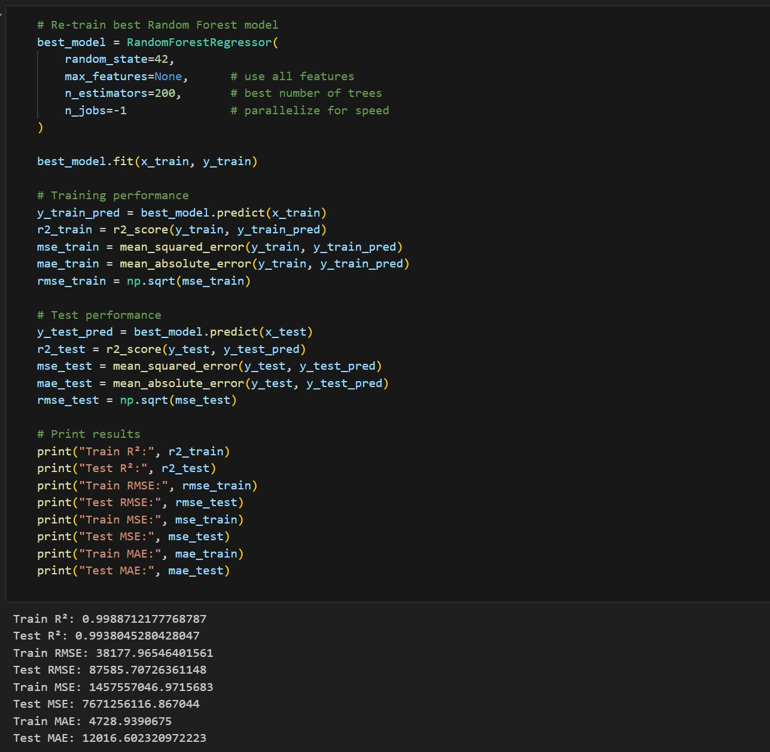

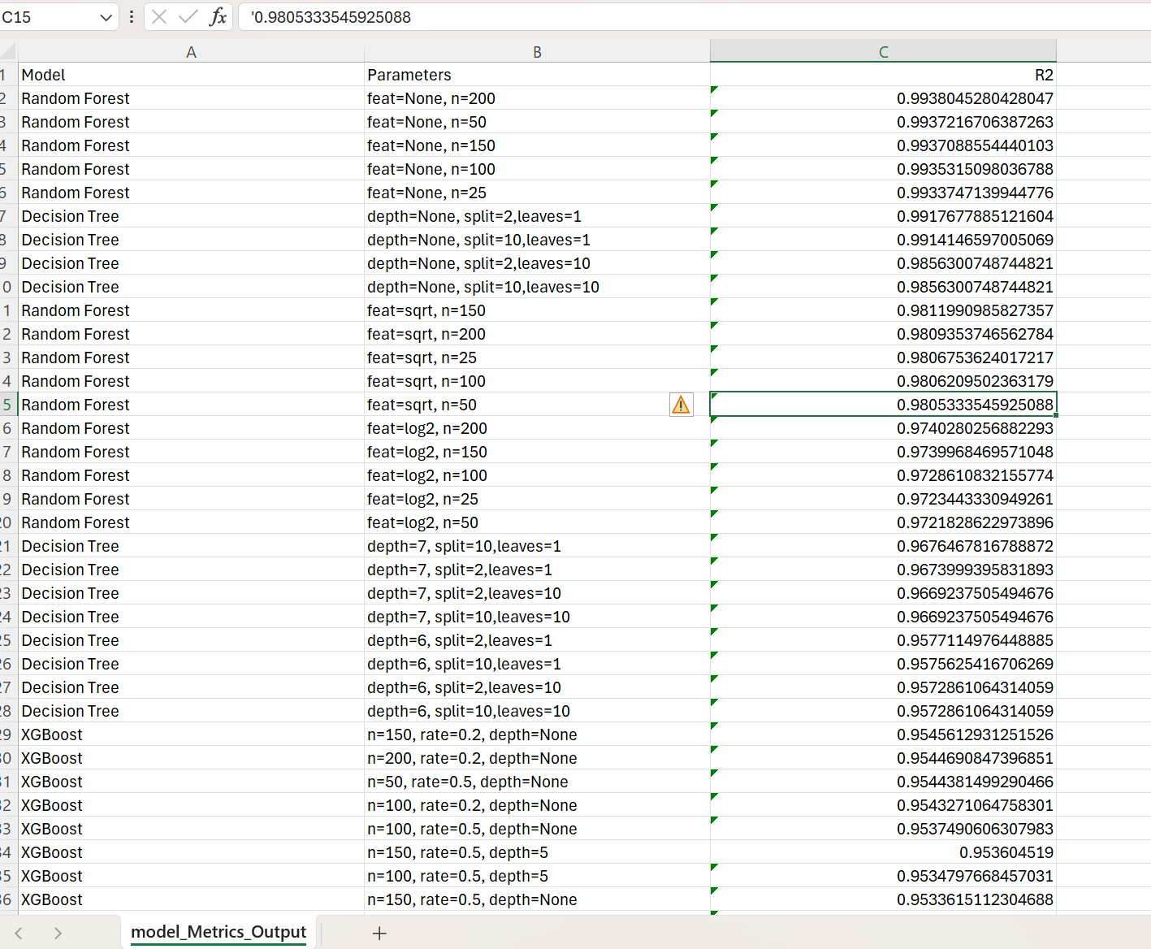

Experiment Tracking Using MLflow:
  - MLflow was used to track experiments and model performance.
  - An experiment called House_Price_Prediction_Model_Train_Log was created to log the model and its metrics.
  - Logged components included:
    - Model parameters
    - Evaluation metrics
    - Trained model artifacts
  - MLflow UI was accessed locally at:
http://127.0.0.1:5000/
  - The final model was also stored in pickle format for local usage.
  - Since preprocessing was included in the pipeline, no additional preprocessing was required during inference.

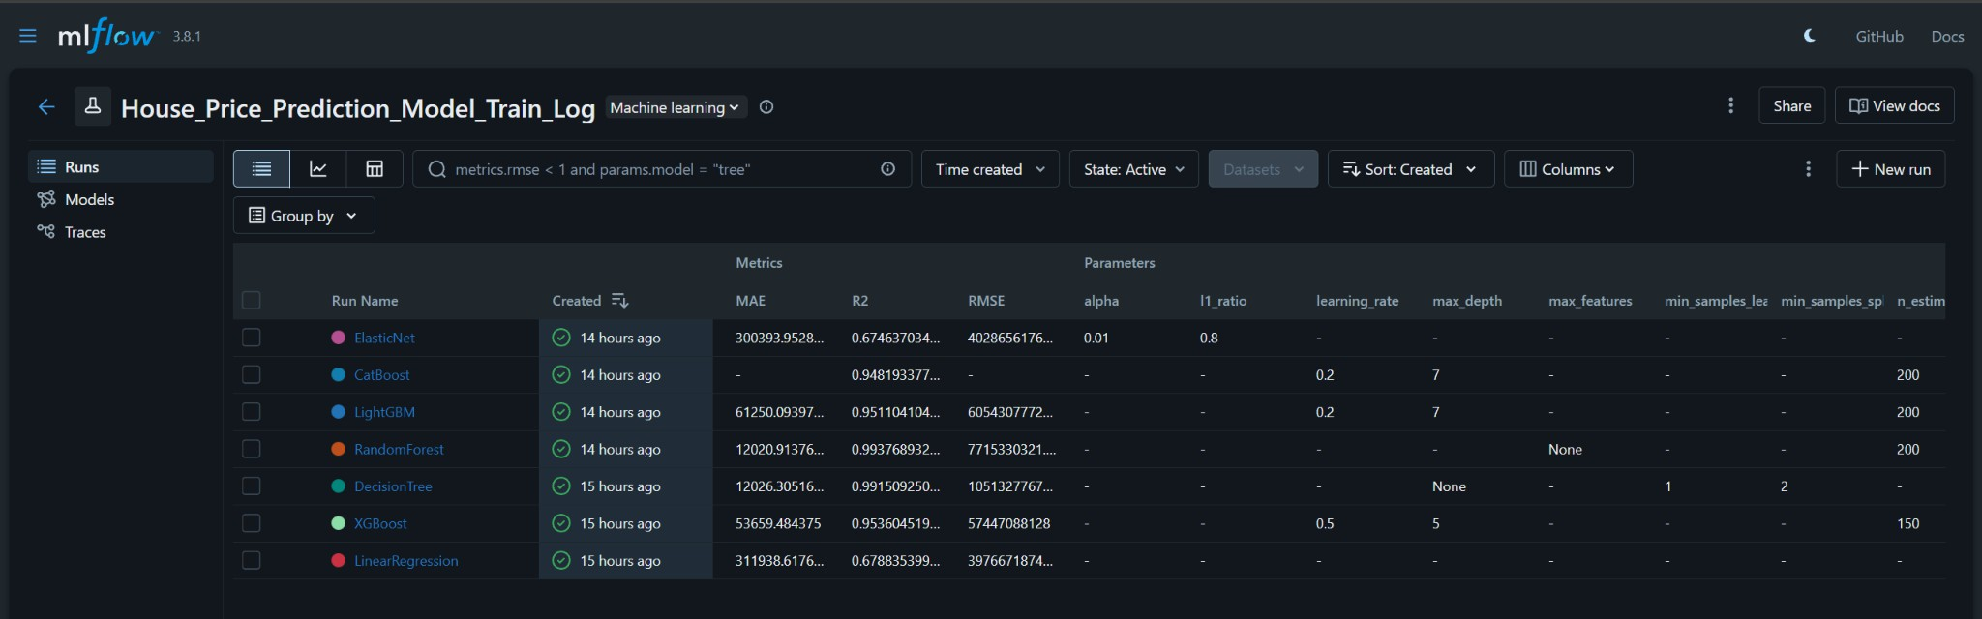
http://127.0.0.1:5000/#/experiments/5/runs?searchFilter=&orderByKey=attributes.start_ti me&orderByAsc=false&startTime=ALL&lifecycleFilter=Active&modelVersionFilter=A ll+Runs&datasetsFilter=W10%3D

Big Data Model Training Using PySpark:
  - For large datasets, PySpark was used instead of Pandas.
  - Gradient Boosting models were trained using Spark MLlib.
  - The PySpark model achieved an R² score of approximately 89%, demonstrating scalability for large datasets.

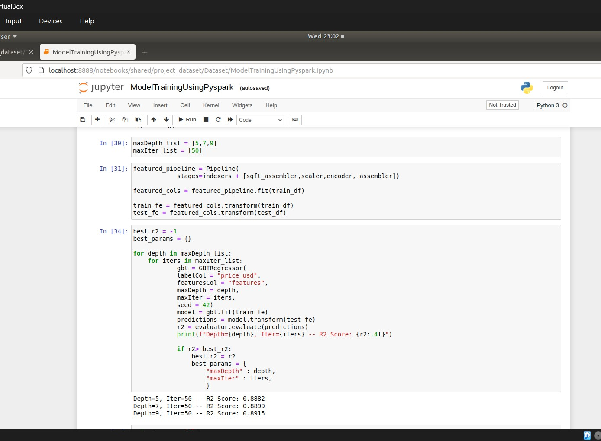
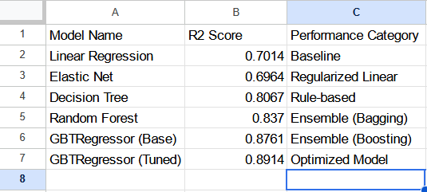

R2 Score :
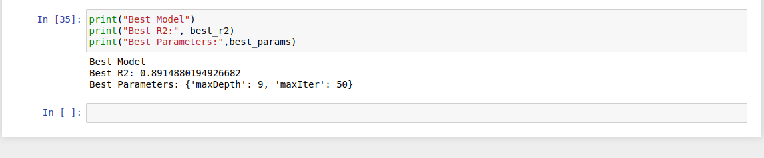

Data Visualization:
  - Tableau was used to create interactive dashboards for data analysis, including:
    - Average living area and price KPIs
    - Price per square foot by state

    - Price distribution
    - Average price by city and bedroom count
  - Additional visualizations were created using:
    - Matplotlib
    - Seaborn
  - These visualizations provided insights into regional price trends and property characteristics.

User Interface Development:
  - A Streamlit application was developed to provide a user-friendly interface.
  - The UI accepts the following inputs:
    - Living area (sq. ft)
    - Number of bedrooms
    - Number of bathrooms
    - City
    - State
    - Zip code (USA)
  - The trained model (pickle file with pipeline) was loaded directly for prediction.
  - Tableau dashboards were embedded within the Streamlit application.

Deployment:
  - The complete application was deployed on an AWS EC2 instance.
  - The deployed system allows users to:
    - Enter property details
    - View predicted house prices
    - Analyze visualization dashboards
  - This deployment enables real-time house price prediction through a web-based interface.

- Visualization:-

Chapter 5

Results

By Matplotlib and seaborn:-
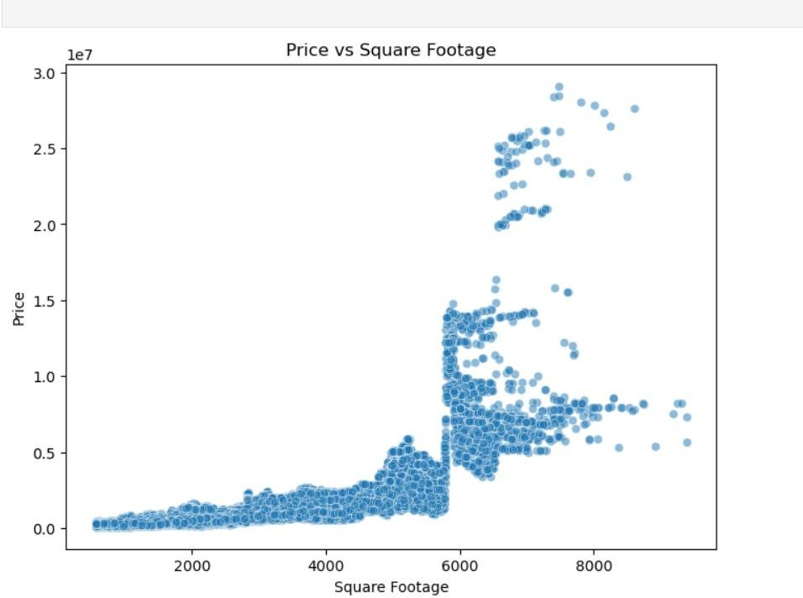

- Positive correlation: In general, larger homes tend to have higher prices. The upward trend is visible, especially in the lower-to-mid range of square footage.
- High variability: Above ~5000 sq ft, prices scatter widely. Some large homes are relatively affordable, while others are extremely expensive. This suggests that square footage alone doesn’t explain price.
- Outliers: A few properties are priced far higher than the rest, even when their square footage isn’t extraordinary. These are likely luxury homes influenced by location, amenities, or other premium features.

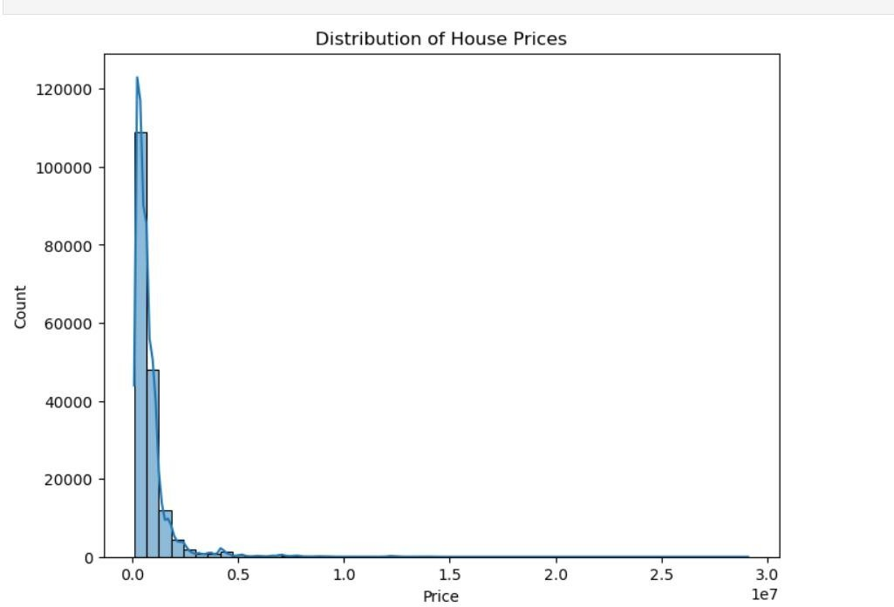

- Right-skewed distribution: Most houses are priced at the lower end (closer to 0–1 million), while fewer houses extend into the very high range (10M+).
- Long tail: The density curve stretches far to the right, meaning there are rare but extremely expensive houses that pull the distribution outward.
- Central tendency: The bulk of the data is concentrated at relatively affordable prices compared to the extreme outliers.

By Tableau:-
Goal:
To understand what factors influence house prices (location, size, bedrooms, state, city) and how price behaves across different segments — so these insights can be used for house price prediction and valuation models.

Dashboard 1:- Market Analysis
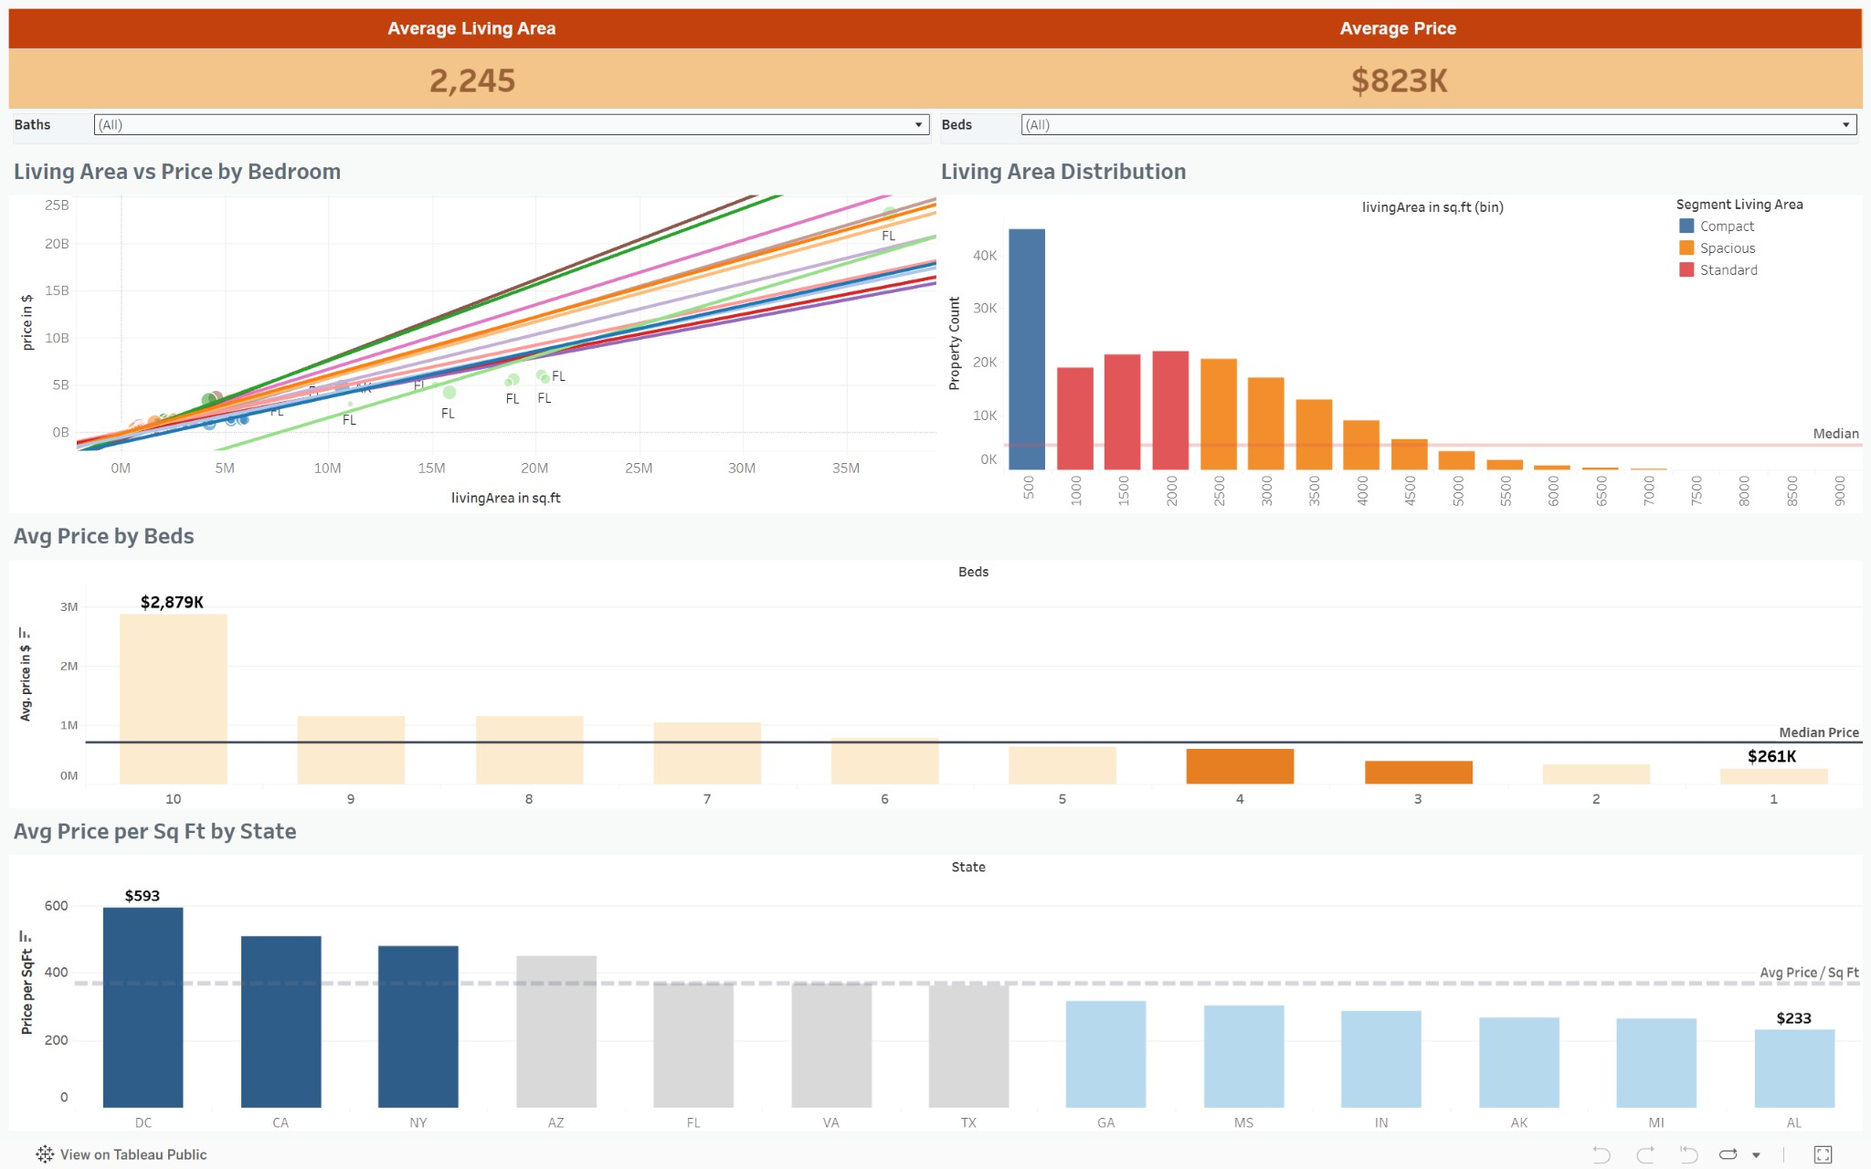

      - Living Area vs Price by Bedrooms (Scatter + Trend)
What you’re analyzing
        - Relationship between living area and price
        - Effect of bedroom count
How to explain
As living area increases, price increases — but the rate differs by bedroom count.
Homes with more bedrooms generally command higher prices for the same living area.
Prediction insight
        - Confirms multicollinearity between:
          - Living area
          - Bedrooms
        - Suggests using interaction features (Area × Beds)

Living Area Distribution
What you’re analyzing
        - Distribution of property sizes
        - Compact vs standard vs spacious homes
How to explain
Most properties cluster within a standard living area range, while very large homes are relatively rare.
Prediction insight
        - Living area is a strong but non-linear predictor
        - Extreme values can cause price jumps

Avg Price by Beds
What you’re analyzing
        - Price trend with increasing bedrooms
How to explain
Prices increase with bedroom count, but the increase is not linear. Beyond a point, additional bedrooms add diminishing value.
Prediction insight
        - Bedrooms should be treated as:
          - Categorical or ordinal
          - Not purely linear numeric feature

Avg Price per Sq Ft by State
What you’re analyzing
        - Efficiency of pricing across states
How to explain
Price per Sq Ft highlights true cost differences independent of house size. Some states have smaller homes but much higher per-unit cost.
Prediction insight
        - Price per Sq Ft is a strong derived feature
        - Helps normalize predictions across different home sizes

Filter
        - Added filter for nos of bedrooms and bathrooms. Based on this filter the entire dashboard gets changed according to the filter applied.
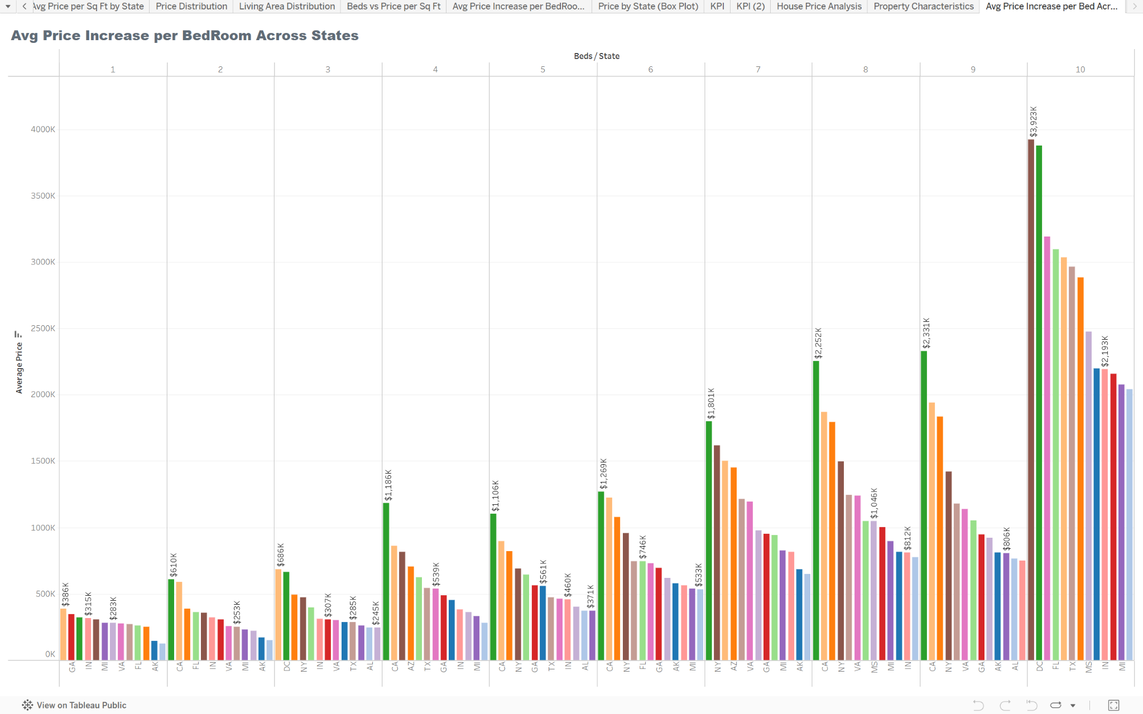

Avg Price Increase per Bedroom Across States
What you’re analyzing
- Incremental value added by each bedroom in different states
How to explain
The impact of an extra bedroom varies significantly by location.
In high-demand states, each additional bedroom adds much more value.
Prediction insight
  - Shows location × bedroom interaction
  - Supports state-specific or region-specific models

Dashboard 2:- Property Characteristics

      - KPI Section – Market Analysis (Top Row)
What we are analyzing
        - Average Living Area
        - Average Price
        - Price per Sq Ft
        - Total Property Count
How to explain
This KPI section provides a high-level snapshot of the housing market after applying filters like State, City, or Zipcode.
It helps quickly understand:
        - Typical house
        - Average property price
        - Market density
        - Cost efficiency (price per sq ft)
Why it matters for prediction
        - These KPIs act as baseline benchmarks.
        - Price per Sq Ft is especially important as a normalized feature in prediction models.

Avg Price by State (Map Chart)
What you’re analyzing
        - Geographic variation of average prices across states
How to explain
This visualization highlights how location significantly impacts house prices. Coastal and metropolitan states (e.g., CA, NY, DC) show much higher

average prices compared to interior states.
Prediction insight
        - State/location must be a strong predictive feature
        - Prices are not evenly distributed geographically

Avg Price by City (Top 10)
What you’re analyzing
        - City-level price concentration
How to explain
Even within the same state, prices vary significantly at the city level.
Top cities like San Francisco, Hollis, and Maspeth command much higher prices.
Prediction insight
        - City is more granular and powerful than state
        - Justifies using City or Zipcode instead of only State in models

Price Distribution (Histogram)
What you’re analyzing
        - Distribution of house prices across ranges
        - Affordable, mid-range, luxury segmentation

How to explain
The market is right-skewed, meaning most properties fall in lower price ranges, while a small number of luxury homes drive the upper tail.
Prediction insight
        - Indicates non-normal distribution
        - Suggests:
          - Log transformation of price
          - Separate modeling for luxury vs affordable segments

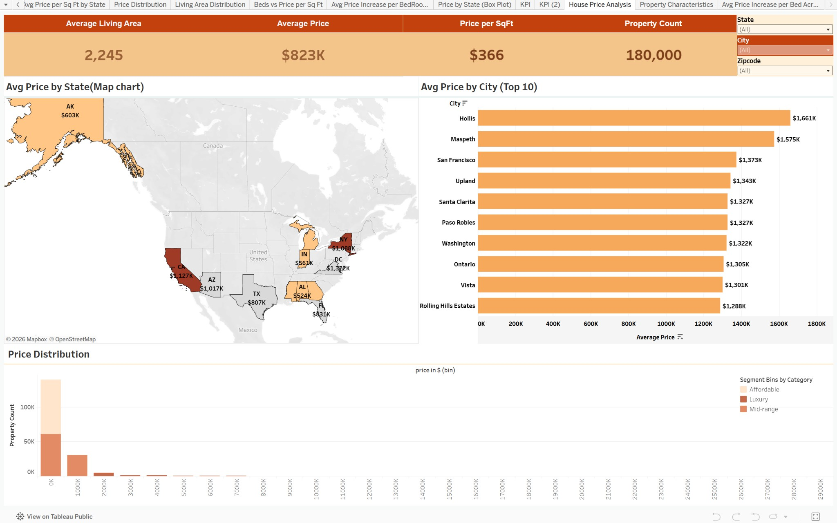

Some Predicted Results on StreamLit :-
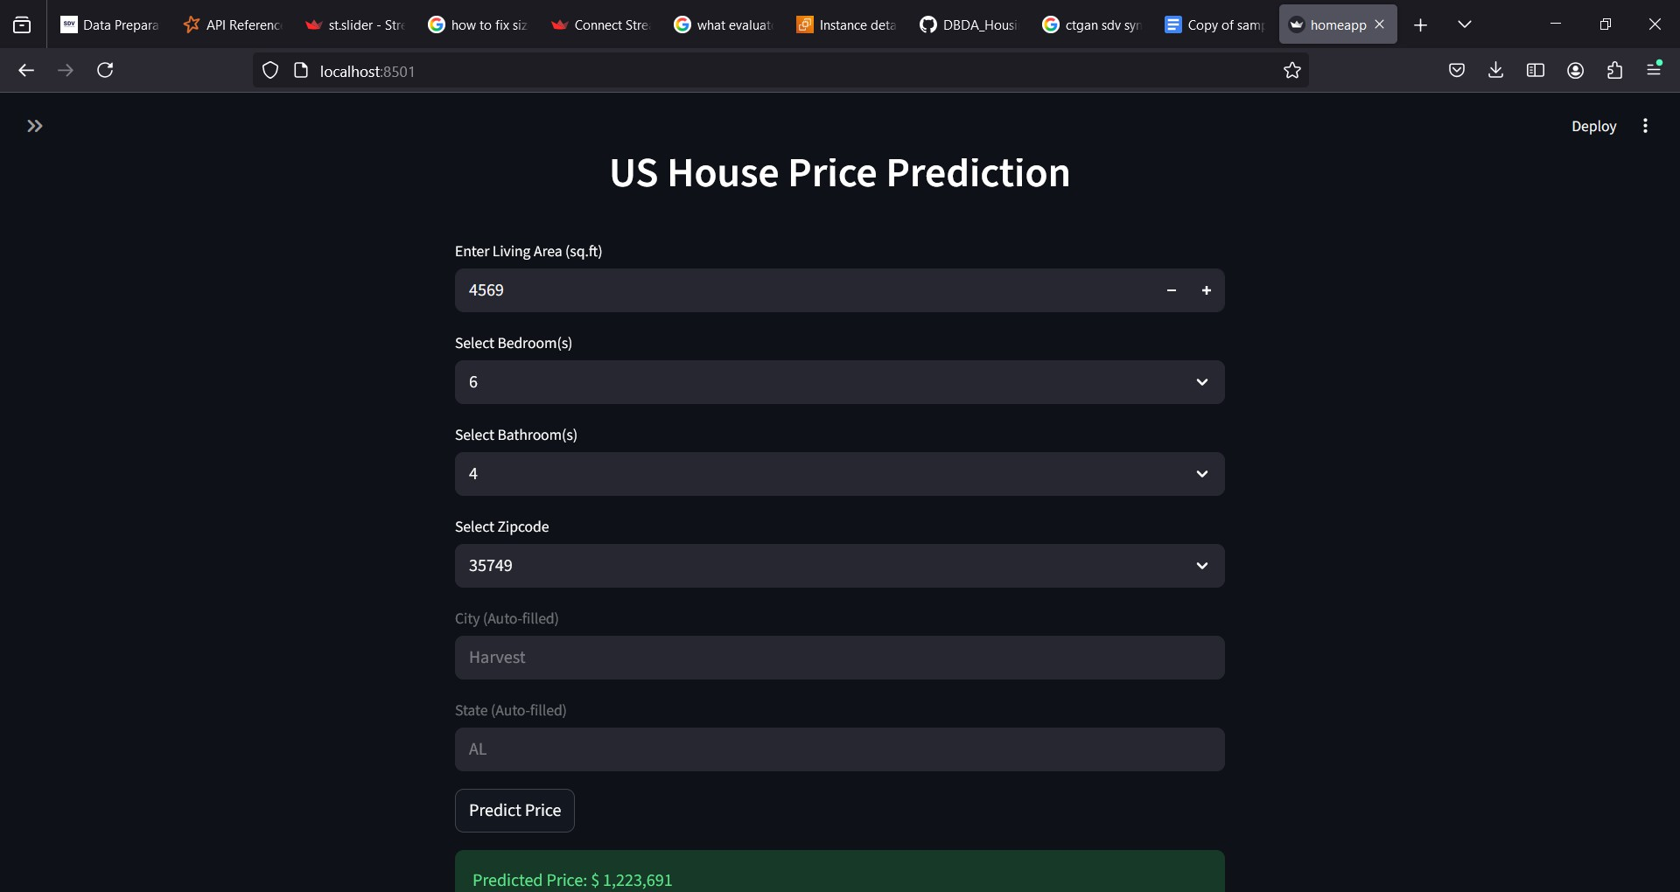

AWS Deployment
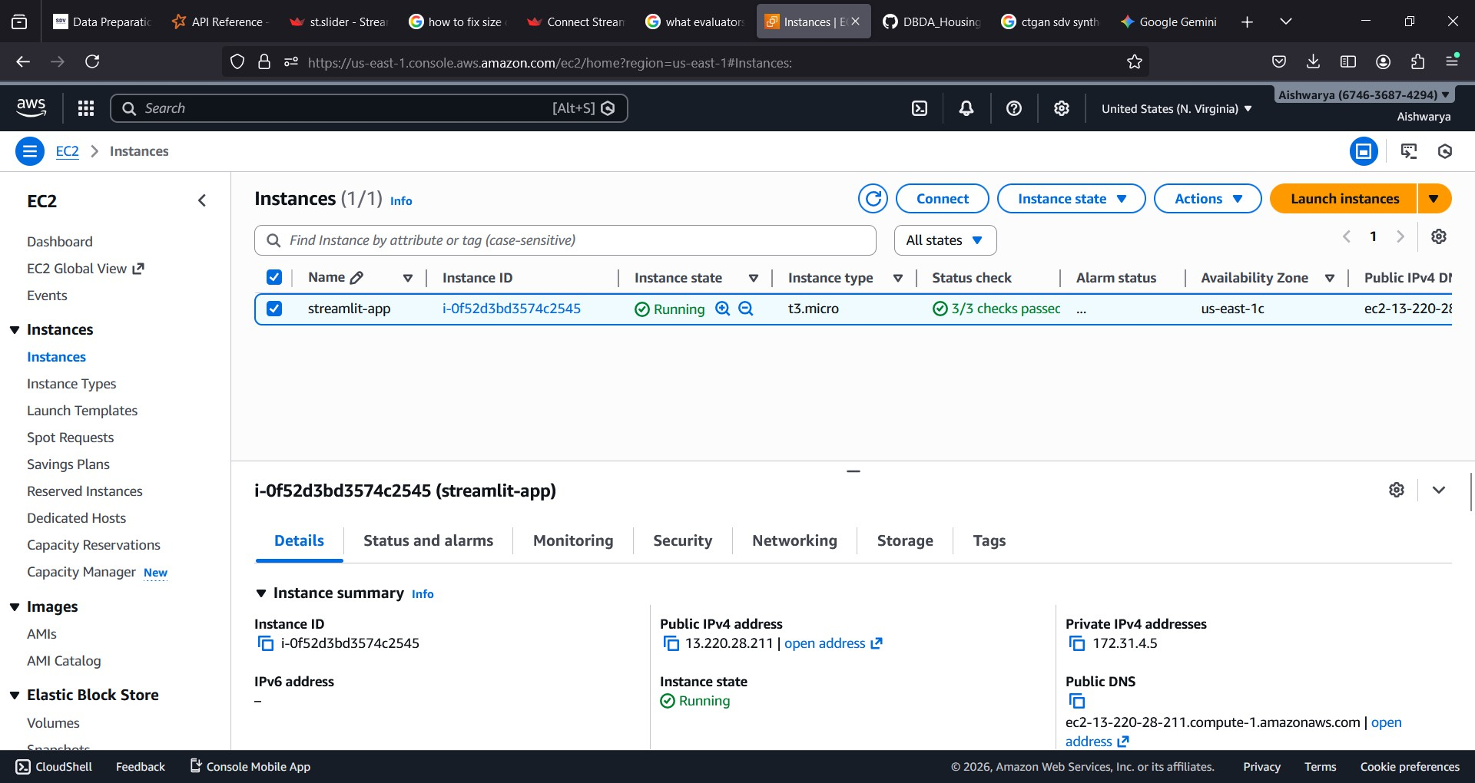

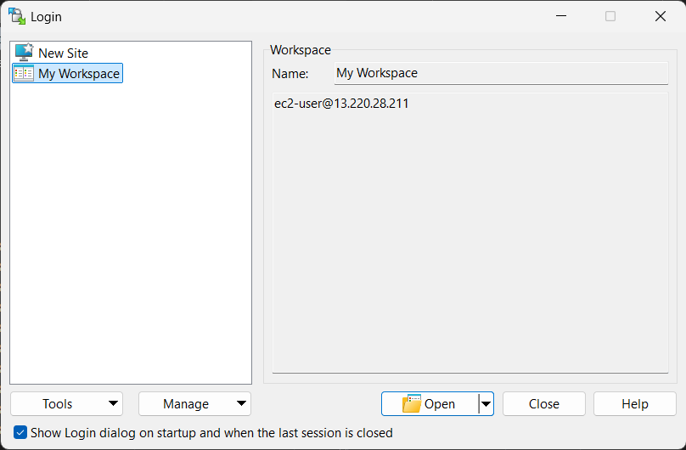

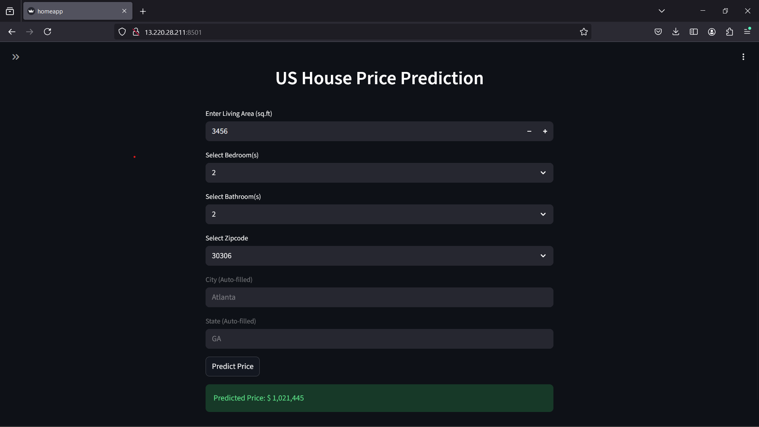

  - Conclusion

Chapter 6 Conclusion

This project presented an end-to-end machine learning framework for residential property price prediction, addressing the inherent complexity and volatility of real estate markets through robust data preprocessing and model evaluation. Multiple regression models were developed and compared to identify the most effective approaches for accurate property valuation.
Using Pandas-based machine learning pipelines, several models were trained, including Linear Regression, Elastic Net Regressor, ,Decision Tree Regressor, Random Forest Regressor, and boosting algorithms such as XGBoost, LightGBM, and CatBoost. For these models, hyperparameter tuning—including adjustments to tree depth, number of estimators, learning rates, and feature sampling strategies—was performed to optimize performance. Among all models trained in the Pandas environment, the Random Forest Regressor achieved the highest performance, with an R² score of approximately 99%, demonstrating its strong capability to model complex, nonlinear relationships in structured housing data.
To evaluate scalability on large datasets, the project also implemented distributed machine learning using PySpark. Models such as Linear Regression, Decision Tree, Random Forest, and Gradient Boosted Trees were trained with multiple hyperparameter configurations. This systematic tuning ensured fair model comparison and improved predictive accuracy in a big data context. Among the PySpark models, Gradient Boosting delivered the best performance, achieving an R² score of approximately 89%, indicating its effectiveness when handling large-scale housing datasets.

In conclusion, the results demonstrate that ensemble-based models consistently outperform for large dataset regression techniques for residential property valuation. While Pandas-based Random Forest models provide exceptional accuracy on moderate-sized datasets, PySpark Gradient Boosting offers a scalable and reliable solution for large datasets. This study highlights the importance of hyperparameter optimization and distributed computing frameworks in developing accurate, production-ready real estate price prediction systems.
In conclusion, ensemble-based models consistently outperform traditional regression techniques for residential property valuation, particularly when handling large datasets. During Pandas-based model training, the Random Forest model achieved exceptional accuracy on moderate-sized datasets through effective hyperparameter tuning. For large datasets, PySpark Gradient Boosting provided a scalable and reliable solution. These results highlight the importance of combining optimized model training with distributed computing frameworks to build accurate, production-ready real estate price prediction systems.

Future Enhancement –
    - Explore deep learning models and hybrid approaches that combine structured data with images or textual property descriptions.
    - Integrate real-time data streaming and automated model retraining to adapt to changing market trends.
    - Enhance deployment by scaling the Streamlit application with containerization tools like Docker and orchestration platforms such as Kubernetes.

Chapter 7 References
- Rawool, Anand G. & Rogye, Dattatray V. & Rane, Sainath G. & Bharadi, Vinayak A. (2021). House Price Prediction Using Machine Learning. Iconic Research and Engineering Journals. 4(11). 29-35. ISSN: 2456-8880.
- Madhuri, C.H. Raga & Anuradha, G. & Pujitha, M. Vani. (2019). House Price Prediction Using Regression Techniques: A Comparative Study. IEEE Xplore: International Conference on Smart Structures and Systems. 1-8.
10.1109/ICSSS.2019.8882831.

- “Machine Learning Engine for Real Estate Price Estimation.” (2024). CEUR-WS.org / AISD. 1-15.
- https://scikit-learn.org/stable/api/index.html

- https://spark.apache.org/docs/latest/api/python/reference/index.html

- https://docs.streamlit.io/

- https://mlflow.org/docs/latest/ml

- https://www.geeksforgeeks.org/machine-learning/machine-learning-algorithms/

