# Screenshots – 2048 Game Deployment on EKS with ALB Ingress

This folder contains visual proof of a successful end-to-end deployment of the 2048 web app on an Amazon EKS cluster, integrated with an ALB ingress controller.

## SS1.png – 2048 Game in Browser (Top View)

- Shows the 2048 game UI accessed through the ALB-generated DNS.

- Confirms successful deployment and ingress routing.

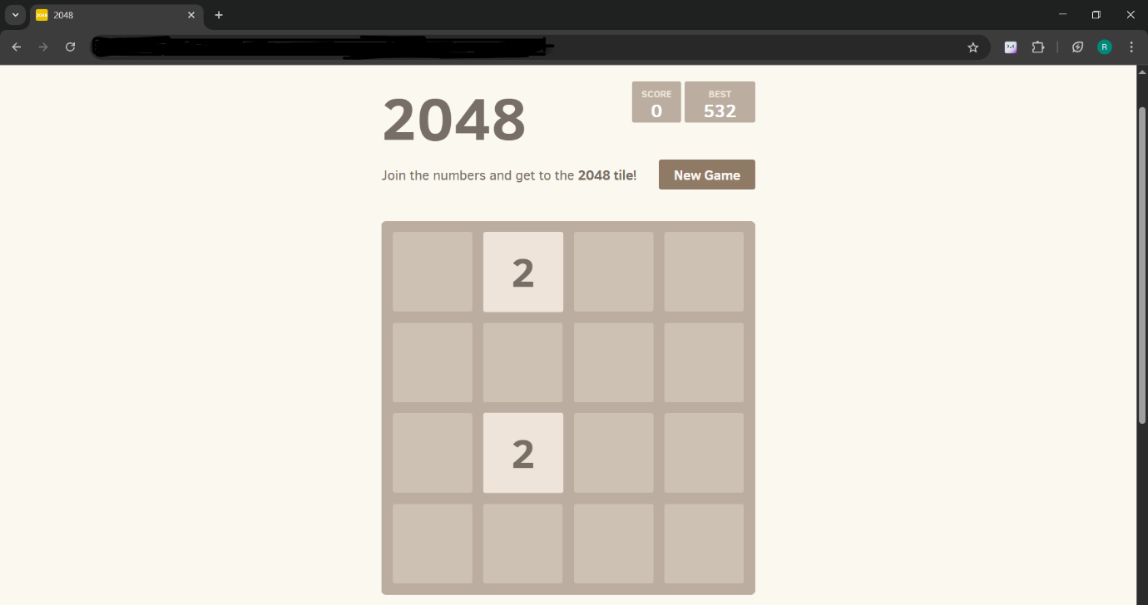

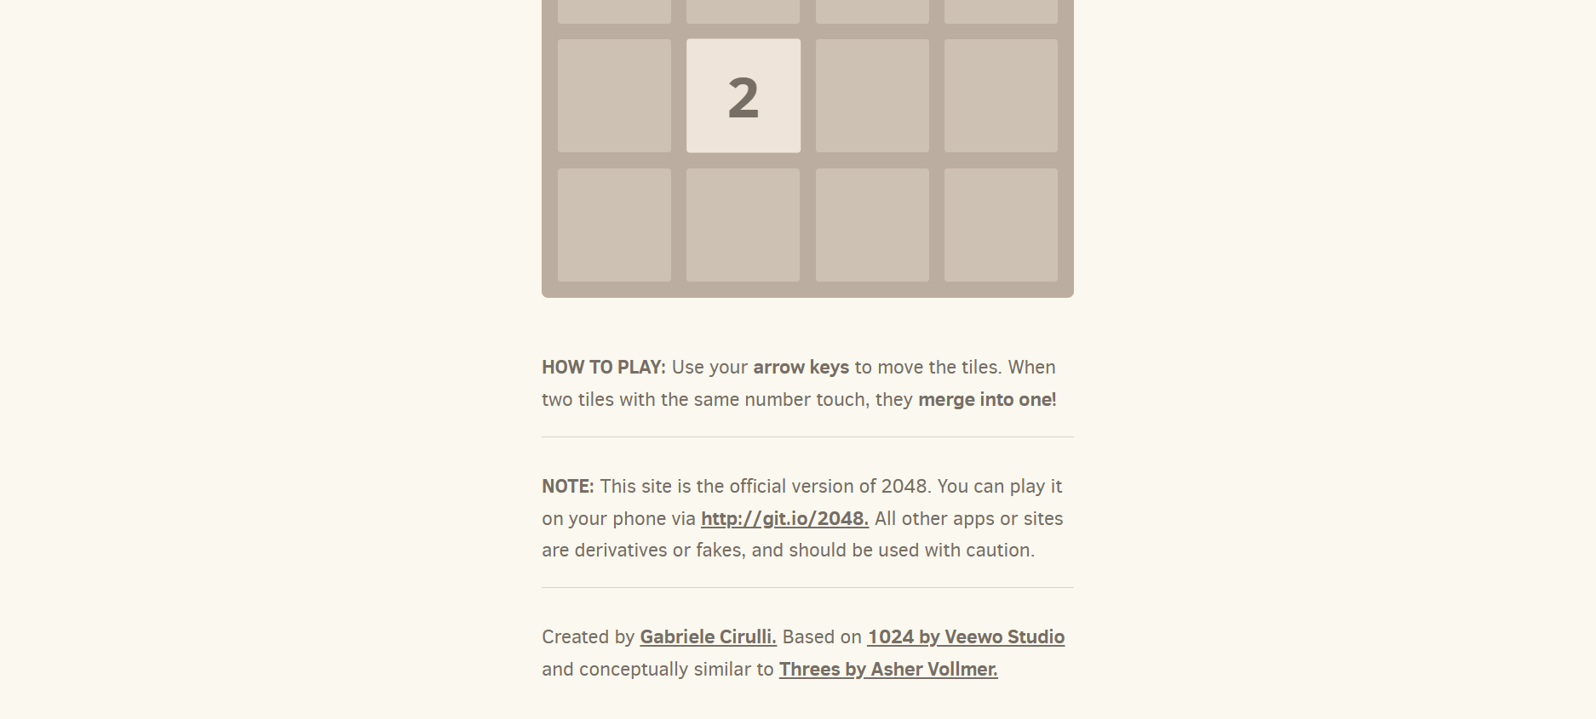

## SS3.png – Load Balancer (AWS Console)

- Displays the Application Load Balancer automatically created by the ALB Controller.

- Confirms ALB status as “Active” and attached VPC.



## SS4.png – ALB Controller Deployment (kubectl)

- Output from `kubectl get deployment -n kube-system aws-load-balancer-controller`.

- Shows controller is up and running with 2/2 pods ready.



## SS5.png – 2048 Pod Replicas Running

- Lists individual 2048 pods managed by the Deployment.

- Proves high availability with multiple pods in running state.

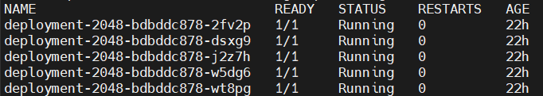

## SS6.png – Service & Deployment Status

- Displays `kubectl get all` for the 2048 service and deployment.

