**Assignment-2**

Name: G.Harshith

RegNo:20BCI7139

1.create , update, delete commands in mysql.

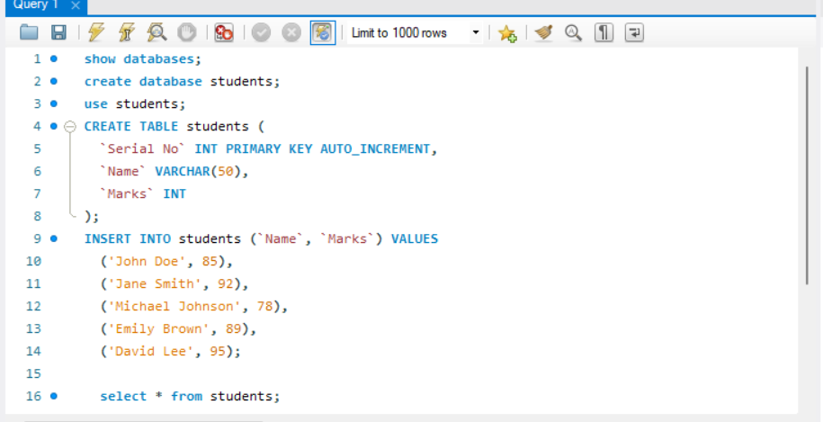

2. create tables and perform joins in mysql.

Tables:

Inner join:

Left join:

right join:

Full outer join:

3. create update, delete commands in mongo.

Create:

Update:

1.

2.

Delete:

1.



2.

