**ASSIGNMENT-3**

Name:- S. Manish

Registration no. : 20BCE7228

**1). FOR DISPLAYING RECORDS:**

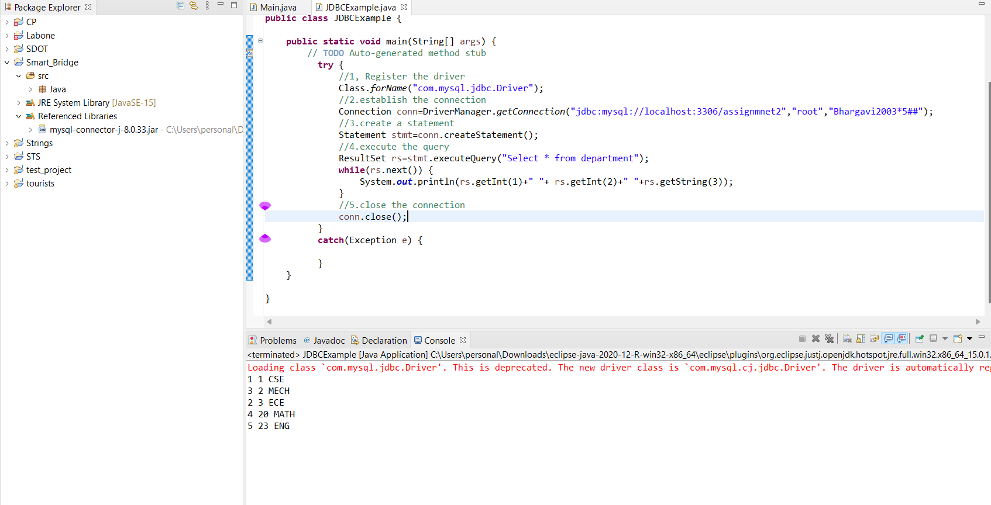

**2.1). PREPARED STATEMENT TO INSERT VALUES FROM USER:**

**package** Java;

**import** java.sql.Connection;

**import** java.sql.DriverManager;

**import** java.sql.PreparedStatement;

**import** java.sql.Statement;

**import** java.sql.ResultSet;

**public** **class** JDBCExample {

**public** **static** **void** main(String[] args) {

// **TODO** Auto-generated method stub

**try** {

//1, Register the driver

Class.*forName*("com.mysql.jdbc.Driver");

//2.establish the connection

Connection conn=DriverManager.*getConnection*("jdbc:mysql://localhost:3306/assignmnet2","root","Bhargavi2003*5##");

//3.create a statement

PreparedStatement stmt=conn.prepareStatement("insert into department values(?,?,?)");

stmt.setInt(1, 6);

stmt.setInt(2, 50);

stmt.setString(3,"CIVIL");

//4.execute the query

**int** result=stmt.executeUpdate();

System.***out***.println("result" + result);

//5.close the connection

conn.close();

}

**catch**(Exception e) {

e.printStackTrace();

}

}

}

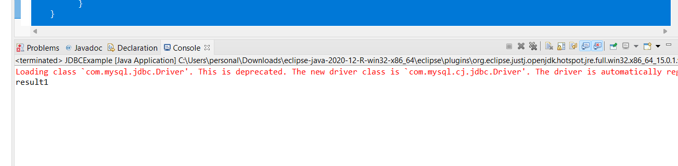

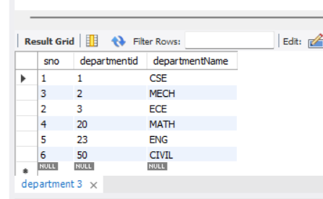

**2.2). INPUT FROM USER USING A SCANNER CLASS:**

**package** Java;

**import** java.sql.Connection;

**import** java.sql.DriverManager;

**import** java.sql.PreparedStatement;

**import** java.sql.Statement;

**import** java.util.Scanner;

**import** java.sql.ResultSet;

**public** **class** JDBCExample {

**public** **static** **void** main(String[] args) {

// **TODO** Auto-generated method stub

**try** {

//1, Register the driver

Class.*forName*("com.mysql.jdbc.Driver");

//2.establish the connection

Connection conn=DriverManager.*getConnection*("jdbc:mysql://localhost:3306/assignmnet2","root","Bhargavi2003*5##");

//3.create a statement

PreparedStatement stmt=conn.prepareStatement("insert into department values(?,?,?)");

Scanner in=**new** Scanner(System.***in***);

System.***out***.println("please enter the sno");

**int** sno=in.nextInt();

stmt.setInt(1, sno);

System.***out***.println("please enter dept id");

**int** departmentid=in.nextInt();

stmt.setInt(2, departmentid);

System.***out***.println("Please enter dept name");

String departmentName=in.next();

stmt.setString(3, departmentName);

**int** result=stmt.executeUpdate();

System.***out***.println("result " + result);

//5.close the connection

conn.close();

}

**catch**(Exception e) {

e.printStackTrace();

}

}

}

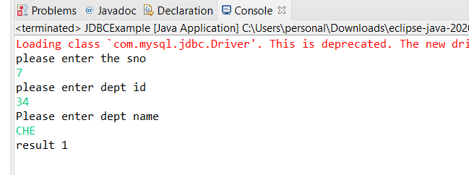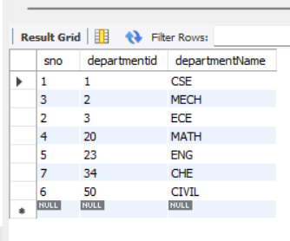

**3). FOR DELETING RECORD:**

**package** Java;

**import** java.sql.Connection;

**import** java.sql.DriverManager;

**import** java.sql.PreparedStatement;

**import** java.sql.Statement;

**import** java.util.Scanner;

**import** java.sql.ResultSet;

**import** java.sql.SQLException;

**public** **class** JDBCExample {

**public** **static** **void** main(String[] args) {

// **TODO** Auto-generated method stub

**try** {

//1, Register the driver

Class.*forName*("com.mysql.jdbc.Driver");

//2.establish the connection

Connection conn=DriverManager.*getConnection*("jdbc:mysql://localhost:3306/assignmnet2","root","Bhargavi2003*5##");

//3.create a statement

Statement stmt=conn.createStatement();

String sql="DELETE FROM department WHERE departmentId=50";

**int** result= stmt.executeUpdate(sql);

System.***out***.println("result "+result);

conn.close();

}

**catch**(Exception e) {

e.printStackTrace();

}

}

}

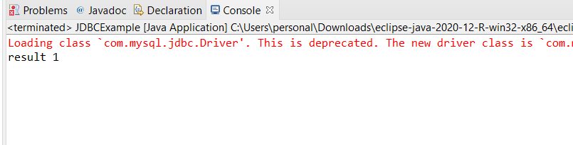

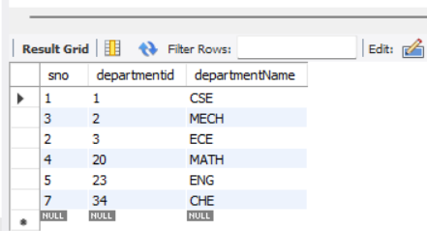

**4). FOR UPDATING RECORD:**

package Java;

import java.sql.Connection;

import java.sql.DriverManager;

import java.sql.PreparedStatement;

import java.sql.Statement;

import java.util.Scanner;

import java.sql.ResultSet;

public class JDBCExample {

public static void main(String[] args) {

// TODO Auto-generated method stub

try {

//1, Register the driver

Class.forName("com.mysql.jdbc.Driver");

//2.establish the connection

Connection conn=DriverManager.getConnection("jdbc:mysql://localhost:3306/assignmnet2","root","Bhargavi2003*5##");

//3.create a statement

Statement stmt=conn.createStatement();

String sql="UPDATE department SET departmentName='CIVIL' WHERE sno=4";

int result=stmt.executeUpdate(sql);

System.out.println("result "+result);

ResultSet rs=stmt.executeQuery("select * from department");

while(rs.next()) {

System.out.println(rs.getInt(1)+" "+rs.getInt(2)+" "+rs.getString(3));

}

conn.close();

}

catch(Exception e) {

e.printStackTrace();

}

}

}

