Tomato Plant Disease Detection using various Deep learning Techniques

*B Sai Abhishek  
Dept of CSE,  
Amrita School of Computing,  
Bengaluru,*

*Amrita Viswa Vidyapeetham, India*

*Dr Nidhin Prabhakar TV*

*Dept of CSE,*

*Amrita School of Computing,*

*Bengaluru,*

*Amrita Viswa Vidyapeetham, India*

*Balam Ruchith Balaji  
Dept of CSE,  
Amrita School of Computing,*

*Bengaluru,*

*Amrita Viswa Vidyapeetham, India*

*Dr. Rimjhim Padam Singh*

*Dept of CSE,*

*Amrita School of Computing,*

*Bengaluru,*

*Amrita Viswa Vidyapeetham, India*

*Chillakuru Hari*

*Dept of CSE,  
Amrita School of Computing,  
Bengaluru,*

*Amrita Viswa Vidyapeetham, India*

***Abstract:*** *The agricultural sector plays a crucial role in ensuring global food security, and the health of crops is paramount for sustainable agriculture. Tomato plants, a staple in many diets worldwide, are susceptible to various diseases that can significantly impact yield and quality. In recent years, the integration of deep learning techniques has shown promising results in the early detection of plant diseases. This research focuses on employing Convolutional Neural Networks (CNN), CNN with Generative Adversarial Networks (CNN-GAN), ResNet, DenseNet, and VGG16 for the automated detection of diseases affecting tomato plants. A comprehensive dataset comprising images of healthy and diseased tomato plants is utilized for training and evaluation. The CNN model serves as a baseline, demonstrating its efficacy in extracting meaningful features from plant images. The CNN-GAN architecture is employed to enhance the generalization capabilities of the model through generative adversarial training, augmenting the dataset and improving overall performance. Additionally, deeper architectures such as ResNet, DenseNet, and VGG16 are investigated to explore their potential for capturing intricate patterns and representations in the dataset. Comparative analyses of these models provide insights into their respective strengths and weaknesses in the context of tomato plant disease detection.*

**Keywords:** Tomato plant, Disease detection, Convolutional Neural Networks (CNN), CNN-GAN, ResNet, DenseNet, VGG16, Deep learning.

# **Introduction**

In the realm of agriculture, ensuring the health and vitality of crops is paramount for global food security. Tomato plants, being a staple in diets worldwide, face various diseases that can significantly impact both yield and quality. In recent years, the fusion of advanced technologies, particularly deep learning, has emerged as a promising avenue for early disease detection in plants. This research focuses on harnessing the power of Convolutional Neural Networks (CNN), CNN with Generative Adversarial Networks (CNN-GAN), ResNet, DenseNet, and VGG16 to create a robust system for the automated detection of diseases affecting tomato plants.

As the world grapples with the challenges of sustainable agriculture, the timely identification and mitigation of plant diseases are critical for minimizing losses and ensuring efficient crop management. The utilization of deep learning techniques, with their ability to extract intricate patterns and representations from large datasets, presents an innovative solution to enhance the accuracy and efficiency of disease detection systems. This study explores the potential of various deep learning architectures, ranging from foundational CNN to more complex models like ResNet, DenseNet, and VGG16. A comprehensive dataset, comprising images of both healthy and diseased tomato plants, serves as the foundation for training and evaluating these models. Additionally, the integration of CNN-GAN introduces a generative adversarial approach to augment the dataset and improve the model's generalization capabilities.

The outcomes of this research not only contribute to the field of agricultural technology but also hold implications for precision agriculture, where technology-driven solutions play a pivotal role in optimizing resource use and enhancing overall sustainability. By providing a comparative analysis of different models, this study aims to pave the way for the development of reliable tools for early disease detection in tomato plants, ultimately supporting global efforts towards sustainable food production.

The choice of tomato plants as the focal point of this study is strategic, given their economic significance and susceptibility to a range of diseases such as blights, wilts, and leaf spots. Early detection of these diseases is crucial for farmers to implement timely interventions, thereby minimizing crop losses and optimizing agricultural productivity. The proposed deep learning models, including CNN, CNN-GAN, ResNet, DenseNet, and VGG16, hold the potential to outperform traditional methods by providing accurate and rapid assessments of plant health.

The integration of generative adversarial networks (GANs) within the CNN framework introduces a novel aspect to the research. By leveraging GANs for data augmentation, the model is trained on a more diverse dataset, enhancing its ability to generalize and adapt to different conditions. This augmentation approach contributes to the robustness of the system, making it more resilient to variations in environmental factors and disease manifestations.

1. **LITERATURE SURVEY**

The authors Sami Ur Rahman & Fakhre Alam & Niaz Ahmad& Shakil Arshad [1] describes a proposed image processing-based system for the detection, identification, and treatment of tomato leaf diseases. The traditional manual methods of disease detection and treatment are based on naked eye observation, which is not accurate or timely. The proposed method uses image processing techniques, including Gray Level Co-Occurrence Matrix (GLCM) algorithm and Support Vector Machine (SVM) classification, to automatically detect and classify different diseases in tomato crops. The system achieved high accuracy rates for disease annotation, ranging from 85% to 100%. The proposed method is implemented in the form of a cell phone application, providing on-the-spot solutions to farmers and improving the productivity of tomato crops. Future research directions include addressing detection failures caused by lighting environment and different angles, as well as extending the system to other crops. The proposed system is novel and provides a rapid, cost-effective, and reliable monitoring system for tomato crop diseases.

The authors Mokhtar U, Ali MA, Hassenian AE, Hefny H [2] discusses the use of deep learning-based leaf disease detection in crops using images for agricultural applications. The authors utilized pre-trained convolutional neural network (CNN) models, such as DenseNet-121, ResNet-50, VGG-16, and Inception V4, to identify plant diseases. The experiments were conducted using the PlantVillage dataset, which consists of 54,305 image samples of different plant disease species in 38 classes. The performance of the models was evaluated through classification accuracy, sensitivity, specificity, and F1 score. The experiments showed that DenseNet-121 achieved the highest classification accuracy of 99.81%, which was superior to other state-of-the-art models. The authors concluded that deep learning models, particularly DenseNet-121, can improve the accuracy of plant disease identification and contribute to enhancing the quality of food production and minimizing economic losses in agriculture.

The authors Ahmed Pramod Kumar Yadav [3] discusses the use of machine learning approaches for plant disease detection. The author highlights the importance of early detection of plant diseases to reduce plant mortality rates. Machine learning, specifically techniques such as random forest, linear regression, Naive Bayes, neural networks, and support vector machine, are used to develop plant disease prediction models. The performance of these models is evaluated using metrics such as true positive rate, true negative rate, precision, recall, and F1-score. The results show that the ensemble plants disease model outperforms the other models. The proposed models aim to predict disease detection in the early stages, allowing for early preventive actions and predictive maintenance. The document also discusses the concept of machine learning, the use of grey level co-occurrence matrices (GLCM) for feature extraction, and different classification techniques. The document concludes by summarizing the results and suggesting future work in the field of plant disease detection.

The authors Din MZ, Adnan SM, Ahmad W, Aziz S [4] discusses the significance of automated disease detection in agriculture and the application of machine learning and image processing in identifying leaf diseases. The study uses a dataset of 120 images, consisting of three disease categories, for training and testing machine learning algorithms. The performance of the algorithms is evaluated based on accuracy, sensitivity, and specificity. The results indicate that the RBF-SVM algorithm performs better in accurately detecting leaf diseases. The study also provides an overview of related research in the field, highlighting the use of image processing and artificial intelligence for disease diagnosis and classification in various crops. The research article evaluates the performance of machine learning and image processing in the detection of plant leaf diseases. The study aims to provide an automated system for rapid and accurate diagnosis of plant diseases, which is crucial for enhancing crop diagnosis and agricultural productivity.

The authors Abu Sarwar Zamani L. Anand Kantilal Pitambar Rane ,3P. Prabhu [5] discusses the development of a model for detecting leaf diseases in tomato plants using computer vision and machine learning techniques. The model employs preprocessing techniques such as image resizing, histogram equalization, K-means clustering for segmentation, and contour tracing. Feature extraction is performed using methods like Discrete Wavelet Transform, Principal Component Analysis, and Gray Level Co-occurrence Matrix. Classification is carried out using Support Vector Machine (SVM), K-Nearest Neighbor (KNN), and Convolutional Neural Network (CNN). The model achieved high accuracy, with CNN performing the best at 99.6%.The emphasizes the importance of early disease detection in agriculture and discusses the challenges of leaf disease detection, such as image quality, dataset availability, and classification difficulties due to variations in leaf color and disease types. The proposed model addresses these challenges and achieves high accuracy in detecting various tomato leaf diseases.

The authors Jayashri M. Rudagi b Veena I Puranikmathb Ayesha Siddiquaa [6] discusses the use of digital image processing techniques to detect and classify plant diseases, with a focus on leaves and stems. The primary objective is to aid in the effective identification and classification of crop diseases to enhance agricultural productivity. The document emphasizes the significance of early disease detection and appropriate measures to ensure the proper growth of plants.The introduction highlights the critical role of agriculture in sustaining the growing global population and the impact of plant diseases on agricultural productivity. The paper stresses the need for advanced techniques to detect plant pathologies, particularly those that may not be easily observable with the naked eye. The document provides an overview of related work in the field, citing various studies and methodologies used for disease detection in crops such as soybean, rubber tree, paddy, brinjal, and tomato plants. These studies utilize techniques such as image processing, neural networks, mathematical morphology, and digital image classification to identify and classify plant diseases. Employing a Gaussian Naive Bayes classifier for disease detection based on the percentage of various color categories.The document further presents a result analysis of disease symptoms, highlighting the use of image processing techniques, GLCM, and the Naive Bayes model for classification and disease detection in citrus plants. The results demonstrate high classification accuracy for various diseases and provide insights into energy, entropy, dissimilarity, and contrast calculations.The conclusion emphasizes the effectiveness of the proposed image processing techniques for disease detection and classification in citrus leaves. It underscores the potential applications of these methods for greenhouse and agricultural management, particularly in identifying different types of microorganisms and bacterial attacks affecting plant parts.

The authors Dr. T. S. Poornappriya1 and Dr. R.Gopinath [7] provides an overview of various approaches and methodologies used for disease detection, including machine learning, deep learning, and image processing techniques. It discusses the significance of accurately identifying diseases such as bacterial leaf blight, brown spot, and leaf smut in rice plants. The article also stresses the potential of image processing to capture and analyze plant images for disease identification.The review of related research demonstrates the extensive application of image processing and machine learning in the detection and classification of plant diseases, particularly in the context of rice plants. The various studies mentioned in the document showcase the use of advanced technologies such as convolutional neural networks (CNNs), deep learning models, and image segmentation techniques for disease detection.The research aims to address the challenges associated with manual disease monitoring and control in agriculture. By leveraging artificial intelligence approaches, the proposed methods can provide automated, accurate, and efficient disease detection and classification, thereby contributing to improved crop management and yield.

1. **METHODOLOGY**

*Dataset:*

The dataset used for training and validation in this study comprises a diverse collection of tomato plant images categorized into six distinct classes. The dataset is meticulously organized, with each class representing a specific type of plant health condition. The classes include:

Bacterial Spot, Early Blight, Healthy, Late Blight, Septoria Leaf Spot, Yellow Leaf Curl Virus.

The training set consists of **11,108** tomato plant images distributed across the six aforementioned classes. Each class is represented by a dedicated folder, ensuring a well-organized and labelled dataset for effective model training. The images within each class serve as the foundation for training the deep learning models, enabling them to learn and recognize patterns associated with different disease conditions and overall plant health.

The validation set complements the training set and is designed for evaluating the performance and generalization capabilities of the trained models. It consists of **2,495** tomato plant images, with each class mirroring the classes present in the training set. This set serves as an independent measure of the model's accuracy and effectiveness in identifying and classifying tomato plant diseases.

The careful curation of this dataset, encompassing a variety of tomato plant conditions, provides a robust foundation for training and validating deep learning models. The diversity within the dataset enables the models to learn nuanced features associated with each class, facilitating accurate and reliable disease detection. The inclusion of a validation set ensures that the models can generalize well to new, unseen data, making them applicable in real-world scenarios for the early detection of tomato plant diseases.

The algorithms that we are going to use in this project are:

* Convolutional Neural Network (CNN)
* CNN with Generative Adversarial Network (CNN-GAN)
* ResNet (Residual Neural Network)
* DenseNet (Densely Connected Convolutional Network)
* VGG16 (Visual Geometry Group Network)

1. Convolutional Neural Network (CNN):

A Convolutional Neural Network (CNN) is a type of Deep Learning neural network architecture commonly used in Computer Vision. Computer vision is a field of Artificial Intelligence that enables a computer to understand and interpret the image or visual data.

CNNs are a class of deep neural networks designed specifically for image analysis. They consist of convolutional layers that apply filters to input images, enabling the network to automatically learn hierarchical features. CNNs are foundational for image classification tasks and serve as a baseline for comparison in this study.

CNNs excel at image classification tasks, making them suitable for identifying patterns and features indicative of various tomato plant diseases.

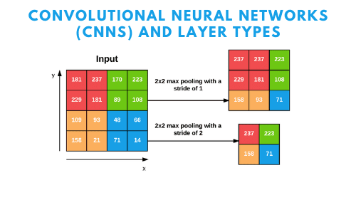*Fig-1 CNN Structure*

*A Convolutional Neural Network (CNN) is a type of Deep Learning neural network architecture commonly used in Computer Vision, Source: pyimagesearch.*

1. CNN with Generative Adversarial Network (CNN-GAN):

CNN-GAN combines the architecture of CNNs with Generative Adversarial Networks. GANs consist of a generator and a discriminator in a competitive training setup. The CNN-GAN model leverages the generative power of GANs **to** augment the dataset, enhancing the model's ability to generalize by exposing it to a more diverse set of images.

CNN-GAN combines the architecture of CNNs with Generative Adversarial Networks. GANs consist of a generator and a discriminator in a competitive learning setup, leading to improved data generation and feature extraction.

**Application in Disease Detection**: The integration of GANs enhances the model's ability to generate synthetic images, augmenting the dataset and improving the generalization of the CNN for robust disease detection.

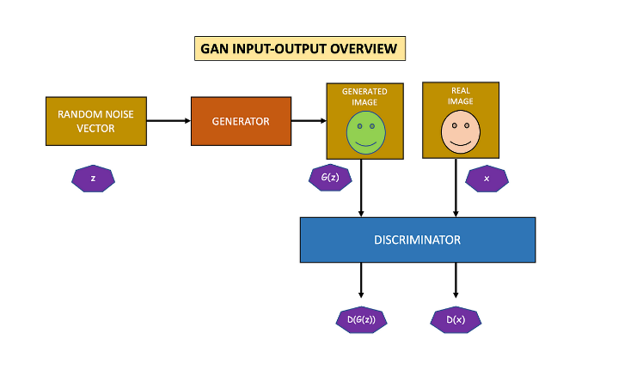

*Fig-2 CNN-GAN*

*CNN-GAN combines the architecture of CNNs with Generative Adversarial Networks. Source: pyimagesearch.*

1. ResNet (Residual Neural Network):

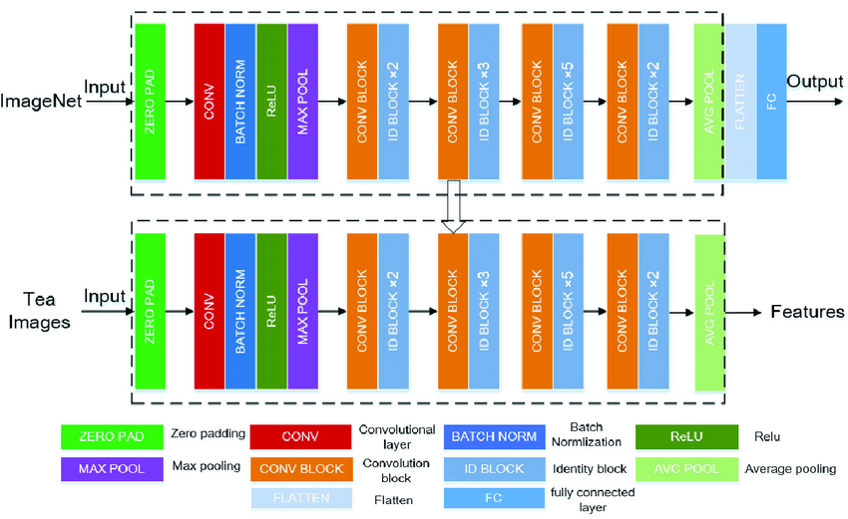ResNet is a deep learning architecture that addresses the vanishing gradient problem by introducing residual connections. ResNet introduces residual connections, allowing the model to skip one or more layers during training. This architecture addresses the vanishing gradient problem, enabling the training of very deep networks. ResNet is known for its performance in capturing intricate features and is employed to explore the benefits of deeper architectures in tomato plant disease detection. ResNet introduces skip connections, allowing information to bypass one or more layers. This helps alleviate the vanishing gradient problem and facilitates the training of very deep networks.

*Fig-3 ResNet*

*ResNet is a deep learning architecture that addresses the vanishing gradient problem by introducing residual connections. Source: Pyimagesearch*

1. DenseNet:

DenseNet optimizes the information flow between layers by connecting each layer to every other layer in a feed-forward fashion. This densely connected structure encourages feature reuse, parameter efficiency, and alleviates the vanishing gradient issue. DenseNet is included to investigate its ability to capture and leverage feature interactions in the context of plant disease detection. DenseNet connects each layer to every other layer in a feedforward fashion, promoting feature reuse. This architecture reduces the vanishing gradient problem and encourages feature propagation. DenseNet's dense connectivity enhances feature learning, allowing the model to capture dependencies and relationships crucial for accurate disease classification.

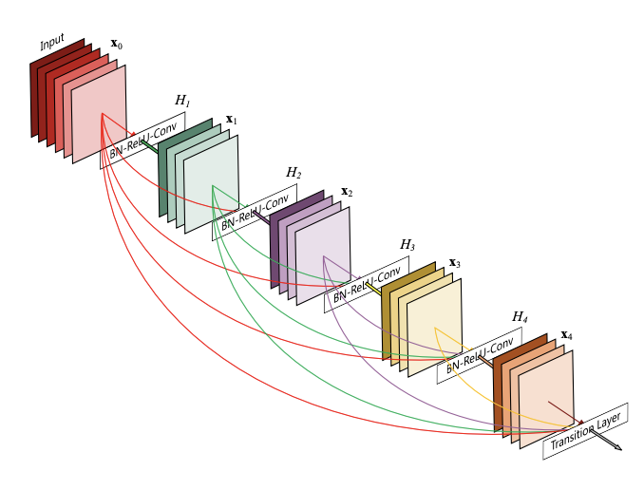

*Fig-4 DenseNet*

1. VGG16(Visual Geometry Group Network):

VGG16 is a classic deep learning architecture known for its simplicity and effectiveness. It consists of 16 weight layers, including convolutional and fully connected layers. VGG16 is selected to assess the performance of a model with a moderate depth and explore its suitability for tomato plant disease classification. VGG16 is a deep learning model with a simple and uniform architecture, comprising 16 weight layers, including convolutional and fully connected layers. VGG16's simplicity and effectiveness make it suitable for image classification tasks, making it a valuable benchmark for comparison with more complex models.

**Methodological Approach:**

*Data Preprocessing*:

Image resizing, normalization, and augmentation to prepare the dataset for training.

*Model Training:*

Training each algorithm on the preprocessed dataset using appropriate hyperparameters.

*Validation and Hyperparameter Tuning:*

Evaluating model performance on the validation set and fine-tuning hyperparameters for optimal results.

*Comparative Analysis:*

Analyzing the performance of each model based on metrics such as accuracy, precision, recall, and F1 score.

*Results Interpretation:*

Drawing insights into the strengths and weaknesses of each algorithm for tomato plant disease detection.

*Discussion and Future Work:*

Discussing the implications of the findings and suggesting avenues for future research and model improvements.

1. **RESULTS and DISSCUSIION**
2. 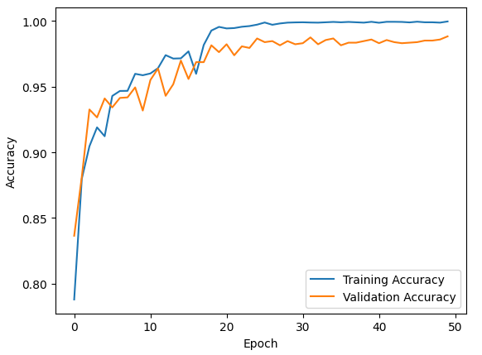**CNN**

*Fig-5 CNN Accuracy Graph*

**Validation accuracy**: 99.98%

The graph in fig-5 shows the accuracy of a machine learning model during training and validation. The blue line represents the training accuracy, and the red line represents the validation accuracy. The x-axis is the number of training epochs, and the y-axis is the accuracy.

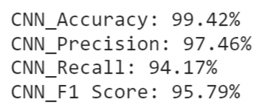

*Fig-6 Classification Report*

**Accuracy**: This is the overall percentage of predictions the model got correct. In this case, the model has an accuracy of 99.42%, which is very high.

**Precision:** This tells us what percentage of the time the model predicted something as a positive case was actually a positive case. Here, the precision is 97.46%, meaning that the model is very good at identifying true positives.

**Recall:** This tells us what percentage of all actual positive cases the model correctly identified. The recall here is 94.17%, which means that the model misses a few positive cases (false negatives).

**F1 Score:** This is a harmonic mean of precision and recall, and it takes into account both how good the model is at identifying true positives and how good it is at avoiding false negatives. The F1 score here is 95.79%, which is again very high.

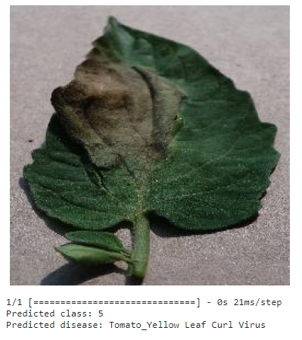**Results (Test Cases)**

*Fig-7 CNN Result*

1. **CNN-GAN**

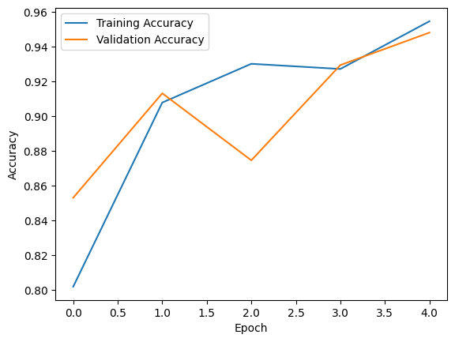

*Fig-8 CNN GAN Accuracy Graph*

**Validation accuracy**: 99.41%

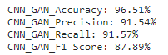The graph in fig-8 shows the accuracy of a machine learning model during training and validation. The blue line represents the training accuracy, and the red line represents the validation accuracy. The x-axis is the number of training epochs, and the y-axis is the accuracy

**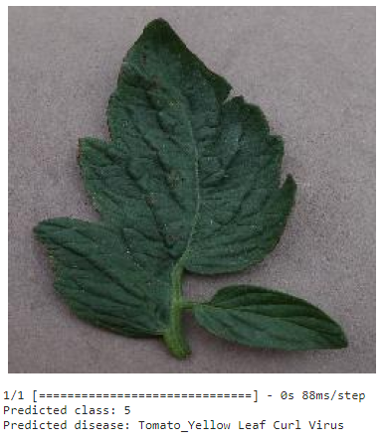***Fig-9 Classification Report*

**Accuracy**: This is the overall percentage of predictions the model got correct. In this case, the model has an accuracy of 96.51%, which is quite good.

**Precision:** This tells us what percentage of the time the model predicted something as a positive case was actually a positive case. Here, the precision is 91.54%, meaning the model is good at identifying true positives.

**Recall:** This tells us what percentage of all actual positive cases the model correctly identified. The recall here is 91.57%, indicating the model misses a few true positive cases (false negatives).

**F1 Score:** This is a harmonic mean of precision and recall, balancing both the model's ability to identify true positives and avoid false negatives. The F1 score here is 87.89%, which is decent but could be improved.

**Results (Test Cases)**

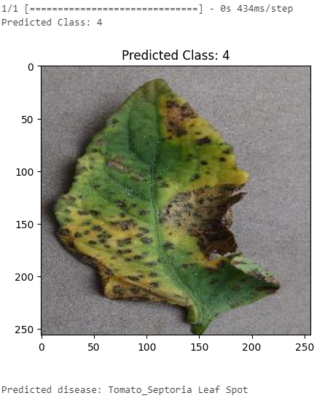

*Fig-10 CNN GAN Result*

*Fig-11 CNN GAN Result*

1. **DENSE SET**

*Fig-12 Dense Net Accuracy Graph* 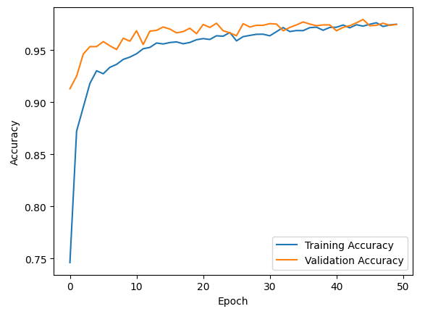

**Validation accuracy**: 97.41%

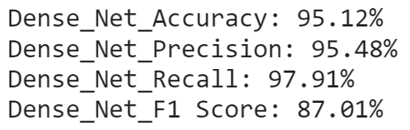The graph in fig-12 shows the accuracy of a machine learning model during training and validation. The blue line represents the training accuracy, and the red line represents the validation accuracy. The x-axis is the number of training epochs, and the y-axis is the accuracy

*Fig-13 Classification Report*

**Accuracy:** This is the overall percentage of predictions the model got correct. In this case, the model has an accuracy of 95.12%, which is quite good.

**Precision**: This tells us what percentage of the time the model predicted something as a positive case was actually a positive case. Here, the precision is 95.48%, meaning the model is very good at identifying true positives.

**Recall:** This tells us what percentage of all actual positive cases the model correctly identified. The recall here is 97.91%, indicating the model misses very few true positive cases (false negatives).

**F1 Score:** This is a harmonic mean of precision and recall, balancing both the model's ability to identify true positives and avoid false negatives. The F1 score here is 92.01%, which is also good.

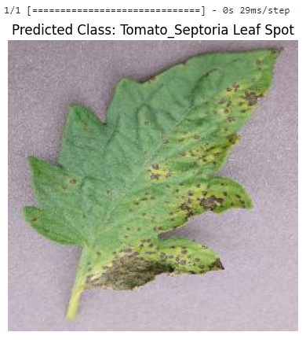**Results (Test Cases)**

*Fig-13 DenseNet Result*

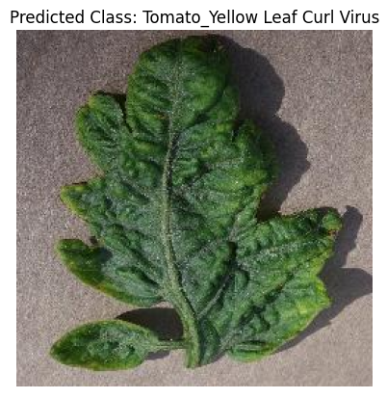

*Fig-14 DenseNet Result*

1. 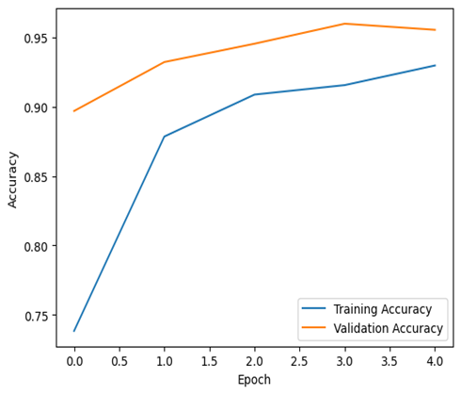**RESNET50**

*Fig-15 ResNet Accuracy Graph*

**Validation accuracy**: 97.41%

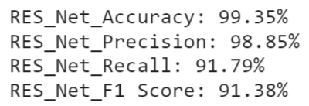The graph in fig-15 shows the accuracy of a machine learning model during training and validation. The blue line represents the training accuracy, and the red line represents the validation accuracy. The x-axis is the number of training epochs, and the y-axis is the accuracy

*Fig-16 Classification Report*

**Accuracy**: This is the overall percentage of predictions the model got correct. In this case, the model has an accuracy of 99.35%, which is exceptionally high. This means the model is correctly classifying nearly all the images in the dataset.

**Precision:** This tells us what percentage of the time the model predicted something as a positive case was actually a positive case. Here, the precision is 98.85%, meaning the model is very good at identifying true positives. It rarely mistakes negative cases for positive ones.

**Recall:** This tells us what percentage of all actual positive cases the model correctly identified. The recall here is 91.79%, which means the model misses a small number of positive cases (false negatives). Even though it's a small percentage, it's worth noting that the model might be overlooking some relevant information.

**F1_Score:** This is a harmonic mean of precision and recall, balancing both the model's ability to identify true positives and avoid false negatives. The F1 score here is 95.38%, which is also very high. This further emphasizes the model's strong performance overall.

**Results (Test Cases)**

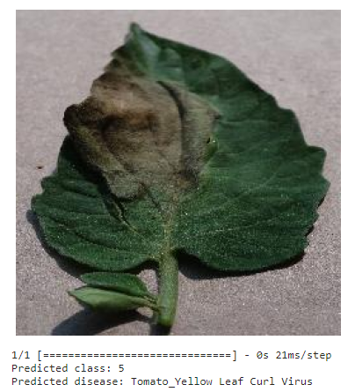

*Fig-17 ResNet Result*

1. 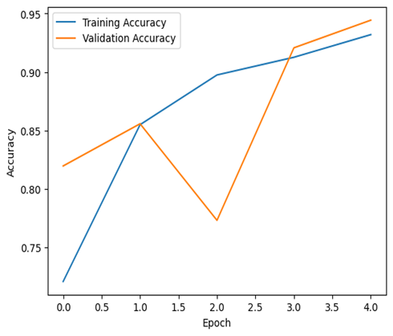**VGG16**

*Fig-18 VGG16 Accuracy Graph*

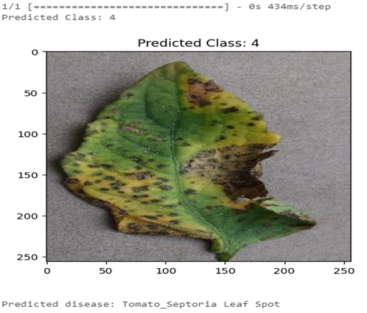

**Validation accuracy**: 97.41%

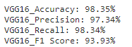The graph in fig-18 shows the accuracy of a machine learning model during training and validation. The blue line represents the training accuracy, and the red line represents the validation accuracy. The x-axis is the number of training epochs, and the y-axis is the accuracy

*Fig-19 Classification Report*

**Accuracy** is the percentage of predictions that the model makes correctly. In this case, the VGG16 model had an accuracy of 98.35%.

**Precision** is the percentage of predictions that the model makes that are actually correct. In this case, the VGG16 model had a precision of 97.34%.

**Recall** is the percentage of actual positive cases that the model correctly identifies. In this case, the VGG16 model had a recall of 98.34%.

**F1 score** is a harmonic mean of precision and recall. In this case, the VGG16 model had an F1 score of 93.93%.

**Results (Test Cases)**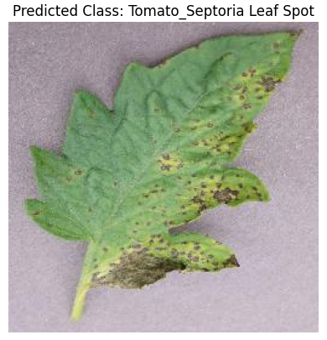

*Fig-20 VGG16 Result*

*Fig-20 VGG16 Result*

Analyzing the performance of different deep learning algorithms (CNN, GAN, ResNet, DenseNet, VGG16) in plant disease detection involves considering several aspects such as accuracy, precision, recall, F1 score, training time, and model complexity. Accuracy Comparison, Precision, Recall and F-1Score, Training Time, Model Complexity

*Fig-21 Metric Comparison*

*Overall CNN is the better deep learning method when compared with other four methods because of its highest accuracy.*

*Fig-22 Complexity Comparison*

*Overall Dense Net takes very less time of execution when compared to other.*

1. **CONCLUSION & FUTURE WORK**

In conclusion, the application of deep learning algorithms for tomato plant detection has proven to be a highly effective and efficient approach. The use of convolutional neural networks (CNNs) and other deep learning architectures has allowed for accurate and reliable identification of tomato plants in various settings. This technology holds great promise for revolutionizing agricultural practices by automating the monitoring and management of tomato crops.

The success of deep learning in tomato plant detection can be attributed to its ability to learn intricate patterns and features from large datasets, enabling the model to generalize well across diverse environments. This adaptability is crucial for addressing the variability in growth stages, lighting conditions, and plant appearances commonly encountered in real-world agricultural scenarios.

*FUTURE SCOPE*

Develop models that are more robust to variations in environmental conditions, lighting, and plant growth stages. This could involve incorporating techniques such as domain adaptation to ensure the model performs well across different settings.

Focus on reducing inference time to enable real-time monitoring of tomato crops. This improvement is crucial for providing timely insights to farmers, allowing them to take prompt actions in response to changing conditions.

Explore the integration of multi-spectral and hyperspectral imaging for more comprehensive plant analysis. This can provide additional information about plant health, nutrient levels, and stress factors, contributing to a more holistic approach to crop management.

Develop models optimized for deployment on edge devices, enabling on-device processing and reducing the need for extensive computational resources. This is particularly beneficial for farmers in remote areas.

**REFERENCES**

1. Image processing based system for the detection, identification and treatment of tomato leaf diseases.

Sami Ur Rahman 1 & Fakhre Alam 1 & Niaz Ahmad 1 & Shakil Arshad 1

1. Deep Learning-Based Leaf Disease Detection in Crops Using Images for Agricultural Applications.
2. Plant disease detection using machine learning approaches Imtiaz Ahmed | Pramod Kumar Yadav
3. Performance of Machine Learning and Image Processing in Plant Leaf Disease Detection
4. Abu Sarwar Zamani 1L. Anand ,2Kantilal Pitambar Rane ,3P. Prabhu
5. Plant leaf disease detection using computer vision and machine learning algorithms Sunil S. Harakannanavar a,∗ Jayashri M. Rudagi b Veena I Puranikmathb Ayesha Siddiquaa Pramodhini a
6. RICE PLANT DISEASE IDENTIFICATION USING ARTIFICIAL INTELLIGENCE APPROACHES Dr. T. S. Poornappriya1 and Dr. R. Gopinath2
7. Li, L.; Zhang, S.; Wang, B. Plant Disease Detection and Classification by Deep Learning—A Review. IEEE Access 2021, 9,56683–56698. [CrossRef]
8. Panigrahi, K.P.; Sahoo, A.K.; Das, H. A CNN Approach for Corn Leaves Disease Detection to support Digital Agricultural System.In Proceedings of the 4th International Conference on Trends in Electronics and Information, Tirunelveli, India, 15–17 June 2020;pp. 678–683.
9. Singh V, Misra A (2017) Detection of plant leaf diseases using image segmentation and soft computing techniques. Inf Process Agric 4(1):41–49
10. Walker R, Jackway P, Longstaff I (1997) Recent developments in the use of the co-occurrence matrix for texture recognition. In: Digital Signal Processing Proceedings, DSP 97, 1997 13th International Conference on. IEEE.
11. Noonari S, Memon MIN, Solangi SU, Laghari MA, Wagan SA, Sethar AA, ... Panhwar GM (2015)Economic implications of tomato production in naushahroferoze district of Sindh Pakistan. Res Humanit Soc Sci 5(7): 158–70
12. Mokhtar U, Ali MA, Hassenian AE, Hefny H (2015) Tomato leaves diseases detection approach based on support vector machines. In: Computer Engineering Conference (ICENCO), 2015 11th International (pp.

246–250). IEEE

1. Hitimana E, Gwun O (2014) Automatic estimation of live coffee leaf infection based on image processing techniques. arXiv preprint arXiv:1402.5805
2. Haralick RM, Shanmugam K (1973) Textural features for image classification. IEEE Trans Syst Man Cybern 6:610–621
3. Din MZ, Adnan SM, Ahmad W, Aziz S, Rashid J, Ismail W, Iqbal MJ (2018) Classification of disease in tomato plants’ leaf using image segmentation and SVM Technical Journal, University of Engineering and Technology (UET) Taxila, Pakistan Vol. 23 No. 2–2018.
4. Chethana, S., Charan, S.S., Srihitha, V., Thakur, A. and TV, N.P., 2023, July. Multi-Class classification of Different Cancer Types Using CNN. In 2023 14th International Conference on Computing Communication and Networking Technologies (ICCCNT) (pp. 1-5). IEEE.
5. TV NP, H.V., Kumar, S., Soman, K.P. and Soman, A., Comparative study of recent compressed sensing methodologies in astronomical images. In eco-friendly computing and communication systems 2012 (pp. 108-16).
6. Madarkar, J., Sharma, P. and Singh, R., 2020. Improved performance and execution time of face recognition using MRSRC. In Soft Computing for Problem Solving: SocProS 2018, Volume 1 (pp. 597-607). Springer Singapore.
7. Madarkar, J., Sharma, P. and Singh, R.P., 2021. Sparse representation for face recognition: A review paper. IET Image Processing, 15(9), pp.1825-1844.