Spam Mail Detection using Bayesian Networks

B Sai Abishek , Balam Ruchith balaji, Chillakuru Hari, K Murali
Department of Computer Science and Engineering, Amrita School of Computing,
Bengaluru, Amrita Vishwa Vidyapeetham, India .
BL.EN.U4AIE21015@bl.students.amrita.edu, BL.EN.U4AIE21017@bl.students.amrita.edu,
BL.EN.U4AIE21038@bl.students.amrita.edu, k_murali@blr.amrita.edu

Abstract— In the ever-evolving landscape of electronic communication, email remains a primary means of information exchange. However, the proliferation of spam emails poses a significant threat to users' privacy, productivity, and overall online experience. This paper presents a sophisticated approach to spam mail detection utilizing Bayesian networks, aiming to enhance email security by accurately identifying and filtering out unwanted or malicious content.The proposed method leverages the probabilistic nature of Bayesian networks to model the relationships between various features commonly found in email datasets. Features include sender information, email content, header details, and other relevant attributes. By incorporating the probabilistic dependencies between these features, the Bayesian network adapts dynamically to changing patterns of spam, demonstrating a high level of adaptability and resilience against emerging threats.
Keywords— Spam mail detection, Bayesian networks, Email security, Probabilistic modeling, Feature extraction, Conditional probabilities.

Introduction
In an era dominated by digital communication, email has become an integral part of our daily lives, facilitating seamless information exchange and connectivity. However, this widespread reliance on email has also given rise to the persistent challenge of spam, an unwelcome intrusion that inundates our inboxes with unsolicited and often malicious content. To combat this menace and ensure the integrity of our digital communication channels, the quest for efficient and accurate spam mail detection mechanisms has become paramount.
One promising approach in the realm of spam mail detection is the utilization of Bayesian networks. Bayesian networks, rooted in probabilistic reasoning and statistical modeling, offer a sophisticated and adaptable framework for analyzing the intricate relationships between various features within an email and predicting the likelihood of it being spam. By leveraging the inherent structure of Bayesian networks, which represents dependencies among variables through a graphical model, we can harness the power of probabilistic inference to make informed decisions about the nature of incoming emails.
This paper delves into the conceptual underpinnings of Bayesian networks and explores their application in the realm of spam mail detection. We will discuss how these networks can effectively capture the probabilistic relationships between different email attributes, such as sender address, content, and metadata, allowing for a holistic assessment of the email's legitimacy. Furthermore, we will explore the advantages of Bayesian networks over traditional rule-based or machine learning approaches, emphasizing their ability to handle uncertainty and adapt to evolving spam tactics.
As we embark on this exploration of Bayesian networks in spam mail detection, we aim to shed light on their potential to enhance the precision and recall of spam filtering systems. By understanding the intricacies of Bayesian networks and their application in this context, we can pave the way for more robust and intelligent defenses against the ever-evolving landscape of spam emails, ultimately ensuring a safer and more secure digital communication environment.

RELATED WORKS
Ahmed, N., Amin, R., Aldabbas, H., Koundal, D., Alouffi, B. and Shah, T [1] The suggested methodology enhances the performance of the classification model in addition to handling high data imbalances. It provides weight to minority classes correctly and handles data imbalance without causing oversampling or undersampling of data. In comparison to the maximum F1-scores of 97%, 95.1%, and 95.3% obtained for spam email categorization using conventional machine learning and deep learning algorithms, with or without resampling, the Dual-Layer architecture produced a minimum F1-score of 97.6%. The Dual Layer ANN classifier achieves 99% as the maximum F1-score for classifying spam emails. The suggested dual-layer architecture produced better performance metrics for each of the specific evaluation categories when compared to previous research investigations. Because of its flexibility, this architecture can be replicated and used for a wide range of additional classification applications in which a notable class imbalance is seen. Additional investigation may be carried out in other domains, including but not limited to using the suggested approach for additional intricate text classification assignments and examining the impact of distinct feature extraction, selection, and preprocessing methodologies on the suggested methodology.
Doshi, J., Parmar, K., Sanghavi, R. and Shekokar, N [2] has talked about how a sizable research community has become interested in spam identification and filtration during the past 20 years. The costly and significant impact of this field on various scenarios, such as customer behavior and bogus reviews, is the cause for a great deal of research in this area. This review covers a range of machine learning models and strategies that researchers have proposed to identify and filter spam in emails and Internet of Things platforms. They were classified as supervised, unsupervised, reinforcement learning, etc. in the study. This study presents a summary of the lessons that may be gained from each area and contrasts these techniques. The study comes to the conclusion that supervised machine learning techniques form the basis of the majority of the suggested email and IoT spam detection approaches. For the supervised model training, obtaining a labeled dataset is an essential and laborious effort. When it comes to spam identification, supervised learning algorithms Naive Bayes and SVM perform better than other models. This study offers thorough explanations of these algorithms along with some suggestions for future research on email spam filtering and detection.

Guo, Y., Mustafaoglu, Z. and Koundal, D [3], In order to identify spam emails, an effective spam detection model based on a supervised learning classifier and BERT model was presented. The features derived from the BERT outputs were used to represent email content, and machine learning classifier methods were used to categorize the feature vectors into spam or ham categories. The experimental findings show that in two publicly accessible datasets, the logistic regression approach produced the best classification results. In conclusion, there is a push to detect spam using the BERT model and classifier. This study can be expanded to include a wide range of applications, such as the identification of bogus news on social media platforms and spam communications in mobile systems. This study shows how well the BERT model interprets text and offers noteworthy elements for further processing. To further confirm the suggested structure, new research is encouraged to combine more thorough layers inside the BERT.

Jáñez-Martino, F., Alaiz-Rodríguez, R., González-Castro, V., Fidalgo, E. and Alegre, E [4] presents a review on spam email detection, focusing on the examination of spammer tactics and the dynamic character of the information in this field. In this context, the antagonistic figure, often known as the spammer, employs complex techniques to get beyond the filters. The most common spammer techniques, according to our analysis of spam datasets over the previous few decades, are image-based spam, concealed text salting, obfuscated words, and poisoning text. More modern tactics include using URLs to link to potentially dangerous websites, multilingual emails to contaminate the content, and attachments like PDF or ".docx" files to insert a spam message. We also looked over the research that was done to identify these ploys and lessen their impact. In order to minimize overfitting by lowering the dimensionality of the input space, we looked at the most current research on filtering spam emails, focusing on the stages of feature extraction and feature selection. Traditional machine learning algorithms continue to be the most widely used methods for spam email filtering in the literature, even in spite of the growing popularity of deep learning in other application fields. The reasons could be their simplicity and great performance in comparison to deep learning models.

Shitanshu Jain, S.C.Jain, Santosh Vishwakarma Make classification models for each KNN and Nave Bayes classification technique, along with a table that contrasts the effectiveness of classifiers from various approaches. Based on the comparison of various measures with KNN classifier methods previously mentioned, the suggested strategy is among the best classification methods using similarity measures. K-NN performs the best overall when compared to other classifiers. The purpose of this study is to provide a range of different Text-Classification Term Weighting Schemes. It has been shown that a novel method of creating classifiers might be created, offering KNN Classification techniques for use in classification challenges and helping to resolve several important flaws with current classification systems.

Zhou, X., Kan, Z., Meng, H. and Li, Y.,[6] provides a thorough algorithm for correcting and reducing noise in trenching depth data used in precision agriculture. It tackles issues like high variability and imprecise measurements of trenching depth. To enhance data quality, the approach combines Kalman filtering with wavelet denoising. The study investigates the effects of various Q/R values and assesses the algorithm's effectiveness using a variety of criteria. The suggested technique successfully lowers noise and fluctuations, according to the results, producing a more accurate depiction of trenching depth. To sum up, the algorithm greatly improves the quality of trenching depth data, which qualifies it for use in precision agriculture applications and offers insightful information for sophisticated monitoring and control systems in the operation of agricultural gear.

Hoang Vuong, Daniel Jilani, Samir Malhotra, Michael P.H. Lau, [7] emphasizes the benefits and drawbacks of several ECG denoising techniques while highlighting the need for workable solutions, particularly in light of wearables and the Internet of medical devices.
Jun Shi, Gong Chen, Yanan Zhao,[9] examines the difficulties in interpreting signals from the actual world that are essentially non-stationary, such as speech, animal sounds, mechanical vibrations, seismic waves, radar, sonar, and biological signals. Several components with time-varying spectral properties are frequently present in these signals. The conventional method of examining these signals is through the use of time-frequency representations (TFRs). Two popular TFR techniques are the wavelet transform (WT) and the short-time Fourier transform (STFT).

Arman Kheirati Roonizi and Ivan W. Selesnick,[10] presents a unique framework for signal denoising using Kalman filters, which combines total variation (TV) denoising with traditional linear time-invariant (LTI) filtering. A band-limited signal (such as a low-frequency component) and a sparse-derivative signal (such as a high-frequency component) are combined to simulate the desired signal in the suggested method. Using zero-phase LTI filtering to estimate the band-limited signal and TV denoising to estimate the sparse-derivative signal, the system uses an iterative Kalman filter/smoother methodology. The method seeks to improve denoising performance for signals containing both low- and high-frequency components by taking these factors into account at the same time.

METHODOLOGY

- Data Set Description:
- Data set format : TEXT
- Data set Composition:
- Train – 2000 text emails
- Test- 800 text email
- Each mail has receiver's Information and Senders information.
- And also it has time, date information also.
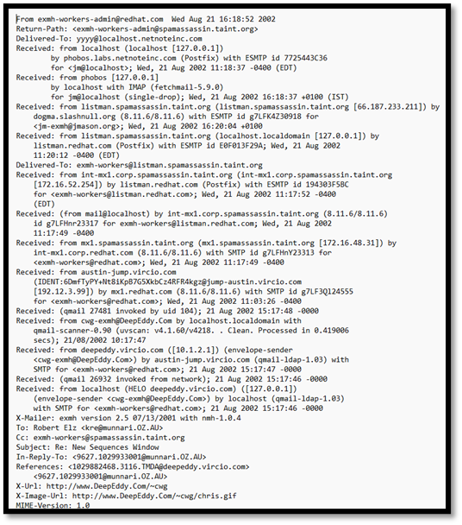
- BAYESIAN NETWORKS
A Bayesian network is a graphical model that represents probabilistic relationships among a set of variables. The relationships are depicted as a directed acyclic graph (DAG), where nodes represent variables, and edges represent probabilistic dependencies between the variables.
Components:
- Nodes (Vertices): Represent random variables.
- Edges (Directed Arrows): Indicate probabilistic dependencies between variables.
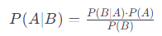
- Conditional Probability Tables (CPTs): Assign probabilities to each variable given the values of its parents..
Where:

- P(A∣B) is the posterior probability of event A given evidence B.
- P(B∣A) is the likelihood of evidence B given that A is true.
- P(A) is the prior probability of event A.
- P(B) is the probability of evidence B.

Bayesian Networks Formula:
The chain rule of probability can be utilized to factorize the joint probability distribution of a Bayesian network:
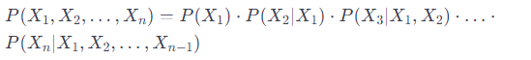
Inference in Bayesian Networks:
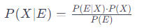
Bayesian networks allow us to perform inference, which involves updating beliefs about certain variables given observed evidence. This is done using the following formula:
Where:
- P(X∣E) is the posterior probability of variable X given evidence E.
- P(E∣X) is the likelihood of evidence E given that X is true.
- P(X) is the prior probability of variable X.
- P(E) is the probability of evidence E.

Bayesian networks can be learned from data, a process known as structure learning. This involves identifying the relationships between variables and determining the structure of the graph. Estimating the probabilities connected to every node in the network is known as parameter learning. For this, learning techniques like the Hill-Climbing algorithm and the Expectation-Maximization (EM) algorithm are frequently utilized.
Different algorithms are used in Bayesian networks to carry out inference. While the Variable Elimination algorithm is the most widely used, there are other algorithms that are also in use, such as the Gibbs Sampling algorithm and the Junction Tree algorithm. These algorithms make it possible to calculate odds and forecasts based on the network's observed data.
Bayesian networks find extensive applications in healthcare, ranging from disease diagnosis to treatment planning. They can model complex relationships between symptoms, medical history, and test results, providing a probabilistic framework for medical decision support systems. As technology continues to advance, Bayesian networks will likely play an increasingly important role in addressing complex and uncertain scenarios in diverse fields.

EXPERIMENTAL SETUP
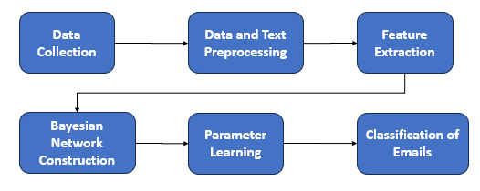
Fig-1 Flow diagram.

Input Data:
The input data is a text data which consists of 2000 ham and spam emails which is in the text format. It contains all the details like date, time, sender, receiver.

Data Preprocessing:
The collected data is processed by going under through text processing methods like removing unwanted words, phrases.

Feature Extraction:
The features are extracted so that it decides how the word is depends on the previous word. Mainly like the conditional probabilities.

Bayesian Network Construction:
The model is constructed based on the features extracted from the feature extraction that is from the previous step.

Parametric Learning:
The model is trained again and again so that accuracy should be so much high, and it should predict the email correctly.

Classification of E-mails:
Now the model is able to predict the email belongs to spam or ham. All the test data is loaded in to the model and predicted. After the prediction the metrics were calculated.

Results
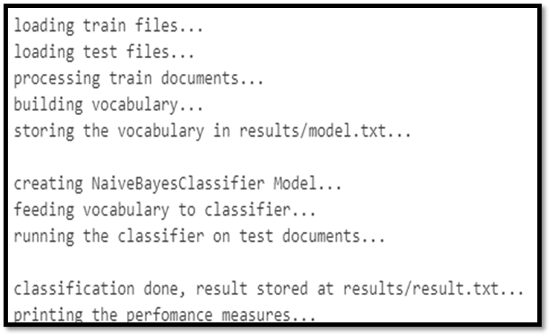
The following are the results of the Bayesian Net work model…Preprocessing, Confusion Matrix, Metrics.

Fig-2 Preprocessing
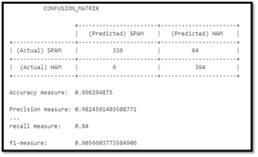
Fig-3 Confusion Matrix

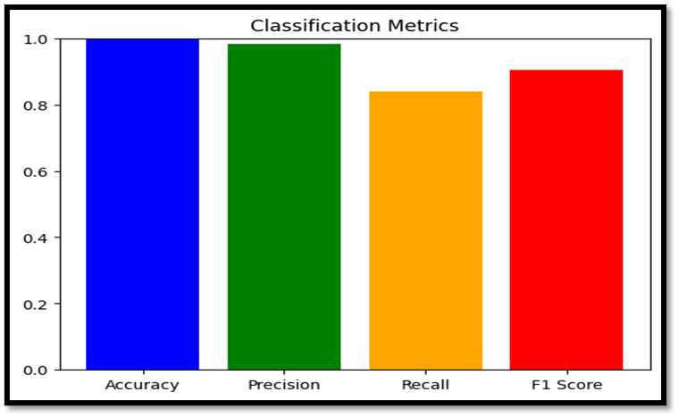
Fig-4 Metrics
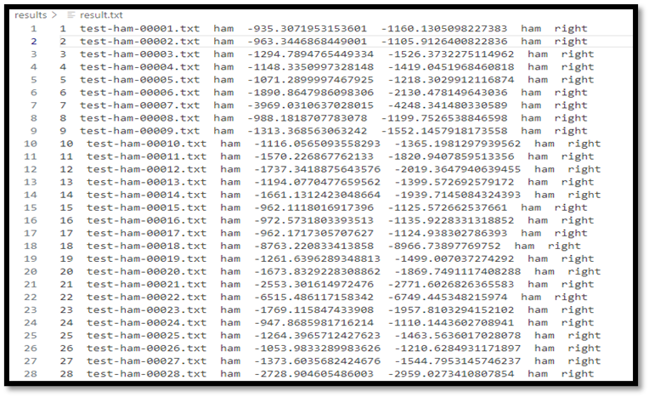
Fig-3 Results.txt

VI. CONCLUSION

In conclusion, Bayesian networks offer a powerful and versatile framework for modelling and reasoning under uncertainty, making them invaluable in the realm of spam mail detection. The probabilistic graphical models provided by Bayesian networks allow us to represent complex relationships among variables in a succinct and interpretable manner. Through the lens of Bayes' theorem, Bayesian networks enable the dynamic updating of probabilities as new evidence emerges, facilitating adaptive and learning-centric systems. This adaptability is crucial in addressing the ever-evolving landscape of spam tactics, where traditional methods often fall short. The personalized touch of Bayesian networks, incorporating user feedback and preferences, enhances the accuracy of spam detection while minimizing false positives. This user-centric approach ensures that legitimate messages are not erroneously flagged, providing a more tailored and efficient email filtering experience. Moreover, the scalability of Bayesian networks makes them well-suited for handling the exponential growth in email exchanges, processing large datasets with efficiency. As we continue to navigate the challenges of our interconnected digital world, the robust and scalable nature of Bayesian networks positions them as a transformative solution in fortifying our email security infrastructure.
As we navigate the intricate landscape of email security, Bayesian networks emerge as a beacon of innovation, offering a holistic and intelligent approach to spam mail detection. Their ability to adapt, learn, and personalize sets the stage for a more secure and efficient email communication environment. By embracing the power of Bayesian networks, we embark on a journey towards a future where our inboxes are not just filtered but safeguarded with a level of intelligence that matches the dynamic nature of the digital era.

REFERENCES
[1] Ahmed, N., Amin, R., Aldabbas, H., Koundal, D., Alouffi, B., & Shah, T. (2022). Machine learning techniques for spam detection in email and IOT platforms: Analysis and research challenges. Security and Communication Networks, 2022, 1–19.
[2] Tida, V. S., & Hsu, S. H. (2022). Universal spam detection using transfer learning of Bert model. In Proceedings of the Annual Hawaii International Conference on System Sciences.
[3] Al Nabki W, Fidalgo E, Alegre E, Alaiz R (2020) File name classifcation approach to identify child sexualabuse. In: Conference: 9th international conference on pattern recognition applications and methods, pp 228–234.
[4] Annadatha A, Stamp M (2016) Image spam analysis and detection. J Comput Virol Hacking Tech 14(1):39–52.
[5] Grobbelaar, M., Phadikar, S., Ghaderpour, E., Struck, A.F., Sinha, N., Ghosh, R. and Ahmed, M.Z.I., 2022. A survey on denoising techniques of electroencephalogram signals using wavelet transform. Signals, 3(3), pp.577-586.
[6] Zhou, X., Kan, Z., Meng, H. and Li, Y., 2023. Research on Trenching Data Correction Method Based on Wavelet Denoising-Kalman Filtering Algorithm. Arabian Journal for Science and Engineering, 48(2), pp.1097-1117.
[7] Sarafan, S., Vuong, H., Jilani, D., Malhotra, S., Lau, M.P., Vishwanath, M., Ghirmai, T. and Cao, H., 2022, July. A novel ecg denoising scheme using the ensemble Kalman filter. In 2022 44th Annual International Conference of the IEEE Engineering in Medicine & Biology Society (EMBC) (pp. 2005-2008). IEEE.
[8] You, N., Han, L., Zhu, D. and Song, W., 2023. Research on image denoising in edge detection based on wavelet transform. Applied Sciences, 13(3), p.1837.
[9] Shi, J., Chen, G., Zhao, Y. and Tao, R., 2023. Synchrosqueezed Fractional Wavelet Transform: A New High-Resolution Time-Frequency Representation. IEEE Transactions on Signal Processing, 71, pp.264-278.
[10] Roonizi, A.K. and Selesnick, I.W., 2022. A Kalman Filter Framework for Simultaneous LTI Filtering and Total Variation Denoising. IEEE Transactions on Signal Processing, 70, pp.4543-4554.
[11] Mohanan, G., Padmanabhan, D.M. and Anisha, G.S., 2021. Classifying Emails into Spam or Ham Using ML Algorithms. In Data Science and Security: Proceedings of IDSCS 2021 (pp. 214-221). Springer Singapore.
[14] Abhishek, S., Sathish, H., Kumar, A. and Anjali, T., 2022, September. A strategy for detecting malicious spam emails using various classifiers. In 2022 4th International Conference on Inventive Research in Computing Applications (ICIRCA) (pp. 554-560). IEEE.

