Freight Rate Prediction — Assessment Report
Machine Learning Engineer Assessment · Spotter

1. Objective
Train a model on data/train_test.csv (48,000 labeled loads, Jan–Oct 2025) to predict posted_rate for every load in data/validation.csv (12,000 loads, Nov–Dec 2025), and separately produce a 31-day fixed-lane predicted-rate curve for December 2025 (Lexington → Fort Wayne, Dry Van, 360 miles, 32,000 lb — only the date changes).

2. Data Exploration & Quality Issues
train_test.csv has 14 columns: load_id, pickup/delivery city with lat/lon, distance, equipment, weight, date, market_index, quote_signal, and the target posted_rate. Two data-quality issues were found and handled explicitly:
- weight: 292 rows (0.6%) have negative values — physically impossible for a load's weight, treated as a sign-entry error and corrected with abs(), not dropped (dropping would discard otherwise-valid rows and the assessment requires predictions for every row regardless).
- weight: a further 300 rows (0.6%) are missing, imputed with the per-equipment median weight learned from training data only (weight distributions differ by equipment type).
- market_index: 374 rows (0.8%) are missing. Left as-is — the model (HistGradientBoostingRegressor) handles missing numeric values natively, and market_index correlates only weakly with the target (r ≈ 0.03), so imputation would add little.
- validation.csv contains 8 pickup/delivery cities never seen in training (Allentown, Charlotte, Chicago, Jackson, Knoxville, Laredo, Norfolk, San Diego), and 736 of its 4,214 pickup→delivery lanes are unseen in training. This drove two modeling choices: pickup/delivery are encoded as native categoricals (so unseen levels degrade gracefully rather than crashing), and lat/lon are included as numeric features so the model has a geography signal that still works for new cities.
distance is overwhelmingly the strongest single predictor (r ≈ 0.91 with posted_rate); weight, market_index and quote_signal each correlate weakly (|r| < 0.1) but still add measurable lift in combination — see Section 4.
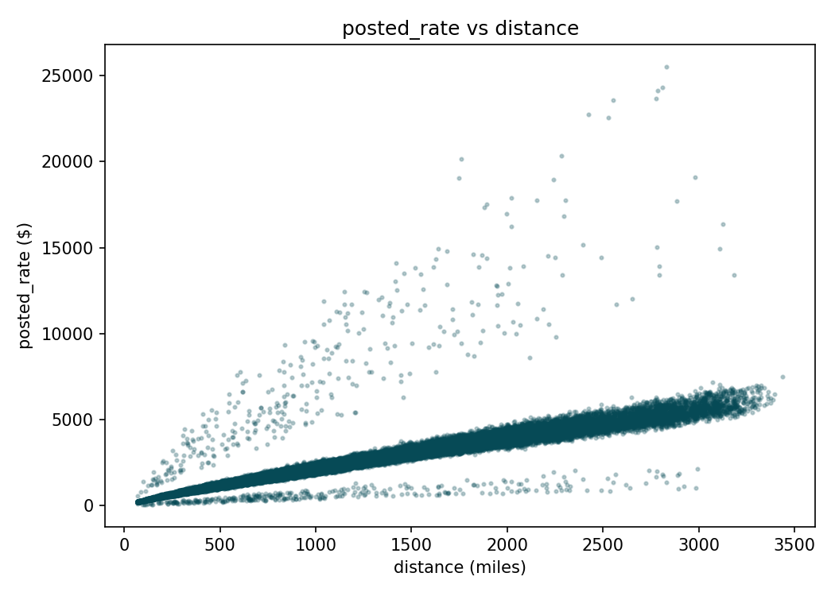
Figure 1 — posted_rate scales strongly and roughly linearly with distance, with variance widening at longer hauls.
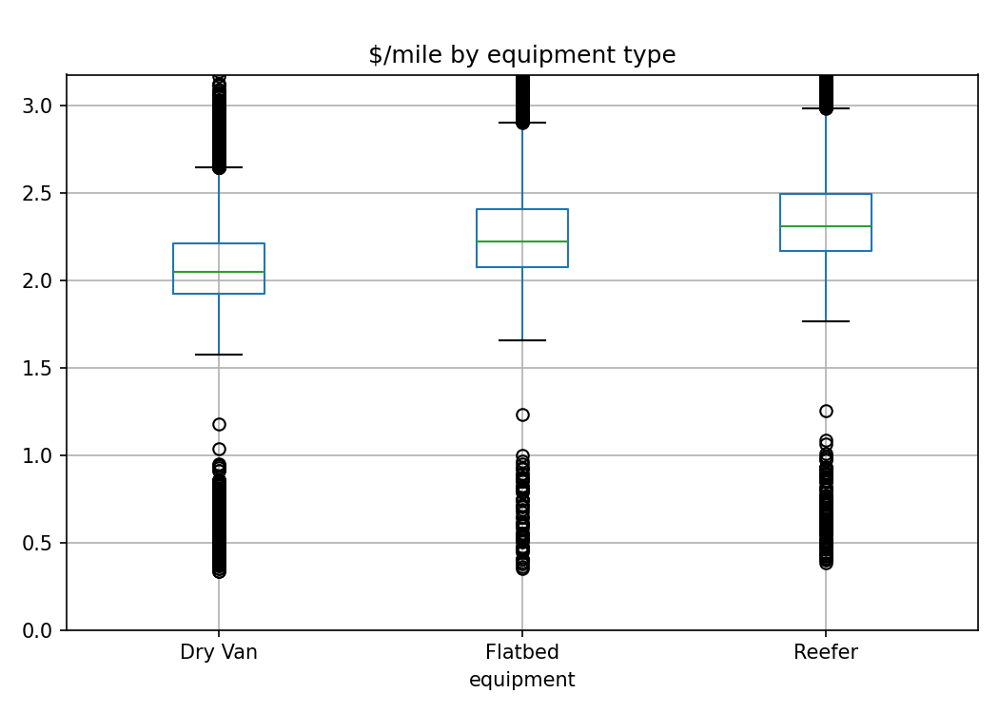
Figure 2 — Reefer and Flatbed command a higher $/mile than Dry Van on average.

3. Train / Validation Split Approach
A time-based (not random) split was used to build the holdout set. train_test.csv covers 2025-01-01 through 2025-10-31, while validation.csv and the December chart inputs are entirely in the future relative to that window (Nov–Dec 2025). A random split would let the model train on rows interleaved throughout the year and be tested on a random sample from the same period — that overstates how well it will generalize to genuinely unseen future dates, which is the actual task here.
Instead, the last ~15% of days in train_test.csv (2025-09-15 onward, 7,294 rows) were held out as a validation set, with the remaining 40,706 rows used for training. This mimics the real deployment scenario: train on the past, evaluate on the future. After confirming performance on this holdout, the final model was refit on all 48,000 labeled rows before generating the submitted predictions, so no labeled data is left unused.

4. Model & Results
Model: scikit-learn HistGradientBoostingRegressor, trained on log1p(posted_rate) (the target is right-skewed — median ≈ $2,031, max ≈ $25,533 — and log-transforming stabilizes variance across the wide range of distances). Predictions are inverted with expm1 and clipped to a $1 floor. Features: distance, weight, market_index, quote_signal, pickup/delivery lat & lon (numeric), plus month, day-of-week, weekend flag, and sin/cos-encoded day-of-year (date seasonality), with equipment/pickup/delivery as native categoricals.
Metric | Value
Holdout MAE | $127.42
Holdout MAPE | 5.74%
Holdout R² | 0.839
Baseline MAE (distance × avg $/mile) | $283.91
Baseline MAPE | 12.08%
Improvement over baseline (MAE) | 55.1% lower

The baseline is a naive heuristic (predicted rate = distance × training-set average $/mile) included specifically to show the gradient-boosted model is capturing real signal beyond "rate scales with distance" — it roughly halves the error of that heuristic.
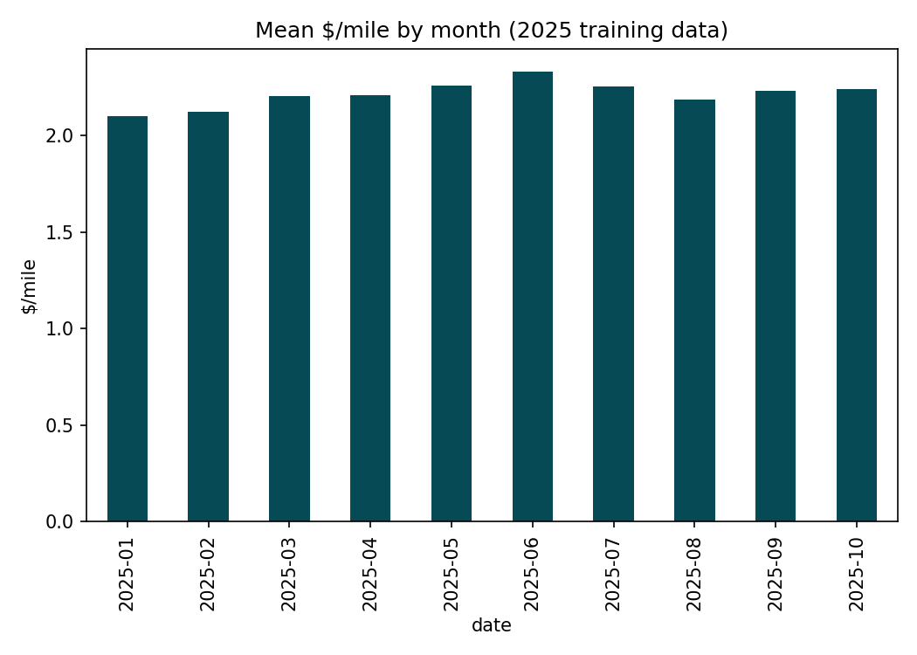
Figure 3 — mean $/mile by month in the training data; no strong single-direction trend, which is why market_index/quote_signal were not extrapolated into December (Section 5).

5. December Fixed-Lane Chart
december_chart_inputs.csv fixes pickup, delivery, distance, equipment and weight, varying only the date across 31 December days. That file does not include lat/lon or market_index/quote_signal columns (unlike train_test.csv/validation.csv), so these were reconstructed before scoring: lat/lon via an exact city→coordinate lookup built from training data, and market_index/quote_signal filled with their training-set global means. Both signals correlate weakly with posted_rate (|r| < 0.1) and showed no consistent month-over-month trend in training data to extrapolate from (Figure 3), so a neutral, evidence-based placeholder was preferred over an unsupported trend assumption. The resulting curve is therefore driven by the features that matter for this lane: distance/weight/equipment (fixed) and date-based seasonality (varying).
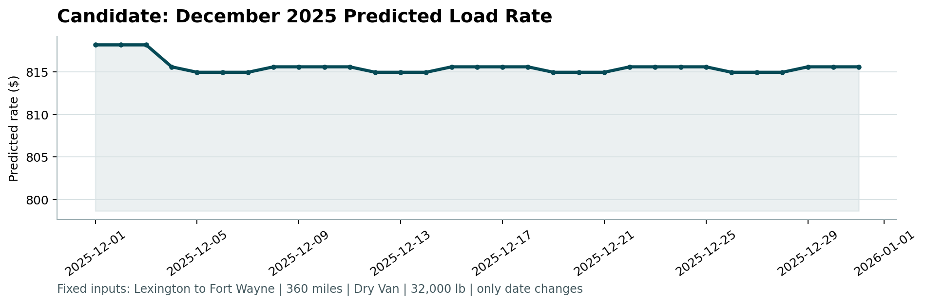
Figure 4 — candidate_december.png, produced by the provided score.py. The model recovers a weekly (day-of-week) cycle from training-data patterns even for dates entirely outside the training window.

6. How to Reproduce
- pip install -r requirements.txt
- python -m src.train # trains model, writes models/freight_rate_model.joblib + outputs/holdout_metrics.json
- python -m src.predict # writes outputs/validation_predictions.csv + outputs/december_chart_inputs_filled.csv
- python score.py --predictions outputs/validation_predictions.csv --december-predictions outputs/december_chart_inputs_filled.csv
- python -m src.eda # optional — regenerates the EDA plots used in this report

7. Limitations & Next Steps
- market_index/quote_signal for December are neutral placeholders, not forecasts — a production version would model these as their own time series if they carry more signal at longer date lags than seen here.
- New cities in validation.csv rely on lat/lon + distance generalizing; a larger training set spanning more lanes would likely improve those specific predictions further.
- Hyperparameters were set to reasonable defaults with early stopping rather than an exhaustive search; a randomized/Bayesian search over max_leaf_nodes, learning_rate and min_samples_leaf is a natural next step given more time.

