Deliverable 2: Low-Level Design (LLD)
Project: ShopEase Agentic RAG Assistant
Engineer: Ruchitha
1. Module-Level Design
The system is decomposed into the following internal modules:
- Document Processing Module (ingest.py): Uses PyPDFLoader to parse raw PDF streams into standard LangChain Document objects.
- Chunking Module (ingest.py): Implements RecursiveCharacterTextSplitter. Logic: splits text based on a hierarchy of characters (\n\n, \n, ) to maintain semantic integrity.
- Embedding Module: Utilizes HuggingFaceEmbeddings with the all-MiniLM-L6-v2 model to map text chunks into a 384-dimensional vector space.
- Vector Storage Module: Managed by ChromaDB. Handles the persistence of vectors and metadata in the chroma_db/ directory.
- Retrieval Module (retriever.py): Interfaces with ChromaDB using a similarity search algorithm to return the top $k=4$ relevant documents.
- Query Processing Module: Standardizes user input into the GraphState schema.
- Graph Execution Module (graph.py): The orchestration engine built on LangGraph. It manages node execution and state transitions.
- HITL Module: A logic-based interceptor that prevents LLM generation and redirects the state to a human-readable output.
2. Data Structures
- Document Representation: LangChain Document object containing page_content (string) and metadata (source, page number).
- Chunk Format: String segments of 1000 characters with a 10% (100 char) overlap.
- Embedding Structure: A list of floats (Vector) representing the semantic meaning of each chunk.
- State Object (GraphState): ```python
class GraphState(TypedDict):
query: str
context: str
answer: str
confidence: str # "high" or "low"
needs_escalation: bool

3. Workflow Design (LangGraph)
- Nodes:
  - retrieve_node: Fetches data from ChromaDB.
  - generate_node: Calls the Llama 3.3 model via Groq.
  - escalate_node: Terminal node for manual intervention.
- Edges:
  - Direct Edge: generate $\rightarrow$ END.
  - Conditional Edge: retrieve $\rightarrow$ route_query (decision point).
- State Flow: The GraphState object is passed between nodes; each node returns an updated version of the state
. 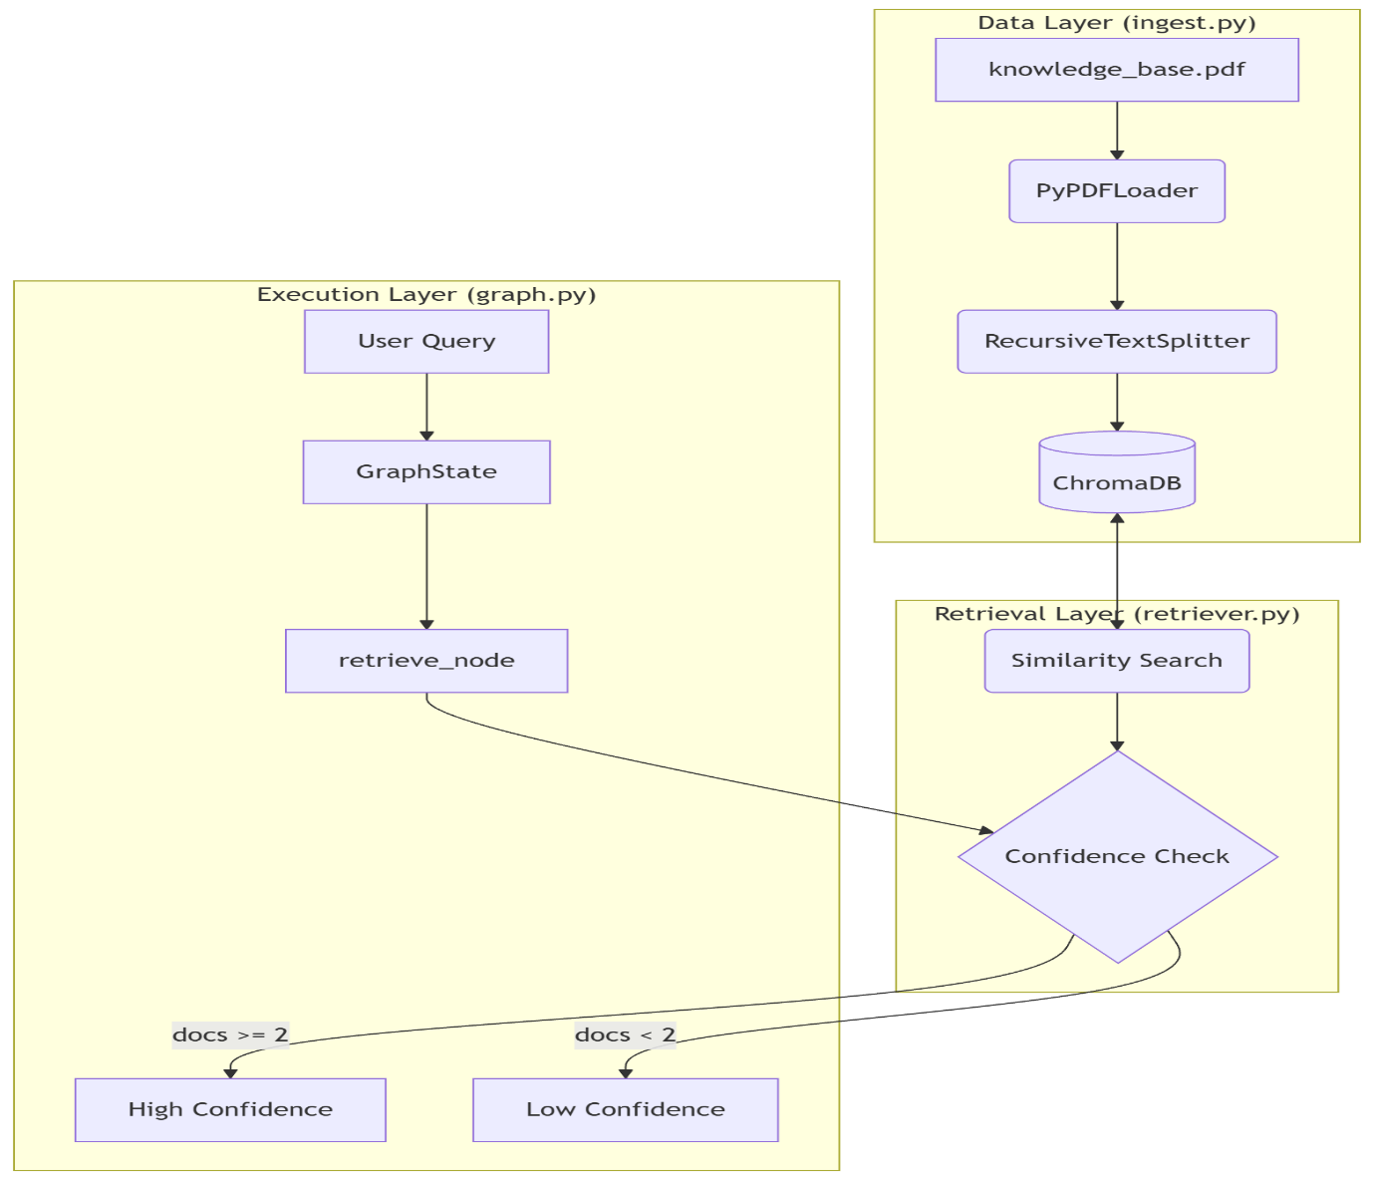
This diagram illustrates the separation of concerns between the Data Ingestion Layer (ingest.py), the Retrieval Layer (retriever.py), and the Graph Execution Engine (graph.py). It highlights how the State Object transitions from a raw query to a confidence-checked context.

4. Conditional Routing Logic
The route_query function acts as the Decision Gate:
- Answer Generation Criteria: Confidence is "high" AND no risk keywords found.
- Escalation Criteria: * Low Confidence: Fewer than 2 relevant chunks found in the database.
  - Missing Context: Database returns null/empty result.
  - Complex/Sensitive Query: Presence of keywords: refund, legal, urgent, manager.

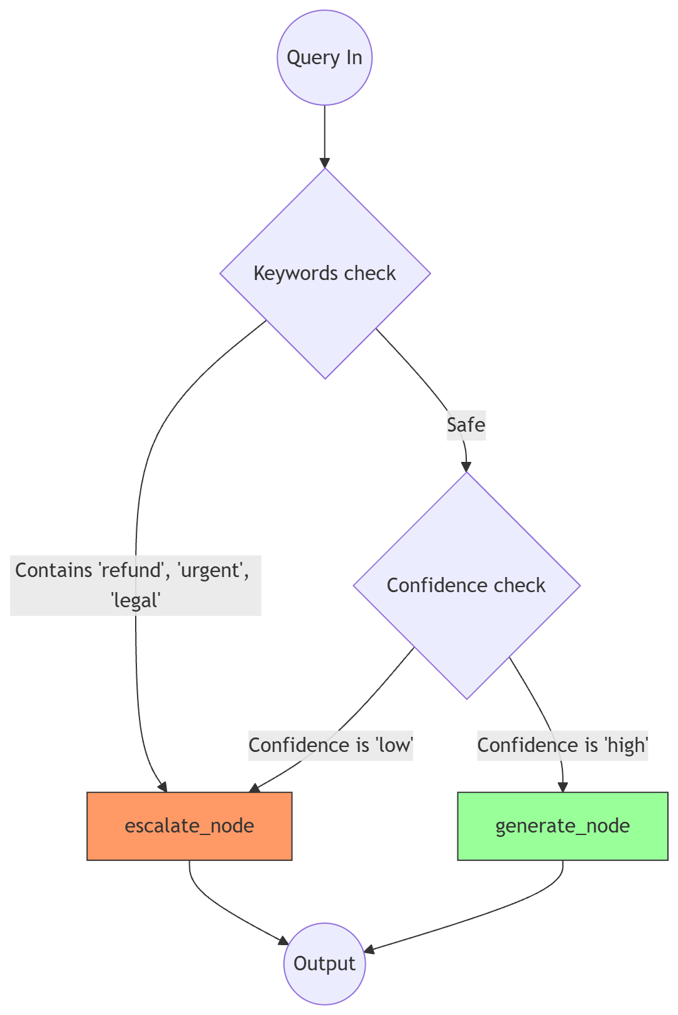

This decision tree represents the internal logic gate of the route_query function. The system first performs an Intent Check for high-risk keywords (refund, urgent, legal). If the query is deemed 'Safe,' it proceeds to a Confidence Check based on retrieval metadata. Any failure in these checks results in a transition to the escalate_node to ensure system safety and accuracy.

5. HITL Design
- Trigger: Automatically triggered when route_query returns "escalate".
- Action: The system sets needs_escalation = True and populates the answer field with a standard redirection message.
- Human Integration: In this CLI version, the output is flagged to the terminal user. In a production system, this state would be pushed to a SQL database for a human agent's dashboard.
6. API / Interface Design
- Input Format: String-based CLI prompt.
- Output Format: Streamed JSON-like state updates showing node completion, followed by the final string response.
- Interaction Flow:
  - User enters query.
  - Terminal shows node progress (🔍 Searching...).
  - Final answer is displayed.
  - System loops back for the next input.
7. Error Handling
- Missing Data: If the knowledge_base.pdf is missing, the ingest_pdf function prints a clear error and exits without crashing the system.
- No Relevant Chunks: Handled by the Router; instead of the LLM guessing, the system escalates.
- LLM Failure: Groq API calls are wrapped in the Graph's execution logic to prevent a total system crash if the network is down.

