
HP Pavilion 15 Laptop PC (model numbers 15-cd001 through 15-cd099)

Maintenance and Service Guide IMPORTANT! This document is intended for HP authorized service providers only.

© Copyright 2017 Hewlett-Packard Development Company, L.P.
Bluetooth is a trademark owned by its proprietor and used by HP Inc. under license. AMD and AMD Radeon are trademarks of Advanced Micro Devices, Inc. Microsoft and Windows are either registered trademarks or trademarks of Microsoft Corporation in
the United States and/or other countries. SD Logo is a trademark of its proprietor.
The information contained herein is subject to change without notice. The only warranties for HP products and services are set forth in
the express warranty statements accompanying such products and services. Nothing herein should be construed as constituting an additional warranty. HP shall not be liable for technical or editorial errors or omissions contained herein.
First Edition: April 2017
Document Part Number: 925117-001
Product notice
This guide describes features that are common to most models. Some features may not be available on your computer.
Not all features are available in all editions of Windows 10. This computer may require upgraded and/or separately purchased hardware, drivers and/or software to take full advantage of Windows 10 functionality. See for http://www.microsoft.com details.

Safety warning notice
WARNING! To reduce the possibility of heat-related injuries or of overheating the device, do not place
the device directly on your lap or obstruct the device air vents. Use the device only on a hard, flat surface. Do not allow another hard surface, such as an adjoining optional printer, or a soft surface, such as pillows or rugs or clothing, to block airflow. Also, do not allow the AC adapter to contact the skin or a soft surface, such as pillows or rugs or clothing, during operation. The device and the AC adapter comply with the user-accessible surface temperature limits defined by the International Standard for Safety of Information Technology Equipment (IEC 60950).

Table of contents

- Product description 1
- Getting to know your computer 5
Locating hardware 5
Locating software 5
Display 6
Buttons and speakers 7
Lights 8
Special keys 9
TouchPad 10
Left side 11
Right side 12
Bottom 14
- Illustrated parts catalog 15
Locating the serial number, model number, product number, and warranty information 15
Computer components 16
Display assembly components 26
Miscellaneous parts 28
- Removal and replacement preliminary requirements 29
Tools required 29
Service considerations 29
Plastic parts 29
Cables and connectors 30
Drive handling 30
Grounding guidelines 31
Electrostatic discharge damage 31
Packaging and transporting guidelines 32
Workstation guidelines 32
- Removal and replacement procedures 34
Component replacement procedures 34
Optical drive 34
Bottom cover 35
Battery 37
Hard drive 38
WLAN module 39
Solid-state drive 41
Memory module 42
USB port board 43
TouchPad cable 45
TouchPad 46
Fan 47
System board 48
Heat sink 52
USB port board cable 55
Display assembly 55
Speakers 62
Power connector cable 64
- Computer Setup (BIOS), TPM, and HP Sure Start 65
Using Computer Setup 65
Starting Computer Setup 65
Navigating and selecting in Computer Setup 65
Restoring factory settings in Computer Setup 66
Updating the BIOS 67
Determining the BIOS version 67
Downloading a BIOS update 67
Changing the boot order using the f9 prompt 68
TPM BIOS settings (select products only) 69
Using HP Sure Start (select products only) 69
- HP PC Hardware Diagnostics (UEFI) 70
Downloading HP PC Hardware Diagnostics (UEFI) to a USB device 71
- Specifications 72
- Backing up and recovering 73
Creating recovery media and backups 73
Creating HP Recovery media (select products only) 74
Using Windows tools 75
Restore and recovery 75
Recovering using HP Recovery Manager 76
What you need to know before you get started 76
Using the HP Recovery partition (select products only) 77
Using HP Recovery media to recover 77
Changing the computer boot order 78
Removing the HP Recovery partition (select products only) 78
- Backing up and recovering 73
Creating recovery media and backups 79
Creating HP Recovery media (select products only) 74
Using Windows tools 75
Restore and recovery 81
Recovering using HP Recovery Manager 76
What you need to know before you get started 82
Using the HP Recovery partition (select products only) 83
Using HP Recovery media to recover 83
Changing the computer boot order 78
Removing the HP Recovery partition (select products only) 78
- Power cord set requirements 85
Requirements for all countries 85
Requirements for specific countries and regions 85
- Recycling 87
Index 88

1 Product description

Category | Description
Product Name | HP Pavilion 15 Laptop PC (model numbers 15-cd001 through 15-cd099)
Processors | - AMD® A12-9720P 2.70-GHz (turbo up to 3.66-GHz) quad core processor (1866-MHz FSB, 2.0-GB L2 cache, 15-W)  - AMD A10-9620P 2.50-GHz (turbo up to 3.40-GHz) quad core processor (1866-MHz FSB, 2.0-GB L2 cache, 15-W)  - AMD A9-9420P 3.00-GHz (turbo up to 3.60-GHz) dual core processor (1866-MHz FSB, 1.0-GB L2 cache, 15-W)  - AMD A6-9220P 2.50-GHz (turbo up to 2.90-GHz) dual core processor (1866-MHz FSB, 1.0-GB L2 cache, 15-W)
Chipset | AMD Integrated soldered-on-circuit (SoC) fusion control hub (FCH)
Graphics | Switchable discrete graphics:  AMD Radeon™ 530M R17M-M1-70 (Meso S3 Pro) with up to 4096-MB of dedicated video memory (256-MB×16 DDR3×8 pieces, 1.5 V/1GHz, 64-bit, S3 package; available only on computer models equipped with an AMD A12-9720P or AMD A10-9620P processor)  AMD Radeon 530M R17M-M1-70 (Meso S3 Pro) with up to 2048-MB of dedicated video memory (256-MB×16 DDR3×4 pieces, 1.5 V/1GHz, 64-bit, S3 package; available only on computer models equipped with an AMD A12-9720P, AMD A10-9620P, or AMD A9-9420P processor)  Support for Dual Graphics: AMD Radeon 535DX Dual Graphics (available only on computer models equipped with an AMD A12-9720P or AMD A10-9620P processor)  Internal graphics:  - AMD Radeon R7 Graphics (available only on computer models equipped with an AMD A12-9720P processor)  - AMD Radeon R5 Graphics (available only on computer models equipped with an AMD A10-9620P or AMD A9-9420P processor)  - AMD Radeon R4 Graphics (available only on computer models equipped with an AMD A6-9220P) Support for dynamic scaling  Support for HD decode, DX12, and high-definition multimedia interface (HDMI)  Support for PX7
Panel | - 15.6-in, full high-definition (FHD), white light-emitting (WLED), BrightView (1920×1080), slim-flat (3.2-mm), UWVA, eDP, 220 nits, 16:9 ultra wide aspect ratio, TouchScreen display assembly  - 15.6-in, high-definition (HD), WLED, BrightView (1366×768), slim-flat (3.2-mm), SVA, eDP, 200 nits, 16:9 ultra wide aspect ratio, TouchScreen display assembly  - 15.6-in, FHD, WLED, AntiGlare (1920×1080), slim-flat (3.2-mm), UWVA, eDP, 220 nits, 16:9 ultra wide aspect ratio non-TouchScreen display assembly  - 15.6-in, FHD, WLED, BrightView (1920×1080), slim-flat (3.2-mm), UWVA, eDP, 220 nits, 16:9 ultra wide aspect ratio non-TouchScreen display assembly  - 15.6-in, FHD, WLED, AntiGlare (1920×1080), slim-flat (3.2-mm), SVA, eDP, 220 nits, 16:9 ultra wide aspect ratio non-TouchScreen display assembly

Category | Description
Panel (continued) | - 15.6-in, HD, WLED, AntiGlare (1366×768), slim-flat (3.2-mm), SVA, eDP, 220 nits, 16:9 ultra wide aspect ratio non-TouchScreen display assembly  - 15.6-in, HD, WLED, BrightView (1366×768), slim-flat (3.2-mm), SVA, eDP, 220 nits, 16:9 ultra wide aspect ratio non-TouchScreen display assembly
Memory | Two SODIMM memory module slots, non-customer-accessible/non-upgradable Supports up to 16-GB of system memory  DDR4-1866 dual channel support (DDR4-2400 downgrade to DDR4-1866) DDR4-1866 single channel support (DDR4-2400 downgrade to DDR4-1866) Supports the following configurations:  - 16384-MB (8192-MB × 2)  - 12288-MB (8192-MB + 4096-MB)  - 8192-MB (8192-MB × 1 or 4096-MB × 2)  - 6144-MB (4096-MB × 1 + 2048-MB × 1)  - 4096-MB (4096-MB × 1 or 2048-MB × 2)
Storage | Support for hard drive and solid-state drive  Hard drive:  Support for 6.35-cm (2.5-in) hard drives in 7.2-mm (.28 in) and 9.5-mm (.37 in) thicknesses (all hard drives use the same bracket)  Support for Accelerometer hard drive protection  Support for the following single hard drive configurations:  - 2-TB, 5400-rpm, 9.5-/7.2-mm  - 1-TB, 5400-rpm, 9.5-/7.2-mm  - 500-GB, 5400-rpm, 7.0-mm  Solid-state drive:  - 512-GB, M.2 SATA-3 solid-state drive with triple-level cell (TLC)  - 256-GB, M.2 SATA-3 solid-state drive  - 128-GB, M.2 SATA-3 solid-state drive  Support for the following dual-storage configurations (available only on computer models equipped with an AMD A9-9420P processor)  1-TB, 5400-rpm, 9.5-/7.2-mm hard drive + 256-GB, M.2 SATA-3 solid-state drive 1-TB, 5400-rpm, 9.5-/7.2-mm hard drive + 128-GB, M.2 SATA-3 solid-state drive
Optical drive | - Support for 9.0-mm tray load, SATA, fixed (not modular)  - Support for DVD±RW DL SuperMulti Drive  - Support for M-disc  - Support for zero-power optical drive
Audio and video | Support for the following cameras:  HP Wide Vision FHD infrared camera with indicator light and 2 infrared lights, USB 2.0, FHD hybrid BSI sensor, f2.2, WDR, 88° wide field of vision, 1080p by 30 frames per second

Category | Description
Audio and video  (continued) | Support for the following cameras:  HP Wide Vision HD camera with indicator light, USB 2.0, HD BSI sensor, f2.0, WDR, 88° wide field of vision, 720p by 30 frames per second  Support for wide dynamic range (WDR) Support for B&O Play  Support for B&O Play Audio Control Support for dual speakers  Support for HP Audio Boost  Support for dual-array digital microphones with appropriate beam-forming, echo-cancellation, noise-suppression software.
Ethernet | Integrated 10/100/1000 network interface card (NIC)
Wireless | WLAN:  Integrated wireless local area network (WLAN) options by way of wireless module Single M.2/PCIe WLAN antenna built into display assembly  Integrated wireless personal area network (PAN) supported by Bluetooth® 4.2 combo card Support for the following WLAN formats:  - Intel Dual Band Wireless-AC 7265 802.11 AC 2×2 WiFi + Bluetooth 4.2 Combo Adapter (non-vPro)  - Intel Dual Band Wireless-AC 3168 802.11AC 1×1 WiFi + Bluetooth 4.2 Combo Adapter (non-vPro)  - Realtek RTL8723DE 802.11 bgn 1×1 WiFi + Bluetooth 4.2 Combo Adapter Compatible with Miracast-certified devices
External media cards | Micro-Secure Digital (SD®) media reader slot
Ports | - AC Smart Pin adapter plug  - Audio-out (headphone)/audio-in (microphone) combo jack  - HDMI v1.4 supporting up to 1920×1080 @ 60Hz  - RJ-45 network  - USB 3.x ports (2)  - USB Type-C port
Keyboard/pointing devices | Full-sized, island-style keyboard TouchPad requirements:  - ClickPad with image sensor  - MultiTouch gestures enabled  - Support for Modern TrackPad gestures  - Taps enabled as default
Power requirements | Support for a 3-cell, 41-WHr, 3.6-AHr, Li-ion battery Support for the following AC adapters:  - 65-W HP Smart AC adapter (non-PFC, EM, RC, 4.5-mm) for use in all countries and regions  - 65-W AC adapter (non-PFC, S-3P, 4.5-mm) for use in all countries and regions

Category | Description
Power requirements  (continued) | - 65-W AC adapter (non-PFC, SB, 4.5-mm) for use only in Argentina  - 45-W HP Smart AC adapter (non-PFC, RC, 4.5-mm, non-slim) for use in all countries and regions  - 45-W AC adapter (non-PFC, SB, 4.5-mm, RA) for use only in Argentina Support for a 1.00-m power cord with a C5 connector in 15 countries/regions.
Security | Security cable lock slot  Support for Trusted Platform Module (TPM) 2.0
Operating system | Preinstalled:  Windows 10  Windows 10 Professional  For developed market (ML):  Windows 10 Home ML Windows 10 Home Plus ML  For emerging market (EM/SL):  - Windows 10 Home EM/SL  - Windows 10 Home Plus EM/SL  - Windows 10 Home Value Notebook EM/SL  - Windows 10 Home Value Notebook Select Geo EM/SL  For China market:  CPPP Windows 10 Home China Language Edition  CPPP Windows 10 Home High-End China Language Edition  For Asia SEAP market (EM/SL):  - SEAP Windows 10 Home EM/SL  - SEAP Windows 10 Home Value Notebook  - SEAP Windows 10 Home Plus  - FreeDOS 2.0
Serviceability | End user replaceable part: AC adapter

2 Getting to know your computer

Locating hardware
To find out what hardware is installed on the computer:
▲ Type device manager in the taskbar search box, and then select the Device Manager app.
A list displays all the devices installed on the computer.
For information about system hardware components and the system BIOS version number, press fn+esc (select products only).

Locating software
To find out what software is installed on your computer:
▲ Select the Start button. – or –
Right-click the Start button, and then select Programs and Features.

Display
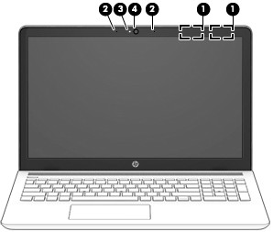

Item | Component | Description
(1) | WLAN antennas (2)* | Send and receive wireless signals to communicate with WLANs.
(2) | Internal microphones (2) | Record sound.
(3) | Camera light | On: One or more cameras are in use.
(4) | Camera | Allow you to video chat, record video, and record still images. Some cameras allow a facial recognition logon to Windows, instead of a password logon.  NOTE: Camera functions vary depending on the camera hardware and software installed on the computer model.
*The antennas are not visible from the outside of the computer. For optimal transmission, keep the areas immediately around the antennas free from obstructions.
For wireless regulatory notices, see the section of the Regulatory, Safety, and Environmental Notices that applies to your country or region.
To access this guide:
▲ Select the Start button, select HP Help and Support, and then select HP Documentation.

Buttons and speakers
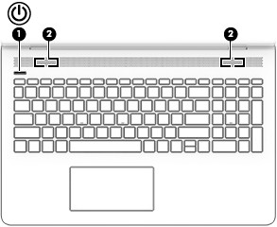

Item | Icon | Component | Description
(1) |  | Power button | - When the computer is off, press the button to turn on the computer.  - When the computer is on, press the button briefly to initiate Sleep.  - When the computer is in the Sleep state, press the button briefly to exit Sleep.  - When the computer is in Hibernation, press the button briefly to exit Hibernation.  CAUTION: Pressing and holding down the power button results in the loss of unsaved information.  If the computer has stopped responding and shutdown procedures are ineffective, press and hold the power button down for at least 5 seconds to turn off the computer.  To learn more about your power settings, see your power options.  ▲ Type power in the taskbar search box, and then select  Power & sleep options. – or –  Right-click the Start button, and then select Power Options.
(2) |  | Speakers | Produce sound.

Lights
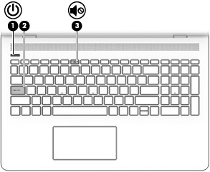

Item | Icon | Component | Description
(1) |  | Power light | - On: The computer is on.  - Blinking: The computer is in the Sleep state, a power-saving state. The computer shuts off power to the display and other unneeded components.  - Off: The computer is off or in Hibernation. Hibernation is a power-saving state that uses the least amount of power.
(2) |  | Caps lock light | On: Caps lock is on, which switches the key input to all capital letters.
(3) |  | Mute light | - On: Computer sound is off.  - Off: Computer sound is on.

Special keys
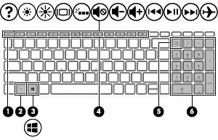

Item | Icon | Component | Description
(1) |  | esc key | Displays system information when pressed in combination with the fn key.
(2) |  | fn key | Displays system information when pressed in combination with another key.
(3) |  | Windows key | Opens the Start menu.  NOTE: Pressing the Windows key again will close the Start menu.
(4) |  | Action keys | Execute frequently used system functions.  NOTE: On select computer models, the f5 action key turns the keyboard backlight feature off or on.
(5) |  | num lock key | Alternates between the navigational and numeric functions on the integrated numeric keypad.
(6) |  | Integrated numeric keypad | A separate keypad to the right of the alphabet keyboard. When num lock is pressed, the keypad can be used like an external numeric keypad.  NOTE: If the keypad function is active when the computer is turned off, that function is reinstated when the computer is turned back on.

TouchPad
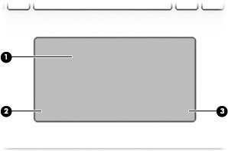

Item | Component | Description
(1) | TouchPad zone | Reads your finger gestures to move the pointer or activate items on the screen.
(2) | Left TouchPad button | Functions like the left button on an external mouse.
(3) | Right TouchPad button | Functions like the left button on an external mouse.

Left side
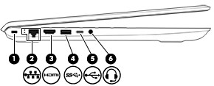

Item | Icon | Component | Description
(1) |  | Security cable slot | Attaches an optional security cable to the computer.  NOTE: The security cable is designed to act as a deterrent, but it may not prevent the computer from being mishandled or stolen.
(2) |  | RJ-45 (network) jack/status lights | Connects a network cable.  - White: The network is connected.  - Amber: Activity is occurring on the network.
(3) |  | HDMI port | Connects an optional video or audio device, such as a high-definition television, any compatible digital or audio component, or an HDMI device.
(4) |  | USB 3.x SuperSpeed port | Connects USB devices, such as a cell phone, camera, activity tracker, or smartwatch, and provides high-speed data transfer.
(5) |  | USB Type-C SuperSpeed port | When the computer is on, connects and charges a USB device that has a Type-C connector, such as a cell phone, camera, activity tracker, or smartwatch, and provides high-speed data transfer.  NOTE: Cables and/or adapters (purchased separately) may be required.
(6) |  | Audio-out (headphone)/Audio-in (microphone) jack | Connects optional powered stereo speakers, headphones, earbuds, a headset, or a television audio cable. Also connects an optional headset microphone. This jack does not support optional standalone devices.  WARNING! To reduce the risk of personal injury, adjust  the volume before putting on headphones, earbuds, or a headset. For additional safety information, refer to the Regulatory, Safety, and Environmental Notices.  To access this guide:  ▲ Select the Start menu, select HP Help and Support, and then select HP Documentation.  NOTE: When a device is connected to the jack, the computer speakers are disabled.

Right side
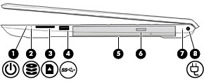

Item | Icon | Component | Description
(1) |  | Power light | - On: The computer is on.  - Blinking: The computer is in the Sleep state, a power-saving state. The computer shuts power off to the display and other unneeded components.  - Off: The computer is off or in Hibernation. Hibernation is a power-saving state that uses the least amount of power.
(2) |  | Drive light | Blinking white: The hard drive is being accessed.  Amber: HP 3D DriveGuard has temporarily parked the hard drive.
(3) |  | Memory card reader | Reads optional memory cards that enable you to store, manage, share, or access information.  To insert a card:  - Hold the card label-side up, with the connectors facing the computer.  - Insert the card into the memory card reader, and then press the card until it is firmly seated.  To remove a card:  ▲ Press in on the card, and then remove it from the memory card reader.
(4) |  | USB 3.x SuperSpeed port | Connects USB devices, such as a cell phone, camera, activity tracker, or smartwatch, and provides high-speed data transfer.
(5) |  | Optical drive (select products only) | Depending on your computer model, reads an optical disc or reads and writes to an optical disc.
(6) |  | Optical drive eject button (select products only) | Releases the optical drive disc tray.
(7) |  | AC adapter and battery light | - White: The AC adapter is connected and the battery is fully charged.  - Blinking white: The AC adapter is disconnected and the battery has reached a low battery level.  - Amber: The AC adapter is connected and the battery is charging.

Item | Icon | Component | Description
(7) |  | AC adapter and battery light (continued) | - Off: The battery is not charging.
(8) |  | Power connector | Connects an AC adapter.

Bottom
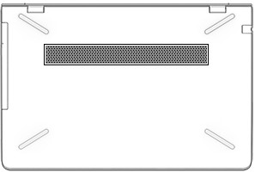

Component | Description
Vent | Enables airflow to cool internal components.  NOTE: The computer fan starts up automatically to cool internal components and prevent overheating. It is normal for the internal fan to cycle on and off during routine operation.

3 Illustrated parts catalog


NOTE: HP continually improves and changes product parts. For complete and current information on supported parts for your computer, go to http://partsurfer.hp.com, select your country or region, and then follow the on-screen instructions.

Locating the serial number, model number, product number, and warranty information
The serial number (1), model number (2), product number (3), and warranty information (4) are located on the bottom of the computer. This information may be needed when travelling internationally or when contacting support.
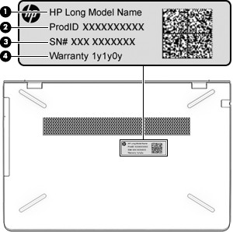

Computer components
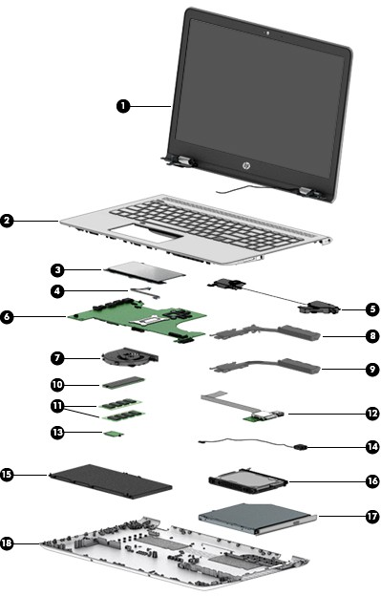

Item | Component | Spare part number
(1) | Display assembly: The display assembly is spared at the subcomponent level only. For more display assembly spare part information, see Display assembly components on page 26.
(2) | Keyboard/top cover in empress red finish with speaker grille in Pike silver finish with backlight (includes backlight cable and keyboard cable):
 | For use in Belgium | 928507-A41
 | For use in Bulgaria | 928507-261
 | For use in Canada | 928507-DB1
 | For use in the Czech Republic and Slovakia | 928507-FL1
 | For use in Denmark, Finland, and Norway | 928507-DH1
 | For use in France | 928507-051
 | For use in Germany | 928507-041
 | For use in Greece | 928507-151
 | For use in Hungary | 928507-211
 | For use in India | 928507-002
 | For use in Israel | 928507-BB1
 | For use in Italy | 928507-061
 | For use in Latin America | 928507-161
 | For use in the Netherlands | 928507-B31
 | For use in Portugal | 928507-131
 | For use in Romania | 928507-271
 | For use in Russia | 928507-251
 | For use in Saudi Arabia | 928507-171
 | For use in Slovenia | 928507-BA1
 | For use in South Korea | 928507-AD1
 | For use in Spain | 928507-071
 | For use in Switzerland | 928507-BG1
 | For use in Taiwan | 928507-AB1
 | For use in Thailand | 928507-281
 | For use in Turkey | 928507-141
 | For use in the United Kingdom | 928507-031
 | For use in the United States | 928507-001
 | Keyboard/top cover in empress red finish with speaker grille in Pike silver finish (includes keyboard cable):
 | For use in Belgium | 928506-A41
 | For use in Bulgaria | 928506-261
 | For use in Canada | 928506-DB1

Item Component | Spare part number
For use in the Czech Republic and Slovakia | 928506-FL1
For use in Denmark, Finland, and Norway | 928506-DH1
For use in France | 928506-051
For use in Germany | 928506-041
For use in Greece | 928506-151
For use in Hungary | 928506-211
For use in India | 928506-002
For use in Israel | 928506-BB1
For use in Italy | 928506-061
For use in Latin America | 928506-161
For use in the Netherlands | 928506-B31
For use in Portugal | 928506-131
For use in Romania | 928506-271
For use in Russia | 928506-251
For use in Saudi Arabia | 928506-171
For use in Slovenia | 928506-BA1
For use in South Korea | 928506-AD1
For use in Spain | 928506-071
For use in Switzerland | 928506-BG1
For use in Taiwan | 928506-AB1
For use in Thailand | 928506-281
For use in Turkey | 928506-141
For use in the United Kingdom | 928506-031
For use in the United States | 928506-001
Keyboard/top cover in mineral silver finish with speaker grille in Pike silver finish with backlight (includes backlight cable and keyboard cable):
For use in Belgium | 926859-A41
For use in Bulgaria | 926859-261
For use in Canada | 926859-DB1
For use in the Czech Republic and Slovakia | 926859-FL1
For use in Denmark, Finland, and Norway | 926859-DH1
For use in France | 926859-051
For use in Germany | 926859-041
For use in Greece | 926859-151
For use in Hungary | 926859-211

Item Component | Spare part number
For use in India | 926859-002
For use in Israel | 926859-BB1
For use in Italy | 926859-061
For use in Latin America | 926859-161
For use in the Netherlands | 926859-B31
For use in Portugal | 926859-131
For use in Romania | 926859-271
For use in Russia | 926859-251
For use in Saudi Arabia | 926859-171
For use in Slovenia | 926859-BA1
For use in South Korea | 926859-AD1
For use in Spain | 926859-071
For use in Switzerland | 926859-BG1
For use in Taiwan | 926859-AB1
For use in Thailand | 926859-281
For use in Turkey | 926859-141
For use in the United Kingdom | 926859-031
For use in the United States | 926859-001
Keyboard/top cover in mineral silver finish with speaker grille in Pike silver finish (includes keyboard cable):
For use in Belgium | 926858-A41
For use in Bulgaria | 926858-261
For use in Canada | 926858-DB1
For use in the Czech Republic and Slovakia | 926858-FL1
For use in Denmark, Finland, and Norway | 926858-DH1
For use in France | 926858-051
For use in Germany | 926858-041
For use in Greece | 926858-151
For use in Hungary | 926858-211
For use in India | 926858-002
For use in Israel | 926858-BB1
For use in Italy | 926858-061
For use in Latin America | 926858-161
For use in the Netherlands | 926858-B31
For use in Portugal | 926858-131

Item Component | Spare part number
For use in Romania | 926858-271
For use in Russia | 926858-251
For use in Saudi Arabia | 926858-171
For use in Slovenia | 926858-BA1
For use in South Korea | 926858-AD1
For use in Spain | 926858-071
For use in Switzerland | 926858-BG1
For use in Taiwan | 926858-AB1
For use in Thailand | 926858-281
For use in Turkey | 926858-141
For use in the United Kingdom | 926858-031
For use in the United States | 926858-001
Keyboard/top cover in opulent blue finish with speaker grille in Pike silver finish with backlight (includes backlight cable and keyboard cable):
For use in Belgium | 928440-A41
For use in Bulgaria | 928440-261
For use in Canada | 928440-DB1
For use in the Czech Republic and Slovakia | 928440-FL1
For use in Denmark, Finland, and Norway | 928440-DH1
For use in France | 928440-051
For use in Germany | 928440-041
For use in Greece | 928440-151
For use in Hungary | 928440-211
For use in India | 928440-002
For use in Israel | 928440-BB1
For use in Italy | 928440-061
For use in Latin America | 928440-161
For use in the Netherlands | 928440-B31
For use in Portugal | 928440-131
For use in Romania | 928440-271
For use in Russia | 928440-251
For use in Saudi Arabia | 928440-171
For use in Slovenia | 928440-BA1
For use in South Korea | 928440-AD1
For use in Spain | 928440-071

Item Component | Spare part number
For use in Switzerland | 928440-BG1
For use in Taiwan | 928440-AB1
For use in Thailand | 928440-281
For use in Turkey | 928440-141
For use in the United Kingdom | 928440-031
For use in the United States | 928440-001
Keyboard/top cover in opulent blue finish with speaker grille in Pike silver finish (includes keyboard cable):
For use in Belgium | 928439-A41
For use in Bulgaria | 928439-261
For use in Canada | 928439-DB1
For use in the Czech Republic and Slovakia | 928439-FL1
For use in Denmark, Finland, and Norway | 928439-DH1
For use in France | 928439-051
For use in Germany | 928439-041
For use in Greece | 928439-151
For use in Hungary | 928439-211
For use in India | 928439-002
For use in Israel | 928439-BB1
For use in Italy | 928439-061
For use in Latin America | 928439-161
For use in the Netherlands | 928439-B31
For use in Portugal | 928439-131
For use in Romania | 928439-271
For use in Russia | 928439-251
For use in Saudi Arabia | 928439-171
For use in Slovenia | 928439-BA1
For use in South Korea | 928439-AD1
For use in Spain | 928439-071
For use in Switzerland | 928439-BG1
For use in Taiwan | 928439-AB1
For use in Thailand | 928439-281
For use in Turkey | 928439-141
For use in the United Kingdom | 928439-031
For use in the United States | 928439-001

Item Component Spare part number
Keyboard/top cover in silk gold finish with speaker grille in Pike silver finish with backlight (includes backlight cable and keyboard cable):
For use in Belgium | 928438-A41
For use in Bulgaria | 928438-261
For use in Canada | 928438-DB1
For use in the Czech Republic and Slovakia | 928438-FL1
For use in Denmark, Finland, and Norway | 928438-DH1
For use in France | 928438-051
For use in Germany | 928438-041
For use in Greece | 928438-151
For use in Hungary | 928438-211
For use in India | 928438-002
For use in Israel | 928438-BB1
For use in Italy | 928438-061
For use in Latin America | 928438-161
For use in the Netherlands | 928438-B31
For use in Portugal | 928438-131
For use in Romania | 928438-271
For use in Russia | 928438-251
For use in Saudi Arabia | 928438-171
For use in Slovenia | 928438-BA1
For use in South Korea | 928438-AD1
For use in Spain | 928438-071
For use in Switzerland | 928438-BG1
For use in Taiwan | 928438-AB1
For use in Thailand | 928438-281
For use in Turkey | 928438-141
For use in the United Kingdom | 928438-031
For use in the United States | 928438-001
Keyboard/top cover in silk gold finish with speaker grille in Pike silver finish (includes keyboard cable):
For use in Belgium | 928437-A41
For use in Bulgaria | 928437-261
For use in Canada | 928437-DB1
For use in the Czech Republic and Slovakia | 928437-FL1
For use in Denmark, Finland, and Norway | 928437-DH1

Item | Component | Spare part number
 | For use in France | 928437-051
 | For use in Germany | 928437-041
 | For use in Greece | 928437-151
 | For use in Hungary | 928437-211
 | For use in India | 928437-002
 | For use in Israel | 928437-BB1
 | For use in Italy | 928437-061
 | For use in Latin America | 928437-161
 | For use in the Netherlands | 928437-B31
 | For use in Portugal | 928437-131
 | For use in Romania | 928437-271
 | For use in Russia | 928437-251
 | For use in Saudi Arabia | 928437-171
 | For use in Slovenia | 928437-BA1
 | For use in South Korea | 928437-AD1
 | For use in Spain | 928437-071
 | For use in Switzerland | 928437-BG1
 | For use in Taiwan | 928437-AB1
 | For use in Thailand | 928437-281
 | For use in Turkey | 928437-141
 | For use in the United Kingdom | 928437-031
 | For use in the United States | 928437-001
(3) | TouchPad (does not include TouchPad bracket or TouchPad cable): | 926853-001
NOTE: The TouchPad spare part kit does not include the TouchPad bracket or TouchPad cable. The TouchPad bracket is available using spare part number 926851-001. The TouchPad cable is available using spare part number 926843-001.
 | TouchPad bracket (not illustrated) | 926851-001
(4) | TouchPad cable (includes double-sided adhesive) | 926843-001
(5) | Speakers (include cables) | 926857-001
(6) | System board (includes processor and replacement thermal material):
 | Equipped with an AMD A12-9720P 2.70-GHz (turbo up to 3.66-GHz) quad core processor (1866-MHz FSB, 2.0-GB L2 cache, 15-W), an AMD Radeon 530 R17M-M1-70 (Meso S3 Pro)  hybrid graphics subsystem with up to 4096-MB of discrete video memory, and the Windows 10 operating system | 926289-601
 | Equipped with an AMD A12-9720P 2.70-GHz (turbo up to 3.66-GHz) quad core processor (1866-MHz FSB, 2.0-GB L2 cache, 15-W), an AMD Radeon 530 R17M-M1-70 (Meso S3 Pro)  hybrid graphics subsystem with up to 4096-MB of discrete video memory, and a non-Windows operating system | 926289-001

Item Component | Spare part number
Equipped with an AMD A12-9720P 2.70-GHz (turbo up to 3.66-GHz) quad core processor (1866-MHz FSB, 2.0-GB L2 cache, 15-W), an AMD Radeon R7 UMA graphics subsystem, and the Windows 10 operating system | 926286-601
Equipped with an AMD A12-9720P 2.70-GHz (turbo up to 3.66-GHz) quad core processor (1866-MHz FSB, 2.0-GB L2 cache, 15-W), an AMD Radeon R7 UMA graphics subsystem, and a non-Windows operating system | 926286-001
Equipped with an AMD A10-9620P 2.50-GHz (turbo up to 3.40-GHz) quad core processor (1866-MHz FSB, 2.0-GB L2 cache, 15-W), an AMD Radeon 530 R17M-M1-70 (Meso S3 Pro)  hybrid graphics subsystem with up to 4096-MB of discrete video memory, and the Windows 10 operating system | 926290-601
Equipped with an AMD A10-9620P 2.50-GHz (turbo up to 3.40-GHz) quad core processor (1866-MHz FSB, 2.0-GB L2 cache, 15-W), an AMD Radeon 530 R17M-M1-70 (Meso S3 Pro)  hybrid graphics subsystem with up to 4096-MB of discrete video memory, and a non-Windows operating system | 926290-001
Equipped with an AMD A10-9620P 2.50-GHz (turbo up to 3.40-GHz) quad core processor (1866-MHz FSB, 2.0-GB L2 cache, 15-W), an AMD Radeon 530 R17M-M1-70 (Meso S3 Pro)  hybrid graphics subsystem with up to 2048-MB of discrete video memory, and the Windows 10 operating system | 926288-601
Equipped with an AMD A10-9620P 2.50-GHz (turbo up to 3.40-GHz) quad core processor (1866-MHz FSB, 2.0-GB L2 cache, 15-W), an AMD Radeon 530 R17M-M1-70 (Meso S3 Pro)  hybrid graphics subsystem with up to 2048-MB of discrete video memory, and a non-Windows operating system | 926288-001
Equipped with an AMD A10-9620P 2.50-GHz (turbo up to 3.40-GHz) quad core processor (1866-MHz FSB, 2.0-GB L2 cache, 15-W), an AMD Radeon R5 UMA graphics subsystem, and the Windows 10 operating system | 926287-601
Equipped with an AMD A10-9620P 2.50-GHz (turbo up to 3.40-GHz) quad core processor (1866-MHz FSB, 2.0-GB L2 cache, 15-W), an AMD Radeon R5 UMA graphics subsystem, and a non-Windows operating system | 926287-001
Equipped with an AMD A9-9420P 3.00-GHz (turbo up to 3.60-GHz) dual core processor (1866-MHz FSB, 1.0-GB L2 cache, 15-W), an AMD Radeon 530 R17M-M1-70 (Meso S3 Pro)  hybrid graphics subsystem with up to 2048-MB of discrete video memory, and the Windows 10 operating system | 926921-601
Equipped with an AMD A9-9420P 3.00-GHz (turbo up to 3.60-GHz) dual core processor (1866-MHz FSB, 1.0-GB L2 cache, 15-W), an AMD Radeon 530 R17M-M1-70 (Meso S3 Pro)  hybrid graphics subsystem with up to 2048-MB of discrete video memory, and a non-Windows operating system | 926921-001
Equipped with an AMD A9-9420P 3.00-GHz (turbo up to 3.60-GHz) dual core processor (1866-MHz FSB, 1.0-GB L2 cache, 15-W), an AMD Radeon R5 UMA graphics subsystem, and the Windows 10 operating system | 926283-601
Equipped with an AMD A9-9420P 3.00-GHz (turbo up to 3.60-GHz) dual core processor (1866-MHz FSB, 1.0-GB L2 cache, 15-W), an AMD Radeon R5 UMA graphics subsystem, and a non-Windows operating system | 926283-001
Equipped with an AMD A9-9420P 3.00-GHz (turbo up to 3.60-GHz) dual core processor (1866-MHz FSB, 1.0-GB L2 cache, 15-W), an AMD Radeon R5 UMA graphics subsystem, hard drive and solid-state drive connectors, and the Windows 10 operating system | 926284-601
Equipped with an AMD A9-9420P 3.00-GHz (turbo up to 3.60-GHz) dual core processor (1866-MHz FSB, 1.0-GB L2 cache, 15-W), an AMD Radeon R5 UMA graphics subsystem, hard drive and solid-state drive connectors, and a non-Windows operating system | 926284-001
Equipped with an AMD A6-9220P 2.50-GHz (turbo up to 2.90-GHz) dual core processor (1866-MHz FSB, 1.0-GB L2 cache, 15-W), an AMD Radeon R4 UMA graphics subsystem, and the Windows 10 operating system | 926285-601

Item | Component | Spare part number
 | Equipped with an AMD A6-9220P 2.50-GHz (turbo up to 2.90-GHz) dual core processor (1866-MHz FSB, 1.0-GB L2 cache, 15-W), an AMD Radeon R4 UMA graphics subsystem, and a non-Windows operating system | 926285-001
 | USB Type-C port bracket (not illustrated) | 926849-001
(7) | Fan (includes cable) | 926845-001
 | Heat sink (includes replacement thermal material):
(8) | For use only on computer models equipped with a graphics subsystem with discrete memory | 926898-001
(9) | For use only on computer models equipped with a graphics subsystem with UMA memory | 926846-001
(10) | Solid-state drive (M.2 SATA3; does not include solid-state drive cable, solid-state drive converter board, or solid-state drive holder):
 | 512-GB, with TLC | 763008-018
 | 256-GB | 865902-021
 | 128-GB | 827560-053
NOTE: The solid-state drive spare part kit does not include the solid-state drive cable, solid-state drive converter board, or solid-state drive holder. The solid-state drive cable is available using spare part number 933617-001. The solid-state drive converter board is available using spare part number 926901-001. The solid-state drive holder is available using spare part number 926902-001.
(11) | Memory modules (2, DDR4-2400, 1.2-V):
 | 8-MB | 862398-855
 | 4-MB | 862397-855
 | 2-MB | 864271-855
(12) | USB port board (includes power light actuator, hard drive light actuator, card reader slot, and USB port; does not include USB port board cable):
 | For use only on computer models equipped with an Intel Dual Band Wireless-AC 7265  802.11 AC 2×2 WiFi + Bluetooth 4.2 Combo Adapter (non-vPro) | 926899-001
 | For use only on computer models equipped with an Intel Dual Band Wireless-AC 3168 802.11AC 1×1 WiFi + Bluetooth 4.2 Combo Adapter (non-vPro) or a Realtek RTL8723DE  802.11 bgn 1×1 WiFi + Bluetooth 4.2 Combo Adapter | 926854-001
 | USB port board cable (not illustrated, includes double-sided adhesive) | 926842-001
(13) | WLAN module:
 | Intel Dual Band Wireless-AC 7265 802.11 AC 2×2 WiFi + Bluetooth 4.2 Combo Adapter (non-vPro) | 901229-855
 | Intel Dual Band Wireless-AC 3168 802.11AC 1×1 WiFi + Bluetooth 4.2 Combo Adapter (non-vPro) | 863934-855
 | Realtek RTL8723DE 802.11 bgn 1×1 WiFi + Bluetooth 4.2 Combo Adapter | 927230-855
(14) | Power connector cable | 810327-007
(15) | Battery (3-cell, 41-WHr, 3.6-AHr, Li-ion) | 920070-855
(16) | Hard drive (does not include hard drive bracket or hard drive cable):
 | 2-TB, 5400-rpm, SATA, 7.0-mm hard drive | 912487-855

Item | Component | Spare part number
 | 1-TB, 5400-rpm, SATA, 7.0-mm hard drive | 778192-005
 | 500-GB, 5400-rpm, SATA, 7.0-mm hard drive | 778186-005
NOTE: The hard drive spare part kit does not include the hard drive bracket or the hard drive cable. The hard drive bracket is available using spare part number 926848-001. The hard drive cable is available using spare part number 926844-001
(17) | DVD±RW DL SuperMulti Drive (does not include optical drive bezel or optical drive bracket) | 920417-011
NOTE: The optical drive spare part kit does not include the optical drive bezel or the optical drive bracket. The optical drive bezel is available using spare part number 926835-001. The optical drive bracket is available using spare part number 926850-001
(18) | Bottom cover | 926832-001
 | Rubber Foot Kit (not illustrated, includes Mylar screw cover) | 926855-001

Display assembly components
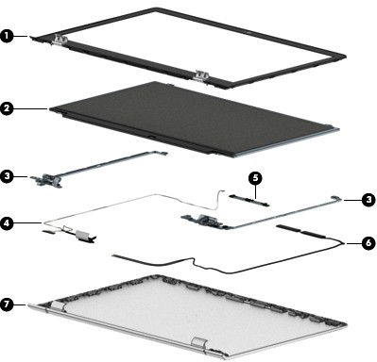

Item | Component | Spare part number
(1) | Display bezel:
 | For use on computer models equipped with a FHD infrared webcam | 926834-001
 | For use on computer models equipped with an HD non-infrared webcam | 926833-001
(2) | Display panel:
 | 15.6-in, FHD, BrightView (1920×1080), WLED, UWVA, TouchScreen | 847651-005
 | 15.6-in, HD, BrightView (1366×768), WLED, SVA, TouchScreen | 809612-016
 | 15.6-in, FHD, BrightView (1920×1080), WLED, UWVA, non-TouchScreen | 842463-011
 | 15.6-in, FHD, AntiGlare (1920×1080), WLED, UWVA, non-TouchScreen | 752920-018
 | 15.6-in, FHD, AntiGlare (1920×1080), WLED, SVA, non-TouchScreen | 798933-014
 | 15.6-in, HD, BrightView (1366×768), WLED, SVA, non-TouchScreen | 847654-010
 | 15.6-in, HD, AntiGlare (1366×768), WLED, SVA, non-TouchScreen | 909185-008
(3) | Hinges (2, include left and right display hinges): | 926852-001
(4) | Display panel cable (includes the webcam/microphone module cable)
 | For use on computer models equipped with an FHD display assembly and an FHD infrared webcam | 926841-001
 | For use on computer models equipped with an FHD display assembly and an HD non-infrared webcam | 926838-001
 | For use on computer models equipped with an HD display assembly and an FHD infrared webcam | 926840-001
 | For use on computer models equipped with an HD display assembly and an HD non-infrared webcam | 926837-001
 | For use on computer models equipped with an FHD/HD display assembly and an FHD infrared webcam | 926839-001
 | For use on computer models equipped with an FHD/HD display assembly and an HD non-infrared webcam | 926836-001
(5) | Webcam/microphone module (includes Mylar and double-sided adhesive):
 | FHD infrared webcam/microphone module | 926727-001
 | HD non-infrared webcam/microphone module | 919573-003
(6) | Wireless Antenna Kit (includes left and right wireless antenna cables and transceivers): | 926826-001
(7) | Display back cover (includes left and right wireless antenna cables and transceivers and rubber padding and shielding):
 | In empress red finish | 926830-001
 | In mineral silver finish | 926827-001
 | In opulent blue finish | 926829-001
 | In silk gold finish | 926828-001

Miscellaneous parts

Component | Spare part number
AC adapter:
65-W HP Smart AC adapter (non-PFC, EM, RC, 4.5-mm) for use only in India and the People’s Republic of China | 913691-850
65-W AC adapter (non-PFC, S-3P, 4.5-mm) for use in all countries and regions | 710412-001
65-W AC adapter (non-PFC, SB, 4.5-mm) for use only in Argentina | 710340-850
45-W HP Smart AC adapter (non-PFC, RC, 4.5-mm, non-slim) for use in all countries and regions | 741553-850
45-W AC adapter (non-PFC, SB, 4.5-mm, RA) for use only in Argentina | 741553-852
HP HDMI-to-VGA adapter | 701943-001
HP USB–C-to-USB–A dongle | 833960-001
Power cord (C5 connector, 1.00-m):
For use in Argentina | 920688-003
For use in Australia | 920688-011
For use in Denmark | 920688-007
For use in Europe | 920688-005
For use in India | 920688-016
For use in Israel | 920688-008
For use in Italy | 920688-002
For use in North America | 920688-001
For use in the People’s Republic of China | 920688-014
For use in South Africa | 920688-010
For use in South Korea | 920688-013
For use in Switzerland | 920688-009
For use in Taiwan | 920688-015
For use in Thailand | 920688-012
For use in the United Kingdom and Singapore | 920688-006
Rubber Foot Kit (includes bottom cover rear feet) | 926855-001
Screw Kit | 927240-001

4 Removal and replacement preliminary requirements

Tools required
You will need the following tools to complete the removal and replacement procedures:
- Flat-bladed screw driver
- Magnetic screw driver
- Phillips P0 screw driver

Service considerations
The following sections include some of the considerations that you must keep in mind during disassembly and assembly procedures.

NOTE: As you remove each subassembly from the computer, place the subassembly (and all accompanying screws) away from the work area to prevent damage.

Plastic parts
CAUTION: Using excessive force during disassembly and reassembly can damage plastic parts. Use care when handling the plastic parts. Apply pressure only at the points designated in
the maintenance instructions.

Cables and connectors
CAUTION: When servicing the computer, be sure that cables are placed in their proper locations during the reassembly process. Improper cable placement can damage the computer.
Cables must be handled with extreme care to avoid damage. Apply only the tension required to unseat or seat the cables during removal and insertion. Handle cables by the connector whenever possible. In all cases, avoid bending, twisting, or tearing cables. Be sure that cables are routed in such a way that they cannot be caught or snagged by parts being removed or replaced. Handle flex cables with extreme care; these cables
tear easily.

Drive handling
CAUTION: Drives are fragile components that must be handled with care. To prevent damage to the computer, damage to a drive, or loss of information, observe these precautions:
Before removing or inserting a drive, shut down the computer. If you are unsure whether the computer is off or in Hibernation, turn the computer on, and then shut it down through the operating system.
Before handling a drive, be sure that you are discharged of static electricity. While handling a drive, avoid touching the connector.
Before removing a diskette drive or optical drive, be sure that a diskette or disc is not in the drive and be sure that the optical drive tray is closed.
Handle drives on surfaces covered with at least one inch of shock-proof foam. Avoid dropping drives from any height onto any surface.
After removing drive, place it in a static-proof bag.
Avoid exposing a drive to products that have magnetic fields, such as monitors or speakers. Avoid exposing a drive to temperature extremes or liquids.
If a drive must be mailed, place the drive in a bubble pack mailer or other suitable form of protective packaging and label the package “FRAGILE.”

Grounding guidelines

Electrostatic discharge damage
Electronic components are sensitive to electrostatic discharge (ESD). Circuitry design and structure determine the degree of sensitivity. Networks built into many integrated circuits provide some protection, but in many cases, ESD contains enough power to alter device parameters or melt silicon junctions.
A discharge of static electricity from a finger or other conductor can destroy static-sensitive devices or microcircuitry. Even if the spark is neither felt nor heard, damage may have occurred.
An electronic device exposed to ESD may not be affected at all and can work perfectly throughout a normal cycle. Or the device may function normally for a while, then degrade in the internal layers, reducing its
life expectancy.
CAUTION: To prevent damage to the computer when you are removing or installing internal components, observe these precautions:
Keep components in their electrostatic-safe containers until you are ready to install them.
Before touching an electronic component, discharge static electricity by using the guidelines described in this section.
Avoid touching pins, leads, and circuitry. Handle electronic components as little as possible. If you remove a component, place it in an electrostatic-safe container.
The following table shows how humidity affects the electrostatic voltage levels generated by different activities.
CAUTION: A product can be degraded by as little as 700 V.
Typical electrostatic voltage levels
 |  | Relative humidity
Event | 10% | 40% | 55%
Walking across carpet | 35,000 V | 15,000 V | 7,500 V
Walking across vinyl floor | 12,000 V | 5,000 V | 3,000 V
Motions of bench worker | 6,000 V | 800 V | 400 V
Removing DIPS from plastic tube | 2,000 V | 700 V | 400 V
Removing DIPS from vinyl tray | 11,500 V | 4,000 V | 2,000 V
Removing DIPS from Styrofoam | 14,500 V | 5,000 V | 3,500 V
Removing bubble pack from PCB | 26,500 V | 20,000 V | 7,000 V
Packing PCBs in foam-lined box | 21,000 V | 11,000 V | 5,000 V

Packaging and transporting guidelines
Follow these grounding guidelines when packaging and transporting equipment:
- To avoid hand contact, transport products in static-safe tubes, bags, or boxes.
- Protect ESD-sensitive parts and assemblies with conductive or approved containers or packaging.
- Keep ESD-sensitive parts in their containers until the parts arrive at static-free workstations.
- Place items on a grounded surface before removing items from their containers.
- Always be properly grounded when touching a component or assembly.
- Store reusable ESD-sensitive parts from assemblies in protective packaging or nonconductive foam.
- Use transporters and conveyors made of antistatic belts and roller bushings. Be sure that mechanized equipment used for moving materials is wired to ground and that proper materials are selected to avoid static charging. When grounding is not possible, use an ionizer to dissipate electric charges.

Workstation guidelines
Follow these grounding workstation guidelines:
- Cover the workstation with approved static-shielding material.
- Use a wrist strap connected to a properly grounded work surface and use properly grounded tools and equipment.
- Use conductive field service tools, such as cutters, screw drivers, and vacuums.
- When fixtures must directly contact dissipative surfaces, use fixtures made only of static-safe materials.
- Keep the work area free of nonconductive materials, such as ordinary plastic assembly aids and Styrofoam.
- Handle ESD-sensitive components, parts, and assemblies by the case or PCM laminate. Handle these items only at static-free workstations.
- Avoid contact with pins, leads, or circuitry.
- Turn off power and input signals before inserting or removing connectors or test equipment.

Equipment guidelines
Grounding equipment must include either a wrist strap or a foot strap at a grounded workstation.
  - When seated, wear a wrist strap connected to a grounded system. Wrist straps are flexible straps with a minimum of one megohm ±10% resistance in the ground cords. To provide proper ground, wear a strap snugly against the skin at all times. On grounded mats with banana-plug connectors, use alligator clips to connect a wrist strap.
  - When standing, use foot straps and a grounded floor mat. Foot straps (heel, toe, or boot straps) can be used at standing workstations and are compatible with most types of shoes or boots. On conductive floors or dissipative floor mats, use foot straps on both feet with a minimum of one megohm resistance between the operator and ground. To be effective, the conductive must be worn in contact with the skin.
The following grounding equipment is recommended to prevent electrostatic damage:
  - Antistatic tape
  - Antistatic smocks, aprons, and sleeve protectors
  - Conductive bins and other assembly or soldering aids
  - Nonconductive foam
  - Conductive computerop workstations with ground cords of one megohm resistance
  - Static-dissipative tables or floor mats with hard ties to the ground
  - Field service kits
  - Static awareness labels
  - Material-handling packages
  - Nonconductive plastic bags, tubes, or boxes
  - Metal tote boxes
  - Electrostatic voltage levels and protective materials
The following table lists the shielding protection provided by antistatic bags and floor mats.

Material | Use | Voltage protection level
Antistatic plastics | Bags | 1,500 V
Carbon-loaded plastic | Floor mats | 7,500 V
Metallized laminate | Floor mats | 5,000 V

5 Removal and replacement procedures

This chapter provides removal and replacement procedures for Authorized Service Provider only parts.
CAUTION: Components described in this chapter should only be accessed by an authorized service provider. Accessing these parts can damage the computer or void the warranty.
CAUTION: This computer does not have user-replaceable parts. Only HP authorized service providers should perform the removal and replacement procedures described here. Accessing the internal part could damage the computer or void the warranty.

Component replacement procedures

NOTE: Details about your computer, including model, serial number, product key, and length of warranty, are on the service tag at the bottom of your computer. See Locating the serial number, model number, product number, and warranty information on page 15 for details.
 NOTE: HP continually improves and changes product parts. For complete and current information on supported parts for your computer, go to http://partsurfer.hp.com, select your country or region, and then follow the on-screen instructions.
There are as many as 57 screws that must be removed, replaced, and/or loosened when servicing Authorized Service Provider only parts. Make special note of each screw size and location during removal
and replacement.

Optical drive

Description | Spare part number
DVD±RW DL SuperMulti Drive (does not include optical drive bezel or optical drive bracket) | 920417-011
NOTE: The optical drive spare part kit does not include the optical drive bezel or the optical drive bracket. The optical drive bezel is available using spare part number 926835-001. The optical drive bracket is available using spare part number 926850-001

Before disassembling the computer, follow these steps:
- Shut down the computer. If you are unsure whether the computer is off or in Hibernation, turn the computer on, and then shut it down through the operating system.
- Disconnect all external devices connected to the computer.
- Disconnect the power from the computer by first unplugging the power cord from the AC outlet, and then unplugging the AC adapter from the computer.
Remove the optical drive:
- Turn the computer upside down on a flat surface.
- Position the computer with the front toward you.
- Remove the Mylar screw cover (1).
The screw cover is available in the Rubber Feet Kit, spare part number 926855-001.

- Remove the Phillips PM2.0×10.7 screw (2) that secures the optical drive to the computer.
- Remove the optical drive (3).
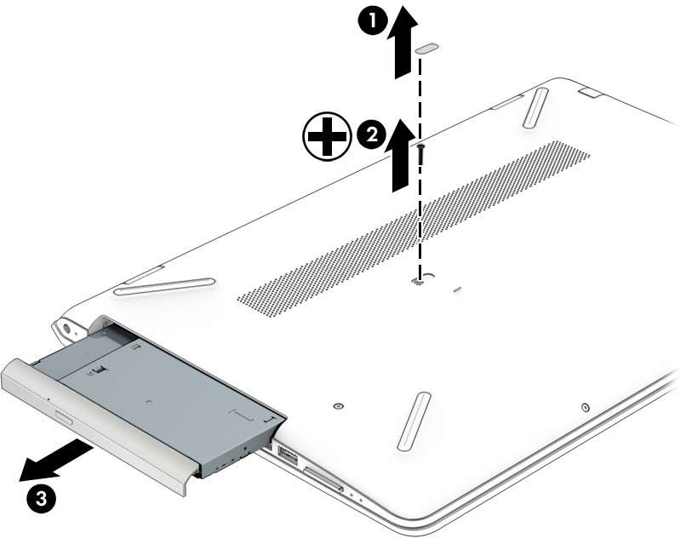
Reverse this procedure to install the optical drive.

Bottom cover

Description | Spare part number
Bottom cover | 926832-001

Before removing the bottom cover, follow these steps:
- Shut down the computer. If you are unsure whether the computer is off or in Hibernation, turn the computer on, and then shut it down through the operating system.
- Disconnect all external devices connected to the computer.
- Disconnect the power from the computer by first unplugging the power cord from the AC outlet, and then unplugging the AC adapter from the computer.
- Remove the optical drive (see Optical drive on page 34). Remove the bottom cover:
  - Remove the computer rubber feet (1).
The rubber feet are available using spare part numbers 926855-001

  - Remove the following screws that secure the bottom cover to the computer:
    - Four Phillips PM2.5×6.7 screws under the rear rubber feet
    - Two Phillips PM2.0×10.7 screws in the middle of the bottom cover
    - Two Phillips PM2.0×5.8 screws under the front rubber feet
    - Two Phillips PM2.0×5.6 screws on the front edge
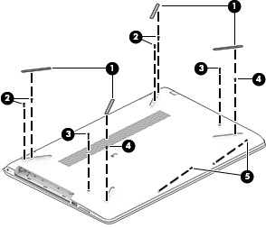
  - Insert a case utility tool (1) or similar thin, plastic tool into the display hinge areas of the bottom cover.
  - Separate the rear edge of the bottom cover (2) from the keyboard/top cover.
  - Insert a case utility tool (3) or similar thin, plastic tool into the optical drive area of the bottom cover.
  - Separate the tabs (4) built into the keyboard/top cover from the slots built into the bottom cover.
  - Remove the bottom cover (5).
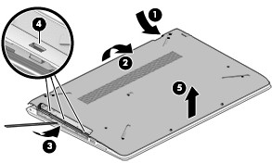

Battery
Reverse this procedure to install the bottom cover.

Description | Spare part number
3-cell, 41-WHr, 3.6-AHr, Li-ion battery | 920070-855

Before removing the battery, follow these steps:
- Shut down the computer. If you are unsure whether the computer is off or in Hibernation, turn the computer on, and then shut it down through the operating system.
- Disconnect all external devices connected to the computer.
- Disconnect the power from the computer by first unplugging the power cord from the AC outlet, and then unplugging the AC adapter from the computer.
- Remove the optical drive (see Optical drive on page 34).
- Remove the bottom cover (see Bottom cover on page 35). Remove the battery:
  - Remove the four Phillips PM2.0×5.7 screws (1) that secure the battery to the keyboard/top cover.
  - Remove the battery (2).
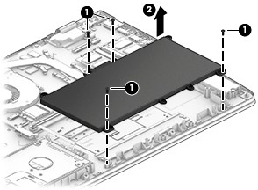
Reverse this procedure to install the battery.

Hard drive

NOTE: The hard drive spare part kit does not include the hard drive bracket or the hard drive cable. The hard drive bracket is available using spare part number 926848-001. The hard drive cable is available using spare part number 926844-001
Description | Spare part number
2-TB, 5400-rpm, SATA, 7.2-mm hard drive | 912487-855
1-TB, 5400-rpm, SATA, 7.2-mm hard drive | 778192-005
500-GB, 5400-rpm, SATA, 7.0-mm hard drive | 778186-005

Before removing the hard drive, follow these steps:
    - Shut down the computer. If you are unsure whether the computer is off or in Hibernation, turn the computer on, and then shut it down through the operating system.
    - Disconnect all external devices connected to the computer.
    - Disconnect the power from the computer by first unplugging the power cord from the AC outlet, and then unplugging the AC adapter from the computer.
    - Remove the optical drive (see Optical drive on page 34).
    - Remove the bottom cover (see Bottom cover on page 35).
    - Remove the battery (see Battery on page 37). Remove the hard drive:
      - Release the zero insertion force (ZIF) connector (1) to which the hard drive cable is connected, and then disconnect the hard drive cable from the system board.
      - Lift the right side of the hard drive (2) to release it from the hard drive bay, and then remove the hard drive.
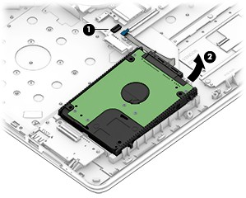

      - If it is necessary to disassemble the hard drive, remove the hard drive brackets (1) from the hard drive, and then disconnect the hard drive cable (2) from the hard drive.
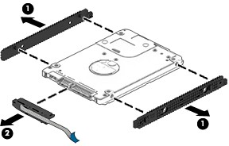
Reverse this procedure to reassemble and install the hard drive.

WLAN module

Description | Spare part number
Intel Dual Band Wireless-AC 7265 802.11 AC 2×2 WiFi + Bluetooth 4.2 Combo Adapter (non-vPro) | 901229-855
Intel Dual Band Wireless-AC 3168 802.11AC 1×1 WiFi + Bluetooth 4.2 Combo Adapter (non-vPro) | 863934-855
Realtek RTL8723DE 802.11 bgn 1×1 WiFi + Bluetooth 4.2 Combo Adapter | 927230-855

CAUTION: To prevent an unresponsive system, replace the wireless module only with a wireless module authorized for use in the computer by the governmental agency that regulates wireless devices in your country or region. If you replace the module and then receive a warning message, remove the module to restore device functionality, and then contact technical support.
Before removing the WLAN module, follow these steps:
- Turn off the computer. If you are unsure whether the computer is off or in Hibernation, turn the computer on, and then shut it down through the operating system.
- Disconnect the power from the computer by first unplugging the power cord from the AC outlet, and then unplugging the AC adapter from the computer.
- Disconnect all external devices from the computer.
- Remove the optical drive (see Optical drive on page 34).
- Remove the bottom cover (see Bottom cover on page 35).
- Remove the battery (see Battery on page 37). Remove the WLAN module:
  - Disconnect the WLAN antenna cables (1) from the terminals on the WLAN module.


NOTE: The WLAN antenna cable labeled "1/MAIN" connects to the WLAN module "Main" terminal. The WLAN antenna cable labeled "2/AUX" connects to the WLAN module "Aux" terminal.
  - Remove the Phillips PM2.0×2.3 screw (2) that secures the WLAN module to the computer. (The WLAN module tilts up.)
  - Remove the WLAN module (3) by pulling the module away from the slot at an angle.

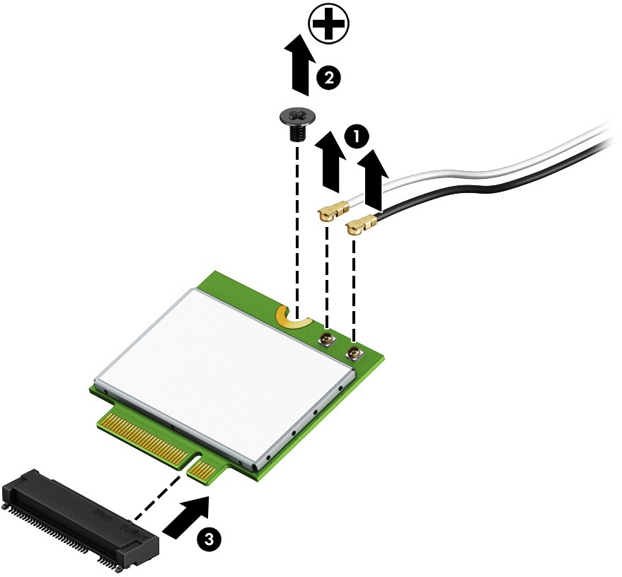
NOTE: WLAN modules are designed with a notch to prevent incorrect insertion.

Reverse this procedure to install the WLAN module.

Solid-state drive

NOTE: The solid-state drive spare part kit does not include the solid-state drive cable, solid-state drive converter board, or solid-state drive holder. The solid-state drive cable is available using spare part number 933617-001. The solid-state drive converter board is available using spare part number 926901-001. The solid-state drive holder is available using spare part number 926902-001.
Description | Spare part number
512-GB, M.2 SATA-3, solid-state drive with TLC | 763008-018
256-GB, M.2 SATA-3, solid-state drive | 865902-021
128-GB, M.2 SATA-3, solid-state drive | 827560-053

Before removing the solid-state drive, follow these steps:
    - Shut down the computer. If you are unsure whether the computer is off or in Hibernation, turn the computer on, and then shut it down through the operating system.
    - Disconnect all external devices connected to the computer.
    - Disconnect the power from the computer by first unplugging the power cord from the AC outlet, and then unplugging the AC adapter from the computer.
    - Remove the optical drive (see Optical drive on page 34).
    - Remove the bottom cover (see Bottom cover on page 35).
    - Remove the battery (see Battery on page 37). Remove the solid-state drive:
      - Remove the Phillips PM2.0×2.3 screw (1) that secures the drive to the system board.
      - Remove the drive (2) by pulling it away from the connector.

NOTE: Solid-state drives are designed with notches to prevent incorrect insertion.

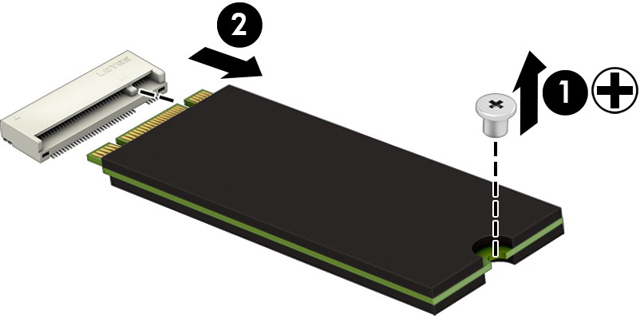

Reverse this procedure to reassemble and install the solid-state drive.

Memory module

NOTE: Primary and expansion memory is installed in a side-by-side configuration in the bottom of the computer. If only one memory module is installed, it must be installed in the socket labeled 1.
Description | Spare part number
8-MB, DDR4-2400, 1.2-V | 862398-855
4-MB, DDR4-2400, 1.2-V | 862397-855
2-MB, DDR4-2400, 1.2-V | 864271-855

Update BIOS before adding memory modules
Before adding new memory, make sure you update the computer to the latest BIOS.
CAUTION: Failure to update the computer to the latest BIOS prior to installing new memory may result in various system problems.
To update BIOS:
- Navigate to www.hp.com.
- Click Support & Drivers, and then click Drivers & Software.
- In the Enter a product name/number box, type the computer model information, and then click Search.
- Click the link for the computer model.
- Select the operating system, and then click Next.
- Under Step 2: Select a Download, click the BIOS link.
- Click the link for the most recent BIOS.
- Click the Download button, and then follow the on-screen instructions. Before removing the memory module, follow these steps:
  - Turn off the computer. If you are unsure whether the computer is off or in Hibernation, turn the computer on, and then shut it down through the operating system.
  - Disconnect the power from the computer by first unplugging the power cord from the AC outlet, and then unplugging the AC adapter from the computer.
  - Disconnect all external devices from the computer.
  - Remove the optical drive (see Optical drive on page 34).
  - Remove the bottom cover (see Bottom cover on page 35).
  - Remove the battery (see Battery on page 37). Remove the memory module:
    - Spread the retaining tabs (1) on each side of the memory module slot to release the memory module. (The edge of the module opposite the slot rises away from the computer.)

    - Remove the memory module (2) by pulling the module away from the slot at an angle.

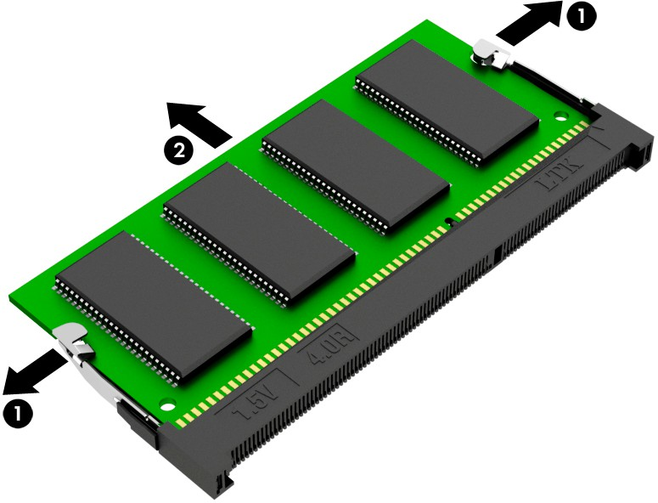
NOTE: Memory modules are designed with a notch to prevent incorrect insertion.

Reverse this procedure to install a memory module.

USB port board
NOTE: The USB port board spare part kit does not include the USB port board cable. The USB port board cable is available using spare part numbers 926842-001.
Description | Spare part number
For use only on computer models equipped with an Intel Dual Band Wireless-AC 7265 802.11 AC 2×2 WiFi + Bluetooth 4.2 Combo Adapter (non-vPro; includes power light actuator, hard drive light actuator, card reader slot, and USB port) | 926899-001
For use only on computer models equipped with an Intel Dual Band Wireless-AC 3168 802.11AC 1×1 WiFi  + Bluetooth 4.2 Combo Adapter (non-vPro) or a Realtek RTL8723DE 802.11 bgn 1×1 WiFi + Bluetooth 4.2 Combo Adapter (includes power light actuator, hard drive light actuator, card reader slot, and USB port) | 926854-001

Before removing the USB port board, follow these steps:
- Shut down the computer. If you are unsure whether the computer is off or in Hibernation, turn the computer on, and then shut it down through the operating system.
- Disconnect all external devices connected to the computer.
- Disconnect the power from the computer by first unplugging the power cord from the AC outlet, and then unplugging the AC adapter from the computer.
- Remove the optical drive (see Optical drive on page 34).
- Remove the bottom cover (see Bottom cover on page 35).
- Remove the battery (see Battery on page 37).

Remove the USB port board:
- Release the ZIF connector (1) to which the USB port board cable is connected, and then disconnect the USB port board cable from the USB port board.
- Remove the USB port board (2).
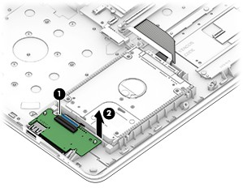

Reverse this procedure to install the USB port board.

TouchPad cable

NOTE: The TouchPad spare part kit does not include the TouchPad cable. The TouchPad cable is available using spare part number 926843-001.
Before removing the TouchPad cable, follow these steps:
- Shut down the computer. If you are unsure whether the computer is off or in Hibernation, turn the computer on, and then shut it down through the operating system.
- Disconnect all external devices connected to the computer.
- Disconnect the power from the computer by first unplugging the power cord from the AC outlet, and then unplugging the AC adapter from the computer.
- Remove the optical drive (see Optical drive on page 34).
- Remove the bottom cover (see Bottom cover on page 35).
- Remove the battery (see Battery on page 37). Remove the TouchPad cable:
  - Release the ZIF connector (1) to which TouchPad cable is connected, and then disconnect the TouchPad cable from the system board.
  - Release the ZIF connector (2) to which TouchPad cable is connected, and then disconnect the TouchPad cable from the TouchPad.
  - Remove the TouchPad cable (3).
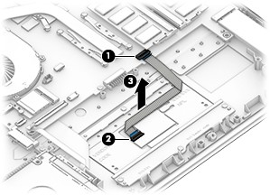
Reverse this procedure to install the TouchPad cable.

TouchPad

NOTE: The TouchPad spare part kit does not include the TouchPad bracket or TouchPad cable. The TouchPad bracket is available using spare part number 926851-001. The TouchPad cable is available using spare part number 926843-001.
Description | Spare part number
TouchPad (does not include TouchPad bracket or TouchPad cable) | 926853-001

Before removing the TouchPad, follow these steps:
- Shut down the computer. If you are unsure whether the computer is off or in Hibernation, turn the computer on, and then shut it down through the operating system.
- Disconnect all external devices connected to the computer.
- Disconnect the power from the computer by first unplugging the power cord from the AC outlet, and then unplugging the AC adapter from the computer.
- Remove the optical drive (see Optical drive on page 34).
- Remove the bottom cover (see Bottom cover on page 35).
- Remove the battery (see Battery on page 37). Remove the TouchPad:
  - Release the ZIF connector (1) to which TouchPad cable is connected, and then disconnect the TouchPad cable from the system board.
  - Remove the three Phillips PM2.0×2.2 broad head screws (2) that secure the TouchPad to the keyboard/ top cover.
  - Remove the three Phillips PM2.0×2.9 screws (3) that secure the TouchPad and TouchPad bracket to the keyboard/top cover.
  - Remove the TouchPad bracket (4) .
  - Remove the TouchPad (5).
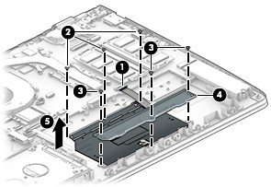

Fan
Reverse this procedure to install the TouchPad.

Description | Spare part number
Fan (includes cable) | 926845-001

Before removing the fan, follow these steps:
- Shut down the computer. If you are unsure whether the computer is off or in Hibernation, turn the computer on, and then shut it down through the operating system.
- Disconnect all external devices connected to the computer.
- Disconnect the power from the computer by first unplugging the power cord from the AC outlet, and then unplugging the AC adapter from the computer.
- Remove the optical drive (see Optical drive on page 34).
- Remove the bottom cover (see Bottom cover on page 35).
- Remove the battery (see Battery on page 37). Remove the fan:
  - Disconnect the fan cable (1) from the system board.
  - Remove the three Phillips PM2.0×5.7 screws (2) that secure the fan to the keyboard/top cover.
  - Remove the fan (3).
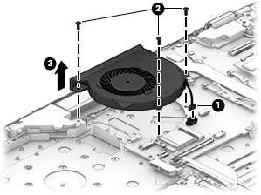
Reverse this procedure to install the fan.

System board

NOTE: All system board spare part kits include a processor and replacement thermal material.

Description | Spare part number
Equipped with an AMD A12-9720P 2.70-GHz (turbo up to 3.66-GHz) quad core processor (1866-MHz FSB, 2.0-GB L2 cache, 15-W), an AMD Radeon 530 R17M-M1-70 (Meso S3 Pro) hybrid graphics subsystem with up to 4096-MB of discrete video memory, and the Windows 10 operating system | 926289-601
Equipped with an AMD A12-9720P 2.70-GHz (turbo up to 3.66-GHz) quad core processor (1866-MHz FSB, 2.0-GB L2 cache, 15-W), an AMD Radeon 530 R17M-M1-70 (Meso S3 Pro) hybrid graphics subsystem with up to 4096-MB of discrete video memory, and a non-Windows operating system | 926289-001
Equipped with an AMD A12-9720P 2.70-GHz (turbo up to 3.66-GHz) quad core processor (1866-MHz FSB, 2.0-GB L2 cache, 15-W), an AMD Radeon R7 UMA graphics subsystem, and the Windows 10 operating system | 926286-601
Equipped with an AMD A12-9720P 2.70-GHz (turbo up to 3.66-GHz) quad core processor (1866-MHz FSB, 2.0-GB L2 cache, 15-W), an AMD Radeon R7 UMA graphics subsystem, and a non-Windows operating system | 926286-001
Equipped with an AMD A10-9620P 2.50-GHz (turbo up to 3.40-GHz) quad core processor (1866-MHz FSB, 2.0-GB L2 cache, 15-W), an AMD Radeon 530 R17M-M1-70 (Meso S3 Pro) hybrid graphics subsystem with up to 4096-MB of discrete video memory, and the Windows 10 operating system | 926290-601
Equipped with an AMD A10-9620P 2.50-GHz (turbo up to 3.40-GHz) quad core processor (1866-MHz FSB, 2.0-GB L2 cache, 15-W), an AMD Radeon 530 R17M-M1-70 (Meso S3 Pro) hybrid graphics subsystem with up to 4096-MB of discrete video memory, and a non-Windows operating system | 926290-001
Equipped with an AMD A10-9620P 2.50-GHz (turbo up to 3.40-GHz) quad core processor (1866-MHz FSB, 2.0-GB L2 cache, 15-W), an AMD Radeon 530 R17M-M1-70 (Meso S3 Pro) hybrid graphics subsystem with up to 2048-MB of discrete video memory, and the Windows 10 operating system | 926288-601
Equipped with an AMD A10-9620P 2.50-GHz (turbo up to 3.40-GHz) quad core processor (1866-MHz FSB, 2.0-GB L2 cache, 15-W), an AMD Radeon 530 R17M-M1-70 (Meso S3 Pro) hybrid graphics subsystem with up to 2048-MB of discrete video memory, and a non-Windows operating system | 926288-001
Equipped with an AMD A10-9620P 2.50-GHz (turbo up to 3.40-GHz) quad core processor (1866-MHz FSB, 2.0-GB L2 cache, 15-W), an AMD Radeon R5 UMA graphics subsystem, and the Windows 10 operating system | 926287-601
Equipped with an AMD A10-9620P 2.50-GHz (turbo up to 3.40-GHz) quad core processor (1866-MHz FSB, 2.0-GB L2 cache, 15-W), an AMD Radeon R5 UMA graphics subsystem, and a non-Windows operating system | 926287-001
Equipped with an AMD A9-9420P 3.00-GHz (turbo up to 3.60-GHz) dual core processor (1866-MHz FSB, 1.0-GB L2 cache, 15-W), an AMD Radeon 530 R17M-M1-70 (Meso S3 Pro) hybrid graphics subsystem with up to 2048-MB of discrete video memory, and the Windows 10 operating system | 926921-601
Equipped with an AMD A9-9420P 3.00-GHz (turbo up to 3.60-GHz) dual core processor (1866-MHz FSB, 1.0-GB L2 cache, 15-W), an AMD Radeon 530 R17M-M1-70 (Meso S3 Pro) hybrid graphics subsystem with up to 2048-MB of discrete video memory, and a non-Windows operating system | 926921-001
Equipped with an AMD A9-9420P 3.00-GHz (turbo up to 3.60-GHz) dual core processor (1866-MHz FSB, 1.0-GB L2 cache, 15-W), an AMD Radeon R5 UMA graphics subsystem, and the Windows 10  operating system | 926283-601
Equipped with an AMD A9-9420P 3.00-GHz (turbo up to 3.60-GHz) dual core processor (1866-MHz FSB, 1.0-GB L2 cache, 15-W), an AMD Radeon R5 UMA graphics subsystem, and a non-Windows  operating system | 926283-001
Equipped with an AMD A9-9420P 3.00-GHz (turbo up to 3.60-GHz) dual core processor (1866-MHz FSB, 1.0-GB L2 cache, 15-W), an AMD Radeon R5 UMA graphics subsystem, hard drive and solid-state drive connectors, and the Windows 10 operating system | 926284-601

Description | Spare part number
Equipped with an AMD A9-9420P 3.00-GHz (turbo up to 3.60-GHz) dual core processor (1866-MHz FSB, 1.0-GB L2 cache, 15-W), an AMD Radeon R5 UMA graphics subsystem, hard drive and solid-state drive connectors, and a non-Windows operating system | 926284-001
Equipped with an AMD A6-9220P 2.50-GHz (turbo up to 2.90-GHz) dual core processor (1866-MHz FSB, 1.0-GB L2 cache, 15-W), an AMD Radeon R4 UMA graphics subsystem, and the Windows 10  operating system | 926285-601
Equipped with an AMD A6-9220P 2.50-GHz (turbo up to 2.90-GHz) dual core processor (1866-MHz FSB, 1.0-GB L2 cache, 15-W), an AMD Radeon R4 UMA graphics subsystem, and a non-Windows  operating system | 926285-001

Before removing the system board, follow these steps:
- Shut down the computer. If you are unsure whether the computer is off or in Hibernation, turn the computer on, and then shut it down through the operating system.
- Disconnect all external devices connected to the computer.
- Disconnect the power from the computer by first unplugging the power cord from the AC outlet, and then unplugging the AC adapter from the computer.
- Remove the optical drive (see Optical drive on page 34), and then remove the following components:
  - Bottom cover (see Bottom cover on page 35)
  - Battery (see Battery on page 37)
  - Hard drive (see Hard drive on page 38)
  - Solid-state drive (see Solid-state drive on page 41)
  - Fan (see Fan on page 47)
When replacing the system board, be sure to remove the following components from the defective system board and install them on the replacement system board:
- WLAN module (see WLAN module on page 39)
- Memory module (see Memory module on page 42)
- Heat sink (see Heat sink on page 52)
- USB port board cable (see USB port board cable on page 55) Remove the system board:
- Disconnect the following cables from the system board:
  - Power connector cable
  - WLAN antenna cables

NOTE: The #1/white WLAN antenna cable connects to the WLAN module "#1/Main" terminal. The #2/ black WLAN antenna cable connects to the WLAN module "#2/Aux" terminal.
  - Display panel ZIF connector cable
  - Speaker cable
  - TouchPad ZIF connector cable

  - Keyboard ZIF connector cable
  - Backlight ZIF connector cable
  - USB port board ZIF connector cable
- Detach the USB port board cable (9) from the keyboard/top cover. (The USB port board cable is attached to the keyboard/top cover with double-sided adhesive.)
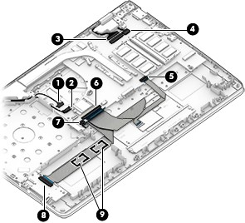
- Remove the five Phillips PM2.0×2.9 screws (1) that secure the system board to the keyboard/top cover.
- Remove the two Phillips PM2.5×6.7 screws (2) that secure the secure the left display hinge WLAN module to the keyboard/top cover.
- Remove the USB Type-C port bracket (3).
The USB Type-C port bracket is available using spare part number 926849-001.

- Swing the display left hinge (4) up and back.
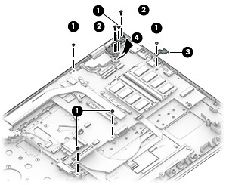
- Lift the left side of the system board (1) until it rests at an angle.
- Remove the system board (2) by sliding it up and to the left at an angle.
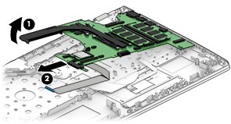
Reverse this procedure to install the system board.

Heat sink

NOTE: The heat sink spare part kit includes replacement thermal material.
Description | Spare part number
For use only on computer models equipped with a graphics subsystem with discrete memory | 926898-001
For use only on computer models equipped with a graphics subsystem with UMA memory | 926846-001

Before removing the heat sink, follow these steps:
- Turn off the computer. If you are unsure whether the computer is off or in Hibernation, turn the computer on, and then shut it down through the operating system.
- Disconnect the power from the computer by first unplugging the power cord from the AC outlet, and then unplugging the AC adapter from the computer.
- Disconnect all external devices from the computer.
- Remove the optical drive (see Optical drive on page 34), and then remove the following components:
  - Bottom cover (see Bottom cover on page 35)
  - Battery (see Battery on page 37)
  - Solid-state drive (see Solid-state drive on page 41)
  - Fan (see Fan on page 47)

  - System board (see System board on page 48) Remove the heat sink:
NOTE: Steps 1 and 2 apply to computer models equipped with a graphics subsystem with discrete memory. See Steps 3 and 4 for heat sink removal information for computer models equipped with a graphics subsystem with UMA memory.
- Remove the six Phillips PM2.0×2.9 screws (1) that secure the heat sink to the system board.

- Remove the heat sink (2).

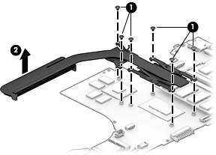

NOTE: Steps 3 and 4 apply to computer models equipped with a graphics subsystem with UMA memory. See Steps 1 and 2 for heat sink removal information for computer models equipped with a graphics subsystem with discrete memory.
- Remove the four Phillips PM2.0×2.9 screws (1) that secure the heat sink to the system board.
- Remove the heat sink (2).
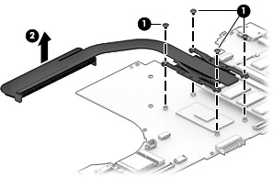


NOTE: The thermal material must be thoroughly cleaned from the surfaces of the heat sink and the system board components each time the heat sink is removed. Replacement thermal material is included with
the heat sink and system board spare part kits.
On computer models equipped with a graphics subsystem with discrete memory: Thermal paste is used on the processor (1) and the heat sink section (2) that services it. Thermal paste is also used on the VGA component (3) and the heat sink section (4) that services it.

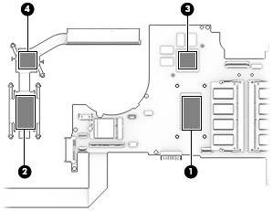
On computer models equipped with a graphics subsystem with UMA memory: Thermal paste is used on the processor (1) and the heat sink section (2) that services it.
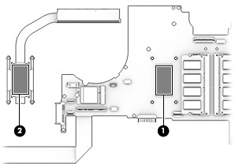

Reverse this procedure to install the heat sink.

USB port board cable

NOTE: The USB port board spare part kit does not include the USB port board cable. The USB port board cable is available using spare part numbers 926842-001.
Before removing the USB port board cable, follow these steps:
- Shut down the computer. If you are unsure whether the computer is off or in Hibernation, turn the computer on, and then shut it down through the operating system.
- Disconnect all external devices connected to the computer.
- Disconnect the power from the computer by first unplugging the power cord from the AC outlet, and then unplugging the AC adapter from the computer.
- Remove the optical drive (see Optical drive on page 34), and then remove the following components:
  - Bottom cover (see Bottom cover on page 35)
  - Battery (see Battery on page 37)
  - Solid-state drive (see Solid-state drive on page 41)
  - Fan (see Fan on page 47)
  - System board (see System board on page 48) Remove the USB port board cable:
- Turn the system board upside down with the front toward you.
- Release the ZIF connector (1) to which USB port board cable is connected, and then disconnect the USB port board cable (2) from the audio jack board.
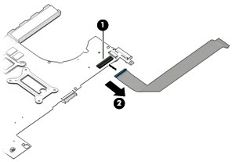

- Remove the USB port board cable.
Reverse this procedure to install the USB port board cable.

Display assembly

NOTE: The display assembly is spared at the subcomponent level. For display assembly spare part information, see the individual removal subsections.

Before removing the display assembly, follow these steps:
- Shut down the computer. If you are unsure whether the computer is off or in Hibernation, turn the computer on, and then shut it down through the operating system.
- Disconnect all external devices connected to the computer.
- Disconnect the power from the computer by first unplugging the power cord from the AC outlet, and then unplugging the AC adapter from the computer.
- Remove the optical drive (see Optical drive on page 34).
- Remove the bottom cover (see Bottom cover on page 35).
- Remove the battery (see Battery on page 37). Remove the display assembly:
  - Disconnect the WLAN antenna cables (1) from the terminals on the WLAN module.

NOTE: The WLAN antenna cable labeled "1/MAIN" connects to the WLAN module "Main" terminal. The WLAN antenna cable labeled "2/AUX" connects to the WLAN module "Aux" terminal.
  - Release the WLAN antenna cables from the retention clips (2) and routing channel built into the right speaker and the keyboard/top cover.
  - Release the ZIF connector (3) to which display panel cable is connected, and then disconnect the display panel cable from the system board.
  - Release the display panel from the retention clips (4) and routing channel built into the left speaker.
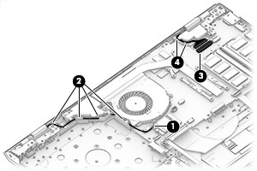
  - Remove the four Phillips PM2.5×6.7 screws (1) that secure the display assembly to the keyboard/ top cover.

  - Swing the display hinges (2) up and back.
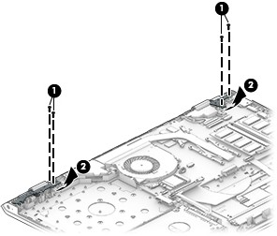
  - Lift the front edge of the keyboard/top cover (1) until it rests at an angle.
  - Slide the keyboard/top cover (2) up and away at an angle and separate it from the display assembly.
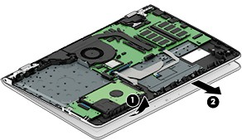

  - If it is necessary to replace the display bezel or any of the display assembly subcomponents:
    - Release the top edge of the display bezel (1) from the display assembly.
    - Release the left and right edges of the display bezel (2) from the display assembly.
    - Release the bottom edge of the display bezel (3) from the display assembly.
    - Remove the display bezel (4) from the display assembly.
The display bezel is available using spare part numbers 926834-001 (for use on computer models equipped with a FHD infrared webcam) and 926833-001 (for use on computer models equipped with an HD non-infrared webcam).
  - If it is necessary to replace the webcam/microphone module:

    - Remove the display bezel.
    - Detach the webcam/microphone module (1) from the display back cover. (The webcam/ microphone module is attached to the display back cover with double-sided adhesive.)
    - Disconnect the webcam/microphone module cable (2) from the webcam/microphone module.
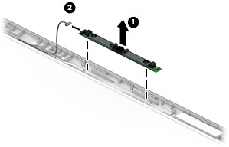

    - Remove the webcam/microphone module.
The webcam/microphone module is available using spare part numbers 926727-001 (FHD infrared webcam/microphone module) and 919573-003 (HD non-infrared webcam/microphone module).
  - If it is necessary to replace the display panel:
    - Remove the display bezel.
    - Remove the four Phillips PM2.0×2.9 screws that secure the display panel to the display back cover.
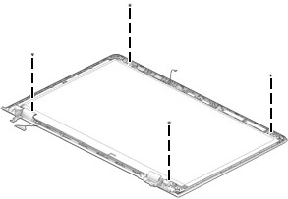
CAUTION: Before turning the display panel upside down, make sure the work surface is clear of tools, screws, and any other foreign objects. Failure to follow this caution can result in damage to the display panel.

    - Swing the top edge of the display panel (1) up and forward until the display panel rests upside down in front of the display back cover.
    - Release the adhesive support strip (2) that secures the display panel cable connector to the display panel.
    - Disconnect the display panel cable (3) from the display panel.
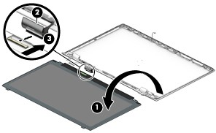
    - Remove the display panel.
The display panel is available using the following spare part numbers:

● | 847651-005 | – 15.6-in, FHD, BrightView (1920×1080), WLED, UWVA, TouchScreen
● | 809612-016 | – 15.6-in, HD, BrightView (1366×768), WLED, SVA, TouchScreen
● | 842463-011 | – 15.6-in, FHD, BrightView (1920×1080), WLED, UWVA, non-TouchScreen
● | 752920-018 | – 15.6-in, FHD, AntiGlare (1920×1080), WLED, UWVA, non-TouchScreen
● | 798933-014 | – 15.6-in, FHD, AntiGlare (1920×1080), WLED, SVA, non-TouchScreen
● | 847654-010 | – 15.6-in, HD, BrightView (1366×768), WLED, SVA, non-TouchScreen
● | 909185-008 | – 15.6-in, HD, AntiGlare (1366×768), WLED, SVA, non-TouchScreen
  - If it is necessary to replace the display hinges:
    - Remove the display bezel.
    - Remove the two Phillips PM2.0×2.9 screws (1) that secure the hinges to the display back cover.
    - Remove the six Phillips PM2.5×3.2 broad head screws (2) that secure the hinges to the display back cover.

    - Remove the display hinges (3).
The display hinges are available using spare part number 926852-001.
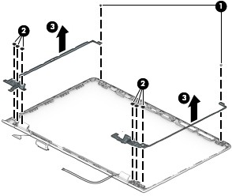

  - If it is necessary to replace the display panel cable:
    - Remove the display bezel.
    - Release the webcam/microphone module.
    - Release the display panel.
    - Release the display hinges.
    - Release the display panel cable from the retention clips (1) and routing channels built into the top, left, and bottom edges of the display back cover.
    - Remove the display panel cable (2).
The display panel cable is available using the following spare part numbers:
      - 926841-001 – For use on computer models equipped with an FHD display assembly and an FHD infrared webcam
      - 926838-001 – For use on computer models equipped with an FHD display assembly and an HD non-infrared webcam
      - 926840-001 – For use on computer models equipped with an HD display assembly and an FHD infrared webcam
      - 926837-001 – For use on computer models equipped with an HD display assembly and an HD non-infrared webcam
      - 926839-001 – For use on computer models equipped with an FHD/HD display assembly and an FHD infrared webcam
      - 926836-001 – For use on computer models equipped with an FHD/HD display assembly and an HD non-infrared webcam

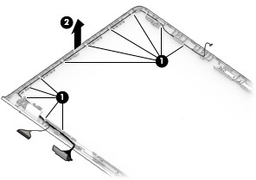
  - If it is necessary to replace the wireless antenna cables and transceivers:
    - Remove the display bezel.
    - Release the display panel.
    - Release the display hinges.
    - Detach the wireless antenna transceivers (1) from the display back cover. (The wireless antenna transceivers are attached to the display back cover with double-sided adhesive.)
    - Release the wireless antenna cables from the retention clips (2) and routing channels built into the top, right, and bottom edges of the display back cover.
    - Remove the wireless antenna cables and transceivers (3).
The wireless antenna cables and transceivers are available using spare part number 926826-001.
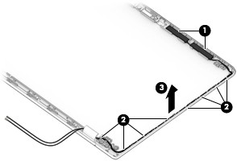

Reverse this procedure to reassemble and install the display assembly.

Speakers

Description | Spare part number
Speakers (includes cables) | 926857-001

Before removing the speakers, follow these steps:
- Turn off the computer. If you are unsure whether the computer is off or in Hibernation, turn the computer on, and then shut it down through the operating system.
- Disconnect the power from the computer by first unplugging the power cord from the AC outlet, and then unplugging the AC adapter from the computer.
- Disconnect all external devices from the computer.
- Remove the optical drive (see Optical drive on page 34), and then remove the following components:
  - Bottom cover (see Bottom cover on page 35)
  - Battery (see Battery on page 37)
  - Solid-state drive (see Solid-state drive on page 41)
  - Fan (see Fan on page 47)
  - System board (see System board on page 48) Remove the speakers:
- Release the power connector cable from the retention clips (1) and routing channel built into the right speaker.
- Release the speaker cable from the retention clips (2) and routing channel built into the keyboard/ top cover.
- Remove the two Phillips PM2.0×2.9 screws (3) that secure the speakers to the keyboard/top cover.

- Remove the speakers (4).
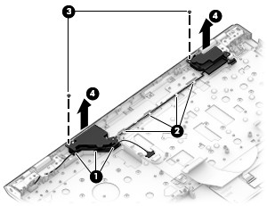
Reverse this procedure to install the speakers.

Power connector cable

Description | Spare part number
Power connector cable | 810327-007

Before removing the power connector cable, follow these steps:
- Shut down the computer. If you are unsure whether the computer is off or in Hibernation, turn the computer on, and then shut it down through the operating system.
- Disconnect all external devices connected to the computer.
- Disconnect the power from the computer by first unplugging the power cord from the AC outlet, and then unplugging the AC adapter from the computer.
- Remove the optical drive (see Optical drive on page 34), and then remove the following components:
  - Bottom cover (see Bottom cover on page 35)
  - Battery (see Battery on page 37)
  - Display assembly (see Display assembly on page 55) Remove the power connector cable:
- Release the power connector cable from the retention clips (1) and routing channel built into the right speaker and the keyboard/top cover (2).
- Remove the power connector cable (3).
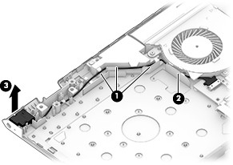
Reverse this procedure to install the power connector cable.

6 Computer Setup (BIOS), TPM, and HP Sure Start

Using Computer Setup
Computer Setup, or Basic Input/Output System (BIOS), controls communication between all the input and output devices on the system (such as disk drives, display, keyboard, mouse, and printer). Computer Setup includes settings for the types of devices installed, the startup sequence of the computer, and the amount of system and extended memory.

NOTE: Use extreme care when making changes in Computer Setup. Errors can prevent the computer from operating properly.

Starting Computer Setup

NOTE: An external keyboard or mouse connected to a USB port can be used with Computer Setup only if USB legacy support is enabled.
To start Computer Setup, follow these steps:
▲ Start Computer Setup.
- Computers or tablets with keyboards:
▲ Turn on or restart the computer, and when the HP logo appears, press f10 to enter Computer Setup.
- Tablets without keyboards:
▲ Turn off the tablet. Press the power button in combination with the volume down button until the Startup menu is displayed, and then tap F10 to enter Computer Setup.

Navigating and selecting in Computer Setup
- To select a menu or a menu item, use the tab key and the keyboard arrow keys and then press enter, or use a pointing device to select the item.

NOTE: On tablets without keyboards, you can use your finger to make selections.
- To scroll up and down, select the up arrow or the down arrow in the upper-right corner of the screen, or use the up arrow key or the down arrow key on the keyboard.
- To close open dialog boxes and return to the main Computer Setup screen, press esc, and then follow the on-screen instructions.

To exit Computer Setup menus, choose one of the following methods:
- To exit Computer Setup menus without saving your changes:
Select the Exit icon in the lower-right corner of the screen, and then follow the on-screen instructions. – or –
Select Main, select Ignore Changes and Exit, and then press enter.
- To save your changes and exit Computer Setup menus:
Select the Save icon in the lower-right corner of the screen, and then follow the on-screen instructions. – or –
Select Main, select Save Changes and Exit, and then press enter.
Your changes go into effect when the computer restarts.

Restoring factory settings in Computer Setup

NOTE: Restoring defaults will not change the hard drive mode.
To return all settings in Computer Setup to the values that were set at the factory, follow these steps:
- Start Computer Setup. See Starting Computer Setup on page 65.
- Select Main, and then select Apply Factory Defaults and Exit.

NOTE: On select products, the selections may display Restore Defaults instead of Apply Factory

Defaults and Exit.

- Follow the on-screen instructions.
- To save your changes and exit, select the Save icon in the lower-right corner of the screen, and then follow the on-screen instructions.
– or –
Select Main, select Save Changes and Exit, and then press enter.
Your changes go into effect when the computer restarts.

NOTE: Your password settings and security settings are not changed when you restore the factory settings.

Updating the BIOS
Updated versions of the BIOS may be available on the HP website.
Most BIOS updates on the HP website are packaged in compressed files called SoftPaqs.
Some download packages contain a file named Readme.txt, which contains information regarding installing and troubleshooting the file.

Determining the BIOS version
To decide whether you need to update Computer Setup (BIOS), first determine the BIOS version on the computer.
BIOS version information (also known as ROM date and System BIOS) can be accessed by pressing fn+esc (if you are already in Windows) or by using Computer Setup.
- Start Computer Setup. See Starting Computer Setup on page 65.
- Select Main, and then select System Information.
- To exit Computer Setup without saving your changes, select the Exit icon in the lower-right corner of the screen, and then follow the on-screen instructions.
– or –
Select Main, select Ignore Changes and Exit, and then press enter.
To check for later BIOS versions, see Downloading a BIOS update on page 67.

Downloading a BIOS update
CAUTION: To reduce the risk of damage to the computer or an unsuccessful installation, download and install a BIOS update only when the computer is connected to reliable external power using the AC adapter. Do not download or install a BIOS update while the computer is running on battery power, docked in an optional docking device, or connected to an optional power source. During the download and installation, follow these instructions:
Do not disconnect power on the computer by unplugging the power cord from the AC outlet. Do not shut down the computer or initiate Sleep.
Do not insert, remove, connect, or disconnect any device, cable, or cord.
- Type support in the taskbar search box, and then select the HP Support Assistant app.
– or –
Select the question mark icon in the taskbar.
- Select Updates, and then select Check for updates and messages.
- Follow the on-screen instructions.
- At the download area, follow these steps:
  - Identify the most recent BIOS update and compare it to the BIOS version currently installed on your computer. Make a note of the date, name, or other identifier. You may need this information to locate the update later, after it has been downloaded to your hard drive.
  - Follow the on-screen instructions to download your selection to the hard drive.
Make a note of the path to the location on your hard drive where the BIOS update is downloaded. You will need to access this path when you are ready to install the update.


NOTE: If you connect your computer to a network, consult the network administrator before installing any software updates, especially system BIOS updates.
BIOS installation procedures vary. Follow any instructions that are revealed on the screen after the download is complete. If no instructions are revealed, follow these steps:
- Type file in the taskbar search box, and then select File Explorer.
- Select your hard drive designation. The hard drive designation is typically Local Disk (C:).
- Using the hard drive path you recorded earlier, open the folder that contains the update.
- Double-click the file that has an .exe extension (for example, filename.exe). The BIOS installation begins.
- Complete the installation by following the on-screen instructions.

NOTE: After a message on the screen reports a successful installation, you can delete the downloaded file from your hard drive.

Changing the boot order using the f9 prompt
To dynamically choose a boot device for the current startup sequence, follow these steps:
- Access the Boot Device Options menu:
  - Computers or tablets with keyboards:
▲ Turn on or restart the computer, and when the HP logo appears, press f9 to enter the Boot Device Options menu.
  - Tablets without keyboards:
▲ Turn off the tablet. Press the power button in combination with the volume down button until the Startup menu is displayed, and then tap F9 to enter the Boot Device Options menu.
- Select a boot device, then press enter.

TPM BIOS settings (select products only)
IMPORTANT: Before enabling Trusted Platform Module (TPM) functionality on this system, you must ensure that your intended use of TPM complies with relevant local laws, regulations and policies, and approvals or licenses must be obtained if applicable. For any compliance issues arising from your operation/usage of TPM which violates the above mentioned requirement, you shall bear all the liabilities wholly and solely. HP will not be responsible for any related liabilities.
TPM provides additional security for your computer. You can modify the TPM settings in Computer Setup (BIOS).

NOTE: If you change the TPM setting to Hidden, TPM is not visible in the operating system.
To access TPM settings in Computer Setup:
- Start Computer Setup. See Starting Computer Setup on page 65.
- Select Security, select TPM Embedded Security, and then follow the on-screen instructions.

Using HP Sure Start (select products only)
Select computer models are configured with HP Sure Start, a technology that continuously monitors
the computer's BIOS for attacks or corruption. If the BIOS becomes corrupted or is attacked, HP Sure Start automatically restores the BIOS to its previously safe state, without user intervention.
HP Sure Start is configured and already enabled so that most users can use the HP Sure Start default configuration. The default configuration can be customized by advanced users.
To access the latest documentation on HP Sure Start, go to http://www.hp.com/support, and select your country. Select Drivers & Downloads, and then follow the on-screen instructions.

7 HP PC Hardware Diagnostics (UEFI)

HP PC Hardware Diagnostics is a Unified Extensible Firmware Interface (UEFI) that allows you to run diagnostic tests to determine whether the computer hardware is functioning properly. The tool runs outside
the operating system so that it can isolate hardware failures from issues that are caused by the operating system or other software components.
When HP PC Hardware Diagnostics (UEFI) detects a failure that requires hardware replacement, a 24-digit Failure ID is generated. This ID can then be provided to support to help determine how to correct the problem.

NOTE: To start diagnostics on a convertible computer, your computer must be in notebook mode and you must use the keyboard attached.
To start HP PC Hardware Diagnostics (UEFI), follow these steps:
- Turn on or restart the computer, quickly press esc.

NOTE: The HP PC Hardware Diagnostics (UEFI) download instructions are provided in English only, and you must use a Windows computer to download and create the HP UEFI support environment because only .exe files are offered.
- Press or tap f2.
The BIOS searches three places for the diagnostic tools, in the following order:
  - Connected USB drive

NOTE: To download the HP PC Hardware Diagnostics (UEFI) tool to a USB drive, see Downloading
HP PC Hardware Diagnostics (UEFI) to a USB device on page 71.

  - Hard drive
  - BIOS
- When the diagnostic tool opens, select the type of diagnostic test you want to run, and then follow the on-screen instructions.

NOTE: If you need to stop a diagnostic test, press esc.

Downloading HP PC Hardware Diagnostics (UEFI) to a USB device

NOTE: The HP PC Hardware Diagnostics (UEFI) download instructions are provided in English only, and you must use a Windows computer to download and create the HP UEFI support environment because only .exe files are offered.
There are two options to download HP PC Hardware Diagnostics to a USB device.

Download the latest UEFI version
- Go to http://www.hp.com/go/techcenter/pcdiags. The HP PC Diagnostics home page is displayed.
- In the HP PC Hardware Diagnostics section, click the Download link, and then select Run. Download any version of UEFI for a specific product
- Go to http://www.hp.com/support, and then select your country. The HP Support page is displayed.
- Click Drivers & Downloads.
- In the text box, enter the product name, and then click Go. – or –
Click Find Now to let HP automatically detect your product.
- Select your computer, and then select your operating system.
- In the Diagnostic section, follow the on-screen instructions to select and download the UEFI version you want.

8 Specifications

 | Metric | U.S.
Computer dimensions
Width | 37.8 cm | 14.9 in
Depth | 25.2 cm | 9.9 in
Height | 2.5 cm | 0.9 in
Weight | 1.9 kg | 4.4 lbs
Temperature
Operating | 5°C to 35°C | 41°F to 95°F
Nonoperating | -20°C to 60°C | -4°F to 140°F
Relative humidity (noncondensing)
Operating | 10% to 90%
Nonoperating | 5% to 95%
Maximum altitude (unpressurized)
Operating | -15 m to 3,048 m | -50 ft to 10,000 ft
Nonoperating | -15 m to 12,192 m | -50 ft to 40,000 ft
NOTE: Applicable product safety standards specify thermal limits for plastic surfaces. The device operates well within this range of temperatures.

9 Backing up and recovering

This chapter provides information about the following processes. The information in the chapter is standard procedure for most products.
- Creating recovery media and backups
- Restoring and recovering your system
For additional information, refer to the HP support assistant app.
▲ Type support in the taskbar search box, and then select the HP Support Assistant app.
  - or –
Click the question mark icon in the taskbar.
IMPORTANT: If you will be performing recovery procedures on a tablet, the tablet battery must be at least 70% charged before you start the recovery process.
IMPORTANT: For a tablet with a detachable keyboard, connect the keyboard to the keyboard dock before beginning any recovery process.

Creating recovery media and backups
The following methods of creating recovery media and backups are available on select products only. Choose the available method according to your computer model.
- Use HP Recovery Manager to create HP Recovery media after you successfully set up the computer. This step creates a backup of the HP Recovery partition on the computer. The backup can be used to reinstall the original operating system in cases where the hard drive is corrupted or has been replaced. For information on creating recovery media, see Creating HP Recovery media (select products only)
on page 74. For information on the recovery options that are available using the recovery media, see Using Windows tools on page 75.
- Use Windows tools to create system restore points and create backups of personal information. For more information, see Recovering using HP Recovery Manager on page 76.

NOTE: If storage is 32 GB or less, Microsoft System Restore is disabled by default.

Creating HP Recovery media (select products only)
If possible, check for the presence of the Recovery partition and the Windows partition. From the Start menu, select File Explorer, and then select This PC.
- If your computer does not list the Windows partition and the Recovery partition, you can obtain recovery media for your system from support. See the Worldwide Telephone Numbers booklet included with
the computer. You can also find contact information on the HP website. Go to http://www.hp.com/ support, select your country or region, and follow the on-screen instructions.
You can use Windows tools to create system restore points and create backups of personal information, see Using Windows tools on page 75.
- If your computer does list the Recovery partition and the Windows partition, you can use HP Recovery Manager to create recovery media after you successfully set up the computer. HP Recovery media can be used to perform system recovery if the hard drive becomes corrupted. System recovery reinstalls
the original operating system and software programs that were installed at the factory and then configures the settings for the programs. HP Recovery media can also be used to customize the system or restore the factory image if you replace the hard drive.
  - Only one set of recovery media can be created. Handle these recovery tools carefully, and keep them in a safe place.
  - HP Recovery Manager examines the computer and determines the required storage capacity for the media that will be required.
  - To create recovery discs, your computer must have an optical drive with DVD writer capability, and you must use only high-quality blank DVD-R, DVD+R, DVD-R DL, or DVD+R DL discs. Do not use rewritable discs such as CD±RW, DVD±RW, double-layer DVD±RW, or BD-RE (rewritable Blu-ray) discs; they are not compatible with HP Recovery Manager software. Or, instead, you can use a high-quality blank USB flash drive.
  - If your computer does not include an integrated optical drive with DVD writer capability, but you would like to create DVD recovery media, you can use an external optical drive (purchased separately) to create recovery discs. If you use an external optical drive, it must be connected directly to a USB port on the computer; the drive cannot be connected to a USB port on an external device, such as a USB hub. If you cannot create DVD media yourself, you can obtain recovery discs for your computer from HP. See the Worldwide Telephone Numbers booklet included with
the computer. You can also find contact information on the HP website. Go to http://www.hp.com/ support, select your country or region, and follow the on-screen instructions.
  - Be sure that the computer is connected to AC power before you begin creating the recovery media.
  - The creation process can take an hour or more. Do not interrupt the creation process.
  - If necessary, you can exit the program before you have finished creating all of the recovery DVDs. HP Recovery Manager will finish burning the current DVD. The next time you start HP Recovery Manager, you will be prompted to continue.
To create HP Recovery media:
IMPORTANT: For a tablet with a detachable keyboard, connect the keyboard to the keyboard dock before beginning these steps.
- Type recovery in the taskbar search box, and then select HP Recovery Manager.
- Select Create recovery media, and then follow the on-screen instructions.
If you ever need to recover the system, see Recovering using HP Recovery Manager on page 76.

Using Windows tools
You can create recovery media, system restore points, and backups of personal information using Windows tools.

NOTE: If storage is 32 GB or less, Microsoft System Restore is disabled by default.
For more information and steps, see the Get started app.
▲ Select the Start button, and then select the Get started app.

Restore and recovery
There are several options for recovering your system. Choose the method that best matches your situation and level of expertise:
IMPORTANT: Not all methods are available on all products.
- Windows offers several options for restoring from backup, refreshing the computer, and resetting the computer to its original state. For more information see the Get started app.
▲ Select the Start button, and then select the Get started app.
- If you need to correct a problem with a preinstalled application or driver, use the Reinstall drivers and/or applications option (select products only) of HP Recovery Manager to reinstall the individual application or driver.
▲ Type recovery in the taskbar search box, select HP Recovery Manager, select Reinstall drivers and/or applications, and then follow the on-screen instructions.
- If you want to recover the Windows partition to original factory content, you can choose the System Recovery option from the HP Recovery partition (select products only) or use the HP Recovery media. For more information, see Recovering using HP Recovery Manager on page 76. If you have not already created recovery media, see Creating HP Recovery media (select products only) on page 74.
- On select products, if you want to recover the computer's original factory partition and content, or if you have replaced the hard drive, you can use the Factory Reset option of HP Recovery media. For more information, see Recovering using HP Recovery Manager on page 76.
- On select products, if you want to remove the recovery partition to reclaim hard drive space, HP Recovery Manager offers the Remove Recovery Partition option.
For more information, see Removing the HP Recovery partition (select products only) on page 78.

Recovering using HP Recovery Manager
HP Recovery Manager software allows you to recover the computer to its original factory state by using the HP Recovery media that you either created or that you obtained from HP, or by using the HP Recovery partition (select products only). If you have not already created recovery media, see Creating HP Recovery media (select products only) on page 74.

What you need to know before you get started
  - HP Recovery Manager recovers only software that was installed at the factory. For software not provided with this computer, you must either download the software from the manufacturer's website or reinstall the software from the media provided by the manufacturer.
IMPORTANT: Recovery through HP Recovery Manager should be used as a final attempt to correct computer issues.
  - HP Recovery media must be used if the computer hard drive fails. If you have not already created recovery media, see Creating HP Recovery media (select products only) on page 74.
  - To use the Factory Reset option (select products only), you must use HP Recovery media. If you have not already created recovery media, see Creating HP Recovery media (select products only) on page 74.
  - If your computer does not allow the creation of HP Recovery media or if the HP Recovery media does not work, you can obtain recovery media for your system from support. See the Worldwide Telephone Numbers booklet included with the computer. You can also find contact information from the HP website. Go to http://www.hp.com/support, select your country or region, and follow the on-screen instructions.
IMPORTANT: HP Recovery Manager does not automatically provide backups of your personal data. Before beginning recovery, back up any personal data you want to retain.
Using HP Recovery media, you can choose from one of the following recovery options:

NOTE: Only the options available for your computer display when you start the recovery process.
  - System Recovery—Reinstalls the original operating system, and then configures the settings for the programs that were installed at the factory.
  - Factory Reset—Restores the computer to its original factory state by deleting all information from the hard drive and re-creating the partitions. Then it reinstalls the operating system and the software that was installed at the factory.
The HP Recovery partition (select products only) allows System Recovery only.

Using the HP Recovery partition (select products only)
The HP Recovery partition allows you to perform a system recovery without the need for recovery discs or a recovery USB flash drive. This type of recovery can be used only if the hard drive is still working.
To start HP Recovery Manager from the HP Recovery partition:
IMPORTANT: For a tablet with a detachable keyboard, connect the keyboard to the keyboard dock before beginning these steps (select products only).
- Type recovery in the taskbar search box, select Recovery Manager, and then select HP Recovery Environment.
- or-
For computers or tablets with keyboards attached, press f11 while the computer boots, or press and hold f11 as you press the power button.
For tablets without keyboards:
Turn on or restart the tablet, and then quickly hold down the volume down button; then select f11.
- or -
Turn on or restart the tablet, and then quickly hold down the Windows button; then select f11.
- Select Troubleshoot from the boot options menu.
- Select Recovery Manager, and then follow the on-screen instructions.

Using HP Recovery media to recover
You can use HP Recovery media to recover the original system. This method can be used if your system does not have an HP Recovery partition or if the hard drive is not working properly.
- If possible, back up all personal files.
- Insert the HP Recovery media, and then restart the computer.

NOTE: If the computer does not automatically restart in HP Recovery Manager, change the computer
boot order. See Changing the computer boot order on page 78.

- Follow the on-screen instructions.

Changing the computer boot order
If your computer does not restart in HP Recovery Manager, you can change the computer boot order, which is the order of devices listed in BIOS where the computer looks for startup information. You can change
the selection to an optical drive or a USB flash drive. To change the boot order:
IMPORTANT: For a tablet with a detachable keyboard, connect the keyboard to the keyboard dock before beginning these steps.
- Insert the HP Recovery media.
- Access BIOS:
For computers or tablets with keyboards attached:
▲ Turn on or restart the computer or tablet, quickly press esc, and then press f9 for boot options. For tablets without keyboards:
▲ Turn on or restart the tablet, and then quickly hold down the volume down button; then select f9.
- or -
Turn on or restart the tablet, and then quickly hold down the Windows button; then select f9.
- Select the optical drive or USB flash drive from which you want to boot.
- Follow the on-screen instructions.

Removing the HP Recovery partition (select products only)
HP Recovery Manager software allows you to remove the HP Recovery partition to free up hard drive space.

IMPORTANT: After you remove the HP Recovery partition, you will not be able to perform System Recovery or create HP recovery media from the HP Recovery partition. So before you remove the Recovery partition, create HP Recovery media; see Creating HP Recovery media (select products only) on page 74.
NOTE: The Remove Recovery Partition option is only available on products that support this function.

Follow these steps to remove the HP Recovery partition:
- Type recovery in the taskbar search box, and then select HP Recovery Manager.
- Select Remove Recovery Partition, and then follow the on-screen instructions.

10 Backing up and recovering

This chapter provides information about the following processes. The information in the chapter is standard procedure for most products.
- Creating recovery media and backups
- Restoring and recovering your system
For additional information, refer to the HP support assistant app.
▲ Type support in the taskbar search box, and then select the HP Support Assistant app.
  - or –
Click the question mark icon in the taskbar.
IMPORTANT: If you will be performing recovery procedures on a tablet, the tablet battery must be at least 70% charged before you start the recovery process.
IMPORTANT: For a tablet with a detachable keyboard, connect the keyboard to the keyboard dock before beginning any recovery process.

Creating recovery media and backups
The following methods of creating recovery media and backups are available on select products only. Choose the available method according to your computer model.
- Use HP Recovery Manager to create HP Recovery media after you successfully set up the computer. This step creates a backup of the HP Recovery partition on the computer. The backup can be used to reinstall the original operating system in cases where the hard drive is corrupted or has been replaced. For information on creating recovery media, see Creating HP Recovery media (select products only)
on page 74. For information on the recovery options that are available using the recovery media, see Using Windows tools on page 75.
- Use Windows tools to create system restore points and create backups of personal information. For more information, see Recovering using HP Recovery Manager on page 76.

NOTE: If storage is 32 GB or less, Microsoft System Restore is disabled by default.

Creating HP Recovery media (select products only)
If possible, check for the presence of the Recovery partition and the Windows partition. From the Start menu, select File Explorer, and then select This PC.
- If your computer does not list the Windows partition and the Recovery partition, you can obtain recovery media for your system from support. See the Worldwide Telephone Numbers booklet included with
the computer. You can also find contact information on the HP website. Go to http://www.hp.com/ support, select your country or region, and follow the on-screen instructions.
You can use Windows tools to create system restore points and create backups of personal information, see Using Windows tools on page 75.
- If your computer does list the Recovery partition and the Windows partition, you can use HP Recovery Manager to create recovery media after you successfully set up the computer. HP Recovery media can be used to perform system recovery if the hard drive becomes corrupted. System recovery reinstalls
the original operating system and software programs that were installed at the factory and then configures the settings for the programs. HP Recovery media can also be used to customize the system or restore the factory image if you replace the hard drive.
  - Only one set of recovery media can be created. Handle these recovery tools carefully, and keep them in a safe place.
  - HP Recovery Manager examines the computer and determines the required storage capacity for the media that will be required.
  - To create recovery discs, your computer must have an optical drive with DVD writer capability, and you must use only high-quality blank DVD-R, DVD+R, DVD-R DL, or DVD+R DL discs. Do not use rewritable discs such as CD±RW, DVD±RW, double-layer DVD±RW, or BD-RE (rewritable Blu-ray) discs; they are not compatible with HP Recovery Manager software. Or, instead, you can use a high-quality blank USB flash drive.
  - If your computer does not include an integrated optical drive with DVD writer capability, but you would like to create DVD recovery media, you can use an external optical drive (purchased separately) to create recovery discs. If you use an external optical drive, it must be connected directly to a USB port on the computer; the drive cannot be connected to a USB port on an external device, such as a USB hub. If you cannot create DVD media yourself, you can obtain recovery discs for your computer from HP. See the Worldwide Telephone Numbers booklet included with
the computer. You can also find contact information on the HP website. Go to http://www.hp.com/ support, select your country or region, and follow the on-screen instructions.
  - Be sure that the computer is connected to AC power before you begin creating the recovery media.
  - The creation process can take an hour or more. Do not interrupt the creation process.
  - If necessary, you can exit the program before you have finished creating all of the recovery DVDs. HP Recovery Manager will finish burning the current DVD. The next time you start HP Recovery Manager, you will be prompted to continue.
To create HP Recovery media:
IMPORTANT: For a tablet with a detachable keyboard, connect the keyboard to the keyboard dock before beginning these steps.
- Type recovery in the taskbar search box, and then select HP Recovery Manager.
- Select Create recovery media, and then follow the on-screen instructions.
If you ever need to recover the system, see Recovering using HP Recovery Manager on page 76.

Using Windows tools
You can create recovery media, system restore points, and backups of personal information using Windows tools.

NOTE: If storage is 32 GB or less, Microsoft System Restore is disabled by default.
For more information and steps, see the Get started app.
▲ Select the Start button, and then select the Get started app.

Restore and recovery
There are several options for recovering your system. Choose the method that best matches your situation and level of expertise:
IMPORTANT: Not all methods are available on all products.
- Windows offers several options for restoring from backup, refreshing the computer, and resetting the computer to its original state. For more information see the Get started app.
▲ Select the Start button, and then select the Get started app.
- If you need to correct a problem with a preinstalled application or driver, use the Reinstall drivers and/or applications option (select products only) of HP Recovery Manager to reinstall the individual application or driver.
▲ Type recovery in the taskbar search box, select HP Recovery Manager, select Reinstall drivers and/or applications, and then follow the on-screen instructions.
- If you want to recover the Windows partition to original factory content, you can choose the System Recovery option from the HP Recovery partition (select products only) or use the HP Recovery media. For more information, see Recovering using HP Recovery Manager on page 76. If you have not already created recovery media, see Creating HP Recovery media (select products only) on page 74.
- On select products, if you want to recover the computer's original factory partition and content, or if you have replaced the hard drive, you can use the Factory Reset option of HP Recovery media. For more information, see Recovering using HP Recovery Manager on page 76.
- On select products, if you want to remove the recovery partition to reclaim hard drive space, HP Recovery Manager offers the Remove Recovery Partition option.
For more information, see Removing the HP Recovery partition (select products only) on page 78.

Recovering using HP Recovery Manager
HP Recovery Manager software allows you to recover the computer to its original factory state by using the HP Recovery media that you either created or that you obtained from HP, or by using the HP Recovery partition (select products only). If you have not already created recovery media, see Creating HP Recovery media (select products only) on page 74.

What you need to know before you get started
  - HP Recovery Manager recovers only software that was installed at the factory. For software not provided with this computer, you must either download the software from the manufacturer's website or reinstall the software from the media provided by the manufacturer.
IMPORTANT: Recovery through HP Recovery Manager should be used as a final attempt to correct computer issues.
  - HP Recovery media must be used if the computer hard drive fails. If you have not already created recovery media, see Creating HP Recovery media (select products only) on page 74.
  - To use the Factory Reset option (select products only), you must use HP Recovery media. If you have not already created recovery media, see Creating HP Recovery media (select products only) on page 74.
  - If your computer does not allow the creation of HP Recovery media or if the HP Recovery media does not work, you can obtain recovery media for your system from support. See the Worldwide Telephone Numbers booklet included with the computer. You can also find contact information from the HP website. Go to http://www.hp.com/support, select your country or region, and follow the on-screen instructions.
IMPORTANT: HP Recovery Manager does not automatically provide backups of your personal data. Before beginning recovery, back up any personal data you want to retain.
Using HP Recovery media, you can choose from one of the following recovery options:

NOTE: Only the options available for your computer display when you start the recovery process.
  - System Recovery—Reinstalls the original operating system, and then configures the settings for the programs that were installed at the factory.
  - Factory Reset—Restores the computer to its original factory state by deleting all information from the hard drive and re-creating the partitions. Then it reinstalls the operating system and the software that was installed at the factory.
The HP Recovery partition (select products only) allows System Recovery only.

Using the HP Recovery partition (select products only)
The HP Recovery partition allows you to perform a system recovery without the need for recovery discs or a recovery USB flash drive. This type of recovery can be used only if the hard drive is still working.
To start HP Recovery Manager from the HP Recovery partition:
IMPORTANT: For a tablet with a detachable keyboard, connect the keyboard to the keyboard dock before beginning these steps (select products only).
- Type recovery in the taskbar search box, select Recovery Manager, and then select HP Recovery Environment.
- or-
For computers or tablets with keyboards attached, press f11 while the computer boots, or press and hold f11 as you press the power button.
For tablets without keyboards:
Turn on or restart the tablet, and then quickly hold down the volume down button; then select f11.
- or -
Turn on or restart the tablet, and then quickly hold down the Windows button; then select f11.
- Select Troubleshoot from the boot options menu.
- Select Recovery Manager, and then follow the on-screen instructions.

Using HP Recovery media to recover
You can use HP Recovery media to recover the original system. This method can be used if your system does not have an HP Recovery partition or if the hard drive is not working properly.
- If possible, back up all personal files.
- Insert the HP Recovery media, and then restart the computer.

NOTE: If the computer does not automatically restart in HP Recovery Manager, change the computer
boot order. See Changing the computer boot order on page 78.

- Follow the on-screen instructions.

Changing the computer boot order
If your computer does not restart in HP Recovery Manager, you can change the computer boot order, which is the order of devices listed in BIOS where the computer looks for startup information. You can change
the selection to an optical drive or a USB flash drive. To change the boot order:
IMPORTANT: For a tablet with a detachable keyboard, connect the keyboard to the keyboard dock before beginning these steps.
- Insert the HP Recovery media.
- Access BIOS:
For computers or tablets with keyboards attached:
▲ Turn on or restart the computer or tablet, quickly press esc, and then press f9 for boot options. For tablets without keyboards:
▲ Turn on or restart the tablet, and then quickly hold down the volume down button; then select f9.
- or -
Turn on or restart the tablet, and then quickly hold down the Windows button; then select f9.
- Select the optical drive or USB flash drive from which you want to boot.
- Follow the on-screen instructions.

Removing the HP Recovery partition (select products only)
HP Recovery Manager software allows you to remove the HP Recovery partition to free up hard drive space.

IMPORTANT: After you remove the HP Recovery partition, you will not be able to perform System Recovery or create HP recovery media from the HP Recovery partition. So before you remove the Recovery partition, create HP Recovery media; see Creating HP Recovery media (select products only) on page 74.
NOTE: The Remove Recovery Partition option is only available on products that support this function.

Follow these steps to remove the HP Recovery partition:
- Type recovery in the taskbar search box, and then select HP Recovery Manager.
- Select Remove Recovery Partition, and then follow the on-screen instructions.

11 Power cord set requirements

The wide-range input feature of the computer permits it to operate from any line voltage from 100 to 120 volts AC, or from 220 to 240 volts AC.
The 3-conductor power cord set included with the computer meets the requirements for use in the country or region where the equipment is purchased.
Power cord sets for use in other countries and regions must meet the requirements of the country or region where the computer is used.

Requirements for all countries
The following requirements are applicable to all countries and regions:
- The length of the power cord set must be at least 1.0 m (3.3 ft) and no more than 2.0 m (6.5 ft).
- All power cord sets must be approved by an acceptable accredited agency responsible for evaluation in the country or region where the power cord set will be used.
- The power cord sets must have a minimum current capacity of 10 amps and a nominal voltage rating of 125 or 250 V AC, as required by the power system of each country or region.
- The appliance coupler must meet the mechanical configuration of an EN 60 320/IEC 320 Standard Sheet C13 connector for mating with the appliance inlet on the back of the computer. Requirements for all countries 113

Requirements for specific countries and regions

Country/region | Accredited agency | Applicable note number
Australia | EANSW | 1
Austria | OVE | 1
Belgium | CEBC | 1
Canada | CSA | 2
Denmark | DEMKO | 1
Finland | FIMKO | 1
France | UTE | 1
Germany | VDE | 1
Italy | IMQ | 1
Japan | METI | 3
The Netherlands | KEMA | 1
Norway | NEMKO | 1
The People's Republic of China | COC | 5

Country/region | Accredited agency | Applicable note number
South Korea | EK | 4
Sweden | CEMKO | 1
Switzerland | SEV | 1
Taiwan | BSMI | 4
The United Kingdom | BSI | 1
The United States | UL | 2
- The flexible cord must be Type HO5VV-F, 3-conductor, 1.0-mm² conductor size. Power cord set fittings (appliance coupler and wall plug) must bear the certification mark of the agency responsible for evaluation in the country or region where it will be used.
- The flexible cord must be Type SPT-3 or equivalent, No. 18 AWG, 3-conductor. The wall plug must be a two-pole grounding type with a NEMA 5-15P (15 A, 125 V) or NEMA 6-15P (15 A, 250 V) configuration.
- The appliance coupler, flexible cord, and wall plug must bear a “T” mark and registration number in accordance with the Japanese Dentori Law. The flexible cord must be Type VCT or VCTF, 3-conductor, 1.00-mm² conductor size. The wall plug must be a two-pole grounding type with a Japanese Industrial Standard C8303 (7 A, 125 V) configuration.
- The flexible cord must be Type RVV, 3-conductor, 0.75-mm² conductor size. Power cord set fittings (appliance coupler and wall plug) must bear the certification mark of the agency responsible for evaluation in the country or region where it will be used.
- The flexible cord must be Type VCTF, 3-conductor, 0.75-mm² conductor size. Power cord set fittings (appliance coupler and wall plug) must bear the certification mark of the agency responsible for evaluation in the country or region where it will be used.

12 Recycling

When a non-rechargeable or rechargeable battery has reached the end of its useful life, do not dispose of the battery in general household waste. Follow the local laws and regulations in your area for battery disposal.
HP encourages customers to recycle used electronic hardware, HP original print cartridges, and rechargeable batteries. For more information about recycling programs, see the HP Web site at http://www.hp.com/recycle.

Index

A
AC adapter light 12, 13
AC adapter, spare part numbers 28 action keys 9
antenna
locations 6
removal 61
spare part number 27, 61
audio, product description 2, 3
audio-in jack 11
audio-out jack 11

B
backups 73, 79 battery
removal 37
spare part number 25, 37
battery light 12, 13 bezel
removal 57
spare part numbers 27, 57 BIOS
determining version 67 downloading an update 67 updating 67
boot order
changing 78, 84
bottom component 14 bottom cover
removal 35
spare part number 26, 35
button components 7 buttons
button 7
optical drive eject 12 TouchPad 10

C
cables, service considerations 30 camera 6
camera light 6 caps lock light 8
chipset, product description 1 components
bottom 14
buttons 7
display 6
left side 11
lights 8
right side 12
speakers 7
special key 9
TouchPad 10
computer components 16 Computer Setup
navigating and selecting 65 restoring factory settings 66
connectors, service considerations 30

D
display assembly components 26
removal 55
spare part numbers 55 display back cover, spare part
numbers 27
display components 6 display panel
product description 1, 2
removal 58
spare part numbers 27, 59 display panel cable
removal 60
spare part numbers 27, 60
drive light 12 drives
precautions 30
preventing damage 30

E
electrostatic discharge 31
equipment guidelines 33
esc key 9
Ethernet, product description 3

F
fan
removal 47
spare part number 25, 47
fn key 9

G
graphics, product description 1 grounding guidelines 31 guidelines
equipment 33
grounding 31
packaging 32
transporting 32
workstation 32

H
hard drive
product description 2
removal 38
spare part numbers 25, 38 hard drive bracket
removal 39
spare part number 26, 38 hard drive cable
removal 39
spare part number 26, 38
HDMI port 11
HDMI-to-VGA adapter, spare part number 28
headphone jack 11 heat sink
removal 52
spare part numbers 25, 52 hinge
removal 59
spare part number 27, 60
HP PC Hardware Diagnostics (UEFI) using 70
HP Recovery Manager
correcting boot problems 78, 84
starting 77, 83 HP Recovery media
creating 74, 80
recovery 77, 83 HP Recovery partition
recovery 77, 83
removing 78, 84

I
integrated numeric keypad 9

J
jacks
audio-in 11
audio-out 11
headphone 11
microphone 11
network 11
RJ-45 11

K
keyboard, product description 3 keyboard/top cover
spare part numbers 17, 18, 19,
20, 21, 22
keys
action 9
esc 9
fn 9
num lock 9
Windows 9

L
left-side components 11 legacy support, USB 65 light components 8 lights
AC adapter 12, 13
battery 12, 13
camera 6
caps lock 8
drive 12
mute 8
network status 11
power 8, 12
RJ-45 status 11

M
memory card reader 12 memory module
product description 2
removal 42
spare part numbers 25, 42 microphone
locations 6
product description 2, 3
microphone jack 11
minimized image recovery 77, 83
minimized image, creating 76, 82
model name 1
mute light 8

N
network jack 11 network status light 11 num lock key 9 numeric keypad 9

O
operating system, product description 4
optical drive location 12
product description 2
removal 34
spare part number 26, 34 optical drive bezel, spare part
number 26, 34
optical drive bracket, spare part number 26, 34
optical drive eject button 12 original system recovery 76, 82

P
packaging guidelines 32 plastic parts, service
considerations 29 pointing device, product
description 3 ports
HDMI 11
product description 3
USB 3.x SuperSpeed 11, 12 USB Type-C SuperSpeed 11
power button 7
power connector 13 power connector cable
removal 64
spare part number 25, 64 power cord
set requirements 85 spare part numbers 28
power light 8, 12
power requirements, product description 3, 4
processor, product description 1 product description
audio 2, 3
chipset 1
display panel 1, 2
Ethernet 3
external media cards 3 graphics 1
hard drive 2
keyboard 3
memory module 2
microphone 2, 3
operating system 4
optical drive 2
pointing device 3
ports 3
power requirements 3, 4
processors 1
product name 1
security 4
serviceability 4
solid-state drive 2
storage 2
video 2, 3
wireless 3
product name 1

R
recover
options 75, 81 recovery
discs 74, 77, 80, 83
HP Recovery Manager 76, 82
media 77, 83
starting 77, 83
supported discs 74, 80
system 76, 82
USB flash drive 77, 83
using HP Recovery media 74, 80 recovery media
creating 74, 80
creating using HP Recovery Manager 74, 80
recovery partition removing 78, 84
removal/replacement procedures 34
right-side components 12
RJ-45 jack 11
RJ-45 status light 11 rubber feet
removal 35
spare part number 35
Rubber Foot Kit, spare part number 26, 28

S
screw cover removal 34
spare part number 34
Screw Kit, spare part number 28 security cable slot 11
security, product description 4 service considerations
cables 30
connectors 30
plastic parts 29
serviceability, product description 4 setup utility
navigating and selecting 65 restoring factory settings 66
solid-state drive
product description 2
removal 41
spare part numbers 25, 41 solid-state drive cable, spare part
number 25, 41
solid-state drive converter board, spare part number 25, 41
solid-state drive holder, spare part number 25, 41
speakers
components 7
location 7
removal 62
spare part number 23, 62 special key components 9 supported discs, recovery 74, 80 Sure Start
using 69 system board
removal 48
spare part numbers 23, 48
system recovery 76, 82 system restore point
creating 75, 81
system restore point, creating 73, 79

T
tools required 29 TouchPad
components 10
removal 46
spare part number 23, 46
TouchPad bracket removal 46
spare part number 23, 46
TouchPad button 10 TouchPad cable
removal 45
spare part number 23, 45, 46
TouchPad zone 10
TPM settings 69
transporting guidelines 32

U
USB 3.x SuperSpeed port 11, 12 USB legacy support 65
USB port board removal 43
spare part number 43 spare part numbers 25
USB port board cable removal 55
spare part number 25, 43, 55 USB Type-C port bracket
removal 50
spare part number 25, 50 USB Type-C SuperSpeed port 11
USB–C-to-USB–A dongle, spare part number 28

V
vent 14
video, product description 2, 3

W
webcam/microphone module removal 57
spare part numbers 27, 58 webcam/microphone module cable
spare part numbers 27 Windows
system restore point 73, 75, 79,
81
Windows key 9 Windows tools
using 75, 81 wireless antenna
locations 6
removal 61
spare part number 27, 61 wireless, product description 3 WLAN antenna
locations 6
removal 61
spare part number 27, 61 WLAN module
removal 39
spare part numbers 25, 39
workstation guidelines 32

