
User Guide

SUMMARY
This guide provides information about components, network connection, power management, security, backing up, and more.

Legal information
© Copyright 2022 HP Development Company, L.P.
Bluetooth is a trademark owned by its proprietor and used by HP Inc. under license.
Intel, Celeron, Pentium, and Thunderbolt are trademarks of Intel Corporation or its
subsidiaries in the U.S. and/or other countries. Windows is either a registered trademark or trademark of Microsoft Corporation in the United States and/or other countries. The microSD logo and microSD are trademarks
of SD-3C LLC. USB Type-C® and USB-C®are registered trademarks of USB Implementers Forum. DisplayPort™ and the DisplayPort™ logo are trademarks owned by the Video Electronics Standards Association (VESA) in the United States and other countries. Miracast® is a registered trademark of Wi-Fi Alliance.
The information contained herein is subject to change without notice. The only warranties for HP products and services are set forth in the express warranty statements accompanying such products and services. Nothing herein should be construed as constituting an additional warranty. HP shall not be liable
for technical or editorial errors or omissions contained herein.
First Edition: January 2022
Document Part Number: N01389-001

Product notice
This guide describes features that are common to most products. Some features might not be available on your computer.
Not all features are available in all editions or versions of Windows. Systems may
require upgraded and/or separately purchased hardware, drivers, software or BIOS update to take full advantage of Windows functionality.
Windows is automatically updated, which is always enabled. High-speed internet and Microsoft account required. ISP fees may apply and additional requirements may apply over time for updates. See http://www.windows.com. If your product ships with Windows in S Mode: Windows in S Mode works exclusively with apps from
the Microsoft Store within Windows. Certain default settings, features, and apps cannot be changed. Some accessories and apps that are compatible with Windows may not work (including some antivirus, PDF writers, driver utilities, and accessibility apps), and
performance may vary, even if you switch out of S Mode. If you switch to Windows, you cannot switch back to S Mode. Learn more at Windows.com/SmodeFAQ.
To access the latest user guides, go to http://www.hp.com/support, and follow the instructions to find your product. Then select Manuals.

Software terms
By installing, copying, downloading, or otherwise using any software product preinstalled on this computer, you agree to be bound by the terms of the HP End User License Agreement (EULA). If you do not accept these license terms, your sole remedy is to return the entire unused product (hardware and software) within 14 days for a full refund subject to the refund policy of your seller.
For any further information or to request a full refund of the price of the computer, please contact your seller.

Safety warning notice
Reduce the possibility of heat-related injuries or of overheating the computer by following the practices described.

WARNING! To reduce the possibility of heat-related injuries or of overheating the computer, do not place the computer directly on your lap or obstruct the computer air vents. Use the computer only on a hard, flat surface. Do not allow another hard surface, such as an adjoining optional printer, or a soft surface, such as pillows or rugs or clothing, to block airflow. Also, do not allow the AC adapter to come into contact with the skin or a soft surface, such as pillows or rugs or clothing, during operation. The computer and the AC adapter comply with the user-accessible surface temperature limits defined by applicable safety standards.

Processor configuration setting (select products only)
Important information about processor configurations.

IMPORTANT: Select products are configured with an Intel® Pentium® N35xx/N37xx series or a Celeron® N28xx/N29xx/N30xx/N31xx series processor and a Windows® operating system. If your computer is configured as described, do not change the processor configuration setting in msconfig.exe from 4 or 2 processors to 1 processor. If you do so, your computer will not restart. You will have to perform a factory reset to restore the original settings.

Table of contents

- Getting started 1
Best practices 1
More HP resources 1
- Getting to know your computer 3
Locating hardware 3
Locating software 3
Right side 3
Left side 4
Display 5
Low blue light mode (select products only) 6
Keyboard area 7
Touchpad settings and components 7
Touchpad settings 7
Adjusting touchpad settings 7
Turning on the touchpad 7
Touchpad components 7
Lights 8
Button, vent, and fingerprint reader 9
Special keys 10
Action keys 12
Bottom 13
Labels 14
- Connecting to a network 17
Connecting to a wireless network 17
Using the wireless controls 17
Airplane mode key 17
Operating system controls 17
Connecting to a WLAN 18
Using HP Mobile Broadband (select products only) 18
Using GPS (select products only) 19
Using Bluetooth wireless devices (select products only) 19
Connecting Bluetooth devices 19
Connecting to a wired network—LAN (select products only) 19
- Enjoying entertainment features 21
Using the camera 21
Using audio 21
Connecting speakers 21
Connecting headphones 21
Connecting headsets 22
Using sound settings 22
Sound settings 22
Audio settings 22
Using video 22
Connecting video devices using an HDMI cable (select products only) 23
Connecting a high-definition TV or monitor using HDMI 23
Setting up HDMI audio 24
Turn on HDMI audio 24
Return audio to computer speakers 24
Discovering and connecting to Miracast-compatible wireless displays (select products only) 24
Using data transfer 24
Connecting devices to a USB Type-C port (select products only) 25
- Navigating the screen 26
Using touchpad and touch screen gestures 26
Tap 26
Two-finger pinch zoom 26
Two-finger slide (touchpad and precision touchpad) 27
Two-finger tap (touchpad and precision touchpad) 27
Three-finger tap (touchpad and precision touchpad) 27
Four-finger tap (touchpad and precision touchpad) 28
Three-finger swipe (touchpad and precision touchpad) 28
Four-finger swipe (precision touchpad) 28
One-finger slide (touch screen) 29
Using an optional keyboard or mouse 29
Using an on-screen keyboard (select products only) 29
- Managing power 30
Using Sleep and Hibernation 30
Initiating and exiting Sleep 30
Initiating and exiting Hibernation (select products only) 31
Shutting down (turning off) the computer 31
Using the Power icon 32
Running on battery power 32
Using HP Fast Charge (select products only) 32
Displaying battery charge 32
Finding battery information in HP Support Assistant (select products only) 33
Conserving battery power 33
Identifying low battery levels 33
Resolving a low battery level 34
Resolving a low battery level when external power is available 34
Resolving a low battery level when no power source is available 34
Resolving a low battery level when the computer cannot exit Hibernation 34
Factory-sealed battery 34
Running on external power 34
- Maintaining your computer 36
Improving performance 36
Using Disk Defragmenter 36
Using Disk Cleanup 36
Using HP 3D DriveGuard (select products only) 36
Identifying HP 3D DriveGuard status 37
Updating programs and drivers 37
Updating both programs and drivers 37
Updating programs only 37
Updating drivers only 37
Cleaning your computer 38
Enabling HP Easy Clean (select products only) 38
Removing dirt and debris from your computer 38
Cleaning your computer with a disinfectant 39
Caring for wood veneer (select products only) 40
Traveling with or shipping your computer 40
- Securing your computer and information 42
Using passwords 42
Setting Windows passwords 42
Setting Setup Utility (BIOS) passwords 43
Using Windows Hello (select products only) 44
Using internet security software 44
Using antivirus software 44
Using firewall software 44
Installing software updates 45
Using HP TechPulse (select products only) 45
Securing your wireless network 45
Backing up your software applications and information 45
Using an optional security cable (select products only) 46
- Using Setup Utility (BIOS) 47
Starting Setup Utility (BIOS) 47
Updating Setup Utility (BIOS) 47
Determining the BIOS version 47
Preparing for a BIOS update 48
Downloading a BIOS update 48
Installing a BIOS update 48
- Using HP PC Hardware Diagnostics 50
Using HP PC Hardware Diagnostics Windows (select products only) 50
Using an HP PC Hardware Diagnostics Windows hardware failure ID code 50
Accessing HP PC Hardware Diagnostics Windows 50
Accessing HP PC Hardware Diagnostics Windows from HP Support Assistant 50
Accessing HP PC Hardware Diagnostics Windows from the Start menu (select products only) 51
Downloading HP PC Hardware Diagnostics Windows 51
Downloading the latest HP PC Hardware Diagnostics Windows version from HP 51
Downloading the HP PC Hardware Diagnostics Windows from the Microsoft Store 51
Downloading HP Hardware Diagnostics Windows by product name or number (select products only) 51
Installing HP PC Hardware Diagnostics Windows 52
Using HP PC Hardware Diagnostics UEFI 52
Using an HP PC Hardware Diagnostics UEFI hardware failure ID code 52
Starting HP PC Hardware Diagnostics UEFI 52
Downloading HP PC Hardware Diagnostics UEFI to a USB flash drive 53
Downloading the latest HP PC Hardware Diagnostics UEFI version 53
Downloading HP PC Hardware Diagnostics UEFI by product name or number (select products only) 53
Using Remote HP PC Hardware Diagnostics UEFI settings (select products only) 54
Downloading Remote HP PC Hardware Diagnostics UEFI 54
Downloading the latest Remote HP PC Hardware Diagnostics UEFI version 54
Downloading Remote HP PC Hardware Diagnostics UEFI by product name or number 54
Customizing Remote HP PC Hardware Diagnostics UEFI settings 54
- Backing up, restoring, and recovering 56
Backing up information and creating recovery media 56
Using Windows tools for backing up 56
Using the HP Cloud Recovery Download Tool to create recovery media (select products only) 56
Restoring and recovering your system 56
Creating a system restore 57
Restoring and recovery methods 57
Recovering using HP Recovery media 57
Changing the computer boot order 58
Using HP Sure Recover (select products only) 58
- Specifications 59
Input power 59
Operating environment 60
- Electrostatic discharge 61
- Accessibility 62
HP and accessibility 62
Finding the technology tools you need 62
The HP commitment 62
International Association of Accessibility Professionals (IAAP) 63
Finding the best assistive technology 63
Assessing your needs 63
Accessibility for HP products 63
Standards and legislation 64
Standards 64
Mandate 376 – EN 301 549 64
Web Content Accessibility Guidelines (WCAG) 64
Legislation and regulations 65
Useful accessibility resources and links 65
Organizations 65
Educational institutions 65
Other disability resources 66
HP links 66
Contacting support 66
Index 67

Getting started

This computer is a powerful tool designed to enhance your work and entertainment.
Read this chapter to learn about best practices after you set up your computer, fun things to do with your computer, and where to find additional HP resources.

Best practices
After you set up and register the computer, we recommend the following steps to get the most out of your smart investment:
- Back up your hard drive by creating recovery media. See Backing up, restoring, and recovering on page 56.
- If you haven’t already done so, connect to a wired or wireless network. See details in Connecting to a network on page 17.
- Become familiar with the computer hardware and software. For more information, see Getting to know your computer on page 3 and Enjoying entertainment features on page 21.
- Update or purchase antivirus software. See Using antivirus software on page 44.
- Access HP Support Assistant app—For quick online support, open the HP Support Assistant app (select products only). HP Support Assistant optimizes computer performance and resolves problems using the latest software updates, diagnostic tools, and guided assistance. Select the Search icon in the taskbar, type support in the search box, and then select HP Support Assistant.

More HP resources
To locate resources that provide product details, how-to information, and more, use this table.
Table 1-1 Additional information

Resource | Contents
Setup Instructions | - Overview of computer setup and features
HP support  For HP support, go to http://www.hp.com/support, and follow the instructions to find your product.  - or –  Select the Search icon in the taskbar, type support in the search box, and then select HP Support Assistant.  - or –  Select the question mark icon in the taskbar. | - Online chat with an HP technician  - Support telephone numbers  - Replacement parts videos (select products only)  - Maintenance and service guides  - HP service center locations
Safety & Comfort Guide  To access this guide: | - Proper workstation setup  - Guidelines for posture and work habits that increase your comfort and decrease your risk of injury

Table 1-1 Additional information (continued)

Resource C | ontents
▲ Select the Search icon in the taskbar, type HP ●  Documentation in the search box, and then select HP Documentation.  – or –  ▲ Go to http://www.hp.com/ergo.  IMPORTANT: You must be connected to the internet to access the latest version of the user guide. | Electrical and mechanical safety information
Regulatory, Safety, and Environmental Notices ●  To access this document:  ▲ Select the Search icon in the taskbar, type support  in the search box, and then select HP Documentation. | Important regulatory notices, including information about proper battery disposal, if needed.
Limited Warranty* ●  To access this document:  ▲ Select the Search icon in the taskbar, type support  in the search box, and then select HP Documentation.  – or –  ▲ Go to http://www.hp.com/go/orderdocuments.  IMPORTANT: You must be connected to the internet to access the latest version of the user guide. | Specific warranty information about this computer
*You can find your HP Limited Warranty located with the user guides on your product and/or on the CD or DVD provided in the box. In some countries or regions, HP might provide a printed warranty in the box. For countries or regions where the warranty is not provided in printed format, you can request a copy from http://www.hp.com/go/orderdocuments. For products purchased in Asia Pacific, you can write to HP at POD, PO Box 161, Kitchener Road Post Office, Singapore 912006. Include your product name, and your name, phone number, and postal address.

Getting to know your computer

Your computer features top-rated components. This chapter provides details about your components, where they are located, and how they work.

Locating hardware
To find out what hardware is installed on your computer, select the Search icon in the taskbar, type device manager in the search box, and then select the Device Manager app.
For information about system hardware components and the system BIOS version number, press fn+esc (select products only).

Locating software
To find out what software is installed on your computer, right-click the Start button, and then select Apps and Features.

Right side
Identify the components on the right side of the computer.
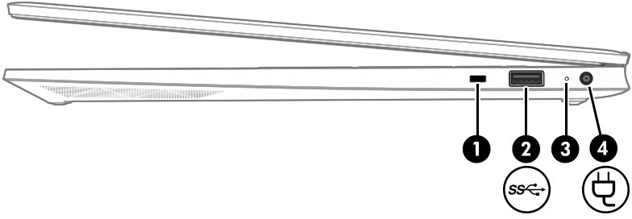

Table 2-1 Right-side components and their descriptions

Component |  |  | Description
(1) |  | Security cable slot | Attaches an optional security cable to the computer.  NOTE: The security cable is designed to act as a deterrent, but it might not prevent the computer from being mishandled or stolen.
(2) |  | USB SuperSpeed 5 Gbps port | Connects a USB device, provides high-speed data transfer, and (for select products) charges small devices (such as a smartphone) when the computer is on or in Sleep mode.  NOTE: Use a standard USB Type-A charging cable or cable
adapter (purchased separately) when charging a small external device.

Table 2-1 Right-side components and their descriptions (continued)

Compo | nent |  | Description
(3) |  | AC adapter and battery light | - White: The AC adapter is connected and the battery is fully charged.  - Blinking amber: The AC adapter is disconnected and the battery has reached a low battery level.  - Amber: The AC adapter is connected and the battery is charging.  - Off: The battery is not charging.
(4) |  | Connects an AC adapter. | Connects an AC adapter.

Left side
Identify the components on the left side of the computer.
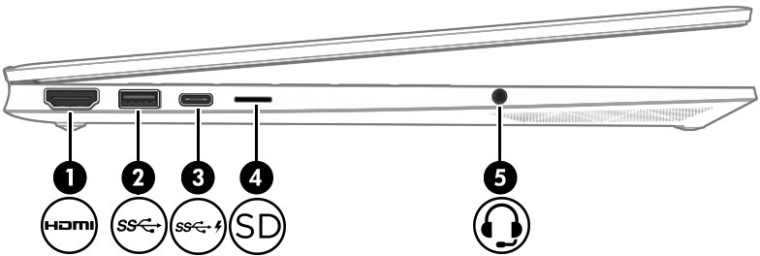

Table 2-2 Left-side components and their descriptions

Component |  |  | Description
(1) |  | HDMI port | Connects an optional video or audio device, such as a high-definition television, any compatible digital or audio component, or a high-speed High-Definition Multimedia Interface (HDMI) device.
(2) |  | USB SuperSpeed 5 Gbps port | Connects a USB device, provides high-speed data transfer, and (for select products) charges small devices (such as a smartphone) when the computer is on or in Sleep mode.  NOTE: Use a standard USB Type-A charging cable or cable adapter (purchased separately) when charging a small external device.
(3) |  | USB Type-C® power connector and SuperSpeed 10 Gbps port with DisplayPort™ output | Connects an AC adapter that has a USB Type-C connector, supplying power to the computer and, if needed, charging the computer battery.  – and –

Table 2-2 Left-side components and their descriptions (continued)

Compo | nent |  | Description
Connects a USB device, provides high-speed data transfer,
and (for select products) charges small devices (such as a smartphone) when the computer is on or in Sleep mode.
NOTE: Use a standard USB Type-C charging cable or cable adapter (purchased separately) when charging a small external device.
– and –
Connects a display device that has a USB Type-C connector, providing DisplayPort output.
(4) |  | microSD memory card reader (select products only) | Reads optional memory cards that enable you to store, manage, share, or access information.  To insert a card:  - Hold the card label-side up, with connectors facing the computer.  - Insert the card into the memory card reader, and then press in on the card until it is firmly seated.  To remove a card:  ▲ Press in on the card, and then remove it from the memory card reader.
(5) |  | Audio-out (headphone)/Audio-in (microphone) combo jack | Connects optional powered stereo speakers, headphones, earbuds, a headset, or a television audio cable. Also connects an optional headset microphone. This jack does not support optional standalone microphones.  WARNING! To reduce the risk of personal injury, adjust the volume before putting on headphones, earbuds, or a headset. For additional safety information, see the Regulatory, Safety, and Environmental Notices.  To access this guide:  ▲ Select the Search icon in the taskbar, type HP Documentation in the search box, and then select HP Documentation.  NOTE: When a device is connected to the jack, the computer speakers are disabled.

Display
The computer display can include essential components such as speakers, antennas, cameras, and microphones.

Low blue light mode (select products only)
Your computer display is shipped from the factory in low blue light mode for improved eye comfort and safety. Also, blue light mode automatically adjusts blue light emissions when you are using the computer at night or for reading.

WARNING! To reduce the risk of serious injury, read the Safety & Comfort Guide. It describes proper workstation setup and proper posture, health, and work habits for computer users. The Safety & Comfort Guide also provides important electrical and mechanical safety information. The Safety & Comfort Guide is available on the web at http://www.hp.com/ergo.

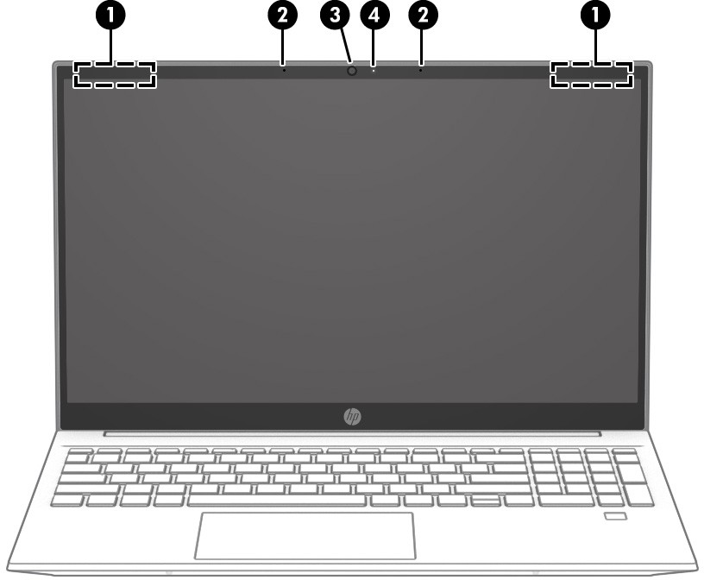
Table 2-3 Display components and their descriptions

Component |  | Description
(1) | WLAN antennas* | Send and receive wireless signals to communicate with wireless local area networks (WLANs).
(2) | Internal microphones (2) | Record sound.
(3) | Camera | Allows you to video chat, record video, and record still images. Some cameras also allow a facial recognition logon to Windows, instead of a password logon.  NOTE: Camera functions vary depending on the camera hardware and software installed on your product.
(4) | Camera light | On: The camera is in use.
*The antennas are not visible from the outside of the computer. For optimal transmission, keep the areas immediately around the antennas free from obstructions.
For wireless regulatory notices, see the section of the Regulatory, Safety, and Environmental Notices that applies to your country or region.

To access this guide:
▲ Select the Search icon in the taskbar, type HP Documentation in the search box, and then select HP Documentation.

Keyboard area
Keyboards can vary by language.

NOTE: The keyboard area, including the function keys and (select products only) power key, is disabled in stand, tent, and tablet modes. To enable the keyboard, including the power key, change to the clamshell mode.

Touchpad settings and components
Learn the touchpad settings and components

Touchpad settings
Learn how to adjust touchpad settings.

Adjusting touchpad settings
Use these steps to adjust touchpad settings and gestures.
  - Select the Search icon in the taskbar, type touchpad settings in the search box, and then press enter.
  - Choose a setting.
Turning on the touchpad
Follow these steps to turn on the touchpad.
- Select the Search icon in the taskbar, type touchpad settings in the search box, and then press enter.
- Using an external mouse, click the touchpad button.
If you are not using an external mouse, press the Tab key repeatedly until the pointer rests on the touchpad button. Then press the spacebar to select the button.

Touchpad components
Identify the touchpad components.

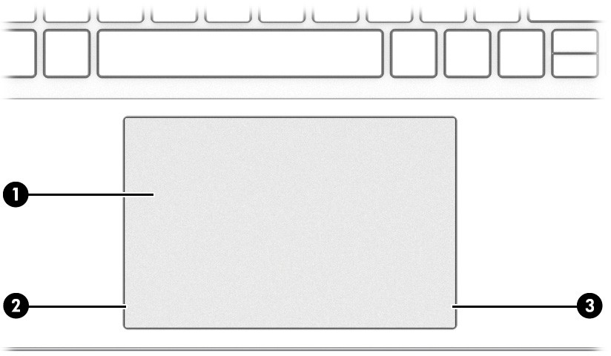
Table 2-4 Touchpad components and their descriptions

Component |  | Description
(1) | Touchpad zone | Reads your finger gestures to move the pointer or activate items on the screen.
(2) | Left control zone | Textured area that allows you to perform additional gestures.
(3) | Right control zone | Textured area that allows you to perform additional gestures.

Lights
Identify the lights on the computer.
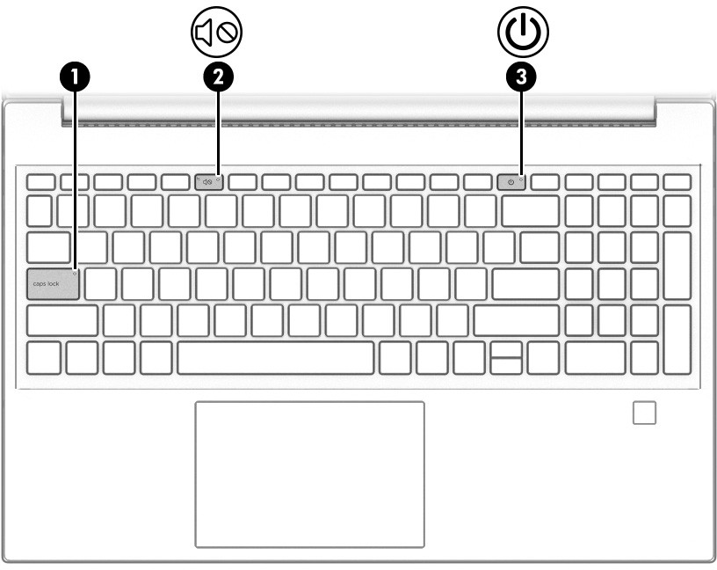

Table 2-5 Lights and their descriptions

Component |  |  | Description
(1) |  | Caps lock light | On: Caps lock is on, which switches the key input to all capital letters.
(2) |  | Mute light | - On: Computer sound is off.  - Off: Computer sound is on.
(3) |  | Power light | - On: The computer is on.  - Blinking (select products only): The computer is in the Sleep state, a power-saving state. The computer shuts off power to the display and other unnecessary components.  - Off: Depending on your computer model, the computer is off, in Hibernation, or in Sleep. Hibernation is the power-saving state that uses the least amount of power.

Button, vent, and fingerprint reader
Identify the computer button, vent and fingerprint reader.
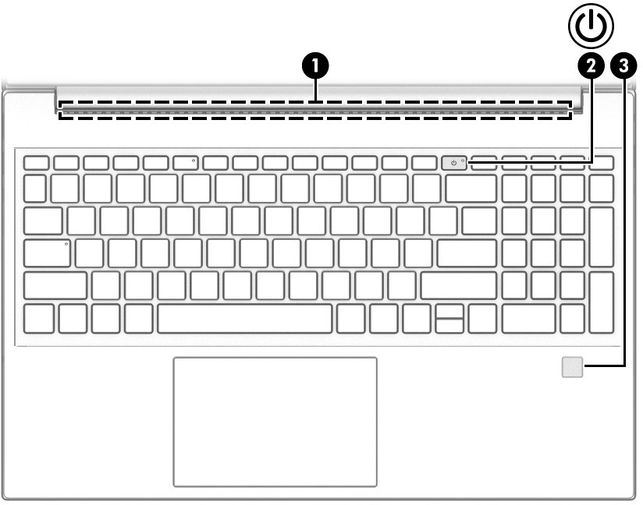

Fingerprint readers, which enable a fingerprint logon, can be located on the touchpad, on a side panel of the computer, or on the top cover below the keyboard.

IMPORTANT: To verify that your computer supports fingerprint reader sign-in, select the Search icon in the taskbar, type Sign-in options in the search box and press enter. If Fingerprint recognition is not listed as an option, then your computer does not include a fingerprint reader.

Table 2-6 Button, vent, and fingerprint reader and their descriptions

Component |  |  | Description
(1) |  | Vent | Enables airflow to cool internal components.  NOTE: The computer fan starts up automatically to cool internal components and prevent overheating. It is normal for the internal fan to cycle on and off during routine operation.
(2) |  | Power button | - When the computer is off, press the button briefly to turn on the computer.  - When the computer is on, press the button briefly to initiate Sleep.  - When the computer is in the Sleep state, press the button briefly to exit Sleep (select products only).  - When the computer is in Hibernation, press the button briefly to exit Hibernation.  IMPORTANT: Pressing and holding down the power button results in the loss of unsaved information.  If the computer has stopped responding and shutdown procedures are ineffective, press and hold the power button down for at least 10 seconds to turn off the computer.  To learn more about your power and sleep settings:  ▲ Right-click the Power icon , and then select Power and sleep settings.
(3) |  | Fingerprint reader (select products only) | Allows a fingerprint logon to Windows, instead of a password logon.  ▲ Swipe down across the fingerprint reader.  IMPORTANT: To prevent fingerprint logon issues, make sure when you register your fingerprint that all sides of your finger are registered by the fingerprint reader.

Special keys
Identify the special keys.

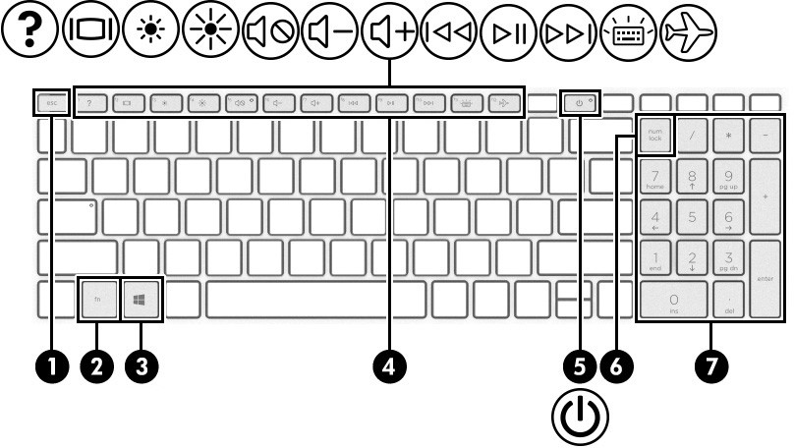

Table 2-7 Special keys and their descriptions

Component |  |  | Description
(1) |  | esc key | Displays system information when pressed in combination with the fn key.
(2) |  | fn key | Executes specific functions when pressed in combination with another key.
(3) |  | Windows key | Opens the Start menu.  NOTE: Pressing the Windows key again will close the Start menu.
(4) |  | Action keys | Execute frequently used system functions as defined by the icon symbols on f1 through f12 function keys.
(5) |  | Power button | - When the computer is off, press the button briefly to turn on the computer.  - When the computer is on, press the button briefly to initiate Sleep.  - When the computer is in the Sleep state, press the button briefly to exit Sleep (select products only).  - When the computer is in Hibernation, press the button briefly to exit Hibernation.  IMPORTANT: Pressing and holding down the power button results in the loss of unsaved information.  If the computer has stopped responding and shutdown procedures are ineffective, press and hold the power button down for at least 10 seconds to turn off the computer.  To learn more about your power and sleep settings:  ▲ Right-click the Power icon , and then select Power and sleep settings.
(6) |  | num lock key | Alternates between the navigational and numeric functions on the integrated numeric keypad.

Table 2-7 Special keys and their descriptions (continued)

Component |  | Description
(7) | Integrated numeric keypad | A separate keypad to the right of the alphabet keyboard. When num lock is pressed, the keypad can be used like an external numeric keypad.  NOTE: If the keypad function is active when the computer is turned off, that function is reinstated when the computer is turned back on.

Action keys
Identify the action keys.
The action keys execute frequently used system functions as defined by the icon symbols on f1 through f12. The action keys vary by computer.
▲ To use an action key, press and hold the key.

NOTE: On some products, you must press the fn key in combination with the action key.

Table 2-8 Action keys and their descriptions

Icon | Description
 | Helps prevent side-angle viewing from onlookers. If needed, decrease or increase brightness for well-lit or darker environments. Press the key again to turn off the privacy screen.  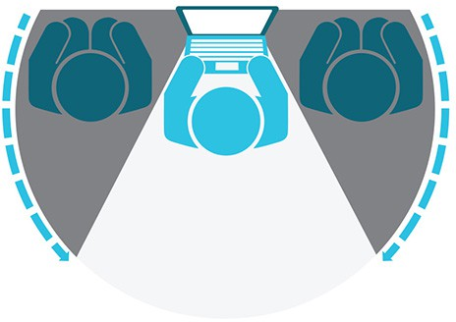
 | Decreases the screen brightness incrementally as long as you hold down the key.
 | Increases the screen brightness incrementally as long as you hold down the key.
 | Opens the “How to get help in Windows" webpage.
 | Switches the screen image between display devices connected to the system. For example, if a monitor is connected to the computer, repeatedly pressing this key alternates the screen image from the computer display to the monitor display to a simultaneous display on both the computer and the monitor.
 | Turns the keyboard backlight off or on. On select products, you can adjust the brightness of the keyboard backlight. Press the key repeatedly to adjust the brightness from high (when you first start up the computer), to low, to off. After you adjust the keyboard backlight setting, the backlight will revert to your previous

Table 2-8 Action keys and their descriptions (continued)

Icon | Description
setting each time you turn on the computer. The keyboard backlight will turn off after 30 seconds of
inactivity. To turn the keyboard backlight back on, press any key or tap the touchpad (select products only). To conserve battery power, turn off this feature.
 | Plays the previous track of an audio CD or the previous section of a DVD or a Blu-ray Disc (BD).
 | Starts, pauses, or resumes playback of an audio CD, a DVD, or a BD.
 | Plays the next track of an audio CD or the next section of a DVD or a BD.
 | Decreases speaker volume incrementally while you hold down the key.
 | Increases speaker volume incrementally while you hold down the key.
 | Mutes or restores speaker sound.
 | Mutes the microphone.
 | Turns the touchpad on or off.
 | Turns the airplane mode and wireless feature on or off.  NOTE: The airplane mode key is also referred to as the wireless button.  NOTE: A wireless network must be set up before a wireless connection is possible.

Bottom
Identify the bottom components.

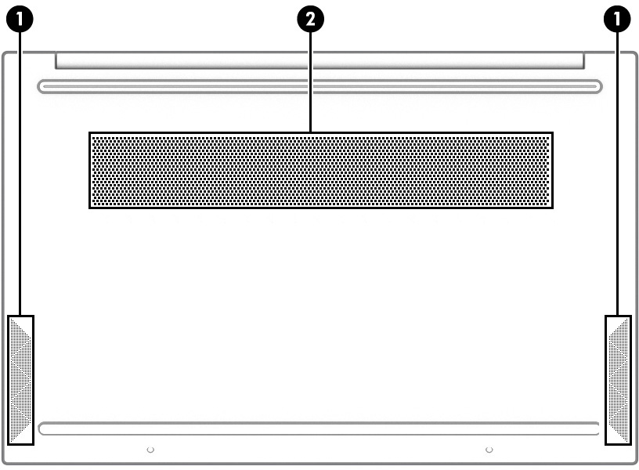

Table 2-9 Bottom components and their descriptions

Component |  | Description
(1) | Speakers (2) | Produce sound.
(2) | Vent | Enables airflow to cool internal components.  NOTE: The computer fan starts up automatically to cool internal components and prevent overheating. It is normal for the internal fan to cycle on and off during routine operation.

Labels
The labels affixed to the computer provide information that you might need when you troubleshoot system problems or travel internationally with the computer. Labels can be in paper form or imprinted on the product.

IMPORTANT: Check the following locations for the labels described in this section: the bottom of the computer, inside the battery bay, under the service door, on the back of the display, or on the bottom of a tablet kickstand.

- Service label—Provides important information to identify your computer. When contacting support, you might be asked for the serial number, the product number, or the model number. Locate this information before you contact support.
Your service label will resemble one of the following examples. Refer to the illustration that most closely matches the service label on your computer.

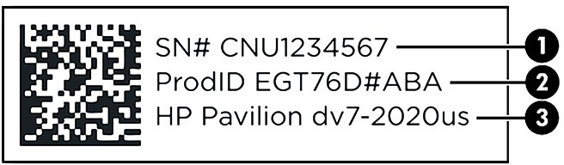

Table 2-10 Service label components

Component
(1) | Serial number
(2) | Product ID
(3) | HP product name and model number
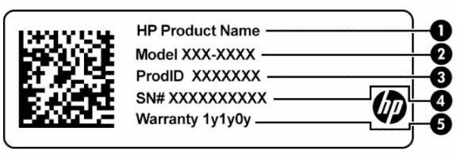
Table 2-11 Service label components

Component
(1) | HP product name
(2) | Model number
(3) | Product ID
(4) | Serial number
(5) | Warranty period

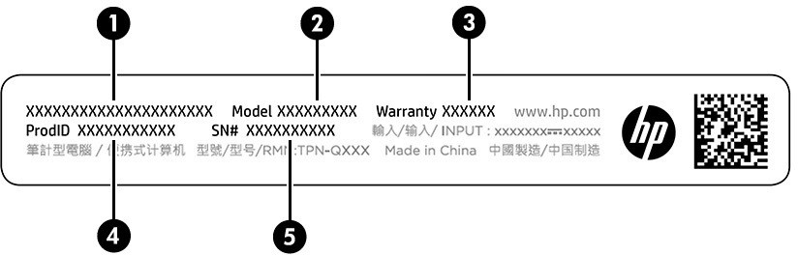
Table 2-12 Service label components

Component
(1) | HP product name
(2) | Model number
(3) | Warranty period

Table 2-12 Service label components (continued)

Comp | onent
(4) | Product ID
(5) | Serial number

- Regulatory labels—Provide regulatory information about the computer.
- Wireless certification labels—Provide information about optional wireless devices and the approval markings for the countries or regions in which the devices have been approved for use.

Connecting to a network

Your computer can travel with you wherever you go. But even at home, you can explore the globe and access information from millions of websites by using your computer and a wired or wireless network connection. This chapter helps you get connected to that world.

NOTE: In most countries Wi-Fi connections support the 802.11ax speed, also known as Wi-Fi 6. This feature is not supported in all countries where Wi-Fi settings must be optimized to local regulatory requirements (802.11ac).

Connecting to a wireless network
Your computer might be equipped with one or more wireless devices.
- WLAN device—Connects the computer to wireless local area networks (commonly referred to as Wi-Fi networks, wireless LANs, or WLANs) in corporate offices, your home, and public places such as airports, restaurants, coffee shops, hotels, and universities. The WLAN device in your computer communicates with a wireless router or a wireless access point, both sold separately.
- HP Mobile Broadband Module—Gives you wireless connectivity over a wireless wide area network (WWAN), a much larger area. Mobile network operators install base stations (similar to cell phone towers) throughout large geographic areas, effectively providing coverage across entire states, regions, or even countries.
- Bluetooth® device—Creates a personal area network (PAN) to connect to other Bluetooth-enabled devices such as computers, phones, printers, headsets, speakers, and cameras. In a PAN, each device communicates directly with other devices, and devices must be relatively close together—typically within 10 m (approximately 33 ft) of each other.

Using the wireless controls
You can control the wireless devices in your computer using one or more features.
- Airplane mode key (also called wireless button or wireless key)
- Operating system controls

Airplane mode key
The computer might have an airplane mode key, one or more wireless devices, and one or two wireless lights. All the wireless devices on your computer are enabled at the factory.
The wireless light indicates the overall power state of your wireless devices, not the status of individual devices.

Operating system controls
The Network and Sharing Center allows you to set up a connection or network, connect to a network, and diagnose and repair network problems.
To use operating system controls:
On the taskbar, right-click the network status icon, and then select Network and Internet settings.

Connecting to a WLAN
Before you can connect to a WLAN with this procedure, you must first set up internet access.

NOTE: When you are setting up internet access in your home, you must establish an account with an internet service provider (ISP). To purchase internet service and a modem, contact a local ISP. The ISP will help set up the modem, install a network cable to connect your wireless router to the modem, and test the internet service.

  - Be sure that the WLAN device is on.
  - On the taskbar, select the network status icon, and then connect to one of the available networks.
If the WLAN is a security-enabled WLAN, you are prompted to enter a security code. Enter the code, and then select Next to complete the connection.

NOTE: If no WLANs are listed, you might be out of range of a wireless router or access point. NOTE: If you do not see the WLAN that you want to connect to:
    - On the taskbar, right-click the network status icon, and then select Network and Internet settings.
    - Select Wi-Fi, and then select Manage known networks.
    - Select Add network.

  - Follow the on-screen instructions to complete the connection.
After the connection is made, right-click the network status icon at the far right of the taskbar to verify the name and status of the connection.

NOTE: The functional range (how far your wireless signals travel) depends on WLAN implementation, router manufacturer, and interference from other electronic devices or structural barriers such as walls and floors.

Using HP Mobile Broadband (select products only)
Your HP Mobile Broadband computer has built-in support for mobile broadband service. Your new computer, when used with a mobile operator’s network, gives you the freedom to connect to the internet, send email, or connect to your corporate network without the need for Wi-Fi hotspots.
You might need the HP Mobile Broadband Module IMEI number, MEID number, or both to activate mobile broadband service. The number might be printed on a label located on the bottom of your computer, inside the battery bay, under the service door, or on the back of the display.
- On the taskbar, right-click the network status icon.
- Select Network and Internet settings.
- Under the Network & Internet section, select Cellular, and then select from the available options.
Some mobile network operators require the use of a subscriber identity module (SIM) card. A SIM card contains basic information about you, such as a personal identification number (PIN), as well as network information. Some computers include a SIM card that is preinstalled. If the SIM card is not preinstalled, it might be included with the HP Mobile Broadband documents provided with your computer, or the mobile network operator might provide it separately from the computer.

For information about HP Mobile Broadband and how to activate service with a preferred mobile network operator, see the HP Mobile Broadband information included with your computer.

Using GPS (select products only)
Your computer might be equipped with a Global Positioning System (GPS) device. GPS satellites deliver location, speed, and direction information to GPS-equipped systems.
To enable GPS, be sure location is enabled under the Location setting.
▲ Select the Search icon in the taskbar, type location in the search box, select Location privacy settings, and then select a setting.

Using Bluetooth wireless devices (select products only)
A Bluetooth device provides short-range wireless communications that replace the physical cable connections that traditionally link electronic devices.
- Computers (desktop, notebook)
- Phones (cellular, cordless, smartphone)
- Imaging devices (printer, camera)
- Audio devices (headset, speakers)
- Mouse
- External keyboard

Connecting Bluetooth devices
Before you can use a Bluetooth device, you must establish a Bluetooth connection.
- Select the Search icon in the taskbar, type bluetooth in the search box, and then select Bluetooth and other devices settings.
- Enable Bluetooth, if it is not already enabled.
- Select Add device, and then in the Add a device dialog box, select Bluetooth.
- Select your device from the list, and then follow the on-screen instructions.

NOTE: If the device requires verification, a pairing code is displayed. On the device that you are adding, follow the on-screen instructions to verify that the code on your device matches the pairing code. For more information, see the documentation provided with the device.
NOTE: If your device does not appear in the list, be sure that Bluetooth on that device is turned on. Some devices might have additional requirements; see the documentation provided with the device.

Connecting to a wired network—LAN (select products only)
Use a LAN connection if you want to connect the computer directly to a router in your home (instead of working wirelessly) or if you want to connect to an existing network at your office.
If there is no RJ-45 (network) port on the computer, connecting to a LAN requires a network cable and a network jack or an optional docking device or expansion product.

To connect the network cable, follow these steps:
- Plug the network cable into the network jack (1) on the computer.
- Plug the other end of the network cable into a network wall jack (2) or router.

NOTE: If the network cable contains noise suppression circuitry (3), which prevents interference from TV and radio reception, orient the circuitry end of the cable toward the computer.
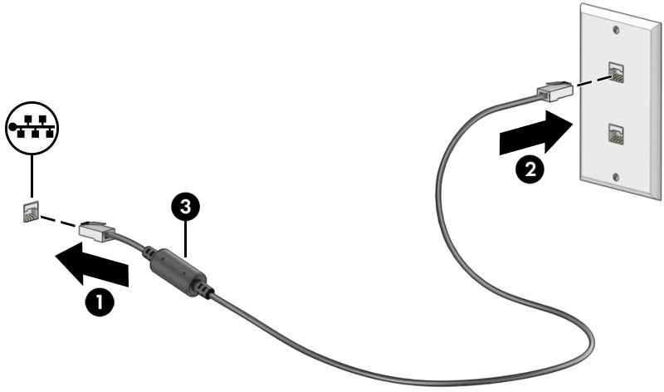

Enjoying entertainment features

Use your HP computer as an entertainment hub to socialize via the camera, enjoy and manage your music, and download and watch movies. Or, to make your computer an even more powerful entertainment center, connect external devices like a monitor, projector, TV, speakers, or headphones.

Using the camera
Your computer has one or more cameras that enable you to connect with others for work or play. Cameras can be front facing, rear facing, or pop up.
To determine which camera or cameras are on your product, see Getting to know your computer on page 3.
Most cameras allow you to video chat, record video, and record still images. Some also provide HD (high-definition) capability, apps for gaming, or facial recognition software like Windows Hello. See Securing your computer and information on page 42 for details about using Windows Hello.
On select products, you can also enhance your camera privacy by turning the camera off. By default, the camera is turned on. To turn off your camera, press the camera privacy key. The camera privacy light turns on. To turn the camera back on, press the key again.
To use your camera, select the Search icon in the taskbar, type camera in the search box, and then select Camera from the list of applications.

NOTE: The first time you select the Camera app, you must select whether Camera can access your precise location.

Using audio
You can download and listen to music, stream audio content (including radio) from the web, record audio, or mix audio and video to create multimedia. You can also play music CDs on the computer (on select products) or attach an external optical drive to play CDs. To enhance your listening enjoyment, attach external audio devices such as speakers or headphones.

Connecting speakers
You can attach wired speakers to your computer by connecting them to a USB port or to the audio-out (headphone)/audio-in (microphone) combo jack on your computer or on a docking station.
To connect wireless speakers to your computer, follow the device manufacturer's instructions. To connect high-definition speakers to the computer, see Setting up HDMI audio on page 24. Before connecting speakers, lower the volume setting.

Connecting headphones
You can connect wired headphones to the headphone jack or to the audio-out (headphone)/audio-in (microphone) combo jack on your computer.

WARNING! To reduce the risk of personal injury, lower the volume setting before putting on headphones, earbuds, or a headset. For additional safety information, see the Regulatory, Safety, and Environmental Notices.
To access this document:
▲ Select the Search icon in the taskbar, type HP Documentation in the search box, and then select HP Documentation.

To connect wireless headphones to your computer, follow the device manufacturer's instructions.

Connecting headsets
Headphones combined with a microphone are called headsets. You can connect wired headsets to the audio-out (headphone)/audio-in (microphone) combo jack on your computer.

WARNING! To reduce the risk of personal injury, lower the volume setting before putting on headphones, earbuds, or a headset. For additional safety information, see the Regulatory, Safety, and Environmental Notices.
To access this document:
▲ Select the Search icon in the taskbar, type HP Documentation in the search box, and then select HP Documentation.

To connect wireless headsets to your computer, follow the device manufacturer's instructions.

Using sound settings
Use sound settings to adjust system volume, change system sounds, or manage audio devices.

Sound settings
To view or change sound settings, follow these steps.
▲ Select the Search icon in the taskbar, type control panel in the search box, select Control Panel, select Hardware and Sound, and then select Sound.

Audio settings
Your computer might include an enhanced sound system by Bang & Olufsen, B&O, or another provider. As a result, your computer might include advanced audio features that can be controlled through an audio control panel specific to your sound system.
Use the audio control panel to view and control audio settings.
▲ Select the Search icon in the taskbar, type audio control in the search box, and then select the audio control panel for your system.

Using video
Your computer is a powerful video device that enables you to watch streaming video from your favorite websites and download video and movies to watch on your computer when you are not connected to a network.

To enhance your viewing enjoyment, use one of the video ports on the computer to connect an external monitor, projector, or TV.

IMPORTANT: Be sure that the external device is connected to the correct port on the computer, using the correct cable. Follow the device manufacturer's instructions.

For information about using your USB Type-C features, go to http://www.hp.com/support, and follow the instructions to find your product.

Connecting video devices using an HDMI cable (select products only)
HDMI (high-definition media interface) cables connect high-definition devices for enhanced audio and video.

Connecting a high-definition TV or monitor using HDMI
To see the computer screen image on a high-definition TV or monitor, connect the high-definition device according to the instructions.

NOTE: To connect an HDMI device to your computer, you need an HDMI cable, purchased separately.

  - Connect one end of the HDMI cable to the HDMI port on the computer. NOTE: HDMI port shape can vary by product.
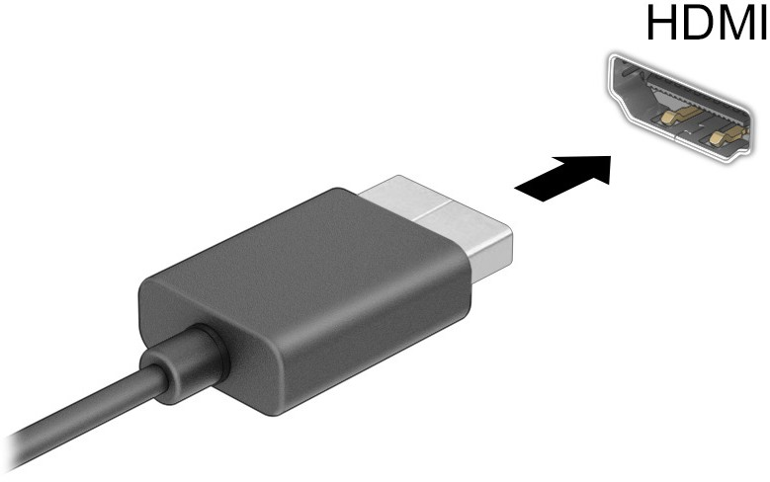

  - Connect the other end of the cable to the high-definition TV or monitor.
  - Press the Windows key + p to cycle through one of four display states:
- PC screen only: View the screen image on the computer only.
- Duplicate: View the screen image simultaneously on both the computer and the external device.
- Extend: View the screen image extended across both the computer and the external device.
- Second screen only: View the screen image on the external device only.

Each time you press the Windows key + p, the display state changes.

NOTE: For best results, especially if you choose the Extend option, increase the screen resolution of the external device, as follows. Select the Start button, select Settings, select System, and then select Display. Under Scale & layout, select the appropriate resolution, and then select Keep changes.

Setting up HDMI audio
HDMI is the only video interface that supports high-definition video and audio.

Turn on HDMI audio
After you connect an HDMI TV to the computer, you can then turn on HDMI audio by following this procedure.
- Right-click the Speakers icon in the notification area, at the far right of the taskbar, select Sound settings, and then select More sound settings.
- On the Playback tab, select the name of the digital output device.
- Select Set Default, and then select OK. Return audio to computer speakers
Follow these steps to return the audio stream to the computer speakers.
- Right-click the Speakers icon in the notification area, at the far right of the taskbar, select Sound settings, and then select More sound settings.
- On the Playback tab, select Speakers.
- Select Set Default, and then select OK.

Discovering and connecting to Miracast-compatible wireless displays (select products only)
Follow these steps to discover and connect to Miracast-compatible wireless displays without leaving your current apps.
- Select the Search icon in the taskbar, type connect in the search box, and then select Connect to a wireless display.
- Under Scale & layout, select Connect next to Connect to a wireless display.
- Select a setting, and then follow the on-screen instructions.

Using data transfer
Your computer is a powerful entertainment device that enables you to transfer photos, videos, and movies from your USB devices to view on your computer.
To enhance your viewing enjoyment, use one of the USB Type-C ports on the computer to connect a USB device, such as a cell phone, camera, activity tracker, or smartwatch, and transfer the files to your computer.

IMPORTANT: Be sure that the external device is connected to the correct port on the computer, using the correct cable. Follow the device manufacturer's instructions.

For information about using your USB Type-C features, go to http://www.hp.com/support, and follow the instructions to find your product.

Connecting devices to a USB Type-C port (select products only)
To connect a USB Type-C device to your computer, you need a USB Type-C cable, purchased separately.
- Connect one end of the USB Type-C cable to the USB Type-C port on the computer.

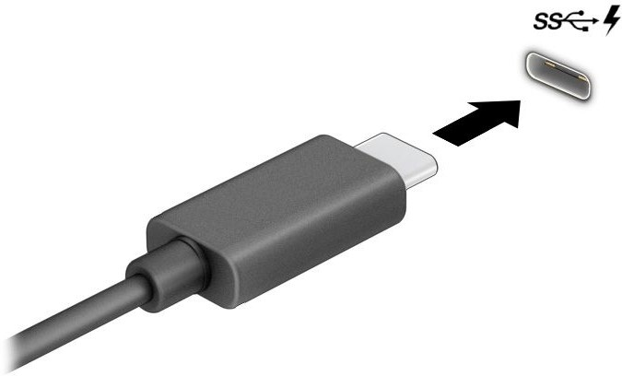

- Connect the other end of the cable to the external device.

Navigating the screen

Depending on your computer model, you can navigate the computer screen using one or more methods.
- Use touch gestures directly on the computer screen.
- Use touch gestures on the touchpad.
- Use an optional mouse or keyboard (purchased separately).
- Use an on-screen keyboard.
- Use a pointing stick.

Using touchpad and touch screen gestures
The touchpad helps you navigate the computer screen and control the pointer using simple touch gestures. You can also use the left and right touchpad buttons as you would use the corresponding buttons on an external mouse. To navigate a touch screen (select products only), touch the screen directly using gestures described in this chapter.
To customize gestures and see videos of how they work, select the Search icon in the taskbar, type control panel in the search box, select Control Panel, and then select Hardware and Sound. Under Devices and Printers, select Mouse.
Some products include a precision touchpad, which provides enhanced gesture functionality. To determine if you have a precision touchpad and find additional information, select Start, select Settings, select Bluetooth & devices, and then select Touchpad.

NOTE: Unless noted, gestures can be used on both the touchpad and a touch screen.

Tap

Point to an item on the screen, and then tap one finger on the touchpad zone or touch screen to select the item. Double-tap an item to open it.

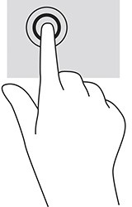

Two-finger pinch zoom
Use the two-finger pinch zoom to zoom out or in on images or text.
- Zoom out by placing two fingers apart on the touchpad zone or touch screen and then moving your fingers together.

  - Zoom in by placing two fingers together on the touchpad zone or touch screen and then moving your fingers apart.
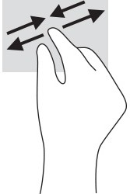

Two-finger slide (touchpad and precision touchpad)
Place two fingers slightly apart on the touchpad zone and then drag them up, down, left, or right to move up, down, or sideways on a page or image.
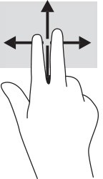

Two-finger tap (touchpad and precision touchpad)
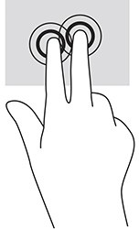
Tap two fingers on the touchpad zone to open the options menu for the selected object. NOTE: The two-finger tap performs the same function as right-clicking with a mouse.

Three-finger tap (touchpad and precision touchpad)
By default, the three-finger tap opens the taskbar search box. Tap three fingers on the touchpad zone to perform the gesture.
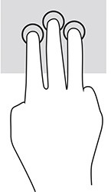
To change the function of this gesture on a precision touchpad, select Start, select Settings, select Bluetooth & devices, and then select Touchpad. Under Three-finger gestures, in the Taps box, select a gesture setting.

Four-finger tap (touchpad and precision touchpad)
By default, the four-finger tap opens the Action Center. Tap four fingers on the touchpad zone to perform the gesture.
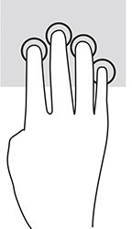
To change the function of this gesture on a precision touchpad, select Start, select Settings, select Bluetooth & devices, and then select Touchpad. Under Four-finger gestures, in the Taps box, select a gesture setting.

Three-finger swipe (touchpad and precision touchpad)
By default, the three-finger swipe switches between open apps and the desktop.
- Swipe 3 fingers away from you to see all open windows.
- Swipe 3 fingers toward you to show the desktop.
- Swipe 3 fingers left or right to switch between open windows.
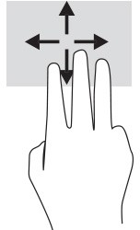
To change the function of this gesture on a precision touchpad, select Start, select Settings, select Bluetooth & devices, and then select Touchpad. Under Three-finger gestures, in the Swipes box, select a gesture setting.

Four-finger swipe (precision touchpad)
By default, the four-finger swipe switches between open desktops.
- Swipe 4 fingers away from you to see all open windows.
- Swipe 4 fingers toward you to show the desktop.
- Swipe 4 fingers left or right to switch between desktops.
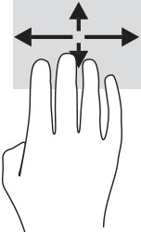
To change the function of this gesture, select Start, select Settings, select Bluetooth & devices, and then select Touchpad. Under Four-finger gestures, in the Swipes box, select a gesture setting.

One-finger slide (touch screen)
Use the one-finger slide to pan or scroll through lists and pages, or to move an object.
  - To scroll across the screen, lightly slide one finger across the screen in the direction you want to move.
  - To move an object, press and hold your finger on an object, and then drag your finger to move the object.
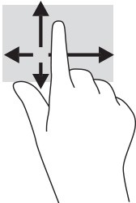

Using an optional keyboard or mouse
An optional keyboard or mouse allows you to type, select items, scroll, and perform the same functions as you do using touch gestures. The keyboard also allows you to use action keys and hot keys to perform specific functions.

Using an on-screen keyboard (select products only)
Select products have an on-screen keyboard.
  - To display an on-screen keyboard, tap the keyboard icon in the notification area, at the far right of the taskbar.
  - Begin typing.

NOTE: Suggested words might be displayed above the on-screen keyboard. Tap a word to select it. NOTE: Action keys and hot keys do not display or function on the on-screen keyboard.

Managing power

Your computer can operate on either battery power or external power. When the computer is running on battery power and an external power source is not available to charge the battery, it is important to monitor and conserve the battery charge.
Some power management features described in this chapter might not be available on your computer.

Using Sleep and Hibernation
Windows has two power-saving states, Sleep and Hibernation.

IMPORTANT: Several well-known vulnerabilities exist when a computer is in the Sleep state. To prevent an unauthorized user from accessing data on your computer, even encrypted data, HP recommends that you always initiate Hibernation instead of Sleep anytime the computer will be out of your physical possession. This practice is particularly important when you travel with your computer.
IMPORTANT: To reduce the risk of possible audio and video degradation, loss of audio or video playback functionality, or loss of information, do not initiate Sleep while reading from or writing to a disc or an external media card.
- Sleep—The Sleep state is automatically initiated after a period of inactivity. Your work is saved to memory, allowing you to resume your work very quickly. You can also initiate Sleep manually. For more information, see Initiating and exiting Sleep on page 30.
- Hibernation—The Hibernation state is automatically initiated if the battery reaches a critical level or the computer has been in the Sleep state for an extended period of time. In the Hibernation state, your work is saved to a hibernation file and the computer powers down. You can also initiate Hibernation manually. For more information, see Initiating and exiting Hibernation (select products only) on page 31.

Initiating and exiting Sleep
You can initiate Sleep several ways.
- Select the Start button, select the Power icon, and then select Sleep.
- Close the display (select products only).
- Press the Sleep hot key (select products only); for example, fn+f1or fn+f12.
- Briefly press the power button (select products only). You can exit Sleep in any of the following ways:
- Briefly press the power button.
- If the computer is closed, raise the display (select products only).
- Press a key on the keyboard (select products only).
- Tap the touchpad (select products only).

When the computer exits Sleep, your work returns to the screen.

NOTE: If you have set a password to be required on exiting Sleep, you must enter your Windows password before your work returns to the screen.

Initiating and exiting Hibernation (select products only)
You can enable user-initiated Hibernation and change other power settings and timeouts using Power and sleep settings.
- Click the Search icon in the taskbar, type power, and then select Choose a power plan.
- In the left pane, select Choose what the power buttons do (wording might vary by product).
- Depending on your product, you can enable Hibernation for battery power or external power in any of the following ways:
  - Power button—Under Power and sleep buttons and lid settings (wording might vary by product), select When I press the power button, and then select Hibernate.
  - Sleep button (select products only)—Under Power and sleep buttons and lid settings (wording might vary by product), select When I press the sleep button, and then select Hibernate.
  - Lid (select products only)—Under Power and sleep buttons and lid settings (wording might vary by product), select When I close the lid, and then select Hibernate.
  - Power menu—Select Change Settings that are currently unavailable, and then, under Shutdown settings, select the Hibernate check box.
The Power menu can be accessed by selecting the Start button.
- Select Save changes.
To initiate Hibernation, use the method that you enabled in step 3. To exit Hibernation, briefly press the power button.
NOTE: If you have set a password to be required on exiting Hibernation, you must enter your Windows password before your work returns to the screen.

Shutting down (turning off) the computer
The Shut down command closes all open programs, including the operating system, and then turns off the display and the computer.

IMPORTANT: Unsaved information is lost when the computer shuts down. Be sure to save your work before shutting down the computer.

Shut down the computer when it will be unused and disconnected from external power for an extended period.
The recommended procedure is to use the Windows Shut down command.

NOTE: If the computer is in the Sleep state or in Hibernation, first exit Sleep or Hibernation by briefly pressing the power button.

- Save your work and close all open programs.

- Select the Start button, select the Power icon, and then select Shut down.
If the computer is unresponsive and you are unable to use the preceding shutdown procedures, try the following emergency procedures in the sequence provided:
  - Press ctrl+alt+delete, select the Power icon, and then select Shut down.
  - Press and hold the power button for at least 10 seconds.
  - If your computer has a user-replaceable battery (select products only), disconnect the computer from external power, and then remove the battery.

Using the Power icon
Different Power icons indicate whether the computer is running on battery or external power. Placing the mouse pointer over the icon reveals a message if the battery has reached a low or critical battery level.

The Power icon  is located on the Windows taskbar. The Power icon allows you to quickly access power settings and view the remaining battery charge.
  - To view the percentage of remaining battery charge, place the mouse pointer over the Power icon .

  - To view power and battery settings, right-click the Power icon , and then select Power and sleep settings.

Running on battery power
When a charged battery is in the computer and the computer is not plugged into external power, the computer runs on battery power. When the computer is off and unplugged from external power, the battery in the computer slowly discharges. The computer displays a message when the battery reaches a low or critical battery level.

WARNING! To reduce potential safety issues, use only the battery provided with the computer, a replacement battery provided by HP, or a compatible battery purchased from HP.

Computer battery life varies, depending on power management settings, programs running on the computer, screen brightness, external devices connected to the computer, and other factors.

NOTE: Select computer products can switch between graphic controllers to conserve battery charge.

Using HP Fast Charge (select products only)
The HP Fast Charge feature allows you to quickly charge your computer battery. The charging time might vary by ± 10%. When the remaining battery charge is between 0 and 50%, the battery will charge to 50% of full capacity in no more than 30 to 45 minutes, depending on your computer model.
To use HP Fast Charge, shut down your computer, and then connect the AC adapter to your computer and to external power.

Displaying battery charge
When you are using your computer while running on battery power only, periodically check the battery charge.

To view the percentage of remaining battery charge, place the mouse pointer over the Power icon .

Finding battery information in HP Support Assistant (select products only)
You can access battery information in several ways.
- Select the Search icon in the taskbar, type support in the search box, and then select the HP Support Assistant app.
– or –
Select the question mark icon in the taskbar.
- Select Fixes & Diagnostics, select Check your battery, and then select Launch. If HP Battery Check indicates that your battery should be replaced, contact support.
HP Support Assistant provides the following tools and information about the battery:
  - HP Battery Check
  - Information about battery types, specifications, life cycles, and capacity

Conserving battery power
Be sure to conserve battery power and maximize battery life.
  - Lower the brightness of the display.
  - Turn off wireless devices when you are not using them.
  - Disconnect unused external devices that are not plugged into an external power source, such as an external hard drive connected to a USB port.
  - Stop, disable, or remove any external media cards that you are not using.
  - Before you leave your work, initiate Sleep or shut down the computer.

Identifying low battery levels
When a battery that is the sole power source for the computer reaches a low or critical battery level, the battery light and power icon indicate a low battery level.
  - The battery light (select products only) indicates a low or critical battery level. – or –
  - The Power icon  shows a low or critical battery notification.

NOTE: For additional information about the Power icon, see Using the Power icon on page 32. The computer takes the following actions for a critical battery level:
  - If Hibernation is disabled and the computer is on or in the Sleep state, the computer remains briefly in the Sleep state and then shuts down and loses any unsaved information.
  - If Hibernation is enabled and the computer is on or in the Sleep state, the computer initiates Hibernation.

Resolving a low battery level
You can quickly resolve low battery level conditions.

Resolving a low battery level when external power is available
Connect one of the following to the computer and to external power.
  - AC adapter
  - Optional docking device or expansion product
  - Optional power adapter purchased as an accessory from HP

Resolving a low battery level when no power source is available
Save your work and shut down the computer.

Resolving a low battery level when the computer cannot exit Hibernation
When the battery level is low and you cannot bring the computer out of Hibernation, connect the AC adapter.
- Connect the AC adapter to the computer and to external power.
- Exit Hibernation by pressing the power button.

Factory-sealed battery
To monitor the status of the battery, or if the battery is no longer holding a charge, run HP Battery Check in the HP Support Assistant app (select products only).
- Select the Search icon in the taskbar, type support in the search box, and then select the HP Support Assistant app.
– or –
Select the question mark icon in the taskbar.
- Select Fixes & Diagnostics, select Check your battery, and then select Launch. If HP Battery Check indicates that your battery should be replaced, contact support.
The battery[ies] in this product cannot be easily replaced by users themselves. Removing or replacing the battery could affect your warranty coverage. If a battery is no longer holding a charge, contact support.

Running on external power
For information about connecting to external power, see the Setup Instructions poster provided in the computer box.
The computer does not use battery power when the computer is connected to external power with an approved AC adapter or an optional docking device or expansion product.

WARNING! To reduce potential safety issues, use only the AC adapter provided with the computer, a replacement AC adapter provided by HP, or a compatible AC adapter purchased from HP.
WARNING! Do not charge the computer battery while you are aboard aircraft.

Connect the computer to external power under any of the following conditions:
- When charging or calibrating a battery
- When installing or updating system software
- When updating the system BIOS
- When writing information to a disc (select products only)
- When running Disk Defragmenter on computers with internal hard drives
- When performing a backup or recovery
When you connect the computer to external power:
- The battery begins to charge.

- The Power icon  changes appearance.

When you disconnect external power:
- The computer switches to battery power.


- The Power icon changes appearance.

Maintaining your computer

Performing regular maintenance keeps your computer in optimal condition. This chapter explains how to use tools like Disk Defragmenter and Disk Cleanup. It also provides instructions for updating programs and drivers, steps to clean the computer, and tips for traveling with (or shipping) the computer.

Improving performance
You can improve the performance of your computer by performing regular maintenance tasks with tools such as Disk Defragmenter and Disk Cleanup.

Using Disk Defragmenter
HP recommends using Disk Defragmenter to defragment your hard drive at least once a month.

NOTE: It is not necessary to run Disk Defragmenter on solid-state drives.

To run Disk Defragmenter:
  - Connect the computer to AC power.
  - Select the Search icon in the taskbar, type defragment in the search box, and then select Defragment and Optimize Drives.
  - Follow the on-screen instructions.
For additional information, access the Disk Defragmenter software Help.

Using Disk Cleanup
Use Disk Cleanup to search the hard drive for unnecessary files that you can safely delete to free up disk space and help the computer run more efficiently.
To run Disk Cleanup:
- Select the Search icon in the taskbar, type disk in the search box, and then select Disk Cleanup.
- Follow the on-screen instructions.

Using HP 3D DriveGuard (select products only)
HP 3D DriveGuard protects a hard drive by parking the drive and halting data requests under some conditions.
  - You drop the computer.
  - You move the computer with the display closed while the computer is running on battery power. A short time after one of these events, HP 3D DriveGuard returns the hard drive to normal operation.
NOTE: Only internal hard drives are protected by HP 3D DriveGuard. A hard drive installed in an optional docking device or connected to a USB port is not protected by HP 3D DriveGuard.

NOTE: Because solid-state drives (SSDs) lack moving parts, HP 3D DriveGuard is unnecessary for these drives.

Identifying HP 3D DriveGuard status
The hard drive light on the computer changes color to show that the drive in a primary hard drive bay, the secondary hard drive bay (select products only), or both are parked.

Updating programs and drivers
HP recommends that you update your programs and drivers on a regular basis. Updates can resolve issues and bring new features and options to your computer. For example, older graphics components might not work well with the most recent gaming software. Without the latest driver, you do not get the most out of your equipment.
Depending on your operating system, you can use the following methods to update programs and drivers:
- Updating both programs and drivers on page 37
- Updating programs only on page 37
- Updating drivers only on page 37

Updating both programs and drivers
Use this procedure to update both programs and drivers.
- Select the Search icon in the taskbar, type support in the search box, and then select the HP Support Assistant app.
– or –
Select the question mark icon in the taskbar.
- Under My notebook, select Updates. The Software and Drivers window opens, and Windows checks for updates.
- Follow the on-screen instructions.

Updating programs only
Use this procedure to update programs only.
- Select Start, and then select Microsoft Store.
- Select the dots next to your profile picture in the top-right corner, and then select Downloads and updates.
- On the Downloads and updates page, select Get updates, and then follow the on-screen instructions.

Updating drivers only
Use this procedure to update drivers only.
- Select the Search icon in the taskbar, type windows update settings in the search box, and then select Windows Update settings.

- Select Check for updates, and then follow the on-screen instructions.

NOTE: If Windows does not find a new driver, go to the device manufacturer's website, and follow the instructions.

Cleaning your computer
Cleaning your computer regularly removes dirt and debris so that your device continues to operate at its best. Use the following information to safely clean the external surfaces of your computer.

Enabling HP Easy Clean (select products only)
HP Easy Clean helps you to avoid accidental input while you clean the computer surfaces. This software disables devices such as the keyboard, touch screen, and touchpad for a preset amount of time so that you can clean all computer surfaces.
- Start HP Easy Clean in one of the following ways:
  - Select the Start menu, and then select HP Easy Clean. – or –
  - Select the HP Easy Clean icon in the taskbar. – or –
  - Select Start, and then select the HP Easy Clean tile.
- Now that your device is disabled for a short period, see Removing dirt and debris from your computer on page 38 for the recommended steps to clean the high-touch, external surfaces on your computer. After you remove the dirt and debris, you can also clean the surfaces with a disinfectant. See Cleaning your computer with a disinfectant on page 39 for guidelines to help prevent the spread of harmful bacteria and viruses.

Removing dirt and debris from your computer
Here are the recommended steps to clean dirt and debris from your computer.
For computers with wood veneer, see Caring for wood veneer (select products only) on page 40.
- Wear disposable gloves made of latex (or nitrile gloves, if you are latex-sensitive) when cleaning the surfaces.
- Turn off your device and unplug the power cord and other connected external devices. Remove any installed batteries from items such as wireless keyboards.

CAUTION: To prevent electric shock or damage to components, never clean a product while it is turned on or plugged in.

- Moisten a microfiber cloth with water. The cloth should be moist, but not dripping wet.

IMPORTANT: To avoid damaging the surface, avoid abrasive cloths, towels, and paper towels.

- Wipe the exterior of the product gently with the moistened cloth.

IMPORTANT: Keep liquids away from the product. Avoid getting moisture in any openings. If liquid makes its way inside your HP product, it can cause damage to the product. Do not spray liquids directly on the product. Do not use aerosol sprays, solvents, abrasives, or cleaners containing hydrogen peroxide or bleach that might damage the finish.

- Start with the display (if applicable). Wipe carefully in one direction, and move from the top of the display to the bottom. Finish with any flexible cables, like power cord, keyboard cable, and USB cables.
- Be sure that surfaces have completely air-dried before turning the device on after cleaning.
- Discard the gloves after each cleaning. Clean your hands immediately after you remove the gloves.
See Cleaning your computer with a disinfectant on page 39 for recommended steps to clean the high-touch, external surfaces on your computer to help prevent the spread of harmful bacteria and viruses.

Cleaning your computer with a disinfectant
The World Health Organization (WHO) recommends cleaning surfaces, followed by disinfection, as a best practice for preventing the spread of viral respiratory illnesses and harmful bacteria.
After cleaning the external surfaces of your computer using the steps in Removing dirt and debris from your computer on page 38, Caring for wood veneer (select products only) on page 40, or both, you might also choose to clean the surfaces with a disinfectant. A disinfectant that is within HP’s cleaning guidelines is an alcohol solution consisting of 70% isopropyl alcohol and 30% water. This solution is also known as rubbing alcohol and is sold in most stores.
Follow these steps when disinfecting high-touch, external surfaces on your computer:
- Wear disposable gloves made of latex (or nitrile gloves, if you are latex-sensitive) when cleaning the surfaces.
- Turn off your device and unplug the power cord and other connected external devices. Remove any installed batteries from items such as wireless keyboards.

CAUTION: To prevent electric shock or damage to components, never clean a product while it is turned on or plugged in.

- Moisten a microfiber cloth with a mixture of 70% isopropyl alcohol and 30% water. The cloth should be moist, but not dripping wet.

CAUTION: Do not use any of the following chemicals or any solutions that contain them, including spray-based surface cleaners: bleach, peroxides (including hydrogen peroxide), acetone, ammonia, ethyl alcohol, methylene chloride, or any petroleum-based materials, such as gasoline, paint thinner, benzene, or toluene.
IMPORTANT: To avoid damaging the surface, avoid abrasive cloths, towels, and paper towels.
- Wipe the exterior of the product gently with the moistened cloth.

IMPORTANT: Keep liquids away from the product. Avoid getting moisture in any openings. If liquid makes its way inside your HP product, it can cause damage to the product. Do not spray liquids directly on the product. Do not use aerosol sprays, solvents, abrasives, or cleaners containing hydrogen peroxide or bleach that might damage the finish.

- Start with the display (if applicable). Wipe carefully in one direction, and move from the top of the display to the bottom. Finish with any flexible cables, like power cord, keyboard cable, and USB cables.
- Be sure that surfaces have completely air-dried before turning the device on after cleaning.
- Discard the gloves after each cleaning. Clean your hands immediately after you remove the gloves.

Caring for wood veneer (select products only)
Your product might feature high-quality wood veneer. As with all natural wood products, proper care is important for best results over the life of the product. Because of the nature of natural wood, you might see unique variations in the grain pattern or subtle variations in color, which are normal.
  - Clean the wood with a dry, static-free microfiber cloth or chamois.
  - Avoid cleaning products containing substances such as ammonia, methylene chloride, acetone, turpentine, or other petroleum-based solvents.
  - Do not expose the wood to sun or moisture for long periods of time.
  - If the wood becomes wet, dry it by dabbing with an absorbent, lint-free cloth.
  - Avoid contact with any substance that might dye or discolor the wood.
  - Avoid contact with sharp objects or rough surfaces that might scratch the wood.
See Removing dirt and debris from your computer on page 38 for the recommended steps to clean the high-touch, external surfaces on your computer. After you remove the dirt and debris, you can also clean the surfaces with a disinfectant. See Cleaning your computer with a disinfectant on page 39 for sanitizing guidelines to help prevent the spread of harmful bacteria and viruses.

Traveling with or shipping your computer
If you must travel with or ship your computer, follow these tips to keep your equipment safe.
  - Prepare the computer for traveling or shipping:
    - Back up your information to an external drive.
    - Remove all discs and all external media cards, such as memory cards.
    - Turn off and then disconnect all external devices.
    - Shut down the computer.
  - Take a backup of your information. Keep the backup separate from the computer.
  - When traveling by air, carry the computer as hand luggage; do not check it with the rest of your luggage.

IMPORTANT: Avoid exposing a drive to magnetic fields. Security devices with magnetic fields include airport walk-through devices and security wands. Airport conveyer belts and similar security devices that check carry-on baggage use X-rays instead of magnetism and do not damage drives.

  - If you plan to use the computer during a flight, listen for the in-flight announcement that tells you when you can use your computer. In-flight computer use is at the discretion of the airline.
  - If you are shipping the computer or a drive, use suitable protective packaging and label the package “FRAGILE.”

- The use of wireless devices might be restricted in some environments. Such restrictions might apply aboard aircraft, in hospitals, near explosives, and in hazardous locations. If you are uncertain of the policy that applies to the use of a wireless device in your computer, ask for authorization to use your computer before you turn it on.
- If you are traveling internationally, follow these suggestions:
  - Check the computer-related customs regulations for each country or region on your itinerary.
  - Check the power cord and adapter requirements for each location in which you plan to use the computer. Voltage, frequency, and plug configurations vary.

WARNING! To reduce the risk of electric shock, fire, or damage to the equipment, do not attempt to run the computer from a voltage converter kit that is sold for appliances.

Securing your computer and information

Computer security is essential for protecting the confidentiality, integrity, and availability of your information. Standard security solutions provided by the Windows operating system, HP applications, the Setup Utility (BIOS), and other third-party software can help protect your computer from a variety of risks, such as viruses, worms, and other types of malicious code.

NOTE: Some security features listed in this chapter may not be available on your computer.

Using passwords
A password is a group of characters that you choose to secure your computer information and to protect online transactions. You can set several types of passwords. For example, when you set up your computer for the first time, you were asked to create a user password to secure your computer. You can set additional passwords in Windows or in HP Setup Utility (BIOS), which is preinstalled on your computer.
You may find it helpful to use the same password for a Setup Utility (BIOS) feature and for a Windows security feature.
To create and save passwords, use the following tips:
- To reduce the risk of being locked out of the computer, record each password and store it in a secure place away from the computer. Do not store passwords in a file on the computer.
- When creating passwords, follow requirements set by the program.
- Change your passwords at least every 3 months.
- An ideal password is long and has letters, punctuation, symbols, and numbers.
- Before you send your computer for service, back up your files, delete confidential files, and then remove all password settings.

NOTE: For additional information about Windows passwords, such as screen-saver passwords:
Select the Search icon in the taskbar, type support in the search box, and then select the HP Support Assistant app.
- or –
Select the question mark icon in the taskbar.

Setting Windows passwords
Windows passwords can help protect your computer from unauthorized access.
Table 8-1 Types of Windows passwords and their functions

Password | Function
User password | Protects access to a Windows user account.

Table 8-1 Types of Windows passwords and their functions (continued)

Password | Function
Administrator password | Protects administrator-level access to computer contents.  NOTE: This password cannot be used to access Setup Utility (BIOS) contents.

Setting Setup Utility (BIOS) passwords
BIOS passwords provide additional layers of security for your computer.
Table 8-2 Types of BIOS passwords and their functions

Password | Function
Administrator password | - Must be entered each time you access Setup Utility (BIOS).  - If you forget your administrator password, you cannot access Setup Utility (BIOS).
Power-on password | - Must be entered each time you turn on or restart the computer.  - If you forget your power-on password, you cannot turn on or restart the computer.

To set, change, or delete an administrator or power-on password in Setup Utility (BIOS):

IMPORTANT: Use extreme care when making changes in Setup Utility (BIOS). Errors can prevent the computer from operating properly.

  - Start Setup Utility (BIOS):
    - Computers or tablets with keyboards:
▲ Turn on or restart the computer, quickly press esc, and then press f10.
    - Tablets without keyboards:
      - Turn on or restart the tablet, and then quickly hold down the volume up button.
        - or -
Turn on or restart the tablet, and then quickly hold down the volume down button.
        - or -
Turn on or restart the tablet, and then quickly hold down the Windows button.
      - Tap f10.
  - Select Security, and then follow the on-screen instructions.
To save your changes, select Exit, select Save Changes and Exit, and then select Yes.

NOTE: If you are using arrow keys to highlight your choice, you must then press enter.

Your changes take effect when the computer restarts.

Using Windows Hello (select products only)
On products equipped with a fingerprint reader or an infrared camera, Windows Hello allows you to enroll your fingerprint, your facial ID, and set up a PIN. After enrollment, you can use your fingerprint reader, facial ID, or PIN to sign in to Windows.
To set up Windows Hello:
  - Select the Start button, select Settings, select Accounts, and then select Sign-in options.
  - If you do not have a password set up, you must add one before you can use other sign-in options. Select Password, and then select Add.
  - Select Facial recognition (Windows Hello) or Fingerprint recognition (Windows Hello), and then select Set up.
  - Select Get started, and then follow the on-screen instructions to enroll your fingerprint or facial ID and set up a PIN.

IMPORTANT: To prevent fingerprint logon issues, be sure when you register your fingerprint that all sides of your finger are registered by the fingerprint reader.
NOTE: The PIN is not limited in length. The default setting is for numbers only. To include alphabetic or special characters, select the include letters and symbols check box.

Using internet security software
When you use your computer to access email, a network, or the internet, you potentially expose your computer to computer viruses, spyware, and other online threats. To help protect your computer, internet security software that includes antivirus and firewall features may be preinstalled on your computer as a trial offer. To provide ongoing protection against newly discovered viruses and other security risks, security software must be kept up to date. HP strongly recommends that you upgrade the security software trial offer or purchase the software of your choice to fully protect your computer.

Using antivirus software
Computer viruses can disable programs, utilities, or the operating system, or cause them to function abnormally. Antivirus software can detect most viruses, destroy them, and in most cases, repair any damage that they cause.
To provide ongoing protection against newly discovered viruses, antivirus software must be kept up to date.
An antivirus program may be preinstalled on your computer. HP strongly recommends that you use the antivirus program of your choice to fully protect your computer.
For more information about computer viruses, select the Search icon in the taskbar, type support in the search box, and then select the HP Support Assistant app.
– or –
Select the question mark icon in the taskbar.

Using firewall software
Firewalls are designed to prevent unauthorized access to a system or network. A firewall can be software you install on your computer, network, or both, or it can be a combination of both hardware and software.

There are two types of firewalls to consider:
- Host-based firewalls—Software that protects only the computer it is installed on.
- Network-based firewalls—Installed between your DSL or cable modem and your home network to protect all the computers on the network.
When a firewall is installed on a system, all data sent to and from the system is monitored and compared with a set of user-defined security criteria. Any data that does not meet those criteria is blocked.

Installing software updates
HP, Windows, and third-party software installed on your computer should be regularly updated to correct security problems and improve software performance.

IMPORTANT: Microsoft sends out alerts regarding Windows updates, which may include security updates. To protect the computer from security breaches and computer viruses, install all updates from Microsoft as soon as you receive an alert.

You can install these updates automatically. To view or change the settings:
- Select the Start button, select Settings, and then select Windows Update.
- Follow the on-screen instructions.
- To schedule a time for installing updates, select Advanced options, and then follow the on-screen instructions.

Using HP TechPulse (select products only)
HP TechPulse is a cloud-based IT solution that enables businesses to effectively manage and secure their company assets.
HP TechPulse helps protect devices against malware and other attacks, monitors device health, and helps reduce time spent solving device and security issues. You can quickly download and install the software, which is highly cost-effective relative to traditional in-house solutions. For more information, go to https://www.hpdaas.com/.

Securing your wireless network
When you set up a WLAN or access an existing WLAN, always enable security features to protect your network from unauthorized access. WLANs in public areas (hotspots) like coffee shops and airports may not provide any security.

Backing up your software applications and information
Regularly back up your software applications and information to protect them from being permanently lost or damaged through a virus attack or a software or hardware failure.

Using an optional security cable (select products only)
A security cable (purchased separately) is designed to act as a deterrent, but it may not prevent the computer from being mishandled or stolen. To connect a security cable to your computer, follow the device manufacturer's instructions.

Using Setup Utility (BIOS)

Setup Utility, or Basic Input/Output System (BIOS), controls communication between all the input and output devices on the system (such as disk drives, display, keyboard, mouse, and printer). Setup Utility (BIOS) includes settings for the types of devices installed, the startup sequence of the computer, and the amount of system and extended memory.

NOTE: To start Setup Utility on convertible computers, your computer must be in notebook mode and you must use the keyboard attached to your notebook.

Starting Setup Utility (BIOS)
You have several ways to access the Setup Utility (BIOS).

IMPORTANT: Use extreme care when making changes in Setup Utility (BIOS). Errors can prevent the computer from operating properly.

▲ Turn on or restart the computer and quickly press f10. – or –
Turn on or restart the computer, quickly press esc, and then press f10 when the Start menu is displayed.

Updating Setup Utility (BIOS)
Updated versions of Setup Utility (BIOS) might be available on the HP website. Most BIOS updates on the HP website are packaged in compressed files called SoftPaqs. Some download packages contain a file named Readme.txt, which contains information regarding installing and troubleshooting the file.

Determining the BIOS version
To decide whether you need to update Setup Utility (BIOS), first determine the BIOS version on your computer. To reveal the BIOS version information (also known as ROM date and System BIOS), use one of these options.
- HP Support Assistant
  - Select the Search icon in the taskbar, type support in the search box, and then select the HP Support Assistant app.
– or –
Select the question mark icon in the taskbar.
  - Under My notebook, select Specifications.
- Setup Utility (BIOS)
  - Start Setup Utility (BIOS) (see Starting Setup Utility (BIOS) on page 47).
  - Select Main, and then make note of the BIOS version.

  - Select Exit, select one of the options, and then follow the on-screen instructions.
- In Windows, press ctrl+alt+s.
To check for later BIOS versions, see Preparing for a BIOS update on page 48.

Preparing for a BIOS update
Be sure to follow all prerequisites before downloading and installing a BIOS update.

IMPORTANT: To reduce the risk of damage to the computer or an unsuccessful installation, download and install a BIOS update only when the computer is connected to reliable external power using the AC adapter. Do not download or install a BIOS update while the computer is running on battery power, docked in an optional docking device, or connected to an optional power source. During the download and installation, follow these instructions:
- Do not disconnect power from the computer by unplugging the power cord from the AC outlet.
- Do not shut down the computer or initiate Sleep.
- Do not insert, remove, connect, or disconnect any device, cable, or cord.
NOTE: If your computer is connected to a network, consult the network administrator before installing any software updates, especially system BIOS updates.

Downloading a BIOS update
After you review the prerequisites, you can check for and download BIOS updates.
  - Select the Search icon in the taskbar, type support in the search box, and then select the HP Support Assistant app.
– or –
Select the question mark icon in the taskbar.
  - Select Updates. The Checking for Updates window opens, and Windows checks for updates.
  - Follow the on-screen instructions.
  - At the download area, follow these steps:
- Identify the most recent BIOS update and compare it to the BIOS version currently installed on your computer. If the update is more recent than your BIOS version, make a note of the date, name,
or other identifier. You might need this information to locate the update later, after it has been downloaded to your hard drive.
- Follow the on-screen instructions to download your selection to the hard drive.
Make a note of the path to the location on your hard drive where the BIOS update is downloaded. You will need to access this path when you are ready to install the update.

Installing a BIOS update
BIOS installation procedures vary. Follow any instructions that appear on the screen after the download is complete. If no instructions appear, follow these steps.
- Select the Search icon in the taskbar, type file in the search box, and then select File Explorer.
- Select your hard drive designation. The hard drive designation is typically Local Disk (C:).

- Using the hard drive path you recorded earlier, open the folder that contains the update.
- Double-click the file that has an .exe extension (for example, filename.exe). The BIOS installation begins.
- Complete the installation by following the on-screen instructions.

NOTE: After a message on the screen reports a successful installation, you can delete the downloaded file from your hard drive.

Using HP PC Hardware Diagnostics

You can use the HP PC Hardware Diagnostics utility to determine whether your computer hardware is running properly. The three versions are HP PC Hardware Diagnostics Windows, HP PC Hardware Diagnostics UEFI (Unified Extensible Firmware Interface), and (for select products only) Remote HP PC Hardware Diagnostics UEFI, a firmware feature.

Using HP PC Hardware Diagnostics Windows (select products only)
HP PC Hardware Diagnostics Windows is a Windows-based utility that allows you to run diagnostic tests to determine whether the computer hardware is functioning properly. The tool runs within the Windows operating system to diagnose hardware failures.
If HP PC Hardware Diagnostics Windows is not installed on your computer, first you must download and install it. To download HP PC Hardware Diagnostics Windows, see Downloading HP PC Hardware Diagnostics Windows on page 51.

Using an HP PC Hardware Diagnostics Windows hardware failure ID code
When HP PC Hardware Diagnostics Windows detects a failure that requires hardware replacement, a 24-digit failure ID code is generated for select component tests. For interactive tests, such as keyboard, mouse, or audio and video palette, you must perform troubleshooting steps before you can receive a failure ID.
▲ You have several options after you receive a failure ID:
- Select Next to open the Event Automation Service (EAS) page, where you can log the case. – or –
- Scan the QR code with your mobile device, which takes you to the EAS page, where you can log the case.
– or –
- Select the box next to the 24-digit failure ID to copy your failure code and send it to support.

Accessing HP PC Hardware Diagnostics Windows
After HP PC Hardware Diagnostics Windows is installed, you can access it from HP Support Assistant or the Start menu.

Accessing HP PC Hardware Diagnostics Windows from HP Support Assistant
After HP PC Hardware Diagnostics Windows is installed, follow these steps to access it from HP Support Assistant.
  - Select the Search icon in the taskbar, type support in the search box, and then select the HP Support Assistant app.
– or –
Select the question mark icon in the taskbar.

  - Select Fixes & Diagnostics.
  - Select Run hardware diagnostics, and then select Launch.
  - When the tool opens, select the type of diagnostic test that you want to run, and then follow the on-screen instructions.

NOTE: To stop a diagnostic test, select Cancel.

Accessing HP PC Hardware Diagnostics Windows from the Start menu (select products only)
After HP PC Hardware Diagnostics Windows is installed, follow these steps to access it from the Start menu.

- Select the Start button, and then select All apps.
- Select HP PC Hardware Diagnostics Windows.
- When the tool opens, select the type of diagnostic test that you want to run, and then follow the on-screen instructions.

NOTE: To stop a diagnostic test, select Cancel.

Downloading HP PC Hardware Diagnostics Windows
The HP PC Hardware Diagnostics Windows downloading instructions are provided in English only. You must use a Windows computer to download this tool because only .exe files are provided.

Downloading the latest HP PC Hardware Diagnostics Windows version from HP
To download HP PC Hardware Diagnostics Windows from HP, follow these steps.
- Go to http://www.hp.com/go/techcenter/pcdiags. The HP PC Diagnostics home page is displayed.
- Select Download HP Diagnostics Windows, and then select the specific Windows diagnostics version to download to your computer or a USB flash drive.
The tool downloads to the selected location.

Downloading the HP PC Hardware Diagnostics Windows from the Microsoft Store
You can download the HP PC Hardware Diagnostics Windows from the Microsoft Store.
- Select the Microsoft Store app on your desktop or select the Search icon in the taskbar, and then type
Microsoft Store in the search box.
- Enter HP PC Hardware Diagnostics Windows in the Microsoft Store search box.
- Follow the on-screen directions.
The tool downloads to the selected location.

Downloading HP Hardware Diagnostics Windows by product name or number (select products only)
You can download HP PC Hardware Diagnostics Windows by product name or number.

NOTE: For some products, you might have to download the software to a USB flash drive by using the product name or number.

- Go to http://www.hp.com/support.
- Select Software and Drivers, select your type of product, and then enter the product name or number in the search box that is displayed.
- In the Diagnostics section, select Download, and then follow the on-screen instructions to select the specific Windows diagnostics version to be downloaded to your computer or USB flash drive.
The tool downloads to the selected location.

Installing HP PC Hardware Diagnostics Windows
To install HP PC Hardware Diagnostics Windows, navigate to the folder on your computer or the USB flash drive where the .exe file downloaded, double-click the .exe file, and then follow the on-screen instructions.

Using HP PC Hardware Diagnostics UEFI
HP PC Hardware Diagnostics UEFI (Unified Extensible Firmware Interface) allows you to run diagnostic tests to determine whether the computer hardware is functioning properly. The tool runs outside the operating system so that it can isolate hardware failures from issues that are caused by the operating system or other software components.

NOTE: For some products, you must use a Windows computer and a USB flash drive to download and create the HP UEFI support environment because only .exe files are provided. For more information, see Downloading HP PC Hardware Diagnostics UEFI to a USB flash drive on page 53.

If your PC does not start in Windows, you can use HP PC Hardware Diagnostics UEFI to diagnose hardware issues.

Using an HP PC Hardware Diagnostics UEFI hardware failure ID code
When HP PC Hardware Diagnostics UEFI detects a failure that requires hardware replacement, a 24-digit failure ID code is generated.
For assistance in solving the problem:
▲ Select Contact HP, accept the HP privacy disclaimer, and then use a mobile device to scan the failure ID code that appears on the next screen. The HP Customer Support - Service Center page appears with your failure ID and product number automatically filled in. Follow the on-screen instructions.
– or –
Contact support, and provide the failure ID code.

NOTE: To start diagnostics on a convertible computer, your computer must be in notebook mode, and you must use the attached keyboard.
NOTE: If you need to stop a diagnostic test, press esc.

Starting HP PC Hardware Diagnostics UEFI
To start HP PC Hardware Diagnostics UEFI, follow this procedure.
- Turn on or restart the computer, and quickly press esc.

- Press f2.
The BIOS searches three places for the diagnostic tools, in the following order:
  - Connected USB flash drive

NOTE: To download the HP PC Hardware Diagnostics UEFI tool to a USB flash drive, see Downloading the latest HP PC Hardware Diagnostics UEFI version on page 53.

  - Hard drive
  - BIOS
- When the diagnostic tool opens, select the type of diagnostic test that you want to run, and then follow the on-screen instructions.

Downloading HP PC Hardware Diagnostics UEFI to a USB flash drive
Downloading HP PC Hardware Diagnostics UEFI to a USB flash drive can be useful in some situations.
- HP PC Hardware Diagnostics UEFI is not included in the preinstallation image.
- HP PC Hardware Diagnostics UEFI is not included in the HP Tool partition.
- The hard drive is damaged.

NOTE: The HP PC Hardware Diagnostics UEFI downloading instructions are provided in English only, and you must use a Windows computer to download and create the HP UEFI support environment because only .exe files are provided.

Downloading the latest HP PC Hardware Diagnostics UEFI version
To download the latest HP PC Hardware Diagnostics UEFI version to a USB flash drive, follow this procedure.
- Go to http://www.hp.com/go/techcenter/pcdiags. The HP PC Diagnostics home page is displayed.
- Select Download HP Diagnostics UEFI, and then select Run.

Downloading HP PC Hardware Diagnostics UEFI by product name or number (select products only)
You can download HP PC Hardware Diagnostics UEFI by product name or number (select products only) to a USB flash drive.

NOTE: For some products, you might have to download the software to a USB flash drive by using the product name or number.

- Go to http://www.hp.com/support.
- Enter the product name or number, select your computer, and then select your operating system.
- In the Diagnostics section, follow the on-screen instructions to select and download the specific UEFI Diagnostics version for your computer.

Using Remote HP PC Hardware Diagnostics UEFI settings (select products only)
Remote HP PC Hardware Diagnostics UEFI is a firmware (BIOS) feature that downloads HP PC Hardware Diagnostics UEFI to your computer. It can then execute the diagnostics on your computer, and it might upload results to a preconfigured server.
For more information about Remote HP PC Hardware Diagnostics UEFI, go to http://www.hp.com/go/techcenter/pcdiags, and then select Find out more.

Downloading Remote HP PC Hardware Diagnostics UEFI
HP Remote PC Hardware Diagnostics UEFI is also available as a SoftPaq that you can download to a server.

Downloading the latest Remote HP PC Hardware Diagnostics UEFI version
You can download the latest HP PC Hardware Diagnostics UEFI version to a USB flash drive.
- Go to http://www.hp.com/go/techcenter/pcdiags. The HP PC Diagnostics home page is displayed.
- Select Download Remote Diagnostics, and then select Run.

Downloading Remote HP PC Hardware Diagnostics UEFI by product name or number
You can download HP Remote PC Hardware Diagnostics UEFI by product name or number.

NOTE: For some products, you might have to download the software by using the product name or number.

- Go to http://www.hp.com/support.
- Select Software and Drivers, select your type of product, enter the product name or number in the search box that is displayed, select your computer, and then select your operating system.
- In the Diagnostics section, follow the on-screen instructions to select and download the Remote UEFI version for the product.

Customizing Remote HP PC Hardware Diagnostics UEFI settings
Using the Remote HP PC Hardware Diagnostics setting in Computer Setup (BIOS), you can perform several customizations.
  - Set a schedule for running diagnostics unattended. You can also start diagnostics immediately in interactive mode by selecting Execute Remote HP PC Hardware Diagnostics.
  - Set the location for downloading the diagnostic tools. This feature provides access to the tools from the HP website or from a server that has been preconfigured for use. Your computer does not require the traditional local storage (such as a hard drive or USB flash drive) to run remote diagnostics.
  - Set a location for storing the test results. You can also set the user name and password that you use for uploads.
  - Display status information about the diagnostics run previously.
To customize Remote HP PC Hardware Diagnostics UEFI settings, follow these steps:
- Turn on or restart the computer, and when the HP logo appears, press f10 to enter Computer Setup.

- Select Advanced, and then select Settings.
- Make your customization selections.
- Select Exit, then select Save Changes and Exit to save your settings. Your changes take effect when the computer restarts.

Backing up, restoring, and recovering

You can use Windows tools or HP software to back up your information, create a restore point, reset your computer, create recovery media, or restore your computer to its factory state. Performing these standard procedures can return your computer to a working state faster.

IMPORTANT: If you will be performing recovery procedures on a tablet, the tablet battery must be at least 70% charged before you start the recovery process.
IMPORTANT: For a tablet with a detachable keyboard, connect the tablet to the keyboard base before beginning any recovery process.

Backing up information and creating recovery media
These methods of creating recovery media and backups are available on select products only.

Using Windows tools for backing up
HP recommends that you back up your information immediately after initial setup. You can do this task either using Windows Backup locally with an external USB drive or using online tools.

IMPORTANT: Windows is the only option that allows you to back up your personal information. Schedule regular backups to avoid information loss.
NOTE: If computer storage is 32 GB or less, Microsoft® System Restore is disabled by default.

Using the HP Cloud Recovery Download Tool to create recovery media (select products only)
You can use the HP Cloud Recovery Download Tool to create HP Recovery media on a bootable USB flash drive. For details:
▲ Go to http://www.hp.com, search for HP Cloud Recovery, and then select the result that matches the type of computer that you have.

NOTE: If you cannot create recovery media yourself, contact support to obtain recovery discs. Go to http://www.hp.com/support, select your country or region, and then follow the on-screen instructions.
IMPORTANT: HP recommends that you follow the Restoring and recovery methods on page 57 to restore your computer before you obtain and use the HP recovery discs. Using a recent backup can return your machine to a working state sooner than using the HP recovery discs. After the system is restored, reinstalling all the operating system software released since your initial purchase can be a lengthy process.

Restoring and recovering your system
You have several tools available to recover your system both within and outside of Windows if the desktop cannot load.

HP recommends that you attempt to restore your system using the Restoring and recovery methods on page 57.

Creating a system restore
System Restore is available in Windows. The System Restore software can automatically or manually create restore points, or snapshots, of the system files and settings on the computer at a particular point.
When you use System Restore, it returns your computer to its state at the time you made the restore point. Your personal files and documents should not be affected.

Restoring and recovery methods
After you run the first method, test to see whether the issue still exists before you proceed to the next method, which might now be unnecessary.
  - Run a Microsoft System Restore.
  - Run Reset this PC.

NOTE: The options Remove everything and then Fully clean the drive can take several hours to complete and leave no information on your computer. It is the safest way to reset your computer before you recycle it.

  - Recover using HP Recovery media. For more information, see Recovering using HP Recovery media on page 57.
For more information about the first two methods, see the Get Help app:
Select the Start button, select All apps, select the Get Help app, and then enter the task you want to perform.

NOTE: You must be connected to the internet to access the Get Help app.

Recovering using HP Recovery media
You can use HP Recovery media to recover the original operating system and software programs that were installed at the factory. On select products, it can be created on a bootable USB flash drive using the HP Cloud Recovery Download Tool.
For details, see Using the HP Cloud Recovery Download Tool to create recovery media (select products only) on page 56.

NOTE: If you cannot create recovery media yourself, contact support to obtain recovery discs. Go to http://www.hp.com/support, select your country or region, and then follow the on-screen instructions.

To recover your system:
▲ Insert the HP Recovery media, and then restart the computer.

NOTE: HP recommends that you follow the Restoring and recovery methods on page 57 to restore your computer before you obtain and use the HP recovery discs. Using a recent backup can return your machine to a working state sooner than using the HP recovery discs. After the system is restored, reinstalling all the operating system software released since your initial purchase can be a lengthy process.

Changing the computer boot order
If your computer does not restart using the HP Recovery media, you can change the computer boot order, the order of devices listed in BIOS for startup information. You can select an optical drive or a USB flash drive, depending on the location of your HP Recovery media.

IMPORTANT: For a tablet with a detachable keyboard, connect the tablet to the keyboard base before beginning these steps.

To change the boot order:
- Insert the HP Recovery media.
- Access the system Startup menu.
  - For computers or tablets with keyboards attached, turn on or restart the computer or tablet, quickly press esc, and then press f9 for boot options.
  - For tablets without keyboards, turn on or restart the tablet, quickly press and hold the volume up button, and then select f9.
– or –
Turn on or restart the tablet, quickly press and hold the volume down button, and then select f9.
- Select the optical drive or USB flash drive from which you want to boot, and then follow the on-screen instructions.

Using HP Sure Recover (select products only)
Select computer models are configured with HP Sure Recover, a PC operating system (OS) recovery solution built into the hardware and software. HP Sure Recover can fully restore the HP OS image without installed recovery software.
Using HP Sure Recover, an administrator or user can restore the system and install:
  - Latest version of the operating system
  - Platform-specific device drivers
  - Software applications, in the case of a custom image
To access the latest documentation for HP Sure Recover, go to http://www.hp.com/support. Follow the on-screen instructions to find your product and locate your documentation.

Specifications

When you travel with or store your computer, the input power ratings and operating specifications provide helpful information.

Input power
The power information in this section might be helpful if you plan to travel internationally with the computer.
The computer operates on DC power, which can be supplied by an AC or a DC power source. The AC power source must be rated at 100 V–240 V, 50 Hz–60 Hz. Although the computer can be powered from a standalone DC power source, it should be powered only with an AC adapter or a DC power source supplied and approved by HP for use with this computer.
The computer can operate on DC power within one or more of the following specifications. The voltage and current for your computer is located on the regulatory label.
Table 12-1 DC power specifications

Input Power | Rating
Operating voltage and current | 5 V dc @ 3 A / 9 V dc @ 3 A / 12 V dc @ 2.5 A / 15 V dc @2 A – 30 W USB-C®  5 V dc @ 2 A / 12 V dc @ 3 A /15 V dc @ 3 A – 45 W USB-C  5 V dc @ 3 A / 9 V dc @ 3 A / 12 V dc @ 3.75 A /15 V dc @ 3 A – 45 W USB-C  5 V dc @ 3 A / 9 V dc @ 3 A / 10 V dc @ 3.75 A / 12 V dc @ 3.75 A /  15 V dc @ 3 A / 20 V dc @ 2.25 A – 45 W USB-C  5 V dc @ 3 A / 9 V dc @ 3 A / 12 V dc @ 5 A / 15 V dc @ 4.33 A / 20 V dc @ 3.25 A – 65 W USB-C  5 V dc @ 3 A / 9 V dc @ 3 A / 10 V dc @ 5 A / 12 V dc @ 5 A / 15 V dc @ 4.33 A / 20 V dc @ 3.25 A – 65 W USB-C  5 V dc @ 3 A / 9 V dc @ 3 A / 10 V dc @ 5 A / 12 V dc @ 5 A / 15 V dc @ 5 A / 20 V dc @ 4.5 A – 90 W USB-C  5 V dc @ 3 A / 9 V dc @ 3 A / 12 V dc @ 5 A / 15 V dc @ 5 A / 20 V dc @ 5 A / 5 V dc USB-A port @ 2 A – 100 W USB-C + 10 W USB-A  19.5 V dc @ 2.31 A – 45 W  19.5 V dc @ 3.33 A – 65 W  19.5 V dc @ 4.62 A – 90 W  19.5 V dc @ 6.15 A – 120 W  19.5 V dc @ 6.9 A – 135 W  19.5 V dc @ 7.70 A – 150 W  19.5 V dc @ 10.3 A – 200 W  19.5 V dc @ 11.8 A – 230 W

Table 12-1 DC power specifications

Input Power Rating

19.5 V dc @ 16.92 A – 330 W
20 V dc @ 14 A – 280 W

NOTE: This product is designed for IT power systems in Norway with phase-to-phase voltage not exceeding 240 V rms.

Operating environment
Use the operating specifications for helpful information when you travel with or store your computer.
Table 12-2 Operating environment specifications

Factor | Metric | U.S.
Temperature
Operating | 5°C to 35°C | 41°F to 95°F
Nonoperating | –20°C to 60°C | –4°F to 140°F
Relative humidity (noncondensing)
Operating | 10% to 90% | 10% to 90%
Nonoperating | 5% to 95% | 5% to 95%
Maximum altitude (unpressurized)
Operating | –15 m to 3,048 m | –50 ft to 10,000 ft
Nonoperating | –15 m to 12,192 m | –50 ft to 40,000 ft

Electrostatic discharge

Electrostatic discharge is the release of static electricity when two objects come into contact—for example, the shock you receive when you walk across the carpet and touch a metal door knob.
A discharge of static electricity from fingers or other electrostatic conductors may damage electronic components.

IMPORTANT: To prevent damage to the computer, damage to a drive, or loss of information, observe these precautions:
- If removal or installation instructions direct you to unplug the computer, first be sure that it is properly grounded.
- Keep components in their electrostatic-safe containers until you are ready to install them.
- Avoid touching pins, leads, and circuitry. Handle electronic components as little as possible.
- Use nonmagnetic tools.
- Before handling components, discharge static electricity by touching an unpainted metal surface.
- If you remove a component, place it in an electrostatic-safe container.

Accessibility

HP's goal is to design, produce, and market products, services, and information that everyone everywhere can use, either on a stand-alone basis or with appropriate third-party assistive technology (AT) devices or applications.

HP and accessibility
Because HP works to weave diversity, inclusion, and work/life into the fabric of the company, it is reflected in everything HP does. HP strives to create an inclusive environment focused on connecting people to the power of technology throughout the world.

Finding the technology tools you need
Technology can unleash your human potential. Assistive technology removes barriers and helps you create independence at home, at work, and in the community. Assistive technology helps increase, maintain, and improve the functional capabilities of electronic and information technology.
For more information, see Finding the best assistive technology on page 63.

The HP commitment
HP is committed to providing products and services that are accessible for people with disabilities. This commitment supports the company's diversity objectives and helps ensure that the benefits of technology are available to all.
The HP accessibility goal is to design, produce, and market products and services that can be effectively used by everyone, including people with disabilities, either on a stand-alone basis or with appropriate assistive devices.
To achieve that goal, this Accessibility Policy establishes seven key objectives to guide HP actions. All HP managers and employees are expected to support these objectives and their implementation in accordance with their roles and responsibilities:
- Raise the level of awareness of accessibility issues within HP, and provide employees with the training they need to design, produce, market, and deliver accessible products and services.
- Develop accessibility guidelines for products and services, and hold product development groups accountable for implementing these guidelines where competitively, technically, and economically feasible.
- Involve people with disabilities in the development of accessibility guidelines and in the design and testing of products and services.
- Document accessibility features, and make information about HP products and services publicly available in an accessible form.
- Establish relationships with leading assistive technology and solution providers.
- Support internal and external research and development that improves assistive technology relevant to HP products and services.

  - Support and contribute to industry standards and guidelines for accessibility.

International Association of Accessibility Professionals (IAAP)
IAAP is a not-for-profit association focused on advancing the accessibility profession through networking, education, and certification. The objective is to help accessibility professionals develop and advance their careers and to better enable organizations to integrate accessibility into their products and infrastructure.
As a founding member, HP joined to participate with other organizations to advance the field of accessibility. This commitment supports HP’s accessibility goal of designing, producing, and marketing products and services that people with disabilities can effectively use.
IAAP will make the profession strong by globally connecting individuals, students, and organizations to learn from one another. If you are interested in learning more, go to http://www.accessibilityassociation.org to join the online community, sign up for newsletters, and learn about membership options.

Finding the best assistive technology
Everyone, including people with disabilities or age-related limitations, should be able to communicate, express themselves, and connect with the world using technology. HP is committed to increasing accessibility awareness within HP and with our customers and partners.
Whether it’s large fonts that are easy on the eyes, voice recognition that lets you give your hands a rest, or any other assistive technology to help with your specific situation—a variety of assistive technologies make HP products easier to use. How do you choose?

Assessing your needs
Technology can unleash your potential. Assistive technology removes barriers and helps you create independence at home, at work, and in the community. Assistive technology (AT) helps increase, maintain, and improve the functional capabilities of electronic and information technology.
You can choose from many AT products. Your AT assessment should allow you to evaluate several products, answer your questions, and facilitate your selection of the best solution for your situation. You will find that professionals qualified to do AT assessments come from many fields, including those licensed or certified
in physical therapy, occupational therapy, speech/language pathology, and other areas of expertise. Others, while not certified or licensed, can also provide evaluation information. You will want to ask about the individual's experience, expertise, and fees to determine if they are appropriate for your needs.

Accessibility for HP products
These links provide information about accessibility features and assistive technology, if applicable and available in your country or region, that are included in various HP products. These resources will help you select the specific assistive technology features and products most appropriate for your situation.
  - HP Aging & Accessibility: Go to http://www.hp.com, type Accessibility in the search box. Select Office of Aging and Accessibility.
  - HP computers: For Windows products, go to http://www.hp.com/support, type Windows Accessibility Options in the Search our knowledge search box. Select the appropriate operating system in the results.
  - HP Shopping, peripherals for HP products: Go to http://store.hp.com, select Shop, and then select Monitors or Accessories.
If you need additional support with the accessibility features on your HP product, see Contacting support on page 66.

Additional links to external partners and suppliers that may provide additional assistance:
- Microsoft Accessibility information (Windows and Microsoft Office)
- Google Products accessibility information (Android, Chrome, Google Apps)

Standards and legislation
Countries worldwide are enacting regulations to improve access to products and services for persons with disabilities. These regulations are historically applicable to telecommunications products and services, PCs and printers with certain communications and video playback features, their associated user documentation, and their customer support.

Standards
The US Access Board created Section 508 of the Federal Acquisition Regulation (FAR) standards to address access to information and communication technology (ICT) for people with physical, sensory, or cognitive disabilities.
The standards contain technical criteria specific to various types of technologies, as well as performance-based requirements which focus on functional capabilities of covered products. Specific criteria cover software applications and operating systems, web-based information and applications, computers, telecommunications products, video and multimedia, and self-contained closed products.

Mandate 376 – EN 301 549
The European Union created the EN 301 549 standard within Mandate 376 as an online toolkit for public procurement of ICT products. The standard specifies the accessibility requirements applicable to ICT products and services, with a description of the test procedures and evaluation methodology for each requirement.

Web Content Accessibility Guidelines (WCAG)
Web Content Accessibility Guidelines (WCAG) from the W3C's Web Accessibility Initiative (WAI) helps web designers and developers create sites that better meet the needs of people with disabilities or age-related limitations.
WCAG advances accessibility across the full range of web content (text, images, audio, and video) and web applications. WCAG can be precisely tested, is easy to understand and use, and allows web developers flexibility for innovation. WCAG 2.0 has also been approved as ISO/IEC 40500:2012.
WCAG specifically addresses barriers to accessing the web experienced by people with visual, auditory, physical, cognitive, and neurological disabilities, and by older web users with accessibility needs. WCAG 2.0 provides characteristics of accessible content:
- Perceivable (for instance, by addressing text alternatives for images, captions for audio, adaptability of presentation, and color contrast)
- Operable (by addressing keyboard access, color contrast, timing of input, seizure avoidance, and navigability)
- Understandable (by addressing readability, predictability, and input assistance)
- Robust (for instance, by addressing compatibility with assistive technologies)

Legislation and regulations
Accessibility of IT and information has become an area of increasing legislative importance. These links provide information about key legislation, regulations, and standards.
  - United States
  - Canada
  - Europe
  - Australia

Useful accessibility resources and links
These organizations, institutions, and resources might be good sources of information about disabilities and age-related limitations.

NOTE: This is not an exhaustive list. These organizations are provided for informational purposes only. HP assumes no responsibility for information or contacts you encounter on the internet. Listing on this page does not imply endorsement by HP.

Organizations
These organizations are a few of the many that provide information about disabilities and age-related limitations.
  - American Association of People with Disabilities (AAPD)
  - The Association of Assistive Technology Act Programs (ATAP)
  - Hearing Loss Association of America (HLAA)
  - Information Technology Technical Assistance and Training Center (ITTATC)
  - Lighthouse International
  - National Association of the Deaf
  - National Federation of the Blind
  - Rehabilitation Engineering & Assistive Technology Society of North America (RESNA)
  - Telecommunications for the Deaf and Hard of Hearing, Inc. (TDI)
  - W3C Web Accessibility Initiative (WAI)

Educational institutions
Many educational institutions, including these examples, provide information about disabilities and age-related limitations.
  - California State University, Northridge, Center on Disabilities (CSUN)
  - University of Wisconsin - Madison, Trace Center
  - University of Minnesota computer accommodations program

Other disability resources
Many resources, including these examples, provide information about disabilities and age-related limitations.
- ADA (Americans with Disabilities Act) Technical Assistance Program
- ILO Global Business and Disability network
- EnableMart
- European Disability Forum
- Job Accommodation Network
- Microsoft Enable

HP links
These HP-specific links provide information that relates to disabilities and age-related limitations. HP comfort and safety guide
HP public sector sales

Contacting support
HP offers technical support and assistance with accessibility options for customers with disabilities.

NOTE: Support is in English only.

- Customers who are deaf or hard of hearing who have questions about technical support or accessibility of HP products:
– Use TRS/VRS/WebCapTel to call (877) 656-7058 Monday through Friday, 6 a.m. to 9 p.m. Mountain Time.
- Customers with other disabilities or age-related limitations who have questions about technical support or accessibility of HP products, choose one of the following options:
– Call (888) 259-5707 Monday through Friday, 6 a.m. to 9 p.m. Mountain Time.

Index

A
AC adapter and battery light, identifying 4
accessibility 62, 63, 65, 66 accessibility needs assessment 63 action key, identifying 11
action keys
airplane mode 12, 13 decrease screen brightness 12 help 12
identifying 12
increase screen brightness 12 keyboard backlight 12, 13
mute microphone 12, 13
mute volume 12, 13
next track 12, 13
pause 12, 13
play 12, 13
previous track 13
privacy screen 12
screen brightness 12
speaker volume 12, 13 switch screen image 12 touchpad 12, 13
using 12 volume
mute 13
airplane mode 17
airplane mode key 12, 13, 17 antivirus software, using 44 assistive technology (AT)
finding 63
purpose 62
AT (assistive technology) finding 63
purpose 62
audio 21
adjusting volume 12, 13
HDMI audio 24
headphones 21
headsets 22
sound settings 22
speakers 21
B
backing up software and information 45
backup, creating 56
backups 56 battery
conserving power 33
discharging 33
factory-sealed 34
finding information 33 low battery levels 33
resolving low battery level 34 battery charge 32
battery information, finding 33 battery power 32
best practices 1 BIOS
determining version 47 downloading an update 48 starting the Setup Utility 47 updating 47
Bluetooth device 17, 19
Bluetooth label 14
boot order, changing 58 bottom components 13 buttons
left touchpad 7
power 10, 11
right touchpad 7
C
camera
identifying 6
using 21
camera light, identifying 6 camera privacy key, using 21 caps lock light 9
caring for your computer 38 cleaning your computer 38
caring for wood veneer 40 disinfecting 39
HP Easy Clean 38
removing dirt and debris 38 components
bottom 13
display 5, 6
keyboard area 7
left side 4
lights 8
right side 3
touchpad 7
connecting to a network 17 connecting to a wireless
network 17 connecting to a WLAN 18 connecting to LAN 19 connectors
power 4
control zone 7
corporate WLAN connection 18 critical battery level 33
customer support, accessibility 66
D
data transfer 24
decrease screen brightness action key 12
Disk Cleanup software 36
Disk Defragmenter software 36 display components 5, 6
display states 23
E
electrostatic discharge 61 esc key, identifying 11 external power, using 34
F
factory-sealed battery 34
fingerprint reader 10
fingerprints, registering 44
firewall software 44 fn key, identifying 11
four-finger swipe touchpad gesture 28
four-finger tap touchpad gesture 28
G
gestures 26
Get Help in Windows 10 action key 12
Get Help in Windows action key 12 GPS 19
H
hardware, locating 3

HDMI port
connecting 23
identifying 4
headphones, connecting 21
headsets, connecting 22 Hibernation
exiting 31
initiated during critical battery level 33
initiating 31
high-definition devices, connecting 23, 24
HP 3D DriveGuard 36 HP Assistive Policy 62 HP Fast Charge 32
HP Mobile Broadband activating 18
IMEI number 18
MEID number 18
HP PC Hardware Diagnostics UEFI downloading 53
failure ID code 52 starting 52
using 52
HP PC Hardware Diagnostics Windows
accessing 50, 51
downloading 51 failure ID code 50 installing 52
using 50
HP Recovery media recovery 57
HP resources 1
HP Sure Recover 58 HP TechPulse 45
I
IMEI number 18
increase screen brightness action key 12
initiating Sleep and Hibernation 30 input power 59
installing
optional security cable 46 integrated numeric keypad,
identifying 12
internal microphones, identifying 6 International Association of
Accessibility Professionals 63 internet security software,
using 44
K
keyboard and optional mouse using 29
keyboard backlight action key 12, 13
keypad, integrated numeric 12 keys
action 11
airplane mode 12, 13
esc 11
fn 11
num lock 11
touchpad 12, 13
Windows 11
L
labels
Bluetooth 14
regulatory 14
serial number 14
service 14
wireless certification 14
WLAN 14
left control zone, identifying 7, 8 left side components 4
lights
AC adapter and battery 4 camera 6
caps lock 9
mute 9
power 9
touchpad 7
low battery level 33 low blue light mode 6
M
maintenance
Disk Cleanup 36
Disk Defragmenter 36 updating programs and
drivers 37
managing power 30
MEID number 18
Miracast 24 mobile broadband
activating 18
IMEI number 18
MEID number 18 mute light, identifying 9
mute microphone action key 12, 13
mute volume action key 12, 13
N
navigating the screen 26 next track action key 12, 13 num lock key, identifying 11
O
on-screen keyboard 29 one-finger slide touch screen
gesture 29
operating environment 60 operating system controls 17
P
passwords
Setup Utility (BIOS) 43 Windows 42
pause action key 12, 13
play action key 12, 13 ports
HDMI 4, 23
USB SuperSpeed 3, 4
USB Type-C 25
USB Type-C power connector and SuperSpeed 10 Gbps port with DisplayPort output 4
power
battery 32
external 34
power button, identifying 10, 11 power connector
identifying 4 Power icon, using 32
power light, identifying 9 power settings, using 32 precision touchpad
using 26
precision touchpad gestures four-finger swipe 28
four-finger tap 28
three-finger swipe 28
three-finger tap 27
two-finger slide 27
two-finger tap 27 previous track action key 13 privacy screen action key 12 privacy screen action key,
Identifying 12 product name and number,
computer 14
public WLAN connection 18
R
recovery 56

discs 57
media 57
USB flash drive 57 recovery media 56
creating using HP Cloud Recovery Download Tool 56
creating using Windows tools 56
regulatory information regulatory label 14
wireless certification labels 14 Remote HP PC Hardware Diagnostics
UEFI settings customizing 54
using 54
resources, accessibility 65
restoring 56
restoring and recovery methods 57 right control zone, identifying 7, 8 right side components 3
S
screen
navigating 26
screen brightness action keys 12 Section 508 accessibility
standards 64
security cable, installing 46 serial number, computer 14 service labels, locating 14
Setup Utility (BIOS) passwords 43 shipping the computer 40 shutdown 31
Sleep
exiting 30
initiating 30 Sleep and Hibernation,
initiating 30 software
Disk Cleanup 36
Disk Defragmenter 36
locating 3 software installed locating 3
software updates, installing 45 sound
See audio
sound settings, using 22
speaker volume action keys 12, 13 speakers
connecting 21 special keys
identifying 10
using 10
specifications 59 standards and legislation,
accessibility 64
switch screen image action key 12 system restore 57
system restore point, creating 56
T
tap touchpad and touch screen gesture 26
three-finger swipe touchpad gesture 28
three-finger tap touchpad gesture 27
touch screen gestures one-finger slide 29
slide 29
tap 26
two-finger pinch zoom 26 touchpad
settings 7
using 26
touchpad and touch screen gestures tap 26
two-finger pinch zoom 26 touchpad buttons
identifying 7
touchpad components 7 touchpad gestures
four-finger swipe 28
four-finger tap 28
three-finger swipe 28
three-finger tap 27
two-finger slide 27
two-finger tap 27
touchpad key 12, 13 touchpad light, identifying 7
touchpad settings, adjusting 7 touchpad zone, identifying 7, 8
transfer data 24
traveling with the computer 14, 40 turning off the computer 31
two-finger pinch zoom touchpad and touch screen gesture 26
two-finger slide touchpad gesture 27
two-finger tap touchpad gesture 27
U
unresponsive system 31
updating drivers 37
updating programs 37
updating programs and drivers 37
USB SuperSpeed 5 Gbps port, identifying 3, 4
USB Type-C port, connecting 25 USB Type-C power connector and SuperSpeed 10 Gbps port with
DisplayPort output, identifying 4
using passwords 42
using the keyboard and optional mouse 29
using the touchpad 26
V
video
HDMI port 23
USB Type-C 25
wireless displays 24
video, using 22 volume
adjusting 12, 13
mute 12
W
Windows
backup 56
recovery media 56 system restore point 56
Windows Hello 21
using 44
Windows key, identifying 11 Windows passwords 42 Windows tools, using 56 wired network (LAN) 19
wireless antennas, identifying 6 wireless button 17
wireless certification label 14 wireless controls
button 17
operating system 17
wireless light 17 wireless network (WLAN)
connecting 18
corporate WLAN connection 18 functional range 18
public WLAN connection 18 wireless network, securing 45 WLAN antennas, identifying 6 WLAN device 14
WLAN label 14
WWAN device 18

