Indian Cricket Team Member Face Identification
Prepared by: Ruchitha PR

1. Problem Statement
Develop a computer-vision system that identifies a person from an image using facial features, trained on selected Indian cricket team members, and classifies a new image into the matching player name.

2. Dataset
15 players, 561 usable face images (images where no face was detected were discarded). Images per player:
Player | Usable images
Bhuvneshwar Kumar | 35
Dinesh Karthik | 31
Hardik Pandya | 40
Jasprit Bumrah | 20
KL Rahul | 36
Kedar Jadhav | 36
Kuldeep Yadav | 43
Mohammed Shami | 32
MS Dhoni | 43
Ravindra Jadeja | 49
Rohit Sharma | 49
Shikhar Dhawan | 40
Vijay Shankar | 30
Virat Kohli | 48
Yuzvendra Chahal | 29

3. Methodology
- Face detection and cropping: MTCNN.
- Feature extraction: FaceNet (InceptionResnetV1, pretrained on VGGFace2) producing a 512-dimensional embedding per face.
- Data augmentation: horizontal flip, brighter and darker versions of each training face (applied to training data only).
- Classification: five classifiers compared (linear SVM, RBF SVM, Logistic Regression, KNN, Random Forest).
- Evaluation: stratified 5-fold cross-validation, split by original photo so augmented copies never appear in test data.

4. Results
Cross-validated accuracy (mean +/- std over 5 folds) and macro F1, in %:
Model | Augmentation | Accuracy | Macro F1
SVM (linear) | No | 88.8 +/- 3.9 | 88.4
SVM (RBF) | No | 90.4 +/- 3.6 | 90.2
Logistic Regression | No | 89.1 +/- 3.3 | 88.5
KNN (k=5) | No | 88.2 +/- 1.8 | 87.5
Random Forest | No | 89.5 +/- 2.7 | 89.2
SVM (linear) | Yes | 88.1 +/- 3.0 | 87.5
SVM (RBF) | Yes | 90.7 +/- 3.8 | 90.6
Logistic Regression | Yes | 89.5 +/- 3.0 | 88.7
KNN (k=5) | Yes | 90.0 +/- 2.7 | 89.4
Random Forest | Yes | 90.7 +/- 2.2 | 90.1
Best configuration: SVM (RBF) with augmentation = Yes, accuracy 90.7% +/- 3.8%.

Per-player results (out-of-fold predictions)
Player | Precision | Recall | F1 | Support
Bhuvneshwar Kumar | 0.97 | 0.89 | 0.93 | 35
Dinesh Karthik | 0.93 | 0.90 | 0.92 | 31
Hardik Pandya | 0.97 | 0.90 | 0.94 | 40
Jasprit Bumrah | 0.94 | 0.85 | 0.89 | 20
KL Rahul | 0.97 | 1.00 | 0.99 | 36
Kedar Jadhav | 1.00 | 0.94 | 0.97 | 36
Kuldeep Yadav | 0.64 | 0.88 | 0.75 | 43
Mohammed Shami | 0.83 | 0.91 | 0.87 | 32
MS Dhoni | 0.98 | 1.00 | 0.99 | 43
Ravindra Jadeja | 0.83 | 0.88 | 0.85 | 49
Rohit Sharma | 0.94 | 0.90 | 0.92 | 49
Shikhar Dhawan | 1.00 | 0.93 | 0.96 | 40
Vijay Shankar | 0.92 | 0.73 | 0.81 | 30
Virat Kohli | 0.98 | 0.98 | 0.98 | 48
Yuzvendra Chahal | 0.89 | 0.83 | 0.86 | 29

Confusion matrix
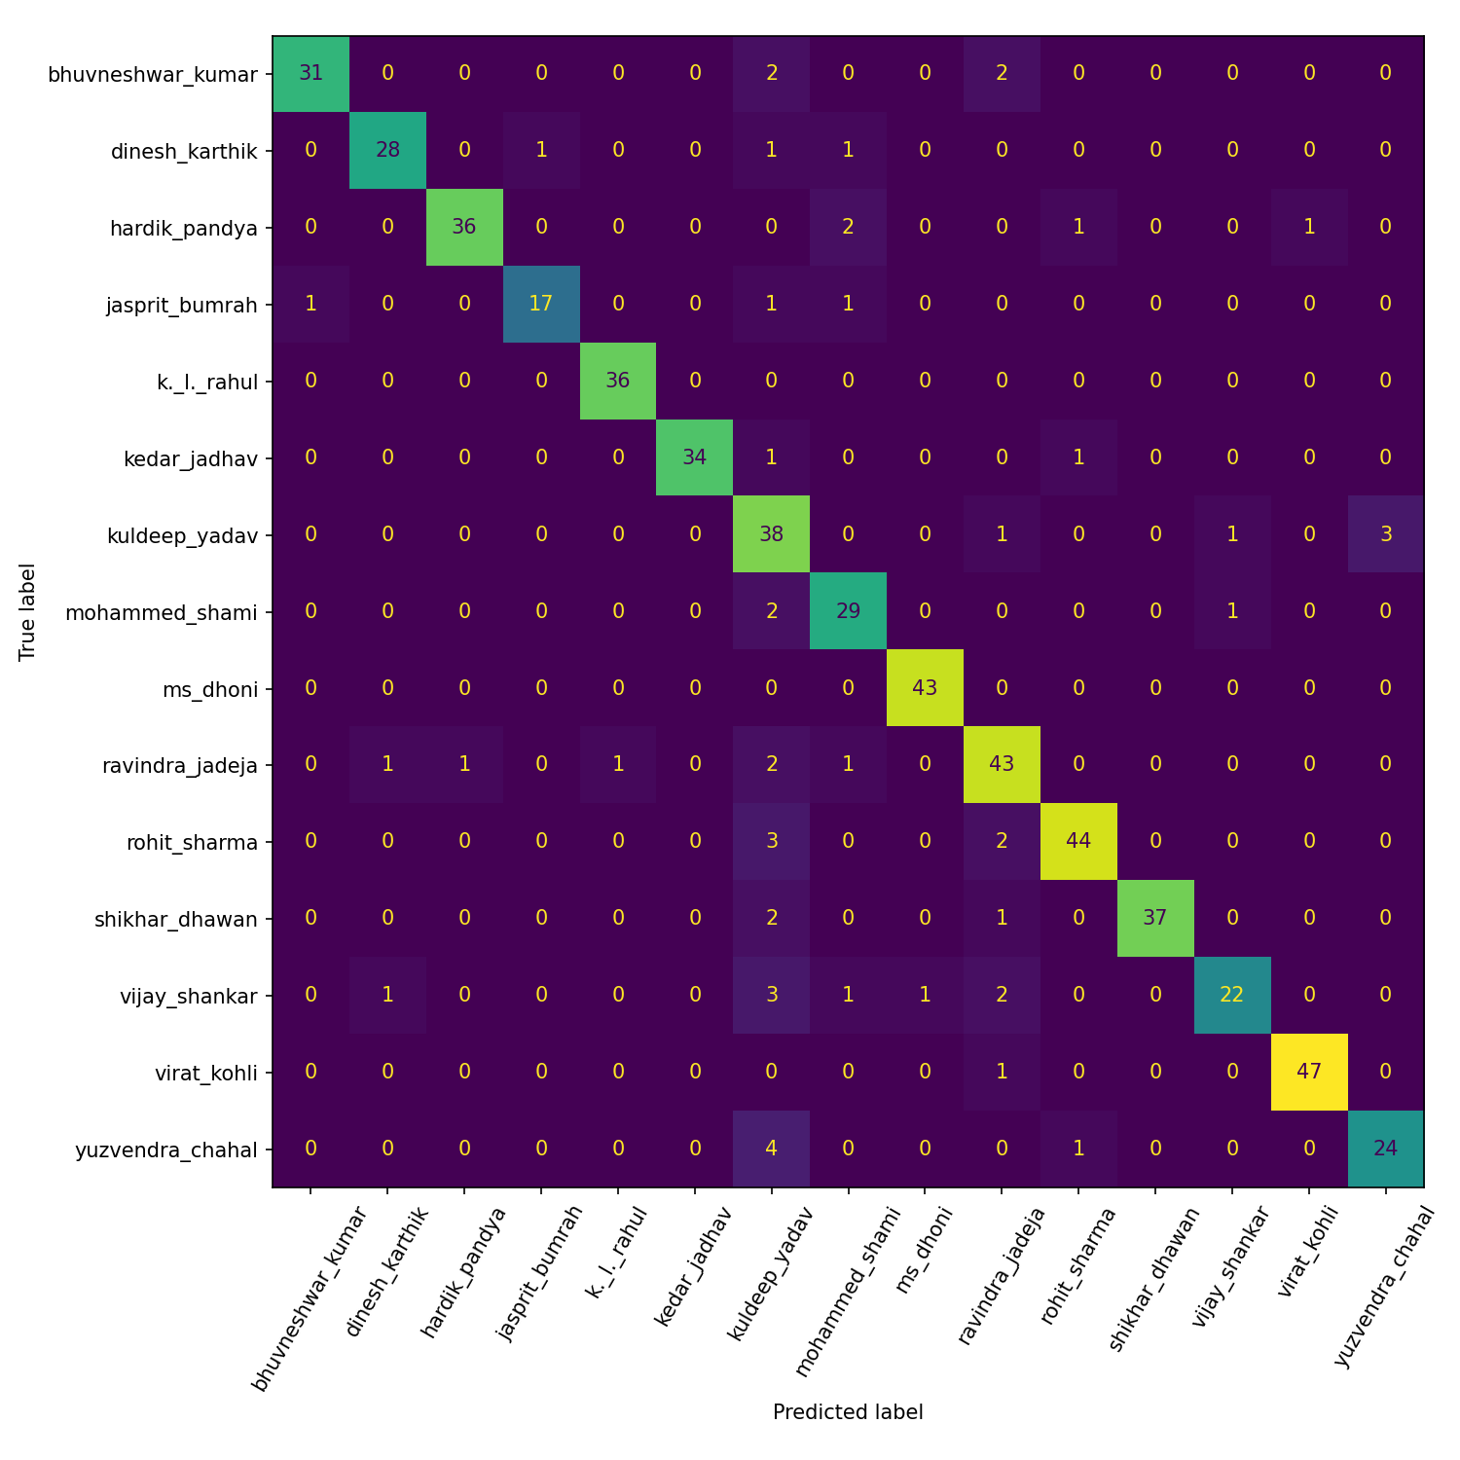

5. Web Application
A Gradio web app (hosted on Hugging Face Spaces) lets a user upload a photo; it detects every face, names each one, and shows confidence scores, with a threshold below which a face is labelled Unknown. https://huggingface.co/spaces/ruchithapr/cricket-face-identifier

6. Limitations
- Closed-set recognition: it only knows these players; other people are matched to the closest player unless the confidence threshold marks them Unknown.
- Small dataset per player; accuracy may drop for unusual angles, occlusion (caps, sunglasses), low resolution or different lighting.
- Photos of the same player from the same event may be near-duplicates, which can make cross-validated accuracy slightly optimistic.
- Face recognition systems can show bias and should not be used for surveillance or any high-stakes decision.

7. Future Work
- Add more players and more varied photos per player.
- Try stronger embeddings (e.g. ArcFace) or fine-tune the network.
- Add an explicit open-set / "not in the team" detector.
- Support video and live camera input.

