**MOVIE RECOMMENDATION SYSTEM**

A project Report

Submitted in the partial fulfillment of the requirements

for the award of the degree of

Bachelor of technology

In

Department of Computer Science and Engineering

By

G. Dilip Reddy (2010030041)

C. Sai Santosh (2010030033)

M. Ruchitha (2010030480)

under the supervision of

Dr. Subhranginee Das

Assistant Professor



Department of Computer Science and Engineering

K L University Hyderabad,

Aziz Nagar, Moinabad Road, Hyderabad – 500 075, Telangana, India.

April, 2022

**DECLARATION**

The Project Report entitled “**Movie Recommendation System**” is a record of bonafide work of **G. Dilip Reddy (2010030041), C. Sai Santosh (2010030033), M. Ruchitha (2010030480)**, submitted as a requirement for the completion of the course **Artificial Neural Networks** in the Department of Computer Science and Engineering to the K L University, Hyderabad. The results embodied in this report have not been copied from any other Departments/University/Institute.

G. Dilip Reddy (2010030041)

C. Sai Santosh (2010030033)

M. Ruchitha (2010030480)

**CERTIFICATE**

This is to certify that the Project Report entitled “**Movie Recommendation System**” is being submitted by **G. Dilip Reddy (2010030041), C. Sai Santosh (2010030036), M. Ruchitha (2010030480),** as a requirement for the completion of the course **Artificial Neural Networks** in the Department of Computer Science and Engineering, K L University, Hyderabad is a record of bonafide work carried out under our guidance and supervision.

The results embodied in this report have not been copied from any other departments/ University/Institute.

## Signature of the Supervisor

Dr. Subhranginee Das

Assistant Professor

## Signature of the HOD Signature of the External Exam

**ACKNOWLEDGEMENT**

First and foremost, we thank the lord almighty for all his grace & mercy showered upon us, for completing this project successfully.

We take grateful opportunity to thank our beloved Founder and Chairman who has given constant encouragement during our course and motivated us to do this project. We are grateful to our Principal **Dr. L. Koteswara Rao** who has been constantly bearing the torch for all the curricular activities undertaken by us.

We pay our grateful acknowledgement & sincere thanks to our Head of the Department **Dr. Chiranjeevi Manike** for her exemplary guidance, monitoring and constant encouragement throughout the course of the project. We would like to convey our heartfelt gratitude to

**Dr. Subhranginee Das** of our department who has supported throughout this project holding a position of supervisor for her tremendous direction and assistance in the completion of our project.

We whole heartedly thank all the teaching and non-teaching staff of our department without whom we won’t have made this project a reality. We would like to extend our sincere thanks especially to our parent, our family members and friends who have supported us to make this project a grand success.

**ABSTRACT**

Recommender systems have changed the way we search for things of interest. This is an information filtering approach used to predict that user's preferences. The most common areas where recommender systems are applied are books, news, articles, music, videos, movies, etc. Here, we propose a movie recommender system. It is based on a content-based filtering approach that takes the information provided by the user, analyzes it, and recommends the most suitable movies for the user at that moment. In this document, the recommendation system is built around the types of genres that users prefer to watch. The approach chosen for this is content-based filtering using genre correlation. Users can easily browse recommendations to find movies they love.

**TABLE OF CONTENTS**

|  |  |  |
| --- | --- | --- |
| **S.No** | **Topic** | **Page No.** |
| 1 | Introduction   * 1. Introduction   2. Problem Statement   3. Motivation | 07  07  07  08 |
| 2 | Literature Survey | 09 |
| 3 | Hardware and Software Requirements | 10 |
| 4 | Technique | 11 |
| 5 | Existing System | 12 |
| 6 | Proposed System | 13 |
| 7 | Flowchart | 14 |
| 8 | Implementation | 15 |
| 9 | Datasets used | 16 |
| 10 | Results | 17 |
| 11 | References | 18 |

1. **INTRODUCTION**

In today's world where the Internet has become an important part of human life, users often face the problem of having too many choices. From

searching for models to finding investment opportunities, there is too much information available. To help users navigate this information explosion, companies are employing recommendation systems to guide them.

Provides user-assignable content according to a collection of items. These systems aim to recommend the movies to users based on movie ratings. Example: I've seen euphoria "Which movie do you like?" The recommender system mimics social processes to enable rapid filtering of information on the web. Many companies are looking to offer his service, which includes recommendations that target appropriate user groups.User actions and their feedback can be saved in a recommendation database and used to generate new recommendations in subsequent user-system interactions. The economic potential of these recommendation systems leads some of the largest e-commerce sites (Amazon.com, Snapdeal, etc.).

* 1. **Problem Statement**

This document is based on a recommendation system that recommends different things to users. This system recommends movies to users. This system provides more accurate results than the existing system. Existing systems work in conjunction with individual user ratings.  
This may not be useful for users with different tastes than the recommendations given by the system, as each user may have different tastes. The system calculates similarities between different users and recommends movies according to ratings given by different users with similar tastes. This provides users with accurate recommendations. This is both a web-based and an Android system with the Amovie web service providing services for users to rate movies, show recommendations, comment, and view similar movies.

* 1. **Motivation**

The main purpose of a movie recommendation system is to filter and predict only the movies that the relevant user is most likely to want to see. The ML algorithms in these recommender systems use data about this user from the system's database.

1. **LITERATURE SURVEY**

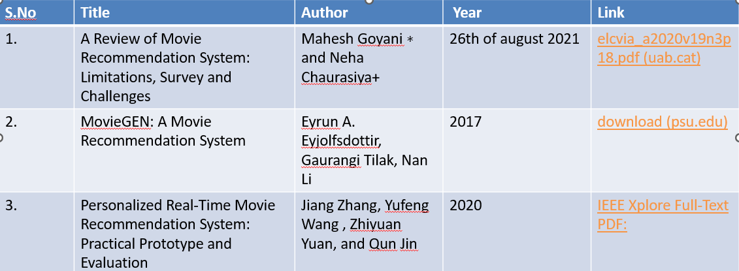

1. **HARDWARE & SOFTWARE REQUIREMENTS**

* **HARDWARE REQUIREMENTS:**

The hardware requirements that map towards the software are as follows:

RAM : 4.00 GB

Processor : Intel(R) Core(TM) i5-4210U CPU @ 1.70GHz 1.70 GHz

* **SOFTWARE REQUIREMENTS:**

The major software requirements of the project are as follows:

Language : Python, Streamlit

Operating system : Windows

Tools : Pycharm

1. **TECHNIQUE**

Content-based filtering:

This is similar to cosine, tagged with keywords next to user profiles, describing the user's preferred likes and dislikes. That is, cosine similarity algorithms recommend this article or similar articles who have fallen in the past. Explore his previously rated articles. We recommend the best items. Different approaches have been proposed in various research papers. works listed below. These approaches are often combined with hybrid recommendation systems.

Collaborative Filtering:  
 Collaborative filtering system recommends articles based on similarity measures between users and/or articles. The system will recommend items that similar users like. Collaborative filtering has many advantages. H. Depends on connectivity only. 2. CF has an explicit evaluation, so there is an actual quality evaluation of the element. 3. Recommendations are based on user similarity, not item similarity, so random recommendations are provided.

1. **EXISTING SYSTEM**

Before recommendation systems existed, people would physically select the

movies they wanted to see from their movie library. Users had to read the reviews and select movies based on ratings. Due to the large audience, this procedure cannot be performed. Therefore, many recommendation systems have been further developed.

Over the last ten years. These systems use different approaches, including collaborative approaches. content-based approach, hybrid approach, etc.

Based on histories and reviews from various customers, the system suggests what not to show. Determining what you are looking for requires efforts. These recommended systems are categorized. They can be divided into two types, collaborative filtering approaches and content-based approaches.

The collaborative approach combines reviews from users with similar tastes. Movies are recommended, but the content-based approach limits to one user. user history and ratings are used to provide recommendations. The movie recommendation system can increase viewership, increase sales, and make movies more popular on OTT platforms. Watching movies changes the way you look at everyday things and the way you look at life. move recommendation systems allows you to bring a whole new perspective while still providing affordable entertainment. These systems use a variety of approaches, including collaborative approaches, content-based approaches, Utility-based approaches, and hybrid approaches.

1. **PROPOSED SYSTEM**

**A. Dataset:**

An extract of a dataset from Kaggle containing over 4500 movie records was used in a Jupiter notebook for analysis and made recommendations. Different attributes have different weights. In our research,referrals are the most relevant. What is generated should be based on the ratings given. Since it is a video of the previous user, I added it. The importance of the rating attribute with respect to other attributes. imdb.com. Probably the largest movie collection with ratings given to these movies by his different movie users from different parts of the world.

**B. Vectorization:**

Vectorization is the process of converting an algorithm from processing one value at a time to processing a sequence of

values ​​(vectors) at a time. A machine learning algorithm used in recommendation systems.

Vectorization is a classical approach for transforming input data from a raw format (such as text) into a vector of real numbers (a format supported by ML models). This approach is used in NLP today, and has worked brilliantly in many areas since the

computers were first built.

**C. Users:**

users can view recommendations for each movie from the web application. Five movies are recommended based on one

input video. This recommendation system recommends different movies to users. This system, on the other hand, the joint approach yields increasingly clear results. Various systems based on the content-based approach. Content-based recommendations. Systems are limited to humans, and these systems do not pre-dictate things. The system responds to individual user reviews, so narrow down your options and explore.

1. **FLOWCHART**

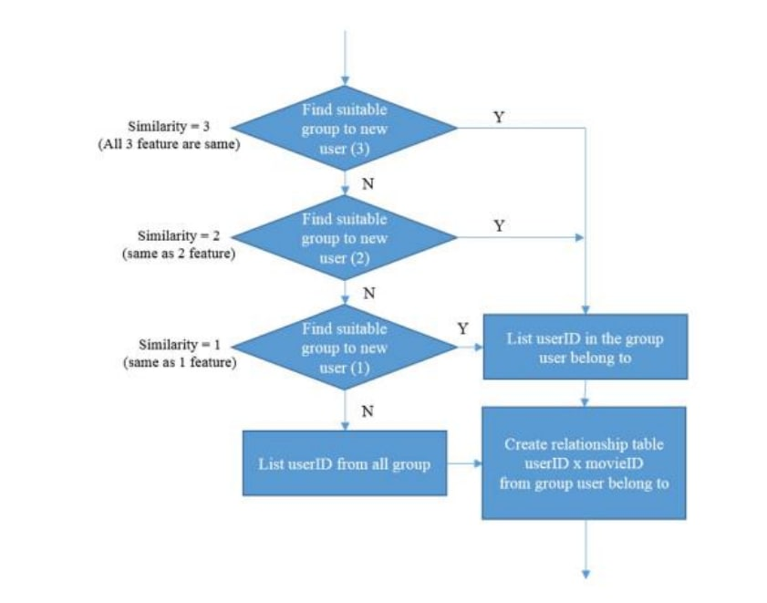

1. **DATASET USED**

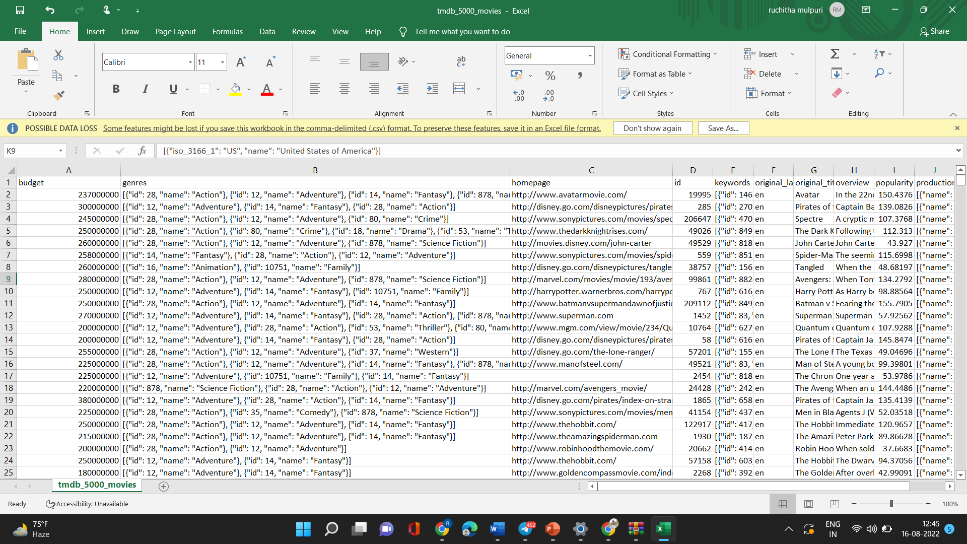

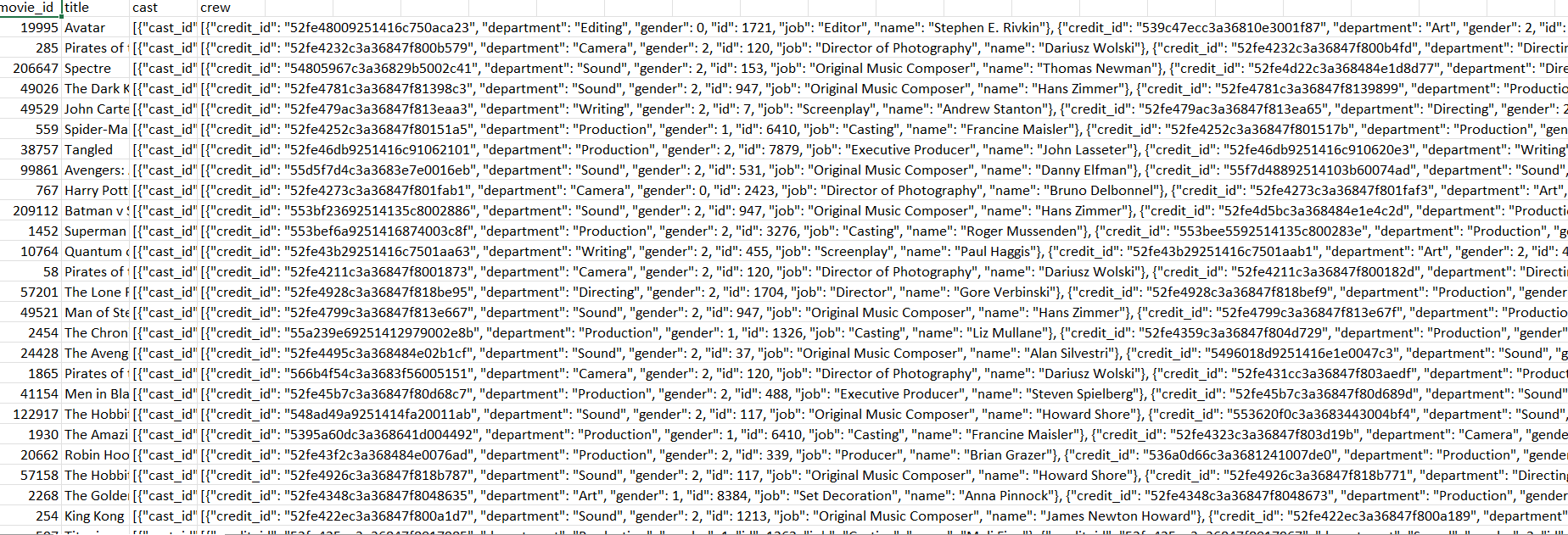

1. **RESULTS**

