**DEPLOYING STATIC WEBSITE USING ACI(DOCKER) BY CLI AND POWRSHELL**

# Project Overview

Develop a static websiteis a userfriendly for create a bar and restaurant. It will also include an "About Us" page, contact information, The primary goal of the Sri Elite Bar and Restaurant project is to establish a premier dining and entertainment destination in rajanna sricilla The goal is to effectively represent the, provide essential information, and improve customer experience.

# Problem Statement

• **Establish a Strong Brand Identity:** Develop a strong brand identity that resonates with the target market and positions Sri Elite as a leading lifestyle destination.

• **Deliver Exceptional Culinary Experiences:** Curate a diverse menu featuring innovative dishes and classic favorites, prepared with the finest ingredients and presented with culinary artistry.

• **Provide Unparalleled Service:** Train and empower our staff to deliver exceptional service that exceeds guest expectations.

• **Create a Vibrant Atmosphere:** Design a stylish and inviting ambiance that fosters social interaction and memorable experiences.

• **Optimize Financial Performance:** Achieve sustainable profitability through effective cost management, revenue generation, and strategic marketing initiatives.

# Project Goals

* Deploy the **BAR AND RESTAURANT** website on Azure using CLI &POWERSHELL.
* Set up a **VIRTUAL MACHINE** with **Azure Container Registry** & **Azure Container Instance**
* Use a  **image to push the container by using docker file**
* Host the static website on these VMs and make it accessible via azure container instance sever name.

# Technologies and Azure Services Used

1. **Azure CLI**: Used to create the resource group and Virtual machine. .
2. **Azure Virtual Machines (VMs)**: Hosted the Bar and Restaurant.
3. **Nginx**: Used as a web server on both VMs to serve the static content.
4. **Git**: Cloned the website from GitHub onto the VMs using a custom script.
5. **Custom Script Extension**: Used to automatically configure the VMs upon deployment.

# Project Steps

1. **Website Development**

* + **Bar and Resaturant:** A static website enabling customers to explore the order , tasty and food essential drinking

1. **Deploying the Website on GitHub**

* + The bar and restaurant was uploaded to a public GitHub repository

1. **Azure Deployment Using CLI & POWERSHELL**

* + **Resource Group**: Created using Azure CLI to hold all the resources.
  + **Virtual machine**: Created using Azure CLI to hold the virtual machine
  + **Azure Container Registry**
  + **Azure Container Instance**

1. **Virtual Machines Setup**

* + **VM 1**: Created in Availability Zone 1 using Azure Portal. Configured with:

Custom Script Extension to clone the website from GitHub.

Azure Container Registry and Azure Container Instance

1. **Load Balancer Configuration**

* + **Load Balancer**: Configured to distribute a push the images into azure container registry by use the VM and ACI
  + Defined to HTTP traffic (port 80) across the VMs.

In ACR enable the respository to connect the ACI for sever name to deploy the website

1. **Testing and Accessing the Website**

* + After push the image to the ACI it will show the website became accessible via the github to Customers can access the website on the server

**How to Use Bar and Restaurant Website:**

* 1. Explore our website.
  2. Select the food item or drinking items which you want from the website.
  3. Confirm your order to book a table.
  4. If you are satisfied with our service can follow us.

**Azure Services and Tools Used:**

* + **Azure CLI**: Resource group creation and managemen.
  + **Azure Virtual Machines**: Hosting the website on multiple VMs.
  + **Azure Container Registry**
  + **Azure Container Instance**
  + **Nginx**: Web server for hosting static content.
  + **Git**: Version control and cloning the website onto VMs.
  + **Custom Script Extension**: Automated configuration of VMs.

# Live Website and Resources

* **Website Link**: bar and restaturant

* **Project Video Link**: Project video

**Screenshots**:

**Created Resource Group Screenshot**

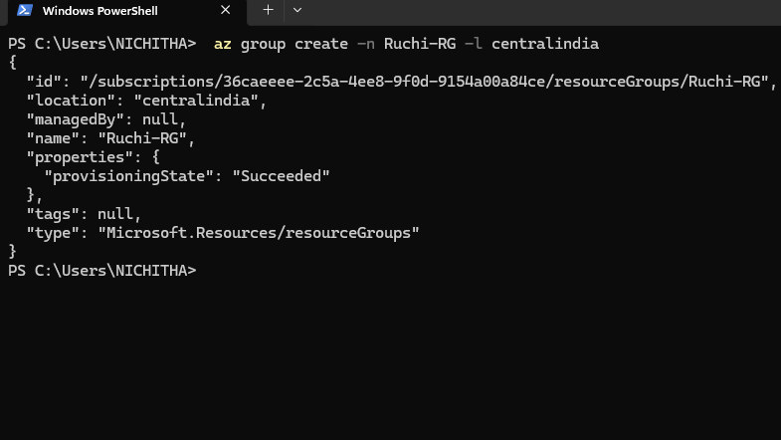

**Resource group in portal**

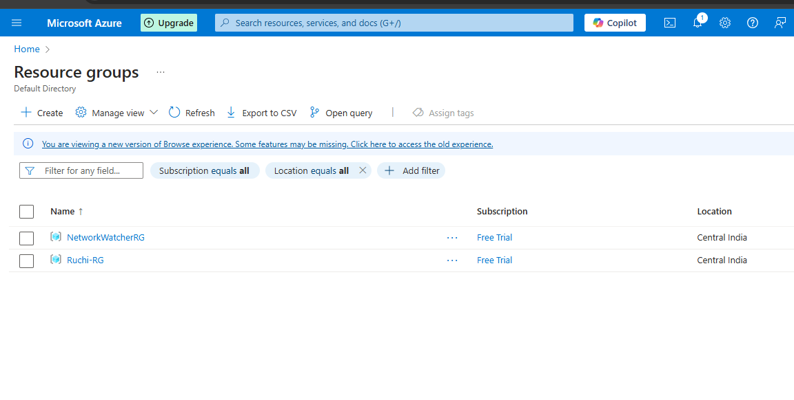

**Create the Virtual Machine**

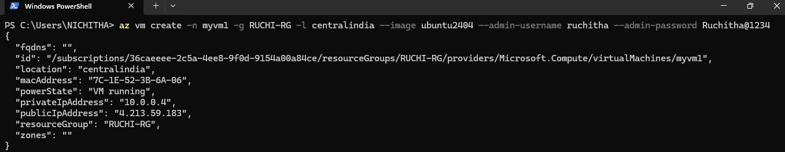

**Created Virtual Machine in portal**

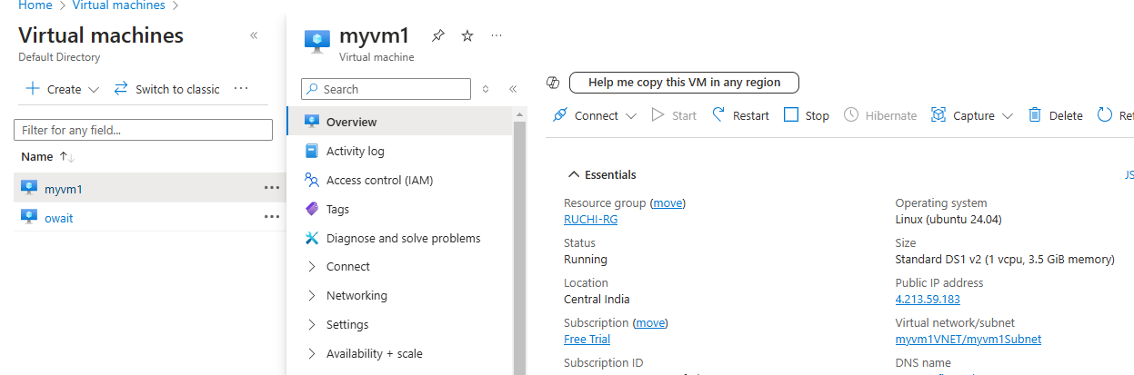

**Created The Azure Container Registry**

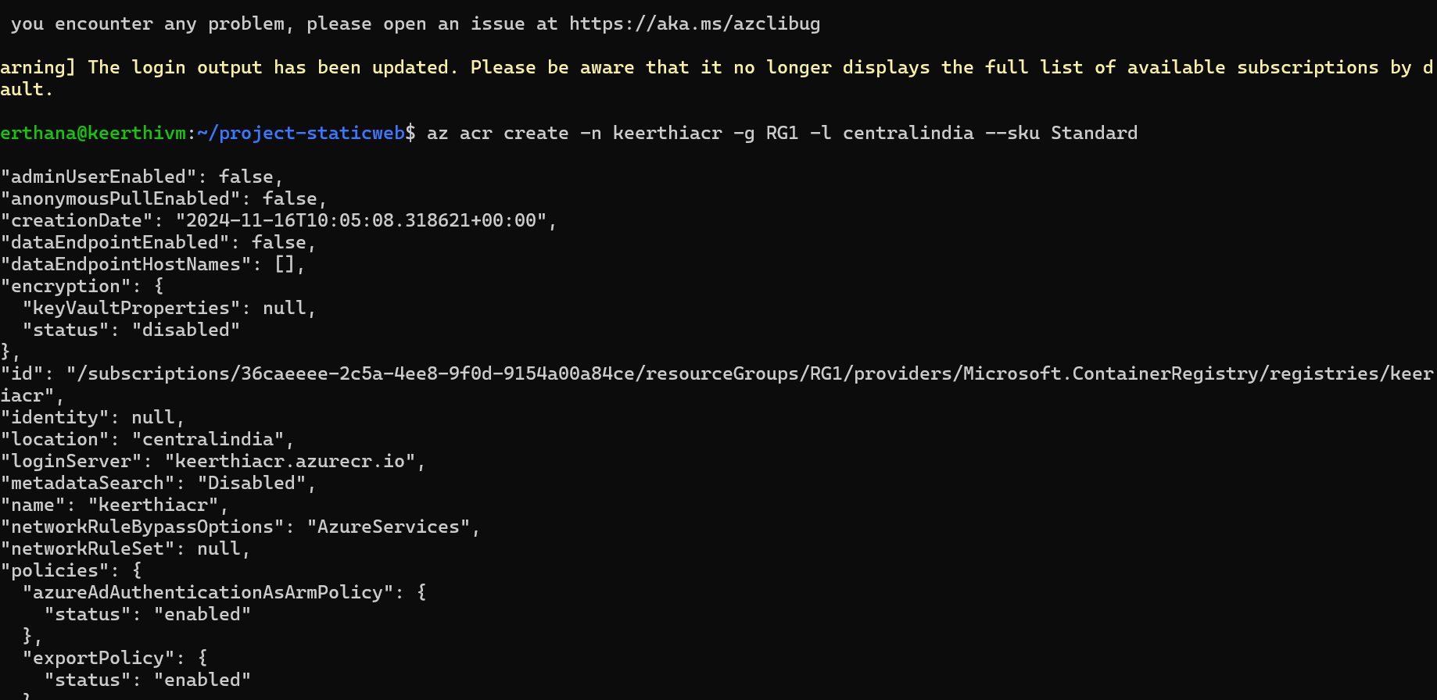

**Created the azure container registry in portal**

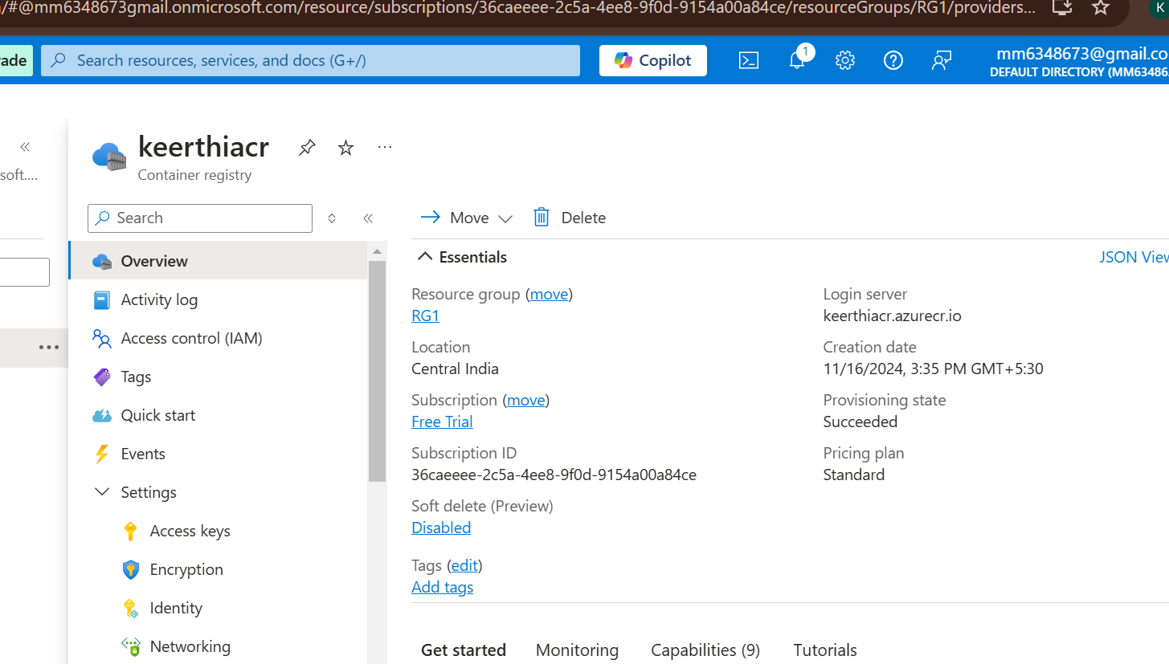

**Website Home Page Screenshot**

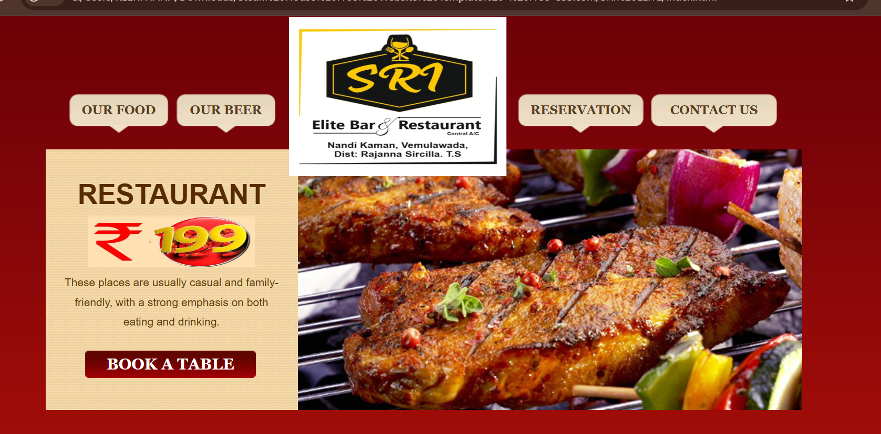

**Food page after deployment**

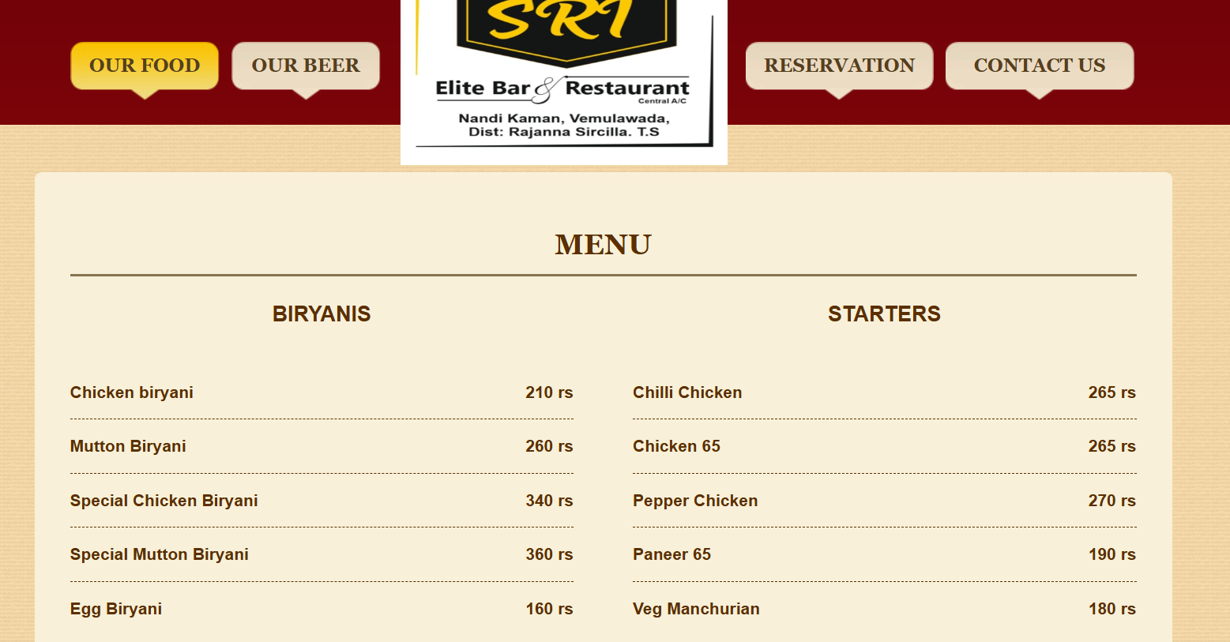

**Beer page after depolyment**

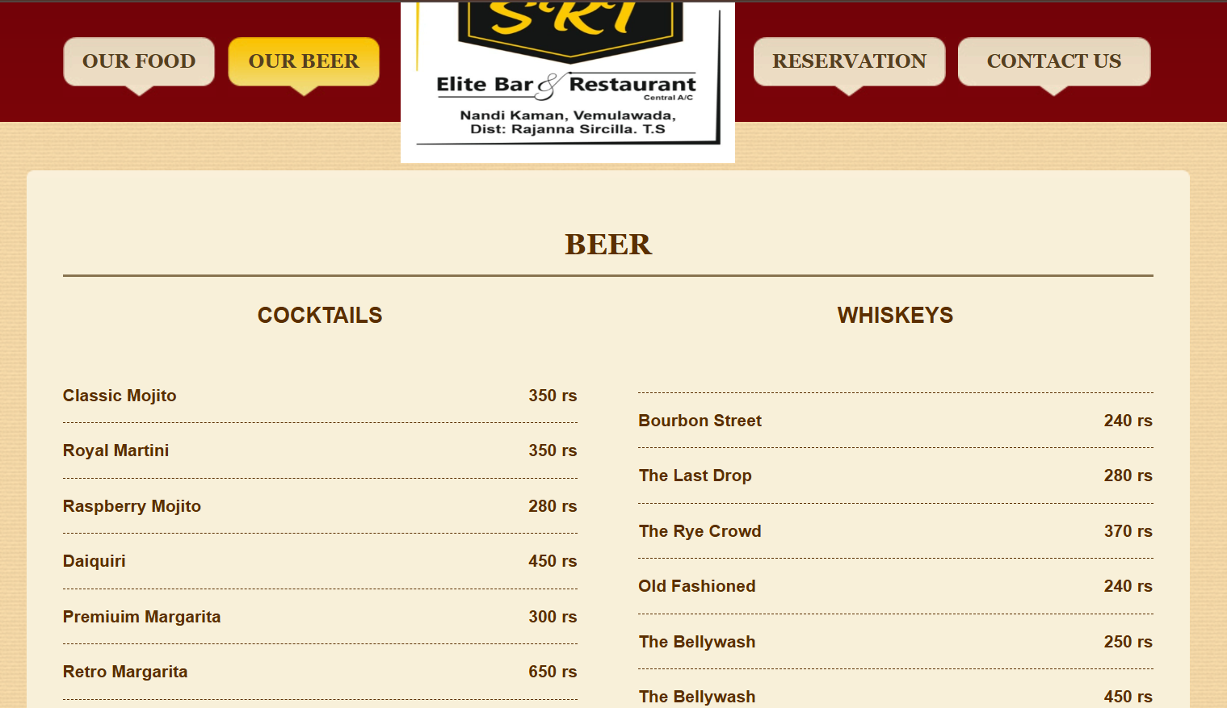

**Reservation page after depolyment**

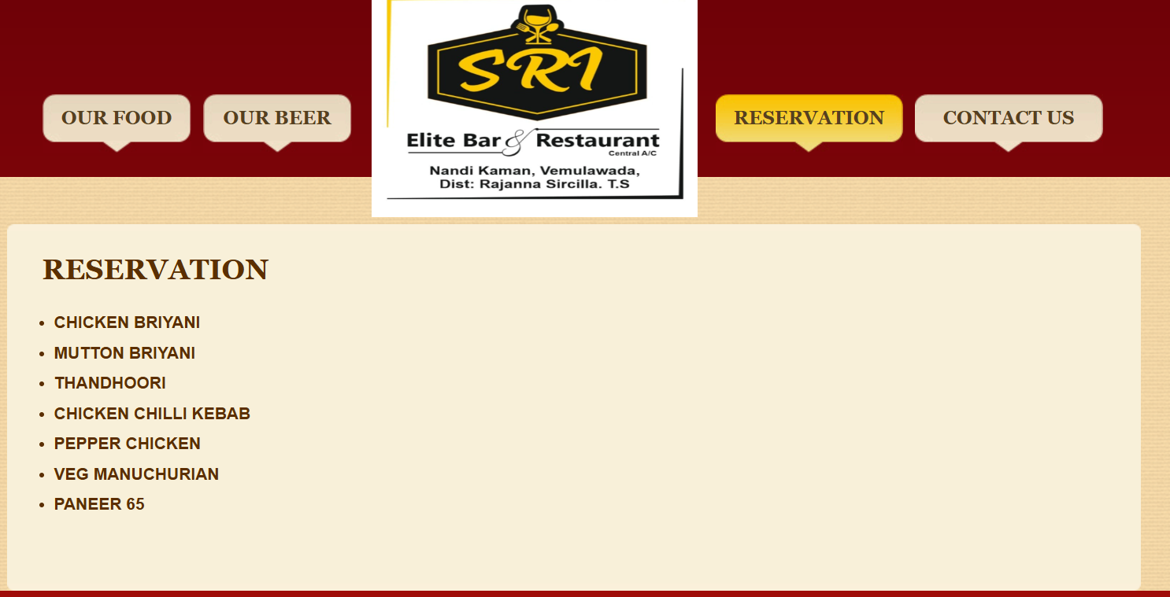

**Contact page after depolyment**

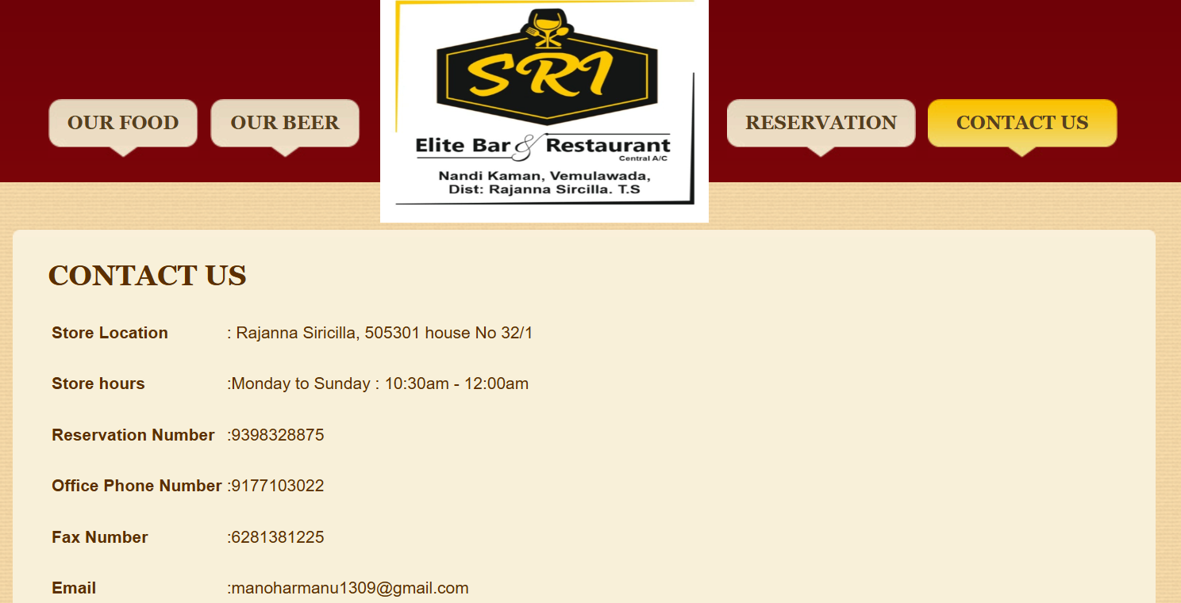

# Conclusion

This sample business plan provides a comprehensive roadmap for launching and operating a successful **Bar and Restaurant** . By following the outlined steps and utilizing the provided resources, entrepreneurs can create a strong foundation for their business and achieve long-term success.