A G E N D A

Parks Board meeting, November 3, 2026
Town of Example Parks Board. Town Hall, Room 2, at 6:00 pm.

Status of this agenda
The board will confirm this agenda at the meeting.

Schedule
Time Item Presenter
6:00 pm Call to order Chair Lee
6:05 pm Public comment Chair Lee
6:30 pm Trail lighting bid Director Ortiz

Roll call

Present:
Chair Lee, Member Ortiz, Member Brown.

Public comment
Speakers sign up at the door before the meeting starts.
Old business
The board will review the trail lighting bid.
Each speaker has three minutes.

Volunteer sign-up
Use the form on the right to sign up.

Consent agenda
The board approves these items together:
• Park rental fees for 2027
• Minutes of October 6
• Donation of two benches

Projects
Project approvals so far:
Project | Approved
Trail lighting | ✓
Pool repairs
Dog park fence | ✓

Park visits
Park visits rose through the summer.
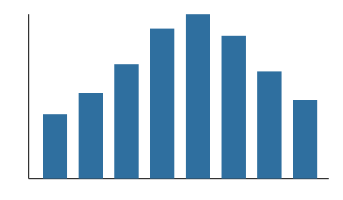

New playground
The new playground opens in December.


Riverside Park cleanup
Thanks to the 40 volunteers who cleaned the trail in October.

Announcements
The pool reopens on December 1.
The skating rink opens on December 15.

Reports
The treasurer's report is attached.
The director's report follows.

Park hours
Summer hours Winter hours
Monday to Friday, 7 am to 9 pm Monday to Friday, 8 am to 6 pm
Weekends, 8 am to 8 pm Weekends, 9 am to 5 pm

Contact
Town of Example Parks Department, 12 Main Street | Call 555-0100 or write to parks@example.com.
Questions about this agenda go to the parks office. | Large-print copies are available at the meeting.

Directions
1. Take Main Street north. | 3. Turn right into the Town Hall lot.
2. Turn left at Oak Avenue. | 4. Room 2 is past the front desk.

Budget documents
The budget documents are online. Click here.

Speaker sign-up
Name: Click or tap here to enter text.

𝐍𝐎𝐓𝐈𝐂𝐄
The pool closes for repairs on November 10.

Seating
[ Chair ] [ Clerk ]
[ ] [ ] [ ] [ ] [ ] [ ]
[ ] [ ] [ ] [ ] [ ] [ ]
^ door

Website
Hours and maps are on the parks web page.

Votes
Items in red need a vote.
- Trail lighting bid
- Pool repair schedule
- Dog park hours

Fall festival
Fall festival: October 31, 4 to 7 pm, at Riverside Park.

Rental contact
Phone: (Click or tap here to enter text.) Click or tap here to enter text.-Click or tap here to enter text.

Partners
Our partner for the fall festival:


Fees
Fee | Amount
Pavilion rental, half day | $40
Pavilion rental, full day | $75
Field lights, per hour | $15

Parking
Parking is free after 5 pm in the Town Hall lot.

Language assistance
Language help is free.
Si necesita ayuda en español, llame al 555-0100. Los servicios de idioma son gratuitos.

