Agenda

Parks Board meeting, November 3, 2026
Town of Example Parks Board. Town Hall, Room 2, at 6:00 pm.

Status of this agenda
This agenda is a draft. The board will confirm it at the meeting.

Schedule
Time | Item | Presenter
6:00 pm | Call to order | Chair Lee
6:05 pm | Public comment | Chair Lee
6:30 pm | Trail lighting bid | Director Ortiz

Roll call
Present: Chair Lee, Member Ortiz, Member Brown.

Public comment
Speakers sign up at the door before the meeting starts.
Each speaker has three minutes.

Old business
The board will review the trail lighting bid.

Volunteer sign-up
Sign up at the parks office or call 555-0100.

Consent agenda
The board approves these items together:
- Park rental fees for 2027
- Minutes of October 6
- Donation of two benches

Projects
Project approvals so far:
Project | Approved
Trail lighting | Yes
Pool repairs | No
Dog park fence | Yes

Park visits
Park visits rose through the summer.
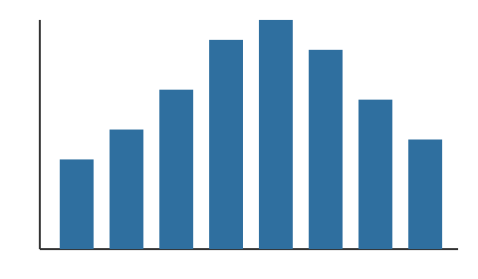

New playground
The new playground opens in December.


Riverside Park cleanup
Thanks to the 40 volunteers who cleaned the trail in October.

Announcements
The pool reopens on December 1.
The skating rink opens on December 15.

Reports
The treasurer's report is attached.
The director's report follows.

Park hours
Summer hours: Monday to Friday, 7 am to 9 pm; weekends, 8 am to 8 pm.
Winter hours: Monday to Friday, 8 am to 6 pm; weekends, 9 am to 5 pm.

Contact
Town of Example Parks Department, 12 Main Street | Call 555-0100 or write to parks@example.com.
Questions about this agenda go to the parks office. | Large-print copies are available at the meeting.

Directions
From Main Street:
- Take Main Street north.
- Turn left at Oak Avenue.
- Turn right into the Town Hall lot.
- Room 2 is past the front desk.

Budget documents
Read the 2027 parks budget.

Speaker sign-up
Name: Click or tap here to enter text.

Notice
The pool closes for repairs on November 10.

Seating
The chair and the clerk sit at the front table. Public seats are in two rows of six facing them, and the door is at the back.

Website
Hours and maps are on the parks web page.

Votes
Items marked (vote) need a vote.
- Trail lighting bid (vote)
- Pool repair schedule
- Dog park hours (vote)

Fall festival
Fall festival: October 31, 4 to 7 pm, at Riverside Park.

Rental contact
Phone number: Click or tap here to enter text.

Partners
Our partner for the fall festival:


Fees
Fee | Amount
Pavilion rental, half day | $40
Pavilion rental, full day | $75
Field lights, per hour | $15

Parking
Parking is free after 5 pm in the Town Hall lot.

Language assistance
Language help is free.
Si necesita ayuda en español, llame al 555-0100. Los servicios de idioma son gratuitos.

