Supporting information for
Tracking Two Decades of Global Gallium Stocks and Flows: A Dynamic Material Flow Analysis
Zhongkui Han ^{a, b, c}, Qiance Liu ^{c}, Xin Ouyang ^{d}, Huiling Song ^{e}, Tianming Gao ^{a, b}, Yanfei Liu ^{f}, Bojie Wen ^{a, b*}, Tao Dai ^{a, b*}

ª Institute of Mineral Resources, Chinese Academy of Geological Sciences, Beijing 100037, China
^{b} Research Center for Strategy of Global Mineral Resources, Chinese Academy of Geological Sciences, Beijing 100037, China
^{c} SDU Life Cycle Engineering, Department of Green Technology, University of Southern Denmark, 5230 Odense, Denmark
^{d} Institute of Geographic Sciences and Natural Resources Research, Chinese Academy of Sciences, 100101 Beijing, China
^{e} Business School, Zhengzhou University, 450001 Zhengzhou, China
^{f} School of Earth Sciences and Resources, China University of Geosciences (Beijing), Beijing 100083, China

Summary information:
Number of pages: 26 pages
Figures: Fig. S1-S9
Tables: Tables S1-S10

Contents
S1 Abbreviated letter index table 1
S2 Calculating methods for each process of Ga cycle 2
S2.1 Ga in Aluminium cycle 2
S2.2 Ga in Zinc cycle 2
S2.3 Ga production 2
S2.4 Production of semi-products 3
S2.5 Production of final products 3
S2.6 In-use stock & outflow 3
S2.7 Waste management 4
S3 Complete overview of the parameters and their respective sources 5
S4 Ga loss during the manufacturing of semi-products 16
S5 Uncertainty analysis results of global Ga flows and stocks 17
S6 Ga loss information in Semi-product manufacturing stage and strategies for improving he circularity 18
S7 World Alumina Refinery Production and amount of Ga in Bayer liquor 20
S8 The standard techniques for production Ga from Bayer liquid 22
References 23

S1 Abbreviated letter index table

Table S1. List of abbreviations
Abbreviation | Full name
PV | Photovoltaic panel
ZEV | Zero-emission vehicle
CIGS | Copper-indium-gallium-selenium thin-film solar cell
LED | Light-emitting diode
ICEV | Internal combustion engine vehicle
IC | Integrated circuit
MOCVD | Metal Organic Chemical Vapor Deposition
MBE | Molecular beam epitaxy
TMG | Trimethylgallium
EoL | End-of-life

S2 Calculating methods for each process of Ga cycle

S2.1 Ga in Aluminium cycle
Mass balances in Aluminium cycle were calculated by the following equations.
$I_{Bayer}\left(t\right)=P_{bauxite}\left(t\right)*\left(1-{Loss}_{bauxite}\left(t\right)\right)*M_{bauxite}\left(t\right)*\left(1-T_{O}\left(t\right)\right)*\left(1-{Loss}_{red}\left(t\right)\right)*\left(1-{Loss}_{Al}\left(t\right)\right)$ (S1)
$I_{Bayer}\left(t\right)={Loss}_{Bayer}\left(t\right)+I_{Al-Ga}\left(t\right)$ (S2)
Where $I_{Bayer}\left(t\right)$ stands for Ga inflow in Bayer liquid in year t, $P_{bauxite}\left(t\right)$ stands for bauxite production in year t, ${Loss}_{bauxite}\left(t\right)$ stands for bauxite loss rate in the beneficiation process in year t, $M_{bauxite}\left(t\right)$ stand for Ga fraction in bauxite in year t, $T_{O}\left(t\right)$ stands for proportion of other uses of bauxite in year t, ${Loss}_{red}\left(t\right)$ stand for fraction of Ga lost to red mud in year t, ${Loss}_{Al}\left(t\right)$ stand for fraction of Ga lost to Aluminum metal in year t, ${Loss}_{Bayer}\left(t\right)$ stand for fraction of Ga lost to Bayer liquid in year t, $I_{Al-Ga}\left(t\right)$ stands for the amount of Ga from Baier liquid to Ga production stage in year t.

S2.2 Ga in Zinc cycle
Mass balances in zinc cycle were calculated by the following equations.
$I_{t-slag}\left(t\right)=P_{ore}\left(t\right)*\left(1-{Loss}_{ore}\left(t\right)\right)*M_{ore}\left(t\right)*\left(1-{Loss}_{metal}\left(t\right)\right)$ (S3)
$I_{t-slag}\left(t\right)={Loss}_{slag}\left(t\right)+I_{Zn-Ga}\left(t\right)$ (S4)
Where $I_{t-slag}\left(t\right)$ stands for total Ga inflow in zinc slag in year t, $P_{ore}\left(t\right)$ stands for zinc ore production in year t, ${Loss}_{ore}\left(t\right)$ stands for zinc ore loss rate in the beneficiation process in year t, $M_{ore}\left(t\right)$ stand for Ga fraction in zinc ore in year t, ${Loss}_{metal}\left(t\right)$ stand for fraction of Ga lost to zinc metal in year t, ${Loss}_{slag}\left(t\right)$ stand for fraction of Ga lost to zinc slag in year t, $I_{Zn-Ga}\left(t\right)$ stands for the amount of Ga from zinc slag to Ga production stage in year t.

S2.3 Ga production
Mass balances in Ga production were calculated by the following equations.
$I_{pri}\left(t\right)=I_{Al-Ga}\left(t\right)*\left(1-R_{Al-Ga}\left(t\right)\right)+I_{Zn-Ga}\left(t\right)*\left(1-R_{Zn-Ga}\left(t\right)\right)$ (S5)
$I_{tpro}\left(t\right)=I_{pri}\left(t\right)+I_{sec}\left(t\right)$ (S6)
$I_{sec}\left(t\right)=(T_{sem}\left(t\right)+T_{eol}\left(t\right))*\left(1-R_{sec}\left(t\right)\right)$ (S7)
$I_{tpro}\left(t\right)=O_{pro}\left(t\right)$ (S8)
Where $I_{pri}\left(t\right)$ stands for the primary Ga production in year t, $R_{Al-Ga}\left(t\right)$ stands for loss rate of Ga extracted from Baier liquid, $R_{Zn-Ga}\left(t\right)$ stands for loss rate of Ga extracted from zinc slag, $I_{sec}\left(t\right)$ stands for secondary Ga production in year t, $T_{sem}\left(t\right)$ and $T_{eol}\left(t\right)$ stand for the amount of Ga new and old scrap collected in year t respectively, $R_{sec}\left(t\right)$ stands for loss rate in the smelting stage of Ga scrap, $I_{tpro}\left(t\right)$ stands for total production of Ga, $O_{pro}\left(t\right)$ stands for Ga outflow in Ga production stage.

S2.4 Production of semi-products
Mass balances in production of semi-products were calculated by the following equations.
$I_{sem}\left(t\right)=O_{pro}\left(t\right)$ (S9)
$I_{fab}\left(t\right)*{MS}_{i}\left(t\right)*\left(1-{Loss}_{i}\left(t\right)\right)=O_{i}\left(t\right)$ (S10)
$\sum_{i}{I_{fab}\left(t\right)*{MS}_{i}\left(t\right)*R_{i}\left(t\right)}=T_{sem}\left(t\right)$ (S11)
Where $I_{sem}\left(t\right)$ stands for Ga inflow in semi-products making stage in year t, ${MS}_{i}\left(t\right)$ stands for market share of Ga inflow in semi-product j in year t, ${Loss}_{i}\left(t\right)$ stands for the Ga loss rate in semi-product i making stage in year t, $O_{i}\left(t\right)$ stands for Ga flow out in semi-product i making stage in year t, $R_{i}\left(t\right)$ stands for the Ga recycling rate in semi-product j making stage in year t.

S2.5 Production of final products
Mass balances in production of final products were calculated by the following equations.
$I_{j}\left(t\right)=\sum_{i}{O_{i}\left(t\right)}$ (S12)
Where $I_{j}\left(t\right)$ stands for the Ga inflow in final product j in year t.

S2.6 In-use stock & outflow
Mass balances in in-use stocks & outflows were calculated by the following equations.
$O_{j}(t)=\int_{t_{0}}^{t}{I_{j}}(t)*pdf\left(t,t^{'}\right)dt^{'}$ (S13)
$S_{j}(t)=\int_{t_{0}}^{t}{(I_{j}}(t)-O_{j}(t))dt$ (S14)
Where $pdf\left(t,t^{'}\right)$ is the life distribution function (Weibull distribution), and t$'$ is the age of the finished product from production to year t, $O_{j}(t)$ for Ga outflow in the finished product j, $S_{j}(t)$ for Ga in-use stock in finished product j.
For Weibull distribution
$pdf\left(t,t^{'}\right)=\int_{0}^{t}{(1-exp(-(\frac{t-t^{'}}{α})^{β}})dt^{'}$ (S15)
For each product, lifetime distribution and parameters are available in Table S1.

Table S2. Lifetime distributions and parameters for finished products
Applications | Distribution function | Scale parameter α | Shape parameter β | Source
LED lightings | Weibull distribution | 10 | 2 | (Løvik et al., 2016; Song et al., 2022)
Mobile phones |  | 3.28 | 2.32 | (He et al., 2018)
Computers |  | 8.4 | 2.2 | (Althaf et al., 2021; Charpentier Poncelet et al., 2022; Song et al., 2022)
Wind turbines |  | 20 | 4 | (Løvik et al., 2016)
ICEVs |  | 16 | 4.8 | (Løvik et al., 2016; Wu et al., 2020)
ZEVs |  | 16 | 4.8 | (Løvik et al., 2016; Wu et al., 2020)
Solar PVs |  | 25 | 5 | (Løvik et al., 2016)
Large durables |  | 6 | 2 | (Song et al., 2022; Wang et al., 2022)
Others |  | 6 | 2 | (Song et al., 2022)

S2.7 Waste management
$I_{re}\left(t\right)=O_{re}\left(t\right)=\sum_{j}{O_{j}}\left(t\right)*\left(1-DR\left(t\right)\right)$ (S18)
Where $I_{re}\left(t\right)$ and $O_{re}\left(t\right)$ stand for the Ga inflow and outflow in waste management stage (recycling process) in year t. $DR\left(t\right)$ is the dissipation ratio of finished product j in year t.

S3 Complete overview of the parameters and their respective sources

Table S3. Main parameters and primary data of global Ga cycle
Process | Description | Unit | Detailed data value | Source | uncertainty range
Gallium in Aluminum cycle | Historic Bauxite production | t | Time series | (USGS) | Low
 | Ga mass fraction in bauxite | (t/t) | 5.4e-005 | (Løvik et al., 2016) | Medium
 | Fraction of Ga lost to red mud | 1 | 0.38 | (Løvik et al., 2015) | Medium
 | Fraction of Ga lost to alumina | 1 | 0.6 | (Løvik et al., 2015) | Medium
 | The proportion of alumina produced by the Bayer liquor | 1 | 0.85 | (Li et al., 2021; Løvik et al., 2015) | Medium
 | The proportion of bauxite used for others (not including the production of alumina by Bayer liquor) | 1 | 0.15 | (Li et al., 2021; Løvik et al., 2015) | Medium
Gallium in Zinc cycle | Zinc ore production | t | Time series | (USGS, n.d.) | Low
 | Gallium mass fraction in Zinc ore | (t/t) | 5.0e-005 | (Frenzel et al., 2016; Jansson et al., 2016) | Medium
 | Fraction of Ga lost to zinc | 1 | 0.02 | (Frenzel et al., 2016) | Medium
 | Mass fraction of Ga in zinc refinery residue | 1 | 0.0035 | (Rao et al., 2019) | Medium
 | Fraction of Ga lost to zinc refinery residue | 1 | 0.98 | (Frenzel et al., 2016) | Medium
Gallium production | Rate of Ga extraction from zinc slag | 1 | 0.9 | (Frenzel et al., 2016) | Medium
 | Rate of gallium extraction from Bayer liquor | 1 | 0.95 | (Løvik et al., 2015) | Medium
 | Yield in recycling of wafer production scrap | 1 | 0.92 | (Løvik et al., 2016, 2015) | Medium
Semi-products manufacturing | Market share of Ga inflow in semi-products | 1 | Time series | (Løvik et al., 2016; Shanghai Metals Market (SMM), 2022) | Low
 | GaN-based LED market share | 1 | 0.7 | Own assumption | High
 | GaAs/GaP-based LED market share | 1 | 0.3 | (Løvik et al., 2016) | Medium
 | Yield in production of sputtering targets/MBE sources | 1 | 1 | (Løvik et al., 2016) | Medium
 | Yield in production of TMG | 1 | 0.92 | (Løvik et al., 2016) | Medium
 | Yield in production of GaAs/GaP substrates | 1 | 0.35 | (Løvik et al., 2016) | Medium
 | Collection rate GaAs/GaP substrate production scrap | 1 | 0.63 | (Løvik et al., 2016) | Medium
 | Deposition yield MOCVD | 1 | 0.11 | (Løvik et al., 2016) | Medium
 | Share of GaAs/GaP LED fabricated on GaAs | 1 | 0.88 | (Løvik et al., 2016) | Medium
 | Loss rate due to dicing of LEDs | 1 | 0.31 | (Løvik et al., 2016) | Medium
 | Loss rate due to non-working devices LED | 1 | 0.08 | (Løvik et al., 2016) | Medium
 | Collection rate of back-grinding/epitaxial lift-off scrap LEDs | 1 | 0.3 | (Løvik et al., 2016) | Medium
 | Collection rate other LED fab. Scrap | 1 | 0 | (Løvik et al., 2016) | Medium
 | Concentration of Ga in GaN | g/cm³ | 5.12 | (Løvik et al., 2016) | Medium
 | Concentration of Ga in GaAs | g/cm³ | 2.56 | (Løvik et al., 2016) | Medium
 | Concentration of Ga in GaP | g/cm³ | 2.87 | (Løvik et al., 2016) | Medium
 | Gallium intensity in AlInGaP | g/cm³ | 0.96 | (Løvik et al., 2016) | Medium
 | Thickness of GaAs substrate | m | 6.53*10^(-4) | (Løvik et al., 2016) | Medium
 | Thickness of GaP substrate | m | 5.62*10^(-4) | (Løvik et al., 2016) | Medium
 | Thickness of deposition layer of LEDs | m | 4*10^(-6) | (Løvik et al., 2016) | Medium
 | Thickness of LED chips | m | 1.4*10^(-4) | (Løvik et al., 2016) | Medium
 | Thickness of IC chips | m | 1*10^(-4) | (Løvik et al., 2016) | Medium
 | Thickness of deposition layer | m | 2*10^(-6) | (Løvik et al., 2016) | Medium
 | Deposition yield MBE | 1 | 0.07 | (Løvik et al., 2016) | Medium
 | Share of integrated circuits produced with MOCVD | 1 | 0.67 | (Løvik et al., 2016) | Medium
 | Share of integrated circuits produced with MEB | 1 | 0.33 | (Løvik et al., 2016) | Medium
 | Collection rate back-grinding scrap IC | 1 | 0.1 | (Løvik et al., 2016) | Medium
 | Collection rate other scrap IC fab. | 1 | 0 | (Løvik et al., 2016) | Medium
 | Loss rate due to dicing of ICs | 1 | 0.15 | (Løvik et al., 2016) | Medium
 | Loss rate due to non-working devices ICs | 1 | 0.08 | (Løvik et al., 2016) | Medium
 | Loss rate due to non-working photovoltaics | 1 | 0.08 | (Løvik et al., 2016) | Medium
 | Deposition yield of CIGS | 1 | 0.45 | (Løvik et al., 2016) | Medium
 | Collection rate non-working photovoltaics scrap | 1 | 0.7 | (Løvik et al., 2016) | Medium
 | Collection rate other photovoltaics scrap | 1 | 0 | (Løvik et al., 2016) | Medium
 | Yield in production of NdFeB magnets | 1 | 0.7 | (Liu et al., 2022; Løvik et al., 2016) | Medium
 | Collection rate NdFeB magnets scrap | 1 | 0 | (Liu et al., 2022; Løvik et al., 2016) | Medium
Final products manufacturing | Market share Consumption structure of all kinds of semi-products | t | Time series | (Shanghai Metals Market (SMM), 2022) | Low
Waste management | Recycling rate of EoL final products | 1 | 0 | Own assumption | High
 | Lifetime distributions and parameters for finished products | - | - | Table S1 | Medium

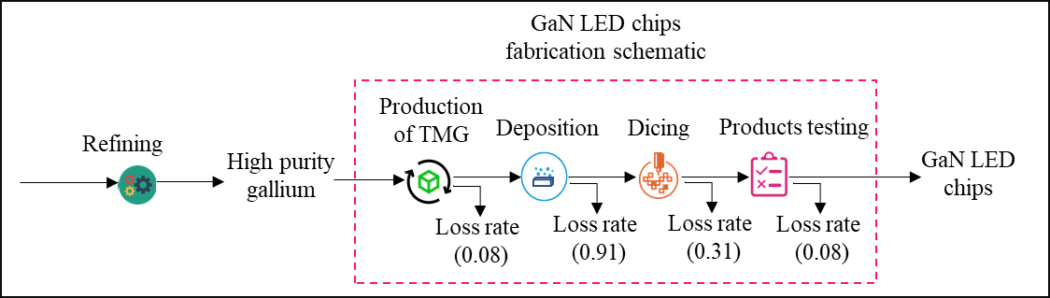
Fig. S1. Framework of GaN LED chips production process
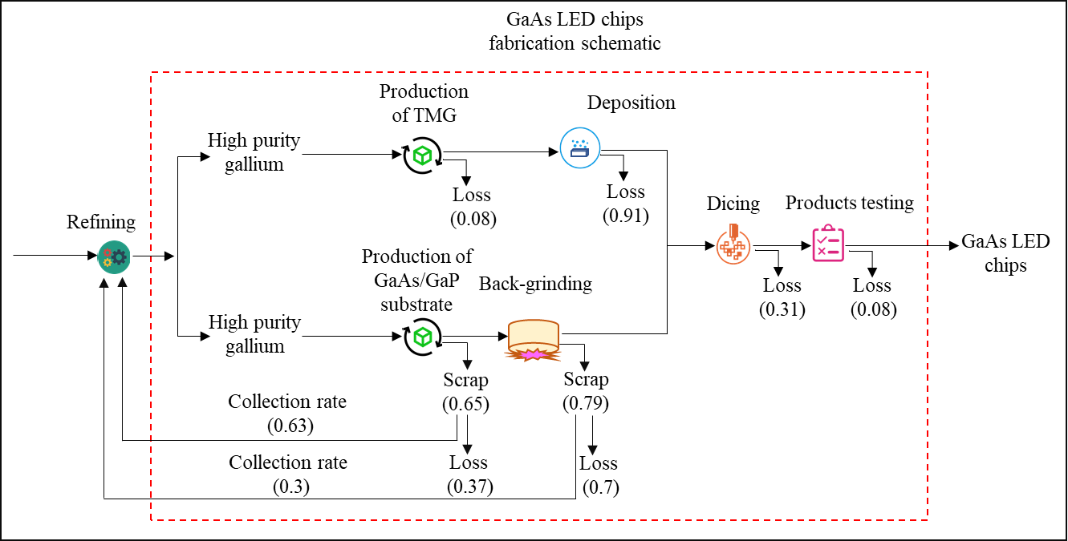
Fig. S2. Framework of GaAs LED chips production process
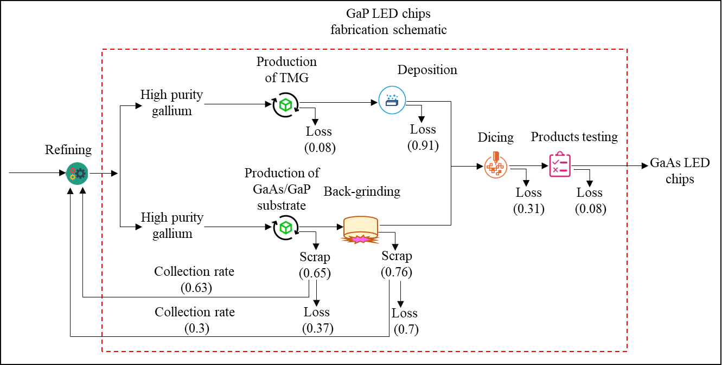
Fig. S3. Framework of GaP LED chips production process

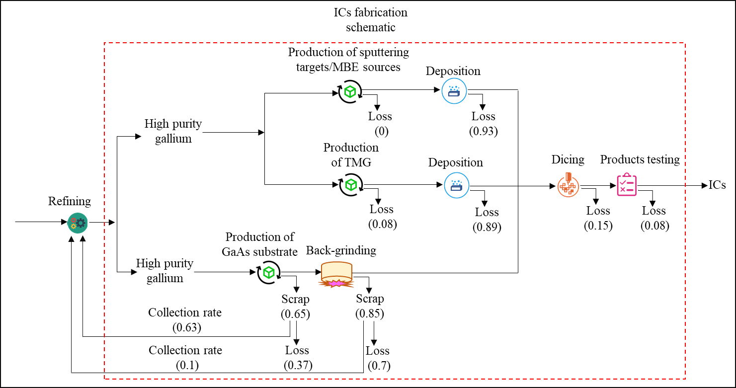
Fig. S4. Framework of ICs production process
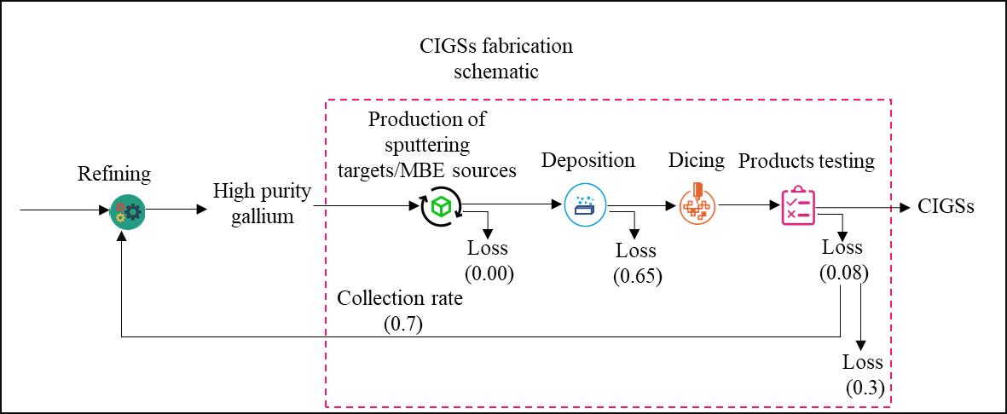
Fig. S5. Framework of CIGSs production process

Table S4. Ga consumption structure of semi-products
 | GaN LEDs | GaAs/GaP LEDs | ICs | CIGSs | NdFeB Magnets | Others
2000 | 7% | 21% | 28% | 2% | 26% | 16%
2001 | 7% | 19% | 31% | 1% | 29% | 13%
2002 | 7% | 19% | 31% | 2% | 30% | 12%
2003 | 7% | 21% | 27% | 2% | 30% | 13%
2004 | 7% | 21% | 25% | 2% | 31% | 15%
2005 | 7% | 20% | 26% | 3% | 30% | 14%
2006 | 6% | 18% | 31% | 2% | 27% | 15%
2007 | 7% | 18% | 32% | 2% | 29% | 12%
2008 | 7% | 21% | 36% | 2% | 22% | 12%
2009 | 8% | 23% | 35% | 2% | 19% | 13%
2010 | 8% | 23% | 35% | 2% | 19% | 13%
2011 | 8% | 23% | 29% | 2% | 22% | 16%
2012 | 8% | 23% | 32% | 2% | 23% | 12%
2013 | 9% | 24% | 33% | 2% | 21% | 11%
2014 | 9% | 24% | 37% | 2% | 20% | 9%
2015 | 8% | 24% | 34% | 2% | 19% | 13%
2016 | 8% | 23% | 35% | 2% | 19% | 12%
2017 | 8% | 23% | 38% | 2% | 19% | 9%
2018 | 8% | 22% | 38% | 2% | 20% | 10%
2019 | 8% | 22% | 40% | 2% | 20% | 8%
2020 | 7% | 21% | 42% | 2% | 19% | 9%
2021 | 7% | 21% | 44% | 2% | 19% | 7%

Table S5. The proportion of GaN LEDs flow to final products
 | LED lingtings | Mobile phones | Computers | Wind turbines | ICEVs | ZEVs | Solar PVs | Large durables
2000 | 22.0% | 8.0% | 20.0% | 0.0% | 2.0% | 0 | 0.0% | 48.0%
2001 | 22.0% | 8.0% | 20.0% | 0.0% | 2.0% | 0 | 0.0% | 48.0%
2002 | 22.0% | 8.0% | 20.0% | 0.0% | 2.0% | 0 | 0.0% | 48.0%
2003 | 22.0% | 8.0% | 20.0% | 0.0% | 2.0% | 0 | 0.0% | 48.0%
2004 | 22.0% | 8.0% | 20.0% | 0.0% | 2.0% | 0 | 0.0% | 48.0%
2005 | 22.0% | 8.0% | 20.0% | 0.0% | 2.0% | 0 | 0.0% | 48.0%
2006 | 22.0% | 8.0% | 20.0% | 0.0% | 2.0% | 0 | 0.0% | 48.0%
2007 | 22.0% | 8.0% | 20.0% | 0.0% | 2.0% | 0 | 0.0% | 48.0%
2008 | 22.0% | 8.0% | 20.0% | 0.0% | 2.0% | 0 | 0.0% | 48.0%
2009 | 22.0% | 8.0% | 20.0% | 0.0% | 2.0% | 0 | 0.0% | 48.0%
2010 | 22.0% | 8.0% | 20.0% | 0.0% | 2.0% | 0 | 0.0% | 48.0%
2011 | 22.0% | 8.0% | 20.0% | 0.0% | 2.0% | 0 | 0.0% | 48.0%
2012 | 30.0% | 9.0% | 19.0% | 0.0% | 2.3% | 0 | 0.0% | 39.6%
2013 | 38.0% | 10.0% | 18.0% | 0.0% | 2.6% | 0 | 0.0% | 31.2%
2014 | 41.0% | 10.5% | 17.0% | 0.0% | 2.9% | 0 | 0.0% | 28.3%
2015 | 44.0% | 11.0% | 16.0% | 0.0% | 2.9% | 0 | 0.0% | 25.4%
2016 | 47.0% | 11.5% | 15.0% | 0.0% | 3.4% | 0 | 0.0% | 22.5%
2017 | 48.0% | 12.0% | 14.0% | 0.0% | 3.4% | 0 | 0.0% | 21.6%
2018 | 49.0% | 12.5% | 13.0% | 0.0% | 3.1% | 0 | 0.0% | 20.7%
2019 | 50.0% | 13.0% | 12.0% | 0.0% | 3.2% | 0 | 0.0% | 19.8%
2020 | 51.0% | 13.5% | 11.0% | 0.0% | 2.6% | 0 | 0.0% | 18.9%
2021 | 52.0% | 14.0% | 10.0% | 0.0% | 2.1% | 0 | 0.0% | 18.0%

Table S6. The proportion of GaAs/GaP LEDs flow to final products
 | LED lingtings | Mobile phones | Computers | Wind turbines | ICEVs | ZEVs | Solar PVs | Large durables
2000 | 17.0% | 3.0% | 5.0% | 0 | 12.0% | 0.0% | 0 | 63.0%
2001 | 17.0% | 3.0% | 5.0% | 0 | 12.0% | 0.0% | 0 | 63.0%
2002 | 17.0% | 3.0% | 5.0% | 0 | 12.0% | 0.0% | 0 | 63.0%
2003 | 17.0% | 3.0% | 5.0% | 0 | 12.0% | 0.0% | 0 | 63.0%
2004 | 17.0% | 3.0% | 5.0% | 0 | 12.0% | 0.0% | 0 | 63.0%
2005 | 17.0% | 3.0% | 5.0% | 0 | 12.0% | 0.0% | 0 | 63.0%
2006 | 17.0% | 3.0% | 5.0% | 0 | 12.0% | 0.0% | 0 | 63.0%
2007 | 17.0% | 3.0% | 5.0% | 0 | 12.0% | 0.0% | 0 | 63.0%
2008 | 17.0% | 3.0% | 5.0% | 0 | 12.0% | 0.0% | 0 | 63.0%
2009 | 17.0% | 3.0% | 5.0% | 0 | 12.0% | 0.0% | 0 | 63.0%
2010 | 17.0% | 3.0% | 5.0% | 0 | 11.9% | 0.1% | 0 | 63.0%
2011 | 17.0% | 3.0% | 5.0% | 0 | 11.8% | 0.2% | 0 | 63.0%
2012 | 20.0% | 4.0% | 5.5% | 0 | 25.2% | 0.8% | 0 | 44.5%
2013 | 24.0% | 5.0% | 6.0% | 0 | 23.6% | 1.4% | 0 | 40.0%
2014 | 28.0% | 6.0% | 6.5% | 0 | 21.7% | 2.3% | 0 | 35.5%
2015 | 32.0% | 7.0% | 7.0% | 0 | 18.6% | 4.4% | 0 | 31.0%
2016 | 36.0% | 8.0% | 7.5% | 0 | 18.7% | 3.3% | 0 | 26.5%
2017 | 40.0% | 9.0% | 8.0% | 0 | 16.2% | 4.8% | 0 | 22.0%
2018 | 44.0% | 10.0% | 8.5% | 0 | 13.0% | 7.0% | 0 | 17.5%
2019 | 48.0% | 11.0% | 9.0% | 0 | 11.7% | 7.3% | 0 | 13.0%
2020 | 52.0% | 12.0% | 9.5% | 0 | 8.3% | 9.7% | 0 | 8.5%
2021 | 55.0% | 13.0% | 10.0% | 0 | 5.9% | 11.1% | 0 | 5.0%

Table S7. The proportion of ICs flow to final products
 | LED lingtings | Mobile phones | Computers | Wind turbines | ICEVs | ZEVs | Solar PVs | Large durables
2000 | 1.0% | 5.0% | 55.0% | 0 | 5.0% | 0.0% | 0 | 34.0%
2001 | 1.0% | 6.0% | 54.0% | 0 | 5.2% | 0.0% | 0 | 33.8%
2002 | 1.0% | 7.0% | 53.0% | 0 | 5.5% | 0.0% | 0 | 33.5%
2003 | 1.0% | 8.0% | 52.0% | 0 | 5.7% | 0.0% | 0 | 33.3%
2004 | 1.0% | 9.0% | 51.0% | 0 | 6.0% | 0.0% | 0 | 33.0%
2005 | 1.0% | 10.0% | 50.0% | 0 | 6.2% | 0.0% | 0 | 32.8%
2006 | 1.0% | 11.0% | 49.8% | 0 | 6.5% | 0.0% | 0 | 31.8%
2007 | 1.0% | 12.0% | 49.5% | 0 | 6.7% | 0.0% | 0 | 30.8%
2008 | 1.0% | 13.0% | 49.3% | 0 | 7.0% | 0.0% | 0 | 29.8%
2009 | 1.0% | 14.0% | 49.0% | 0 | 7.2% | 0.0% | 0 | 28.8%
2010 | 2.0% | 15.0% | 48.5% | 0 | 7.4% | 0.1% | 0 | 27.0%
2011 | 3.0% | 17.0% | 48.0% | 0 | 7.6% | 0.1% | 0 | 24.3%
2012 | 4.0% | 20.0% | 46.5% | 0 | 7.7% | 0.3% | 0 | 21.5%
2013 | 5.0% | 22.0% | 45.0% | 0 | 7.5% | 0.5% | 0 | 20.0%
2014 | 6.0% | 24.0% | 43.5% | 0 | 7.2% | 0.8% | 0 | 18.5%
2015 | 7.0% | 26.0% | 42.0% | 0 | 6.5% | 1.5% | 0 | 17.0%
2016 | 8.0% | 28.0% | 40.5% | 0 | 6.8% | 1.2% | 0 | 15.5%
2017 | 9.0% | 30.0% | 39.0% | 0 | 6.2% | 1.8% | 0 | 14.0%
2018 | 10.0% | 32.0% | 37.5% | 0 | 5.2% | 2.8% | 0 | 12.5%
2019 | 11.0% | 34.0% | 36.0% | 0 | 4.9% | 3.1% | 0 | 11.0%
2020 | 12.0% | 36.0% | 34.5% | 0 | 3.7% | 4.3% | 0 | 9.5%
2021 | 13.0% | 38.0% | 33.0% | 0 | 2.8% | 5.2% | 0 | 8.0%

Table S8. The proportion of CIGSs flow to final products
 | LED lingtings | Mobile phones | Computers | Wind turbines | ICEVs | ZEVs | Solar PVs | Large durables
2000 |  |  |  |  |  |  | 100%
2001 |  |  |  |  |  |  | 100%
2002 |  |  |  |  |  |  | 100%
2003 |  |  |  |  |  |  | 100%
2004 |  |  |  |  |  |  | 100%
2005 |  |  |  |  |  |  | 100%
2006 |  |  |  |  |  |  | 100%
2007 |  |  |  |  |  |  | 100%
2008 |  |  |  |  |  |  | 100%
2009 |  |  |  |  |  |  | 100%
2010 |  |  |  |  |  |  | 100%
2011 |  |  |  |  |  |  | 100%
2012 |  |  |  |  |  |  | 100%
2013 |  |  |  |  |  |  | 100%
2014 |  |  |  |  |  |  | 100%
2015 |  |  |  |  |  |  | 100%
2016 |  |  |  |  |  |  | 100%
2017 |  |  |  |  |  |  | 100%
2018 |  |  |  |  |  |  | 100%
2019 |  |  |  |  |  |  | 100%
2020 |  |  |  |  |  |  | 100%
2021 |  |  |  |  |  |  | 100%

Table S9. The proportion of NdFeB magnets flow to final products
 | LED lingtings | Mobile phones | Computers | Wind turbines | ICEVs | ZEVs | Solar PVs | Large durables
2000 | 0 | 1.2% | 66.6% | 9.5% | 5.1% | 0.0% | 0 | 17.6%
2001 | 0 | 5.1% | 69.0% | 5.9% | 3.9% | 0.0% | 0 | 16.1%
2002 | 0 | 6.7% | 67.7% | 4.5% | 6.0% | 0.0% | 0 | 15.0%
2003 | 0 | 5.4% | 71.0% | 2.6% | 5.3% | 0.0% | 0 | 15.7%
2004 | 0 | 4.6% | 75.1% | 2.2% | 4.7% | 0.0% | 0 | 13.5%
2005 | 0 | 5.2% | 75.0% | 2.4% | 5.6% | 0.0% | 0 | 11.8%
2006 | 0 | 7.5% | 68.4% | 3.4% | 7.1% | 0.0% | 0 | 13.6%
2007 | 0 | 9.4% | 59.2% | 6.5% | 10.2% | 0.0% | 0 | 14.7%
2008 | 0 | 9.0% | 53.9% | 11.6% | 10.8% | 0.0% | 0 | 14.7%
2009 | 0 | 13.5% | 40.8% | 18.3% | 10.1% | 0.0% | 0 | 17.3%
2010 | 0 | 14.0% | 38.7% | 19.1% | 8.0% | 0.1% | 0 | 20.0%
2011 | 0 | 16.0% | 24.7% | 28.8% | 11.8% | 0.2% | 0 | 18.6%
2012 | 0 | 14.0% | 34.8% | 23.8% | 9.9% | 0.3% | 0 | 17.2%
2013 | 0 | 17.9% | 26.0% | 24.7% | 10.8% | 0.7% | 0 | 20.0%
2014 | 0 | 17.8% | 23.3% | 25.8% | 10.7% | 1.2% | 0 | 21.3%
2015 | 0 | 15.4% | 21.2% | 32.0% | 9.3% | 2.2% | 0 | 19.9%
2016 | 0 | 14.6% | 14.6% | 35.2% | 11.9% | 2.1% | 0 | 21.6%
2017 | 0 | 11.3% | 12.7% | 35.4% | 11.8% | 3.5% | 0 | 25.3%
2018 | 0 | 9.3% | 9.1% | 35.0% | 11.4% | 6.1% | 0 | 28.9%
2019 | 0 | 8.8% | 10.1% | 36.5% | 10.2% | 6.4% | 0 | 28.0%
2020 | 0 | 6.3% | 10.8% | 40.4% | 7.0% | 8.1% | 0 | 27.4%
2021 | 0 | 5.7% | 10.3% | 38.7% | 6.6% | 12.2% | 0 | 26.5%

S4 Ga loss during the manufacturing of semi-products
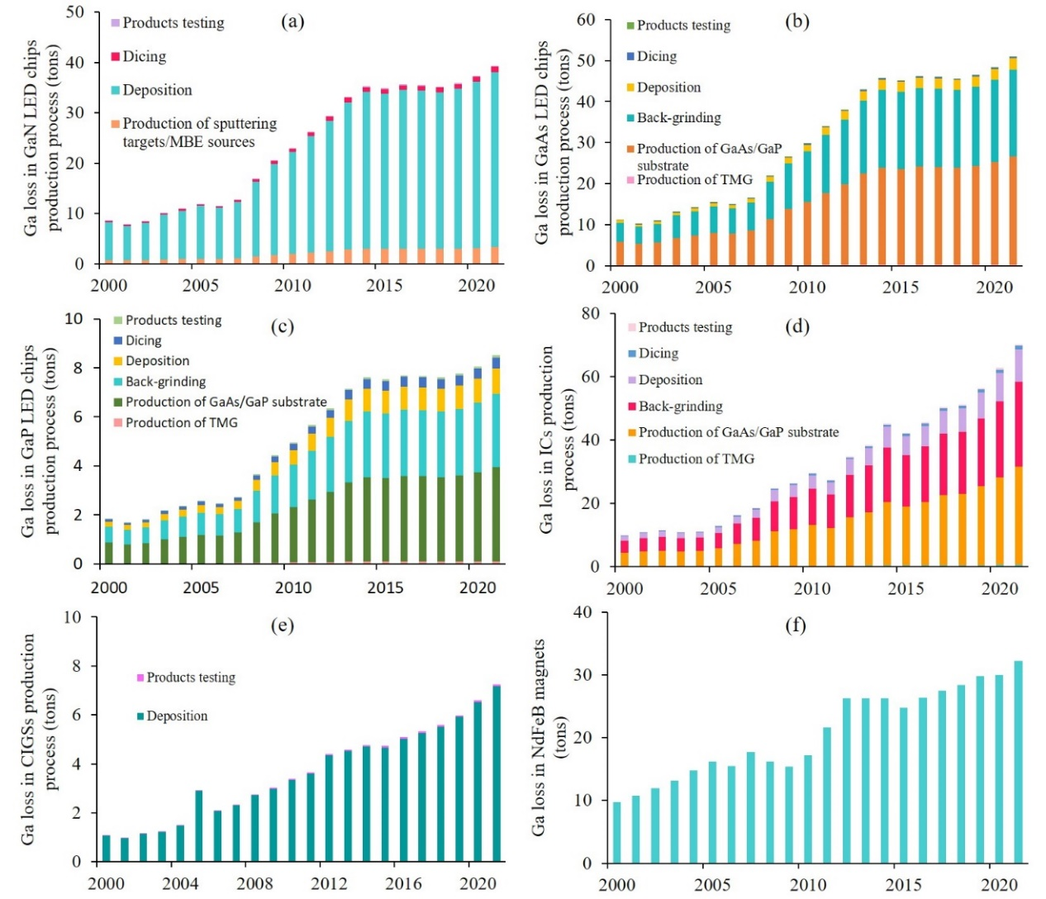
Fig. S6. Historical trends in Ga loss during the manufacturing of semi-products. Ga loss in GaN LED chips (a), Ga loss in GaAs LED chips (b), Ga loss in GaP LED chips (c), Ga loss in ICs (d), Ga loss in CIGSs (e) and Ga loss in NdFeB magnets. TMG = Trimethylgallium, MEB = Molecular beam epitaxy.

S5 Uncertainty analysis results of global Ga flows and stocks
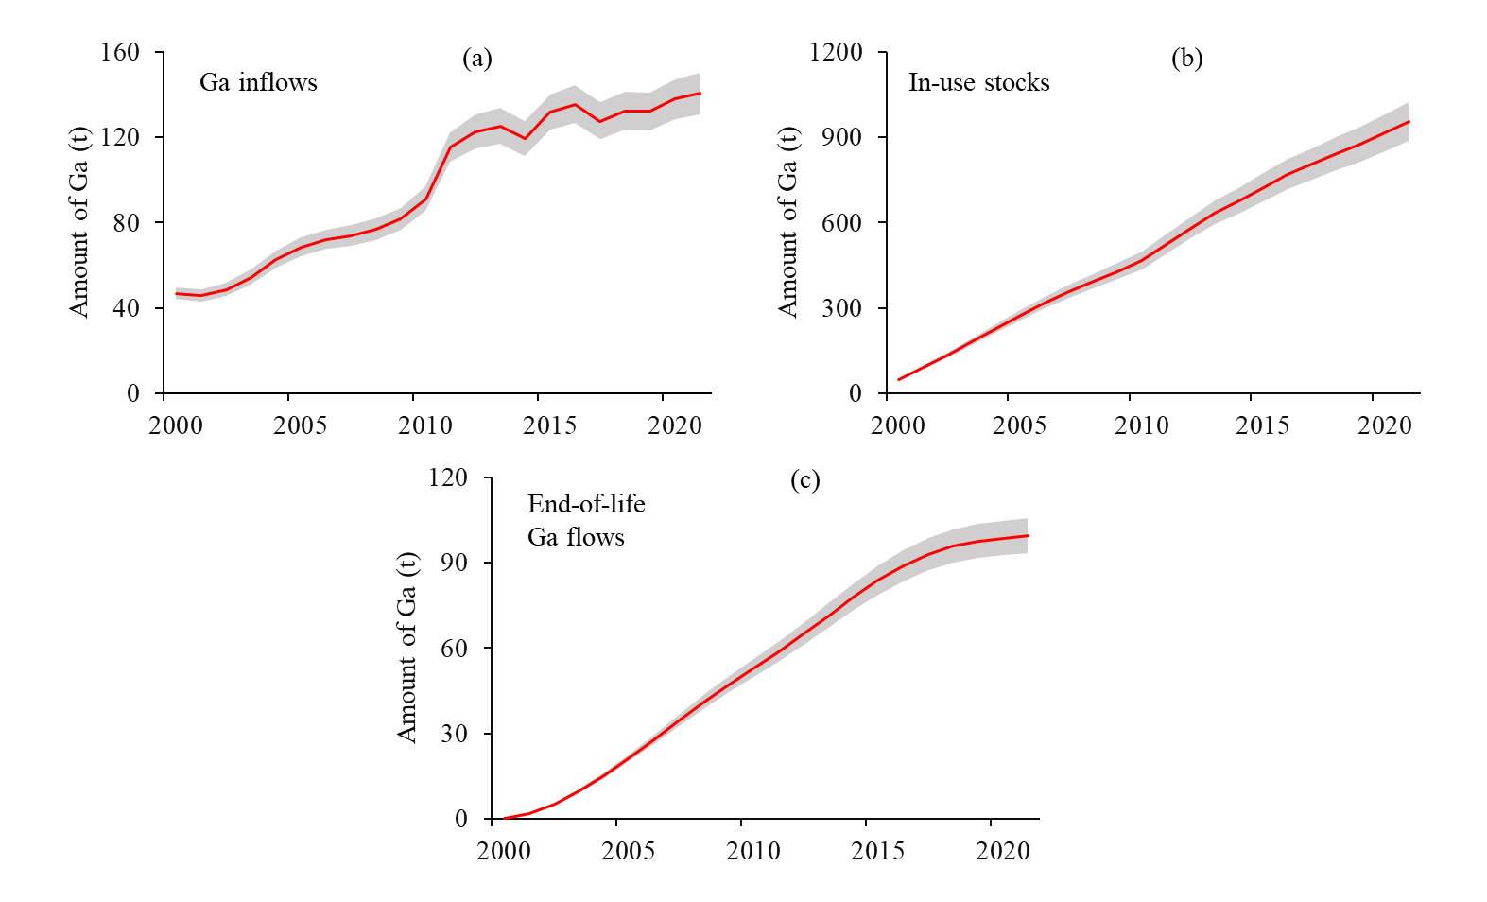
Fig. S7. Uncertainty analysis results of global Ga inflows (a), in-use stocks (b) and end-of life Ga flows (c).

S6 Ga loss information in Semi-product manufacturing stage and strategies for improving he circularity

Table S10. Ga loss information in Semi-product manufacturing stage from 2000 to 2021 and strategies for improving he circularity
Semi-products | Subsegment | Cumulative Ga loss (tons) | Reasons | Improving the circularity of Ga
GaN LEDs production stage | Production of TMG | 43.9 | Lack of effective recycling measures. | Enhancing recovery of a variety of intermediates, e.g., gallium trichloride, magnesium-based gallium iodide, and ether complexes of trimethyl gallium.
 | Deposition | 459.5 | Low deposition efficiency. | Exploring techniques to improve deposition efficiency. In metal organic chemical vapor deposition (MOCVD), improvements in reactor design, precursor materials, and process control should be ongoing to enhance deposition efficiency and yield.
 | Dicing | 14.09 | - | -
 | Products testing | 2.5 | - | -
GaAs/GaP LEDs production stage | Production of TMG | 4.6 | - | -
 | Production of GaAs/GaP substrate | 381.6 | Low deposition efficiency. | Optimizing parameters such as temperature, gas flow, and pressure in the vapor deposition chamber is essential to ensure the uniform growth of gallium arsenide and enhance the yield.
 | Back-grinding | 305.5 | 1. High dicing loss rate before the backgrinding.  2. Low scrap collection rate. | 1. Optimizing the technical process parameters for various grinding processes like rotary grinding, double-sided grinding, and other similar processes can significantly reduce material losses and improve yield in semiconductor manufacturing.  2. Invest in efficient waste collection systems that capture as much of the cut material as possible.
 | Deposition | 48.4 | Low deposition efficiency | The measures to improve the cycle are the same as in the GaN LEDS production stage.
 | Dicing | 38.3 | Low economic efficiency of recycling. | Utilize efficient dissolution and leaching processes to selectively extract Ga from the GaAs/GaP LED scraps.
 | Products testing | 6.8 | -
ICs | Production of TMG | 6.5 | -
 | Production of GaAs/GaP substrate | 311.7 | Low deposition efficiency. | Optimizing parameters such as temperature, gas flow, and pressure in the vapor deposition chamber is essential to ensure the uniform growth of gallium arsenide and enhance the yield.
 | Back-grinding | 269.9 | 1. High dicing loss rate before the backgrinding.  2. Low scrap collection rate. | The measures to improve the cycle are the same as in the GaAs/GaP LEDs production stage.
 | Deposition | 101.5 | Low deposition efficiency. | The measures to improve the cycle are the same as in the GaN LEDS production stage.
 | Dicing | 11.8 | -
 | Products testing | 5.4 | -
CIGSs | Deposition | 79.5 | Low deposition efficiency. | The measures to improve the cycle are the same as in the GaN LEDS production stage.
 | Products testing | 1.0 | - | -
NdFeB magnets | - | 458.5 | Low economic efficiency of recycling. | Utilize efficient dissolution and leaching processes to selectively extract gallium from the NdFeB magnet scraps.

S7 World Alumina Refinery Production and amount of Ga in Bayer liquor
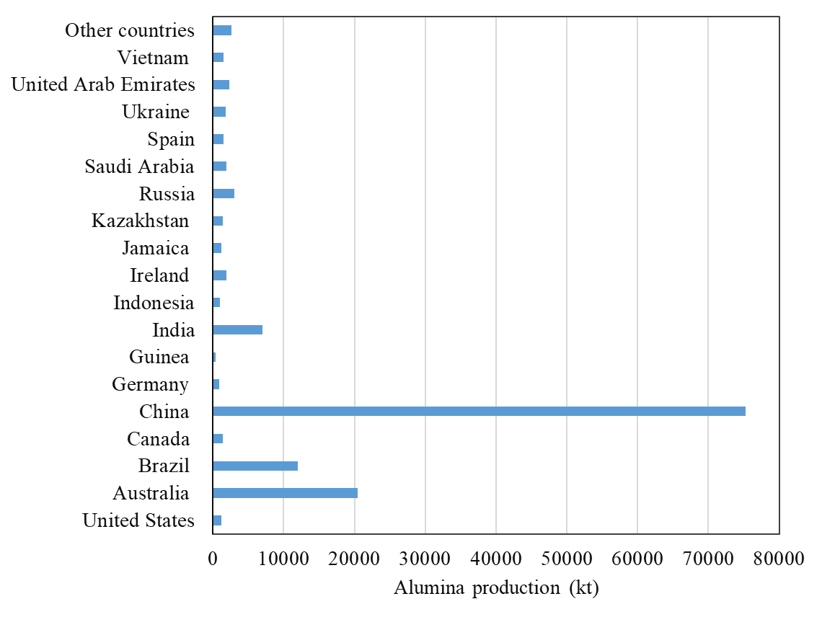
Fig. S8. World Alumina Refinery Production
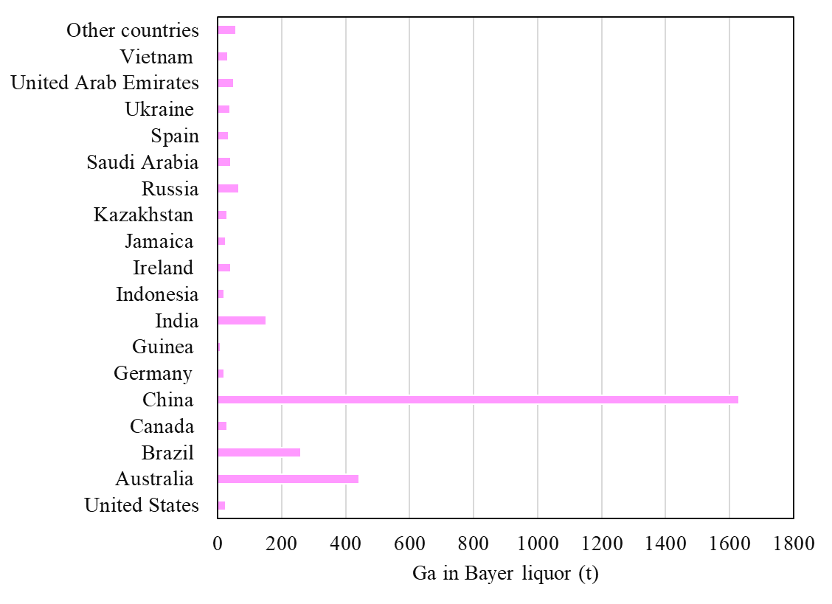
Fig. S9. Amount of Ga in Baier liquid in countries in 2021

S8 The standard techniques for production Ga from Bayer liquid

The standard techniques for production Ga from Bayer liquid include solvent extraction, ion exchange, electrochemistry, and adsorption (Kou et al., 2022; Roosen et al., 2017). The electrochemical method has a simple process and equipment. Still, the highly toxic cathode electrolysis of mercury is seriously harmful to the environment and human health and has been banned by most countries (Chai et al., 2023). The extractant used in solvent extraction method is expensive, and the extractant dissolved in the seed mother liquor also has adverse effects on the electrolysis in the post-sequence process (Lu et al., 2017). The ion exchange process is simple, high recovery, and easy to operate, but it is limited by vanadium and aluminum co-extraction and resin degradation (Lu et al., 2017). Currently, adsorption stands out as the most cost-effective method for Ga extraction, offering a combination of low expenses, high efficiency, operational adaptability, suitability for low concentrations, and environmentally sustainable practices (Chai et al., 2023; Lu et al., 2017; Roosen et al., 2017).

References
Althaf, S., Babbitt, C.W., Chen, R., 2021. The evolution of consumer electronic waste in the United States. Journal of Industrial Ecology 25, 693–706. https://doi.org/10.1111/jiec.13074
Chai, N., Gao, L., Li, S., Cao, Y., Ma, Z., Li, L., Hu, M., 2023. In-suit ion-imprinted bio-sorbent with superior adsorption performance for gallium(III) capture. Journal of Cleaner Production 387, 135861. https://doi.org/10.1016/j.jclepro.2023.135861
Charpentier Poncelet, A., Helbig, C., Loubet, P., Beylot, A., Muller, S., Villeneuve, J., Laratte, B., Thorenz, A., Tuma, A., Sonnemann, G., 2022. Losses and lifetimes of metals in the economy. Nature Sustainability 5, 717–726. https://doi.org/10.1038/s41893-022-00895-8
Frenzel, M., Ketris, M.P., Seifert, T., Gutzmer, J., 2016. On the current and future availability of gallium. Resources Policy 47, 38–50. https://doi.org/10.1016/j.resourpol.2015.11.005
He, P., Wang, C., Zuo, L., 2018. The present and future availability of high-tech minerals in waste mobile phones: Evidence from China. Journal of Cleaner Production 192, 940–949. https://doi.org/10.1016/j.jclepro.2018.04.222
Jansson, N.F., Malmström, L., Zetterqvist, A., Allen, R.L., 2016. A comment on the occurrence of gallium and germanium in the Zinkgruvan Zn-Pb-Ag-(Cu) sulphide deposit, Bergslagen, Sweden. Gff 138, 533–535. https://doi.org/10.1080/11035897.2016.1165284
Kou, Z., Bian, W., Wang, C., 2022. Preparation of novel amidoxime resin and its performance in gallium (III) extraction from Bayer liquor. Chemical Engineering Journal Advances 11, 100317. https://doi.org/10.1016/j.ceja.2022.100317
Li, Q., Dai, T., Gao, T., Zhong, W., Wen, B., Li, T., Zhou, Y., 2021. Aluminum material flow analysis for production, consumption, and trade in China from 2008 to 2017. Journal of Cleaner Production 296, 126444. https://doi.org/10.1016/j.jclepro.2021.126444
Liu, Q., Sun, K., Ouyang, X., Sen, B., Liu, L., Dai, T., Liu, G., 2022. Tracking Three Decades of Global Neodymium Stocks and Flows with a Trade-Linked Multiregional Material Flow Analysis. Environmental Science & Technology. https://doi.org/10.1021/acs.est.2c02247
Løvik, A.N., Restrepo, E., Müller, D.B., 2016. Byproduct Metal Availability Constrained by Dynamics of Carrier Metal Cycle: The Gallium-Aluminum Example. Environmental Science and Technology 50, 8453–8461. https://doi.org/10.1021/acs.est.6b02396
Løvik, A.N., Restrepo, E., Müller, D.B., 2015. The global anthropogenic gallium system: Determinants of demand, supply and efficiency improvements. Environmental Science and Technology 49, 5704–5712. https://doi.org/10.1021/acs.est.5b00320
Lu, F., Xiao, T., Lin, J., Ning, Z., Long, Q., Xiao, L., Huang, F., Wang, W., Xiao, Q., Lan, X., Chen, H., 2017. Resources and extraction of gallium: A review. Hydrometallurgy 174, 105–115. https://doi.org/10.1016/j.hydromet.2017.10.010
Rao, S., Wang, D., Liu, Z., Zhang, K., Cao, H., Tao, J., 2019. Selective extraction of zinc, gallium, and germanium from zinc refinery residue using two stage acid and alkaline leaching. Hydrometallurgy 183, 38–44. https://doi.org/10.1016/j.hydromet.2018.11.007
Roosen, J., Mullens, S., Binnemans, K., 2017. Chemical immobilization of 8-hydroxyquinoline and 8-hydroxyquinaldine on chitosan-silica adsorbent materials for the selective recovery of gallium from Bayer liquor. Hydrometallurgy 171, 275–284. https://doi.org/10.1016/j.hydromet.2017.05.026
Shanghai Metals Market (SMM), 2022. Market analysis of gallium industry chain in China.
Song, H., Wang, C., Sen, B., Liu, G., 2022. China Factor: Exploring the Byproduct and Host Metal Dynamics for Gallium-Aluminum in a Global Green Transition. Environmental Science and Technology 56, 2699–2708. https://doi.org/10.1021/acs.est.1c04784
USGS, n.d. Bauxite and Alumina Statistics and Information [WWW Document]. URL https://www.usgs.gov/centers/national-minerals-information-center/bauxite-and-alumina-statistics-and-information (accessed 7.3.23a).
USGS, n.d. Zinc Statistics and Information [WWW Document]. URL https://www.usgs.gov/centers/national-minerals-information-center/zinc-statistics-and-information (accessed 7.3.23b).
Wang, Q.C., Chen, W.Q., Wang, P., Dai, T., 2022. Illustrating the supply chain of dysprosium in China through material flow analysis. Resources, Conservation and Recycling 184, 106417. https://doi.org/10.1016/j.resconrec.2022.106417
Wu, Y., Yang, L., Tian, X., Li, Y., Zuo, T., 2020. Temporal and spatial analysis for end-of-life power batteries from electric vehicles in China. Resources, Conservation and Recycling 155, 104651. https://doi.org/10.1016/j.resconrec.2019.104651

