Supporting Information for

Tracking the Global Anthropogenic Gallium Cycle during 2000-2020: a Trade-Linked Multiregional Material Flow Analysis

Summary information:
Number of SI pages: 11
Number of SI Figures: 7
Number of SI Tables: 2

System definition
World resources. The global average gallium (Ga) content of bauxite resources is 50 parts per million, with regional averages ranging from 28 ppm (Western Guanxi, China) to 75 ppm (Caribbean) (USGS National Minerals Information Center, 2018). It's estimated that there's over a million tons of Gallium present in the world's bauxite resources, and a significant amount being present in the world's zinc resources. Nonetheless, only a fraction, less than 10% of the Ga found in these resources can be feasibly extracted (USGS National Minerals Information Center, 2023). The global Ga reserves of gallium are about 230,000 t, of which 190,000 t (83%) are in China (Dun et al., 2019).
Mining&Smelting. Ga metal is extracted as a byproduct, mainly from the Bayer process for alumina production and to a much smaller amount from the hydrometallurgical route for zinc refining. Other alternative sources, including fly ash generated from the combustion of coal in power plants, phosphate ores and aluminous clay stone and mudstone are not addressed in this study due to their lack of commercialization currently (Lu et al., 2017). In the Bayer process, gallium accumulates in the alkaline solution (Bayer liquor) used to dissolve bauxite. However, only a small part of the gallium may be extracted since that few aluminum producers have Ga extraction facilities, while the rest ends up in the waste (red mud) or as an impurity flows into aluminum cycle (Licht et al., 2015). About 30%-50% of the Ga in bauxite entering Bayer process will remain undissolved, which is so-called red mud and will be disposed of together with iron oxides, silicates and undissolved aluminum hydroxide (Zhao et al., 2012). About 40% of the Ga dissolved from bauxite enters the Ga extraction process when Ga accumulated in the Bayer liquor reaches a steady level. The most preferentially used method to extract Ga from liquor is iron-exchange process. Due to the fact that there is no records on the exact amount of Ga extracted from lithosphere, the gallium input in the bauxite production is calculated backward by using the primary production of Ga, the average Ga content in bauxites, the yield in Ga recovery from Bayer liquor and the above-mentioned technical parameters (Løvik et al., 2015).
Refining
Refining of crude gallium to a purity of 99.9999% (6N) or higher purities is achieved by a combination of methods, of which fractional crystallization and directional crystallization are most commonly used (Oliveira et al., 2021). Although the overall yields of the refining process various among different method and final purities, the discarded material would be reintroduced at an earlier stage in the process chain. This recovery is here defined as part of the refining process. Thus, the overall yield of refining stage is close to 95-100% (Jia et al., 2022). The surplus between primary Ga production and refined Ga consumption are most likely stockpiled (USGS National Minerals Information Center, 2018).
Fabrication
Refined Ga is further processed in the fabrication stage, in the forms of Ga metal or Ga-containing compounds. The main sources of Ga demand arise from their uses in compound semiconductors, such as gallium arsenide (GaAs), gallium nitride (GaN), gallium phosphide (GaP) and copper indium gallium diselenide (CIGS). These ingredients are either grown as single crystals and cut into wafers or produced directly from precursor gases or other sources during the fabrication process. Integrated circuits (ICs), light emitting diodes (LEDs), neodymium iron boron (NdFeB) permanent magnets and copper indium gallium selenide (CIGS) solar cells are four major Ga-containing products. Other industrial uses include low-melting alloys, catalysts, medical applications, and heat transfer substance in atomic industry (Foley et al., 2017).
The fabrication of semiconductor devices (i.e., wafers) consist of a few microns thick deposition layer on the surface of much thicker substrate. A large amount of industrial scrap is produced during the back-grinding process of substrate, which reduced substrate thickness to allow the operation of semiconductor devices. Other main forms of industrial scrap include bulk crystal pieces, broken wafers, and slurries from cutting, etching and polishing of wafers. Part of industrial scraps may be recycled directly as new scraps in closed loop. Additionally, in the fabrication of NdFeB magnets, Ga is generally added as a minor element to improve the magnetic properties and corrosion resistance (Bai et al., 2007).
Manufacturing/Use
All the Ga semi-products are further processed and assembled into finished products through the manufacturing stage. Then the finished products enter use phase and become the in-use stocks. ICs are mainly used in smartphones, tablets, and other wireless devices. LEDs are mainly used in general lighting, automotive and other display applications. Typical applications of NdFeB magnets are electric robots, computers and audio systems (Yao et al., 2021).
Waste management
Given that it is challenging for separating and recovering Ga from end-of-life products that contain multiple metals and materials (such as electric vehicles and computers), Ga is often treated as impurity in recycled old scraps. Wastes containing gallium will be handled through typical waste management methods such as landfilling and incineration. With limited information available on recycling gallium-containing products, these end-of-life materials are considered non-recoverable and will ultimately end up in the environment.

Table A1. Average lifespans of Ga-containing products (Werner et al., 2018; Zhang et al., 2015; Sekine et al., 2017).
Application | LEDs | ICs | NdFeB permanent magnets | Photovoltaics | Others
Lifespan (in years) | 6 | 5 | 11 | 28 | 7

Table A2. Variation coefficients of different parameters used for Monte Carlo simulation.
Parameter | Symbol |  | Coefficient of variation | Reference
Primary Ga production | $$Y$$ | 5% |  | (USGS National Minerals Information Center, 2001-2023)
Share of Ga production from aluminum route | $$a$$ | 5% |  | (USGS National Minerals Information Center, 2001-2023)
Ga concentration in bauxite/zinc ores | / | 10% |  | (Løvik et al., 2015; Lu et al., 2017)
Yield in gallium recovery from Bayer liquor | $$y_{1}$$ | 10% |  | (Løvik et al., 2015; Jia et al., 2022)
Loss rate of zinc route | $$y_{2}$$ | 10% |  | (Løvik et al., 2015; Licht et al., 2015)
Fraction of Ga in bauxite going to red mud | k | 10% |  | (Løvik et al., 2015; Jia et al., 2022; Licht et al., 2015)
Fraction of dissolved Ga going to alumina | $$l$$ | 10% |  | (Løvik et al., 2015; Jia et al., 2022; Licht et al., 2015)
Material yield rates in fabrication stage | $$R_{m,j}$$ | 10% |  | (Løvik et al., 2015; Jia et al., 2022; Licht et al., 2015; Meylan et al., 2017)
Collection rates of new scraps from fabrication | $$w_{3-m,j}$$ | 10% |  | (Løvik et al., 2015; Jia et al., 2022)
Market shares of different Ga-containing applications | $$P_{m,j}$$ | 20% |  | (Licht et al., 2015; CBC Metal, 2022; Eheliyagoda et al., 2019)

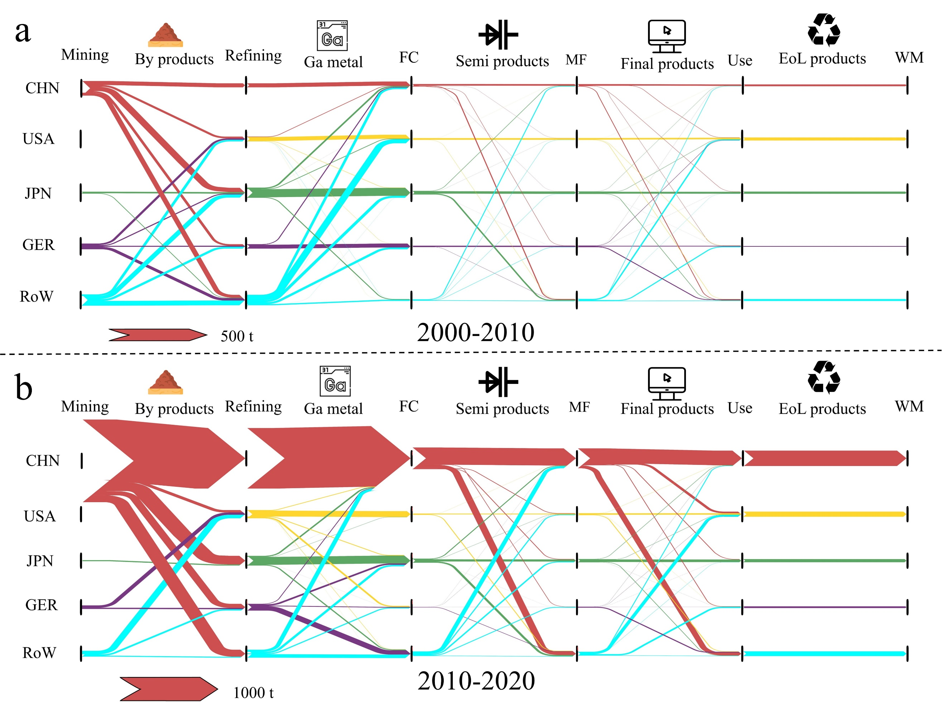
Figure A1. The accumulated trade-linked global Ga flows for (a) 2000-2010 and (b) 2010-2020. FC: fabrication, MF: manufacturing, WM: waste management, CHN: China, USA: the Unites States, JPN: Japan, GER: Germany, RoW: rest of the world.

Figure A2. Dynamics of accumulation of Ga in-use stocks during 2000-2020: (a) world, (b) China, (c) USA, (d) Japan, (e) Germany, and (f) RoW.
Figure A3. Dynamics of End-of-Life flows during 2000-2020: (a) World, (b) China, (c) USA, (d) Japan, (e) Germany, and (f) RoW.

Figure A4. Total exported Ga in each Ga-containing product of four major countries (China, USA, Japan and Germany) in 2010, 2015 and 2020.


Figure A5. Ga content in bauxite (a) and zinc ores (b) imports for China, USA, Japan and Germany between 2000-2020.
Note:
1. The Ga content in the trade of bauxite and zinc ores was approximated by multiplying the average global gallium concentration in bauxite (57 ppm)(Løvik et al., 2015) and zinc ore (50 ppm)(Lu et al., 2017) by the quantities of trade ores.
2. Error bars represent the upper and lower limits, accounting for the uncertainty in Ga content within the host ores of bauxite (a) and zinc ores (b).

Figure A6. Gallium supply surplus of each country/region during 2000-2020.

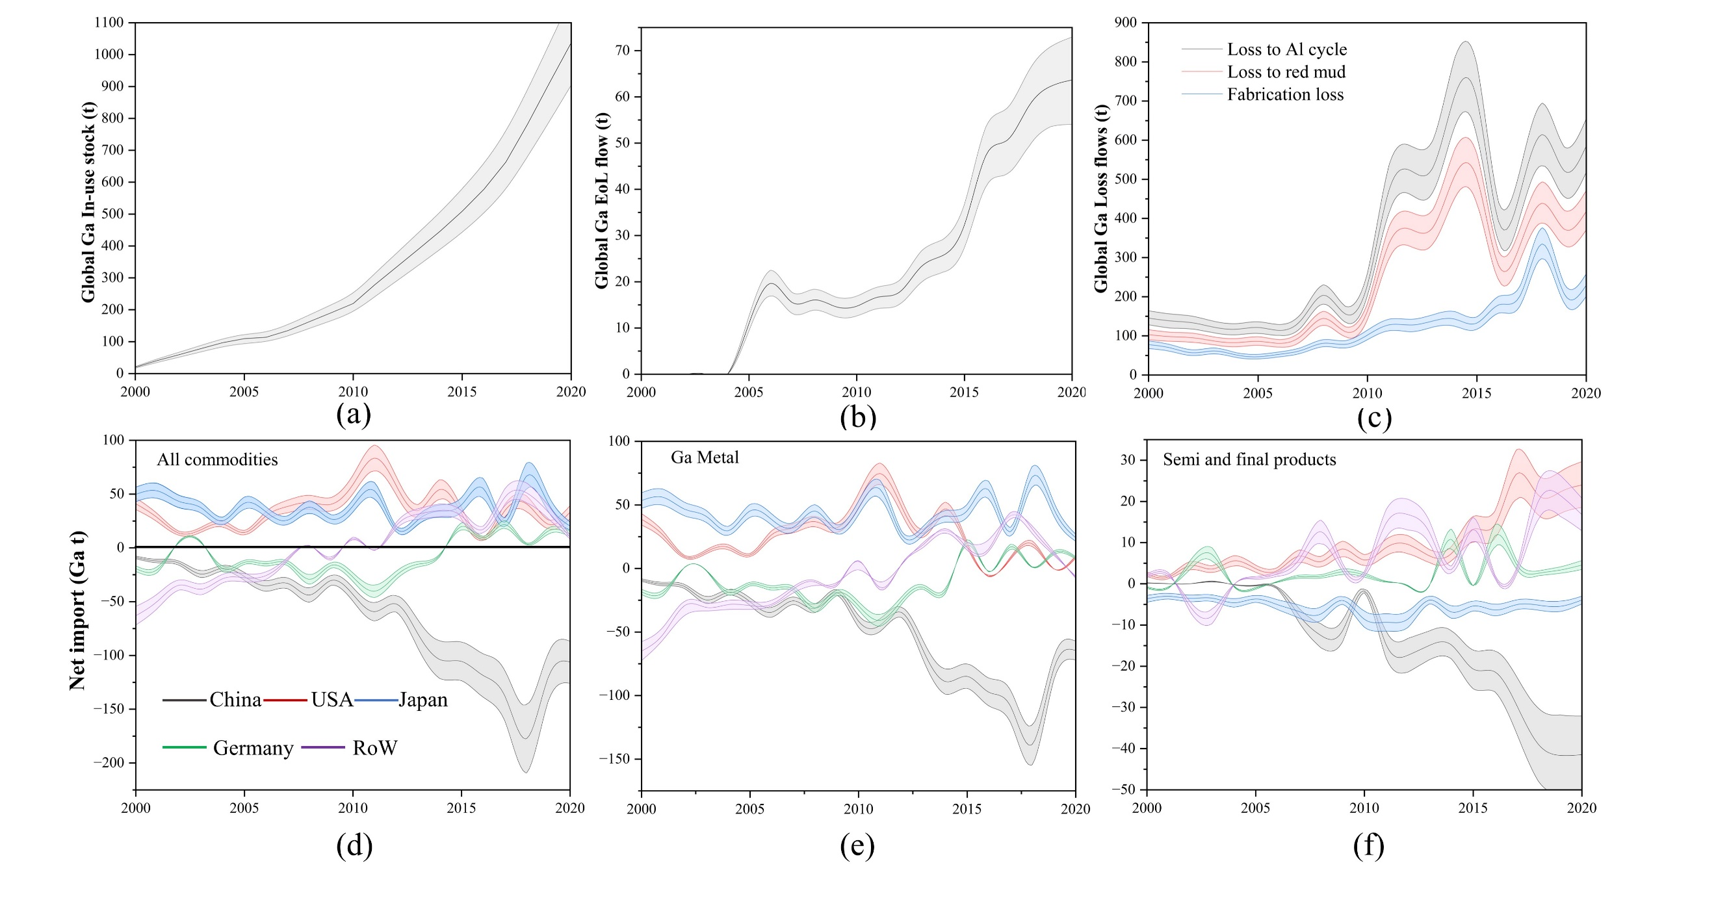
Figure A7. Uncertainty analysis results for (a) global in-use stock, (b) global EoL flow, (c) global loss flows of smelting and fabrication stage, net imports of Ga in all (d) Ga-containing commodities, (e) Ga metals, and (f) semi-products and final products.

References
Bai, G., Gao, R.W., Sun, Y., Han, G.B., Wang, B., 2007. Study of high-coercivity sintered NdFeB magnets. Journal of Magnetism and Magnetic Materials 308 (1), 20–23. DOI: 10.1016/j.oneear.2021.02.014.
CBC Metal, 2022. Gallium Consumption Statistics 2000-2020. https://en.cbcie.com/ (accessed on April 13, 2023).
China Nonferrous Metals Association Gallium, Selenium & Tellurium Branch (CNMA). http://chinagasete.org/ (accessed on April 13, 2023).
Dun, Y., Jin, H., Luo, C., Luan, W., Song, Z., 2019. Current Situation and Utilization Trend of the Global Gallium Resources (in Chinese). Conservation and Utilization of Mineral Resources 5 (39), 9–15.
Eheliyagoda, D., Zeng, X., Wang, Z., Albalghiti, E., Li, J., 2019. Forecasting the temporal stock generation and recycling potential of metals towards a sustainable future: The case of gallium in China. The Science of the Total Environment 689, 332–340. DOI: 10.1016/j.scitotenv.2019.06.413.
Foley, N.K., Jaskula, B.W., Kimball, B.E., Schulte, R.F., Schulz, K.J., DeYoung, J.H., Seal, R.R., Bradley, D.C., 2017. Chapter H of critical mineral resources of the United States—economic and environmental geology and prospects for future supply. https://doi.org/10.3133/pp1802H (accessed on April 13, 2023).
Jia, H., Zhou, Y., WANG, A., Wang, G., Li, T., Wang, C., Xing, W., Ma, Z., Li, P., 2022. Evolution of the Anthropogenic Gallium Cycle in China From 2005 to 2020. Frontiers in Energy Research 10. DOI: 10.3389/fenrg.2022.944617.
Licht, C., Peiró, L.T., Villalba, G., 2015. Global Substance Flow Analysis of Gallium, Germanium, and Indium: Quantification of Extraction, Uses, and Dissipative Losses within their Anthropogenic Cycles. Journal of Industrial Ecology 19 (5), 890–903. DOI: 10.1111/jiec.12287.
Liu, Q., Sun, K., Ouyang, X., Sen, B., Liu, L., Dai, T., Liu, G., 2022. Tracking Three Decades of Global Neodymium Stocks and Flows with a Trade-Linked Multiregional Material Flow Analysis. Environmental Science & Technology 56 (16), 11807–11817. DOI: 10.1021/acs.est.2c02247.
Løvik, A.N., Restrepo, E., Müller, D.B., 2015. The global anthropogenic gallium system: determinants of demand, supply and efficiency improvements. Environmental Science & Technology 49 (9), 5704–5712. DOI: 10.1021/acs.est.5b00320.
Lu, F., Xiao, T., Lin, J., Ning, Z., Long, Q., Xiao, L., Huang, F., Wang, W., Xiao, Q., Lan, X., Chen, H., 2017. Resources and extraction of gallium: A review. Hydrometallurgy 174, 105–115. DOI: https://doi.org/10.1016/j.hydromet.2017.10.010
Meylan, G., Reck, B.K., Rechberger, H., Graedel, T.E., Schwab, O., 2017. Assessing the Reliability of Material Flow Analysis Results: The Cases of Rhenium, Gallium, and Germanium in the United States Economy. Environmental Science & Technology 51 (20), 11839–11847. DOI: 10.1021/acs.est.7b03086.
Oliveira, R.P. de, Benvenuti, J., Espinosa, D., 2021. A review of the current progress in recycling technologies for gallium and rare earth elements from light-emitting diodes. Renewable and Sustainable Energy Reviews 145, 111090. DOI: 10.1016/j.rser.2021.111090.
Sekine, N., Daigo, I., Goto, Y., 2017. Dynamic Substance Flow Analysis of Neodymium and Dysprosium Associated with Neodymium Magnets in Japan. Journal of Industrial Ecology 21 (2), 356–367. DOI: 10.1111/jiec.12458.
USGS National Minerals Information Center, 2018. 2016 Minerals Yearbook-Gallium. https://d9-wret.s3.us-west-2.amazonaws.com/assets/palladium/production/s3fs-public/atoms/files/myb1-2016-galli.pdf (accessed on April 13, 2023).
USGS National Minerals Information Center, 2001-2023. Gallium statistics and information 2000-2020. https://www.usgs.gov/centers/national-minerals-information-center/gallium-statistics-and-information (accessed on April 13, 2023).
USGS National Minerals Information Center, 2023. Mineral Commodity Summaries-Gallium. https://pubs.usgs.gov/periodicals/mcs2023/mcs2023-gallium.pdf (accessed on April 13, 2023).
Werner, T.T., Ciacci, L., Mudd, G.M., Reck, B.K., Northey, S.A., 2018. Looking Down Under for a Circular Economy of Indium. Environmental Science & Technology 52 (4), 2055–2062. DOI: 10.1021/acs.est.7b05022
Yao, T., Geng, Y., Sarkis, J., Xiao, S., Gao, Z., 2021. Dynamic neodymium stocks and flows analysis in China. Resources, Conservation and Recycling 174, 105752. DOI: https://doi.org/10.1016/j.resconrec.2021.105752
Zhang, J., Chen, W., Chen, X., Ying, K., Cheng, G., Qiu Yingji, Jin, B., 2015. Life prediction of LED lamps based on BRM under three-parameter weibull distribution. Chinese Journal of Liquid Crystals and Displays (30), 525–530. DOI: 10.3788/YJYXS20153003.0525
Zhao, Z., Yang, Y., Xiao, Y., Fan, Y., 2012. Recovery of gallium from Bayer liquor: A review. Hydrometallurgy 125-126, 115–124. DOI: 10.1016/j.hydromet.2012.06.002.

