1. **Implement an inventory selection system.**

Use this wireframe as a reference for creating the system.

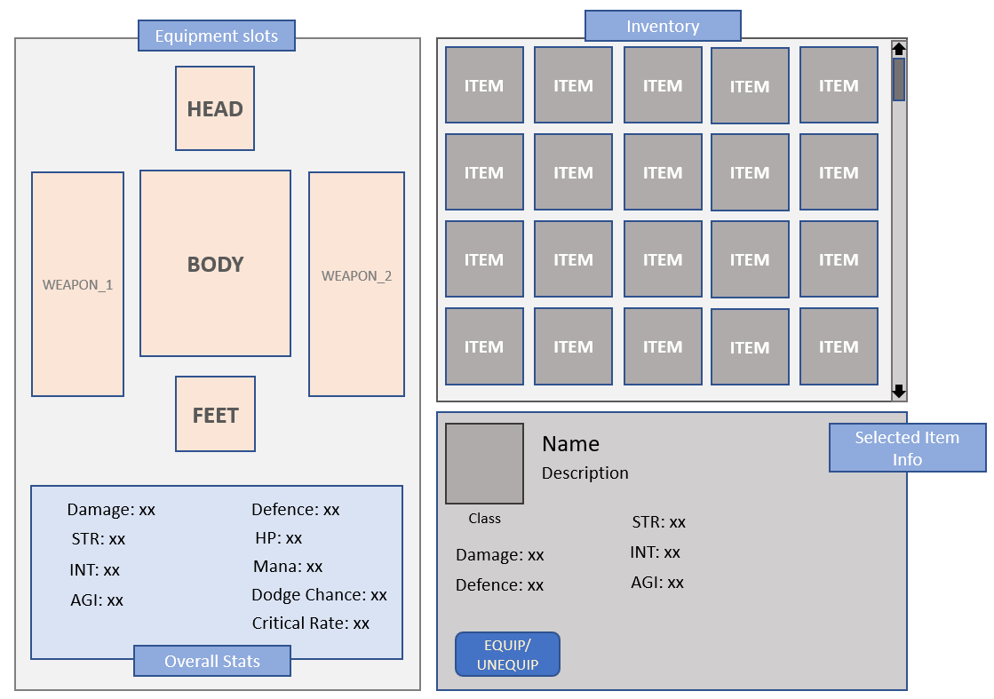

The inventory system should have the following features:

* Import item data from the scriptable object provided with this test.
* Items in the inventory can be dragged and dropped onto its respective equipment slot. (Weapon item can be used in any of the weapon slots)
* The overall stats panel should show the cumulative values of all currently equipped items.
  + 1 STR = 12 HP
  + 1 INT = 14 MANA
  + 1 AGI = 0.2% Dodge, 0.15% Crit chance
* On selecting an item from the inventory, all of its attributes should be displayed in the ‘selected item info’ panel.
  + When an item is selected, the expected attribute change should be shown in the overall stats panel by mentioning the value change next to the attribute. For example,
    - Current damage is 10 and a weapon with damage 25 is selected, the damage attribute should be shown as 10 **+ 15.** (Where 10 is the damage of the equipped weapon and +15 is the damage increase if the selected item is equipped)
  + Items can also be equipped or unequipped by pressing the equip/unequip button in the selected item info panel.
* Each item should belong to an item class. An item can be of the following class:
  + Common
  + Uncommon
  + Rare
  + Legendary
  + Mythical.

Each class should have a distinct color associated with it.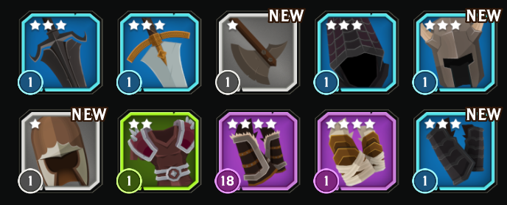

* Implement a save system. When the application is restarted, all equipped items in the previous session should be retained.

**BONUS POINTS**

* Use OOPS wherever applicable.
* Implement sorting of items in the inventory. By default, items are sorted by type and class (Mythical first) Add an option in the inventory panel to sort items by:
  + Type
  + Class
  + Alphabetical
* Implement bonus perks for mythical items. Each mythical item can have one perk which grants a % bonus to one of the following attributes
  + Damage
  + Defense
  + STR
  + INT
  + AGI

On equipping the item, the overall value of the attribute should increase by the mentioned percentage amount. The bonus perk has to be mentioned in the item info panel (BONUS: X% ATTR_NAME)

1. **Create a multiplayer Asteroids game**.
   * Use Unity Networking(UNet)
   * Game should be server authoritative i.e. only input should be sent from the clients.
   * Game should be playable via LAN
   * You can find a reference Asteroids game here: <http://www.freeasteroids.org/>
   * Design and implement 3 power-up which can be picked up by players.
   * Design and implement 3 types of enemies.

**BONUS POINTS**

* + Add a lobby system
  + Automatic server discovery. (Players can see a list of available games which they can join.)

Your assessment for both tasks will be done based on your technical implementation, code quality and scalability.

Art and graphics are not in the evaluation criterion.