Hi, Welcome to the Userplane Ad Network!

Userplane is pleased to offer full advertising support for all of its applications and partner websites. This guide will help you install your Userplane Ad Code.

Getting Started!
First you need your Zone ID. If you don’t have one – just email support@userplane.com to request one with subject “Ad Zone ID”.

How do I get paid?
Userplane has an extensive team of ad sales people with the sole duty of filling ad inventory placed on Webchat, Webmessenger, and web pages of general online communities. You can send us as much inventory as you wish, from the US and abroad.

Userplane will provide a login to the Userplane ad server that will display your hourly ad stats. At the end of each month Userplane will notify you of your Monthly CPM and the payment amount of all ads served for your account. Within 30-60 days after each monthly period you will receive your payment check!

Where do I check my stats?
Just login to:
http://admin.subtracts.userplane.com/admin/

With your login/password information.

Will competitors be advertised on my site?
Probably not. We categorize every site and all ad inventory, then make sure that sites do not show ads from their respective category. Thus, if you are an online dating site, you would not see ads that are categorized as “online dating”. If they slip through, simply email us a screen shot of the ad and we will remove it!

Ad Placement
Userplane supports ad placement in the following locations on your website:

- Full Banner and Text Ad Display within Webmessenger
- Leaderboard Banner, Text Ads, In-Line Text Ads and Video Ad Display within Webchat
- Full and Leaderboard Banner, Text advertising on any web page within your website

Here are some sample screen shots:

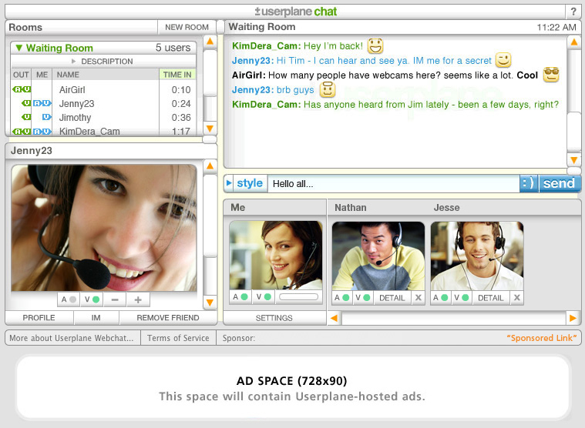

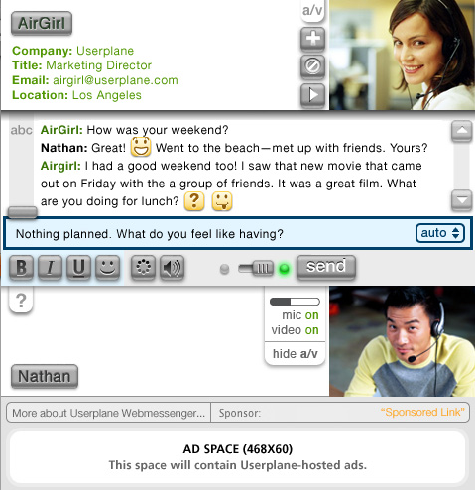

Webmessenger:

The Webmessenger width (in page or in a popup) must have a minimum width of 468 pixels. Simply place your Webmessenger into the following frame set, with the top frame being your Webmessenger page. Replace the BANNER ZONE ID and TEXT ZONE ID text blocks with the Zone ID's sent to you, it should look like: zoneID=xxx&textZoneID=xxx when you are complete.

<frameset rows="*,108" framespacing="0" frameborder="no" border="0">
<frame src="Webmessenger Frame" name="Webmessenger_Frame" scrolling="NO" noresize>
<frame src="http://subtracts.userplane.com/mmm/bannerstorage/ch_int_frameset.html?app=wm&zoneID=BANNER ZONE ID&textZoneID=TEXT ZONE ID" name="Ad_Frame" scrolling="NO" noresize> </frameset>

Webchat:
The Webchat width (in page or in a popup) must have a minimum width of 728 pixels. Simply place your Webchat into the following frame set, with the top frame being your Webchat page. Replace the BANNER ZONE ID and TEXT ZONE ID text blocks with the Zone ID's sent to you, it should look like: zoneID=xxx&textZoneID=xxx when you are complete.

<frameset rows="*,145" framespacing="0" frameborder="no" border="0">
<frame src="Webchat Frame" name="Webchat_Frame" scrolling="NO" noresize>
<frame src="http://subtracts.userplane.com/mmm/bannerstorage/ch_int_frameset.html?app=wc&zoneID=BANNER ZONE ID&textZoneID=TEXT ZONE ID" name="Ad_Frame" scrolling="NO" noresize> </frameset>

General Site Placement

Leaderboard (728x90)

<iframe src='http://subtracts.userplane.com/mmm/adframe.php?zoneid=BANNER ZONE ID' framespacing='0' frameborder='no' scrolling='no' width='728' height='90'></iframe>

Full Banner (468x90)

<iframe src='http://subtracts.userplane.com/mmm/adframe.php?zoneid=BANNER ZONE ID' framespacing='0' frameborder='no' scrolling='no' width='468' height='60'></iframe>

*if you can not use iframe code, please contact us to get a different form of banner invocation

Thank you for using the Userplane Ad Network! We are happy to help you grow your site and be your network of choice!

Userplane : )

