Maple sirup
The characteristics of maple sirup are discussed here so that the development of color and flavor will be better understood.

Composition of sap and sirup
Table 8 gives the composition of maple sap and sirup. The analyses in this and later tables are not average values; they are analyses of typical saps and sirups. Usually the sirup and sap have essentially the same composition, except that on an “as is” basis the constituents of the sirup show a thirtyfold to fiftyfold increase as a result of concentrating the sap to sirup. The amounts of some of the constituents, when expressed on a dry-weight basis, are less in sirup than in sap because of their removal from solution as insoluble sugar sand.
The different kinds of sugar in maple sap are not numerous (91). Sucrose, the same sugar as in cane sugar, comprises 96 percent of the dry matter of the sap and 99.95 percent of the total sugar (table 9). The other 0.05 percent is composed of raffinose together with three unidentified oligosaccharides. Unfermented sap does not contain any simple or hexose sugars.
The sap contains a relatively large number of nonvolatile organic acids (table 10), even though they account for only a small proportion of the solids (89). The concentration of malic acid is 10 times that of other organic acids. It
TABLE 8.—Composition of maple sap and sirup¹
Item | Sap | Sap (dry weight) | Sirup (dry weight)
 | Percent | Percent | Percent
Sugars | 2.000 | 97.0 | 98.0
Organic acids | .030 | 1.5 | .3
Ash | .014 | .7 | .8
Protein | .008 | .4 | .4
Unaccounted for | .009 | .4 | .5
TABLE 9.—Sugars in maple sap and sirup¹
Sugars | Sap | Sap (dry weight) | Sirup (dry weight)
 | Percent | Percent | Percent
Hexoses | 0 | 0 | 0–12
Sucrose | 1.44 | 96.00 | 88–99
Raffinose and a glycosyl sucrose | .00021 | .014
Oligosaccharides:²
I | .00018 | .013
II | .00020 | .014
III | .00042 | .028
may prove to be useful in detecting adulteration (151). One or more of these acids may be important in forming “maple flavor.” Sap contains soluble ligninlike substances that are involved in the formation of maple flavor (117).
The ash or mineral matter (table 11) accounts for only 0.66 percent of the whole sirup, or 1 percent of the dry solids. Although the minerals are only a minor part of the sirup, they have been useful in establishing the purity of maple sirup and they contribute an astringency to the sirup that many find desirable.
Calcium, a part of the ash, is responsible for the sugar-sand scale, calcium malate, which forms on the pans (18). The low sodium and high potassium content of the ash suggests the use of maple in dietary foods.
Composition of sugar sand ranges as follows (18):
 |  | Range
Sugar sand in run | percent | 0.05– 1.42
pH |  | 6.30– 7.20
Ca | percent | 0.61–10.91
K | do | 0.146–0.380
Mg | do | 0.011–0.190
Mn | do | 0.06– 0.29
P | do | 0.03– 1.18
Fe | p.p.m. | 38–1,250
Cu | p.p.m. | 7– 143
B | p.p.m. | 3.4– 23
Mo | p.p.m. | 0.17– 2.46
Free acid | percent | 0.07– 0.37
Total malic acid | do | 0.76–38.87
Acids other than malic | do | 0.08– 2.62
Undetermined material | do | 6.94–34.16
Calcium malate | do | 1.30–49.41
Sugars in dried samples | do | 33.90–85.74
Sugar sand in dried samples | do | 14.26–66.09
TABLE 10.—Nonvolatile organic acids in maple sap and sirup¹
Acid | Sap | Sap (dry weight) | Sirup (dry weight)
 | Percent | Percent | Percent
Malic | 0.021 | 1.40 | 0.141
Citric | .002 | .13 | .015
Succinic | .0003 | .02 | .012
Fumaric | .0003 | .02 | .006
Glycolic or dihydroxybutyric | .000 | .00 | .006
Unidentified acids:
I, II, III, IV | Trace | Trace | Trace
V, VI, VII | 0 | 0 | Trace
TABLE 11.—Mineral composition of maple sirup¹
Item | Sirup | Dry weight
 | Percent | Percent
Soluble ash | 0.38 | 0.58
Insoluble ash | .28 | .42
Total ash | .66 | 1.00
Potassium | .26 | .40
Calcium | .07 | .11
Silicon oxide | .02 | .03
Manganese | .005 | .008
Sodium | .003 | .005
Magnesium | Trace | Trace

The nitrogenous matter constitutes only a small part of the total solids (88).⁴ Expressed as nitrogen, the sap contains only 0.0013 percent and the sirup 0.06 percent. The sap does not contain any free amino acids except late in the sap-flow season. Nitrogen occurs only in the form of peptides. Whether the nitrogenous matter enters into the formation of maple color or flavor is an open question. An increase in free amino acids is associated with the development of “buddy sap.”

Color and flavor
Maple sap as it comes from the tree is a sterile, crystal-clear liquid with a sweet taste. None of the brown color or flavor that we associate with maple sirup is in the sap. This is easily demonstrated by collecting sap aseptically, freezing it, and then freeze-drying it. The solid obtained is white or very light yellow and has only a sweet taste. The typical color and flavor of maple sirup are the result of chemical reactions, involving certain substances in the sap, brought about by heat as the sap boils (148). Since at least one of the products of the reaction is the brown color, it is known as a browning reaction. Neither the exact nature of this reaction nor the identity of the reacting substances is known. Indications are that one or more of the 6 sugars or their degradation products and one or more of the 12 organic acids in maple sap are involved in the browning reaction.
Experimental evidence indicates that the color and flavor of maple sirup are related to triose sugar (52–54, 118–120, 122, 155). These sugars are not constituents of sap when it comes from the tree but are formed as a result of the two reactions shown in chart 14. Evidence also indicates that the phenolic lignin like substances of maple sap are intermediate in the flavor reactions and may account for the specificity of maple flavor (117).
The amount of invert hexose sugars is directly proportional to the amount of fermentation that has occurred. The first reaction is the bacterial or enzymatic hydrolysis of the sucrose to form invert sugar, a mixture of fructose and
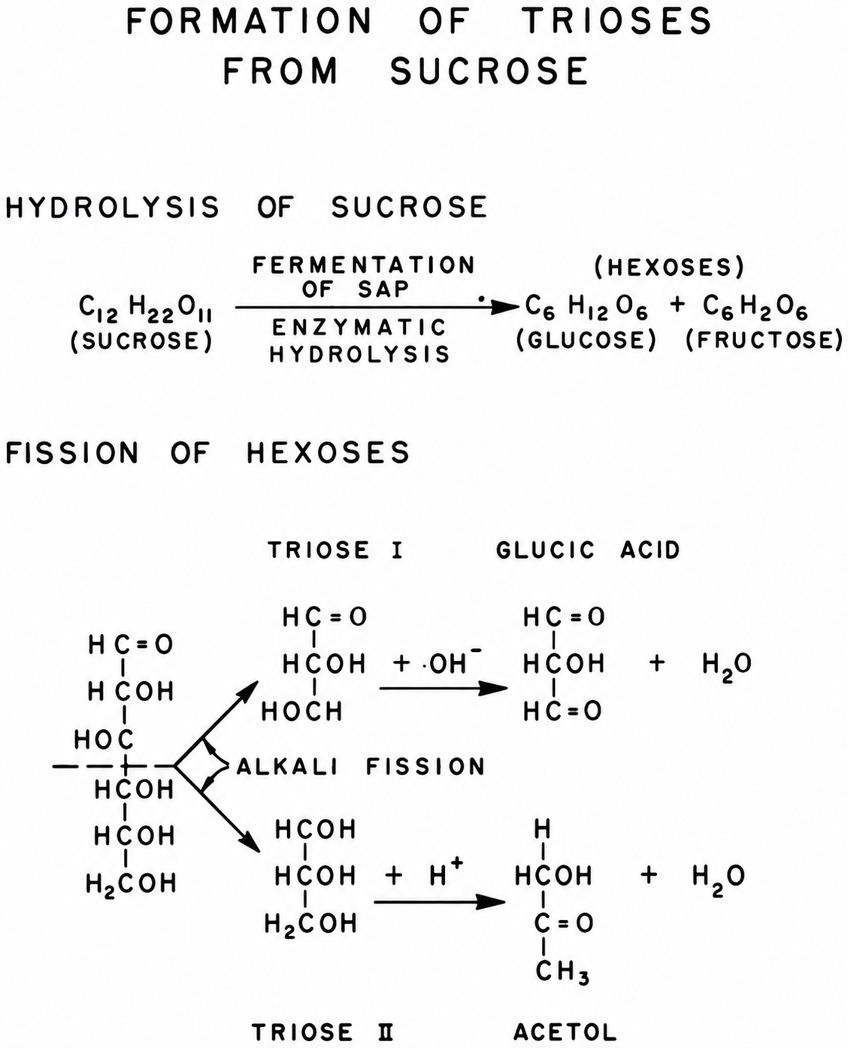
Chart 14.—Chemical reactions showing the formation of trioses from the sucrose of sap. In the first reaction, 1 molecule of sucrose is hydrolyzed by enzymes to yield 2 molecules of hexose sugars. In the second reaction, these hexoses are broken by alkaline fission into trioses.
dextrose (chart 14). The second reaction is the alkaline degradation of the fructose and dextrose to trioses (98). The second reaction occurs while the sap is boiling in the sap pan, where the alkalinity of the sap reaches a pH of 8 to 9. These trioses are highly active chemically. They can combine with themselves to form color compounds, and they can react with other substances in the sap (such as organic acids) to form the maple flavor substances (79).
Experiments have established that up to a point the amount of color formed is proportional to the amount of flavor formed. This makes it possible to evaluate flavor in terms of color, a measurable quantity. When the point is reached at which the background flavor “caramel” begins to be noticeable, this relation no longer holds.
The identity of the compounds responsible for the flavor of maple has proved to be elusive. Certainly, all the components of maple sirup
contribute to its flavor—the sugar, the organic acid salts, and even the oil, butter, or whatever was used as an antifoam agent during evaporation. An unknown number of trace materials in the sirup or sugar give it “maple flavor.” These compounds have defied identification for many years because they exist in very small amounts (a few parts per million), and their chemical character in many cases is so similar to carbohydrates that separation from the sugars of the sirup has been extremely difficult (123). Now with the modern techniques of gas chromatography and mass spectrometry, progress is being made in solving the mystery of “maple flavor.” The flavor compounds identified can be divided into two groups according to their probable source. One group, possibly formed from ligneous material in the sap, contains such compounds as vanillin, syringealdehyde, dihydroconiferyl alcohol, acetovanillone, ethylvanillin, and guaiacyl acetone. A second group, most likely formed by caramelization of the carbohydrates in the sap, includes acetol, methylcyclopentenolone (cyclotene), furfural, hydroxymethylfurfural, isomaltol, and alpha-furonone (25, 116). It has been impossible to make a synthetic maple flavor by combining these compounds. Perhaps one or more key compounds have not yet been identified. Even if all these compounds were available, a proper balance of the many parts of a mixture to give the desired combination flavor would be difficult to achieve since they have not been accurately measured.
Factors that control color and flavor are: (1) Amount of fermentation products in the sap (75); (2) pH of the boiling sap; (3) concentration of the solids (sugars); (4) time of heating (time necessary to evaporate sap to sirup); and (5) temperature of the boiling sap (1a, 150). The two most important factors are the time of heating and the amount of fermentation products in the sap (150). The temperature of the sap under atmospheric pressure (open pan) boiling is fixed, and nothing can be done about it. Neither can anything be done about changes in pH of the boiling sap. At the beginning of evaporation, the natural acidity of fresh sap is lost and the sap becomes alkaline. It is during this alkaline phase of the pH cycle that hexose sugars, if any are present, undergo alkaline degradations. The sap then remains alkaline until sufficient organic acids are formed by the decomposition of the sap sugars to make the sap acid again.
The longer the boiling time, the darker the sirup; and, conversely, the shorter the boiling time, the lighter the sirup. During evaporation, the effect of the boiling-point factor increases as the solids concentration of the sap increases. The relation between the amount of hexose sugars (invert sugar) produced during the fermentation of the sap and the length of time the sap is boiled is of the greatest importance. Thus, the color and flavor of sirup made in exactly the same boiling time from a series of saps of equal solids concentration (Brix value) but with increasing amounts of invert sugar will be progressively darker and stronger. The stronger maple flavor, however, is usually masked by the acrid caramel flavor. Although flavor and color are formed because of exothermic chemical reactions, the amount of flavor that can be produced is limited by the concentration of the sap-soluble lignaceouslike materials that are probable flavor precursors. Indications are that there are sufficient of these flavor precursors in sap to permit forming a product that is from 15 to 30 times richer in maple flavor than is commercial “pure maple sirup” (154). These precursors can be utilized to increase the flavor by subjecting the sirup to higher temperatures. This method is used in preparing high-flavored maple products, described later.

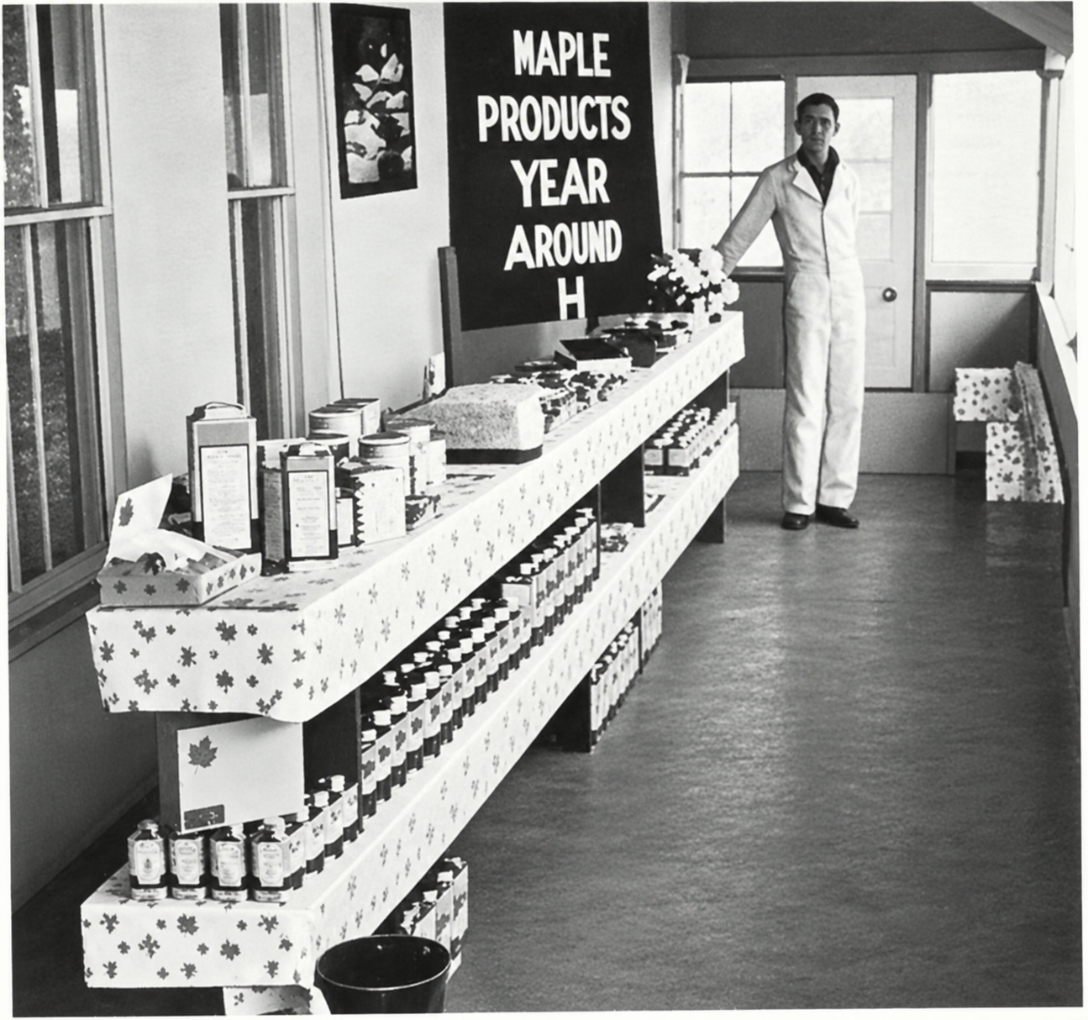
PN–4831
Figure 135.—A central evaporator plant must have a salesroom for displaying and selling the products manufactured.

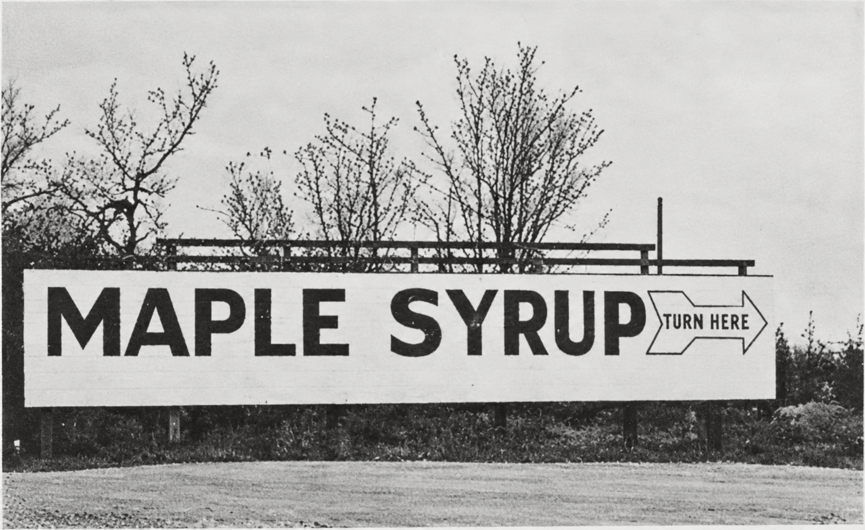
PN–4832
Figure 136.—A large, easily read sign advertising the central evaporator plant is essential for directing the public to the plant for the purchase of maple products.

¹ Typical values, not averages. Maple sap and sirup vary in composition between rather wide limits.
¹ Typical values, not averages.
² The oligosaccharides have been isolated by chromatography but have not been identified.
¹ Typical values, not averages.
¹ Typical values, not averages.
⁴ Also unpublished data of Eastern Regional Research Center.

