Basic firewall management skills and understanding of network traffic filtering.

1.Open firewall configuration tool (Windows Firewall or terminal for UFW) :
Opening Windows Defender Firewall using command line:
Wf.msc

2.List current firewall rules :
Get-NetFirewallRule

3.Add a rule to block inbound traffic on a specific port (e.g., 23 for Telnet) :
New-NetFirewallRule -DisplayName "Block Telnet Port 23" -Direction Inbound -LocalPort 23 -Protocol TCP -Action Block
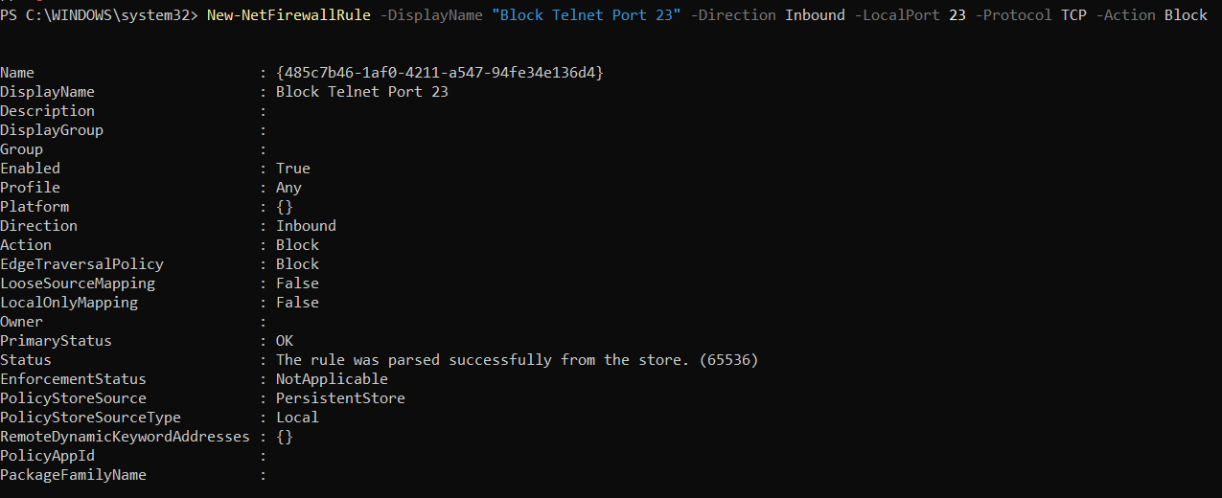

To Verify:
Get-NetFirewallRule -DisplayName "Block Telnet Port 23"

4.Test the rule by attempting to connect to that port locally or remotely:
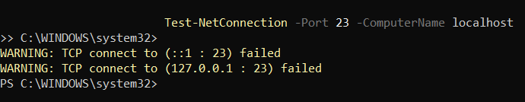

5.Add rule to allow SSH (port 22) if on Linux.
Cannot do this since I am using Windows.

6.Remove the test block rule to restore original state:
Remove-NetFirewallRule -DisplayName "Block Telnet Port 23"
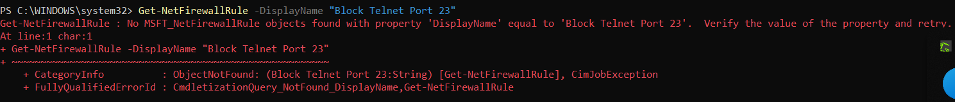

7.Document commands or GUI steps used.
Documentation done.

8.Summarize how firewall filters traffic:
A firewall filters network traffic by inspecting packets and deciding whether to allow, block, or log them based on a set of predefined rules. It essentially acts as a security checkpoint between networks (e.g., your computer and the internet).

1. Rule-Based Filtering
Firewalls use rules that specify conditions such as:
- Source IP address
- Destination IP address
- Port number (e.g., 80, 443, 23)
- Protocol (TCP, UDP, ICMP)
- Direction (Inbound or Outbound)
Traffic that matches a rule triggers the specified action.

2. Inbound vs. Outbound Filtering
- Inbound rules control what traffic is allowed to enter the system/network.
- Outbound rules control what traffic is allowed to leave.

3. Default Policies
Every firewall has default policies:
- ACCEPT – allow all traffic unless blocked
- DROP/DENY – block all traffic unless allowed
Traffic not matching any rule follows the default action.

4. Stateful Inspection
Modern firewalls track active connections. This means:
- If you initiate a connection, return traffic for that connection is automatically allowed.
- Only new, unexpected connections are evaluated against the rules.

5. Packet Inspection
Firewalls inspect each packet’s header to decide if it is safe, including:
- Source/destination IP
- Ports
- Flags (e.g., SYN, ACK)
- Protocol type
Depending on type (packet-filter, stateful, next-gen), they may also inspect payloads.

6. Enforcement
When a rule matches:
- ALLOW: traffic passes through
- BLOCK/DROP: traffic is silently discarded or rejected
- LOG: record the attempt in the firewall logs

