Scan Results:

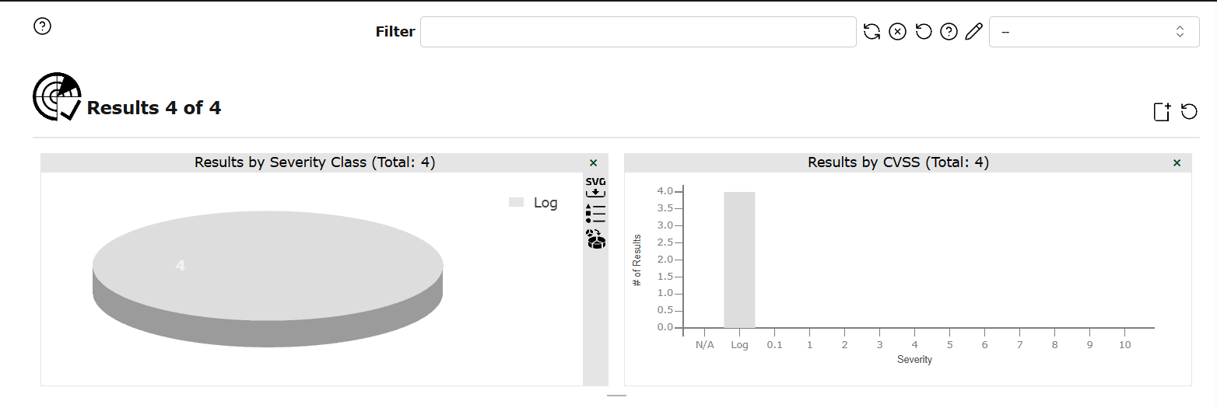
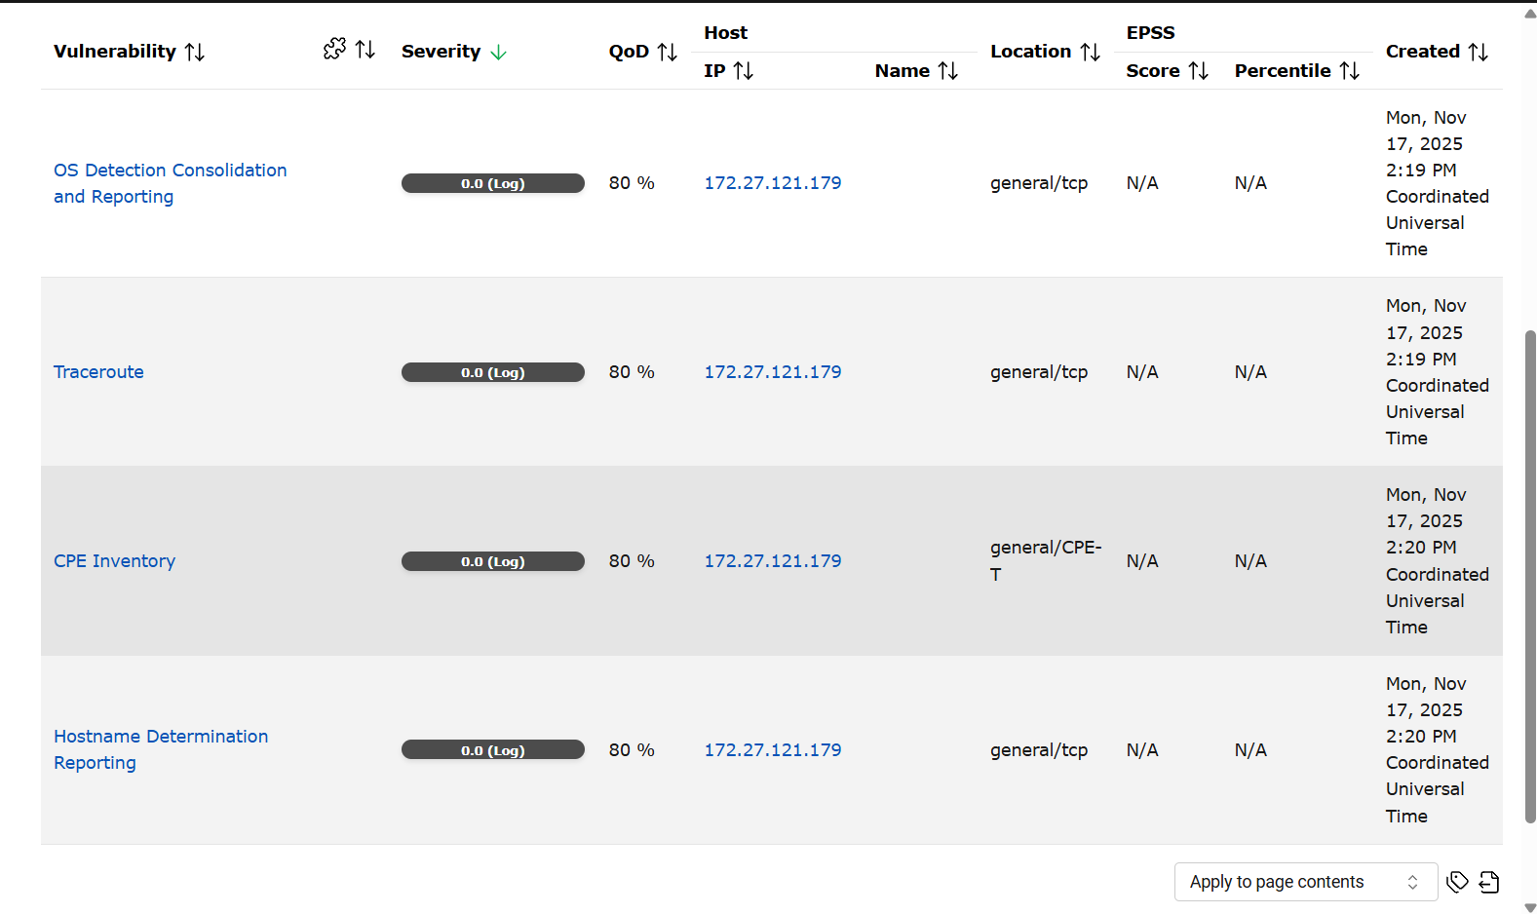

OS Detection Consolidation and Reporting:
Severity: Low (Informational)
Description
The scanner was able to identify the target operating system as Linux Kernel using ICMP-based OS fingerprinting. This happens when the system responds with certain ICMP characteristics that help determine OS type.
Impact
Attackers can use OS fingerprinting to tailor their exploits to Linux-based systems.
While not a direct vulnerability, this information disclosure can improve attacker accuracy during reconnaissance.
Mitigation
To reduce OS fingerprinting accuracy:
- Enable ICMP hardening:
sudo sysctl -w net.ipv4.icmp_echo_ignore_broadcasts=1
sudo sysctl -w net.ipv4.icmp_ignore_bogus_error_responses=1
- Use firewall rules to restrict inbound ICMP:
sudo ufw limit icmp
- Harden TCP/IP stack to reduce fingerprint data:
sudo sysctl -w net.ipv4.tcp_syncookies=1
Conclusion
Not critical. Informational only. Optional hardening can be applied.
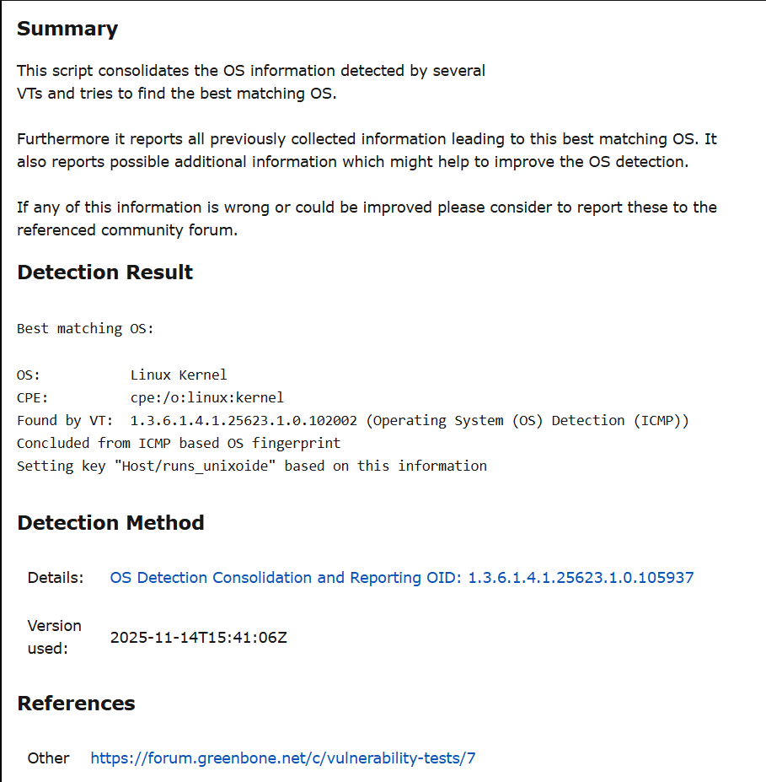
Figure 1 OS Detection Consolidation and Reporting Scan Result
Traceroute:
Severity: Low (Informational)
Description
The scanner successfully determined the route between itself and the target. The network distance was 1 hop, meaning the scan occurred locally.
Impact
Revealing network path information can help attackers:
- Map network topology
- Determine network segmentation
- Identify pivot opportunities
This is low risk since the target is a local machine.
Mitigation
You may limit this information using firewall rules:
- Deny or rate-limit UDP/ICMP traceroute probes:
- sudo iptables -A INPUT -p udp --dport 33434:33534 -j DROP
- sudo iptables -A INPUT -p icmp --icmp-type time-exceeded -j DROP
Conclusion
Not a vulnerability. Safe to ignore for an internal machine.
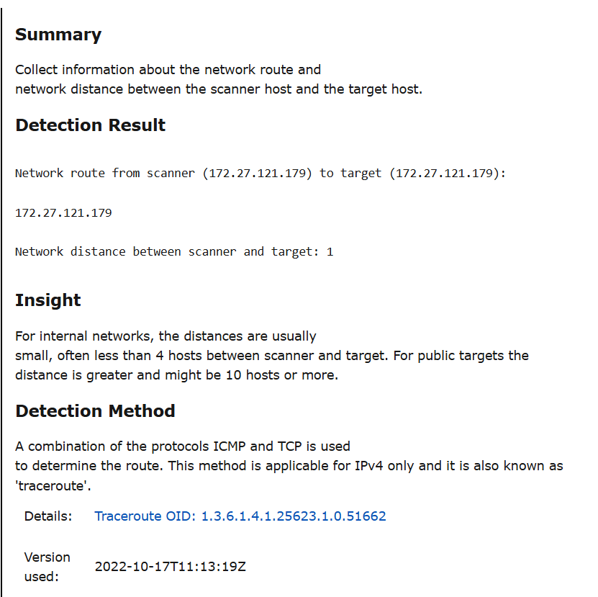
Figure 2 Traceroute Scan Result
CPE Inventory:
Severity: Low (Informational)
Description
The scanner detected a CPE identifier:
cpe:/o:linux:kernel
A CPE (Common Platform Enumeration) string reveals the OS or application version/type.
Impact
CPE disclosure improves attacker OS profiling and helps them match known CVEs to your system.
Mitigation
- Keep system packages updated to reduce the risk of vulnerable software being tied to the CPE.
- Restrict network exposure to minimize external reconnaissance.
Conclusion
Harmless on local scans. No action required unless exposed publicly.
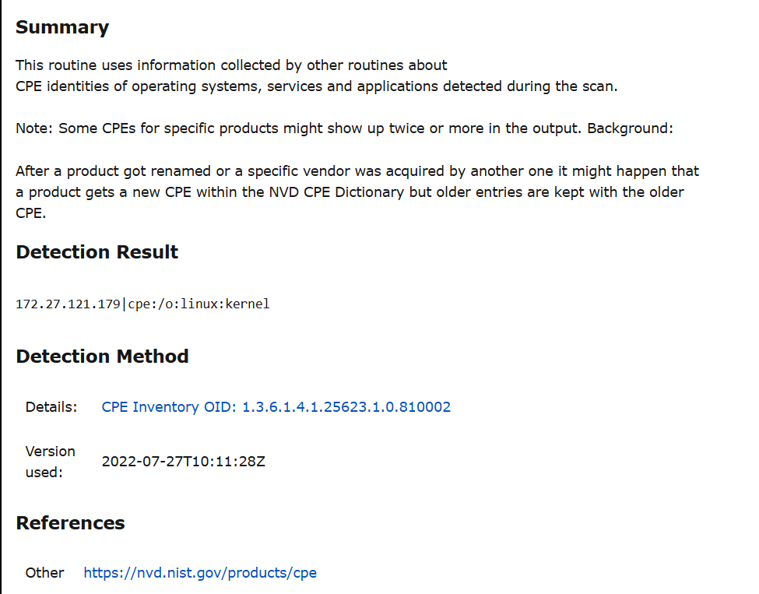
Figure 3 CPE Inventory Scan Results
Hostname Determination Reporting:
Severity: Low (Informational)
Description
The scanner resolved the hostname of the target directly from the IP address. No DNS or service leakage occurred.
Impact
Hostname disclosure is minimal risk but can assist attackers in organizing targets.
Mitigation
- No mitigation required.
- Optional: disable unnecessary hostname banners in services (SSH, mail servers, etc.)
Conclusion
Safe to ignore.
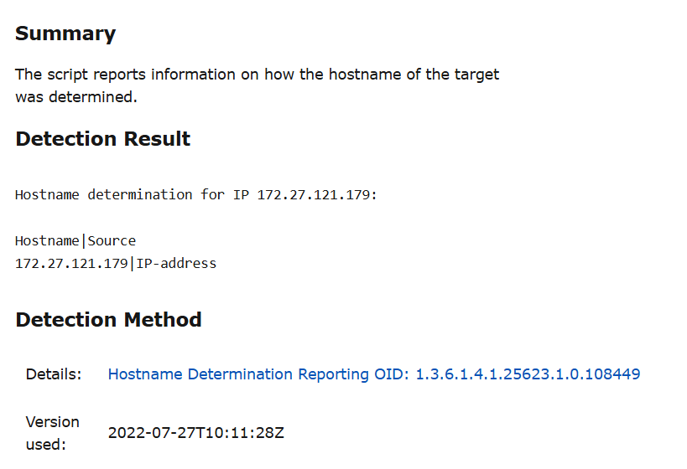
Figure 4 Hostname Determination Reporting Scan Result

