Software Design Document

# Project: Online voting system for club/school

Name: Rudhramani k

Reg no: 727723EUCS195

### Introduction:

The project is about to create an online voting system for clubs/school.

#### Purpose:

online voting, voting management, result management and candidate posts or updates.

creation of the portal is used to create an online way of voting that creates an advantage of that there is no need of irl voting.

#### Scope:

* There is more advantage than to create a irl voting where the people needs to in-person to vote.
* To lower the gathering for the voting through the online voting.

### System Overview:

#### Roles:

1. **Admin**
   * Has full control over election management
   * Starts and ends elections
   * Removes unqualified candidates
   * Sets voting duration and publishes results
2. **User**
   * Represents students, teachers, or staff
   * Has two roles: **Voter** or **Candidate**
     + **Voter**: Can vote and view results
     + **Candidate**: Can submit nominations and view election details

#### Tech Stack:

**Frontend**: User interface for admin and users (HTML, CSS, JS, React or Angular)

**Backend**: Business logic, user roles, voting rules (Node.js, Java Spring Boot, etc.)

**Database**: Stores users, elections, votes, roles (MySQL, PostgreSQL, Firebase, etc.)

**Authentication**: Secure login system (JWT, OAuth, or basic sessions)

### System Architecture:

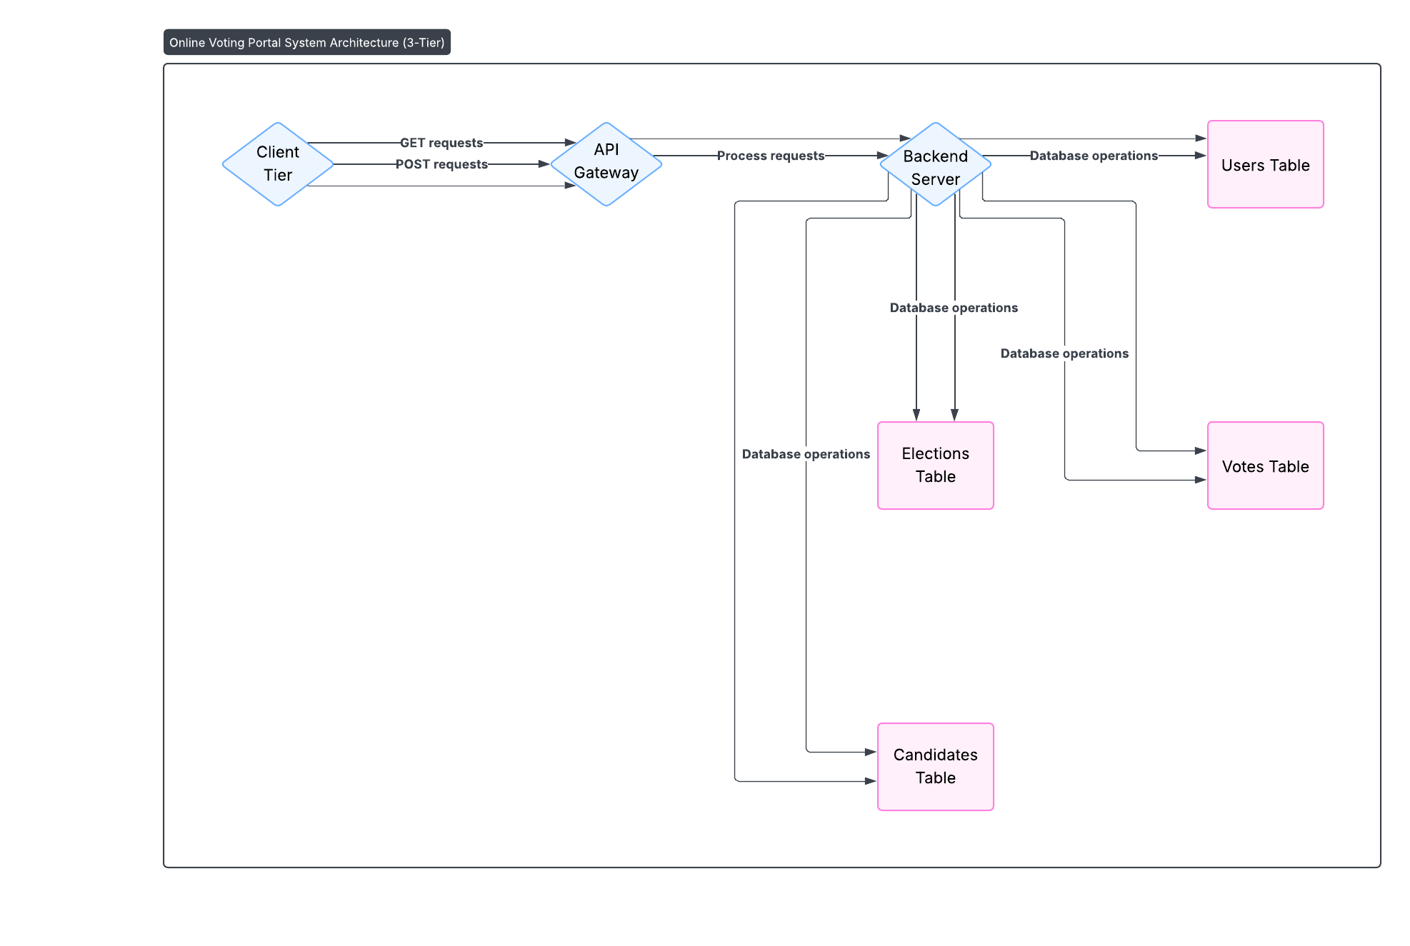

### Modules & Components:

The Main modules are:

* Admin:
* Can create election
* Can remove candidate
* Can view result
* User:
* There are two roles (Voter, Candidate).
* Can participate in the election as candidate.
* Can vote as a voter.
* Election:
* Can show the result.
* Votes are counted.
* Who won (between the candidates)..

### Data Design:

#### ER Diagram:

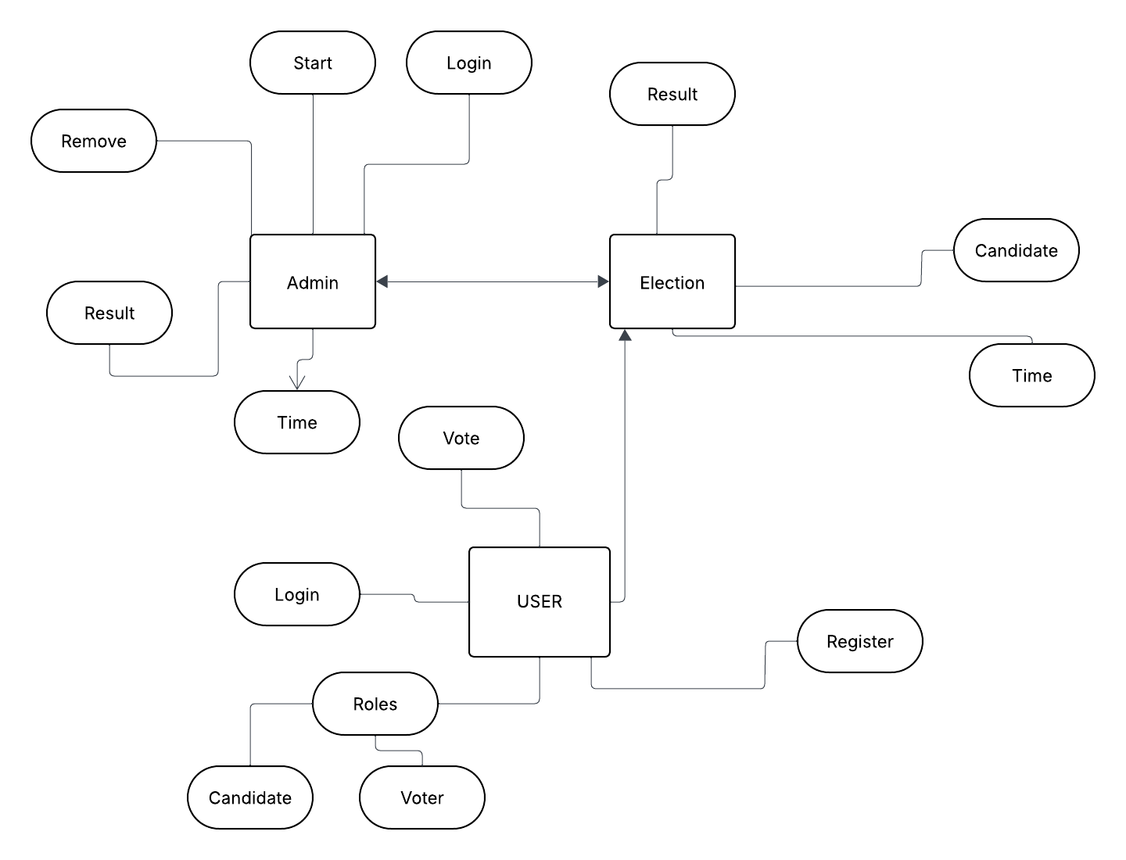

#### Use Case Diagram:

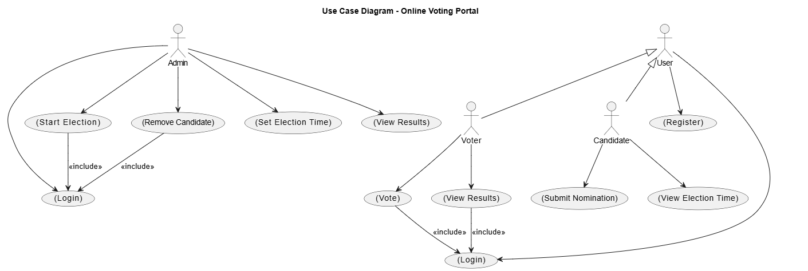

#### Sequence Diagram:

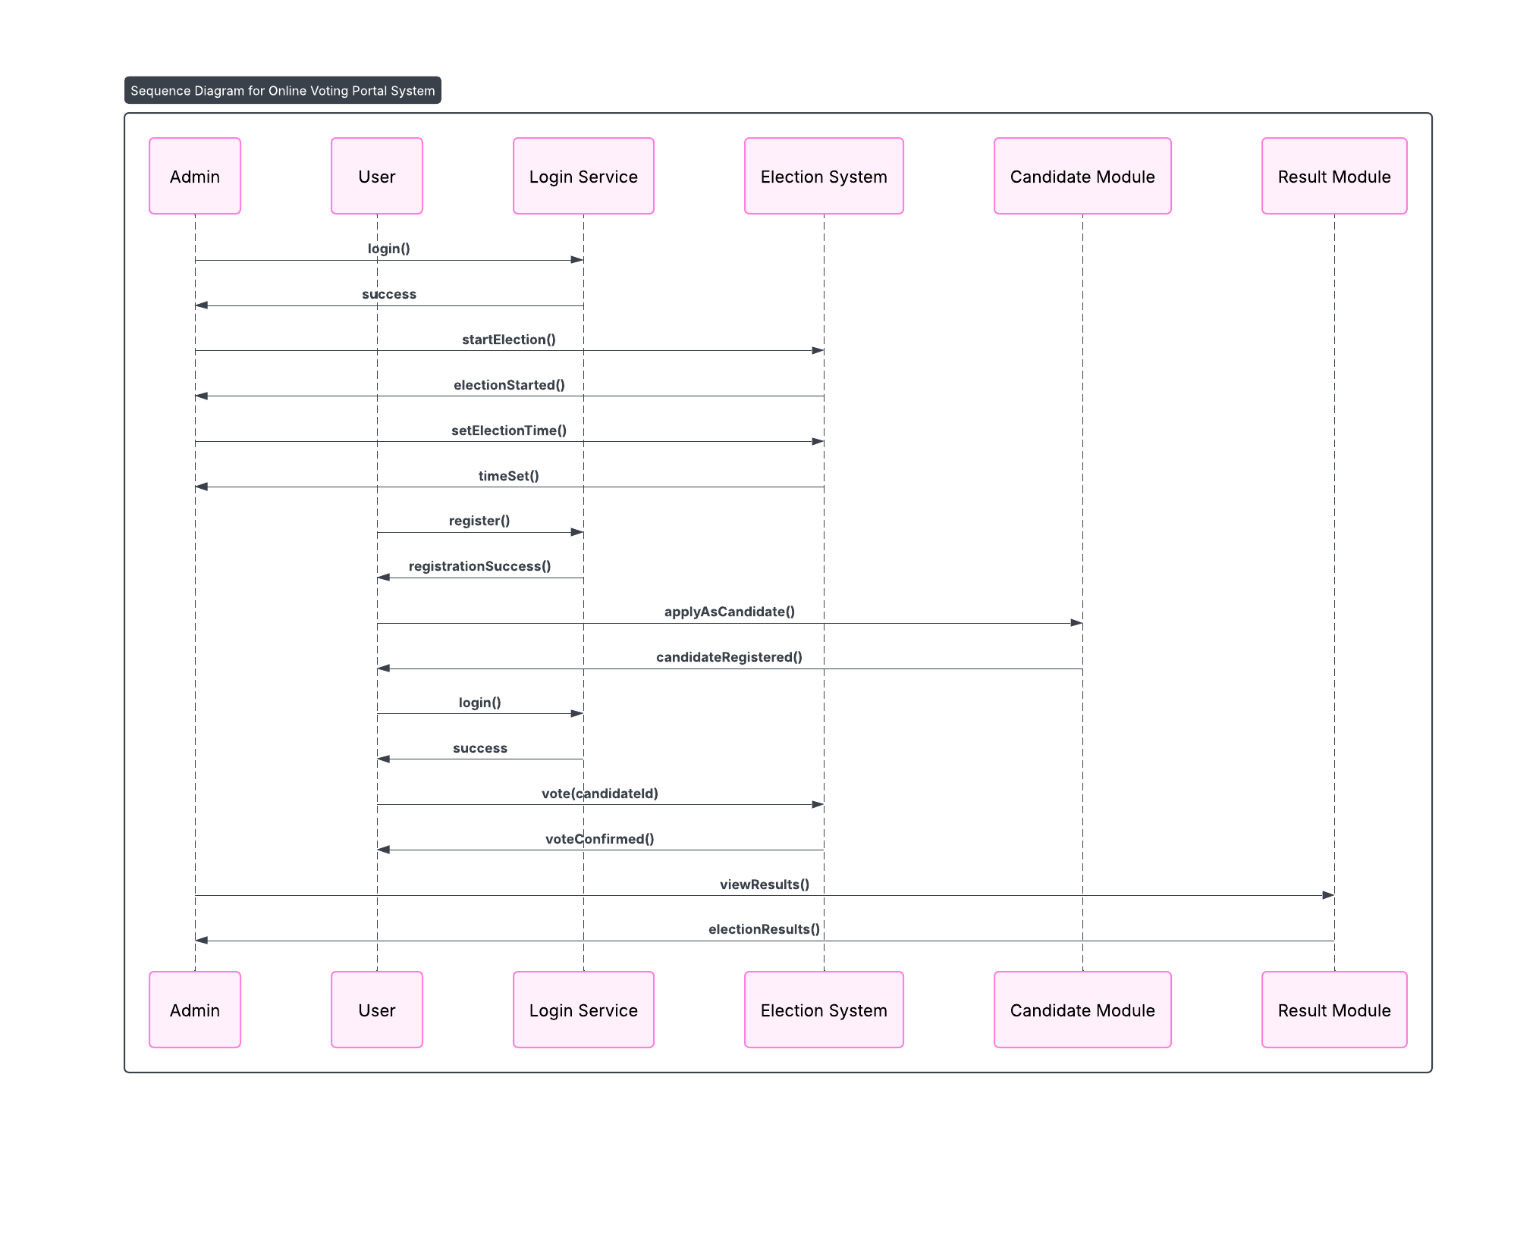

#### Class Diagram:

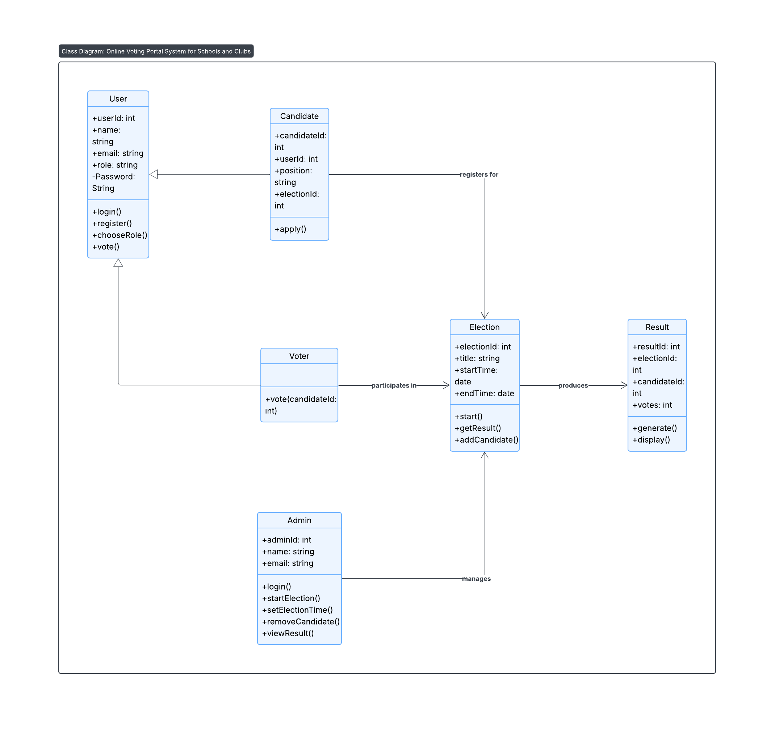

#### Activity Diagram:

