|  |  |
| --- | --- |
| sym01_s | **윈도우프로그래밍**  **LAB 02** |
| **분반** | **001** |
| **학번** | **2010044** |
| **이름** | **박진희** |

**# 실습 문제 1**

#1 quiz1.cpp 프로그램 소스(수정한 결과 소스)

#include <iostream>

using namespace std;

#include <stdlib.h>

#include <time.h>

int GetRandom() {

srand((unsigned)time(NULL));

return rand() % 100;

}

void AddQuiz(int a, int b) {

int answer;

cout << a << "+" << b << "=";

cin >> answer;

if (answer == a + b)

cout << "Correct!";

else

cout << "Wrong answer!";

}

void main() {

AddQuiz(GetRandom(), GetRandom());

}

#2 실행 화면

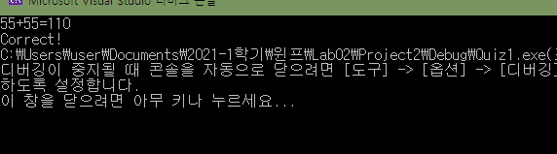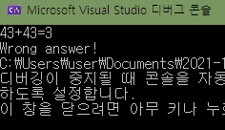

**# 실습 문제 2**

#1 quiz2.cpp 프로그램 소스(수정한 결과 소스)

#include <iostream>

using namespace std;

#include <stdlib.h>

#include <time.h>

int GetRandom() {

srand((unsigned)time(NULL));

return rand() % 100;

}

void AddQuiz(int a, int b) {

int answer;

bool checker=true;

while (checker) {

cout << a << "+" << b << "=";

cin >> answer;

if (answer == a + b) {

cout << "Correct!";

checker = false;

}

else

cout << "Wrong answer! Try again"<<endl;

}

}

void main() {

AddQuiz(GetRandom(), GetRandom());

}

#2 실행 화면

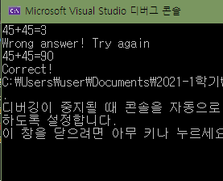

**# 실습 문제 3**

#1 quiz3.cpp 프로그램 소스(수정한 결과 소스)

#include <iostream>

using namespace std;

#include <stdlib.h>

#include <time.h>

int GetRandom() {

srand((unsigned)time(NULL));

return rand() % 100;

}

int AddQuiz(int a, int b) {

int answer;

cout << a << "+" << b << "=";

cin >> answer;

if (answer == a + b) {

cout << "Correct"<< endl;

return 1;

}

else {

cout << "Wrong" << endl;

return 0;

}

}

void main() {

char retry = 'Y';

int answer = 0;

int question = 0;

while (retry=='Y') {

question++;

answer +=AddQuiz(GetRandom(), GetRandom());

cout << "계속하려면Y, 아니면 아무 키나:";

cin >> retry;

}

cout << answer << " correct answers out of " << question << " problems";

}

#2 실행 화면

