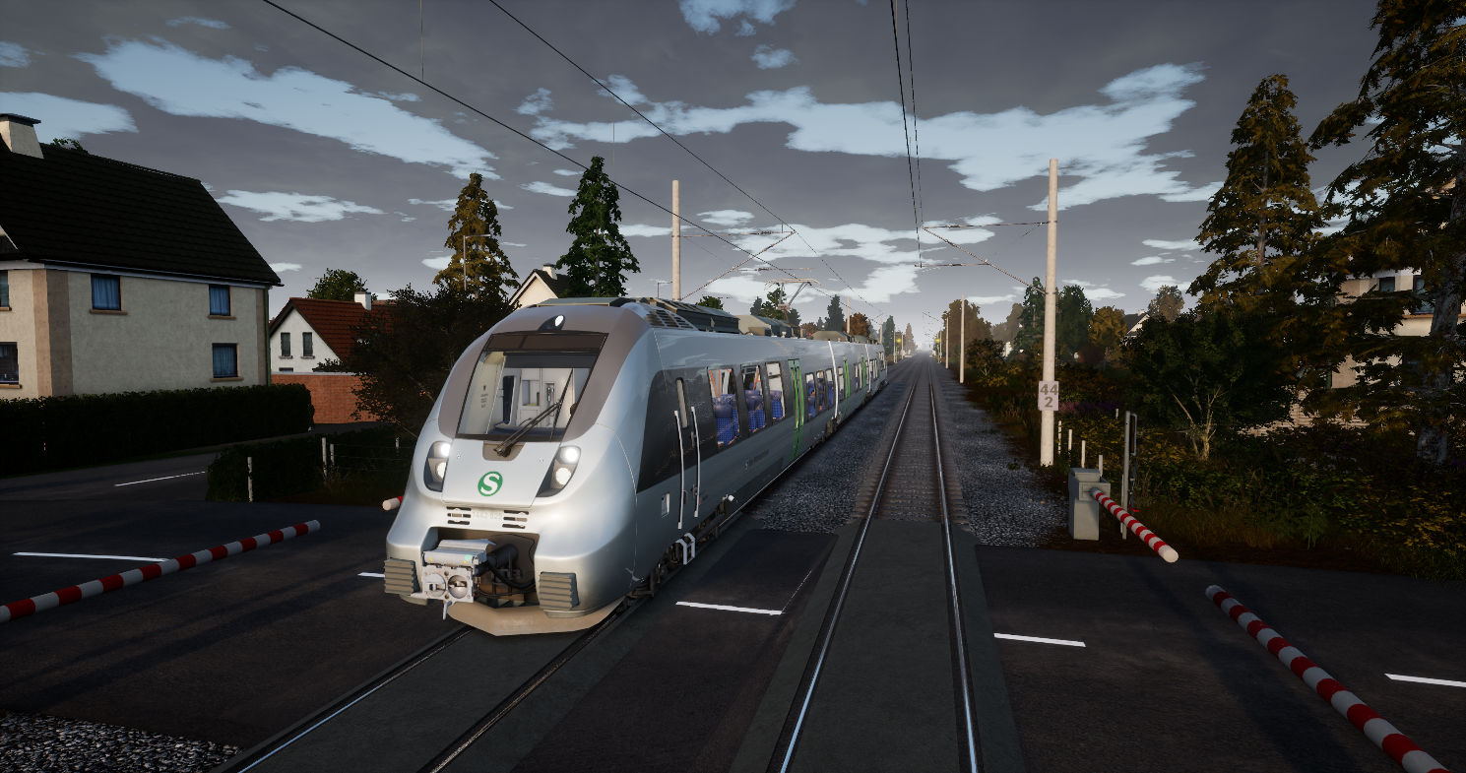

TimetableTool Manual

Rudolf Heijink

Version 0.1, May 2020

***Copyright © 2019 Rudolf Heijink.***



***This work is licensed under the Creative Commons Attribution-NonCommercial-ShareAlike 4.0 International License. To view a copy of this license, visit http://creativecommons.org/licenses/by-nc-sa/4.0/ or send a letter to Creative Commons, PO Box 1866, Mountain View, CA 94042, USA.***

***You are free to:***

* **Share** — copy and redistribute the material in any medium or format
* **Adapt** — remix, transform, and build upon the material

The licensor cannot revoke these freedoms as long as you follow the license terms.

***Under the following terms:***

|  |  |
| --- | --- |
| http://mirrors.creativecommons.org/presskit/icons/by.large.png | **Attribution** — You must give [appropriate credit](http://creativecommons.org/licenses/by-nc-sa/4.0/), provide a link to the license, and [indicate if changes were made](http://creativecommons.org/licenses/by-nc-sa/4.0/). You may do so in any reasonable manner, but not in any way that suggests the licensor endorses you or your use. |
| http://mirrors.creativecommons.org/presskit/icons/nc-eu.large.png | **NonCommercial** — You may not use the material for [commercial purposes](http://creativecommons.org/licenses/by-nc-sa/4.0/). |
| http://mirrors.creativecommons.org/presskit/icons/sa.large.png | **ShareAlike** — If you remix, transform, or build upon the material, you must distribute your contributions under the [same license](http://creativecommons.org/licenses/by-nc-sa/4.0/) as the original. |
|  | **No additional restrictions** — You may not apply legal terms or [technological measures](http://creativecommons.org/licenses/by-nc-sa/4.0/) that legally restrict others from doing anything the license permits. |

***Notices:***

* You do not have to comply with the license for elements of the material in the public domain or where your use is permitted by an applicable [exception or limitation](http://creativecommons.org/licenses/by-nc-sa/4.0/).
* No warranties are given. The license may not give you all of the permissions necessary for your intended use. For example, other rights such as [publicity, privacy, or moral rights](http://creativecommons.org/licenses/by-nc-sa/4.0/) may limit how you use the material.
* Dovetail Games has been granted a non-exclusive license for commercial use of this guide.

# Preface

***Introduction***

***Images***

Each chapter is introduced with a screenshot I made in game.

***Acknowledgements***

A big thank you to all community members that contributed to the contents of this guide. Many of them will not be aware of their contribution, but lots of information comes from the community forums.

***Frontpage image:***

<Description>

***Disclaimer***

This manual and TimetableTool are provided “as is” the author cannot accept any consequences from the use of Tool and Manual.

The contents is the sole responsibility of the author.

***Contact***

Comments are welcome at [trainsimulator@hollandhiking.nl](mailto:trainsimulator@hollandhiking.nl).

But please be aware that I cannot provide you help with your game issues. If you have any questions, please use one of the regular community forums.

If you volunteer to help me developing TimetableTool please contact me!

Enjoy reading!

Rudolf Heijink

Contents

Preface 3

1 Introduction 6

2 Route introduction Fout! Bladwijzer niet gedefinieerd.

2.1 About <Route Name> **Fout! Bladwijzer niet gedefinieerd.**

2.2 Review **Fout! Bladwijzer niet gedefinieerd.**

2.3 Route features **Fout! Bladwijzer niet gedefinieerd.**

2.4 Additional content **Fout! Bladwijzer niet gedefinieerd.**

2.5 Manual and streams **Fout! Bladwijzer niet gedefinieerd.**

3 Rolling stock Fout! Bladwijzer niet gedefinieerd.

3.1 Engines **Fout! Bladwijzer niet gedefinieerd.**

3.2 Wagons **Fout! Bladwijzer niet gedefinieerd.**

4 Additions to the manual Fout! Bladwijzer niet gedefinieerd.

4.1 Signalling **Fout! Bladwijzer niet gedefinieerd.**

4.2 Time tables **Fout! Bladwijzer niet gedefinieerd.**

4.3 Collectables **Fout! Bladwijzer niet gedefinieerd.**

5 Route in real life Fout! Bladwijzer niet gedefinieerd.

5.1 General background information **Fout! Bladwijzer niet gedefinieerd.**

5.2 Google Earth **Fout! Bladwijzer niet gedefinieerd.**

5.3 You tube videos **Fout! Bladwijzer niet gedefinieerd.**

5.4 Technical manuals **Fout! Bladwijzer niet gedefinieerd.**

5.5 Nice to know **Fout! Bladwijzer niet gedefinieerd.**

6 Known issues 13

A. Links to documentation and tools 14

Index 15

List of figures

**Geen gegevens voor lijst met afbeeldingen gevonden.**

# Introduction

TrainSimWorld has a big new feature, Timetable services, where you can choose from up to 350 drives on a single day. In the present version, there is only one timetable, but I believe some day DTG will make it possible to develop our own timetables. West Somerset Railway may be a good example, what about this:

* A day with only some maintenance activities
* A diesel heritage day
* Separate summer/winter time tables

And whatever you can think of. Designing all services for such a day, requires new skills and tools. I believe a tool to plan your services ahead and plot them into one or more timetables is absolutely necessary. You simply cannot test 25 one hour during services properly.

Therefore, I have the idea of creating a timetable tool for some time. Now I take the opportunity to combine this with learning a lot of new C# programming skills.

This first version is still a bit primitive. It works, but it is not yet optimized for easy use. I definitely will add a number of shortcuts, but first I need a stable base and demonstrate the principles on how this all works.

I included two completely worked out timetables:

The services timetable for Heavy Haul (Sandpatch) and the timetable for WSR. This shows how it works and how to use it, while being simple enough to reveal errors fast. These two timetables will be installed automatically

## Donations

Until now I never asked for donations for my software. I do not need to make money with them, but as I get more experience, and applications get more complex, my expenses are increasing. For example, I use some development tools that are not free:

Jetbrains Resharper, helps me a lot to improve code quality.

GhostDoc is a tool that helps me to document the source code.

Finally< I will need to puchase code signing certificates. This makes sure you can trust my software.

Therefore, now ask you to donate me if you sue this software:

* For professional developers, I ask Euro 25 per year. This is cheap
* For non-commercial use, a one time Euro 5 donation makes me happy.

# Updates

## New in this version

This the initial version. It has all core functions working, but the user interface is not yet great and you definitely will like more views.

## Next version

I will need to do a lot of code cleanup (refactoring) to make the code better readable and maintainable. I also will create a few shortcuts to make it possible to work faster, maybe I will introduce a workflow to guide you through all steps to create a timetable.

## Versions in development

The source code is publicly available for free at Github. There you can see the most recent versions, but keep in mind they may have bugs and you need to compile the code by yourself. If you want to help me, let me know!

Technologies used:

1. SQLite database
2. Visual Studio 2019 Community Edition, Net Core3.1
3. C# 8.0
4. Caliburn.Micro MVVM library
5. Dapper for Database Access
6. Squirrel to create installation packages
7. Word and PDF for the user manual

## Version 0.1

This version is the initial version. It is not meant for operational use. Just for review.

# Installation

# Creating a Timetable

# Reference guide

# Trouble shooting

# Known issues

1. Links to documentation and tools

This guide, other guides for TSW and TSWTools are available here:

|  |  |
| --- | --- |
| Topic | URL |
| Holland Hiking | <http://www.hollandhiking.nl/trainsimulator/index.php> |
|  |  |
|  |  |
|  |  |
|  |  |

# Index

**Geen indexgegevens gevonden.**