UPSA Campus — Additional Visual Evidence Layer
Supplementary evidence pack for LEGONRUSH | Independent from the first video-survey pack
Purpose: add a second, complementary layer of visual evidence for refining the UPSA school environment. This is NOT a replacement, corrected version, or merged update of the first pack. Upload both packs to Claude Code and instruct it to compare them as separate evidence sets.

1. What this ZIP contains
The uploaded archive contains 72 still images and one MP4 recording. The stills include institutional/building views, aerial or promotional campus images, campus courts and sports grounds, entrance and façade details, pedestrian paths, road edges, perimeter fencing, and nearby street context. Image filenames have been retained in the extracted source_assets folder so each observation can be traced to the supplied archive.
Four contact sheets index the 72 still images. The original video is included as a source asset, but this brief does not claim that every frame of that video has been separately analysed in this layer. Use the video as additional context and extract frames if a particular alignment or sequence needs to be resolved.

2. High-confidence visual subjects

UPSA Central Administration / Opoku Ampomah Building — probable identification
Several supplied images show a distinctive institutional building with a broad curved dark-blue glass façade, white/light exterior walls, a prominent forecourt and landscaping. Some supplied image labels refer to the Opoku Ampomah Building / Central Administration. Treat this as a strong visual identity cue, but confirm the precise in-game footprint and orientation from the canonical campus map and project geometry.

UPSA Twin Towers — labelled reference
The archive includes a file named Twin-Towers.jpg and other high-rise views. Use these images for the towers’ massing, façade rhythm, window bands and relation to nearby campus blocks. Do not infer exact coordinates from appearance alone.

UPSA multi-storey academic/residential blocks — identity to verify
Multiple white/light-coloured blocks with blue window accents, repeated horizontal floor bands, central gables or raised entrance features, and patterned blue/white façade panels appear in the archive. Some could be different buildings. Do not assign official names merely because their styles resemble one another.

Sports and recreation areas
Several images show fenced courts, a running track or sports field, perimeter paths and adjacent blocks. Preserve the relationship between the sports enclosure, fences, paths and surrounding buildings; verify exact edges and orientation against map geometry.

Pedestrian circulation and road edges
Street-level images show paved walkways, kerbs, ramps or drainage edges, perimeter walls, gates/fences, street lighting, utility poles, parking/forecourts and road surfaces. These are useful for environmental detail, but their precise side-of-road placement must be map-matched.

Landscaping and campus open spaces
Images include lawns, planted forecourts, trees, paths and a fountain/landscaped gathering space. Model these as site-specific features only where their location is supported by map context or repeated views.

3. Building height and naming policy
Do not publish guessed floor counts. Count only clearly visible above-ground storeys in a sufficiently clear façade view; distinguish visible storeys from total storeys when the roof, ground floor or rear wing is hidden. Record values as “at least N visible storeys” when occlusion prevents a reliable total. Use a building’s signage or official source for naming, then reconcile with the map. Keep all uncertain identities labelled PROVISIONAL.
This archive alone does not consistently establish exact building coordinates, cardinal orientation, or which of the visually similar blocks corresponds to each in-game footprint. The repository’s authoritative geography and any official UPSA maps take precedence over visual guesswork.

4. How this layer relates to the first pack
Pack 1 is the timestamped video overview/survey brief. Pack 2 (this pack) is an independent still-image and supplementary-video evidence layer. They should remain separate in the evidence hierarchy, each with its own filenames and notes. Claude should cross-reference them, not overwrite Pack 1, and should explicitly list any disagreements between the packs before changing geometry.

5. Required workflow for Claude Code
- Read the repository’s CLAUDE.md, README, geography docs and existing UPSA-related references first.
- Inspect both evidence packs independently. Preserve each pack’s original filenames and refer to evidence as Pack 1 / video frame timestamp or Pack 2 / source filename.
- Identify the UPSA campus boundary and existing canonical building footprints before proposing changes.
- Build an evidence ledger: candidate building/feature, source file/frame, visual cue, probable identity, relative-position clue, visible-storey count or range, confidence, and what still needs verification.
- Use official UPSA sources and map/satellite context to verify names and position. Treat map imagery as potentially stale; recent photos may show changes not yet mapped.
- Compare the evidence to the existing world and identify only specific mismatches: missing buildings, wrong massing, orientation, façade, entrance, path, fence, road edge or landscape.
- Add or refine the UPSA environment as an additional layer. Do not replace the first layer’s files or silently overwrite canonical geography.
- Preserve road/path topology, gate/access points, collision geometry, race and challenge routes, ghosts, records, leaderboards and existing IDs.
- Before editing, state the exact proposed files and whether each change is visual-only or changes authoritative geometry. Then implement on a working branch, run relevant tests/build and inspect the rendered area.
- Do not push to main or deploy to production without explicit approval. Report changed files, evidence basis, unresolved ambiguities, tests, commit and push status.

6. Suggested evidence ledger fields
Feature ID | Candidate name | Pack/source filename or video timestamp | Visible architectural cues | Visible storeys | Relative position/adjacency | Map/official-source match | Confidence (high/medium/low) | Proposed action | Unresolved question

7. Important safeguards
- Do not confuse the UPSA Central Administration / Opoku Ampomah Building with the UPSA hostel blocks or the separate UGBS Graduate Building near UPSA Junction opposite GOIL.
- Do not use promotional renderings as proof of current construction status or exact placement.
- Do not assume two similar-looking buildings are the same building.
- Do not move canonical coordinates solely to make a screenshot look right.
- Do not delete or replace first-pack evidence. Keep both packs available for future comparisons.

8. Contact sheets
The accompanying four contact sheets show the 72 supplied still images in archive order. Use them for fast browsing, then open the original full-resolution image for any feature that matters.
Contact sheet 1
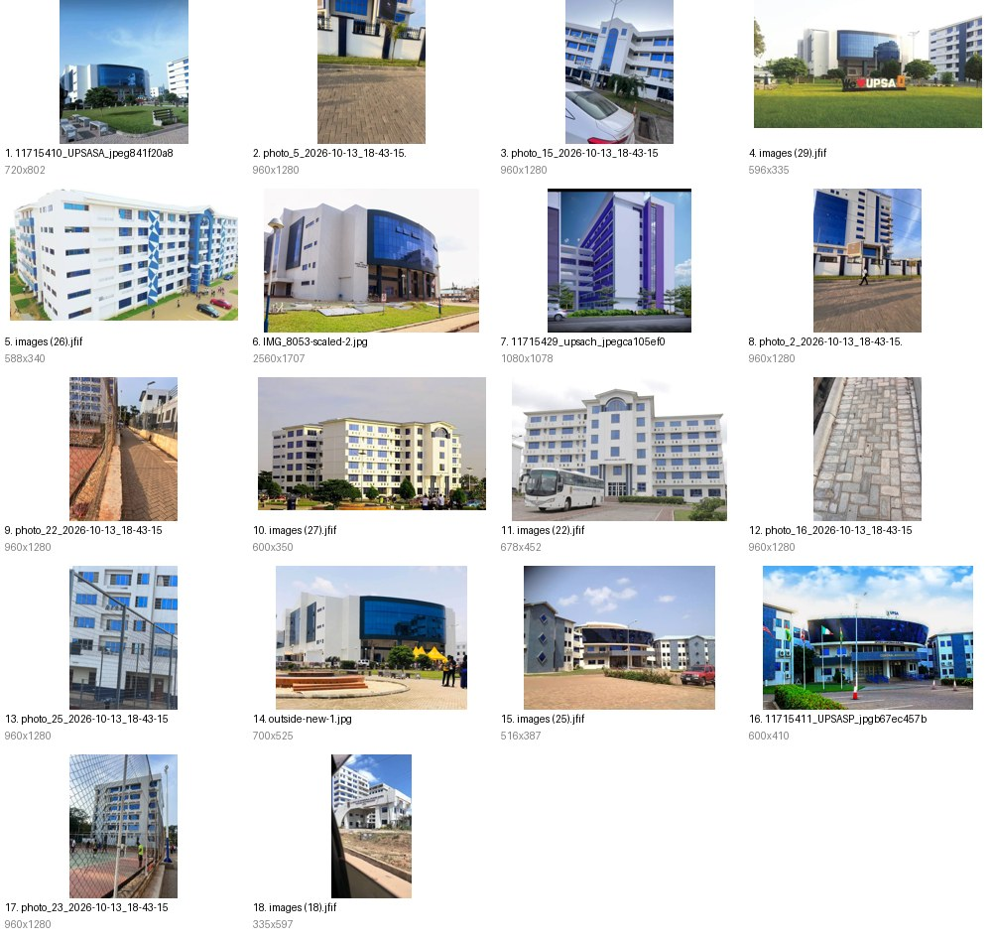
Contact sheet 2
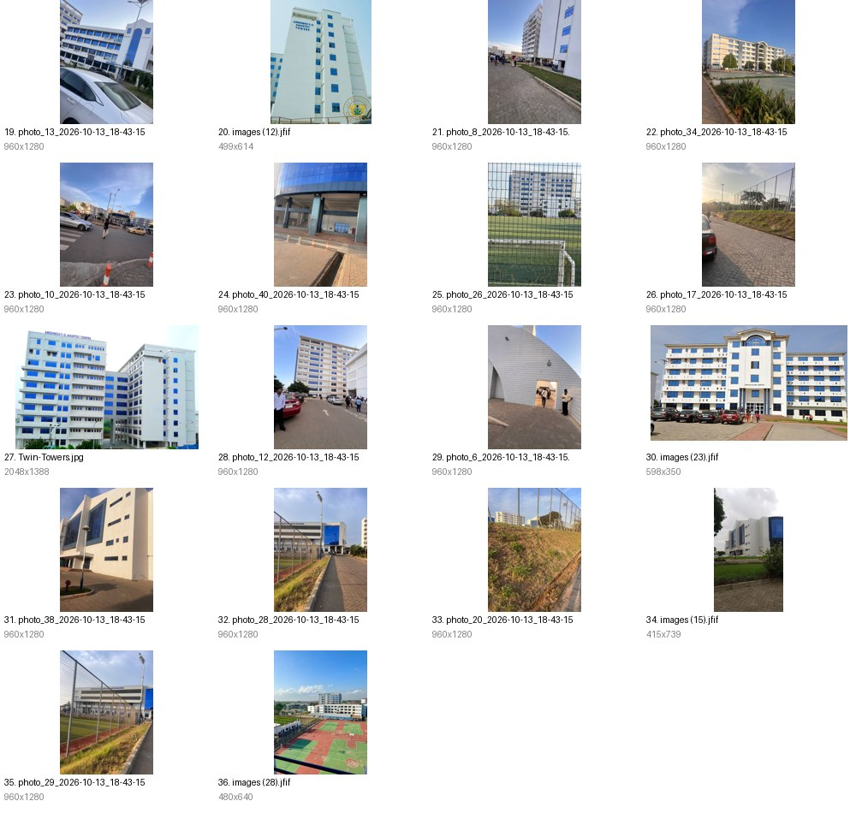
Contact sheet 3
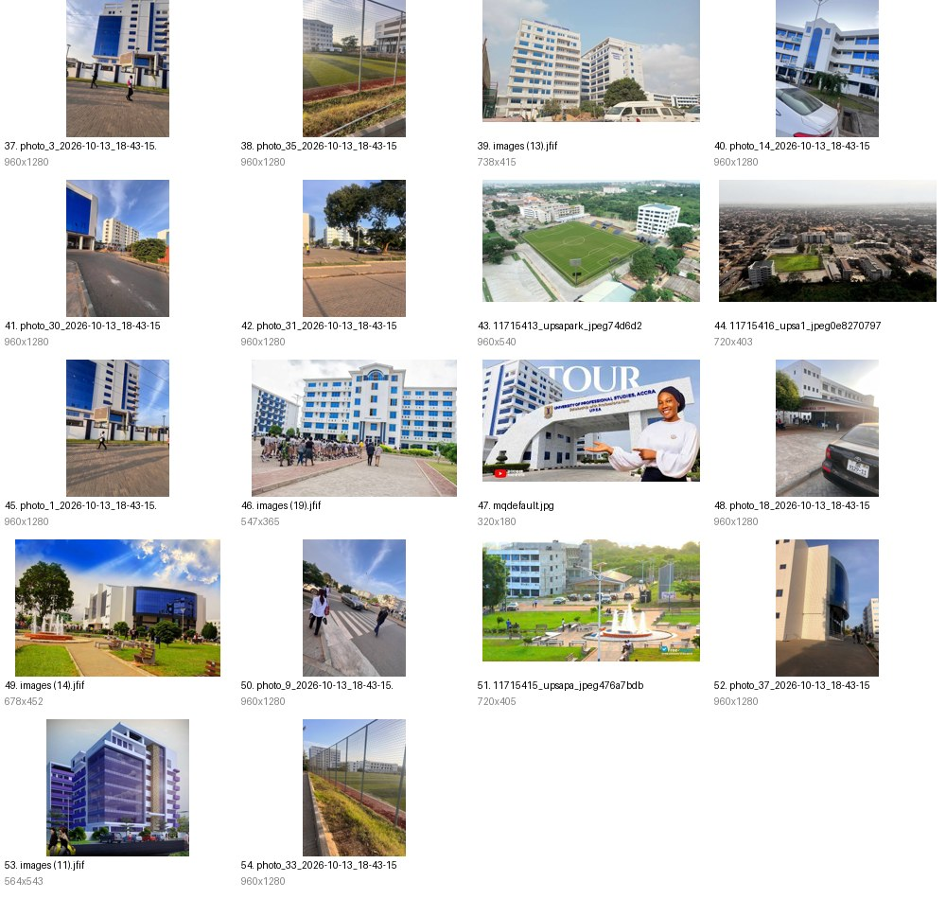
Contact sheet 4
