LEGONRUSH — PCU BUILDING & ASTRO TURF
Ground • façade • sports-ground edge • roads • lighting • surrounding environment
Purpose Use the supplied real-life photos and in-game screenshot to correct this exact scene. Claude must fix the PCU building appearance AND site environment/ground, and remove the incorrect generic block explicitly circled and marked “REMOVE” in the game screenshot. Align location/orientation with current canonical geography; do not invent coordinates.

IN-GAME SCENE — current implementation; red markup indicates the unwanted generic block  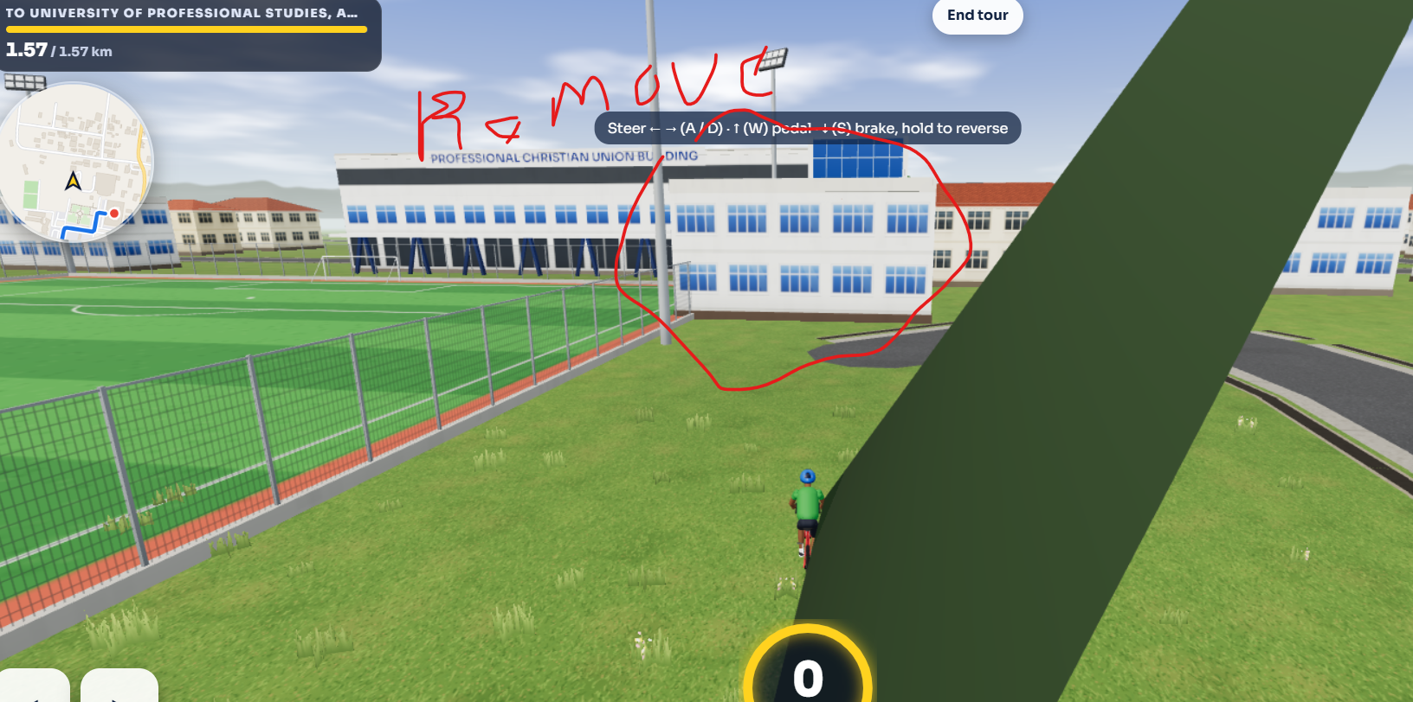 | REAL-LIFE REFERENCE — Professional Christian Union Building, Astro Turf fence, floodlight, grass verge and curb  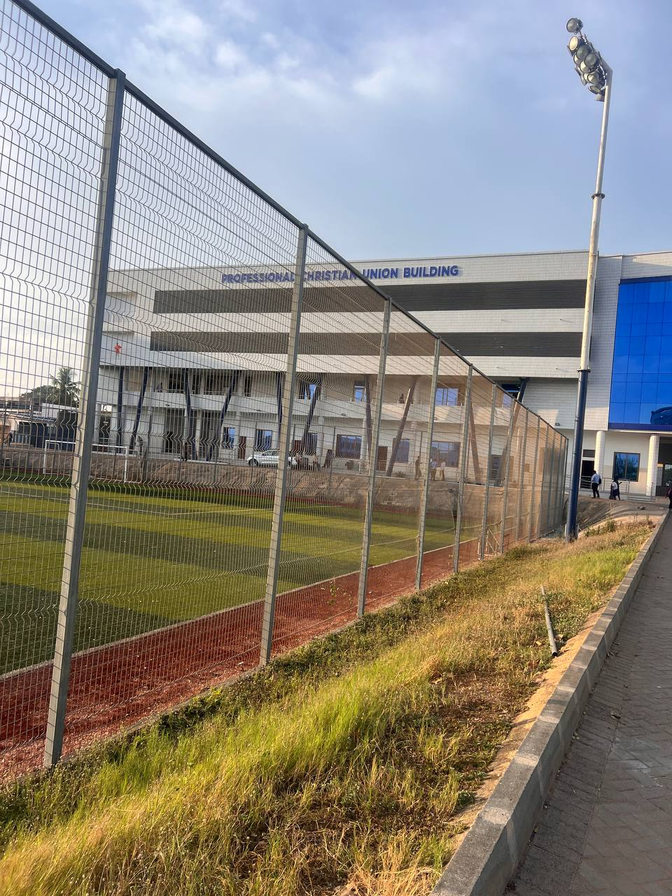

Main problems visible in the supplied game screenshot
• REMOVE the generic white multi-storey block outlined in red in the in-game image. It is an incorrect foreground/adjacent model in this view and obscures the real PCU façade and site relationships. First check object/feature IDs so the removal targets only this wrong mesh, not the PCU building or a legitimate neighbouring building elsewhere.
• A huge dark-green diagonal mesh/object cuts across the camera view. Diagnose its source (likely malformed vegetation/mesh, oversized prop, or geometry issue) and remove or rebuild it. It must not intersect the player camera or cover the road/buildings.
• The PCU façade is too generic compared with the supplied real photos: the long horizontal upper bands, white tiled finish, dark slatted bands, blue glazed end volume and distinctive angled blue columns need to be recreated accurately.
• The site is presented as broad undifferentiated grass. Rebuild the real ground layers and boundaries: synthetic-turf football pitch, red track/run-off strip, metal mesh fence, verge, curb, paved access road/forecourt and drainage where visible.
• The relationships between pitch, fence, building frontage, adjoining blue-glass volume, side road and tall floodlight need to match the real references. Do not shift the whole scene by eye; use existing map/canonical geometry and the aerial/video reference.

1. PCU building façade — exact visual target
REAL-LIFE DETAIL — tiled white façade, horizontal balcony/gallery bands, dark-blue angled columns  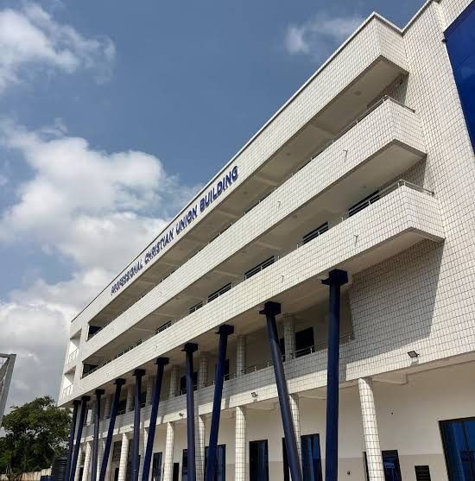 | REAL-LIFE APPROACH VIEW — PCU sign, blue-glass end volume, fence/floodlight and access path  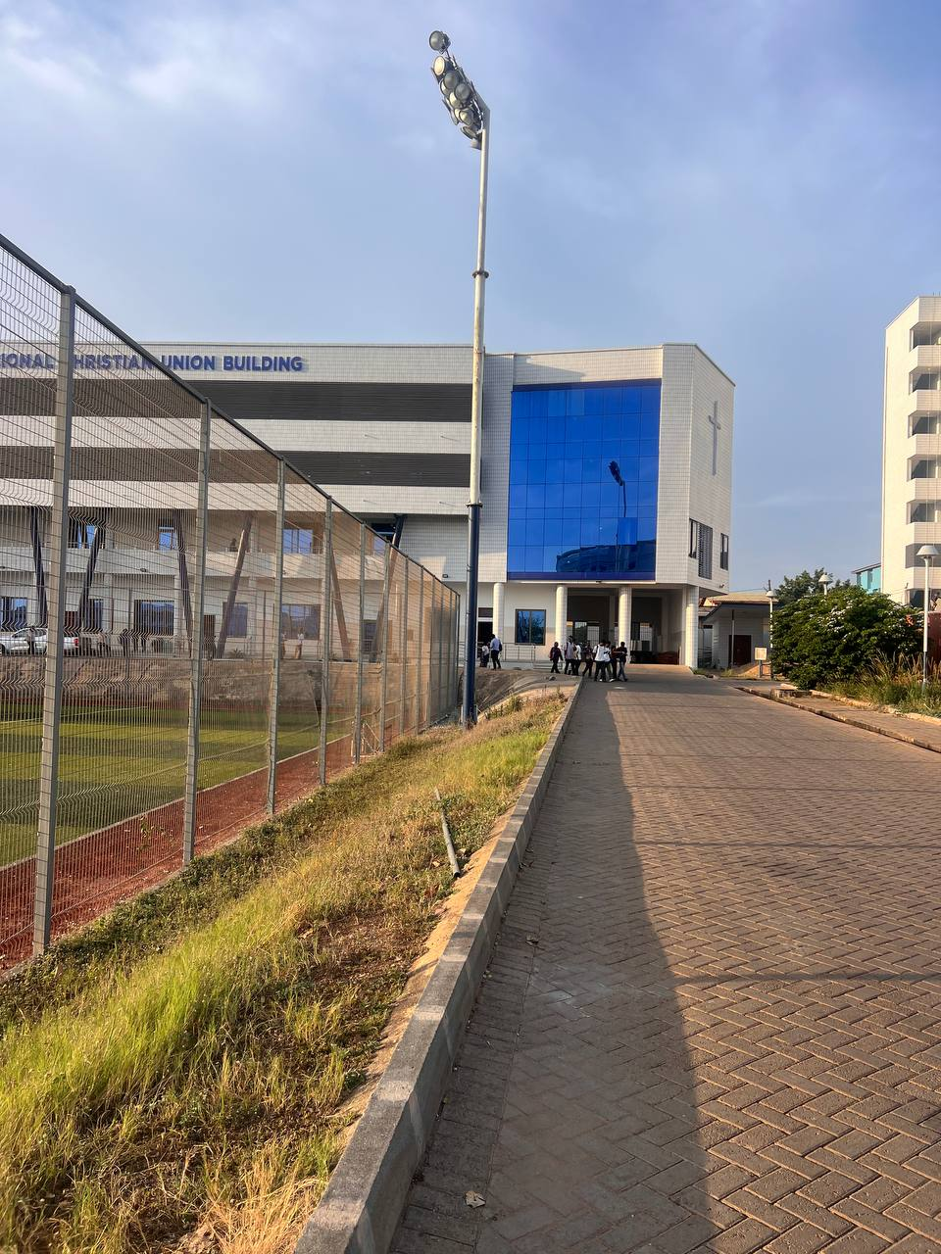

Model specification
• Main mass: a long, low-to-mid-rise rectangular academic/community building. Preserve the long horizontal proportion; do not replace it with a boxy apartment-style block.
• Materials/colour: off-white/light grey small square tile or panel grid across the façade; restrained dark charcoal horizontal bands/slatted screening across the upper levels; dark-blue/navy structural columns; blue-tinted windows and doors at ground level.
• Upper façade: continuous projecting horizontal floor/gallery bands and recessed balcony/corridor voids. Keep the repeated horizontal layering; avoid random rows of identical blue windows across every wall.
• Supports: repeated tall dark-blue angled/leaning columns under the projecting upper façade, set in a consistent rhythm. White cylindrical/square support columns appear behind/among them at ground level; match source photos without exaggerating thickness.
• End volume: a tall rectangular blue reflective curtain-glass panel occupies the right/end portion in the supplied approach photos. Keep this visually distinct from the tiled white PCU mass. Do not merge it into another building unless the underlying data confirms a shared building entity.
• Signage: “PROFESSIONAL CHRISTIAN UNION BUILDING” runs along the upper edge. Put it on the correct visible face, aligned to the long façade; use readable blue lettering. Avoid floating, oversized, misspelled or duplicated signs.
• Ground floor: recessed frontage with doors/windows, columns, steps/ramps and small paved entry area as visible. Keep pedestrian access open and do not put opaque walls across the colonnade.
Do not guess unseen details Photos show the visible exterior faces only. Where rear elevations, exact floor counts, room interiors or hidden roof details are not visible, follow existing map/source data and keep any uncertain detail conservative.

2. Ground and environment — correct the whole PCU/Astro Turf edge
REAL-LIFE SITE EDGE — mesh fence, pitch, red boundary strip, grassy verge, raised curb and floodlight | REAL-LIFE SIDE ACCESS — brick-pattern paving, colonnade, handrails and linear drainage channel  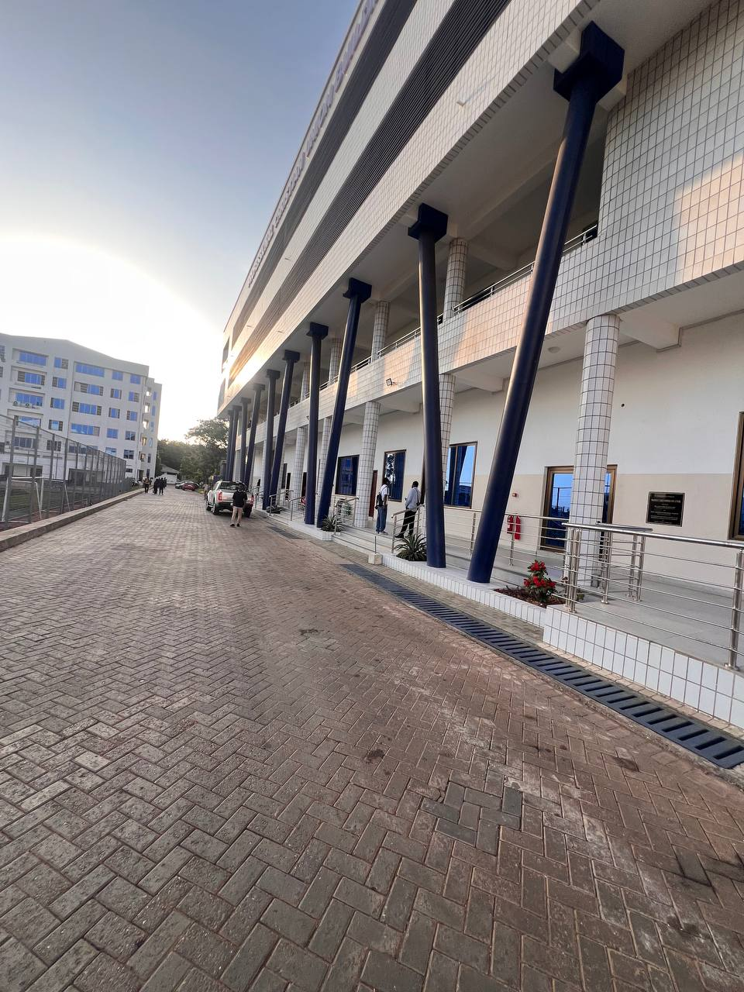

Ground-surface layers
• Football pitch: use a flat, playable rectangular field with synthetic green turf, alternating/mottled green mowing bands and white football markings (touchlines, penalty/goal area and centre markings where in view). The pitch must not be ordinary bumpy meadow grass.
• Pitch perimeter: create a narrow red/rust-coloured running/run-off strip at the visible edges, separated cleanly from the green pitch; match its width and continuity to reference imagery rather than turning it into a large red road.
• Fence: a continuous metal welded-wire/mesh fence with repeated slim grey posts and a consistent grid. Keep it aligned around the Astro Turf boundary, with believable height and spacing. Avoid opaque panels or fence posts floating above the ground.
• Verge: outside the fence, reproduce the rough, slightly dry grassy bank/strip seen in the close photos. It is narrow and bounded by the curb/path; use varied low grass clumps and earth, not random weeds spread over the entire game lawn.
• Road/path: the main pedestrian/vehicle approach beside the PCU is paved with small rectangular interlocking/herringbone blocks in a muted grey-brown tone. Match the real paved approach and keep the path width, direction and junctions in their canonical positions.
• Kerbs and drainage: create a continuous raised concrete curb separating the paved road from the grass verge. Along the building colonnade, preserve the visible long linear grated drain/slot; make the drain follow the building edge and not cross the playable route unexpectedly.
• Building forecourt: paved, maintained, mostly clear of props and clutter; use a coherent relationship between road, entrance steps/ramps, railings and doorways. Do not cover it with grass textures.
• Terrain quality: remove abrupt texture seams, z-fighting, grass poking through paving, floating fence bases, curb gaps and ground patches that climb building walls. Terrain/mesh surfaces should meet cleanly and remain collision-safe.

Sports-ground props and surroundings
• Floodlight mast: reproduce the tall slim grey metal pole and elevated cluster/array of stadium lamps visible beside the fence. It is a floodlight, not a short street lamp. Place it relative to the pitch edge using the site/map reference.
• Other context: show the adjoining blue-glass end building to the PCU’s right as a separate volume if confirmed in the current building registry; show the light-coloured multi-storey building beyond it only if that neighbouring footprint is present at the correct location.
• Fence, field and building must not overlap incorrectly. Ensure the fence sits at the field boundary, pitch surface stays inside the fence, and the walkway remains outside the fence.
• The huge diagonal green object in the game screenshot is a defect, not desired environmental vegetation. Locate its generating asset/mesh and fix the root cause; do not mask it by moving the camera or deleting unrelated trees.

3. Placement and scene validation
AERIAL/VIDEO CONTACT SHEET — use to understand PCU, Astro Turf and nearby buildings in context  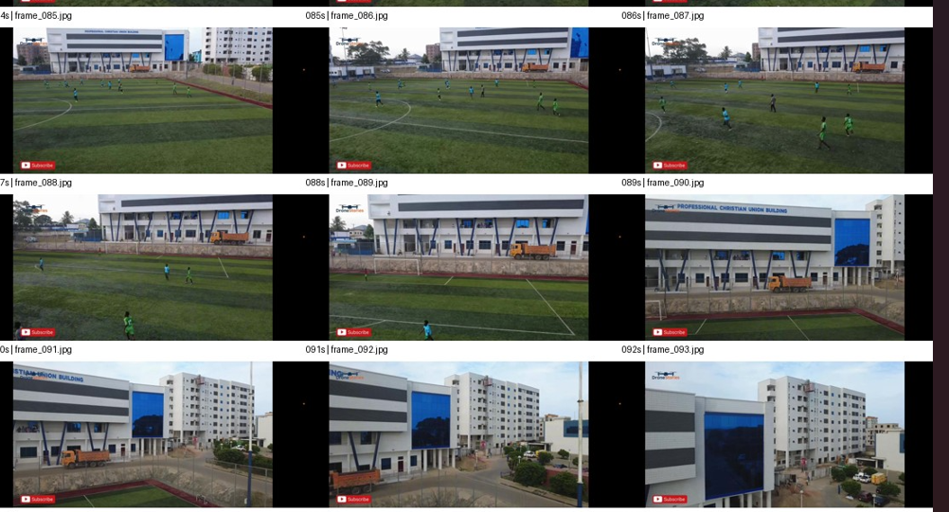 | GROUND-LEVEL CONTEXT — adjacent building, paved access road and landscaping  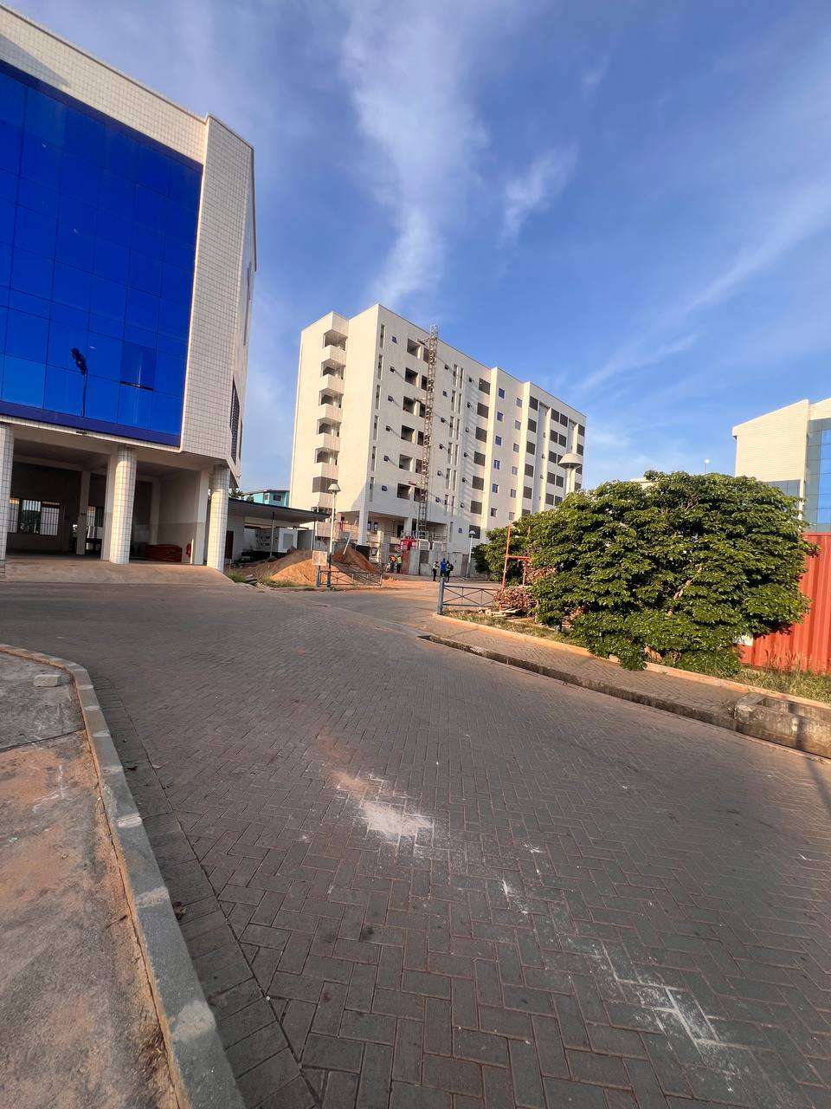

Geographic correction rules
• Inspect the repository’s existing building/landmark IDs, authoritative GeoJSON/map source, site layers, prop placement and recent git diff before edits.
• Use the aerial/video frames and the game’s own geography/minimap together to identify the PCU footprint, Astro Turf rectangle, adjacent blue-glass volume, surrounding tower, fence line and access road. Photos provide architectural evidence; they are not a substitute for coordinates.
• Adjust PCU position and rotation only if the map/footprint evidence shows the current placement is wrong. Preserve road/path topology, entrances/access points, collision shapes, destination IDs, race routes, records and leaderboards.
• The explicitly circled generic block must be removed from the incorrect location. Before deleting, trace its ID/source so only the misplaced duplicate/incorrect feature is removed. Do not delete the real adjacent building if it belongs at another footprint.
• Make the ground, fence and props conform to the corrected ground plane. Audit elevations and mesh offsets so the building sits on the ground, sidewalks meet curbs, and the pitch/fence do not float or intersect.
• Use separate commits/changes for: (a) authoritative placement/rotation, (b) façade/building mesh, and (c) terrain/materials/props, so regressions can be isolated.

4. Ready-to-paste instruction for Claude Code
Correct the existing LEGONRUSH scene around the Professional Christian Union Building (PCU Building) and Astro Turf, using every supplied image in this brief. This task covers building appearance, ground surfaces, site environment and placement validation. The in-game screenshot includes a generic pale multi-storey block circled in red and marked REMOVE: trace its feature/mesh ID and remove that incorrect object from this scene only. Also investigate the oversized dark-green diagonal mesh crossing the camera view and fix the source object/geometry.
First inspect CLAUDE.md/AGENTS.md, git status/history, existing canonical map/geography, building registry/IDs, collision/access records, and terrain/prop generation. Use the aerial/contact-sheet and game map context for placement and the real ground-level photos for appearance. Do not invent coordinates or relocate buildings by eye. Preserve roads, routes, gates, entrances, collisions, stable IDs and gameplay.
Rebuild the PCU façade from the reference: long horizontal off-white tiled mass; dark horizontal bands/slatted screening; repeated upper gallery/balcony recesses; evenly spaced dark navy angled columns; lower recessed doors/windows and accessible entrance; blue reflective curtain-glass end volume kept distinguishable from neighbouring structures; correctly aligned readable “PROFESSIONAL CHRISTIAN UNION BUILDING” sign. Do not substitute a generic apartment façade.
Rebuild the surroundings: realistic rectangular synthetic football turf with alternating green bands and white markings; narrow red/rust run-off border; continuous welded-wire metal fence with evenly spaced posts; tall stadium floodlight mast; narrow uneven grass/earth verge outside fence; continuous concrete curb; grey-brown interlocking brick access paving; entrance forecourt and the long grated drain along the colonnade where supported by the photos. Fix texture seams, grass-on-paving, floating objects, terrain intersections, fence gaps and z-fighting. Keep the field inside the fence and pedestrian/vehicle route outside it. Keep the neighboring blue-glass volume and other buildings as separate map-matched structures.
After implementation, inspect several camera views (front façade, along the side colonnade, from the pitch, and from the road). Run project tests, type checks and production build; verify route/access/collision tests and ensure the large green obstruction and wrong block are gone. Report files and IDs changed, what was moved versus visually remodeled, evidence used, tests/build results, any unresolved uncertainties, and branch status. Do not push to main or deploy.

Acceptance checklist
• The incorrect circled block is gone from this scene; the true PCU remains intact.
• No huge green mesh/prop obstructs the camera or ride path.
• The PCU façade has the correct horizontal massing, white tiled skin, dark bands, navy angled supports, blue-glass end and signage.
• The Astro Turf, red perimeter strip and continuous metal fence align cleanly.
• Paved road/sidewalk, curb, verge and building-side drain resemble the real reference photos.
• No new route, collision, access-point or geometry regressions; build/tests pass and screenshots have been inspected.

